**About us**

Aeromaps Consultancy Ltd is a firm registered in Kenya to offer environmental, health and safety consultancy services. Our team comprises of experts in various disciplines including: engineers; environmental specialists; geographers and GIS experts; enforcement and regulatory specialists. Our commitment to our customers is to deliver value through technical excellence, professionalism, timely delivery, and trust. Our dedication to building mutual relationships through participatory problem identification and solution implementation defines us.

**Our Values**

1. Technical Excellence
2. Professionalism
3. Trust and integrity
4. Partnership
5. Customer satisfaction

**Our Vision**

To be a leading professional partner in Environmental, Health and Safety.

**Our Mision**

A partner of choice in helping clients to address challenges in Environmental, Health and Safety through professionalism and technical excellence.

**Our clients**

**Home Page Slide show Photos**

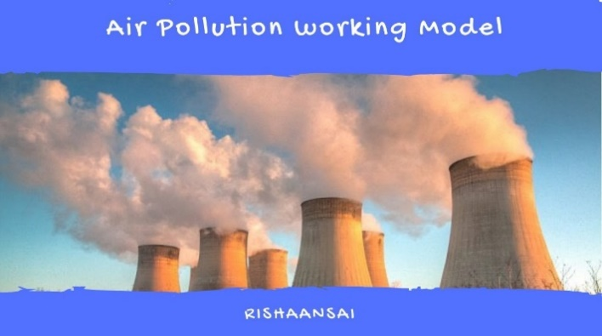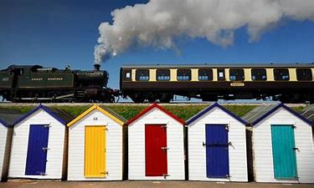

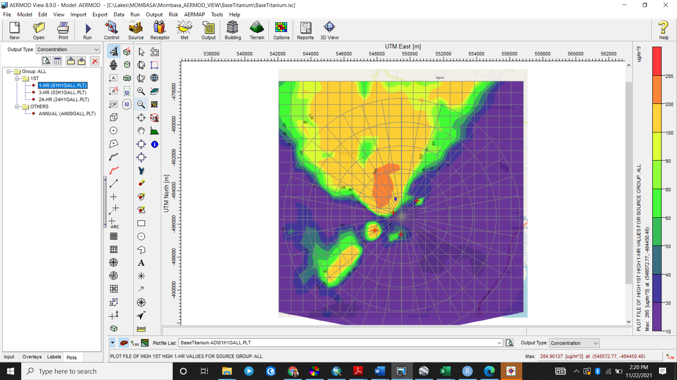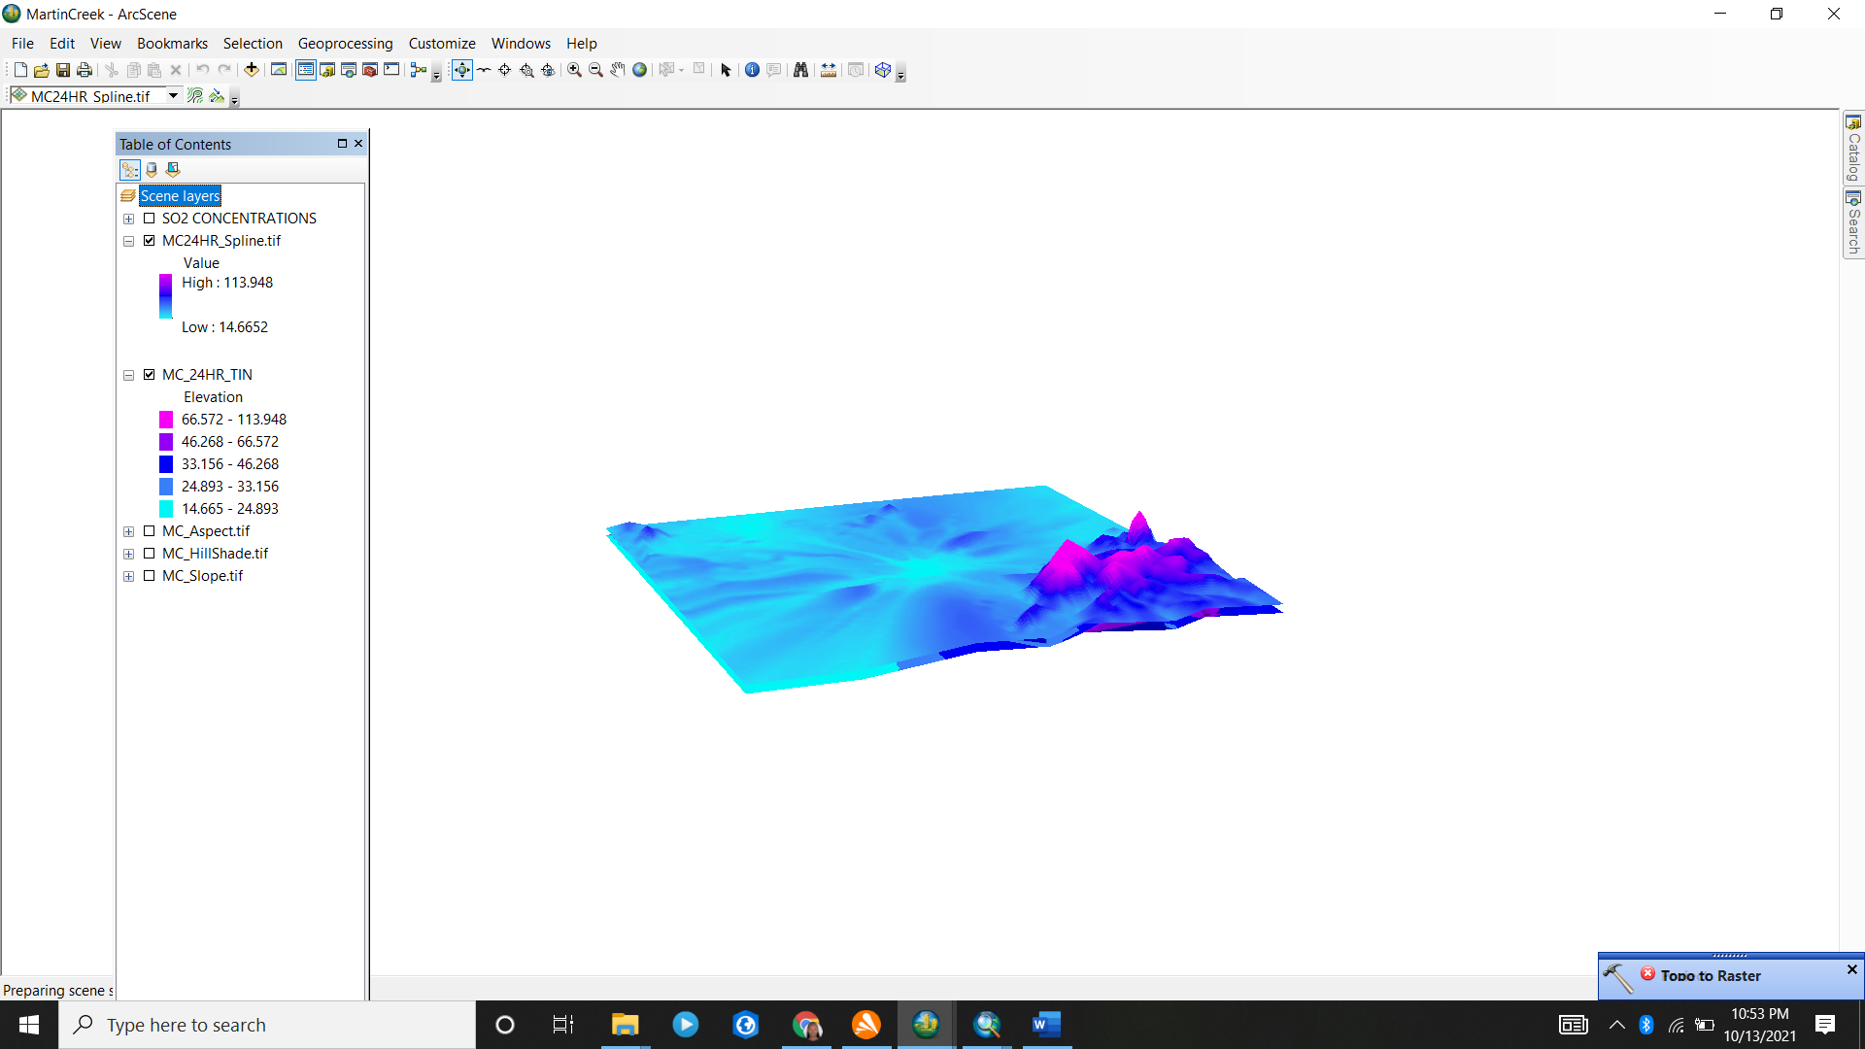

**We serve clients in diverse sectors:**

1. Power
2. Energy
3. Mining
4. Industrial
5. Infrustructure
6. Corporates

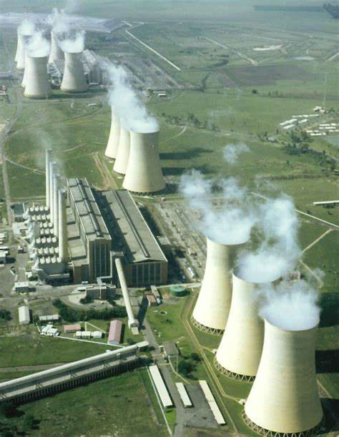 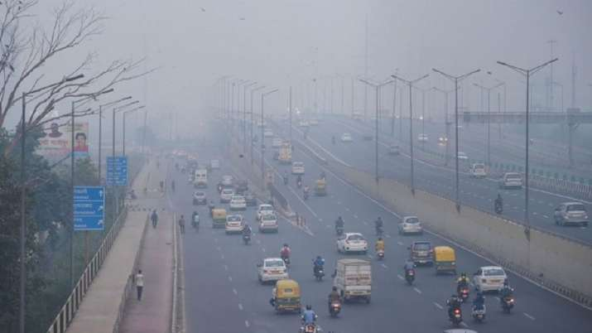

Energy

Transport

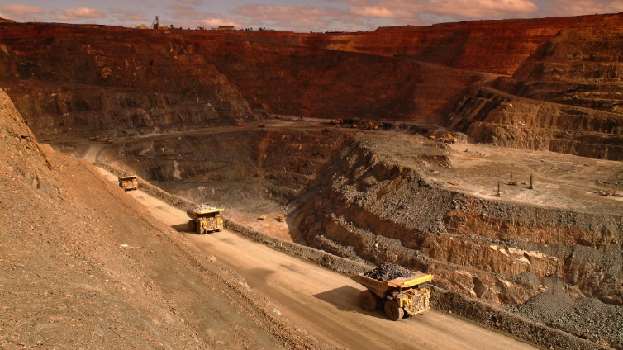

Mining

Mining

**Services offerred**

Air disperssion modelling:

|  |  |  |
| --- | --- | --- |
|  |  |  |
| Air dispersion modelling | * Project site assessment * Land cover analysis * Terrain and building influence |  |
| * Air dispersion and noise modelling |  |
| Geographic Informations Systems for resource mapping and planning | * Spatial data capture and development of databases * Spatial data analysis and visualization (mapping) * Spatio-temporal modelling * Land cover classification and analysis * Remote sensing |  |
| Emission Monitoring | * Measurement and monitoring of temporal air emissions. |  |
| Environmental and Social Impact Assessment and Audits | * Environmental and social impact assessments for new projects or changes to existing projects. |  |
| Trainings | * Geographic information systems * Green energy solutions * Environmental audits * Air dispersionsion modelling |  |