Unofficial Sample Test Plan for
JavaScript Program

Version Details

Version 1.0 | 1st April 2010 | First version
Version 1.0 | 1st April 2010 | First version
Version 1.x | xx | …
Version 1.x | xx | …
Version 1.x | xx | …
Version 1.x | xx | …
Version 1.x | xx | …

Table of Contents

Introduction 3
Test Objective 3
Process Overview 3
Test Strategy 3
Test Case 1: White box testing 3
Test Case 1a: White Box Testing 3
Test Case 1b: Black Box Testing 4
Test Case 1bi: Boundary value testing 4
Test Case 1bii: Testing for illegal values 6
Test Case 2: Testing Program’s Logic 6
Test Case 3: Integration Testing 7
Test Case 3a: Testing entire program with expected values 7
Test case 3b: Testing robustness of the second form 8
Bug Report Form 9

Introduction

Sample text for introduction

Test Objective

The main objective is to spot errors and bugs in our program. We will also attempt to spot for logical errors. Any errors, bugs or logical errors spotted will be recorded in the “Bug form”.

Process Overview
The following represents the overall flow of the testing process:
- Identify the scope.
- Identify which particular test(s) will be used to test for each module.
- Select test data.
- Identify the expected results for each test.
- Document the test case configuration, test data, and expected results.
- Perform the test(s).
- Documentation of results ( inclusive of bugs )

Test Strategy

The following outlines the types of testing that will be done for white box testing, black box testing, and integration testing.

Test Case 1: White box testing

Test Case 1a: White Box Testing

We’ll perform unit testing as part of our white box test. The test data is as follows:
Input fields | Input value ( case 1) | Input Value (case 2)
Name | Johnny Boy | Billy Boy
Place of birth | San Francisco | San Francisco
Age | 25 | 25
Spending per month | 1000 | 1000
Salary per month | 100000 | 2000
Age at which you wish to retire at | 55 | 55
Amount of money I want by retirement age | 1000000 | 1000000

Expected output for white box testing – unit testing
The expected output for each of the input values is a dynamically generated input box. Also, the input fild on the left will be disabled. An example can be seen on the following screen shot:
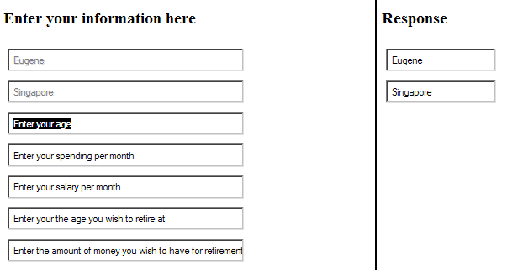

Results of the test:

Test Case 1b: Black Box Testing

Test Case 1bi: Boundary value testing
We will perform black box testing by employing the boundary value testing. The test values are as follows:

Input fields | Minimum Value | Common Value | Maximum value | Comments
Name | A single character, such as ‘a’ | Eugene | An extremely long string, no more than 255 characters. | Range of values (X):  Single character 1<= X <= 255 characters
Place of birth | A single character, such as ‘a’ | New York City | An extremely long string, no more than 255 characters. | Range of values (X):  Single character 1<= X <= 255 characters
Age | 1 | 25 | No more than 200 years old | Range of values (X):  1 <= X <= 200
Spending per month | 1 | 2000 | 1000000000 | Range of values (X):  1 <= X <= 1000000000
Salary per month | 2 | 5000 | 1000000000 | Notice that that we are assuming that our user earns more than he spends.  Range of values (X):  1 <= X <= 1,000,000,000
Age at which you wish to retire at | This age should be greater than the present age | This age should be greater than the present age | This age should be greater than the present age | Range of values (X):  1 <= X <= 200
Amount of money I want by retirement age | We will be using ‘1’ here | A decent number such as 1,000,000 | No more than a trillion dollars | Range of values (X):  1 <= X <= 1,000,000,000

Expected output for black box testing – boundary value testing
For values that are within the range of the boundary values, we should expect a dynamically generated input field for each of our input. Also, the input field on where we have entered our values in will be disabled. An example can be seen on the previous screen shot.

Results of the test:

Test Case 1bii: Testing for illegal values
The next phase of this test is testing for illegal values. The test data are as follows:
Input fields | Input Value | Case 1 | Case 2 | Case 3
Name | Digits or empty values | 1 | ~!@#$%^&*()” | Testing
Place of birth | Digits or empty values | 1 | ~!@#$%^&*()” | testing
Age | Characters and empty values | a | ~!@#$%^&*()” | -1
Spending per month | Characters and empty values | a | ~!@#$%^&*()” | -1
Salary per month | Characters and empty values | a | ~!@#$%^&*()” | -1
Age at which you wish to retire at | Characters and empty values | a | ~!@#$%^&*()” | -1
Amount of money I want by retirement age | Characters and empty values | a | ~!@#$%^&*()” | -1

Expected output for black box testing – testing for illegal values
Each of the above invalid input will result in an alert box telling us that we have input an incorrect value. If not we have a problem in our program.

Results of the test:

Test Case 2: Testing Program’s Logic
We will test for the program’s logic in terms of user’s age versus its retirement age. The user’s age should be of smaller value than his desired retirement age. As such the test data is as follows:
Input fields | Input value of first form
Name | Johnny Boy
Place of birth | San Francisco
Age | 30
Spending per month | 1000
Salary per month | 2000
Age at which you wish to retire at | 25
Amount of money I want by retirement age | 1000000
If our program does not spot this error, than it has a bug.

Results of the test:

Test Case 3: Integration Testing
There are two parts to this test: testing the entire program and changing values of the second form.

Test Case 3a: Testing entire program with expected values
The test data of the program is as follows:
Input fields | Input value ( case 1) | Input Value (case 2) | Input Value (case 3) | Input Value (case 4)
Name | Johnny Boy | Johnny Boy | Johnny Boy | Johnny boy
Place of birth | San Francisco | San Francisco | San Francisco | San Francisco
Age | 25 | 25 | 25 | 25
Spending per month | 1000 | 1000 | 1000 | 1000
Salary per month | 100000 | 2000 | 2000 | 100000
Age at which you wish to retire at | 55 | 55 | 28 | 28
Amount of money I want by retirement age | 2000000 | 2000000 | 1000000 | 1000000

The output for case 1 is:
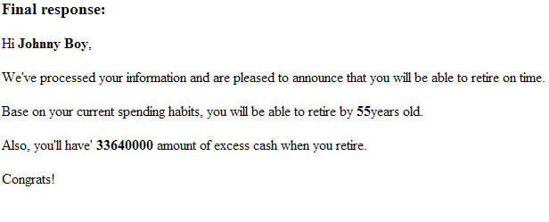

The output for case 2 is:
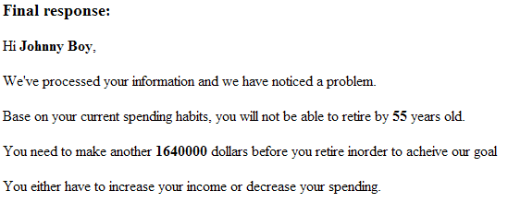

The output for case 3 is:
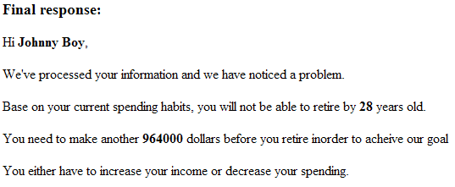

The output for case 4 is:
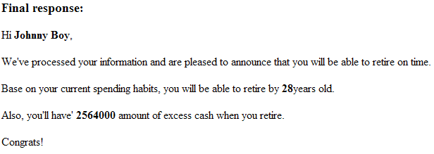

Test case 3b: Testing robustness of the second form
We will attempt to test the robustness of the program by changing values in the second form. The test values are as follows:
Input fields | Input value of first form | Input Value the second form (random values)
Name | Johnny Boy | 25
Place of birth | San Francisco | 100
Age | 25 | Johnny Boy
Spending per month | 1000 | Some characters
Salary per month | 100000 | More characters
Age at which you wish to retire at | 30 | Even more characters
Amount of money I want by retirement age | 1000000 | 1000000
We should expect the program to inform us of the error in the second form.

Results of the test:

Bug Report Form

The following bug(s) are found:

Bug Number | Phase | Actions leading to error | Possible remedies | Comments
1.
2.
3.

