Setup Guide
Installing and Running the Example JSF Applications
Table of Contents
1. Introduction 3
2. Creating the directory structure 3
3. Overview of the example applications 4
4. Installing the Eclipse IDE for Java EE Developers 6
Step 1. Download Eclipse 6
Step 2. Extract the Eclipse ZIP file 7
5. (Optional) Installing Adobe Dreamweaver with JSF support 7
Step 1. Download and install Adobe Dreamweaver 8
Step 2. Download and install JSFToolbox for Dreamweaver extensions 8
6. Importing the example applications 11
Step 1. Create a shortcut to the Eclipse executable 11
Step 2. Launching Eclipse 11
Step 3. Launch the Eclipse import project wizard 13
Step 4. Importing existing projects 14
Step 5. Select the ZIP file containing the Eclipse projects 15
7. Configure application servers 16
Step 1. Configure the Apache Tomcat server 16
Step 2. Select Tomcat server 17
Step 3. Install Tomcat server 18
Step 4. Accept the license agreement 20
Step 5. Select the web applications to deploy to Tomcat 21
Step 6. Open Tomcat Server Configuration 23
Step 7. Configure the JBoss server 24
6. Installing the computer store database 27
Step 1. Download MySQL 5.1 Community Edition 27
Step 2. Install the MySQL database (client and server) 28
Step 3. Setup the Computer Store database 28
9. Running the example applications 30
Step 1. Deploy the web applications 31
Installing the JDBC data source on JBoss 32
Adding the MySQL JDBC driver to JBoss 32
Step 2. Start JBoss 32
Step 3. (Optional) Create a Dreamweaver site for each example application 32
Step 4. (Optional) Open JSF pages in Dreamweaver 33
Step 5. (Optional) Preview JSF pages in your web browser from Dreamweaver 34
10. (Optional) Generating a Java EE application using seam-gen 35
Step 1. Install the JBoss Seam Framework 35
Step 2. Run the seam-gen utility 35
seam help 35
seam setup 36
seam create-project 39
seam generate 39
seam explode 40
Step 3. Import the Seam generated project into Eclipse 41

Introduction
Each chapter of this book includes a corresponding Eclipse Web Tools Platform (WTP) web application project that contains the example Java source code and JSF markup for the examples in the chapter.
This document explains how to set up Eclipse WTP to build and deploy the example applications, and provides detailed step-by-step instructions on how to get each of the example applications up and running on Apache Tomcat and JBoss.
Please follow this guide sequentially and perform the steps described in each section in the order in which the instructions are presented.

Creating the directory structure
For best results, it is recommended that you create the following directory structure when running the source code examples included with this book. This ensures a common file system layout between your computer and the author's environment to help you become oriented quickly with the tools and concepts used to develop and test the example applications included with the book.
The recommended directory structure for this book is shown in the following listing.
Choosing an installation root directory ($INSTALL_ROOT)
The installation root directory ($INSTALL_ROOT) for the source code bundle accompanying this book is C:\ on the author's computer. The operating system used was Windows Vista (64-bit).
On non-Windows systems, this directory could be located elsewhere, for example in your user home directory.
It is important that none of the directory names in the $INSTALL_ROOT path contain a space character, otherwise build and deployment errors may occur at a later stage.
Please begin by creating the following directories:
[$INSTALL_ROOT\JSF1.2Components]
[Libraries]
[Projects]
[Servers]
[Tools]
[Workspace]

When you have installed and configured all the tools and example projects used in this book according to the procedures outlined in this setup guide, you should see the following files and folders:
[$INSTALL_ROOT\JSF1.2Components]
[Libraries]
[jboss-seam-2.2.0.GA]
jboss-seam-2.2.0.GA.zip
mysql-connector-java-5.1.8-bin.jar
[Projects]
[ComputerStore]
[Servers]
[apache-tomcat-6.0.14]
[jboss-4.2.3.GA]
[Tools]
[eclipse]
[Workspace]
[ComputerStore]
[7627_01_Web]
[7627_02_Web]
[7627_03_Web]
[7627_04_Web]
[7627_05_Web]
[7627_06_Application]
[7627_06_EJB]
[7627_06_Web]
[7627_Appendix_Web]

Overview of the example applications
This book includes a number of example applications based on a fictional computer hardware store. The example applications for chapters 1 to 5 were implemented as an Eclipse Dynamic Web Project. These projects will be deployed as standard Java EE Web Application Archives (WAR files) to the Apache Tomcat server using the Eclipse WTP Servers tab. Furthermore, these applications are deployed as exploded WAR files as opposed to packaged WAR files.
What is a WAR file?
A WAR file is a ZIP file that includes additional metadata files in special subdirectories in the root of the archive named /META-INF and /WEB-INF. These metadata files include /META-INF/MANIFEST.MF (manifest information such as the date the archive was built, the Java compiler version, the program version information, and so on), /WEB-INF/web.xml (the web application deployment descriptor containing configuration information for servlets, filters, and other Java Web artifacts), and framework-specific configuration files such as /WEB-INF/faces-config.xml.
Java EE application servers such as Apache Tomcat and JBoss support the deployment of both exploded and packaged WAR files. An exploded WAR file is a WAR file that has been extracted during the deployment process. Exploded WAR file deployment is useful for development because files such as JSF pages can be modified and hot-deployed (redeployed) without restarting the application server.
Packaged WAR files are deployed as archives with the .WAR file extension and are useful for production deployments since only a single file needs to be deployed to the production application server. The drawback of packaged WAR deployments is that files cannot be individually redeployed; any changes to the application require redeployment of the entire WAR file and typically restarting the application server.
The example application used for both chapters 6 and 7 was implemented using three Eclipse projects, one Enterprise Application Project (7627_06_Application), one EJB Project (7627_06_EJB), and one Dynamic Web Project (7627_06_Web). The reason for three projects is because we are deploying the example application for this chapter as an Enterprise Application Archive (EAR file) that contains Enterprise JavaBeans 3.0 (EJB3) components.
The Eclipse IDE for Java EE Developers (Galileo release) divides a Java EE application into separate projects that can be configured, built, and deployed in a modular way. Eclipse supports packaged deployment of EAR files to a number of Java EE applications servers.
What is an EAR file?
An EAR file is an Enterprise Application Archive file that also conforms to the ZIP specification. Java EE applications deployed as EAR files may contain EJB JARs, Java utility or library JARs, and WAR files. Like WAR files, EAR files may be deployed as packaged or exploded archives. Once again, it is more convenient to use exploded EAR deployment in a development environment, and packaged EAR deployment in a production environment. An EAR file can contain EJB components packaged as a JAR file. To deploy an EAR file, you need a compliant Java EE application server such as JBoss. Tomcat only provides a web container for running Servlets/JSPs, so EJBs and EAR files cannot be deployed to Tomcat.
At the time of writing, the Eclipse IDE for Java EE Developers (Galileo release) did not provide a mechanism to support exploded EAR deployments. Therefore, although we created the example application for chapter 6 as separate Eclipse projects based on Java EE modules using the Eclipse IDE tooling, we will not be deploying the EAR file for chapters 6 and 7 using Eclipse's server deployment tooling. Instead, a custom Ant build script is provided that performs the necessary compilation and exploded deployment of our EAR file.
What is Ant?
Apache Ant is a popular open source build tool for Java developers similar to the GNU Make build tool. Ant build scripts are XML based and perform common tasks such as executing a Java compiler to compile source code, creating JAR/WAR/EAR files, copying files, and so on. For more information about Ant please visit http://ant.apache.org.
Alternately, the JBoss Seam library includes a tool named "seam-gen" that can be used to create a single Eclipse project that can be deployed to JBoss as an exploded EAR file. Although this approach was not used in the book, it will be covered here as a reference for the reader later in this guide.

Installing the Eclipse IDE for Java EE Developers
The first step in running the example applications is to download and install the Eclipse IDE for Java EE Developers from the eclipse.org website. This distribution of Eclipse includes the Web Tools Platform (WTP) that was used to build, deploy, and test the example applications. At the time of writing, the download URL for this software is http://www.eclipse.org/downloads/.

Step 1. Download Eclipse
Download the Eclipse IDE for Java EE Developers ZIP file from the eclipse.org website as shown in the following screenshot:
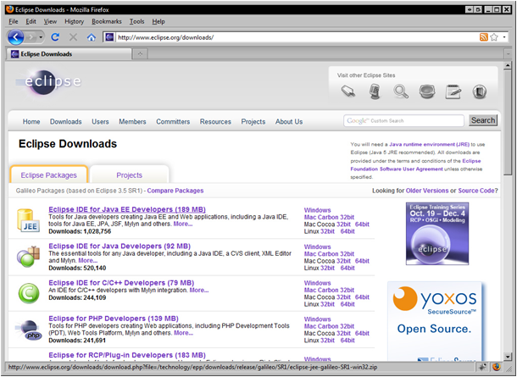

Step 2. Extract the Eclipse ZIP file
Extract the ZIP file you downloaded from the eclipse.org website to the following directory:
$INSTALL_ROOT\JSF1.2Components\Tools
Once the ZIP file is extracted, you should see a directory named “eclipse” under the Tools directory.

(Optional) Installing Adobe Dreamweaver with JSF support
All the Facelets XHTML pages for the example applications included with this book were developed using Adobe Dreamweaver CS4 and the JSFToolbox for Dreamweaver suite of extensions. By using Adobe Dreamweaver for JSF user interface development we can leverage the best visual web authoring tool in the industry to create next-generation JSF user interfaces.

Step 1. Download and install Adobe Dreamweaver
A fully functional 30-day trial version of Adobe Dreamweaver may be downloaded from the www.adobe.com website.
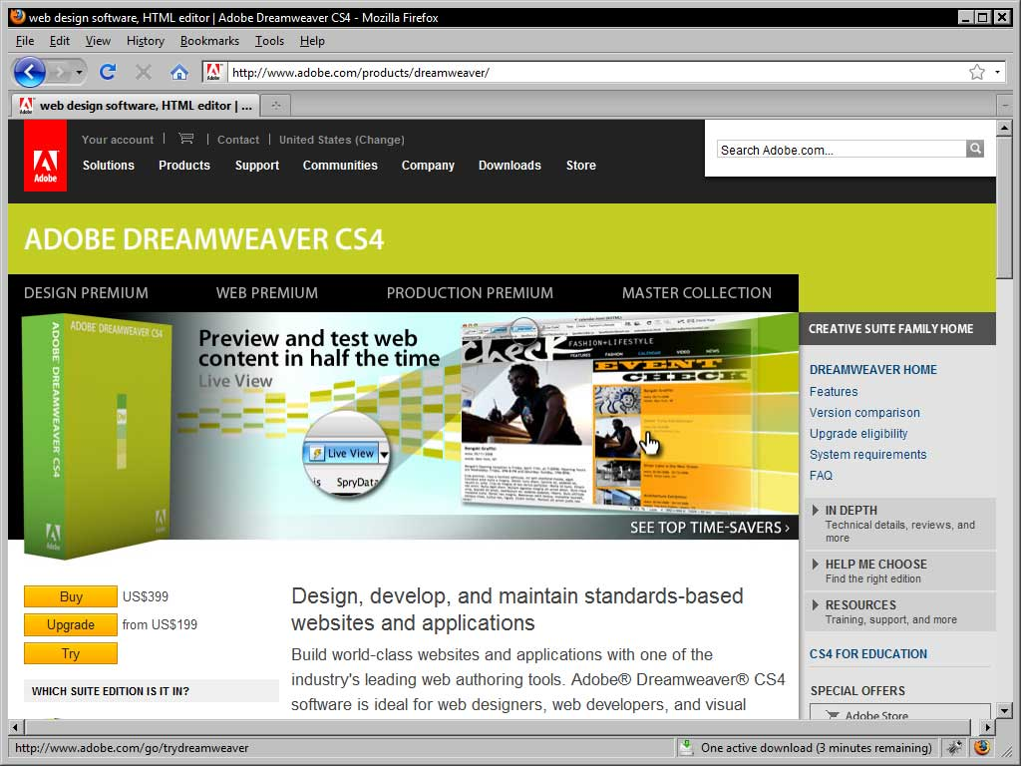

Step 2. Download and install JSFToolbox for Dreamweaver extensions
The JSFToolbox for Dreamweaver suite of design and coding extensions adds comprehensive JSF support to Adobe Dreamweaver. It enhances Dreamweaver industry-leading design time experience to JSF development through a wide range of innovative features and JSF user interface development tooling.
The JSFToolbox for Dreamweaver suite of extensions was developed by the author's company, Tarantula Consulting Inc., and can be downloaded from www.jsftoolbox.com.
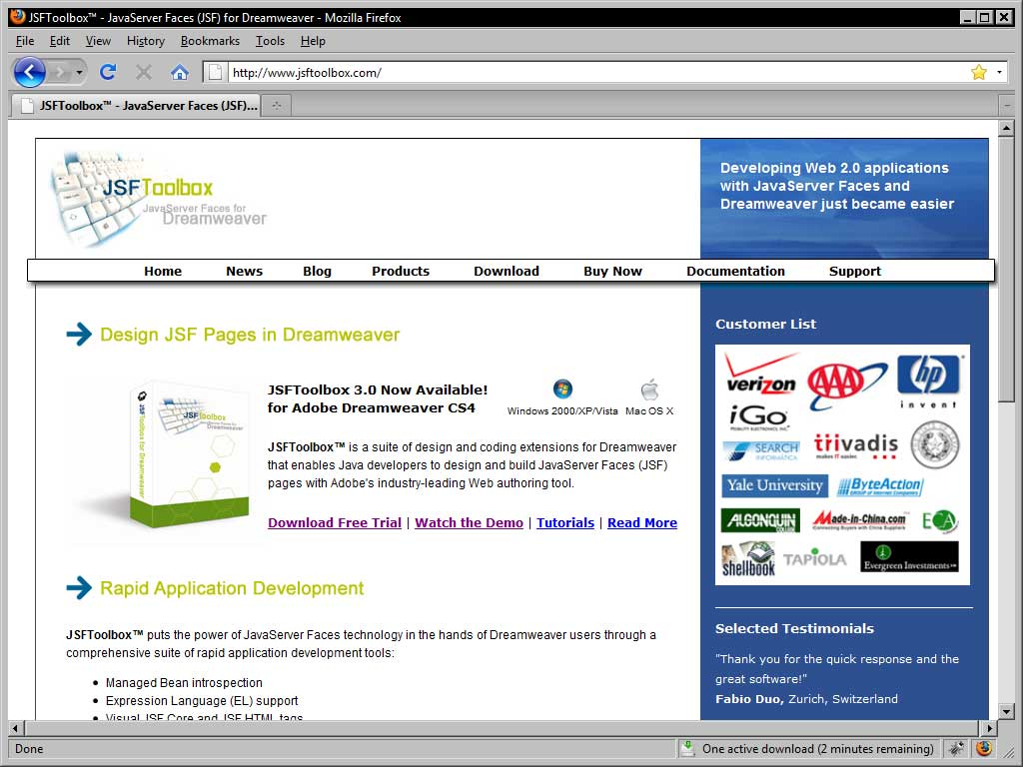
With these JSF extensions installed, the following features are added to Dreamweaver:
- Visual JSF tags (design view)
- Drag-and-drop toolbars for JSF components
- Managed bean EL code hints (code view)
- Syntax auto-complete for JSF tags (code view)
- JSF tag property inspector panels
- Context-sensitive help for JSF tags (right-click in code view)
- Facelets source code formatting
- JSF EL Expression Builder
- Automatic JSF tag library management (add/remove)
- Much more
JSF extensions are available as both a free Community Edition and a Professional Edition for Dreamweaver on Windows and Mac from the www.jsftoolbox.com website and support all the tag libraries covered in this book. The extensions are installed using the Adobe Extension Manager, as shown in the following screenshot:
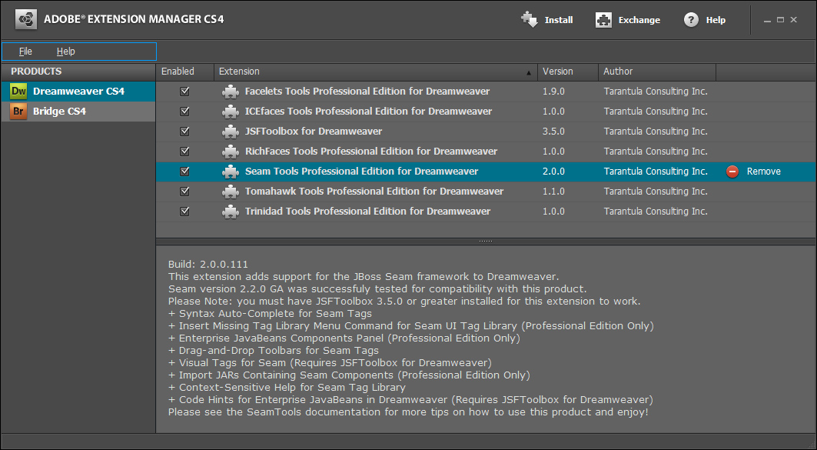

Importing the example applications
Once you have downloaded the Eclipse IDE, the next step is to start Eclipse. The following instructions assume you are running the example applications on a computer with the Windows operating system installed.

Step 1. Create a shortcut to the Eclipse executable
The eclipse directory contains the Eclipse executable. To launch it, simply double-click on the file. There are no start menu locations created during this installation procedure. It is recommended that you create a shortcut on your desktop or start menu by dragging and dropping (while holding the Alt key on Windows) the Eclipse executable to these locations.

Step 2. Launching Eclipse
Start Eclipse by double-clicking on the Eclipse executable (eclipse.exe on Windows) in the eclipse directory, or by double-clicking the shortcut you created in the previous step. The first time you launch Eclipse it will ask you to select a workspace location as shown in the following screenshot. When prompted, please enter $INSTALL_ROOT\Workspace (where $INSTALL_ROOT is the root directory you created in the initial steps of the procedure described earlier).
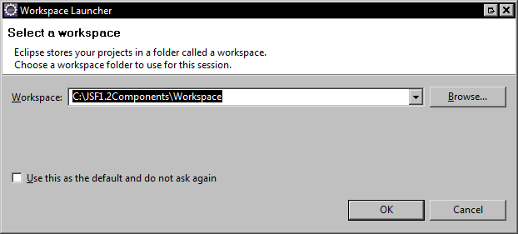

The Eclipse welcome screen will be shown as per the following screenshot:
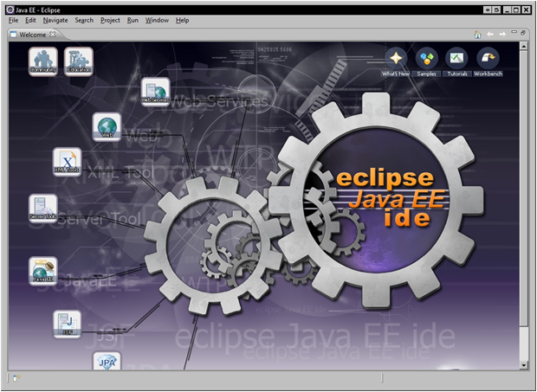

Step 3. Launch the Eclipse import project wizard
The example applications for this book are pre-configured Eclipse projects that can be imported directly into the Eclipse workspace. These projects are located inside the ZIP file named 7627_CodeBundle.zip. You do not have to extract this ZIP file to import the projects into Eclipse. Eclipse is able to import multiple existing projects directly from the ZIP file into your workspace.
In Eclipse, choose File | Import.
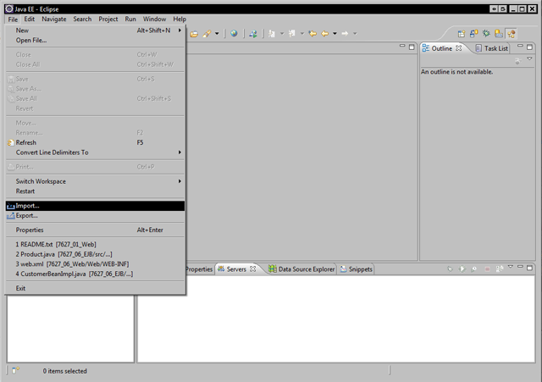

Step 4. Importing existing projects
Choose General | Existing Projects into Workspace and click Next.
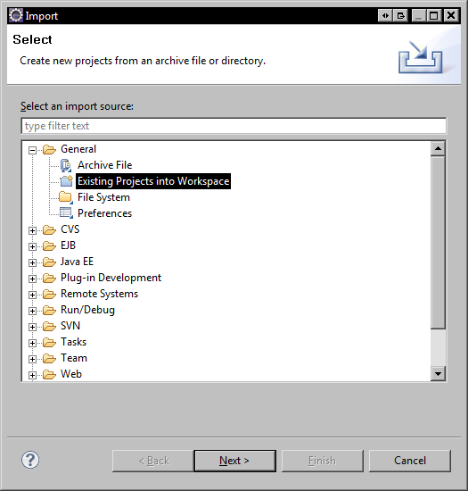

Step 5. Select the ZIP file containing the Eclipse projects
Click the Select archive file radio button and then click the Browse… button beside the file name field. Browse for the zip file named 7627_CodeBundle.zip that you downloaded from the Packt website. All the projects contained in the zip file will be selected. Click Finish.
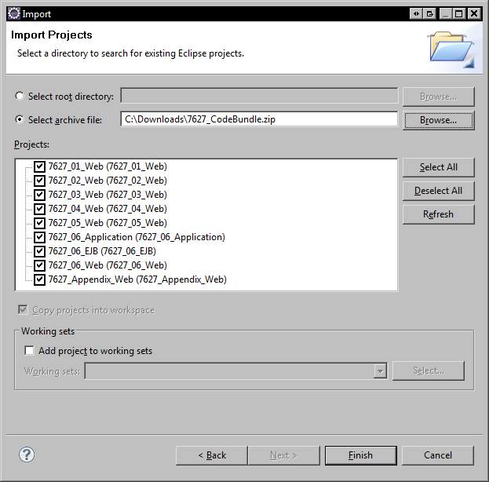

Configure application servers

Step 1. Configure the Apache Tomcat server
Right-click inside the Servers tab and choose New | Server.
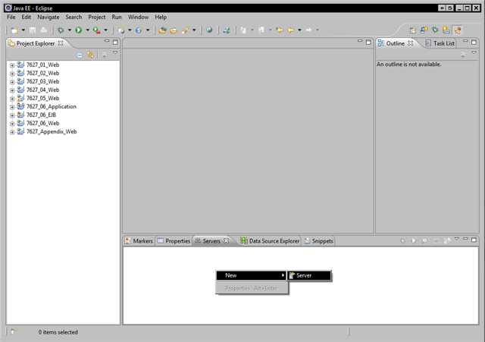

Step 2. Select Tomcat server
Select the Apache Tomcat Server v6.0 from the Apache server category.
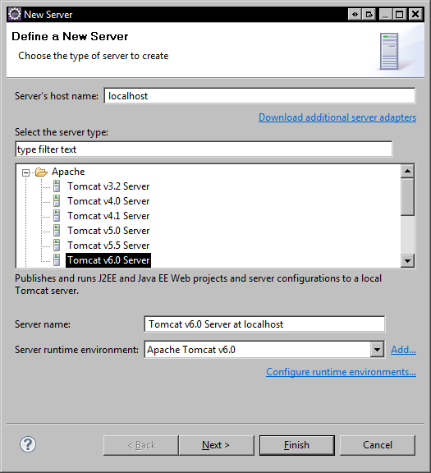

Step 3. Install Tomcat server
The next step is to select the Tomcat installation directory, and optionally, to download the Tomcat server. Assuming you do not already have the Tomcat server installed, browse to select the desired Tomcat server installation directory. For this example, we created a folder named $INSTALL_ROOT\JSF1.2Components\Servers\apache-tomcat-6.0.14. Once you select the folder, you may see a warning saying that "The Tomcat installation directory is not valid. It is missing expected file or folder lib/jasper-el.jar. Simply ignore this message for now.
The following screenshot displays the Tomcat server installation dialog window:
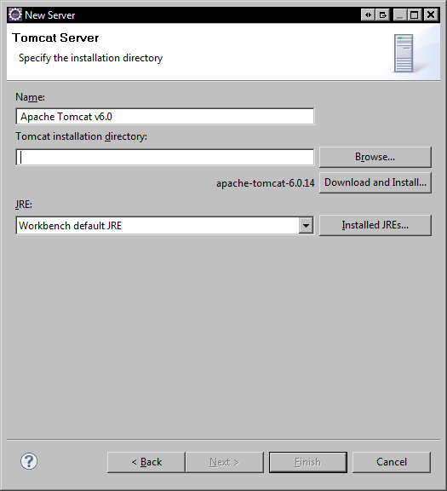
Once you have created and selected the Tomcat installation directory, click Download and Install to download and install the Tomcat server.

Step 4. Accept the license agreement
Read the license agreement, accept it, and click Finish.
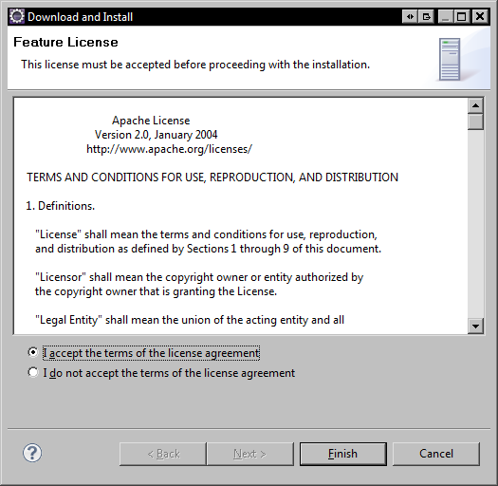

Click Next >.
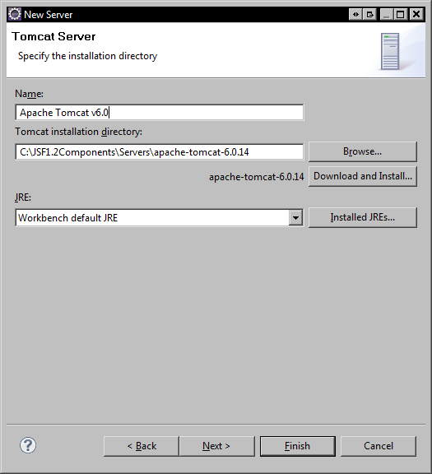

Step 5. Select the web applications to deploy to Tomcat
Add the web application projects to the list of projects configured for deployment to Apache Tomcat. Notice that we select all the available projects except the 7627_06_Web project. This web application will be deployed as part of an EAR file to the JBoss server in a later step. We should not deploy it to Tomcat.
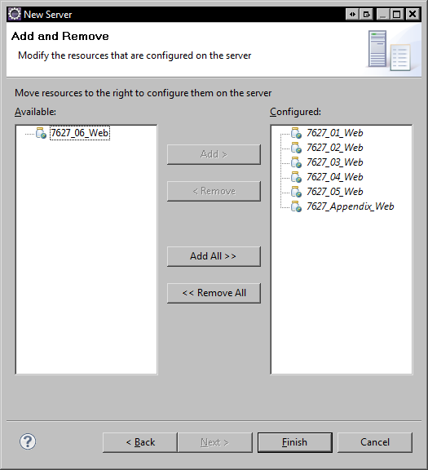

Step 6. Open Tomcat Server Configuration
In the Servers tab, double-click the entry for "Tomcat v6.0 Server at localhost". The server's configuration file is opened. Under Server Locations, select Use Tomcat installation (takes control of Tomcat installation). Leave all the other options unchanged.
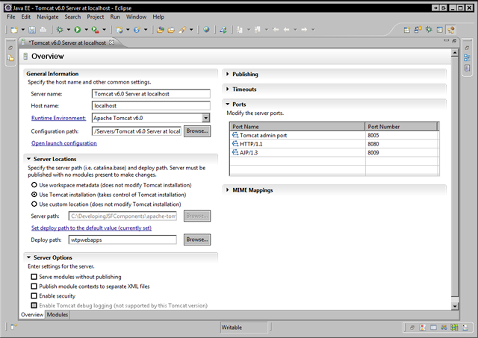

Step 7. Configure the JBoss server
Now that Tomcat is configured and the web applications for chapters 1 through 5 have been added for deployment, it is time to configure the JBoss server for deploying the example application for chapters 6 and 7.
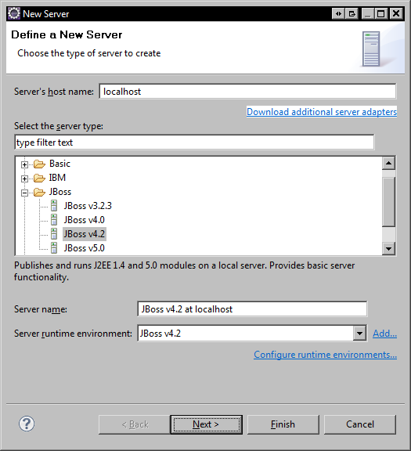
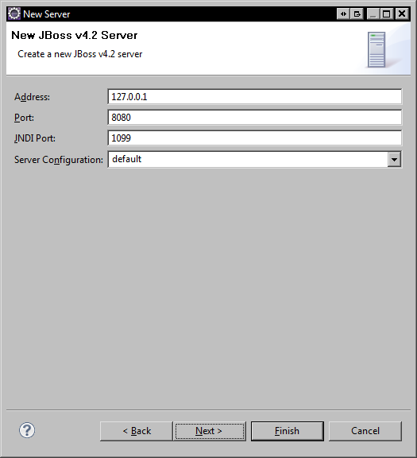
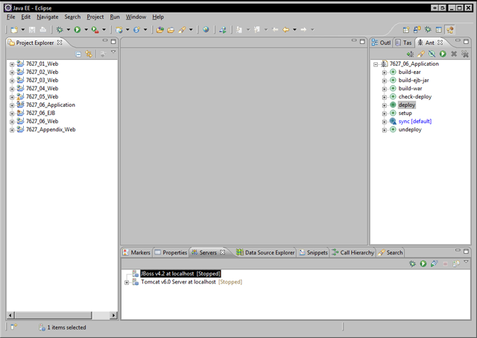

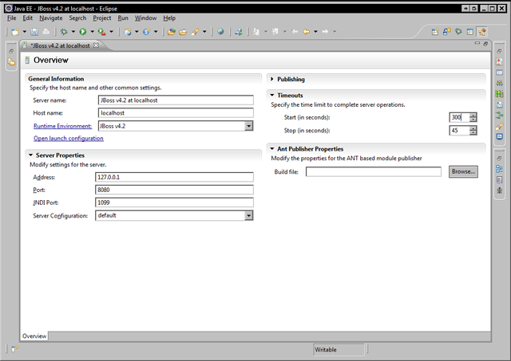

6. Installing the computer store database
Some of the example applications for this book require a MySQL database to be installed and configured. The following section describes how to install the MySQL 5.1 database on a Windows computer. If you already have MySQL 5.1 installed, please skip to Step 3 in this section.

Step 1. Download MySQL 5.1 Community Edition
You can download the MySQL database from the www.mysql.org website. The "Windows Essentials" distribution of the MySQL Community Edition database includes an installer that installs both the MySQL database server and command-line client on your computer.
If you do not already have MySQL installed and are running Windows, this is the recommended version. Depending on your platform, you may need to download two separate files, one for the MySQL server and one for the MySQL client. Please choose the distribution that best meets your platform specifications (operating system, architecture, and so on).

Step 2. Install the MySQL database (client and server)
When running the installer on Windows, you will be prompted to add the MySQL bin directory to the system PATH. Make sure you choose this option as shown in the following screenshot to make it easier to execute MySQL commands from the console. You can accept the default values for all the other screens displayed by the installation wizard.
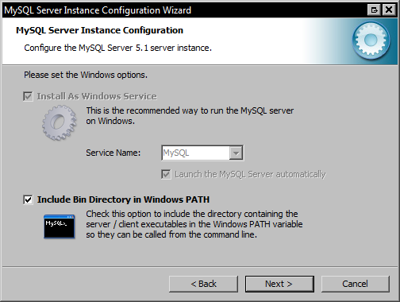

Step 3. Setup the Computer Store database
Once MySQL is installed, the next step is to create the fictional computer store relational database included in the code bundle for this book. Open a command shell (on Windows, use Start | Run and type "cmd") and to the directory named:
$INSTALL_ROOT\JSF1.2Components\Workspace\7627_06_Application\misc
Then execute the following commands in the following order, as shown in the next screenshots. This procedure will start the MySQL command-line client from a specific directory so we can easily execute a SQL script to create and populate our fictional computer store database.
> mysql –u root -p
mysql> create database computer_store;
mysql> grant all on computer_store.* to ‘jsfbook’@’localhost’ identified by ‘jsfbook’;
mysql> use computer_store;
mysql> source computer_store_db.sql;

The following screenshot demonstrates the above procedure:
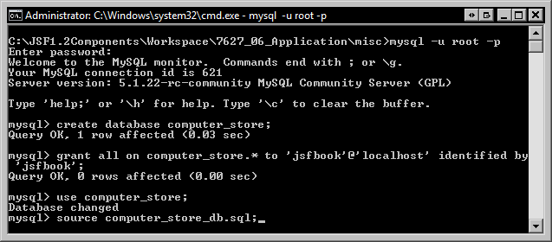
The computer store database SQL script contains Data Definition Language (DDL) and Data Manipulation Language (DML) statements to create the relational database schema and to populate it with sample data. Once the script has finished running, please type show tables; in the MySQL command prompt and press the Enter key to verify that the following tables have been successfully created:
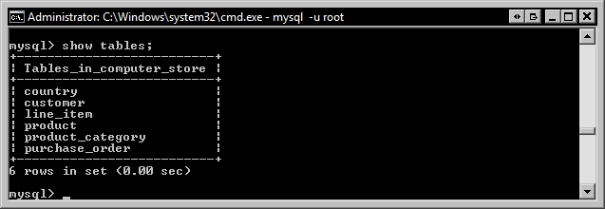
The computer store relational database schema is represented by the following Entity-Relationship (ER) diagram:
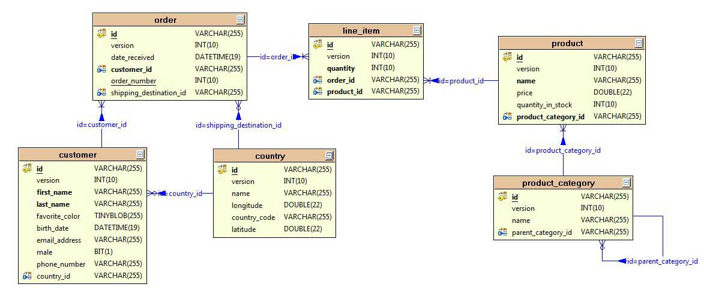

Running the example applications
To run the example applications for chapters 1 to 5 (inclusive), you will need to start the Apache Tomcat server using the Eclipse IDE Servers tab. Right-click the server and choose Start. Make sure the server starts up without any errors.
Once Tomcat is running, you can examine the Facelets example pages by opening them in Dreamweaver or your preferred XHTML editor.
The example applications use a naming convention that makes it easy to access the pages using your web browser. The following table lists the base URL for the web application that corresponds to each chapter.

Chapter | Base URL | Application Server
Chapter 1 | http://localhost:8080/chapter1/index.html | Apache Tomcat 6.0
Chapter 2 | http://localhost:8080/chapter2/index.html | Apache Tomcat 6.0
Chapter 3 | http://localhost:8080/chapter3/index.html | Apache Tomcat 6.0
Chapter 4 | http://localhost:8080/chapter4/index.html | Apache Tomcat 6.0
Chapter 5 | http://localhost:8080/chapter5/index.html | Apache Tomcat 6.0
Chapter 6 | http://localhost:8080/chapter6/index.html | JBoss AS 4.2
Chapter 7 | http://localhost:8080/chapter6/index.html | JBoss AS 4.2
Appendix | http://localhost:8080/jsf2/index.html | Apache Tomcat 6.0

To view each page in the browser, open the URLs above and click on the index page links or enter the URLs displayed in the screenshots contained in the book.

Step 1. Deploy the web applications
Before you can test the example applications, you need to deploy them to either Apache Tomcat or JBoss according to the preceding table. Applications for chapters 1-5 and the appendix can be deployed to Tomcat using the Eclipse WTP Servers tooling demonstrated earlier. For chapters 6 and 7, a custom Ant build script is used to deploy the application file as an exploded EAR file to the JBoss application server.
To run the custom Ant build script, open the Ant view in Eclipse by selecting Window | Show View | Other | Ant | Ant. Then drag-and-drop the file named build.xml from the 7627_06_Application project in the Eclipse workspace to the Ant view.
The Ant build script defines a target named "sync" that creates an exploded EAR deployment to JBoss and assumes you installed JBoss in C:\JSF1.2Components\Servers\jboss-4.2.3.GA. You can specify the location of the JBoss server by editing the file named build.properties in the 7627_06_Application project in Eclipse. Once the build script has been added to the Ant view, you can double-click on it to run default "sync" target.

Installing the JDBC data source on JBoss
The example application for chapter 6 requires a custom JDBC data source configuration file to be added to JBoss. Simply copy the file named:
7627_06_Application/misc/computer-store-ds.xml
to the directory named:
$INSTALL_ROOT/Servers/jboss-4.2.3.GA/server/default/deploy

Adding the MySQL JDBC driver to JBoss
The next step is to copy the JDBC driver JAR file named 7627_06_Application/misc/mysql-connector-java-5.1.8-bin.jar to the following directory:
$INSTALL_ROOT/Servers/jboss-4.2.3.GA/server/default/lib

Step 2. Start JBoss
Before starting JBoss, double-click the JBoss v4.2 entry in the Eclipse WTP Servers tab to open the server configuration. Ensure the Timeouts section has a value of 300 in the Start (in seconds) field and save the server configuration. Then, right-click JBoss v4.2 and choose Start.

Step 3. (Optional) Create a Dreamweaver site for each example application
Alternately, you can create a Dreamweaver site for each chapter and map the site root folder to the Web folder of the example application Eclipse project. This enables you to open, edit, and preview the pages in Dreamweaver.
To create a Dreamweaver site, open Dreamweaver and choose Site | New Site. Then enter the chapter name and site root folder (Web directory) of the example application for the chapter as shown in the following screenshot:
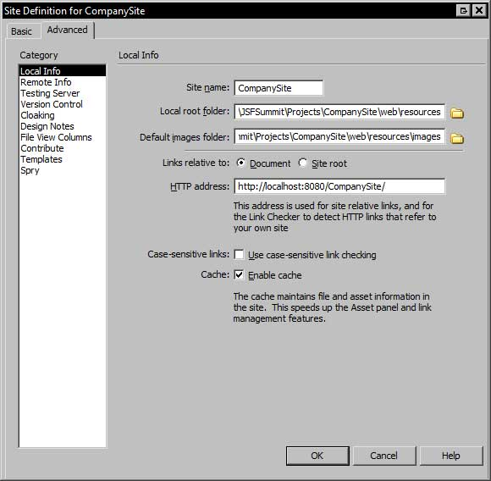

Step 4. (Optional) Open JSF pages in Dreamweaver
Once you have installed the JSFToolbox for Dreamweaver suite of extensions, Dreamweaver will recognize the .jsf and .xhtml file extensions as Facelets XHTML documents. Opening these files in Dreamweaver enables you to edit JSF pages visually in Dreamweaver's design view, use JSF component drag-and-drop toolbars, edit source code using property inspector panels, automatically manage JSF tag libraries, and much more.
The following screenshot shows a RichFaces data table example page open in Dreamweaver's design view using the JSFToolbox for Dreamweaver, Facelets Tools for Dreamweaver, and RichFaces Tools for Dreamweaver plugins.
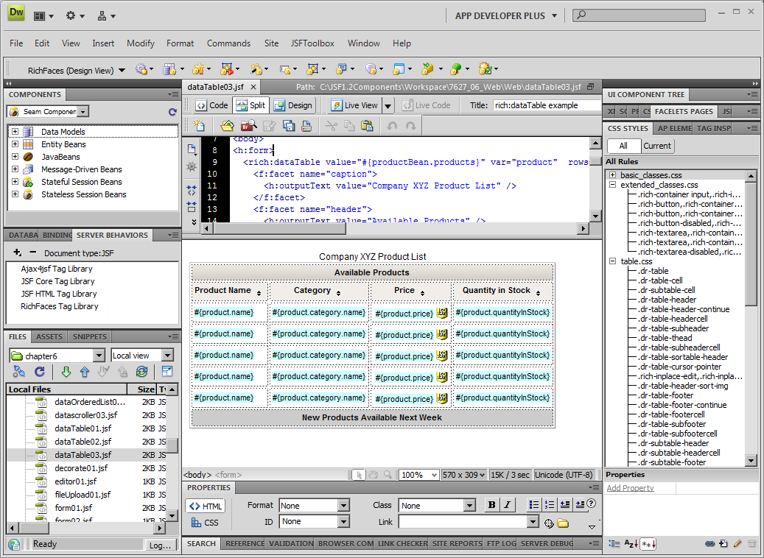

Step 5. (Optional) Preview JSF pages in your web browser from Dreamweaver
One of the benefits of Dreamweaver is its tight integration with web browsers. Once we have created a Dreamweaver site, we can open a JSF page and quickly preview it using the F12 key or the Preview/Debug in Browser menu from the Dreamweaver document toolbar.

(Optional) Generating a Java EE application using seam-gen
The next section discusses how to generate a Java EE application from the relational database included with this book using the JBoss Seam framework's seam-gen utility. This utility will generate an Eclipse project that can be imported into our IDE.

Step 1. Install the JBoss Seam Framework
The version of the JBoss Seam framework used for this book is version 2.2.0 GA. The JBoss Seam framework can be downloaded from http://seamframework.org/Download. It is recommended that you extract the ZIP file named jboss-seam-2.2.0.GA.zip to the directory named $INSTALL_ROOT\JSF1.2Components\Libraries.

Step 2. Run the seam-gen utility
The next step is to open a command shell and to change directories to the newly extracted JBoss Seam folder. This directory contains a batch file named seam.bat for Windows systems and a shell script named "seam" for Unix-based systems that can be used to execute commands with the seam-gen utility, such as creating a new project, generating JPA entities from a relational database, generating CRUD screens based on Facelets that include a UI composition template, and more.
We can think of the seam-gen utility as a command-line wizard program that automates a lot of the work involved in setting up a new Java EE project. It can help to "bootstrap" the development process by generating a simple but fully functional application that can be used as the starting point for a real Java EE application.

seam help
One of the first commands to learn with seam-gen is seam help. This command displays the Seam command-line documentation as shown in the following screenshot:
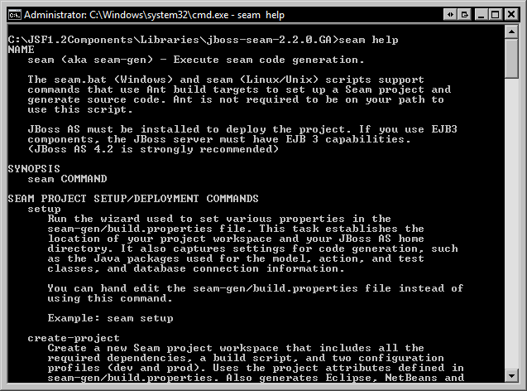

seam setup
The starting point of the seam-gen process is the Seam interview. This is a short prompt-based interview that captures important information about your Java project, such as the type of application server(s) you will be deploying to, the JDBC URL of your relational database, and more. Let’s walk through this process together.
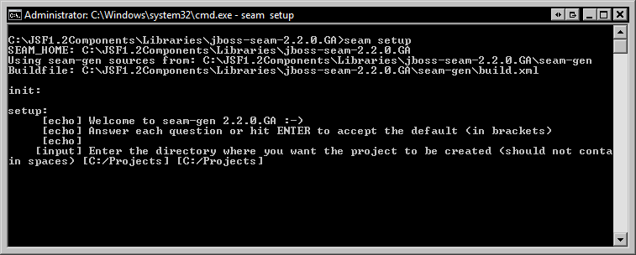

The following information should be entered (assuming a Windows environment):
Seam interview question | User specified value
Project directory | C:/JSF1.2Components/Projects
JBoss home directory | C:/JSF1.2Components/Servers/jboss-4.2.3.GA
JBoss AS domain | [default]
GlassFish home directory | [default]
GlassFish domain | [default]
Project name | ComputerStore
Use ICEfaces instead of RichFaces | (Adjust as needed)
If RichFaces, select theme | (Adjust as needed)
If ICEfaces, download or enter path | (Adjust as needed)
Deploy as EAR or WAR | ear
Package name for classes | com.example.computerstore
Package name for session beans | com.example.computerstore.bean
Package name for JPA entities | com.example.computerstore.model
Package name for test cases | com.example.computerstore.test
What kind of database? | mysql
JDBC driver path | C:/JSF1.2Components/Libraries/mysql-connector-java-5.1.8-bin.jar
Hibernate dialect | [default]
JDBC driver class | [default]
JDBC DataSource class | [default]
JDBC URL | jdbc:mysql://localhost/computer_store
Database username | admin
Database password | admin
Database catalog name | computer_store
Tables already exist | y
Recreate tables | n

Once the interview is successfully completed, you should see a list of all the settings you have specified, as shown in the following screenshot:
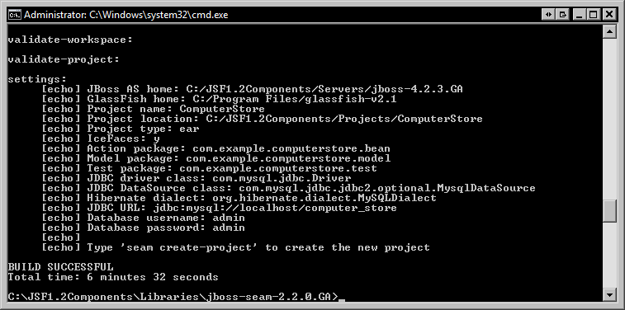

The above settings specify a seam-gen configuration for an EAR deployment on the JBoss 4.2 application server. The ICEfaces component library will be used, and reverse engineering will be based on our MySQL computer_store database.
Deploying a seam-gen application on GlassFish
If you are interested in deploying a Seam-generated Java EE application on GlassFish, additional steps are needed to adapt the Ant build scripts for this purpose. Please see the author’s JSF blog at http://www.jsftoolbox.com/blog for more details.
Starting over: creating a new Java EE project
The "seam setup" procedure is only performed once per project. If you start a new Java EE project and would like to use seam-gen to bootstrap your development cycle, execute the "seam clean" command to reset the interview state and then run "seam setup" again.

seam create-project
Now that seam-gen is configured properly, we can create a new project. This command will generate a set of files in a directory structure that is recognized by popular IDEs such as Eclipse, NetBeans, and IntelliJ IDEA. In our demonstration, we will import the project into Eclipse once it is created. As instructed by the previous step, execute the "seam create-project" command.
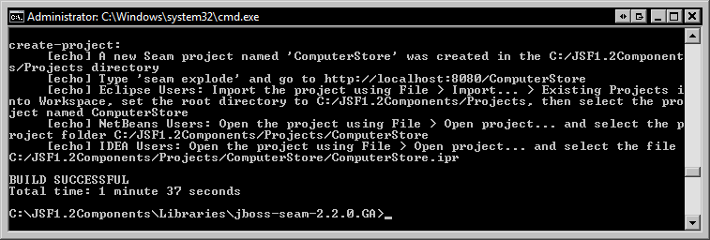

seam generate
The next step is to generate JPA entities and CRUD screens from the computer store database. The "seam generate" target will connect to our database, extract the database metadata, and generate the necessary JPA entity classes, Facelets pages, and more for our application.
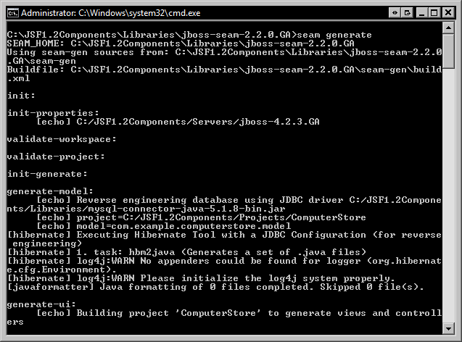

seam explode
The last Seam command we will run is the "seam explode" command. This command deploys the EAR file generated by Seam to the JBoss application server. Once the application is deployed in this manner, changes to JSF pages and certain Java classes (not typically EJB classes) can be hot deployed to the running application.
The following screenshot demonstrates running the "seam explode" target.
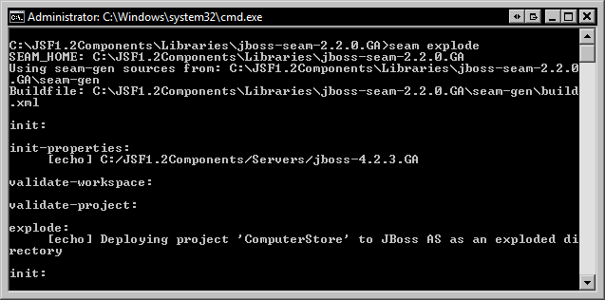

Step 3. Import the Seam generated project into Eclipse
Now that our project has been created, we can import it into Eclipse for development purposes. Simply choose File | Import from the File menu, select Existing Projects into Workspace, then select the Select root directory radio button, and browse for the $INSTALL_ROOT/Projects/ComputerStore directory. Click Finish and the project will be imported into Eclipse. Conveniently, Seam calls the "explode" Ant build target during an Eclipse auto-build so the project deployment directory is automatically updated.

