# 1 登录

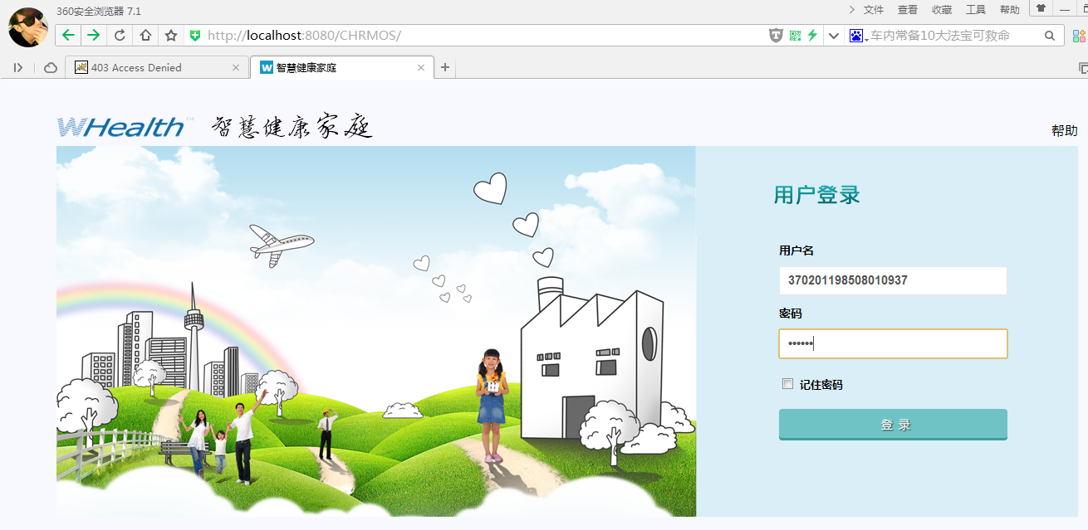

121.42.151.57:8080/CHRMOS/ 370201198508010937 000000

select id as id, name as name, username as username, password as password, gender as gender, birthday as birthday, idcard as idcard, familyid as familyid, picname as picname, mobile as mobile, email as email, createtime as createtime, freeze as freeze, areaid as areaid, dr as dr, memo as memo, usercode as usercode, medicalid as medicalid, nativeplace as nativeplace, houseid as houseid, houseauth as houseauth, familyauth as familyauth, drugstoreid as drugstoreid, rfid as rfid from mk_chrmos_member WHERE ( username = ? and password = ? and dr = ? )

(身份证号)370201198508010937(String), (密码MD5) 670b14728ad9902aecba32e22fa4f6bd(String), (默认带N)N(String)

# 2 血压 历史检测结果

<http://localhost:8080/CHRMOS/portal/historyDataAdvice/historyDataAdvice.jsp>

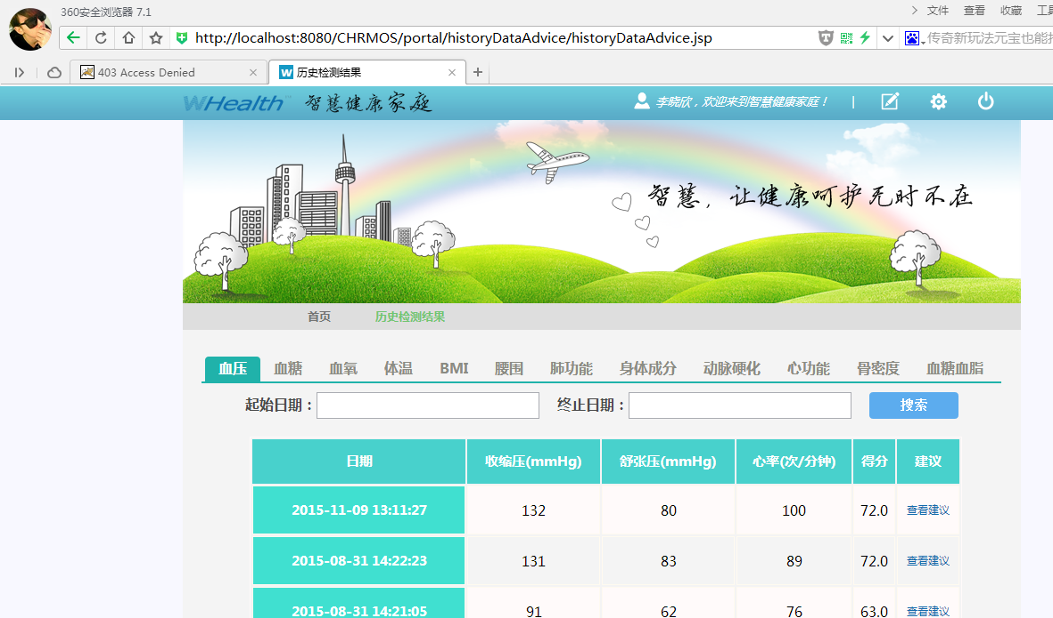

select id as id, memberid as memberid, syspressure as syspressure, diapressure as diapressure, pluse as pluse, testtime as testtime, doc_pressure_tip as docPressureTip, doc_pressure_sug as docPressureSug, doc_pressure_diet as docPressureDiet, doc_pressure_sport as docPressureSport, doc_pressure_mental as docPressureMental, doc_pressure_lifestyle as docPressureLifestyle, doc_heart_tip as docHeartTip, doc_heart_sug as docHeartSug, doc_heart_diet as docHeartDiet, doc_heart_sport as docHeartSport, doc_heart_mental as docHeartMental, doc_heart_lifestyle as docHeartLifestyle, score as score, dr as dr, memo as memo, houseid as houseid, areaid as areaid, expertasses as expertasses, expertsugg as expertsugg, attibute as attibute, datasource as datasource, devicemodel as devicemodel, avgpressure as avgpressure from mk_bloodplure WHERE ( memberid = ? and dr = ? ) order by testtime DESC limit ? , ?

（会员ID）141230195302328692(String), (默认带N)N (String),（分页） 0(Integer), （分页）5(Integer)

# 3.血糖

select id as id, memberid as memberid, testtime as testtime, bloodtype as bloodtype, bloodvalue as bloodvalue, doc_tip as docTip, doc_sug as docSug, doc_diet as docDiet, doc_sport as docSport, doc_mental as docMental, doc_lifestyle as docLifestyle, score as score, DR as DR, memo as memo, houseid as houseid, areaid as areaid, datasource as datasource, devicemodel as devicemodel from mk_blood WHERE ( memberid = ? ) order by testtime DESC limit ? , ?

（会员ID）141230195302328692(String),（分页） 0(Integer), （分页）5(Integer)

# 4.血氧

select id as id, memberid as memberid, testtime as testtime, oxygenvalue as oxygenvalue, pluse as pluse, doc_tip as docTip, doc_sug as docSug, doc_diet as docDiet, doc_sport as docSport, doc_mental as docMental, doc_lifestyle as docLifestyle, score as score, DR as DR, memo as memo, houseid as houseid, areaid as areaid from mk_bloodoxygen WHERE ( memberid = ? ) order by testtime DESC limit ? , ?

（会员ID）141230195302328692(String),（分页） 0(Integer), （分页）5(Integer)

# 5.体温

select id as id, memberid as memberid, testtime as testtime, temperature as temperature, doc_tip as docTip, doc_sug as docSug, doc_diet as docDiet, doc_sport as docSport, doc_mental as docMental, doc_lifestyle as docLifestyle, score as score, DR as DR, memo as memo, houseid as houseid, areaid as areaid from mk_temperature WHERE ( memberid = ? ) order by testtime DESC limit ? , ?

（会员ID）141230195302328692(String),（分页） 0(Integer), （分页）5(Integer)

# 6.腰围

select id as id, memberid as memberid, testtime as testtime, height as height, waistline as waistline, waistRatio as waistRatio, doc_tip as docTip, doc_sug as docSug, doc_diet as docDiet, doc_sport as docSport, doc_mental as docMental, doc_lifestyle as docLifestyle, score as score, DR as DR, memo as memo, houseid as houseid, areaid as areaid, datasource as datasource, devicemodel as devicemodel from mk_waist WHERE ( memberid = ? ) order by testtime DESC limit ? , ?

（会员ID）141230195302328692(String),（分页） 0(Integer), （分页）5(Integer)