**Loayon John Paul BSIT-3D**

**Creating a New user using postman:**

**In this photo I created a new user to test in postman.**

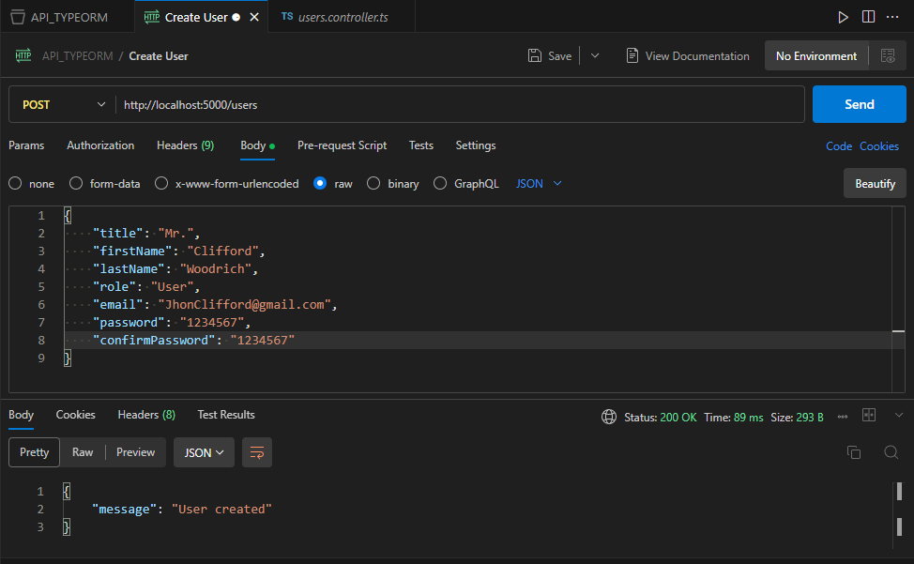

**Getting All Users Created:**

**Testing if all the users I created existed.**  
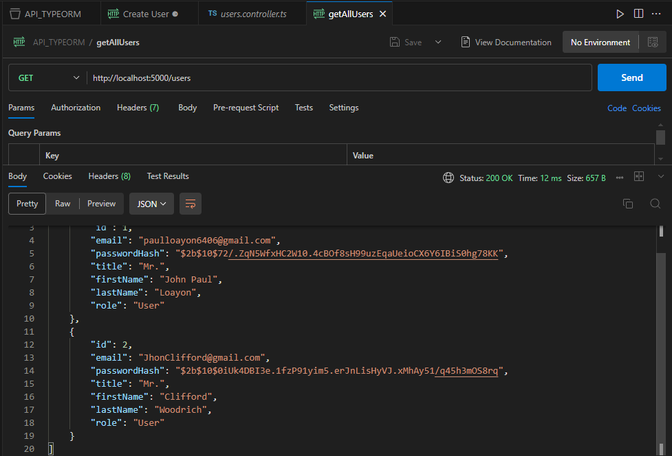

**Getting User by ID:**

In this photo, I checked if the function getUserById is working using postman. The user id I check is number 2.  
  
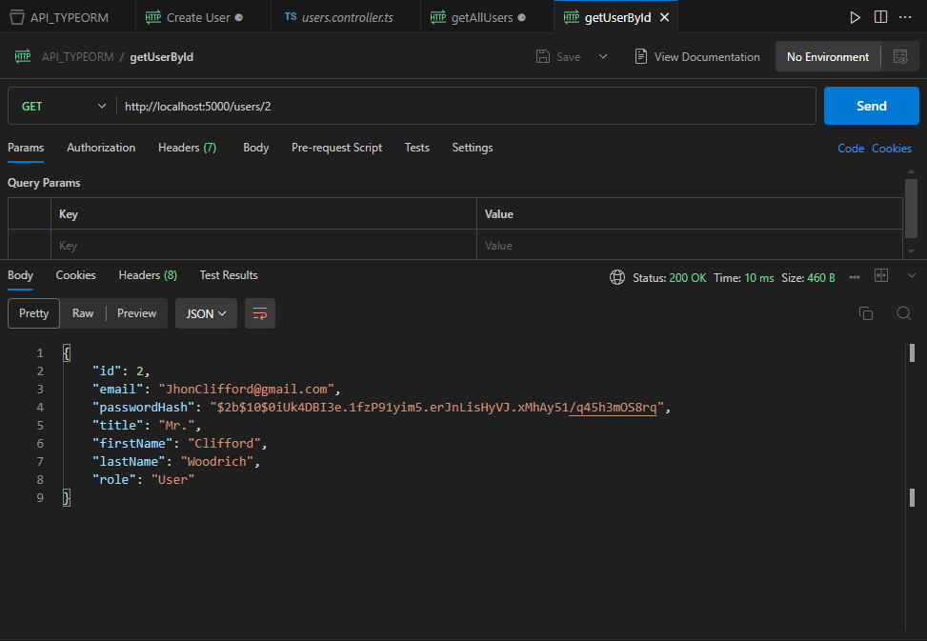

**Updating User:**  
 I change something and updated the user with the ID of number 1.  
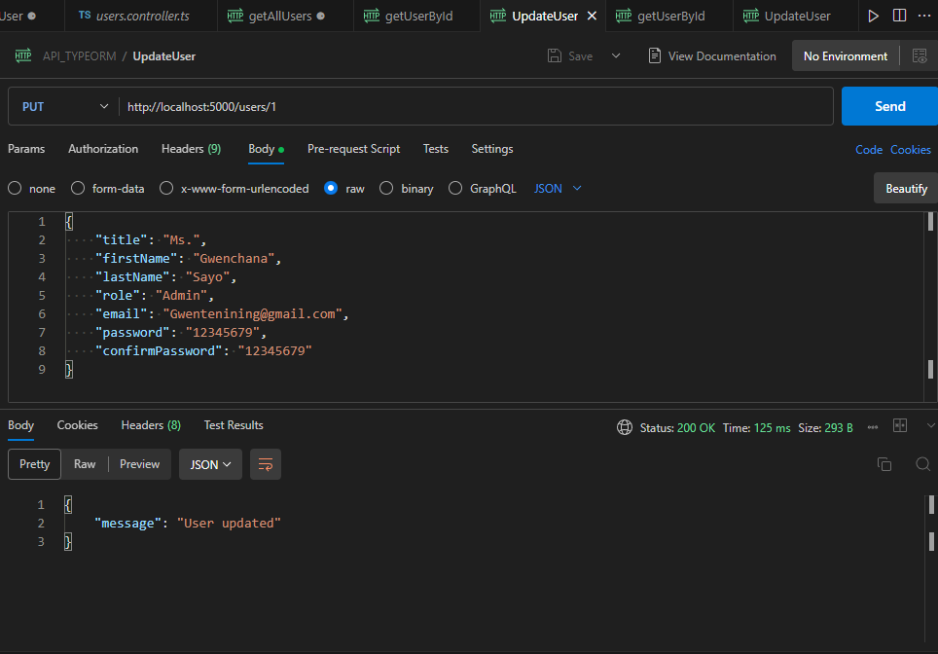

**Checking in the database if the data existed.**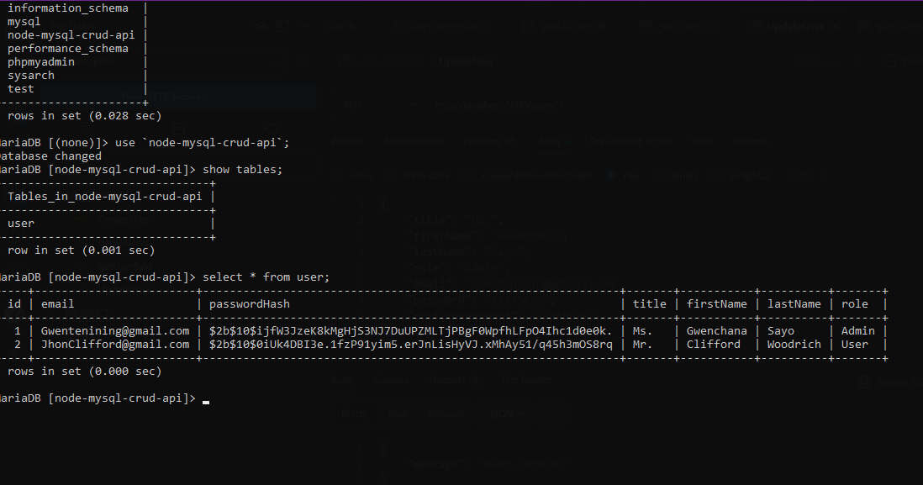  
  
**Deleting the User:**  
 in this photo I deleted the user with the ID number of 2.  
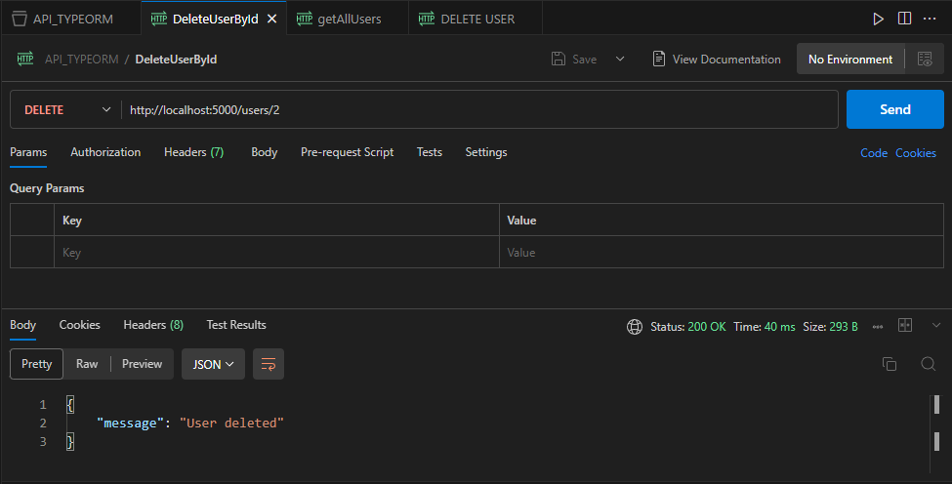

Checking the database is updated after the deletion of user with id of number 2  
