
Operated for the U.S. Department of Energy by
Sandia Corporation

Mark Taylor P.O. Box 5800
Principal Member of Technical Staff Albuquerque, NM 87185

Phone: (505) 284-1874
Internet: mataylo@sandia.gov

Date: 14 December 2014
To: Prof. Paul Ullrich
From: Mark Taylor
Subject: Letter of Collaboration

Dear Paul,

I am writing this letter to express my intent to collaborate with your NSF Computational Mathematics application entitled A New Approach for the Computational Needs of Next-Generation High-Resolution Climate Simulations. If your application is selected for funding it is my intent to collaborate in this research by assisting with algorithm development and intercomparison with the CAM Spectral Element model. Your focus on developing new approaches for reaching high horizontal resolutions will be of great benefit to the climate modeling community. Thank you for the opportunity to participate.

Sincerely,
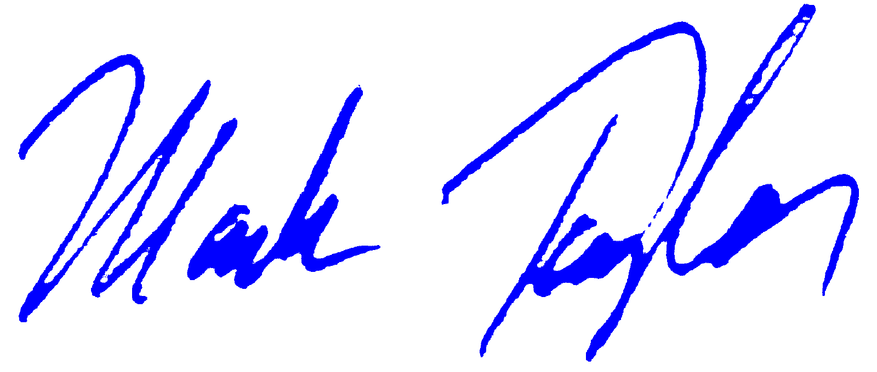
Mark Taylor

