WEEK 1 TASK
Data Cleaning and Preliminary Analysis with R
Credit Scoring Dataset: Cleaning, Transformation and Exploratory Analysis

Prepared by: Nayani Paul
Virtual R Data Analyst Internship | YuvaIntern
Dataset: Credit Scoring data (modeldata::credit_data, 4,454 loan applicants)
Tools: R 4.6.1 | dplyr, tidyr, ggplot2, caret, officer
Code repository: https://github.com/paulmark-05/data_analysis_R
26 September 2026

Contents
1. Introduction and Objective
2. Dataset Selection and Overview
3. Loading the Data and First Inspection
4. Data Quality Assessment
5. Handling Missing Values
6. Outlier Detection and Treatment
7. Feature Engineering
8. Normalization and Scaling
9. Encoding Categorical Variables
10. Exploratory Data Analysis
11. Key Insights and Next Steps
12. Appendix: Reproducibility and Session Information

Introduction and Objective
Banks and lending companies must decide, every day, whether a loan applicant is likely to repay. A wrong 'approve' decision creates a credit loss; a wrong 'reject' decision loses a good customer. Before any predictive model can support that decision, the underlying data must be trustworthy. This report documents the first stage of that work: acquiring a public credit scoring dataset, auditing its quality, cleaning it and producing a first exploratory analysis in R.
The objectives of this week's task were to:
• Select a public dataset that has real-world complexity: missing values, outliers and a mix of categorical and numerical variables.
• Build a documented, reproducible cleaning pipeline in R (missing values, outliers, normalization, encoding).
• Describe the data with summary(), str(), descriptive statistics, correlations and visualizations.
• Record initial insights that will guide the visualization (Week 2) and modelling (Week 3) stages.
Every code block in this document was executed by the accompanying R script (R/week1_data_cleaning.R), and the console output shown beneath each block is the actual output captured at run time, so the report is fully reproducible.

Dataset Selection and Overview
The dataset chosen is the Credit Scoring dataset originally published by Dr. Lluís A. Belanche Muñoz (Universitat Politècnica de Catalunya) and redistributed on GitHub by Dr. Gaston Sanchez (github.com/gastonstat/CreditScoring). It is openly available in R through the CRAN package 'modeldata' as credit_data. Each row is one loan applicant, and the target variable Status records whether the loan turned out 'good' (repaid) or 'bad' (defaulted / serious arrears).
Why this dataset was selected:
• Business relevance: credit-risk scoring is one of the most common data-analyst use cases in banking and fintech.
• It contains genuine missing values in six columns (most notably Income), not artificially injected ones.
• It mixes 9 numerical and 5 categorical variables, which exercises both imputation and encoding techniques.
• Several monetary variables are heavily right-skewed with extreme values, so outlier treatment is necessary.
• It has a clear binary outcome, which makes it suitable for the classification model planned in Week 3.
Table 1: Data dictionary of the Credit Scoring dataset
Variable | Type | Description
Status | Categorical (target) | Credit outcome: good (repaid) or bad (defaulted)
Seniority | Numeric | Years with current employer
Home | Categorical | Housing situation: owner, rent, parents, private, other, ignore
Time | Numeric | Requested loan term in months
Age | Numeric | Applicant age in years
Marital | Categorical | Marital status: married, single, separated, divorced, widow
Records | Categorical | Existing record of past arrears / defaults (yes/no)
Job | Categorical | Employment type: fixed, freelance, part-time, others
Expenses | Numeric | Regular monthly expenses
Income | Numeric | Monthly income
Assets | Numeric | Value of assets owned
Debt | Numeric | Amount of existing debt
Amount | Numeric | Loan amount requested
Price | Numeric | Price of the goods being financed

Downloading the dataset
The data is obtained from the public 'modeldata' package and saved as a raw CSV file in data/raw/. The rest of the pipeline reads from that CSV, exactly as it would with a file downloaded from a website, so the raw file is never modified.
R code
# Download the public dataset and store an untouched raw copy
library(modeldata)
data("credit_data", package = "modeldata")
write.csv(credit_data, "data/raw/credit_data_raw.csv", row.names = FALSE)
# Read it back as our raw starting point
raw <- read.csv("data/raw/credit_data_raw.csv", stringsAsFactors = TRUE)
cat("Rows:", nrow(raw), " Columns:", ncol(raw), "\n")
Console output
Rows: 4454 Columns: 14

Loading the Data and First Inspection
The first step with any new dataset is to confirm its structure: the number of rows, the data type R assigned to each column, and a sample of values. str() gives the structure and head() shows the first records.
R code
str(raw)
Console output
'data.frame': 4454 obs. of 14 variables:
$ Status : Factor w/ 2 levels "bad","good": 2 2 1 2 2 2 2 2 2 1 ...
$ Seniority: int 9 17 10 0 0 1 29 9 0 0 ...
$ Home : Factor w/ 6 levels "ignore","other",..: 6 6 3 6 6 3 3 4 3 4 ...
$ Time : int 60 60 36 60 36 60 60 12 60 48 ...
$ Age : int 30 58 46 24 26 36 44 27 32 41 ...
$ Marital : Factor w/ 5 levels "divorced","married",..: 2 5 2 4 4 2 2 4 2 2 ...
$ Records : Factor w/ 2 levels "no","yes": 1 1 2 1 1 1 1 1 1 1 ...
$ Job : Factor w/ 4 levels "fixed","freelance",..: 2 1 2 1 1 1 1 1 2 4 ...
$ Expenses : int 73 48 90 63 46 75 75 35 90 90 ...
$ Income : int 129 131 200 182 107 214 125 80 107 80 ...
$ Assets : int 0 0 3000 2500 0 3500 10000 0 15000 0 ...
$ Debt : int 0 0 0 0 0 0 0 0 0 0 ...
$ Amount : int 800 1000 2000 900 310 650 1600 200 1200 1200 ...
$ Price : int 846 1658 2985 1325 910 1645 1800 1093 1957 1468 ...
R code
head(raw, 8)
Console output
Status Seniority Home Time Age Marital Records Job Expenses Income Assets Debt
1 good 9 rent 60 30 married no freelance 73 129 0 0
2 good 17 rent 60 58 widow no fixed 48 131 0 0
3 bad 10 owner 36 46 married yes freelance 90 200 3000 0
4 good 0 rent 60 24 single no fixed 63 182 2500 0
5 good 0 rent 36 26 single no fixed 46 107 0 0
6 good 1 owner 60 36 married no fixed 75 214 3500 0
7 good 29 owner 60 44 married no fixed 75 125 10000 0
8 good 9 parents 12 27 single no fixed 35 80 0 0
Amount Price
1 800 846
2 1000 1658
3 2000 2985
4 900 1325
5 310 910
6 650 1645
7 1600 1800
8 200 1093
summary() gives a five-number summary for each numeric column, frequency counts for each factor, and the count of NA (missing) values. That makes it the fastest way to spot data problems.
R code
summary(raw)
Console output
Status Seniority Home Time Age Marital
bad :1254 Min. : 0.00 ignore : 20 Min. : 6.0 Min. :18.0 divorced : 38
good:3200 1st Qu.: 2.00 other : 319 1st Qu.:36.0 1st Qu.:28.0 married :3241
Median : 5.00 owner :2107 Median :48.0 Median :36.0 separated: 130
Mean : 7.99 parents: 783 Mean :46.4 Mean :37.1 single : 977
3rd Qu.:12.00 priv : 246 3rd Qu.:60.0 3rd Qu.:45.0 widow : 67
Max. :48.00 rent : 973 Max. :72.0 Max. :68.0 NAs : 1
NAs : 6
Records Job Expenses Income Assets Debt
no :3681 fixed :2805 Min. : 35.0 Min. : 6 Min. : 0 Min. : 0
yes: 773 freelance:1024 1st Qu.: 35.0 1st Qu.: 90 1st Qu.: 0 1st Qu.: 0
others : 171 Median : 51.0 Median :125 Median : 3000 Median : 0
partime : 452 Mean : 55.6 Mean :142 Mean : 5404 Mean : 343
NAs : 2 3rd Qu.: 72.0 3rd Qu.:170 3rd Qu.: 6000 3rd Qu.: 0
Max. :180.0 Max. :959 Max. :300000 Max. :30000
NAs :381 NAs :47 NAs :18
Amount Price
Min. : 100 Min. : 105
1st Qu.: 700 1st Qu.: 1117
Median :1000 Median : 1400
Mean :1039 Mean : 1463
3rd Qu.:1300 3rd Qu.: 1692
Max. :5000 Max. :11140
Observations from the first inspection: the data has 4454 applicants and 14 variables. The target is imbalanced: 1254 applicants (28.2%) are 'bad' and 3200 (71.8%) are 'good'. Income, Assets and Debt contain NA values, and Assets and Debt have maxima (300,000 and 30,000) far above their third quartiles, a first sign of extreme outliers. The Home variable contains a level called 'ignore' that has no business meaning.

Data Quality Assessment

Missing values
R code
na_tbl <- data.frame(Variable = names(raw),
Missing = colSums(is.na(raw)),
Percent = round(100 * colMeans(is.na(raw)), 2)) |>
arrange(desc(Missing))
rownames(na_tbl) <- NULL
na_tbl
cat("Rows with at least one missing value:", sum(!complete.cases(raw)),
sprintf("(%.1f%% of rows)\n", 100 * mean(!complete.cases(raw))))
Console output
Variable Missing Percent
1 Income 381 8.55
2 Assets 47 1.06
3 Debt 18 0.40
4 Home 6 0.13
5 Job 2 0.04
6 Marital 1 0.02
7 Status 0 0.00
8 Seniority 0 0.00
9 Time 0 0.00
10 Age 0 0.00
11 Records 0 0.00
12 Expenses 0 0.00
13 Amount 0 0.00
14 Price 0 0.00
Rows with at least one missing value: 415 (9.3% of rows)
R code
p_missing <- na_tbl |>
filter(Missing > 0) |>
ggplot(aes(x = reorder(Variable, Missing), y = Missing)) +
geom_col(fill = "#D1495B", width = 0.6) +
geom_text(aes(label = paste0(Missing, " (", Percent, "%)")), hjust = -0.1, size = 3.5) +
coord_flip() +
expand_limits(y = max(na_tbl$Missing) * 1.25) +
labs(title = "Missing values per variable",
subtitle = "Only variables with at least one missing value are shown",
x = NULL, y = "Number of missing values")
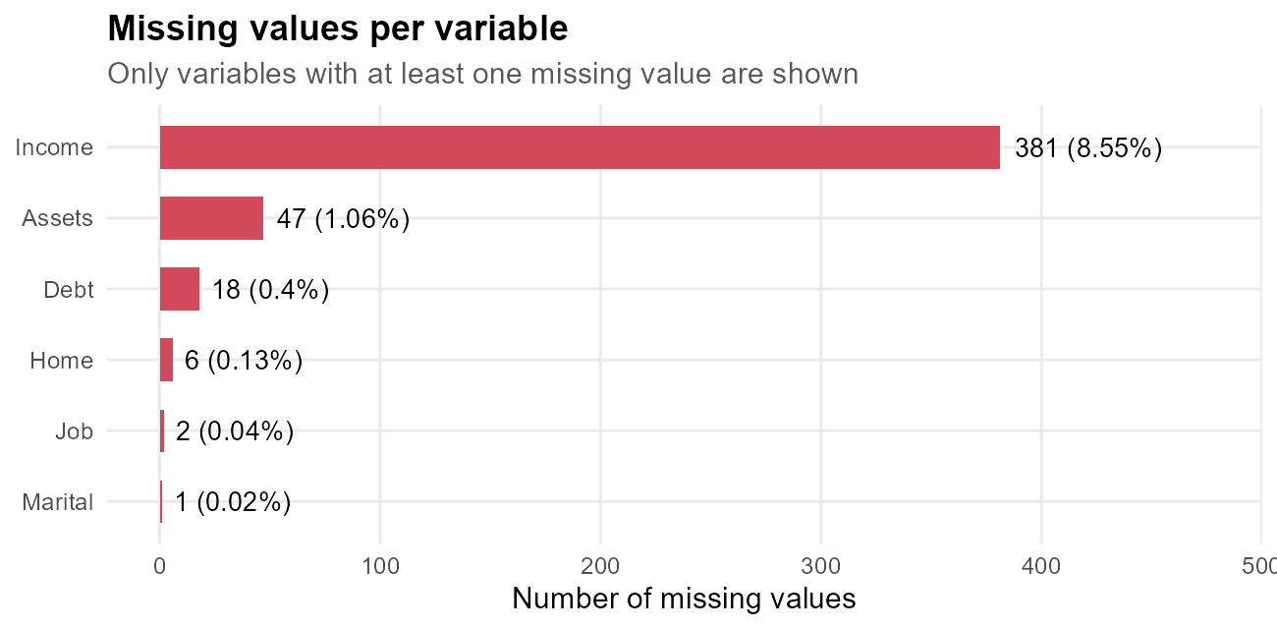
Figure 1: Count and percentage of missing values by variable
Before choosing an imputation strategy it is important to know whether values are missing completely at random (MCAR) or whether the fact of being missing is itself informative. The check below compares the default rate of applicants with and without a recorded income, and applies a chi-square test of independence.
R code
raw |>
mutate(Income_missing = is.na(Income)) |>
group_by(Income_missing) |>
summarise(Applicants = n(), Bad_rate_pct = round(100 * mean(Status == "bad"), 1))
chisq.test(table(Income_missing = is.na(raw$Income), Status = raw$Status))
Console output
# A tibble: 2 × 3
Income_missing Applicants Bad_rate_pct
<lgl> <int> <dbl>
1 FALSE 4073 25.5
2 TRUE 381 57
Pearson's Chi-squared test with Yates' continuity correction
data: table(Income_missing = is.na(raw$Income), Status = raw$Status)
X-squared = 169, df = 1, p-value <2e-16
Finding: applicants without a recorded income default at 57.0% versus 25.5% for those with income (chi-square p-value = <2e-16). The missingness is therefore NOT random: it is associated with credit risk. For this reason the income values are imputed *and* a flag variable Income_missing is kept, so this signal is not lost.

Duplicates, invalid categories and logical consistency
R code
cat("Exact duplicate rows:", sum(duplicated(raw)), "\n")
cat("Applicants whose loan Amount exceeds the Price of the goods:",
sum(raw$Amount > raw$Price), "\n")
cat("Age range:", range(raw$Age), " | Loan term range (months):", range(raw$Time), "\n")
table(raw$Home, useNA = "ifany")
Console output
Exact duplicate rows: 2
Applicants whose loan Amount exceeds the Price of the goods: 0
Age range: 18 68 | Loan term range (months): 6 72
ignore other owner parents priv rent <NA>
20 319 2107 783 246 973 6
2 exact duplicate row(s) were found: identical on all 14 variables, which is almost certainly a double entry of the same application, so they are removed. Ages (18 to 68) and loan terms (6 to 72 months) fall in plausible ranges, and no applicant asks for more than the price of the goods, so Amount and Price are logically consistent. The Home level 'ignore' (20 rows) carries no meaning and is merged into 'other'.

Handling Missing Values
A different strategy was chosen for each type of variable, based on the amount and nature of the missing data:
Table 2: Missing-value treatment strategy
Variable | Missing | Strategy | Rationale
Home, Marital, Job | 6 / 1 / 2 | Replace with the most frequent category (mode) | Very few rows affected; mode keeps the category distribution intact
Income | 381 (8.6%) | Median income of the applicant's Job group + missing flag | Income depends strongly on job type; median is robust to skew; flag keeps the risk signal
Assets | 47 (1.1%) | Overall median | Small share; median is robust to the extreme right tail
Debt | 18 (0.4%) | Overall median (which is 0) | Most applicants have no debt, so the median of 0 is the most plausible value

Dropping incomplete rows (listwise deletion) was rejected because it would discard 415 applicants (9.3% of the data), and those rows have a different default rate, which would bias every later analysis.
R code
# (0) Remove exact duplicate rows
clean <- raw[!duplicated(raw), ]
rownames(clean) <- NULL
cat("Rows after removing duplicates:", nrow(clean), "\n")
# (a) Merge the meaningless 'ignore' level into 'other'
clean$Home[which(clean$Home == "ignore")] <- "other"
clean$Home <- droplevels(clean$Home)
# (b) Categorical variables: impute with the mode
for (v in c("Home", "Marital", "Job")) {
m <- mode_value(clean[[v]])
clean[[v]][is.na(clean[[v]])] <- m
cat(sprintf("%-8s -> missing values replaced by mode '%s'\n", v, m))
}
# (c) Keep a flag before imputing Income (missingness is informative)
clean$Income_missing <- factor(ifelse(is.na(clean$Income), "yes", "no"))
# (d) Income: median within each Job group
job_medians <- clean |> group_by(Job) |>
summarise(Median_income = median(Income, na.rm = TRUE))
print(job_medians)
clean <- clean |>
group_by(Job) |>
mutate(Income = ifelse(is.na(Income), median(Income, na.rm = TRUE), Income)) |>
ungroup() |>
as.data.frame()
# (e) Assets and Debt: overall median
clean$Assets[is.na(clean$Assets)] <- median(clean$Assets, na.rm = TRUE)
clean$Debt[is.na(clean$Debt)] <- median(clean$Debt, na.rm = TRUE)
cat("\nRemaining missing values:", sum(is.na(clean)), "\n")
Console output
Rows after removing duplicates: 4452
Home -> missing values replaced by mode 'owner'
Marital -> missing values replaced by mode 'married'
Job -> missing values replaced by mode 'fixed'
# A tibble: 4 × 2
Job Median_income
<fct> <dbl>
1 fixed 126
2 freelance 142
3 others 93
4 partime 95.5
Remaining missing values: 0
R code
# Did imputation distort the Income distribution?
rbind(Before = summary(raw$Income)[1:6], After = summary(clean$Income))
Console output
Min. 1st Qu. Median Mean 3rd Qu. Max.
Before 6 90 125 141.7 170 959
After 6 93 128 141.2 164 959
The quartiles and mean of Income barely move after imputation, which confirms that the group-median approach filled the gaps without distorting the overall distribution.

Outlier Detection and Treatment
Two complementary rules were used to detect outliers in every numeric variable: the IQR rule (values below Q1 - 1.5 x IQR or above Q3 + 1.5 x IQR) and the z-score rule (|z| > 3). The IQR rule does not assume normality, which suits these skewed monetary variables.
R code
num_vars <- c("Seniority", "Time", "Age", "Expenses", "Income",
"Assets", "Debt", "Amount", "Price")
outlier_tbl <- do.call(rbind, lapply(num_vars, function(v) {
x <- clean[[v]]
q <- quantile(x, c(0.25, 0.75))
iqr <- q[2] - q[1]
lo <- q[1] - 1.5 * iqr
hi <- q[2] + 1.5 * iqr
z <- (x - mean(x)) / sd(x)
data.frame(Variable = v, Q1 = q[1], Q3 = q[2], Upper_fence = hi, Max = max(x),
IQR_outliers = sum(x < lo | x > hi), Z_outliers = sum(abs(z) > 3))
}))
rownames(outlier_tbl) <- NULL
outlier_tbl
Console output
Variable Q1 Q3 Upper_fence Max IQR_outliers Z_outliers
1 Seniority 2 12 27.0 48 150 56
2 Time 36 60 96.0 72 0 0
3 Age 28 45 70.5 68 0 0
4 Expenses 35 72 127.5 180 17 31
5 Income 93 164 270.5 959 242 79
6 Assets 0 6000 15000.0 300000 276 65
7 Debt 0 0 0.0 30000 767 62
8 Amount 700 1300 2200.0 5000 72 48
9 Price 1117 1692 2554.5 11140 173 56
R code
p_box_before <- clean |>
select(all_of(num_vars)) |>
pivot_longer(everything(), names_to = "Variable", values_to = "Value") |>
ggplot(aes(x = "", y = Value)) +
geom_boxplot(fill = "#9ECAE1", outlier.colour = "#D1495B", outlier.alpha = 0.4) +
facet_wrap(~ Variable, scales = "free_y", nrow = 2) +
labs(title = "Boxplots of numeric variables before outlier treatment",
subtitle = "Red points are values outside the 1.5 x IQR whiskers", x = NULL, y = NULL)
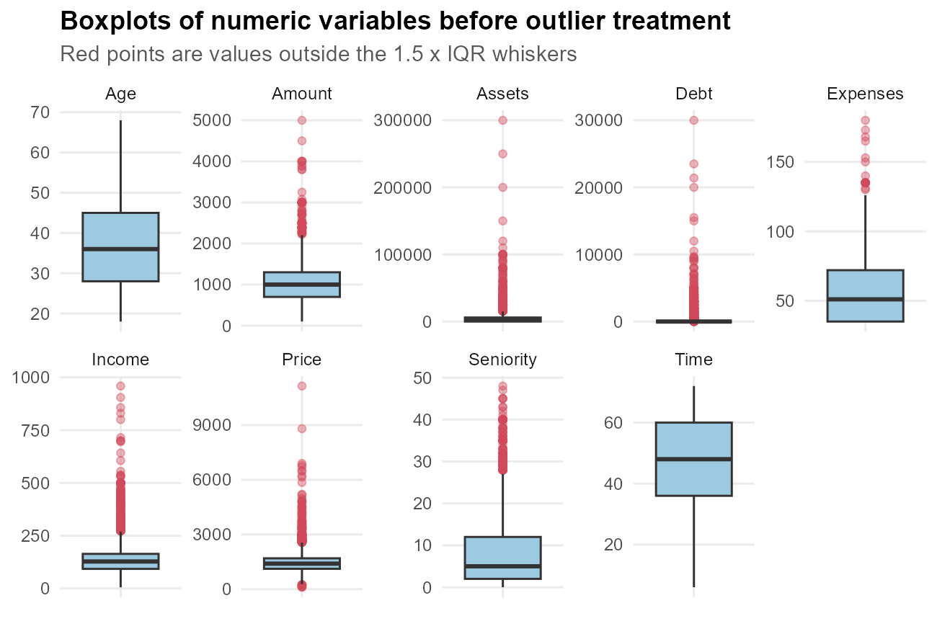
Figure 2: Outliers in the numeric variables before treatment
Interpretation: Seniority, Time, Age and Expenses have few or no extreme points, and their values are all realistic. The monetary variables Income, Assets, Debt, Amount and Price have long right tails. For Debt the IQR is zero (most applicants have no debt), so every non-zero debt is technically flagged; this shows why a single mechanical rule should not be applied blindly.
Treatment decision: the extreme values are not data-entry errors (a few wealthy applicants really can hold large assets), so deleting rows is not justified. Instead the five monetary variables are winsorized: values below the 1st percentile or above the 99th percentile are capped at those percentiles. This keeps every applicant while stopping a handful of extreme values from dominating means, correlations and model coefficients.
R code
winsorize <- function(x, probs = c(0.01, 0.99)) {
q <- quantile(x, probs, na.rm = TRUE)
pmin(pmax(x, q[1]), q[2])
}
cap_vars <- c("Income", "Assets", "Debt", "Amount", "Price")
before <- sapply(clean[cap_vars], function(x) c(Mean = mean(x), SD = sd(x), Max = max(x)))
for (v in cap_vars) clean[[v]] <- winsorize(clean[[v]])
after <- sapply(clean[cap_vars], function(x) c(Mean = mean(x), SD = sd(x), Max = max(x)))
round(rbind(before, after), 1) |>
as.data.frame() |>
mutate(Stage = rep(c("Before", "After"), each = 3), .before = 1)
Console output
Stage Income Assets Debt Amount Price
Mean Before 141.2 5376 341.8 1039.1 1462.8
SD Before 77.4 11517 1243.9 474.6 628.3
Max Before 959.0 300000 30000.0 5000.0 11140.0
Mean.1 After 140.0 4993 304.3 1033.7 1450.2
SD.1 After 70.1 7686 875.5 448.6 545.2
Max.1 After 429.0 50000 4774.5 2500.0 3559.5
After capping, the standard deviation of Assets and Debt drops sharply while the means change far less. The bulk of the distribution is untouched and only the extreme tail has been tamed.

Feature Engineering
Raw columns rarely express risk directly. Credit analysts reason in ratios (how large is the loan compared with the goods, how heavy is the repayment compared with income), so the following derived variables were created:
• LoanToPrice = Amount / Price: share of the purchase that is financed.
• Installment = Amount / Time: approximate repayment per month.
• PaymentBurden = Installment / Income: share of income needed for the repayment.
• DisposableIncome = Income - Expenses: money left after regular expenses.
• AgeGroup: age bands, useful for reporting and non-linear age effects.
• HasAssets: whether the applicant owns any assets at all.
R code
clean <- clean |>
mutate(LoanToPrice = Amount / Price,
Installment = Amount / Time,
PaymentBurden = Installment / Income,
DisposableIncome = Income - Expenses,
AgeGroup = cut(Age, breaks = c(17, 25, 35, 45, 55, Inf),
labels = c("18-25", "26-35", "36-45", "46-55", "56+")),
HasAssets = factor(ifelse(Assets > 0, "yes", "no")))
summary(clean[, c("LoanToPrice", "Installment", "PaymentBurden", "DisposableIncome")])
table(clean$AgeGroup)
Console output
LoanToPrice Installment PaymentBurden DisposableIncome
Min. :0.0899 Min. : 3.33 Min. :0.0229 Min. :-62.0
1st Qu.:0.6000 1st Qu.: 16.67 1st Qu.:0.1190 1st Qu.: 40.0
Median :0.7692 Median : 20.83 Median :0.1693 Median : 73.0
Mean :0.7254 Mean : 24.14 Mean :0.2053 Mean : 84.5
3rd Qu.:0.8825 3rd Qu.: 27.08 3rd Qu.:0.2415 3rd Qu.:107.0
Max. :1.0000 Max. :416.67 Max. :2.7778 Max. :394.0
18-25 26-35 36-45 46-55 56+
702 1509 1173 775 293

Normalization and Scaling
The numeric variables are measured on very different scales (Age is in tens, Assets in thousands). Distance-based and regularized models are sensitive to scale, so two standard normalizations were applied: z-score standardization, (x - mean) / sd, which gives mean 0 and standard deviation 1, and min-max scaling, (x - min) / (max - min), which maps values to the range [0, 1]. In addition, a log transformation was tested on the most skewed variables.
R code
num_model <- c(num_vars, "LoanToPrice", "Installment", "PaymentBurden", "DisposableIncome")
zscore <- function(x) (x - mean(x)) / sd(x)
minmax <- function(x) (x - min(x)) / (max(x) - min(x))
scaled_z <- as.data.frame(lapply(clean[num_model], zscore))
scaled_mm <- as.data.frame(lapply(clean[num_model], minmax))
data.frame(z_mean = round(sapply(scaled_z, mean), 3),
z_sd = round(sapply(scaled_z, sd), 3),
mm_min = sapply(scaled_mm, min),
mm_max = sapply(scaled_mm, max))
Console output
z_mean z_sd mm_min mm_max
Seniority 0 1 0 1
Time 0 1 0 1
Age 0 1 0 1
Expenses 0 1 0 1
Income 0 1 0 1
Assets 0 1 0 1
Debt 0 1 0 1
Amount 0 1 0 1
Price 0 1 0 1
LoanToPrice 0 1 0 1
Installment 0 1 0 1
PaymentBurden 0 1 0 1
DisposableIncome 0 1 0 1
R code
# Skewness before and after a log(1 + x) transformation
skew_vars <- c("Income", "Assets", "Debt", "Amount", "Price", "Seniority")
data.frame(Skew_original = sapply(clean[skew_vars], skewness),
Skew_log1p = sapply(clean[skew_vars], function(x) skewness(log1p(x)))) |>
round(2)
Console output
Skew_original Skew_log1p
Income 1.61 0.03
Assets 3.37 -0.49
Debt 3.34 1.84
Amount 0.55 -0.81
Price 0.93 -0.71
Seniority 1.38 -0.19
The log transformation reduces the skewness of Income, Amount and Price substantially. Assets and Debt contain many zeros, so for them the binary feature HasAssets and the capped raw value are more informative than a log. The z-scored values are the ones used in the model-ready file.

Encoding Categorical Variables
Statistical models need numeric inputs. The target Status is label-encoded as Default = 1 for 'bad' and 0 for 'good'. The categorical predictors are one-hot encoded with caret::dummyVars() using full-rank coding (k - 1 dummy columns per variable) to avoid perfect multicollinearity, which is also known as the dummy-variable trap.
R code
clean$Default <- ifelse(clean$Status == "bad", 1, 0)
cat_vars <- c("Home", "Marital", "Records", "Job", "AgeGroup", "HasAssets", "Income_missing")
dummies <- caret::dummyVars(~ Home + Marital + Records + Job + AgeGroup +
HasAssets + Income_missing,
data = clean, fullRank = TRUE)
encoded <- as.data.frame(predict(dummies, newdata = clean))
cat("Categorical variables:", length(cat_vars), "-> dummy columns:", ncol(encoded), "\n")
names(encoded)
model_ready <- cbind(Default = clean$Default, scaled_z, encoded)
cat("\nModel-ready dataset:", nrow(model_ready), "rows x", ncol(model_ready), "columns\n")
Console output
Categorical variables: 7 -> dummy columns: 18
[1] "Home.owner" "Home.parents" "Home.priv" "Home.rent"
[5] "Marital.married" "Marital.separated" "Marital.single" "Marital.widow"
[9] "Records.yes" "Job.freelance" "Job.others" "Job.partime"
[13] "AgeGroup.26-35" "AgeGroup.36-45" "AgeGroup.46-55" "AgeGroup.56+"
[17] "HasAssets.yes" "Income_missing.yes"
Model-ready dataset: 4452 rows x 32 columns

Exploratory Data Analysis

Descriptive statistics of numeric variables
R code
desc_stats <- do.call(rbind, lapply(num_model, function(v) {
x <- clean[[v]]
data.frame(Variable = v, Mean = mean(x), SD = sd(x), Median = median(x),
IQR = IQR(x), Min = min(x), Max = max(x), Skewness = skewness(x))
}))
desc_stats |> mutate(across(where(is.numeric), ~ round(.x, 2)))
Console output
Variable Mean SD Median IQR Min Max Skewness
1 Seniority 7.99 8.18 5.00 10.00 0.00 48.00 1.38
2 Time 46.43 14.66 48.00 24.00 6.00 72.00 -0.77
3 Age 37.08 10.99 36.00 17.00 18.00 68.00 0.48
4 Expenses 55.57 19.51 51.00 37.00 35.00 180.00 1.02
5 Income 140.03 70.06 128.00 71.00 37.51 428.98 1.61
6 Assets 4992.55 7686.09 3000.00 6000.00 0.00 50000.00 3.37
7 Debt 304.27 875.47 0.00 0.00 0.00 4774.50 3.34
8 Amount 1033.72 448.55 1000.00 600.00 200.00 2500.00 0.55
9 Price 1450.20 545.19 1400.00 575.00 375.00 3559.49 0.93
10 LoanToPrice 0.73 0.20 0.77 0.28 0.09 1.00 -0.74
11 Installment 24.14 15.90 20.83 10.42 3.33 416.67 8.59
12 PaymentBurden 0.21 0.15 0.17 0.12 0.02 2.78 4.46
13 DisposableIncome 84.46 67.80 73.00 67.00 -62.00 393.98 1.51

Categorical variables and default rates
R code
cat_summary <- do.call(rbind, lapply(cat_vars, function(v) {
clean |>
group_by(Level = as.character(.data[[v]])) |>
summarise(Count = n(),
Share_pct = round(100 * n() / nrow(clean), 1),
Bad_rate_pct = round(100 * mean(Default), 1)) |>
mutate(Variable = v, .before = 1)
}))
as.data.frame(cat_summary)
Console output
Variable Level Count Share_pct Bad_rate_pct
1 Home other 339 7.6 45.7
2 Home owner 2111 47.4 18.6
3 Home parents 783 17.6 29.8
4 Home priv 246 5.5 34.1
5 Home rent 973 21.9 39.9
6 Marital divorced 38 0.9 36.8
7 Marital married 3240 72.8 25.6
8 Marital separated 130 2.9 49.2
9 Marital single 977 21.9 33.6
10 Marital widow 67 1.5 28.4
11 Records no 3679 82.6 22.4
12 Records yes 773 17.4 55.5
13 Job fixed 2807 63.1 20.7
14 Job freelance 1022 23.0 32.5
15 Job others 171 3.8 39.8
16 Job partime 452 10.2 60.0
17 AgeGroup 18-25 702 15.8 37.0
18 AgeGroup 26-35 1509 33.9 27.0
19 AgeGroup 36-45 1173 26.3 30.8
20 AgeGroup 46-55 775 17.4 21.5
21 AgeGroup 56+ 293 6.6 19.5
22 HasAssets no 1627 36.5 40.3
23 HasAssets yes 2825 63.5 21.2
24 Income_missing no 4071 91.4 25.4
25 Income_missing yes 381 8.6 57.0

Distributions
R code
p_hist <- clean |>
select(Age, Seniority, Time, Expenses, Income, Amount, Price, LoanToPrice, PaymentBurden) |>
pivot_longer(everything(), names_to = "Variable", values_to = "Value") |>
ggplot(aes(Value)) +
geom_histogram(bins = 30, fill = "#2E86AB", colour = "white") +
facet_wrap(~ Variable, scales = "free", ncol = 3) +
labs(title = "Distribution of key numeric variables (after cleaning)", x = NULL, y = "Count")
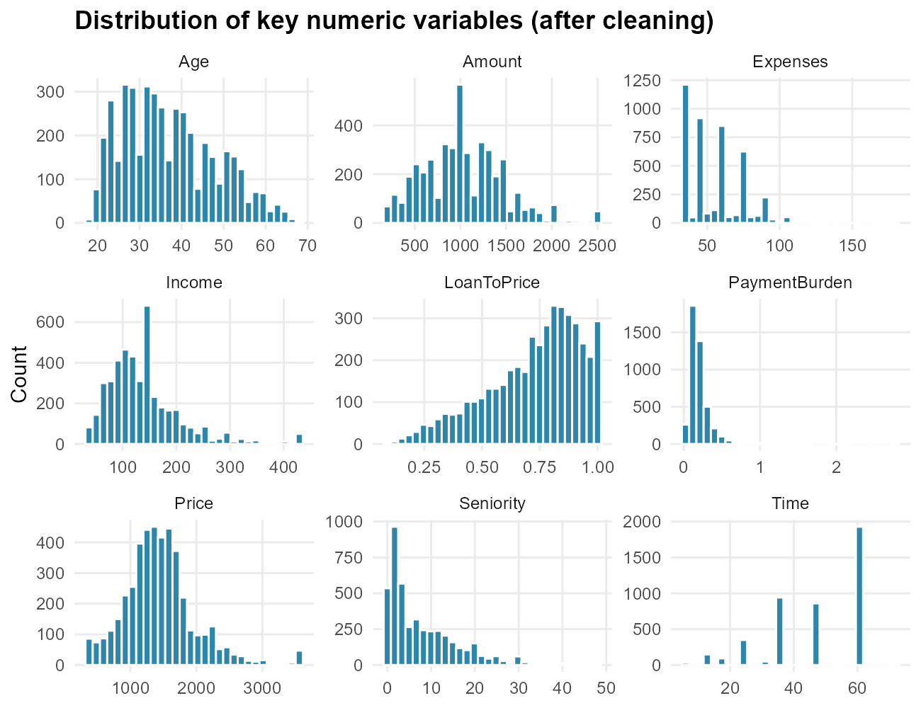
Figure 3: Histograms of the cleaned numeric variables
Age, Income, Amount and Price are right-skewed: most applicants are young to middle-aged and ask for moderate loans, with a long tail of larger values. Time (loan term) is concentrated on a few standard terms (for example 36, 48 and 60 months), which is typical of product-based lending. LoanToPrice is concentrated below 1, so most loans finance only part of the purchase.

Good versus bad applicants
R code
status_means <- clean |>
group_by(Status) |>
summarise(across(c(Age, Seniority, Income, Assets, Debt, Amount, LoanToPrice,
PaymentBurden), ~ round(mean(.x), 2)))
as.data.frame(status_means)
Console output
Status Age Seniority Income Assets Debt Amount LoanToPrice PaymentBurden
1 bad 35.41 4.59 122.9 3366 303.7 1144.8 0.8 0.24
2 good 37.74 9.32 146.7 5630 304.5 990.2 0.7 0.19
R code
p_box_status <- clean |>
select(Status, Seniority, Income, Assets, Amount, LoanToPrice, Age) |>
pivot_longer(-Status, names_to = "Variable", values_to = "Value") |>
ggplot(aes(Status, Value, fill = Status)) +
geom_boxplot(outlier.alpha = 0.25) +
facet_wrap(~ Variable, scales = "free_y", nrow = 2) +
scale_fill_manual(values = PAL) +
labs(title = "Key variables by credit outcome", x = NULL, y = NULL) +
theme(legend.position = "none")
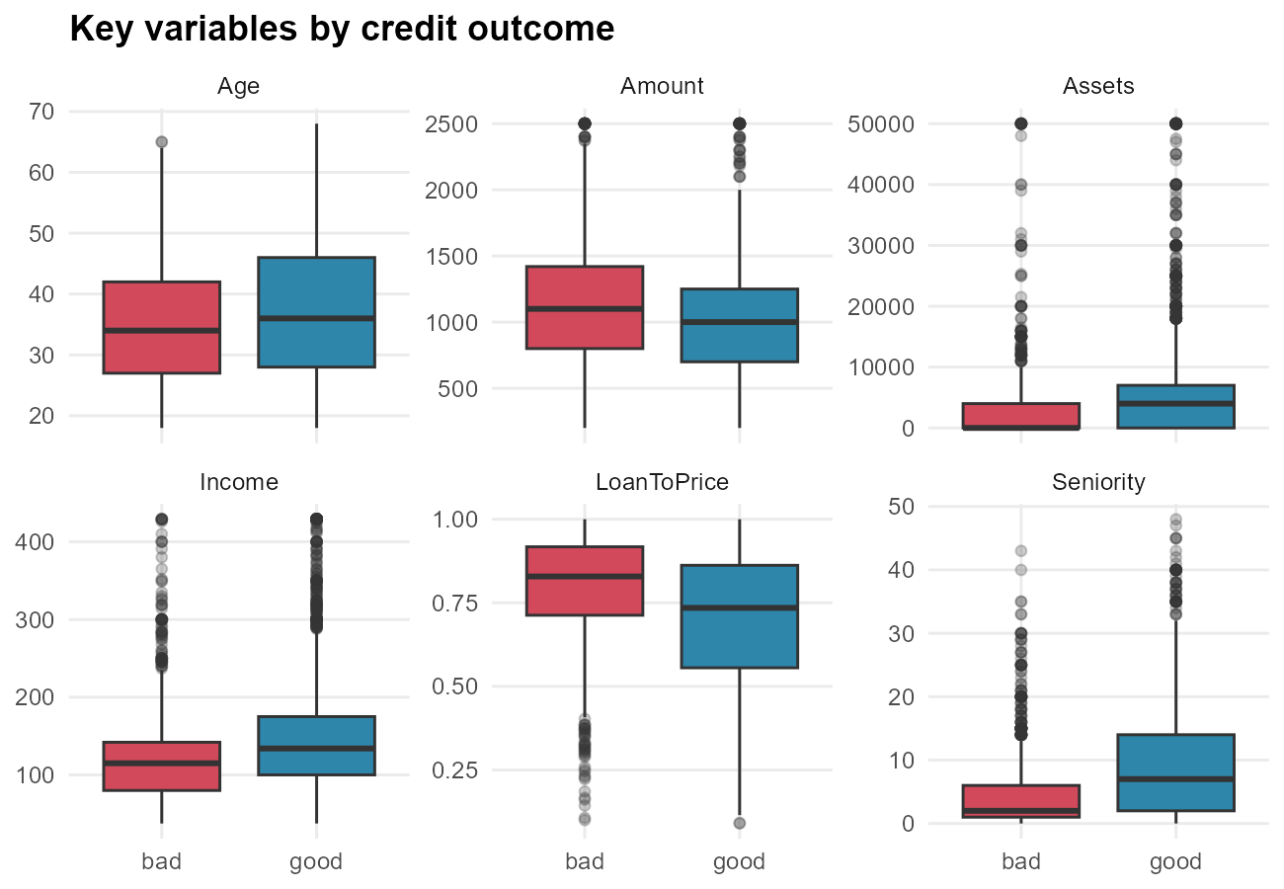
Figure 4: Distribution of key variables for good and bad applicants
R code
p_bad_cat <- cat_summary |>
filter(Variable %in% c("Records", "Job", "Home", "Marital")) |>
ggplot(aes(x = reorder(Level, Bad_rate_pct), y = Bad_rate_pct)) +
geom_col(fill = "#D1495B") +
geom_hline(yintercept = 100 * mean(clean$Default), linetype = "dashed") +
geom_text(aes(label = paste0(Bad_rate_pct, "%")), hjust = -0.15, size = 3) +
coord_flip() +
facet_wrap(~ Variable, scales = "free_y") +
expand_limits(y = 80) +
labs(title = "Default (bad) rate by category",
subtitle = "Dashed line = overall default rate", x = NULL, y = "Bad rate (%)")
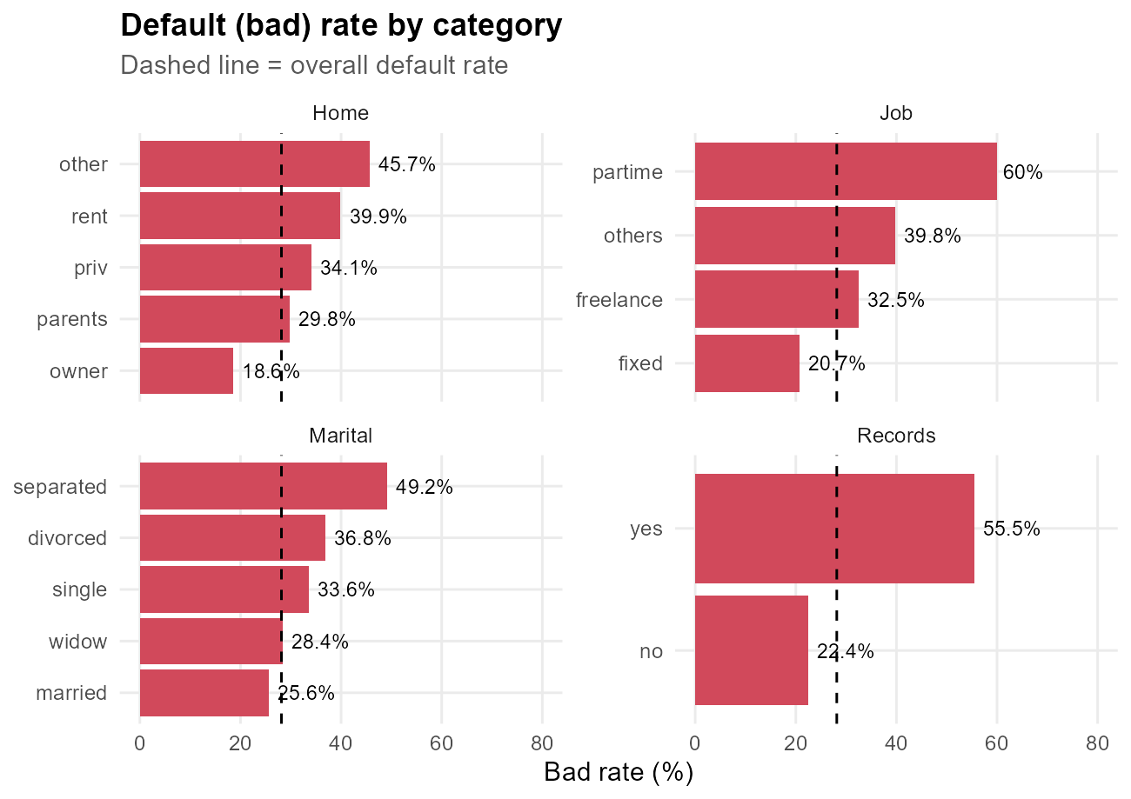
Figure 5: Default rate by level of the main categorical variables

Correlations
R code
cor_mat <- cor(cbind(clean[num_model], Default = clean$Default))
# Correlation of every numeric variable with the target
sort(round(cor_mat[, "Default"], 3)[-ncol(cor_mat)])
# Strongest pairwise correlations between predictors
cor_pairs <- as.data.frame(as.table(cor_mat[num_model, num_model])) |>
filter(as.integer(Var1) < as.integer(Var2)) |>
arrange(desc(abs(Freq))) |>
rename(Correlation = Freq) |>
mutate(Correlation = round(Correlation, 3))
head(cor_pairs, 8)
Console output
Seniority DisposableIncome Income Assets Age
-0.260 -0.166 -0.153 -0.132 -0.095
Debt Price Installment Expenses Time
0.000 0.008 0.016 0.028 0.100
PaymentBurden Amount LoanToPrice
0.134 0.155 0.218
Var1 Var2 Correlation
1 Income DisposableIncome 0.960
2 Amount Price 0.727
3 Installment PaymentBurden 0.643
4 Amount LoanToPrice 0.517
5 Seniority Age 0.506
6 Price Installment 0.485
7 Time LoanToPrice 0.478
8 Time Amount 0.460
R code
p_cor <- as.data.frame(as.table(cor_mat)) |>
ggplot(aes(Var1, Var2, fill = Freq)) +
geom_tile(colour = "white") +
geom_text(aes(label = sprintf("%.2f", Freq)), size = 2.3) +
scale_fill_gradient2(low = "#2E86AB", mid = "white", high = "#D1495B",
midpoint = 0, limits = c(-1, 1), name = "r") +
labs(title = "Correlation matrix (Pearson)", x = NULL, y = NULL) +
theme(axis.text.x = element_text(angle = 45, hjust = 1), legend.position = "right")
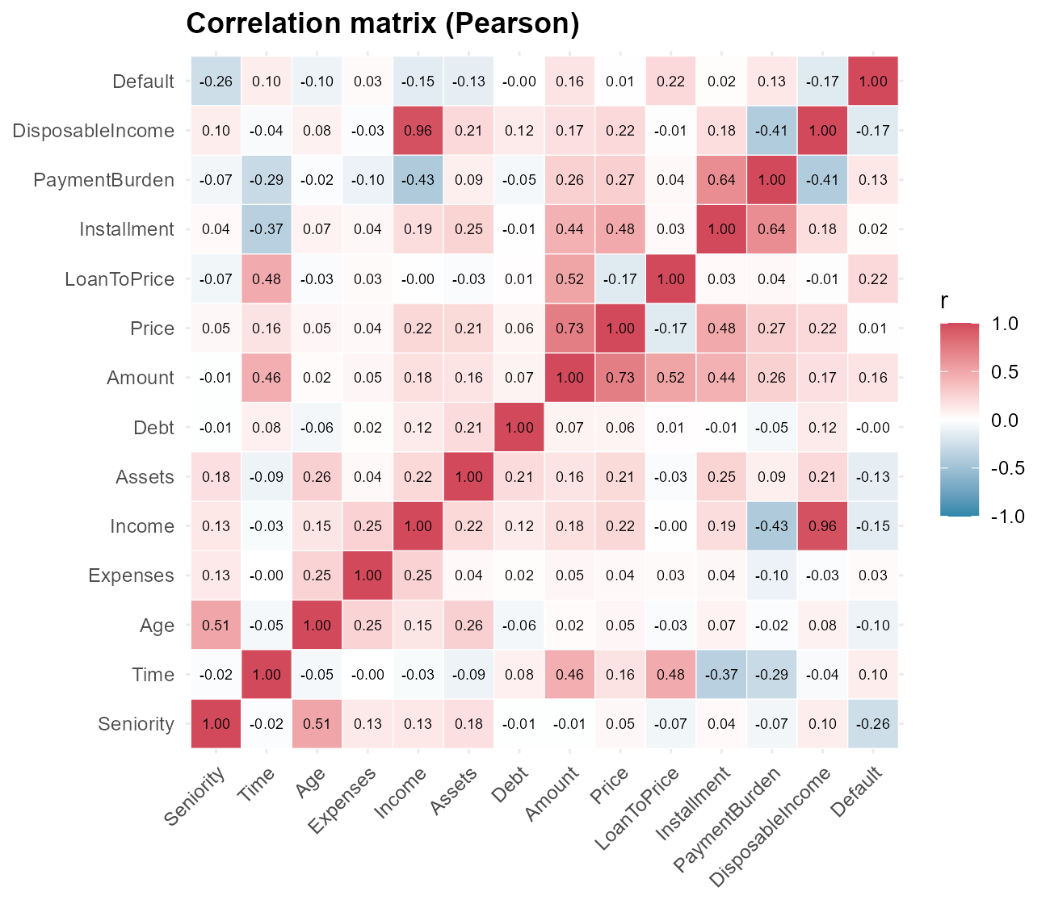
Figure 6: Correlation heatmap of numeric variables and the Default flag

Key Insights and Next Steps

Summary of the cleaning process
Table 3: Cleaning and transformation log
Step | Action
Raw data | 4454 rows x 14 columns, 415 rows with NA
Duplicates | 2 exact duplicate rows removed -> 4452 applicants
Invalid category | Home = 'ignore' merged into 'other'
Missing categorical | Mode imputation (Home, Marital, Job)
Missing Income | Median by Job group + Income_missing flag
Missing Assets/Debt | Median imputation
Outliers | Winsorized at 1st/99th percentile (5 monetary variables)
New features | LoanToPrice, Installment, PaymentBurden, DisposableIncome, AgeGroup, HasAssets
Scaling | Z-score and min-max scaling; log1p tested
Encoding | One-hot encoding -> 18 dummy columns; Status -> Default (0/1)

Initial insights
• Class imbalance: 28.1% of applicants are 'bad'. Accuracy alone will be a misleading metric in Week 3; ROC-AUC, sensitivity and specificity must be reported.
• Past arrears are the strongest single warning sign: applicants with Records = yes default at 55.5% versus 22.4% without records.
• Job stability matters: part-time workers default at 60% and freelancers at 32.5%, compared with 20.7% for fixed contracts.
• Home ownership is protective: owners default at 18.6%, renters at 39.9%.
• Bad applicants have lower seniority (mean 4.6 vs 9.3 years), lower income (123 vs 147) and finance a larger share of the purchase (LoanToPrice 0.80 vs 0.70).
• Missing income is itself a risk signal (57.0% default rate vs 25.5%), so the Income_missing flag is retained.
• Among the original variables the strongest correlation is Amount-Price (r = 0.73). Engineered ratios are naturally correlated with their parent columns (e.g. Income-DisposableIncome, r = 0.96), so multicollinearity will be checked before modelling.

Next steps
The cleaned dataset (data/processed/credit_clean.csv) will be used in Week 2 to build a set of visualizations for a non-technical audience, and the model-ready dataset (data/processed/credit_model_ready.csv) will support hypothesis testing and a classification model in Week 3.
R code
write.csv(clean, "data/processed/credit_clean.csv", row.names = FALSE)
saveRDS(clean, "data/processed/credit_clean.rds")
write.csv(model_ready, "data/processed/credit_model_ready.csv", row.names = FALSE)
cat("Saved cleaned data:", nrow(clean), "rows x", ncol(clean), "columns\n")
Console output
Saved cleaned data: 4452 rows x 22 columns

Appendix: Reproducibility and Session Information
The complete, commented script is available in the project repository at R/week1_data_cleaning.R. Running source('R/week1_data_cleaning.R') from the project root re-creates this document, the figures in outputs/figures/week1/ and the processed data files.
R code
cat(R.version.string, "\n")
pk <- c("dplyr", "tidyr", "ggplot2", "caret", "officer", "flextable", "modeldata")
data.frame(Package = pk, Version = sapply(pk, function(p) as.character(packageVersion(p))),
row.names = NULL)
Console output
R version 4.6.1 (2026-06-24 ucrt)
Package Version
1 dplyr 1.2.1
2 tidyr 1.3.2
3 ggplot2 4.0.3
4 caret 7.0.1
5 officer 0.7.6
6 flextable 0.10.1
7 modeldata 1.6.0

