WEEK 3 TASK
Statistical Analysis and Predictive Modeling using R
Hypothesis testing and a credit-default classification model

Prepared by: Nayani Paul
Virtual R Data Analyst Internship | YuvaIntern
Dataset: Credit Scoring data (modeldata::credit_data, 4,454 loan applicants)
Tools: R 4.6.1 | dplyr, tidyr, ggplot2, caret, officer
Code repository: https://github.com/paulmark-05/data_analysis_R
26 September 2026

Contents
1. Introduction and Objectives
2. Dataset Identification and Rationale
3. Hypothesis Formulation
4. Distribution and Assumption Checks
5. Hypothesis Testing Results
6. Correlation and Multicollinearity Analysis
7. Model Building with Cross-Validation
8. Model Evaluation on the Test Set
9. Model Diagnostics
10. Interpretation of the Logistic Regression Model
11. Strengths, Limitations and Improvements
12. Conclusion

Introduction and Objectives
Weeks 1 and 2 cleaned the credit-scoring data and showed visually which applicant characteristics are associated with default. Visual patterns can, however, arise by chance. This week the patterns are tested formally with hypothesis tests, and then combined into a predictive classification model that estimates each applicant's probability of default.
• Formulate and test statistical hypotheses about the drivers of default.
• Check distributional assumptions (normality, equal variance) and choose tests accordingly.
• Build a logistic regression model, and a random forest as a benchmark, using stratified train/test splitting and repeated 10-fold cross-validation.
• Evaluate the models with a confusion matrix, sensitivity, specificity and ROC-AUC, and run diagnostic checks.
• Interpret the model for the business and identify improvements.

Dataset Identification and Rationale
The Credit Scoring dataset (public; modeldata::credit_data, originally from Dr. L. A. Belanche Muñoz via github.com/gastonstat/CreditScoring) was selected for predictive modelling because:
• It has a clearly defined binary outcome (Status: good/bad), which is ideal for a classification model.
• With 4,452 cleaned records it is large enough for a stratified train/test split and repeated cross-validation, and still small enough to be fully transparent.
• It combines numeric and categorical predictors, so it demonstrates both kinds of hypothesis test (t/Wilcoxon and chi-square) and dummy-variable modelling.
• The problem is realistic and has an obvious business use: automated pre-screening of loan applications.
• The data was already cleaned and validated in Week 1 (duplicates, missing values, outliers), so the modelling rests on a reliable foundation.
R code
credit <- readRDS("data/processed/credit_clean.rds")
credit$Status <- factor(credit$Status, levels = c("bad", "good")) # 'bad' = event of interest
cat("Records:", nrow(credit), "\n")
round(prop.table(table(credit$Status)), 3)
Console output
Records: 4452
bad good
0.281 0.719

Hypothesis Formulation
Based on the Week 2 visual findings, the following hypotheses were formulated. A significance level of α = 0.05 is used throughout.
Table 1: Hypotheses tested
ID | Null hypothesis (H0) | Alternative (H1) | Test
H1 | Income has the same distribution for good and bad borrowers | Distributions differ (bad borrowers earn less) | Wilcoxon rank-sum (+ Welch t-test)
H2 | Job seniority has the same distribution for good and bad borrowers | Distributions differ (bad borrowers have less seniority) | Wilcoxon rank-sum
H3 | The loan-to-price ratio has the same mean for good and bad borrowers | Means differ | Welch two-sample t-test
H4 | Having a past arrears record is independent of the credit outcome | Arrears record and outcome are associated | Pearson chi-square
H5 | Employment type is independent of the credit outcome | Employment type and outcome are associated | Pearson chi-square
H6 | Loan amount and price of goods are uncorrelated | They are correlated | Pearson & Spearman correlation

Distribution and Assumption Checks
Parametric tests such as the t-test assume approximately normal data within each group and (for the classical version) equal variances. These assumptions were checked with the Shapiro-Wilk test, Q-Q plots and an F-test for equality of variances.
R code
# Shapiro-Wilk normality test (valid for n <= 5000) for each group
norm_vars <- c("Income", "Seniority", "LoanToPrice", "Age", "Amount")
normality <- do.call(rbind, lapply(norm_vars, function(v) {
data.frame(Variable = v,
W_bad = shapiro.test(credit[[v]][credit$Status == "bad"])$statistic,
p_bad = shapiro.test(credit[[v]][credit$Status == "bad"])$p.value,
W_good = shapiro.test(credit[[v]][credit$Status == "good"])$statistic,
p_good = shapiro.test(credit[[v]][credit$Status == "good"])$p.value)
}))
rownames(normality) <- NULL
normality |> mutate(across(where(is.numeric), ~ signif(.x, 3)))
Console output
Variable W_bad p_bad W_good p_good
1 Income 0.860 5.50e-32 0.879 1.63e-44
2 Seniority 0.733 8.82e-41 0.887 2.03e-43
3 LoanToPrice 0.911 2.11e-26 0.953 6.03e-31
4 Age 0.962 1.26e-17 0.962 3.35e-28
5 Amount 0.979 2.26e-12 0.975 4.18e-23
R code
par(mfrow = c(1, 3))
qqnorm(credit$Income, main = "Q-Q plot: Income", pch = 20, col = "#2E86AB55")
qqline(credit$Income, col = "#D1495B", lwd = 2)
qqnorm(log(credit$Income), main = "Q-Q plot: log(Income)", pch = 20, col = "#2E86AB55")
qqline(log(credit$Income), col = "#D1495B", lwd = 2)
qqnorm(credit$LoanToPrice, main = "Q-Q plot: LoanToPrice", pch = 20, col = "#2E86AB55")
qqline(credit$LoanToPrice, col = "#D1495B", lwd = 2)
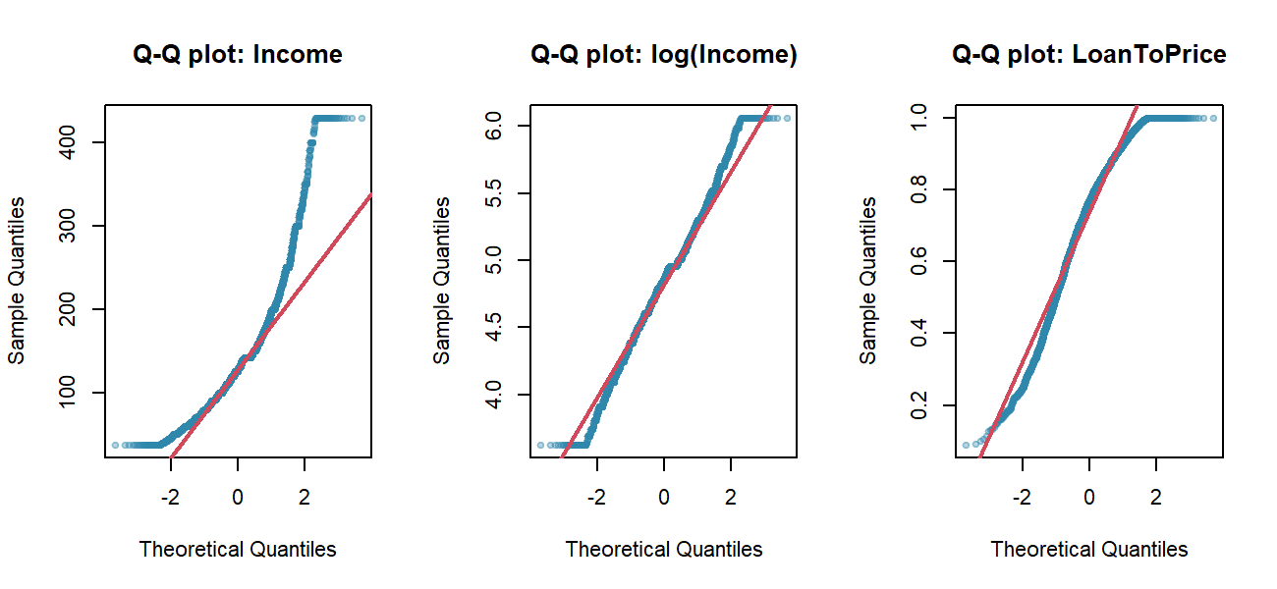
Figure 1: Normal Q-Q plots
R code
# F-test for equality of variances of Income between the two groups
var.test(Income ~ Status, data = credit)
Console output
F test to compare two variances
data: Income by Status
F = 0.77, num df = 1252, denom df = 3198, p-value = 0.0000001
alternative hypothesis: true ratio of variances is not equal to 1
95 percent confidence interval:
0.7060 0.8493
sample estimates:
ratio of variances
0.7736
Conclusion on assumptions: every Shapiro-Wilk test rejects normality (p < 0.001), and the Q-Q plots show clear curvature, especially in the right tail of Income; the log transform helps but does not fully normalise it. The F-test also shows unequal variances. Therefore: (1) the non-parametric Wilcoxon rank-sum test is used as the primary test for skewed variables; (2) where a t-test is reported, Welch's version (which does not assume equal variances) is used. With more than 1,200 observations per group the Central Limit Theorem makes the Welch t-test on means robust anyway, so both tests are reported for comparison.

Hypothesis Testing Results

Numeric variables: H1 to H3
R code
wilcox.test(Income ~ Status, data = credit)
t.test(Income ~ Status, data = credit) # Welch t-test (var.equal = FALSE)
Console output
Wilcoxon rank sum test with continuity correction
data: Income by Status
W = 1555519, p-value <2e-16
alternative hypothesis: true location shift is not equal to 0
Welch Two Sample t-test
data: Income by Status
t = -11, df = 2582, p-value <2e-16
alternative hypothesis: true difference in means between group bad and group good is not equal to 0
95 percent confidence interval:
-28.13 -19.57
sample estimates:
mean in group bad mean in group good
122.9 146.7
R code
wilcox.test(Seniority ~ Status, data = credit)
t.test(LoanToPrice ~ Status, data = credit)
Console output
Wilcoxon rank sum test with continuity correction
data: Seniority by Status
W = 1215463, p-value <2e-16
alternative hypothesis: true location shift is not equal to 0
Welch Two Sample t-test
data: LoanToPrice by Status
t = 16, df = 2810, p-value <2e-16
alternative hypothesis: true difference in means between group bad and group good is not equal to 0
95 percent confidence interval:
0.08633 0.10982
sample estimates:
mean in group bad mean in group good
0.7959 0.6978

Categorical variables: H4 and H5
R code
cramers_v <- function(tab) {
chi <- suppressWarnings(chisq.test(tab, correct = FALSE))$statistic
sqrt(chi / (sum(tab) * (min(dim(tab)) - 1)))
}
tab_rec <- table(credit$Records, credit$Status)
chisq.test(tab_rec)
cat("Cramer's V (Records):", round(cramers_v(tab_rec), 3), "\n\n")
tab_job <- table(credit$Job, credit$Status)
chisq.test(tab_job)
cat("Cramer's V (Job):", round(cramers_v(tab_job), 3), "\n")
cat("Minimum expected cell count:", round(min(chisq.test(tab_job)$expected), 1), "\n")
Console output
Pearson's Chi-squared test with Yates' continuity correction
data: tab_rec
X-squared = 344, df = 1, p-value <2e-16
Cramer's V (Records): 0.279
Pearson's Chi-squared test
data: tab_job
X-squared = 323, df = 3, p-value <2e-16
Cramer's V (Job): 0.269
Minimum expected cell count: 48.1

Correlation: H6
R code
cor.test(credit$Amount, credit$Price, method = "pearson")
cor.test(credit$Amount, credit$Price, method = "spearman", exact = FALSE)
Console output
Pearson's product-moment correlation
data: credit$Amount and credit$Price
t = 71, df = 4450, p-value <2e-16
alternative hypothesis: true correlation is not equal to 0
95 percent confidence interval:
0.7129 0.7406
sample estimates:
cor
0.727
Spearman's rank correlation rho
data: credit$Amount and credit$Price
S = 4620812093, p-value <2e-16
alternative hypothesis: true rho is not equal to 0
sample estimates:
rho
0.6858

Summary of hypothesis tests
R code
rank_biserial <- function(v) { # effect size for Wilcoxon
w <- wilcox.test(credit[[v]] ~ credit$Status)$statistic
n1 <- sum(credit$Status == "bad"); n2 <- sum(credit$Status == "good")
abs(unname(1 - 2 * w / (n1 * n2)))
}
test_summary <- data.frame(
Hypothesis = c("H1 Income", "H2 Seniority", "H3 LoanToPrice", "H4 Records",
"H5 Job", "H6 Amount~Price"),
Test = c("Wilcoxon", "Wilcoxon", "Welch t", "Chi-square", "Chi-square", "Pearson r"),
Statistic = c(wilcox.test(Income ~ Status, credit)$statistic,
wilcox.test(Seniority ~ Status, credit)$statistic,
t.test(LoanToPrice ~ Status, credit)$statistic,
chisq.test(tab_rec)$statistic, chisq.test(tab_job)$statistic,
cor(credit$Amount, credit$Price)),
p_value = c(wilcox.test(Income ~ Status, credit)$p.value,
wilcox.test(Seniority ~ Status, credit)$p.value,
t.test(LoanToPrice ~ Status, credit)$p.value,
chisq.test(tab_rec)$p.value, chisq.test(tab_job)$p.value,
cor.test(credit$Amount, credit$Price)$p.value),
Effect_size = c(rank_biserial("Income"), rank_biserial("Seniority"),
abs(diff(tapply(credit$LoanToPrice, credit$Status, mean))) / sd(credit$LoanToPrice),
cramers_v(tab_rec), cramers_v(tab_job), cor(credit$Amount, credit$Price)),
Effect_measure = c("rank-biserial r", "rank-biserial r", "Cohen's d", "Cramer's V",
"Cramer's V", "Pearson r"))
test_summary$Decision <- ifelse(test_summary$p_value < 0.05, "Reject H0", "Fail to reject H0")
test_summary |> mutate(Statistic = round(Statistic, 2), Effect_size = round(Effect_size, 3),
p_value = format.pval(p_value, digits = 3, eps = 1e-16))
Console output
Hypothesis Test Statistic p_value Effect_size Effect_measure Decision
1 H1 Income Wilcoxon 1555518.50 <1e-16 0.224 rank-biserial r Reject H0
2 H2 Seniority Wilcoxon 1215462.50 <1e-16 0.394 rank-biserial r Reject H0
3 H3 LoanToPrice Welch t 16.38 <1e-16 0.486 Cohen's d Reject H0
4 H4 Records Chi-square 344.44 <1e-16 0.279 Cramer's V Reject H0
5 H5 Job Chi-square 323.34 <1e-16 0.269 Cramer's V Reject H0
6 H6 Amount~Price Pearson r 0.73 <1e-16 0.727 Pearson r Reject H0
All six null hypotheses are rejected at the 5% level. With more than 4,000 observations even small differences become statistically significant, so effect sizes matter more for the business interpretation. The largest effects are for loan-to-price (Cohen's d = 0.49, close to medium) and seniority (rank-biserial r = 0.39, medium). Past arrears (Cramer's V = 0.28) and employment type (V = 0.27) show small-to-medium associations, and income has the smallest but still meaningful effect (r = 0.22). All five are therefore candidate predictors for the model.

Correlation and Multicollinearity Analysis
Highly correlated predictors make logistic regression coefficients unstable and hard to interpret. The Variance Inflation Factor (VIF = 1 / (1 - R²), where R² comes from regressing one predictor on all the others) was computed for the candidate numeric predictors. VIF > 5 is a common warning threshold.
R code
vif_manual <- function(df) {
sapply(names(df), function(v) {
r2 <- summary(lm(reformulate(setdiff(names(df), v), v), data = df))$r.squared
1 / (1 - r2)
})
}
cand <- c("Seniority", "Time", "Age", "Expenses", "Income", "Assets", "Debt",
"Amount", "Price", "LoanToPrice")
round(vif_manual(credit[cand]), 2)
cat("\nWithout Price:\n")
round(vif_manual(credit[setdiff(cand, "Price")]), 2)
Console output
Seniority Time Age Expenses Income Assets Debt
1.36 1.48 1.49 1.13 1.18 1.24 1.08
Amount Price LoanToPrice
18.83 14.20 9.26
Without Price:
Seniority Time Age Expenses Income Assets Debt
1.36 1.48 1.49 1.13 1.18 1.23 1.08
Amount LoanToPrice
1.64 1.54
Amount, Price and LoanToPrice are mathematically linked (LoanToPrice = Amount / Price), so keeping all three inflates their VIFs. Dropping Price brings every VIF to an acceptable level while keeping the information: the loan size (Amount) and the share financed (LoanToPrice). Derived variables that duplicate other columns (Installment, PaymentBurden, DisposableIncome, AgeGroup, HasAssets) are also excluded from the model for the same reason.

Model Building with Cross-Validation

Model choice
Logistic regression was chosen as the primary model because it is the industry standard for credit scoring: it outputs a probability of default, its coefficients translate directly into odds ratios that regulators and credit officers can understand, and it is fast and stable. A random forest was trained as a non-linear benchmark to check whether a more flexible model captures substantially more signal.

Train/test split
R code
model_vars <- c("Status", "Seniority", "Home", "Time", "Age", "Marital", "Records", "Job",
"Expenses", "Income", "Assets", "Debt", "Amount", "LoanToPrice",
"Income_missing")
model_df <- credit[, model_vars]
set.seed(2026)
train_idx <- createDataPartition(model_df$Status, p = 0.75, list = FALSE)
train <- model_df[train_idx, ]
test <- model_df[-train_idx, ]
rbind(Train = c(n = nrow(train), bad_rate = round(mean(train$Status == "bad"), 3)),
Test = c(n = nrow(test), bad_rate = round(mean(test$Status == "bad"), 3)))
Console output
n bad_rate
Train 3340 0.281
Test 1112 0.281
createDataPartition() performs a stratified split, so the default rate is the same in the training (75%) and test (25%) sets. The test set is kept completely aside until the final evaluation.

Repeated 10-fold cross-validation
Within the training set, 10-fold cross-validation repeated 3 times (30 resamples) is used to estimate out-of-sample performance and to tune the random forest. Because the classes are imbalanced, ROC-AUC is used as the optimisation metric instead of accuracy.
R code
ctrl <- trainControl(method = "repeatedcv", number = 10, repeats = 3,
classProbs = TRUE, summaryFunction = twoClassSummary,
savePredictions = "final")
set.seed(2026)
fit_glm <- train(Status ~ ., data = train, method = "glm", family = binomial,
preProcess = c("center", "scale"), metric = "ROC", trControl = ctrl)
set.seed(2026)
fit_rf <- train(Status ~ ., data = train, method = "rf", ntree = 200,
tuneGrid = data.frame(mtry = c(2, 4, 6)),
metric = "ROC", trControl = ctrl)
fit_glm
fit_rf$results[, c("mtry", "ROC", "Sens", "Spec")]
Console output
Generalized Linear Model
3340 samples
14 predictor
2 classes: 'bad', 'good'
Pre-processing: centered (22), scaled (22)
Resampling: Cross-Validated (10 fold, repeated 3 times)
Summary of sample sizes: 3006, 3006, 3006, 3006, 3006, 3006, ...
Resampling results:
ROC Sens Spec
0.8402 0.5043 0.9156
mtry ROC Sens Spec
1 2 0.8416 0.3309 0.9543
2 4 0.8418 0.4720 0.9139
3 6 0.8391 0.5057 0.9033
R code
cv_res <- resamples(list(Logistic = fit_glm, RandomForest = fit_rf))
summary(cv_res)$statistics$ROC
Console output
Min. 1st Qu. Median Mean 3rd Qu. Max. NA's
Logistic 0.7843 0.8182 0.8448 0.8402 0.8597 0.8935 0
RandomForest 0.7975 0.8220 0.8441 0.8418 0.8543 0.8899 0
R code
cv_long <- cv_res$values |>
pivot_longer(-Resample, names_to = "key", values_to = "value") |>
separate(key, into = c("Model", "Metric"), sep = "~") |>
filter(Metric %in% c("ROC", "Sens", "Spec"))
p_cv <- ggplot(cv_long, aes(x = Model, y = value, fill = Model)) +
geom_boxplot(alpha = 0.7) +
facet_wrap(~ Metric, scales = "free_y") +
scale_fill_manual(values = c(Logistic = "#1F4E79", RandomForest = "#F4A259")) +
labs(title = "Cross-validated performance (30 resamples)",
subtitle = "Sens = sensitivity for 'bad' at a 0.5 threshold; Spec = specificity",
x = NULL, y = NULL) +
theme(legend.position = "none")
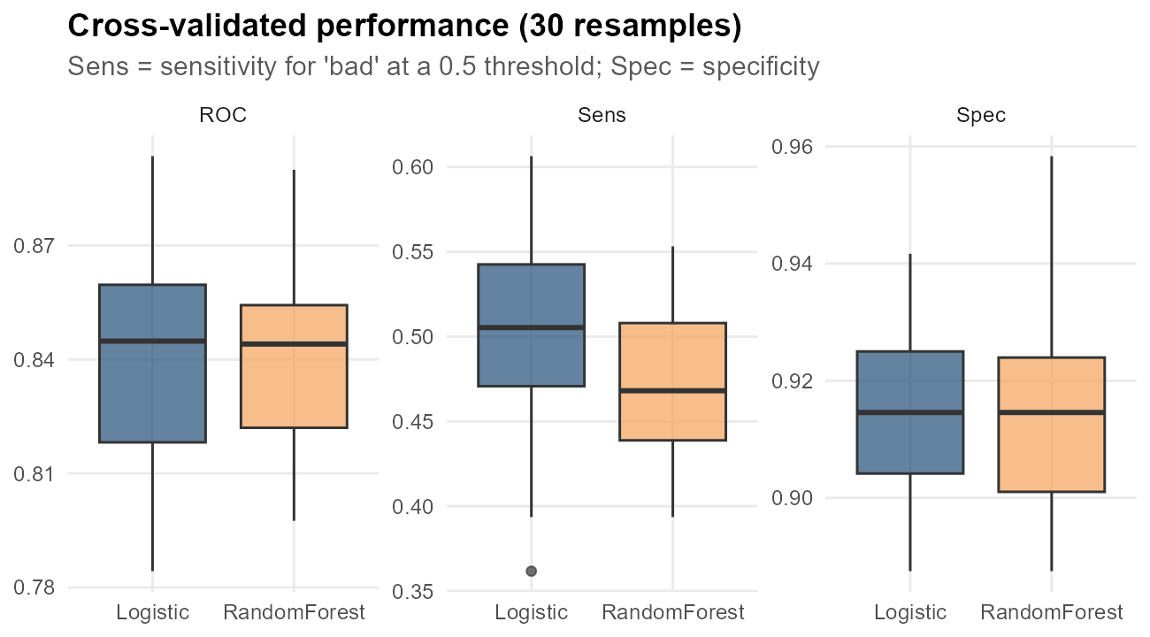
Figure 2: Distribution of cross-validated ROC, sensitivity and specificity
Cross-validated mean ROC-AUC is 0.840 for logistic regression and 0.842 for the random forest. Both models have high specificity but modest sensitivity at the default 0.5 cut-off: with only 28% bad loans, a 0.5 threshold is too conservative for flagging risk. The threshold is therefore tuned in the next section.

Choosing a classification threshold
The threshold is selected with Youden's J statistic (sensitivity + specificity - 1), using only the out-of-fold cross-validation predictions from the training data. This avoids any information leaking from the test set.
R code
cv_pred_glm <- fit_glm$pred
roc_cv <- roc(cv_pred_glm$obs, cv_pred_glm$bad, levels = c("good", "bad"),
direction = "<", quiet = TRUE)
thr <- coords(roc_cv, "best", best.method = "youden",
ret = c("threshold", "sensitivity", "specificity"))
thr_glm <- thr$threshold[1]
round(thr, 3)
Console output
threshold sensitivity specificity
1 0.295 0.74 0.786

Model Evaluation on the Test Set
R code
test$p_glm <- predict(fit_glm, newdata = test, type = "prob")[, "bad"]
test$p_rf <- predict(fit_rf, newdata = test, type = "prob")[, "bad"]
roc_glm <- roc(test$Status, test$p_glm, levels = c("good", "bad"), direction = "<", quiet = TRUE)
roc_rf <- roc(test$Status, test$p_rf, levels = c("good", "bad"), direction = "<", quiet = TRUE)
cat("Test AUC - Logistic:", round(auc(roc_glm), 3),
" 95% CI:", paste(round(ci.auc(roc_glm)[c(1, 3)], 3), collapse = "-"), "\n")
cat("Test AUC - Random forest:", round(auc(roc_rf), 3),
" 95% CI:", paste(round(ci.auc(roc_rf)[c(1, 3)], 3), collapse = "-"), "\n")
roc.test(roc_glm, roc_rf)$p.value # DeLong test: are the two AUCs different?
Console output
Test AUC - Logistic: 0.833 95% CI: 0.807-0.86
Test AUC - Random forest: 0.83 95% CI: 0.803-0.857
[1] 0.7031
R code
pred_class <- factor(ifelse(test$p_glm >= thr_glm, "bad", "good"), levels = c("bad", "good"))
cm_glm <- confusionMatrix(pred_class, test$Status, positive = "bad")
cm_glm
Console output
Confusion Matrix and Statistics
Reference
Prediction bad good
bad 229 171
good 84 628
Accuracy : 0.771
95% CI : (0.745, 0.795)
No Information Rate : 0.719
P-Value [Acc > NIR] : 0.0000464005
Kappa : 0.477
Mcnemar's Test P-Value : 0.0000000722
Sensitivity : 0.732
Specificity : 0.786
Pos Pred Value : 0.573
Neg Pred Value : 0.882
Prevalence : 0.281
Detection Rate : 0.206
Detection Prevalence : 0.360
Balanced Accuracy : 0.759
'Positive' Class : bad
R code
cm_05 <- confusionMatrix(factor(ifelse(test$p_glm >= 0.5, "bad", "good"), levels = c("bad", "good")),
test$Status, positive = "bad")
thr_rf <- coords(roc(fit_rf$pred$obs, fit_rf$pred$bad, levels = c("good", "bad"),
direction = "<", quiet = TRUE), "best", ret = "threshold")$threshold[1]
cm_rf <- confusionMatrix(factor(ifelse(test$p_rf >= thr_rf, "bad", "good"), levels = c("bad", "good")),
test$Status, positive = "bad")
metric_row <- function(cm, auc_val, name, t) {
data.frame(Model = name, Threshold = round(t, 3), AUC = round(auc_val, 3),
Accuracy = round(cm$overall["Accuracy"], 3),
Sensitivity = round(cm$byClass["Sensitivity"], 3),
Specificity = round(cm$byClass["Specificity"], 3),
Precision = round(cm$byClass["Pos Pred Value"], 3),
F1 = round(cm$byClass["F1"], 3), Kappa = round(cm$overall["Kappa"], 3))
}
perf <- rbind(metric_row(cm_05, auc(roc_glm), "Logistic (0.5 cut-off)", 0.5),
metric_row(cm_glm, auc(roc_glm), "Logistic (Youden cut-off)", thr_glm),
metric_row(cm_rf, auc(roc_rf), "Random forest (Youden cut-off)", thr_rf))
rownames(perf) <- NULL
perf
Console output
Model Threshold AUC Accuracy Sensitivity Specificity Precision
1 Logistic (0.5 cut-off) 0.500 0.833 0.811 0.521 0.925 0.731
2 Logistic (Youden cut-off) 0.295 0.833 0.771 0.732 0.786 0.573
3 Random forest (Youden cut-off) 0.302 0.830 0.775 0.751 0.785 0.577
F1 Kappa
1 0.608 0.488
2 0.642 0.477
3 0.653 0.491
Table 2: Test-set performance comparison
Model | Threshold | AUC | Accuracy | Sensitivity | Specificity | Precision | F1 | Kappa
Logistic (0.5 cut-off) | 0.500 | 0.833 | 0.811 | 0.521 | 0.925 | 0.731 | 0.608 | 0.488
Logistic (Youden cut-off) | 0.295 | 0.833 | 0.771 | 0.732 | 0.786 | 0.573 | 0.642 | 0.477
Random forest (Youden cut-off) | 0.302 | 0.830 | 0.775 | 0.751 | 0.785 | 0.577 | 0.653 | 0.491

R code
roc_df <- bind_rows(
data.frame(Model = sprintf("Logistic (AUC %.3f)", auc(roc_glm)),
FPR = 1 - roc_glm$specificities, TPR = roc_glm$sensitivities),
data.frame(Model = sprintf("Random forest (AUC %.3f)", auc(roc_rf)),
FPR = 1 - roc_rf$specificities, TPR = roc_rf$sensitivities))
p_roc <- ggplot(roc_df, aes(FPR, TPR, colour = Model)) +
geom_abline(linetype = "dashed", colour = "grey60") +
geom_path(linewidth = 1.1) +
annotate("point", x = 1 - cm_glm$byClass["Specificity"], y = cm_glm$byClass["Sensitivity"],
size = 3.5, colour = "#1F4E79") +
annotate("text", x = 1 - cm_glm$byClass["Specificity"] + 0.03,
y = cm_glm$byClass["Sensitivity"] - 0.05, hjust = 0, size = 3.2,
label = "chosen logistic cut-off") +
scale_colour_manual(values = c("#1F4E79", "#F4A259"), name = NULL) +
coord_equal() +
labs(title = "ROC curves on the held-out test set",
x = "False positive rate (1 - specificity)", y = "True positive rate (sensitivity)")
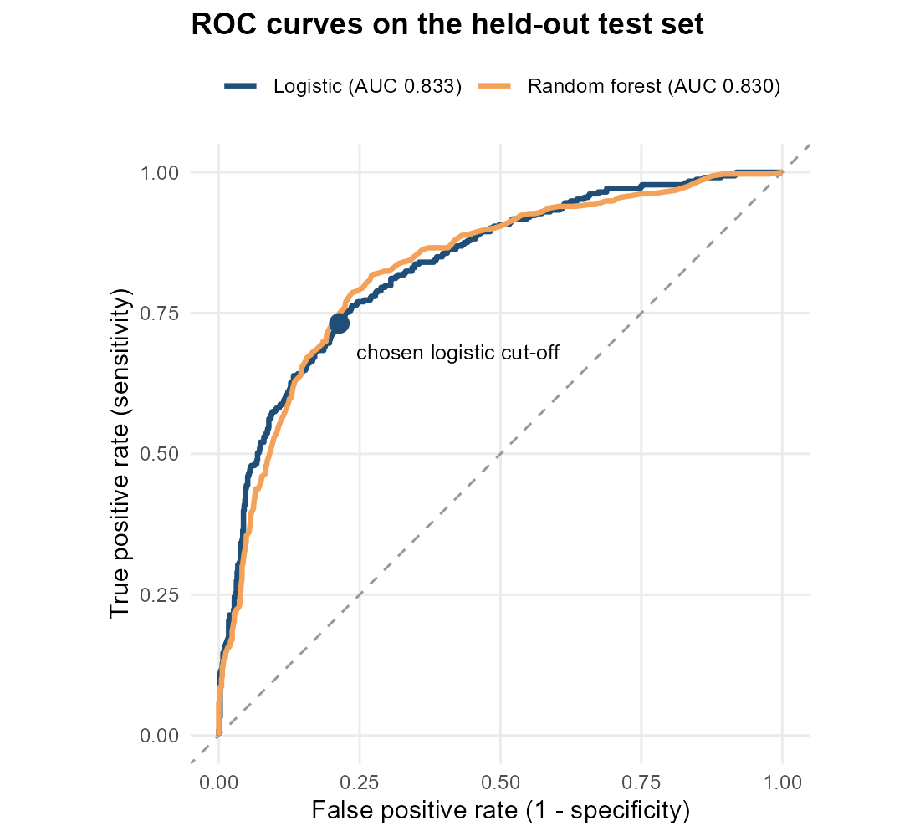
Figure 3: ROC curves of both models on the test set
R code
cm_df <- as.data.frame(cm_glm$table)
p_cm <- ggplot(cm_df, aes(Reference, Prediction, fill = Freq)) +
geom_tile(colour = "white") +
geom_text(aes(label = Freq), size = 7, fontface = "bold") +
scale_fill_gradient(low = "#EAF4F2", high = "#2E86AB") +
labs(title = "Confusion matrix - logistic regression (test set)",
subtitle = sprintf("Threshold = %.3f", thr_glm),
x = "Actual outcome", y = "Predicted outcome") +
theme(legend.position = "none", panel.grid = element_blank())
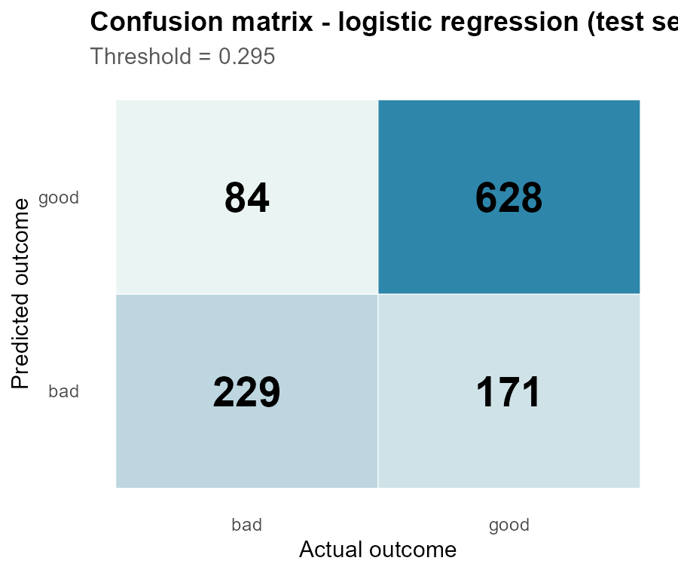
Figure 4: Confusion matrix for the logistic regression model
Interpretation: on 1112 unseen applicants the logistic model reaches an AUC of 0.833: if we pick one random bad and one random good applicant, the model ranks the bad one as riskier 83% of the time. With the tuned threshold it catches 73.2% of the bad loans (sensitivity), while correctly approving 78.6% of the good ones (specificity). Using the naive 0.5 cut-off would catch only 52.1% of the bad loans. The random forest reaches an AUC of 0.830; the DeLong test comparing the two ROC curves gives p = 0.703, so there is no significant difference. The simpler, interpretable logistic model is therefore preferred.

Model Diagnostics
For interpretation and diagnostics, the same logistic model is re-fitted with glm() on the unscaled training data, so that coefficients are expressed in the original units. Its predictions are identical to the caret model's.
R code
train_glm <- train |> mutate(Default = as.integer(Status == "bad")) |> select(-Status)
logit <- glm(Default ~ ., data = train_glm, family = binomial)
cat("Null deviance:", round(logit$null.deviance, 1), " on", logit$df.null, "df\n")
cat("Residual deviance:", round(deviance(logit), 1), " on", logit$df.residual, "df\n")
cat("AIC:", round(AIC(logit), 1), "\n")
cat("McFadden pseudo R-squared:", round(1 - logit$deviance / logit$null.deviance, 3), "\n")
# Likelihood-ratio test of the full model against the intercept-only model
anova(glm(Default ~ 1, data = train_glm, family = binomial), logit, test = "Chisq")
Console output
Null deviance: 3970 on 3339 df
Residual deviance: 2830 on 3317 df
AIC: 2876
McFadden pseudo R-squared: 0.287
Analysis of Deviance Table
Model 1: Default ~ 1
Model 2: Default ~ Seniority + Home + Time + Age + Marital + Records +
Job + Expenses + Income + Assets + Debt + Amount + LoanToPrice +
Income_missing
Resid. Df Resid. Dev Df Deviance Pr(>Chi)
1 3339 3970
2 3317 2830 22 1140 <2e-16 ***
---
Signif. codes: 0 '***' 0.001 '**' 0.01 '*' 0.05 '.' 0.1 ' ' 1

Residual analysis (binned residual plot)
Raw residuals of a logistic model are only 0/1 minus a probability, so they are not informative individually. The binned residual plot groups observations by predicted probability and plots the average residual in each bin; about 95% of bins should fall inside the ±2 standard-error band.
R code
bins <- data.frame(p = fitted(logit), y = train_glm$Default) |>
mutate(bin = ntile(p, 40)) |>
group_by(bin) |>
summarise(p_mean = mean(p), resid = mean(y - p), n = n(),
se = 2 * sqrt(mean(p) * (1 - mean(p)) / n()))
cat("Share of bins inside the +/-2 SE band:",
round(mean(abs(bins$resid) <= bins$se), 3), "\n")
p_bin <- ggplot(bins, aes(p_mean, resid)) +
geom_ribbon(aes(ymin = -se, ymax = se), fill = "grey85") +
geom_hline(yintercept = 0, colour = "grey40") +
geom_point(colour = "#1F4E79", size = 2) +
labs(title = "Binned residual plot (training data, 40 bins)",
subtitle = "Grey band = +/- 2 standard errors",
x = "Mean predicted probability of default", y = "Mean residual (observed - predicted)")
Console output
Share of bins inside the +/-2 SE band: 0.9
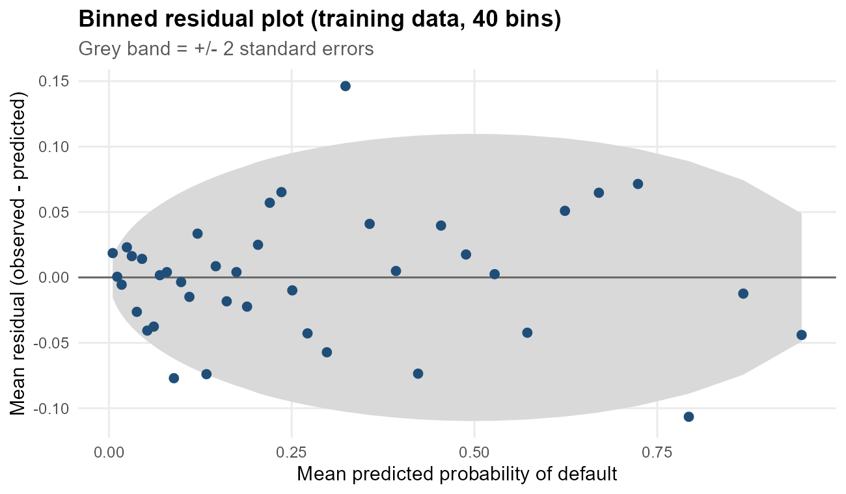
Figure 5: Binned residual plot for the logistic regression

Calibration and goodness of fit
R code
# Hosmer-Lemeshow test (10 groups), implemented directly
hl <- data.frame(p = fitted(logit), y = train_glm$Default) |>
mutate(g = ntile(p, 10)) |> group_by(g) |>
summarise(obs = sum(y), exp = sum(p), n = n())
hl_stat <- sum((hl$obs - hl$exp)^2 / (hl$exp * (1 - hl$exp / hl$n)))
cat("Hosmer-Lemeshow chi-square =", round(hl_stat, 2), ", df = 8, p-value =",
round(pchisq(hl_stat, df = 8, lower.tail = FALSE), 4), "\n")
calib <- test |> mutate(decile = ntile(p_glm, 10)) |>
group_by(decile) |>
summarise(predicted = mean(p_glm), observed = mean(Status == "bad"), n = n())
p_cal <- ggplot(calib, aes(predicted, observed)) +
geom_abline(linetype = "dashed", colour = "grey50") +
geom_line(colour = "#1F4E79") + geom_point(size = 2.5, colour = "#1F4E79") +
scale_x_continuous(labels = percent, limits = c(0, 1)) +
scale_y_continuous(labels = percent, limits = c(0, 1)) +
coord_equal() +
labs(title = "Calibration on the test set", subtitle = "Deciles of predicted risk",
x = "Mean predicted default probability", y = "Observed default rate")
Console output
Hosmer-Lemeshow chi-square = 10.84 , df = 8, p-value = 0.2109
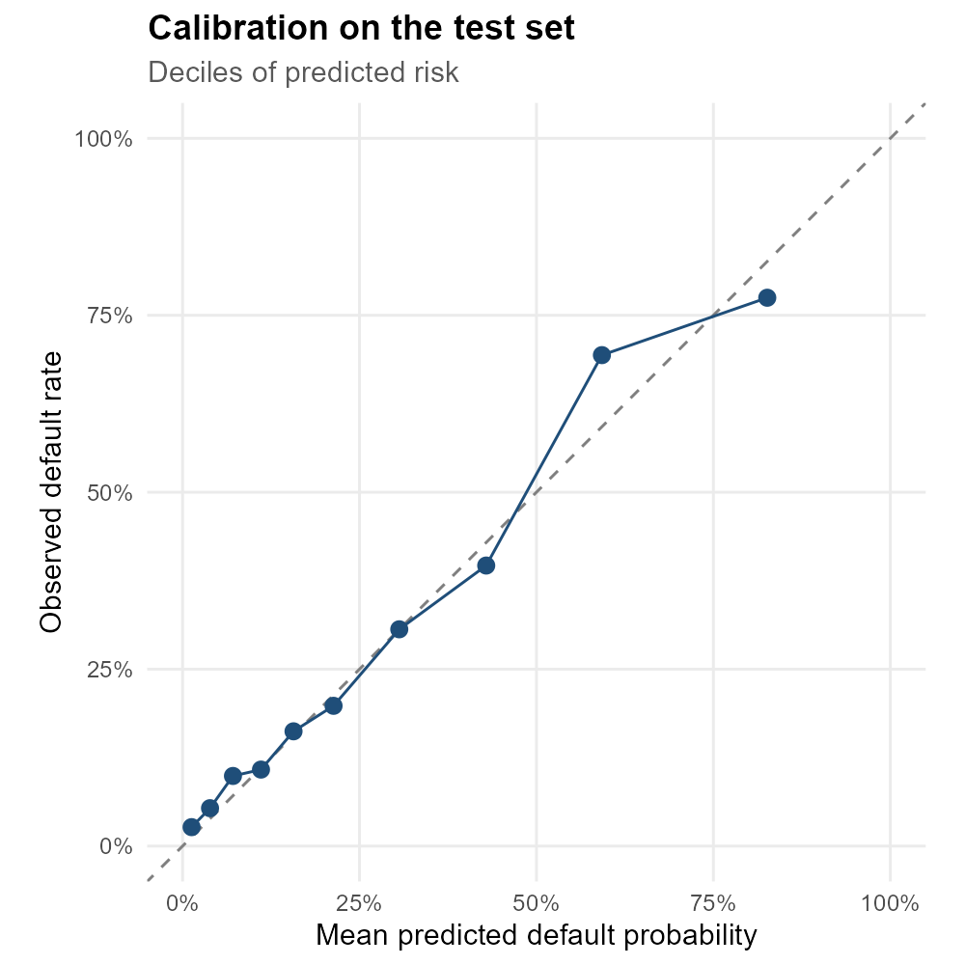
Figure 6: Calibration plot: predicted vs. observed default rate by decile

Influential observations
R code
cooks <- cooks.distance(logit)
cut_cook <- 4 / nrow(train_glm)
cat("Observations with Cook's distance > 4/n:", sum(cooks > cut_cook),
sprintf("(%.1f%%)\n", 100 * mean(cooks > cut_cook)))
cat("Maximum Cook's distance:", round(max(cooks), 4), "\n")
Console output
Observations with Cook's distance > 4/n: 216 (6.5%)
Maximum Cook's distance: 0.0125
R code
plot(cooks, type = "h", col = "#1F4E79", main = "Cook's distance",
ylab = "Cook's distance", xlab = "Training observation")
abline(h = cut_cook, col = "#D1495B", lty = 2)
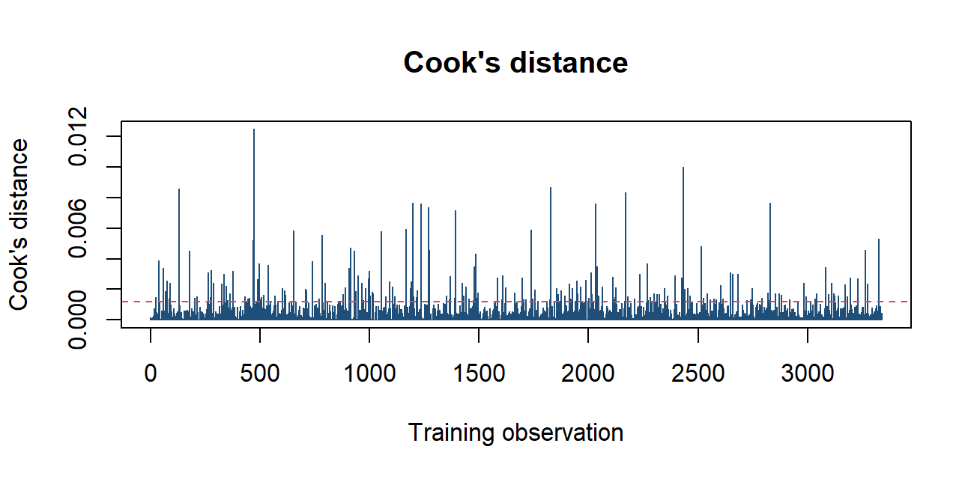
Figure 7: Cook's distance for each training observation
Diagnostic summary: 90% of the binned residuals fall inside the ±2 SE band, so there is no systematic misfit across the risk range. The Hosmer-Lemeshow test gives p = 0.211 (no evidence of lack of fit). On the test set, the calibration points lie close to the diagonal, meaning a predicted probability of 40% corresponds to roughly a 40% observed default rate. This matters if the probabilities are used for pricing or provisioning. No single observation has a Cook's distance near 1, so no individual applicant is driving the results; the winsorization applied in Week 1 helped here.

Interpretation of the Logistic Regression Model
R code
coef_tbl <- summary(logit)$coefficients
or_tbl <- data.frame(Term = rownames(coef_tbl),
Estimate = coef_tbl[, 1], Std_Error = coef_tbl[, 2],
z = coef_tbl[, 3], p_value = coef_tbl[, 4],
Odds_ratio = exp(coef_tbl[, 1]),
OR_low = exp(coef_tbl[, 1] - 1.96 * coef_tbl[, 2]),
OR_high = exp(coef_tbl[, 1] + 1.96 * coef_tbl[, 2]))
rownames(or_tbl) <- NULL
or_tbl |> mutate(across(c(Estimate, Std_Error, z), ~ round(.x, 4)),
across(c(Odds_ratio, OR_low, OR_high), ~ round(.x, 3)),
p_value = signif(p_value, 3))
Console output
Term Estimate Std_Error z p_value Odds_ratio OR_low OR_high
1 (Intercept) -3.0133 0.6364 -4.7347 2.19e-06 0.049 0.014 0.171
2 Seniority -0.0869 0.0089 -9.7166 2.56e-22 0.917 0.901 0.933
3 Homeowner -0.8540 0.1843 -4.6328 3.61e-06 0.426 0.297 0.611
4 Homeparents -0.7920 0.1939 -4.0852 4.40e-05 0.453 0.310 0.662
5 Homepriv -0.4139 0.2529 -1.6369 1.02e-01 0.661 0.403 1.085
6 Homerent -0.1468 0.1863 -0.7883 4.31e-01 0.863 0.599 1.244
7 Time 0.0015 0.0042 0.3533 7.24e-01 1.001 0.993 1.010
8 Age 0.0124 0.0058 2.1149 3.44e-02 1.012 1.001 1.024
9 Maritalmarried -0.4952 0.5260 -0.9414 3.47e-01 0.609 0.217 1.709
10 Maritalseparated 0.7891 0.5785 1.3641 1.73e-01 2.201 0.708 6.841
11 Maritalsingle 0.0508 0.5319 0.0956 9.24e-01 1.052 0.371 2.984
12 Maritalwidow 0.2783 0.6543 0.4253 6.71e-01 1.321 0.366 4.762
13 Recordsyes 1.7572 0.1193 14.7329 3.96e-49 5.796 4.588 7.323
14 Jobfreelance 0.3527 0.1347 2.6183 8.84e-03 1.423 1.093 1.853
15 Jobothers 0.6521 0.2401 2.7163 6.60e-03 1.920 1.199 3.073
16 Jobpartime 1.4424 0.1446 9.9762 1.94e-23 4.231 3.187 5.617
17 Expenses 0.0156 0.0031 5.0473 4.48e-07 1.016 1.010 1.022
18 Income -0.0076 0.0009 -8.8208 1.14e-18 0.992 0.991 0.994
19 Assets 0.0000 0.0000 -4.0070 6.15e-05 1.000 1.000 1.000
20 Debt 0.0002 0.0001 3.8739 1.07e-04 1.000 1.000 1.000
21 Amount 0.0008 0.0001 5.8833 4.02e-09 1.001 1.001 1.001
22 LoanToPrice 2.0711 0.3116 6.6468 3.00e-11 7.934 4.308 14.612
23 Income_missingyes 1.4712 0.1781 8.2619 1.43e-16 4.354 3.071 6.173
R code
p_or <- or_tbl |>
filter(Term != "(Intercept)", p_value < 0.05) |>
ggplot(aes(x = Odds_ratio, y = reorder(Term, Odds_ratio))) +
geom_vline(xintercept = 1, linetype = "dashed") +
geom_errorbar(aes(xmin = OR_low, xmax = OR_high), width = 0.25, colour = "grey40",
orientation = "y") +
geom_point(aes(colour = Odds_ratio > 1), size = 3) +
scale_x_log10() +
scale_colour_manual(values = c(`TRUE` = "#D1495B", `FALSE` = "#2E86AB"),
labels = c("Reduces risk", "Increases risk"), name = NULL) +
labs(title = "Significant predictors of default (odds ratios, 95% CI)",
subtitle = "Per one-unit increase (numeric) or vs. reference level (categorical); log scale",
x = "Odds ratio", y = NULL)
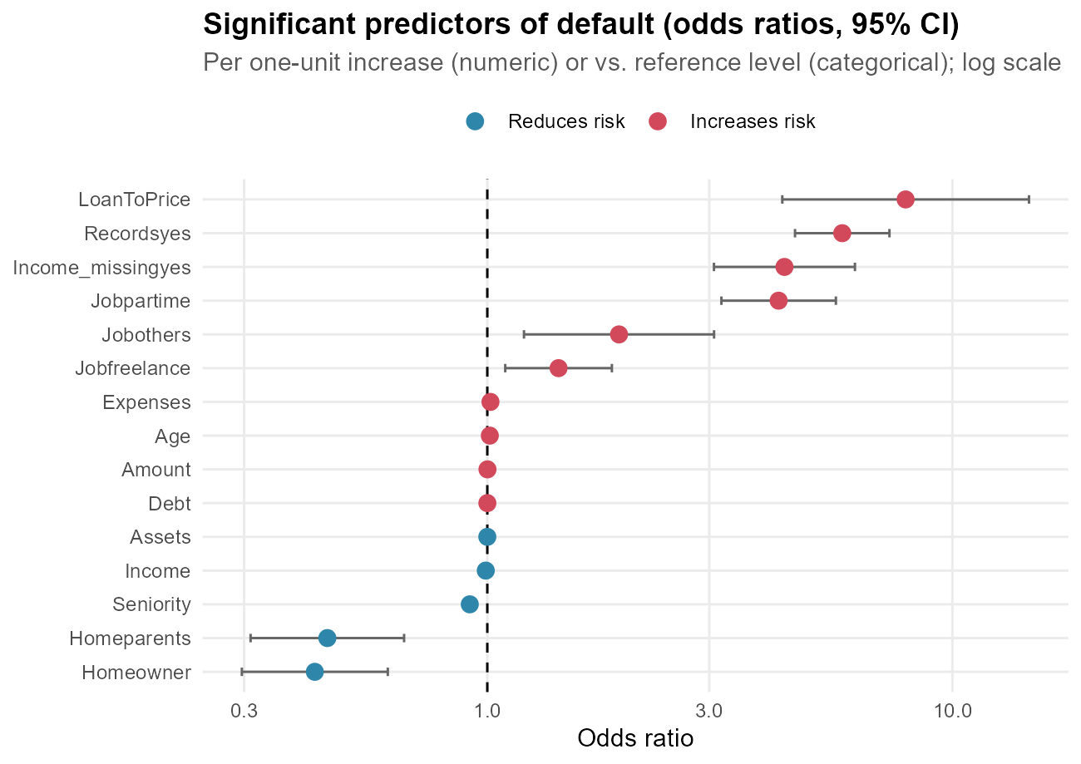
Figure 8: Odds ratios of statistically significant predictors
R code
imp <- varImp(fit_rf)$importance |>
tibble::rownames_to_column("Variable") |>
arrange(desc(Overall)) |> head(12)
p_imp <- ggplot(imp, aes(Overall, reorder(Variable, Overall))) +
geom_col(fill = "#F4A259") +
labs(title = "Random forest variable importance (top 12)",
x = "Relative importance (0-100)", y = NULL)
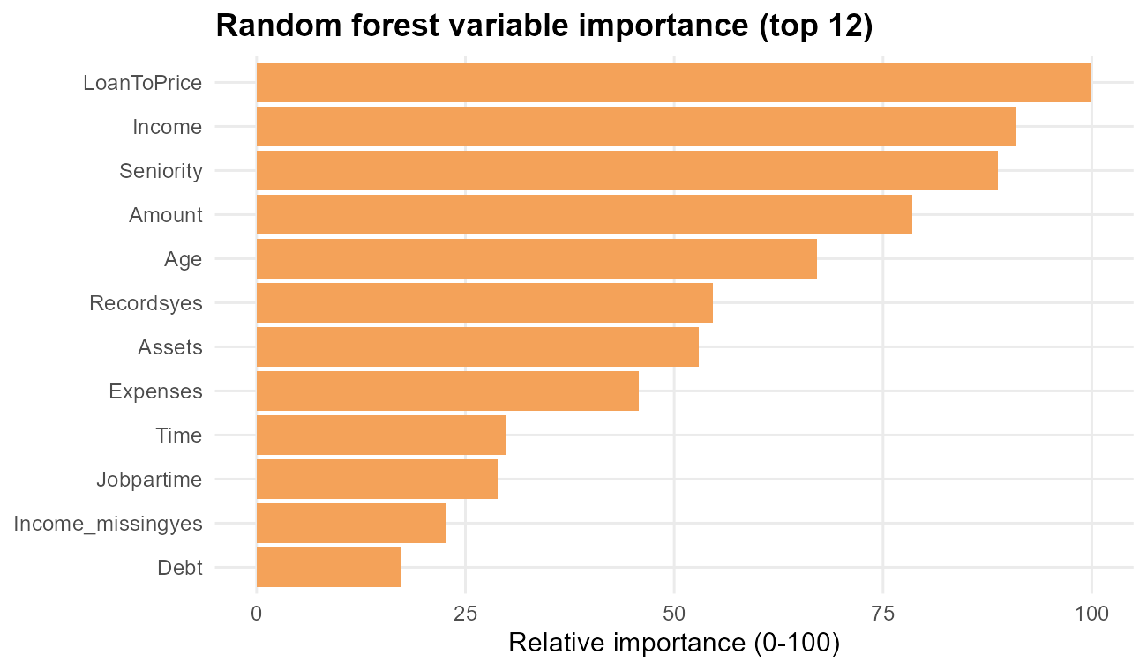
Figure 9: Variable importance from the random forest benchmark
Key effects, holding all other variables constant:
• A past arrears record multiplies the odds of default by 5.80 (Recordsyes).
• Part-time employment multiplies the odds by 4.23 compared with a fixed contract; freelance by 1.42.
• Each additional year of seniority multiplies the odds by 0.917, i.e. about 8.3% lower odds per year; ten years lowers the odds by about 58%.
• A 10-percentage-point increase in the loan-to-price ratio multiplies the odds by 1.23.
• Renting (vs. the reference housing level 'other') has an odds ratio of 0.86, and owning a home 0.43.
• Missing income remains significant after imputation (odds ratio 4.35), which confirms the Week 1 decision to keep the missing-value flag.
The random forest's importance ranking largely agrees with the logistic model: income, seniority, loan amount, loan-to-price, arrears records and employment type are among the most influential variables. This agreement between a linear and a non-linear model increases confidence that these are genuine risk drivers.

Strengths, Limitations and Improvements

Strengths
• Interpretable: every coefficient converts into an odds ratio a credit officer can understand and audit.
• Validated honestly: stratified hold-out test set, repeated 10-fold cross-validation, and a threshold chosen without touching the test data.
• Well calibrated probabilities, so scores can be used directly for risk-based pricing or expected-loss estimates.
• Stable: acceptable VIFs, no dominant influential observations, and results consistent with an independent random forest model.

Limitations
• Discrimination is good but not excellent (AUC about 0.83); some bad loans remain hard to distinguish using only 14 application variables.
• The linear-logit assumption may miss non-linear effects (for example the non-monotonic age pattern seen in Week 2).
• Class imbalance means precision for the 'bad' class is moderate: some good applicants are flagged for review.
• The dataset is historical and from a single lender, so the model may not transfer to other populations or economic conditions without re-validation.

Potential improvements
• Add non-linear terms (splines for Age and Seniority) or interaction terms (e.g. Job x Home, found in the Week 2 heatmap).
• Try gradient boosting (xgboost) and regularised regression (glmnet) with the same cross-validation framework.
• Choose the threshold with a business cost matrix (the cost of a missed default vs. a lost good customer) rather than Youden's J; this is developed in the Week 4 report.
• Handle imbalance explicitly with class weights or SMOTE/down-sampling inside the cross-validation loop.
• Enrich the data with bureau scores, transaction history or macro-economic indicators.

Conclusion
The hypothesis tests confirmed, with statistical rigour, the risk drivers suggested visually in Week 2: past arrears, employment type, job seniority, income and loan-to-price all differ significantly between good and bad borrowers. A logistic regression combining these factors achieves a test-set AUC of 0.833, catches 73.2% of defaults at the tuned threshold, and produces well-calibrated, interpretable probabilities. A random forest benchmark (AUC 0.830) did not justify giving up that interpretability. The model is a solid, explainable baseline credit score. Week 4 integrates these results with the cleaning and visualization work into a final report with business recommendations.

