WEEK 4 TASK: FINAL REPORT
Predicting Credit Default with R
Final Comprehensive Report: Data Preparation, Visualization, Modeling and Business Impact

Prepared by: Nayani Paul
Virtual R Data Analyst Internship | YuvaIntern
Dataset: Credit Scoring data (modeldata::credit_data, 4,454 loan applicants)
Tools: R 4.6.1 | dplyr, tidyr, ggplot2, caret, officer
Code repository: https://github.com/paulmark-05/data_analysis_R
26 September 2026

Contents
1. Executive Summary
2. Introduction
3. Data Preparation
4. Exploratory and Visual Analysis
5. Statistical Testing and Predictive Modeling
6. Results: Business Impact of the Model
7. Discussion
8. Conclusion: Lessons Learned, Challenges and Future Directions
9. Appendix A: Project Structure and Reproducibility
10. Appendix B: Annotated Key R Code

Executive Summary
This project used R to build an end-to-end, reproducible analysis of a public credit-scoring dataset of 4,454 loan applicants. The goal was to understand what drives loan default and to build a model that helps a lender decide which applications to approve automatically, review manually, or decline. The work followed four stages: data cleaning (Week 1), visualization (Week 2), statistical testing and predictive modeling (Week 3), and integration into business recommendations (this report).
Key findings:
• Around 28.1% of loans default. Risk is concentrated, not random: it is driven by credit history, employment stability and affordability.
• Applicants with past arrears default at 55.5% versus 22.4% without; part-time workers at 60% versus 20.7% for fixed contracts; home owners at only 18.6%.
• All six formal hypothesis tests were significant (p < 0.001); seniority and loan-to-price ratio showed the largest effect sizes.
• A logistic regression credit score achieved a test-set AUC of 0.833 (95% CI 0.807-0.860), matched a random-forest benchmark (AUC 0.830), and produced well-calibrated probabilities (Hosmer-Lemeshow p = 0.21).
• Business impact: assuming a missed default costs 5 times as much as a wrongly declined good customer, the model's cost-optimal policy reduces total credit-decision cost by 65% compared with approving everyone. It cuts the default rate among approved loans from 28.1% to 9.2% while still approving 49% of applicants.
Main recommendations: adopt the score as a pre-screening tool with three risk grades (auto-approve, manual review, decline), make credit history and employment type verified fields, require documentation when income is not declared, and monitor the model quarterly.

Introduction

Business context
Lending is a business of managing risk. Every approved loan that defaults costs the lender part of the principal, collection effort and capital; every good applicant who is turned away is lost revenue and a lost customer relationship. Data-driven credit scoring lets a lender make these decisions consistently, quickly and transparently, and explain them to customers and regulators.

Objectives and research questions
• Q1 - Data: Is the available data reliable enough for decision-making, and how must it be cleaned?
• Q2 - Patterns: Which applicant characteristics are associated with default, and how strongly?
• Q3 - Evidence: Are these associations statistically significant once chance is accounted for?
• Q4 - Prediction: How accurately can default be predicted from application data?
• Q5 - Impact: How should the model be used, and what is it worth to the business?

Dataset
The public Credit Scoring dataset (Belanche Muñoz, via github.com/gastonstat/CreditScoring; available in R as modeldata::credit_data) contains 14 variables per applicant: the outcome Status (good/bad), 8 numeric variables (seniority, loan term, age, expenses, income, assets, debt, loan amount, price of goods) and 5 categorical variables (home, marital status, arrears records, job).

Approach and tools
All work was done in R 4.6.1. dplyr and tidyr were used for data manipulation; ggplot2, lattice and base graphics for visualization; stats, caret and pROC for testing, modeling and evaluation; and officer and flextable to generate these Word reports directly from code, so every number, table and chart is reproducible. The workflow is summarised below.
Table 1: Project workflow
Stage | Main activities | Output
1. Data preparation | Audit, duplicates, missing values, outliers, feature engineering, scaling, encoding | credit_clean.csv, Week 1 report
2. Visual analysis | 13 charts: composition, comparisons, trends, relationships, anomalies | Figures, Week 2 report
3. Statistics & modeling | Assumption checks, 6 hypothesis tests, logistic regression & random forest, CV, diagnostics | Trained models, Week 3 report
4. Integration | Cost-based decision policy, risk grades, recommendations | This final report

Data Preparation
The raw data had 4,454 rows, of which 415 (9.3%) contained at least one missing value. Missing values occurred in six columns, most notably Income (8.6%).
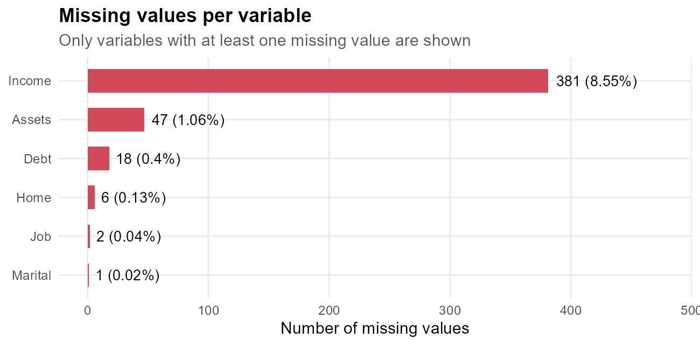
Figure 1: Missing values per variable in the raw data

Cleaning methodology
Table 2: Cleaning and transformation log (Week 1)
Step | Action
Raw data | 4454 rows x 14 columns, 415 rows with NA
Duplicates | 2 exact duplicate rows removed -> 4452 applicants
Invalid category | Home = 'ignore' merged into 'other'
Missing categorical | Mode imputation (Home, Marital, Job)
Missing Income | Median by Job group + Income_missing flag
Missing Assets/Debt | Median imputation
Outliers | Winsorized at 1st/99th percentile (5 monetary variables)
New features | LoanToPrice, Installment, PaymentBurden, DisposableIncome, AgeGroup, HasAssets
Scaling | Z-score and min-max scaling; log1p tested
Encoding | One-hot encoding -> 18 dummy columns; Status -> Default (0/1)

Justification of the main choices:
• Imputation instead of deletion: dropping incomplete rows would have discarded 9.3% of applicants who default at a different rate, which would bias the analysis.
• Informative missingness: applicants without a declared income defaulted at 57.0% versus 25.5% (chi-square p < 0.001), so a flag variable was kept. It later proved to be one of the strongest model predictors (odds ratio 4.4).
• Group-wise median imputation: income depends on job type, so each missing income was filled with the median of the applicant's job group; the overall income distribution was preserved.
• Winsorization instead of removal: extreme monetary values (e.g. assets up to 300,000) are plausible rather than errors, so they were capped at the 1st/99th percentiles rather than deleted.
• Feature engineering: ratios such as loan-to-price and payment burden express affordability better than raw amounts; loan-to-price became a top predictor.
R code
# Key cleaning steps (excerpt from R/week1_data_cleaning.R)
clean <- raw[!duplicated(raw), ] # 1. remove duplicates
clean$Home[which(clean$Home == "ignore")] <- "other" # 2. fix invalid level
for (v in c("Home", "Marital", "Job")) # 3. mode imputation
clean[[v]][is.na(clean[[v]])] <- mode_value(clean[[v]])
clean$Income_missing <- factor(ifelse(is.na(clean$Income), "yes", "no")) # 4. keep signal
clean <- clean |> group_by(Job) |> # 5. group-median income
mutate(Income = ifelse(is.na(Income), median(Income, na.rm = TRUE), Income)) |> ungroup()
for (v in c("Income", "Assets", "Debt", "Amount", "Price")) # 6. winsorize 1%/99%
clean[[v]] <- winsorize(clean[[v]])
clean <- clean |> mutate(LoanToPrice = Amount / Price, # 7. engineered ratios
PaymentBurden = (Amount / Time) / Income)

Resulting dataset
R code
cat("Clean dataset:", nrow(credit), "applicants x", ncol(credit), "variables;",
"missing values:", sum(is.na(credit)), "\n")
credit |> summarise(across(c(Age, Seniority, Income, Amount, LoanToPrice),
list(mean = mean, median = median))) |>
pivot_longer(everything(), names_to = c("Variable", ".value"), names_sep = "_") |>
mutate(across(where(is.numeric), ~ round(.x, 2)))
Console output
Clean dataset: 4452 applicants x 22 variables; missing values: 0
# A tibble: 5 × 3
Variable mean median
<chr> <dbl> <dbl>
1 Age 37.1 36
2 Seniority 7.99 5
3 Income 140. 128
4 Amount 1034. 1000
5 LoanToPrice 0.73 0.77
With a clean, complete and consistent dataset in place, the next step was to explore it visually and find which characteristics separate good borrowers from bad ones.

Exploratory and Visual Analysis
Thirteen visualizations were produced in Week 2. The four most decision-relevant are reproduced here; each one answers a business question.

Employment stability
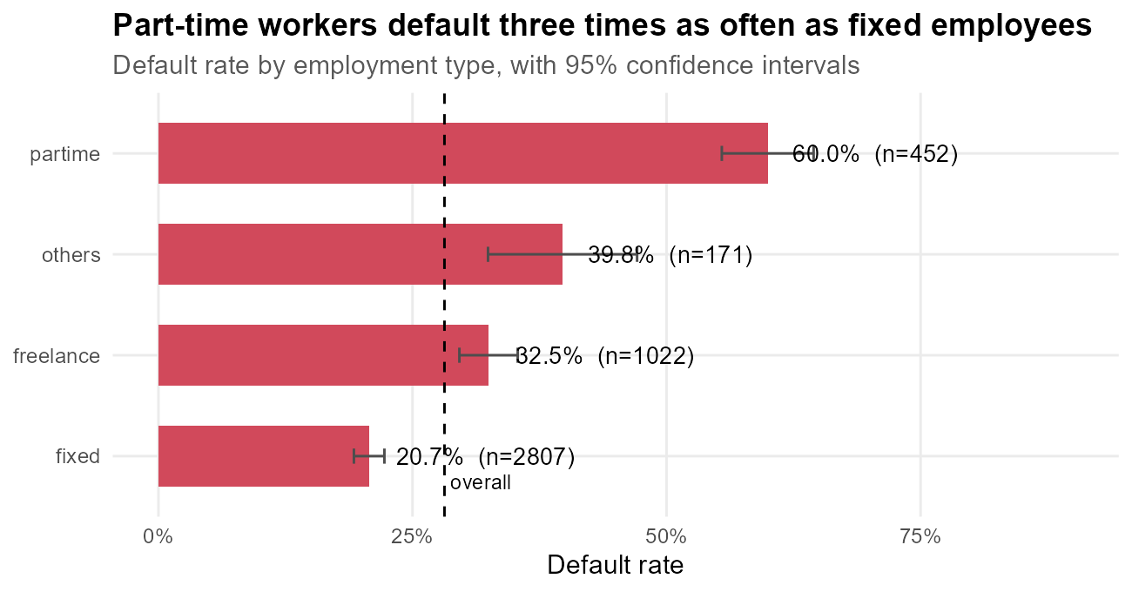
Figure 2: Default rate by employment type (from Week 2)
Part-time workers default at 60%, almost three times the 20.7% of fixed-contract employees; the confidence intervals do not overlap. Income volatility translates directly into repayment risk.

Experience and age
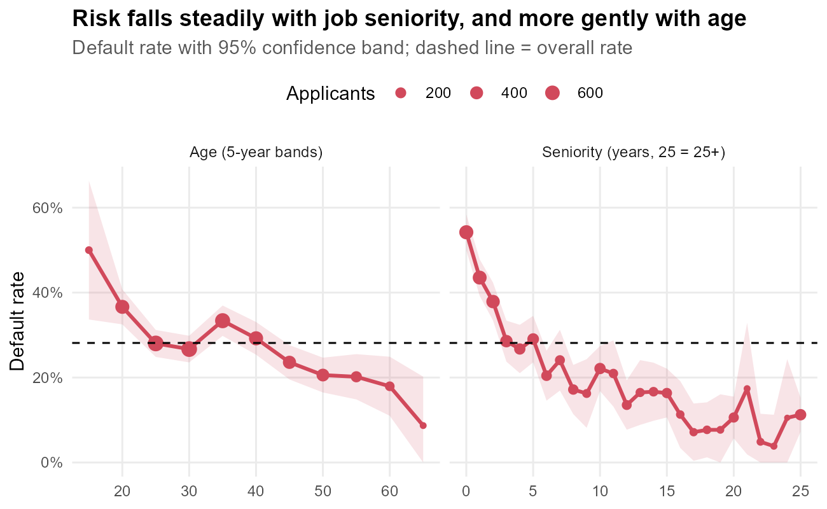
Figure 3: Default rate trends by age and job seniority (from Week 2)
Default risk falls sharply over the first five years with an employer and continues to decline after that. The age effect points the same way but is weaker and not strictly monotonic. In the multivariate model, once seniority is accounted for, age has only a small residual effect.

Combined risk factors
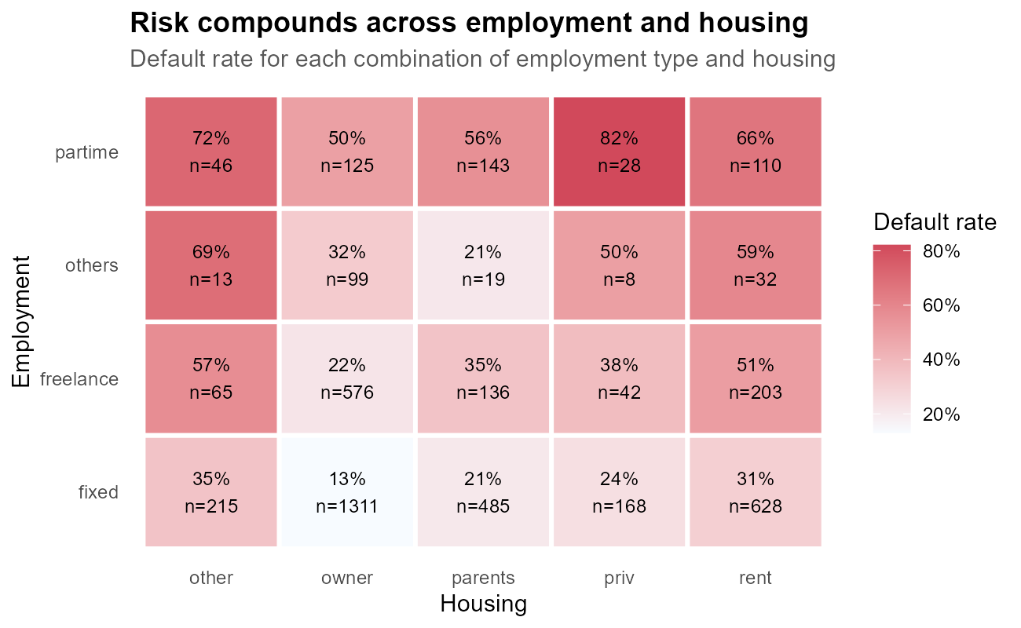
Figure 4: Default rate by employment type and housing (from Week 2)
Risk factors compound: part-time workers who rent default at 66.4% and those in 'other' housing at 71.7%, while fixed-contract home owners default at only 13%. This is why a multivariate model is needed rather than single-variable rules.

Overall ranking of risk drivers
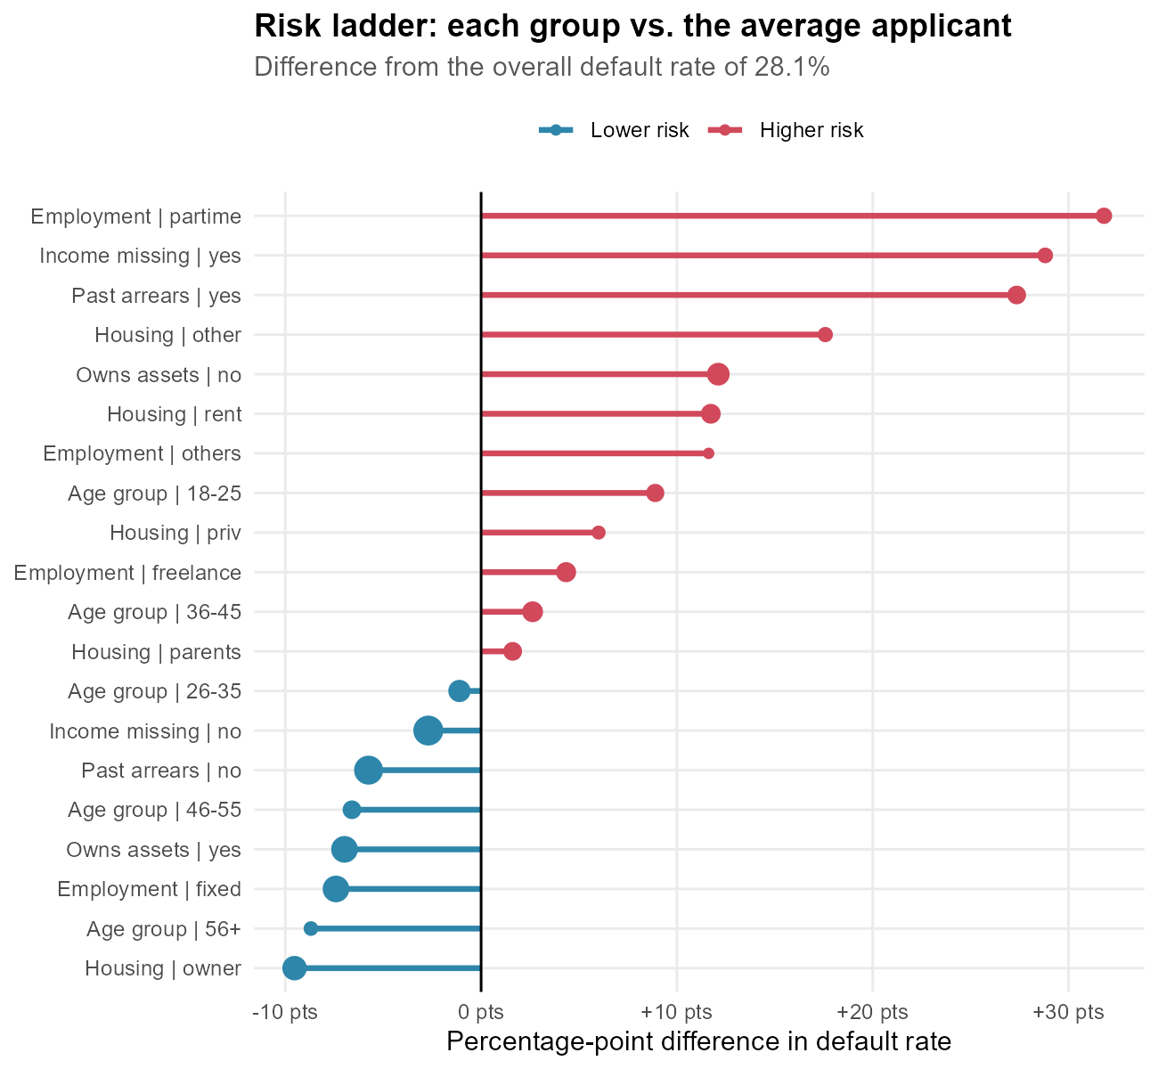
Figure 5: Risk ladder: segment default rates versus the portfolio average (from Week 2)
The risk ladder summarises the visual analysis: part-time employment, undeclared income and past arrears raise risk the most, while home ownership, fixed employment and older age groups lower it. These visual patterns were then tested formally.

Statistical Testing and Predictive Modeling

Hypothesis tests
Normality tests (Shapiro-Wilk, Q-Q plots) showed that the numeric variables are strongly skewed, so non-parametric Wilcoxon tests and Welch t-tests (which allow unequal variances) were used. Categorical associations were tested with chi-square tests, with effect sizes reported alongside.
Table 3: Summary of hypothesis tests (Week 3)
Hypothesis | Test | Statistic | p_value | Effect_size | Effect_measure | Decision
H1 Income | Wilcoxon | 1,555,518.50 | <1e-16 | 0.22 | rank-biserial r | Reject H0
H2 Seniority | Wilcoxon | 1,215,462.50 | <1e-16 | 0.39 | rank-biserial r | Reject H0
H3 LoanToPrice | Welch t | 16.38 | <1e-16 | 0.49 | Cohen's d | Reject H0
H4 Records | Chi-square | 344.44 | <1e-16 | 0.28 | Cramer's V | Reject H0
H5 Job | Chi-square | 323.34 | <1e-16 | 0.27 | Cramer's V | Reject H0
H6 Amount~Price | Pearson r | 0.73 | <1e-16 | 0.73 | Pearson r | Reject H0

All six null hypotheses were rejected. Statistical significance is expected with more than 4,000 observations, so the effect sizes are the more informative result: seniority and loan-to-price show medium-sized effects, arrears records and job type small-to-medium ones.

Model development
Before modelling, multicollinearity was checked with variance inflation factors. Price was dropped because it is almost fully explained by Amount and LoanToPrice (VIF > 14). The data was split 75/25 with stratification, and two models were trained with 10-fold cross-validation repeated 3 times, using ROC-AUC as the selection metric:
R code
# Model training (excerpt from R/week3_modeling.R)
train_idx <- createDataPartition(model_df$Status, p = 0.75, list = FALSE) # stratified split
ctrl <- trainControl(method = "repeatedcv", number = 10, repeats = 3, # 10-fold CV x 3
classProbs = TRUE, summaryFunction = twoClassSummary)
fit_glm <- train(Status ~ ., data = train, method = "glm", family = binomial,
preProcess = c("center", "scale"), metric = "ROC", trControl = ctrl)
fit_rf <- train(Status ~ ., data = train, method = "rf", metric = "ROC", trControl = ctrl)
# threshold chosen on out-of-fold predictions (Youden's J), never on the test set
thr <- coords(roc(fit_glm$pred$obs, fit_glm$pred$bad), "best", best.method = "youden")

Model performance
Table 4: Test-set performance (1,112 unseen applicants)
Model | Threshold | AUC | Accuracy | Sensitivity | Specificity | Precision | F1 | Kappa
Logistic (0.5 cut-off) | 0.500 | 0.833 | 0.811 | 0.521 | 0.925 | 0.731 | 0.608 | 0.488
Logistic (Youden cut-off) | 0.295 | 0.833 | 0.771 | 0.732 | 0.786 | 0.573 | 0.642 | 0.477
Random forest (Youden cut-off) | 0.302 | 0.830 | 0.775 | 0.751 | 0.785 | 0.577 | 0.653 | 0.491

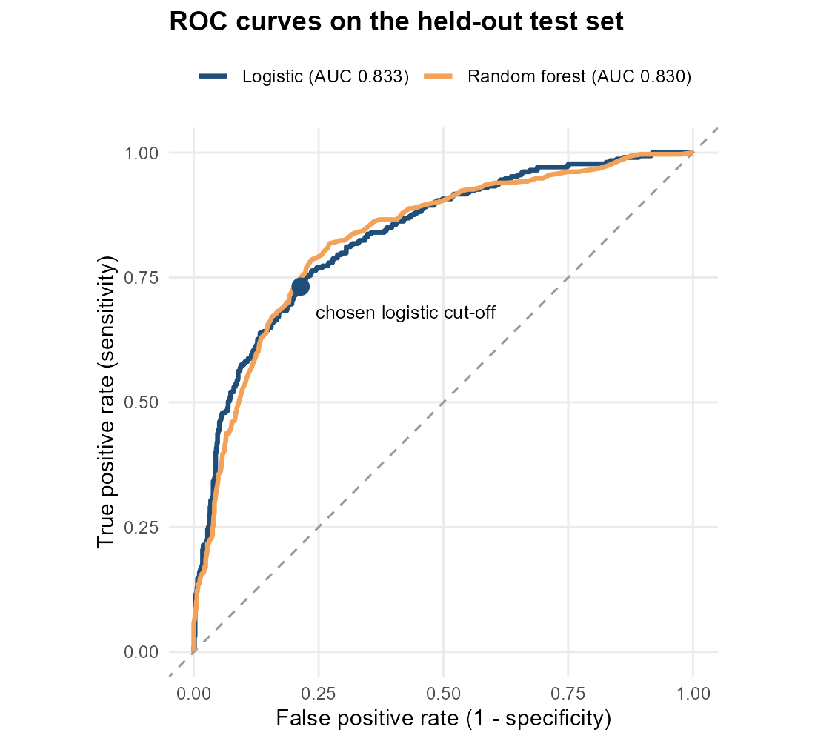
Figure 6: ROC curves on the test set (from Week 3)
The logistic regression reaches an AUC of 0.833 on unseen data, essentially identical to the random forest (0.830; DeLong test not significant). At the tuned threshold it identifies 73.2% of the defaults while approving 78.6% of the good applicants. The simpler model was selected because it is equally accurate, transparent, and easy to explain to applicants and regulators.

What the model says: drivers of default
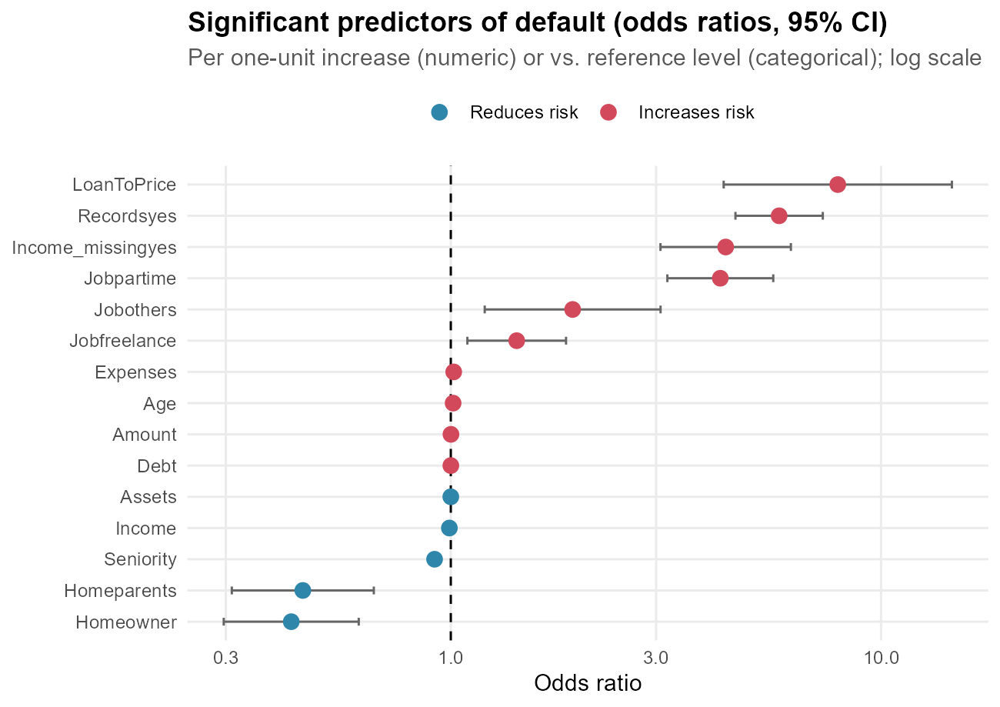
Figure 7: Odds ratios of significant predictors (from Week 3)
• Past arrears record: odds of default x5.8.
• Part-time employment: x4.2 versus a fixed contract; freelance: x1.4.
• Undeclared income: x4.4, even after imputing a typical income.
• Each extra year of job seniority: odds down by 8.3%.
• Home owner versus 'other' housing: odds x0.43 (less than half).
• Financing 10 percentage points more of the purchase: odds x1.23.

Diagnostics
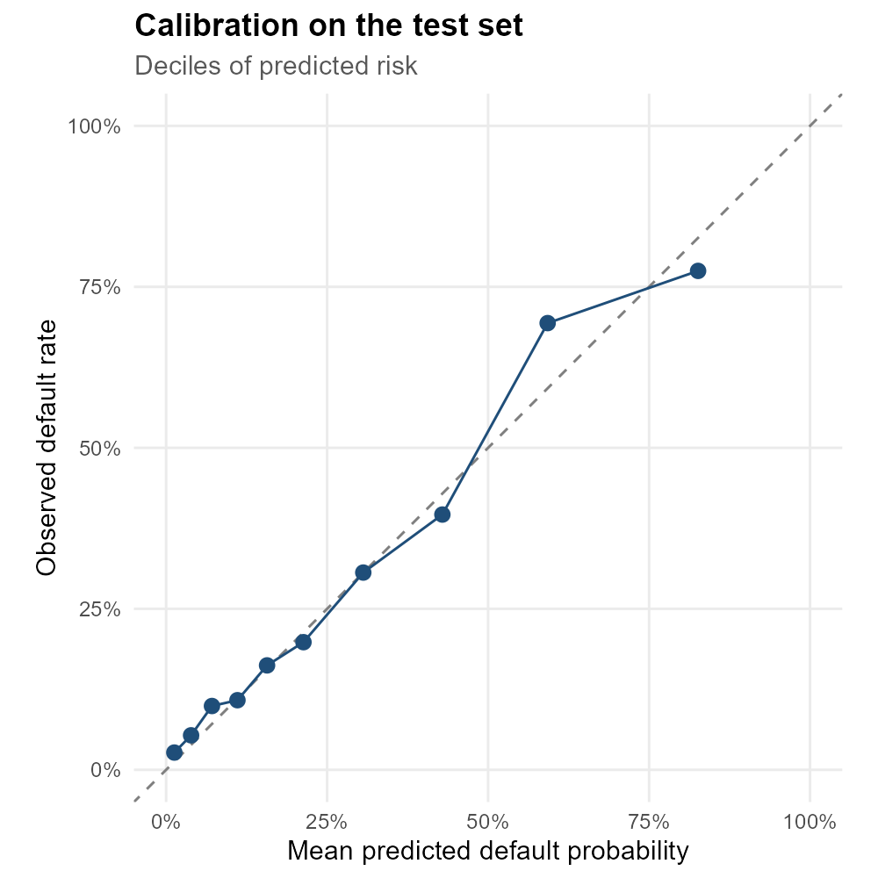
Figure 8: Calibration of predicted probabilities (from Week 3)
The model's probabilities are well calibrated (Hosmer-Lemeshow p = 0.21; points close to the diagonal), binned residuals show no systematic pattern, and no observation is unduly influential. McFadden's pseudo R-squared is 0.287, which is a good value for individual-level credit data.

Results: Business Impact of the Model
A statistical score only creates value when it is turned into a decision rule. This section translates the model into an approval policy and quantifies its effect.

Choosing the cut-off with business costs
Two errors are possible: approving a loan that defaults (false negative) and declining a good applicant (false positive). Their costs are not equal. Losing much of the principal on a default typically costs several times more than the margin lost on one rejected good loan. A cost ratio of 5:1 was assumed (a common rule-of-thumb; the sensitivity to this assumption is shown in 6.3). The cut-off that minimises total cost was chosen on the cross-validation predictions, and then evaluated once on the test set.
R code
COST_FN <- 5; COST_FP <- 1 # missed default costs 5x a wrongly declined good loan
cv <- w3$fit_glm$pred # out-of-fold CV predictions (training data only)
grid <- seq(0.05, 0.80, by = 0.005)
cost_curve <- data.frame(threshold = grid, cost = sapply(grid, function(t) {
COST_FN * sum(cv$bad < t & cv$obs == "bad") + COST_FP * sum(cv$bad >= t & cv$obs == "good")
}))
thr_cost <- cost_curve$threshold[which.min(cost_curve$cost)]
cat("Cost-optimal threshold (CV):", thr_cost,
"| theoretical optimum for a calibrated model = 1/(1+5) =", round(1 / 6, 3), "\n")
Console output
Cost-optimal threshold (CV): 0.175 | theoretical optimum for a calibrated model = 1/(1+5) = 0.167
R code
p_cost <- ggplot(cost_curve, aes(threshold, cost / max(cost))) +
geom_line(colour = "#1F4E79", linewidth = 1.1) +
geom_vline(xintercept = thr_cost, linetype = "dashed", colour = "#D1495B") +
geom_vline(xintercept = w3$thr_glm, linetype = "dotted", colour = "grey40") +
annotate("text", x = thr_cost + 0.01, y = 0.95, hjust = 0, size = 3.3, colour = "#D1495B",
label = paste("cost-optimal =", thr_cost)) +
annotate("text", x = w3$thr_glm + 0.01, y = 0.85, hjust = 0, size = 3.3, colour = "grey30",
label = paste("Youden =", round(w3$thr_glm, 3))) +
labs(title = "Total decision cost by probability cut-off (5:1 cost ratio)",
subtitle = "Cross-validation predictions; cost scaled to the maximum",
x = "Decline if predicted probability of default >= cut-off", y = "Relative total cost")
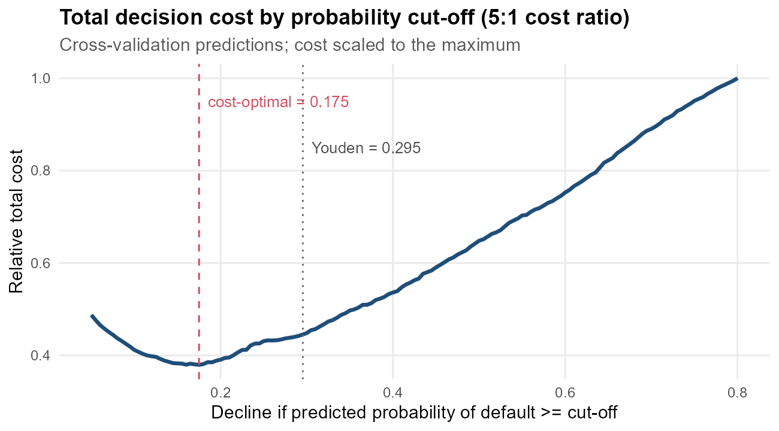
Figure 9: Relative total decision cost across probability cut-offs

Comparison of decision strategies
R code
strat_tbl |>
mutate(Threshold = ifelse(Threshold > 1, NA, round(Threshold, 3)),
across(c(Approval_rate, Bad_rate_approved, Defaults_caught, Good_rejected, Cost_saving),
~ paste0(round(100 * .x, 1), "%")))
Console output
Strategy Threshold Approval_rate Bad_rate_approved Defaults_caught
1 Approve everyone (no model) NA 100% 28.1% 0%
2 Model: 0.5 cut-off 0.500 79.9% 16.9% 52.1%
3 Model: Youden cut-off 0.295 64% 11.8% 73.2%
4 Model: cost-optimal cut-off 0.175 48.9% 9.2% 84%
Good_rejected Cost_units Cost_saving
1 0% 1565 0%
2 7.5% 810 48.2%
3 21.4% 591 62.2%
4 38.2% 555 64.5%
Without a model the lender approves everyone and 28.1% of approved loans go bad. With the cost-optimal cut-off the model catches 84.0% of the defaults. The price is declining or reviewing 38.2% of good applicants, and total decision cost falls by 65%. The 0.5 cut-off approves more applicants but lets many more defaults through, which is why it is the most expensive of the three model policies.
R code
tradeoff <- data.frame(t = seq(0.05, 0.95, by = 0.01)) |>
rowwise() |>
mutate(approval = mean(test$p_glm < t),
bad_rate = mean(test$Status[test$p_glm < t] == "bad")) |>
ungroup()
p_trade <- ggplot(tradeoff, aes(approval, bad_rate)) +
geom_line(colour = "#1F4E79", linewidth = 1.1) +
geom_hline(yintercept = mean(test$Status == "bad"), linetype = "dashed") +
annotate("point", x = strat_tbl$Approval_rate[4], y = strat_tbl$Bad_rate_approved[4],
colour = "#D1495B", size = 3.5) +
annotate("text", x = strat_tbl$Approval_rate[4], y = strat_tbl$Bad_rate_approved[4] + 0.02,
label = "cost-optimal policy", colour = "#D1495B", size = 3.3, hjust = 1) +
annotate("text", x = 0.35, y = mean(test$Status == "bad") + 0.012, size = 3.2,
label = "default rate if everyone is approved") +
scale_x_continuous(labels = percent) + scale_y_continuous(labels = percent) +
labs(title = "Strategy curve: approval rate vs. default rate of the approved book",
subtitle = "Test set; moving right approves more applicants",
x = "Share of applicants approved", y = "Default rate among approved loans")
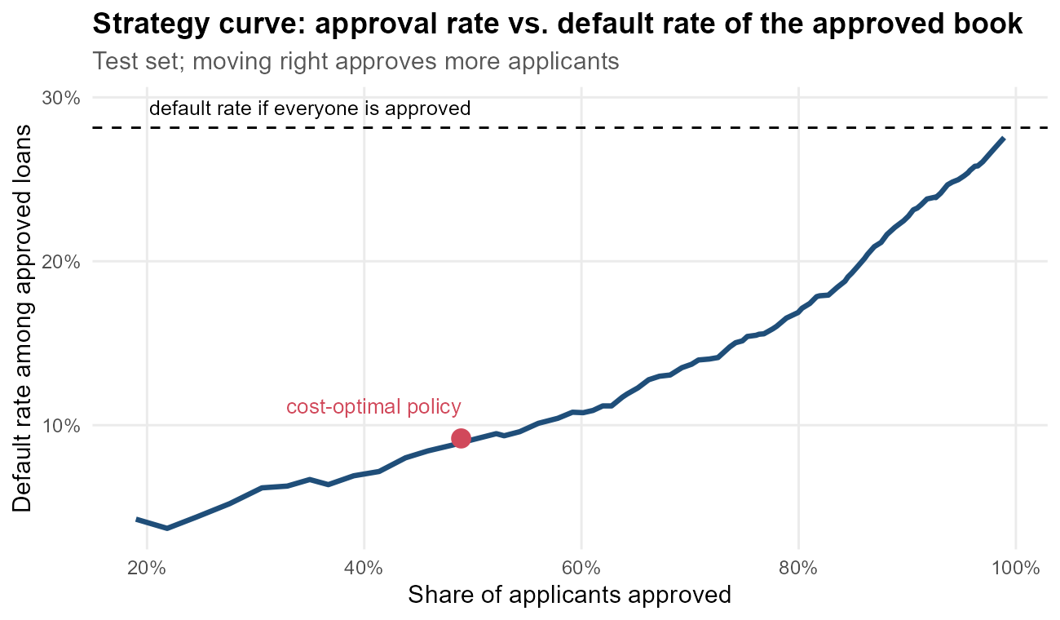
Figure 10: Trade-off between approval rate and portfolio quality
The strategy curve gives management a simple menu: each point is an achievable combination of growth (approval rate) and risk (default rate of the approved portfolio). The business can choose a point according to its risk appetite instead of relying on a single technical cut-off.

Sensitivity to the cost assumption
R code
sens <- do.call(rbind, lapply(c(2, 3, 5, 8, 10), function(r) {
cc <- sapply(grid, function(t) r * sum(cv$bad < t & cv$obs == "bad") +
sum(cv$bad >= t & cv$obs == "good"))
t <- grid[which.min(cc)]
data.frame(Cost_ratio = paste0(r, ":1"), Threshold = t,
Approval_rate = round(100 * mean(test$p_glm < t), 1),
Bad_rate_approved = round(100 * mean(test$Status[test$p_glm < t] == "bad"), 1))
}))
sens
Console output
Cost_ratio Threshold Approval_rate Bad_rate_approved
1 2:1 0.300 64.2 11.9
2 3:1 0.210 54.3 9.6
3 5:1 0.175 48.9 9.2
4 8:1 0.115 35.7 6.5
5 10:1 0.110 35.0 6.7
As a missed default becomes more expensive, the optimal cut-off falls and the lender approves fewer applicants with a cleaner portfolio. The model supports any of these policies; the choice is a business decision about risk appetite, which should be agreed with the credit-risk and finance teams.

Risk grades for operational use
R code
grades <- test |>
mutate(Grade = cut(p_glm, breaks = c(0, 0.10, 0.20, 0.35, 0.50, 1),
labels = c("A", "B", "C", "D", "E"), include.lowest = TRUE)) |>
group_by(Grade) |>
summarise(Applicants = n(), Share = round(100 * n() / nrow(test), 1),
Predicted_PD = round(100 * mean(p_glm), 1),
Observed_default = round(100 * mean(Status == "bad"), 1)) |>
mutate(Action = c("Auto-approve", "Approve", "Manual review", "Review + collateral / smaller loan",
"Decline")[as.integer(Grade)])
as.data.frame(grades)
Console output
Grade Applicants Share Predicted_PD Observed_default Action
1 A 366 32.9 4.5 6.3 Auto-approve
2 B 222 20.0 14.7 14.4 Approve
3 C 182 16.4 26.7 26.9 Manual review
4 D 119 10.7 42.3 38.7 Review + collateral / smaller loan
5 E 223 20.1 70.8 73.1 Decline
Table 5: Risk grades on the test set with suggested actions
Grade | Applicants | Share | Predicted_PD | Observed_default | Action
A | 366 | 32.9 | 4.5 | 6.3 | Auto-approve
B | 222 | 20.0 | 14.7 | 14.4 | Approve
C | 182 | 16.4 | 26.7 | 26.9 | Manual review
D | 119 | 10.7 | 42.3 | 38.7 | Review + collateral / smaller loan
E | 223 | 20.1 | 70.8 | 73.1 | Decline

The grades separate risk clearly: grade A applicants (32.9% of applicants) default only 6.3% of the time, while grade E applicants (20.1%) default 73.1% of the time. Predicted and observed default rates are close in every grade, which confirms the calibration. Grades A-B can be processed automatically, which saves underwriting time; analysts can then concentrate on grades C-D.

Discussion

Interpretation of results
The three analytical stages point to the same conclusions. Descriptive analysis (Week 1), visualization (Week 2), hypothesis testing and two different models (Week 3) all identify the same drivers: credit history, employment stability, housing stability and affordability. When a linear model and a non-linear random forest agree, and the formal tests confirm the visual patterns, we can be confident the findings reflect real behaviour and not artefacts of one method.

Statistical versus practical significance
With thousands of observations almost every difference becomes 'statistically significant'. This report therefore always pairs p-values with effect sizes and business metrics. For example, age is statistically significant in the model but its effect per year is small, whereas arrears records and part-time employment multiply the odds of default several times over. Those are the variables that should drive policy.

Business implications
• Underwriting policy: use the score to route applications into grades, automating the clear cases and focusing expert attention on the grey zone.
• Data capture: make arrears history, employment type and seniority mandatory, verified fields. Undeclared income should trigger a documentation request, because it is a strong risk signal in its own right.
• Product design: long-term, high loan-to-price loans carry more risk, so a minimum down-payment or risk-based pricing could be introduced for them.
• Customer fairness and transparency: the logistic model's odds ratios make each decision explainable. Variables such as marital status and age should be reviewed for fairness and regulatory compliance before deployment; marital status was not significant in the model and could be removed.

Limitations
• The data is historical and from one source; relationships may shift with the economy or the lender's customer mix.
• Only accepted applicants have observed outcomes (reject-inference bias), which is common to all credit-scoring data.
• The cost ratio is an assumption; real loss-given-default and margin figures should replace it.
• An AUC of 0.83 is good but leaves room for improvement; richer data (bureau scores, transactions) would help most.

Conclusion: Lessons Learned, Challenges and Future Directions

Summary: the value of a data-driven approach
Starting from a raw public dataset with missing values, duplicates and extreme outliers, this project produced a clean analytical dataset, a visual explanation of credit risk, statistically verified risk drivers, and a calibrated, interpretable credit score with a test-set AUC of 0.833. Turned into a cost-aware policy, the score reduces expected decision cost by about 65% versus approving everyone. A data-driven approach replaces intuition with consistent, measurable and explainable decisions, and it makes the trade-off between growth and risk explicit, so it can be managed.

Lessons learned
• Data cleaning is analysis: the decision to keep a missing-income flag, made during cleaning, produced one of the strongest predictors.
• Missing data should be investigated, not just filled; testing whether missingness relates to the outcome changed the strategy.
• Accuracy is misleading for imbalanced problems; ROC-AUC, sensitivity/specificity and business cost are far more informative.
• Thresholds are business decisions; the same model can support very different policies.
• Simple, interpretable models are often as good as complex ones on tabular data, and they are easier to trust and deploy.
• Generating reports from code (officer) guarantees that the numbers in the document match the analysis.

Challenges overcome
Table 6: Challenges encountered and how they were solved
Challenge | Solution
Missing income for 8.6% of applicants | Group-median imputation + missing-indicator flag
Heavy right-skew and extreme outliers | Winsorization at 1st/99th percentile; ratio features
Non-normal data | Non-parametric tests and Welch t-test
Multicollinearity (Amount, Price, LoanToPrice) | VIF analysis; Price removed from model
Class imbalance (28% bad) | ROC-based tuning, Youden and cost-based thresholds
Sparse categories (e.g. 'ignore', 'divorced') | Merged invalid level; kept small but valid levels
Communicating to non-technical readers | Question-led chart titles, risk ladder, risk grades

Recommendations for further analysis
• Test gradient boosting (xgboost) and penalised regression (glmnet) within the same cross-validation framework.
• Add spline terms for age and seniority and interaction terms such as Job x Home.
• Replace the assumed cost ratio with actual loss-given-default and profit-margin data, and optimise expected profit directly.
• Carry out a fairness audit across age and marital-status groups before any production use.
• Validate the model out-of-time on newer applications and set up monitoring for population drift (e.g. Population Stability Index).
• Deploy the score as an R Shiny app or a plumber API for loan officers.

Appendix A: Project Structure and Reproducibility
R code
data_analysis_R/
|-- run_all.R # runs weeks 1-4 in order
|-- R/
| |-- 00_helpers.R # settings, plotting theme, Word helpers
| |-- week1_data_cleaning.R # cleaning + preliminary analysis
| |-- week2_visualization.R # 13 visualizations
| |-- week3_modeling.R # hypothesis tests + models
| `-- week4_final_report.R # this report
|-- data/raw/credit_data_raw.csv # untouched source data
|-- data/processed/ # cleaned + model-ready data
|-- outputs/figures/week1..week4/ # all charts (PNG, 200 dpi)
|-- outputs/models/ # saved results used across weeks
`-- reports/ # the four Word reports
To reproduce everything: open the project in RStudio and run source('run_all.R'). Code repository: https://github.com/paulmark-05/data_analysis_R
R code
cat(R.version.string, "\n")
pk <- c("dplyr", "tidyr", "ggplot2", "lattice", "caret", "randomForest", "pROC",
"officer", "flextable", "modeldata")
data.frame(Package = pk, Version = sapply(pk, function(p) as.character(packageVersion(p))),
row.names = NULL)
Console output
R version 4.6.1 (2026-06-24 ucrt)
Package Version
1 dplyr 1.2.1
2 tidyr 1.3.2
3 ggplot2 4.0.3
4 lattice 0.22.9
5 caret 7.0.1
6 randomForest 4.7.1.2
7 pROC 1.19.1
8 officer 0.7.6
9 flextable 0.10.1
10 modeldata 1.6.0

Appendix B: Annotated Key R Code
Selected functions that are reused across the project:
R code
# Default rate with a 95% confidence interval for any grouping (Week 2)
rate_by <- function(data, ...) {
data |> group_by(...) |>
summarise(n = n(), bad_rate = mean(Default)) |>
mutate(se = sqrt(bad_rate * (1 - bad_rate) / n), # binomial standard error
lo = pmax(0, bad_rate - 1.96 * se), # lower 95% bound
hi = pmin(1, bad_rate + 1.96 * se)) |> ungroup() # upper 95% bound
}
# Cap extreme values at chosen percentiles instead of deleting rows (Week 1)
winsorize <- function(x, probs = c(0.01, 0.99)) {
q <- quantile(x, probs, na.rm = TRUE)
pmin(pmax(x, q[1]), q[2])
}
# Variance inflation factor without extra packages (Week 3)
vif_manual <- function(df) sapply(names(df), function(v) {
r2 <- summary(lm(reformulate(setdiff(names(df), v), v), data = df))$r.squared
1 / (1 - r2) # VIF = 1 / (1 - R^2)
})
# Cramer's V effect size for a chi-square test (Week 3)
cramers_v <- function(tab) {
chi <- suppressWarnings(chisq.test(tab, correct = FALSE))$statistic
sqrt(chi / (sum(tab) * (min(dim(tab)) - 1)))
}

