Contents

Introduction 1

Task 1: Understanding Excel functions 1

VLOOKUP Function - Primary Industry Sector for Customer with Loyalty ID OMA000261 1

FILTER Function - Employment Status for Customers in KSA with Doctorate Degree 1

PivotTable - Breakdown of Customers' Citizenship Across GCC States 2

Task 2: Data Visualisation for Decision-Making 3

Annual Purchase Revenues, Costs, and Profits for 2022 and 2023 3

Total Revenue in 2023 by Industry Sector 3

Total Monthly Revenue for 2022 and 2023 4

Task 3: Customer Demographics 5

Top 5 Purchases by Total Profits in 2023 5

Education Levels by GCC State 5

Revenue Breakdown by Customer Demographics 6

Total Revenue by Marital Status in 2023 6

Total Revenue by GCC State in 2023 7

Task 4: Descriptive Data Analytics 8

Descriptive Statistics for Total Profits in 2022 and 2023 8

Pareto Chart and Frequency Distribution of Monthly Purchase Revenues for 2022 and 2023 9

For 2022 9

For 2023 9

Task 5: Predictive Analytics 10

Regression Analysis of Perceived Customer Quality vs. GZ’s Profits for 2022 and 2023 10

Forecasting Monthly Purchase Revenues for the First Six Months of 2024 10

Creating an Investment Portfolio Using Excel Solver 11

*Figure i VLOOKUP Function* 2

*Figure ii FILTER Function* 3

*Figure iii PivotTable* 4

*Figure iv Annual Purchase Revenues* 5

*Figure v Total Revenue in 2023 by Industry Sector* 5

*Figure vi Monthly Revenue for 2022 and 2023* 6

*Figure vii Top 5 Purchases in 2023* 7

*Figure viii Education Levels* 8

*Figure ix* *Total Revenue by Marital Status in 2023* 9

*Figure x Total Revenue by GCC State in 2023* 10

*Figure xi Pareto chart for the year 2022* 12

*Figure xii Pareto chart of the year 2023* 13

*Figure xiii Monthly Purchase Revenues* 14

*Table 1 Total Revenue by Marital Status in 2023* 8

*Table 2 Total Revenue by GCC State in 2023* 9

*Table 3 Descriptive Statistics* 11

*Table 4 Forecasting Monthly Purchase* 14

*Table 5 Investment Portfolio* 15

**Business Analytics Report for Retirement Savings Plans in the GCC Region**

# Introduction

This paper seeks to utilize customer information related to Gulf Zone Hypermarket to inform the retirement savings trends in the GCC. The core elements include customer characteristics, behavior and trends, and profitability investigation. Some of the analyses involved using more complex Excel tools like VLOOKUP, PivotTables and Charts, regression analysis, data visualization, and Solver techniques for optimization for strategic management. The results will help GZ’s Pensions and Lifetime Savings Advisory Team develop new Self-Invested Pension Plan (SIPP) products.

# Task 1: Understanding Excel functions

## VLOOKUP Function - Primary Industry Sector for Customer with Loyalty ID OMA000261

The following VLOOKUP formula was used during Excel analysis to determine the primary industry sector of the customer with Loyalty ID "OMA000261":=VLOOKUP("OMA000261", Sheet1!A1:AQ2000,10, FALSE)



*Figure i VLOOKUP Function*

This formula will input the loyalty card number in sheet 1, to be precise, in the first column A and extract from the tenth column of data, which is the industry sector.

The primary industry sector for the customer was identified as Professional and business services.

## FILTER Function - Employment Status for Customers in KSA with Doctorate Degree

Employment Status for customers who lived in KSA state and have a Doctorate were sorted out by applying the Excel's FILTER function:

=FILTER(Sheet1!I:I, (Sheet1!C:C="KSA") *(Sheet1!G:G="Doctorate degree"))

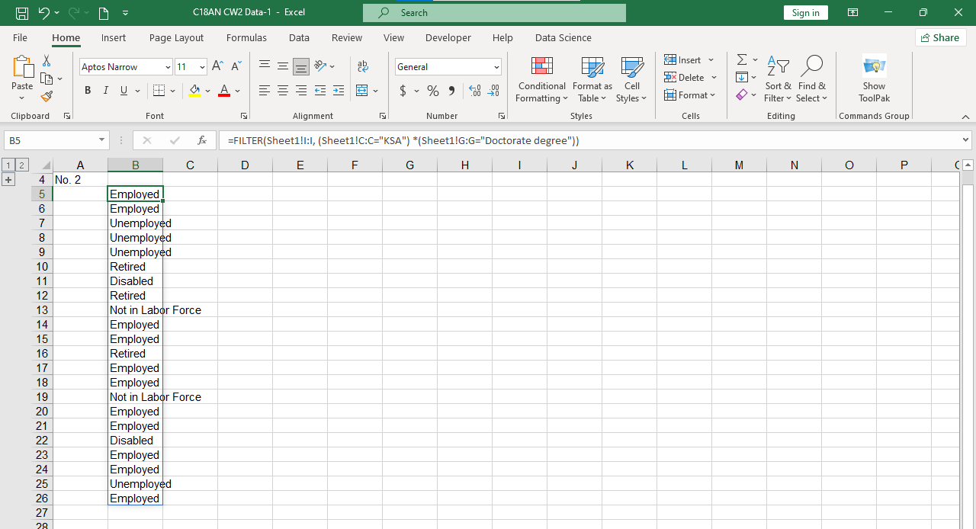

*Figure ii FILTER Function*

## PivotTable - Breakdown of Customers' Citizenship Across GCC States

A Pivot Table was created to analyze the breakdown of customers' citizenship by GCC state.

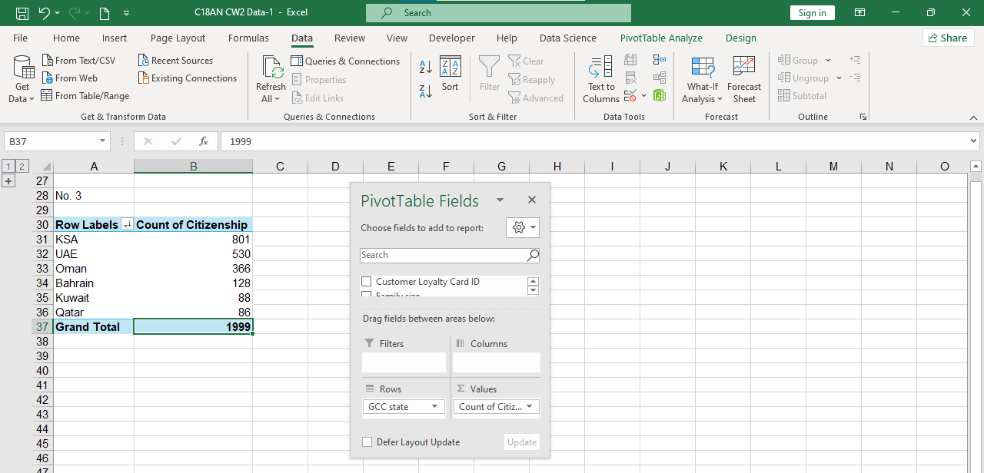

*Figure iii PivotTable*

The PivotTable analysis revealed that the citizenship of the customers is spread across the six GCC states randomly. The state that had the most number of customers was KSA, which had 801 customers and a good local market base. On the other hand, Qatar was the worst performer, with the least of 86 customers tested.

# Task 2: Data Visualisation for Decision-Making

## Annual Purchase Revenues, Costs, and Profits for 2022 and 2023

A clustered column chart was applied since it is appropriate for performing comparisons of different categories: revenues, costs, and profits for two distinct years: 2022 and 2023. This means that the relationship between the two years in each category can be easily made.

*Figure iv Annual Purchase Revenues*

The chart highlights the revenues, costs, and profits of the product for 2022 and 2023. There is evidence of an increment in revenues from 2022 to 2023, with the same trends occurring for the cost line. However, looking at profits, they have an upward trend of 2023 as compared to 2022.

## Total Revenue in 2023 by Industry Sector

A pie chart is appropriate when depicting the proportion of total revenue generated by various industries in 2023. It visually underlines the share of each sector in the total revenue.

*Figure v Total Revenue in 2023 by Industry Sector*

According to the pie chart, the revenues recorded in 2023 were dominated by the "Manufacturing" sector, while the "Commercial and Trading" sector was the second largest. The " Professional Business Services" sector offered the least; hence, it may require focusing on development.

## Total Monthly Revenue for 2022 and 2023

A line chart was used to present the revenue over time (monthly revenues for the years 2022 and 2023). It assists in displaying the trend and comparing the two years at the monthly level.

*Figure vi Monthly Revenue for 2022 and 2023*

The simple line graph highlights that the monthly revenues were generally higher in 2023 than the preceding year, with the upward surges at specific months of the year suggesting cyclic revenue generation.

# Task 3: Customer Demographics

## Top 5 Purchases by Total Profits in 2023

The following table contains the details of the five customers who contributed the most to the profits in the year 2023 in terms of demographic characteristics.

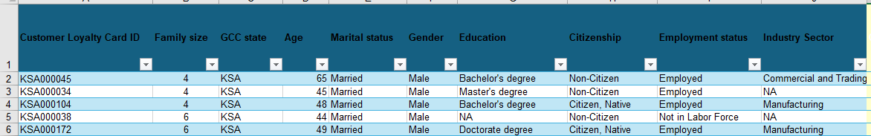

*Figure vii Top 5 Purchases in 2023*

The top 5 profitable customers in 2023 are married males from KSA, more are employed, and they have a family size of 4 or more. Their education levels range from having a Bachelor's degree, Master's degree, up to a Doctorate level, while one of them has no recorded education level. Interestingly, the customers of high profitability can be both citizens and non-citizens. The industries classified include Commercial and Trading as well as Manufacturing; this means that these two sectors may be home to persons with considerable amounts of disposable income. Such trends imply that high-profit customers could be identified from the married, employed male population in KSA, who are involved in the Commercial, Trading, or Manufacturing business.

## Education Levels by GCC State

A stacked column chart was used. It does this correctly by displaying education levels with each GCC state so comparisons within and between states can be made.

*Figure viii Education Levels*

KSA has the largest number of educated customers, especially those with a Bachelor's degree, which shows that KSA has a high educated penetration. Oman also has a large number of people with Bachelor's degrees. This distribution is quite broad in the UAE, though it has more distribution in high school and Master's level. Bahrain, though, has fewer customers in the total population, but it has a good number of Bachelor's degree holders, unlike Qatar, which has a large spread of high school graduates. Overall, these findings imply that it is possible to target certain segments within KSA and Oman as educated while targeting Qatar may be appealing to high school-level consumers.

## Revenue Breakdown by Customer Demographics

### Total Revenue by Marital Status in 2023

*Table 1 Total Revenue by Marital Status in 2023*

|  |  |
| --- | --- |
| **Marital Status** | **Total Revenue ($)** |
| Married | 4836349.16 |
| Never Married | 1544134.20 |
| Divorced | 771102.60 |
| Widowed | 414037.76 |
| Separated | 199432.40 |
| NA | 33585.40 |

*Figure ix Total Revenue by Marital Status in 2023*

Married customers provided the largest overall revenue in the year 2023, reaching $ 4,836,349.16, which is comparatively the highest in the whole series. This suggests that the marital population is one of the important target markets of GZ's pension and savings plan. Specific information emphasizing family-oriented saving advantages may increase the appeal of this group. On the other hand, the amount that was earned from separated and widowed customers was comparatively small, and this means that there was a need to target these groups in order to promote participation.

### Total Revenue by GCC State in 2023

*Table 2 Total Revenue by GCC State in 2023*

|  |  |
| --- | --- |
| **GCC State** | **Total Revenue ($)** |
| KSA | 3790131.12 |
| UAE | 1609104.40 |
| Oman | 1225676.00 |
| Bahrain | 455445.00 |
| Qatar | 416584.00 |
| Kuwait | 301701.00 |

*Figure x Total Revenue by GCC State in 2023*

The biggest revenue was generated by the Kingdom of Saudi Arabia (KSA), $3,790,131.12; the next one was the UAE, $1,609,104.40. This indicates that KSA could be a suitable market for GZ's pension campaign, which could bring significant outcomes. Less revenue from Kuwait and Qatar suggests that such regions may require additional and more specific measures to increase their activity. The "NA" category has very little revenue, which suggests purchases made by non-resident or unidentified customers; a significant impact is not observed in the general strategy.

# Task 4: Descriptive Data Analytics

## Descriptive Statistics for Total Profits in 2022 and 2023

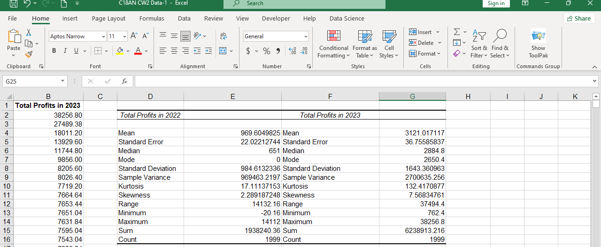

*Table 3 Descriptive Statistics*

|  |  |  |
| --- | --- | --- |
|  | **Total Profits in 2022 ($)** | **Total Profits in 2023** |
| Mean | 969.60 | 3121.02 |
| Standard Deviation | 984.61 | 1643.36 |
| Kurtosis | 17.11 | 132.42 |
| Skewness | 2.29 | 7.57 |
| Range | 14132.16 | 37494.40 |

Comparing the average profit shown in this table, it is clear that the value in 2023 is higher ($3,121.02) than in 2022 ($969.60), demonstrating an increase in profitability. Large standard deviations, particularly in 2023 ($1,643.36), indicate that the majority of the customers' profits significantly differ from the mean. The values of skewness and kurtosis show that both years are positively skewed and have extreme values, especially in 2023. The range for 2023 is significantly higher than for 2022, as it encompasses a profit gap. The overall increase in profits from 2022 to 2023 underscores successful growth, although profit consistency may require attention.

## Pareto Chart and Frequency Distribution of Monthly Purchase Revenues for 2022 and 2023

### For 2022

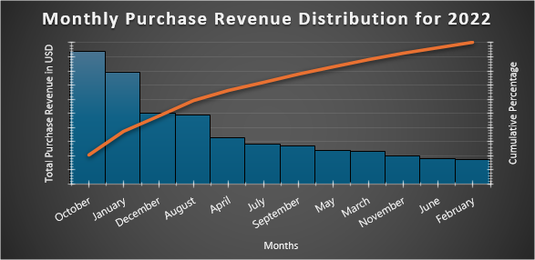

*Figure xi Pareto chart for the year 2022*

The Pareto chart for the year 2022 depicts October as the month that generated the highest revenues, followed by December and January. The cumulative line underscores that, as expected, which complies with the 80/20 Pareto rule, the total revenue is boosted by a few months, including October, December, and January. This suggests seasonality and could be useful for planning campaigns occurring during high sales months.

### For 2023

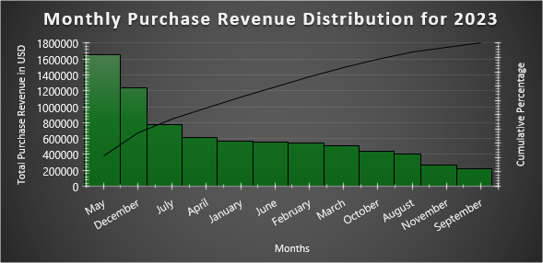

*Figure xii Pareto chart of the year 2023*

According to the Pareto chart of the year 2023, the month of May marks the highest value of revenue, along with December and July. It can be observed that the cumulative percentage line for revenue is steeper; this infers that revenue is more concentrated in fewer months than in the year 2022. This pattern implies that the customers purchase large scales during mid-year and towards the end of the year. Directing promotional strategies during such months could improve overall profit.

# Task 5: Predictive Analytics

## Regression Analysis of Perceived Customer Quality vs. GZ’s Profits for 2022 and 2023

In 2022, the regression analysis reveals that the perceived service quality has a high predictive ability concerning GZ's profits in the sense that the R² value = 0.738. The "Quality of Services" coefficient is equal to 271.35, implying that an increase in the perceived service quality by one unit will lead to a corresponding increase in profits. The p-value is equal to 0, indicating a statistically significant relationship. An R² value of 0.438 is estimated when the model is fitted to 2023 data, slightly lower the R² value when compared with 2022 while still being statistically significant. The coefficient of 461.63 further suggests that service quality has a larger effect on the profit equation for the year 2023.

## Forecasting Monthly Purchase Revenues for the First Six Months of 2024

*Figure xiii Monthly Purchase Revenues*

With this trendline equation y = 28820x + 61397, the forecasted revenue from January to June 2024 is gradually soaring high. The values flow from $781897 in January to $925997 in June, which shows a positive trend. This upward trend implies a level of customer satisfaction and future revenue expectations and hence is useful in future planning for the year

*Table 4 Forecasting Monthly Purchase*

|  |  |  |
| --- | --- | --- |
| **Month** | **Index** | **Forecasted Revenue ($)** |
| Jan-24 | 25 | $781,897.00 |
| Feb-24 | 26 | $810,717.00 |
| Mar-24 | 27 | $839,537.00 |
| Apr-24 | 28 | $868,357.00 |
| May-24 | 29 | $897,177.00 |
| Jun-24 | 30 | $925,997.00 |

## Creating an Investment Portfolio Using Excel Solver

*Table 5 Investment Portfolio*

|  |  |  |  |  |
| --- | --- | --- | --- | --- |
|  | **Stocks** | **Bonds** | **Mutual Funds** | **Totals** |
| Expected Return | 8% | 5% | 7% |  |
| Risk Level | 6% | 2% | 4% |  |
| Investment Allocation | 0.199998 | 0.2 | 0.600003 | 1.000001 |
| Return Contribution | 0.016 | 0.01 | 0.04200021 | 0.068 |
| Risk Contribution | 0.012 | 0.004 | 0.02400012 | 0.04 |

Solver's optimal solution splits the investments into 20% Stocks, 20% Bonds, and 60% Mutual Funds, and in doing that, maximum return is ensured with minimum risk possible. The return contribution adds up to 6.8%; the risk contribution is constrained to 4%. This allocation reduces such risks to an acceptable level but at the same time gives as much expected returns as could be wished by the client for their investments.