(1) Binary, Octal and Hexadecimal numbering systems.

The decimal numbering system.
Imagine a mile travelled indicator on a car. You reset it and it reads
0000
After you have travelled one mile it reads
0001
Continuing your travel you will see it read 0002, 0003 up to 0009.
After you get to this point the tens wheel advances to 1 and the units wheel is reset.
This results in the mile indicator reading 0010.

Effectively the units wheel has reset to 0 and sent a carry to the tens wheel.

There is also a reset and carry when you reach 0999.
The units wheel resets and sends a carry to the tens.
The tens reset and sends a carry to the hundreds.
The hundreds reset and carry to the thousands.
This results in the number 1000 on the miles travelled indicator.

The decimal numbering system uses ten different characters (Digits).0,1,2,3,4,5,6,7,8,9.

The binary numbering system
Binary means two. In this numbering system only two digits are allowed, 0 and 1.
Digits 2 to 9 are not allowed.

Imagine a miles travelled indicator with only two digits (0 and 1) on each wheel.
If you reset the indicator it would read
0000
After 1 mile it would read
0001
The next mile forces the units wheel to reset and carry
so the number on the indicator would read 0010

After the third mile the indicator would read 0011
Coming up to the fourth mile, the units wheel would reset and carry to the second wheel. The second wheel would reset and carry to the third wheel.
So after the fourth mile the indicator would read 0100.

We should now be able to count in binary.
Have a go
Miles Indicator Miles Indicator
0 000000 11 001011
1 000001 12 001100
2 000010 13 001101
3 000011 14 001110
4 000100 15 001111
5 000101 16 010000
6 000110 17 010001
7 000111 18 010010
8 001000 19 010011
9 001001 20 010100
10 001010 21 010101
etc. (when will the indicator reset?)

Bits, LSB and MSB
Each digit in a binary number is called a bit.
For example; the number 100101 is 6 bits long.
The most left digit is called the most significant bit (MSB).
The most right digit is called the least significant bit (LSB).

The octal numbering system
Octal means 8.. In this numbering system only 8 digits are allowed, 0,1,2,3,4,5,6,7..
Digits 8 and 9 are not allowed.

Imagine a miles travelled indicator with only 8 digits (0 to 7) on each wheel.
If you reset the indicator it would read
0000
After 1 mile it would read
0001
After 7 miles it would read
0007
The next mile (eight mile) forces the units wheel to reset and carry
so the number on the indicator would read
0010
After the ninth mile is would result in
0011
After the tenth mile it would read
0012
After sixty third miles it would read
0077
the next mile would cause the units wheel to reset and carry to the second wheel
The second wheel would reset and carry to the third wheel.
So after the sixty fourth mile the indicator would read 0100.

We should now be able to count in octal.
Have a go
Miles Indicator Miles Indicator
0 000000 11 000013
1 000001 12 000014
2 000002 13 000015
3 000003 14 000016
4 000004 15 000017
5 000005 16 000020
6 000006 17 000021
7 000007 18 000022
8 000010 19 000023
9 000011 20 000024
10 000012 21 000025

etc. (when will the indicator reset?)

The hexadecimal numbering system
Hexadecimal means 16. In this numbering system 16 digits are allowed, we use all the ten digits of the decimal system plus A,B,C,D,E,F.
The sixteen digits in this system are 0,1,2,3,4,5,6,7,8,9,,A,B,C,D,E,F. (Count them)

Imagine a miles travelled indicator with 16 digits (0 to F) on each wheel.
If you reset the indicator it would read
0000
After 1 mile it would read
0001
After 9 miles it would read
0009
After the next mile it would read
000A,
After the fifteenth mile it would read
000F
The next mile (sixteenth mile) forces the units wheel to reset and carry
so the number on the indicator would read
0010
After the seventeenth mile the indicator would show
0011
After the thirty first mile it would read
001F
The next mile (thirty second mile) forces the units wheel to reset and carry
so the number on the indicator would read
0020
And so on.

We should now be able to count in hexadecimal.
Have a go
Miles Indicator Miles Indicator
0 000000 11 0000B
1 000001 12 0000C
2 000002 13 0000D
3 000003 14 0000E
4 000004 15 0000F
5 000005 16 00010
6 00006 17 000011
7 00007 18 000012
8 00008 19 000013
9 00009 20 000014
10 0000A 21 000015
etc. (when will the indicator reset?)

Determining which numbering system you are in
The words “base” or “radix” are used to indicate which numbering system you are working with. The base of the decimal system is 10, octal is 8 etc. If confusion can arise it is common practice to put the base in subscript after the number in question, .

For example:
In the decimal numbering system the number 101 may be written as 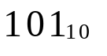
In the binary numbering system the number 101 may be written as 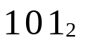
In the octal numbering system the number 101 may be written as 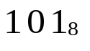
In the hexadecimal numbering system the number 101 may be written as 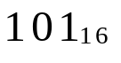

Converting from one number system to another.

Converting from binary to decimal.

Say you have a binary miles travelled indicator and it reads 000111, how many miles have you travelled ?.

This question involves converting a binary number to it’s decimal equivalent.

A possible solution: one method to convert this binary number to decimal would be to use a lookup table as shown previously. But this means you always need a look up table. However bringing look up tables into exams is not allowed so you must find another way to convert binary to digital.

Let’s look at the Decimal numbering system
If we look at the number 2752 what does this number mean?

We have 2 units, 5 tens, 7 hundreds and 2 thousands.
We can add these together and we get the answer.

2000  700  50  ..+.....2  2752 | (2 x 1000)  (7 x 100)  (5 x 10 )  (2 x 1)

In a decimal system:
anything in the units column is multiplied by 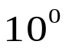, (note any value to the power of 0 is 1)
anything in the tens column is multiplied by 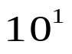,
anything in the hundreds column is multiplied by 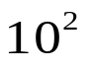,
anything in the thousands column is multiplied by 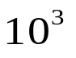.

 | x | x | x | x
decimal number | 2 | 7 | 5 | 2

In the binary system:
If we take a four bit binary number say 1011.
The LSB column is multiplied by 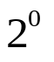,
The next LSB is multiplied by 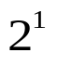,
The next LSB is multiplied by 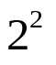,
The MSB is multiplied by 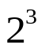.

multiplier | x | x | x | x
binary number | 1 | 0 | 1 | 1

We multiply each bit by it’s decimal value to convert to decimal.

1 x 8  0 x 4  1 x 2  1 x 1 | 8  0  2  ..+.....1  11

We have now converted the binary number 1011 into it’s decimal equivalent which is 11.
We can write this as 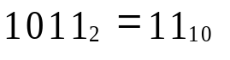

Here is some for you to try.
Binary | Decimal? |  | Binary | Decimal? |  | Binary | Decimal?
10 | 2 |  | 101 | 5 |  | 101011 | 43
100 | 4 |  | 110 | 6 |  | 101111 | 47
1000 | 8 |  | 10111 | 23 |  | 10011 | 19
10000 | 16 |  | 11011 | 27 |  | 11100 | 28
100000 | 32 |  | 1010101 | 85 |  | 101 | 5
1000000 | 64 |  | 0101010 | 42 |  | 110 | 6
11 | 3 |  | 00001 | 1 |  | 1001 | 9
111 | 7 |  | 110101 | 53 |  | 1100111 | 103
1111 | 15 |  | 10101 | 21 |  | 1011111 | 95
11111 | 31 |  | 1001 | 9 |  | 1101111 | 111
111111 | 63 |  | 1100 | 12 |  | 1110111 | 119
1111111 | 127 |  | 1011 | 11 |  | 1111011 | 123

Converting octal to decimal
If we take a four digit octal number say 2743.
The LSD (lowest significant digit) is multiplied by 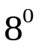,
The next LSD is multiplied by 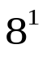,
The next LSD is multiplied by 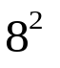,
The MSD is multiplied by 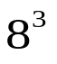.

multiplier | x | x | x | x
octal number | 2 | 7 | 4 | 3

We multiply each digit by it’s decimal value to convert to decimal.

2 x 512  7 x 64  4 x 8  3 x 1 | 1024  448  32  ..+.....3  1507

We have now converted the octal number 2743 into it’s decimal equivalent, which is 1507. We can write this as 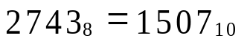

Here is some for you to try.
Octal | Decimal? |  | Octal | Decimal? |  | Octal | Decimal?
17 | 15 |  | 432 | 282 |  | 77 | 63
246 | 166 |  | 12 | 10 |  | 63 | 51
423 | 275 |  | 7765 | 4085 |  | 23445 | 10021
721 | 465 |  | 3542 | 1890 |  | 3241 | 1697
456 | 302 |  | 7765 | 4085 |  | 2341 | 1249
32 | 26 |  | 435 | 285 |  | 224 | 148
77 | 63 |  | 101 | 65 |  | 771 | 505
7 | 7 |  | 0 | 0 |  | 12 | 10

Converting hexadecimal to decimal

If we take a four digit hexadecimal number say 1E3A.
The LSD (lowest significant digit) is multiplied by 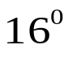,
The next LSD is multiplied by 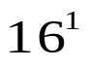,
The next LSD is multiplied by 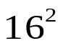,
The MSD is multiplied by 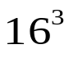.

multiplier | x | x | x | x
octal number | 1 | E | 3 | A

We multiply each digit by it’s decimal value to convert to decimal.

1 x 4096  (E=14) 14 x 256  3 x 16  (A=10) 10 x 1 | 4096  3584  48  ..+.....10  7738

We have now converted the hexadecimal number 1E3A into it’s decimal equivalent, which is 7738. We can write this as 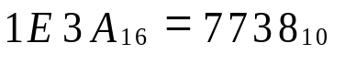

Here is some for you to try.
Hex | Decimal? |  | Hex | Decimal? |  | Hex | Decimal?
A | 10 |  | 4 | 4 |  | 1000 | 4096
F | 15 |  | 12 | 18 |  | 101 | 257
4E3 | 1267 |  | 77A | 1914 |  | 45 | 69
7C1 | 1985 |  | E | 14 |  | 241 | 577
4B6 | 1206 |  | 101 | 257 |  | 34C | 844
3F | 63 |  | F2 | 242 |  | 224 | 548
FF | 255 |  | FF | 255 |  | 7E | 126
C | 12 |  | FFF | 4095 |  | 12 | 18

Converting decimal to binary.
If you travelled 32 miles, what number would be on your binary miles travelled indicator ?.
This question involves converting from decimal to binary. The method by which one converts from decimal to binary is called Repeated division by 2.

Here is an example:
Convert 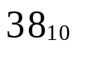 into binary.
Firstly we divide 38 by 2, the remainder this will give us the LSB
We divide the remainder by 2 this will give us the next LSB
We continue this until we can’t divide any longer.
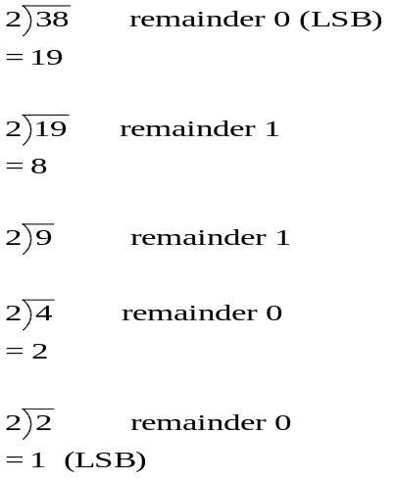

Answer: =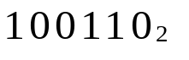

Here is some for you to try.
Decimal | Binary? |  | Decimal | Binary? |  | Decimal | Binary?
7 | 111 |  | 16 | 10000 |  | 24 | 11000
9 | 1001 |  | 31 | 11111 |  | 17 | 10001
20 | 10100 |  | 32 | 100000 |  | 19 | 10011
2561 | 101000000001 |  | 45 | 101101 |  | 18 | 10010
24 | 11000 |  | 21 | 10101 |  | 27 | 11011
63 | 111111 |  | 18 | 10010 |  | 511 | 111111111
64 | 1000000 |  | 27 | 11011 |  | 512 | 1000000000
15 | 1111 |  | 24 | 11000 |  | 1024 | 10000000000

Confirm your answers by converting the answers from binary into decimal.

Converting decimal to octal.
If you travelled 118 miles, what number would be on your octal miles travelled indicator ?.
This question involves converting from decimal to octal.
The method by which one converts from decimal to octal is called Repeated division by 8.

Here is an example:
Convert 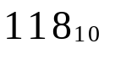 into octal.
Firstly we divide 118 by 8, the remainder this will give us the LSD
We divide the remainder by 8 this will give us the next LSD
We continue this until we can’t divide any longer.
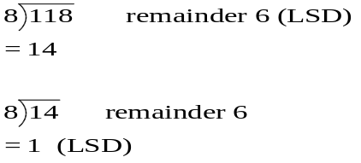

Answer: =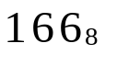

Converting decimal to Hex.
If you travelled 204 miles, what number would be on your hex miles travelled indicator ?.
This question involves converting from decimal to hex.
The method by which one converts from decimal to hex is called Repeated division by 16.

Here is an example:
Convert 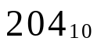 into hex.
Firstly we divide 204 by 16, the remainder this will give us the LSD
We divide the remainder by 16 this will give us the next LSD
We continue this until we can’t divide any longer.
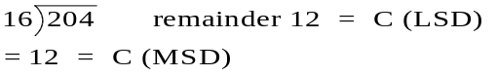

Answer: =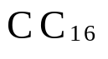

Here is some for you to try.
Decimal | Octal? | Hex? |  | Decimal | Octal | Hex
7 | 7 | 7 |  | 124 | 174 | 7C
9 | 11 | 9 |  | 171 | 253 | AB
20 | 24 | 14 |  | 119 | 167 | 77
2561 | 5001 | A01 |  | 181 | 265 | B5
24 | 30 | 18 |  | 271 | 417 | 10F
63 | 77 | 3F |  | 511 | 777 | 1FF
64 | 100 | 40 |  | 512 | 1000 | 200
15 | 17 | F |  | 1024 | 2000 | 400
Confirm your answers by converting the answers from octal into decimal and from Hex to decimal.
Converting from binary to octal and from octal to binary.
Example: say you wish to convert the binary number 1001101110 to octal, you could convert the number to decimal and then into octal but there is an easier way.

Starting from the left, separate the binary number into groups of threes. Some times you will have to include zeros before the number to make sure all groups have three digits.
001 001 101 110

Two zeros have been added to the number we are interested in.
Each single group is then converted into a single octal digit
001 001 101 110
↓ ↓ ↓ ↓
1 1 5 6

So 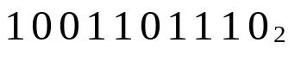=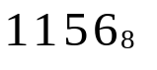

It is just as easy to go from octal to binary
In this case we get each digit of the octal number and convert it into three binary digits
Say we have the octal number 56743 and wish to convert to binary
5 6 7 4 3
↓ ↓ ↓ ↓ ↓
101 110 111 100 011

So 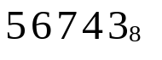=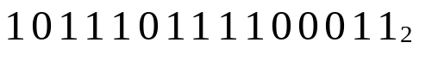

Converting from binary to hex and from hex to binary.
Example: say you wish to convert the binary number 1 1110 0110 1110 to hex, you could convert the number to decimal and then into hex but once again, there is an easier way.

Starting from the left, separate the binary number into groups of fours. Some times you will have to include zeros before the number to make sure all groups have four digits.
0001 1110 0110 1110

Three zeros have been added to the number we are interested in.
Each single group is then converted into a single octal digit

0001 1110 0110 1110
↓ ↓ ↓ ↓
1 E 5 E

So 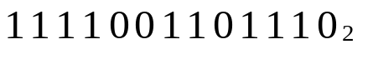=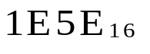
It is just as easy to go from hex to binary
In this case we get each digit of the hex number and convert it into four binary digits
Say we have the hex number F3AEC and wish to convert to binary
F 3 A E C
↓ ↓ ↓ ↓ ↓
1111 0011 1010 1110 1011

So 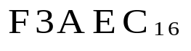=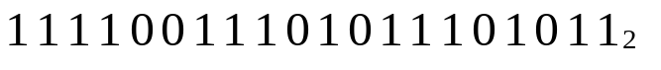

2.1 Binary coded decimal (BCD)
When using displays such as seven segment displays (like on your calculator) a special number system is used, this system is called binary coded decimal (BCD). In BCD each decimal digit is represented by four binary digits.
Example: Convert the following BCD number 10101110111 to decimal. The method by which you convert is very similar to converting from binary to Hex.

Starting from the left, separate the binary coded number into groups of fours. Some times you will have to include zeros before the number to make sure all groups have four digits.
0101 0111 0111

A zero has been added to the number we are interested in.
Each single group is then converted into a single decimal digit
0101 0111 0111
↓ ↓ ↓
1 7 7

So the BCD number 10101110111=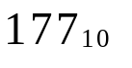

When working in BCD you should appreciate that numbers such as 1100 and 11000001 are illegal. Why?.

2.2 Gray coding schemes
Grey code is used with special types of sensors called shaft encoders. Grey code uses two digits 0 and 1. We are mainly interested in counting in grey code. Say we have a 3 bit grey code, we wish to count from the lowest number 000 to the highest number.

The rule for counting in grey code is;
only one bit can change when going from a number to the following number.
The LSB is changed first, if this code has already occurred in the sequence the next LSB is changed. This can best be seen from an example.

PTO.

Decimal equivalent | Grey Code | Comments
0 | 000 | The LSB is changed and we obtain the number 001. This code has not been used before so it is valid.
1 | 001 | The LSB is changed and we obtain the number 000. This code has been used before so it is not valid.  The next LSB is changed and we obtain the number 011.  This code has not been used before so it is valid.
2 | 011 | The LSB is changed and we obtain the number 010. This number has not been used before so it is valid.
3 | 010 | The LSB is changed and we obtain the number 011. This code has been used before so it is not valid.  The next LSB is changed and we obtain the number 000. This code has been used before so it is not valid.  The next LSB is changed and we obtain the number 110.  This code has not been used before so it is valid.
4 | 110 | The LSB is changed and we obtain the number 111. This code has not been used before so it is valid.
5 | 111 | The LSB is changed and we obtain the number 110. This code has been used before so it is not valid.  The next LSB is changed and we obtain the number 101.  This code has not been used before so it is valid.
6 | 101 | The LSB is changed and we obtain the number 100. This code has not been used before so it is valid.
7 | 100

Try four bit grey code, if you get it right when you go from 15 back to 0 only one bit should change.

2.3 Binary addition
When adding two binary numbers the rules are as follows
0+0 = 0, 0+1= 1 1+1= 10, (zero and carry one).
1+1+1 = 11 (one carry one).

Example 1010110 + 11011

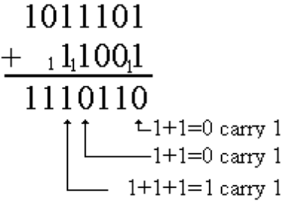
Try adding the binary numbers below.
10110  +1110  100100 | 1011  +111011  1000110 | 101101  +111011  1101000 | 111  +111011  1000010 | 1010011  +111011  10001110
101101  +11101  1001010 | 1011010  +1110  1101000 | 1011010  +111111  10011001 | 1011010  +111011  10010101 | 1001101  +111011  10001000

To check
Convert the above numbers to decimal, add them and convert the answer to binary.

2.4 Subtraction
When subtracting two binary numbers the rules are as follows
0-0 = 0, 1-0= 1 1-1= 0, 10-1=1

Lets look at 10-1 more closely.

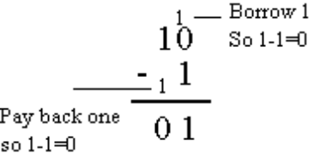

Here are some examples of subtraction

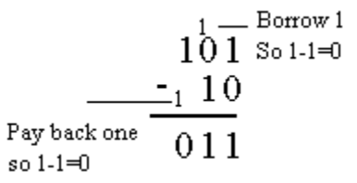

Try the following binary subtraction problems

10110  -1110  1000 | 1011  -11  1000 | 101101  -1011  100010 | 111  -1  110 | 1010011  -111011  11000
101101  -11101  10000 | 1011010  -1110  1001100 | 1011010  -111111  11011 | 1011010  -111011  11111 | 1001101  -111011  10010

To check
Convert the above numbers to decimal, subtract them and convert the answer to binary.

2.5 Representing positive and negative binary numbers
By now we all know that the number 100 represents the decimal value 4, but how do we represent the value -4?.
In this section, this is the problem we are faced with, how do we represent both plus and minus binary numbers. There are three different systems used to represent plus and minus numbers. These are
(1) The sign magnitude system,
(2) The 1’s complement system,
(3) The 2’s complement system.

We will look at all three, but the 2’s complement system is the most important.

(1) The sign magnitude system,
In the sign magnitude system the left-most bit is called the sign bit and the other bits are the magnitude bits (see below)

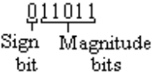

The sign bit determines whether is positive (sign bit = 0) or negative (sign bit =1).
The magnitude bits determine it’s value. In the case above the sign bit is 0 so the number is positive, the magnitude bits give the value decimal value 27. So the number 011011 represents the value +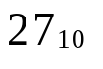

To write the value -27 one needs to only change the sign bit. So we have 111011 = -.
So in a 6 bit sign magnitude system the number 111011 represents -.

Note: Some confusion may arise because in the binary system 111011=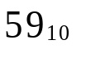, so you must be told which system you are in.

The 1’s complement system
Another way of representing negative numbers is the 1’s complement system. Positive numbers are represented the same way as positive sign magnitude numbers.
For example in the 1’s complement system the number 011011 represents the value +. To represent a negative number in 1’s complement form you change all the ones to zeros and all the zeros to ones. So - is represented in 1’s complement form by 100100.

Note: Some confusion may arise because in the binary system 100100=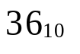, so you must be told which system you are in.

The 2’s complement system
In the 2’s complement system positive numbers are represented in the same way as the 1’s complement system and as the sign magnitude system. Negative numbers are represented by changing the ones to zeros and the zeros to ones and adding one.
For example:
For example in the 2’s complement system the number 011011 represents the value +. To represent a negative number in 2’s complement form you change all the ones to zeros and all the zeros to ones, then you add 1. So - is represented in 1’s complement form by 100101.

Example
In this example we wish to find the negative value of (a) a sign magnitude number, (b) a 1’s complement number and (c) a 2’s complement number.

We will start off with an eight bit number say 0001011 (this represents 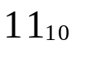 in all the above systems)
To represent -in sign magnitude form you change the left most bit to a 1. This results in 1001011 = -

To represent -in 1’s compliment form you change the ones to zeros and the zeros to ones. This results in 1110100 = -

To represent -in 2’s compliment form you change the ones to zeros and the zeros to ones and add 1. This results in 1110101 = -

Example 2
In this example we wish to find the positive value of (a) a sign magnitude number, (b) a 1’s complement number and (c) a 2’s complement number.

We will start off with an eight bit number say 1001011 (the fact that the left most bit is a 1 implies that the number is negative in all the above systems).

To find the value if the number is in sign magnitude form, you first appreciate that it is a negative number, ignore the left most bit and convert 001011 to decimal.
Since 001011 = . So the original number 1001011 must equal -.

To find the value of the number if the number is in 1’s complement form, you just get the 1’s complement of the number. Change the ones to zeros and the zeros to ones. This results in 0110100 = 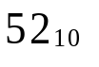. So the original number 1001011 must equal -

To find the value of the number if the number is in 2’s complement form, you just get the 1’s complement of the number and add 1. Change the ones to zeros and the zeros to ones and add 1. This results in 0110101 = 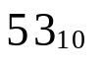.
So the original number 1001011 must equal -.

You should appreciate that getting the 1’s complement of a number gives you the negative of that number in 1’s complement form.
For example say we have 00001001 = 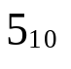
If we get the 1’s complement of 00001001 we find how we represent - in 1’s complement form.
The 1’s complement of 00001001 is 11110110 = -

We have said that if we get the 1’s complement of a number we are getting the negative of that number in 1’s complement form. So if we get the 1’s complement of - we should obtain --5 = +5.
Lets try it.
The 1’s complement of 11110110 is 00001001 = +. So it works.

You should appreciate that getting the 2’s complement of a number gives you the negative of that number in 2’s complement form.
For example say we have 00001001 =
If we get the 2’s complement of 00001001 we find how we represent - in 2’s complement form.
The 1’s complement of 00001001 is 11110111 = - in 2’s complement form.

We have said that if we get the 2’s complement of a number we are getting the negative of that number in 2’s complement form. So if we get the 2’s complement of - we should obtain --5 = +5.
Lets try it.
The 2’s complement of 11110111 is 00001001 = +. So it also works.

Exercises
Fill in the table using 8 bit numbers

Decimal Sign Magnitude One's Complement Two's Complement
15 00001111 00001111 00001111
14 00001110 00001110 00001110
13 00001101 00001101 00001101
12 00001100 00001100 00001100
11 00001011 00001011 00001011
10 00001010 00001010 00001010
9 00001001 00001001 00001001
8 00001000 00001000 00001000
7 00000111 00000111 00000111
6 00000110 00000110 00000110
5 00000101 00000101 00000101
4 00000100 00000100 00000100
3 00000011 00000011 00000011
2 00000010 00000010 00000010
1 00000001 00000001 00000001
+0 00000000 00000000
0 00000000
-0 10000000 11111111
-1 10000001 11111110 11111111
-2 10000010 11111101 11111110
-3 10000011 11111100 11111101
-4 10000100 11111011 11111100
-5 10000101 11111010 11111011
-6 10000110 11111001 11111010
-7 10000111 11111000 11111001
-8 10001000 11110111 11111000
-9 10001001 11110110 11110111
-10 10001010 11110101 11110110
-11 10001011 11110100 11110101
-12 10001100 11110011 11110100
-13 10001101 11110010 11110011
-14 10001110 11110001 11110010
-15 10001111 11110000 11110001
-16 11110000

2.6 Arithmetic operations using 2’s complement
In this section we are going to add and subtract using the 2’s complement numbering system. We will be using 8 bits to represent the numbers. Before we continue we must appreciate two things.

(1) The maximum and minimum number that can be represented using 2’s complement with 8 bits. 127 (01111111) and the most negative number is -128 (10000000). You will get errors in your addition or subtraction if the result outside these limits.

(2) If during adding or subtracting, our answer results in 9 bits, the most left number is discarded.

Addition and subtraction using 2’s complement.
Lets try a few simple additions in 2’s complement. In 2’s complement positive numbers are the same as they are in binary.
Decimal | 2’s comp |  | Decimal | 2’s comp
8  +9  17 | 00001000  +00001001  00010001 |  | 27  +31  58 | 00011011  +00011111  00111010

Lets get more adventurous

Decimal | 2’s comp |  | Decimal | 2’s comp
-8  +9  1 | 11111001  +00001000  100000001  discard the 9th bit  =00000001 |  | -27  +31  58 | 11100101  +00011111  100000100  discard the 9th bit  =00000100

Lets look at the problem 9-8=
We could get 9 and subtract 8 from it or we could get 9 and add -8 to it because
9-8=9+(-8).

Lets do these two operations in binary to show they result in the same answer.

Decimal | 2’s comp |  | Decimal | 2’s comp
9  -8  1 | 00001001  -00001000  00000001 |  | 9  +(-8)  1 | 00001001  +11111000  100000001  discard the 9th bit  00000001

Subtracting when the answer ends up negative.
Consider the question 23-37. We can rewrite this as 23+(-37). The next operation is to write -37 in 2’s complement form. We first write the value 37 and then get it’s 2’s complement.
37= 00100101 so -37= 11011011 (in 2’s complement form.)

Decimal | 2’s complement
23  +(-37)  -14 | 00010111  +11011011  11110010

Our answer is 11110010, this is in 2’s complement form and because the most left bit is a 1, the number is a negative number. To find out what this number is we find it’s 2’s complement, this will give us its value and we already know its sign.

So 2’s complement of 11110010 is 00001110 =14.
So 11110010 is -14 which is correct.

Activity
Using 8 bits and 2’s complement do the following addition and subtraction questions.

23-12= 12-8= 12-14=
31-24= 18-9= 14-23=

Decimal | 2’s complement | Decimal | 2’s complement | Decimal | 2’s complement
23  -12  11 | 00010111  -11110100  00001011 | 12  -8  4 | 00001100  -11111000  00000100 | 12  -14  -2 | 00001100  -11110010  11111110
31  -24  7 | 00011111  -11101000  00000111 | 18  -9  9 | 00010010  -11110111  00001001 | 14  -23  -9 | 00001110  -11101001  11110111

