CPU - Main Screen:

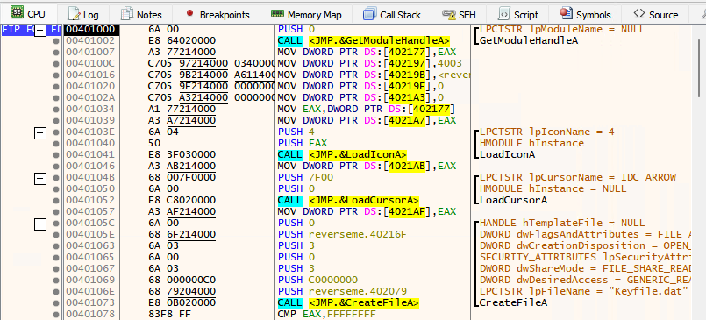

Left – Right (Sections):

([Breakpoint](https://en.wikipedia.org/wiki/Breakpoint)/[Registers Location](https://en.wikipedia.org/wiki/X86#x86_registers)) | ([VAS – Virtual Address space](https://en.wikipedia.org/wiki/Virtual_address_space)) | ([Opcode](https://en.wikipedia.org/wiki/Opcode)) | ([Disassembly](https://en.wikipedia.org/wiki/Disassembler)) | (Comments / API’s ([xAnalyzer](https://github.com/ThunderCls/xAnalyzer)))

CPU - Main Screen (Graph Mode):

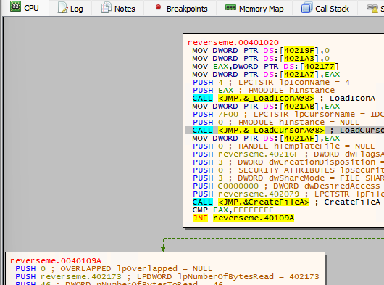

CPU - Bottom Screen:

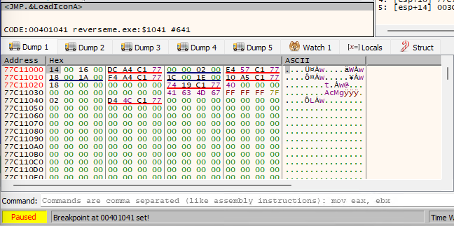

Top – Bottom (Sections):

(Execution Window)

([5 Hex Dumps](https://en.wikipedia.org/wiki/Hexadecimal)) | ([Watch 1](https://help.x64dbg.com/en/latest/gui/settings/GUI.html#show-watch-labels-in-side-bar)) | (Locals) | ([Struct](https://github.com/x64dbg/x64dbg/issues/1305))

([Command Bar](https://help.x64dbg.com/en/latest/commands/index.html))

(Status Bar/ Info Bar/ Time Debugging Bar)

Notes: Struct is use to import header file Structs (Check Link Above). Parse header (Select File) + Visit Type (Struct name) + (nan) Function

CPU - Stack Screen:

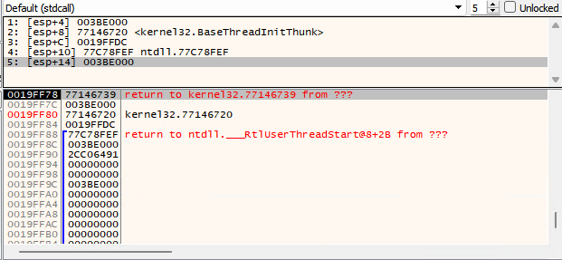

Top – Bottom (Sections):

([Stack Trace](https://en.wikipedia.org/wiki/Stack_trace) - Menu bar) | (No. of [Stack Traces](https://en.wikipedia.org/wiki/Stack_trace) (Default: 5)) | (Stack Tracer Status: (Unlocked/Calls/Locked))

(SP/ESP/RSP: Stack pointer for top address of the stack) | ([VAS – Virtual Address space](https://en.wikipedia.org/wiki/Virtual_address_space)) | (Comments)

CPU - Registers Screen:

X32Dbg / X64Dbg

|  |  |
| --- | --- |
|  |  |

General Purpose Registers:

* AL/AH/AX/EAX/RAX: Accumulator
* BL/BH/BX/EBX/RBX: Base index (for use with arrays)
* CL/CH/CX/ECX/RCX: Counter (for use with loops and strings)
* DL/DH/DX/EDX/RDX: Extend the precision of the accumulator (e.g. combine 32-bit EAX and EDX for 64-bit integer operations in 32-bit code)
* BP/EBP/RBP: Stack base pointer for holding the address of the current [stack frame](https://en.wikipedia.org/wiki/Stack_frame).
* SP/ESP/RSP: Stack pointer for top address of the stack.
* SI/ESI/RSI: *Source index* for [string](https://en.wikipedia.org/wiki/String_(computer_science)) operations.
* DI/EDI/RDI: *Destination index* for string operations.
* R8 – R15(x64 only): Eight additional 64-bit general registers.
* IP/EIP/RIP: Instruction pointer. Holds the [program counter](https://en.wikipedia.org/wiki/Program_counter), the address of next instruction.

|  |  |  |  |  |
| --- | --- | --- | --- | --- |
| Control Registers:   * [ZF – Zero Flag](https://en.wikipedia.org/wiki/Zero_flag) * [OF – Overflow Flag](https://en.wikipedia.org/wiki/Overflow_flag) * [CF – Carry Flag](https://en.wikipedia.org/wiki/Carry_flag) * [PF – Parity Flag](https://en.wikipedia.org/wiki/Parity_flag) * [SF – Sign Flag](https://en.wikipedia.org/wiki/Negative_flag) * [TF – Trap Flag](https://en.wikipedia.org/wiki/Trap_flag) * [AF – Adjust Flag](https://en.wikipedia.org/wiki/Adjust_flag) * [DF – Direction Flag](https://en.wikipedia.org/wiki/Direction_flag) * [IF – Interrupt Enable Flag](https://en.wikipedia.org/wiki/Interrupt_flag) | Segment Registers:   * CS: Code * DS: Data * SS: Stack * ES: Extra data * FS: Extra data #2 * GS: Extra data #3 | | Debug Registers:   * DR0 -> DR3: Breakpoints * DR6: Debug Status * DR7: Debug Control | |
| Log Tab:    [GUI Manual - Log](https://help.x64dbg.com/en/latest/gui/views/Log.html) | | Notes Tab:    [GUI Manual - Notes](https://help.x64dbg.com/en/latest/gui/views/Notes.html) | |
| Breakpoints Tab:    There are 2 types of breakpoints: (Software / Hardware).  Hardware only has (4 breakpoint Slots).  [GUI Manual – Conditional Breakpoints](https://help.x64dbg.com/en/latest/introduction/ConditionalBreakpoint.html) | | | |

|  |
| --- |
| Memory Map Tab:    [Memory Map](https://en.wikipedia.org/wiki/Memory_map):  In [computer science](https://en.wikipedia.org/wiki/Computer_science), a **memory map** is a structure of data (which usually resides in memory itself) that indicates how [memory](https://en.wikipedia.org/wiki/Main_memory) is laid out. |

|  |
| --- |
| Call Stack Tab:    A **call stack** is a [stack](https://en.wikipedia.org/wiki/Stack_(abstract_data_type)) [data structure](https://en.wikipedia.org/wiki/Data_structure) that stores information about the active [subroutines](https://en.wikipedia.org/wiki/Subroutine) of a [computer program](https://en.wikipedia.org/wiki/Computer_program)  [GUI Manual – Call Stack](https://help.x64dbg.com/en/latest/gui/views/CallStack.html) |

|  |
| --- |
| Structured Exception Handler (SEH) Chain Tab:    [Wikipedia – SEH mechanism](https://en.wikipedia.org/wiki/Microsoft-specific_exception_handling_mechanisms#SEH) |
| Script Tab: |

Symbols Tab: 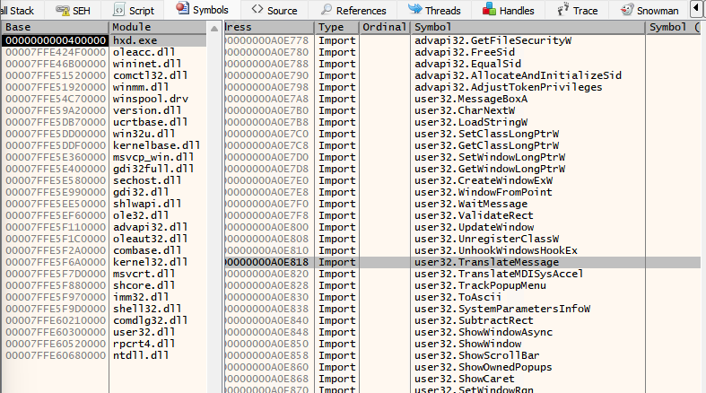

|  |
| --- |
| References Tab: |

Threads Tab: 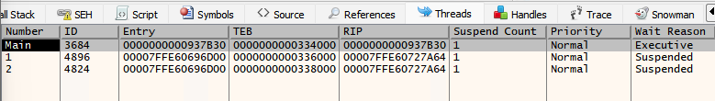

|  |
| --- |
| Handles Tab: |

|  |
| --- |
| Trace Tab:    Left – Right (Sections):  (Steps) | ([VAS – Virtual Address space](https://en.wikipedia.org/wiki/Virtual_address_space)) | ([Opcode](https://en.wikipedia.org/wiki/Opcode)) | ([Disassembly](https://en.wikipedia.org/wiki/Disassembler)) | (Comments / API’s ([xAnalyzer](https://github.com/ThunderCls/xAnalyzer)))  [GUI Manual - Trace](https://help.x64dbg.com/en/latest/gui/views/Trace.html) |

|  |
| --- |
| Snowman Tab:    Snowman - C++ Decomplier (Plugin)  <https://github.com/x64dbg/snowman/releases/tag/plugin-v1> |