OBSERVATIONS IN WORD EDITOR:
- Document prepared in word editor be exported to save it as a word doc / pdf document
Solution:
Here is a simple PHP script to export HTML to MS Word. Please modify this script to export data from the "document_section" table for a specific document_id in PMS application.
Filename: index.php
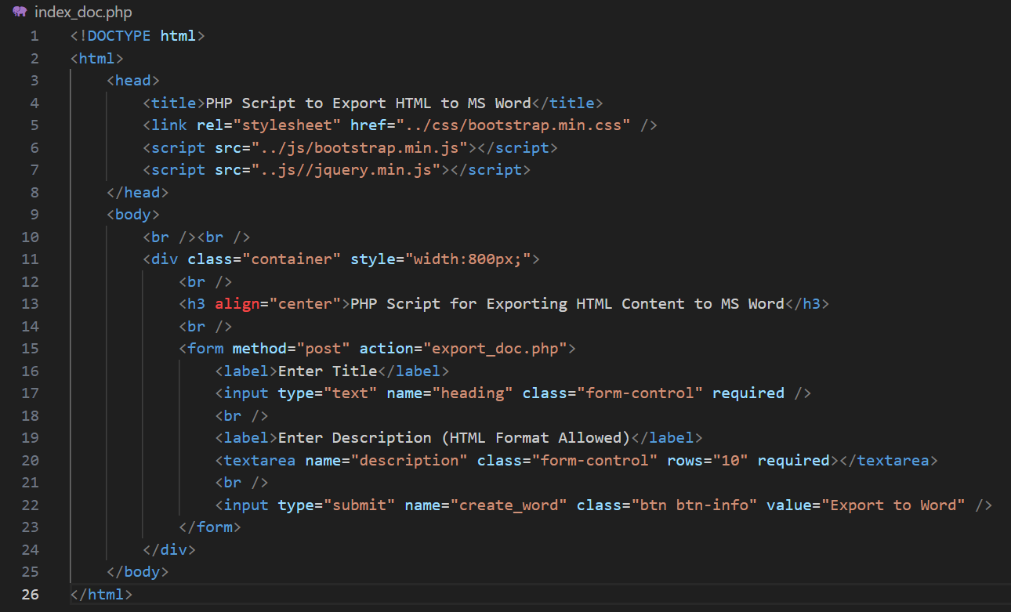
Filename: export_doc.php
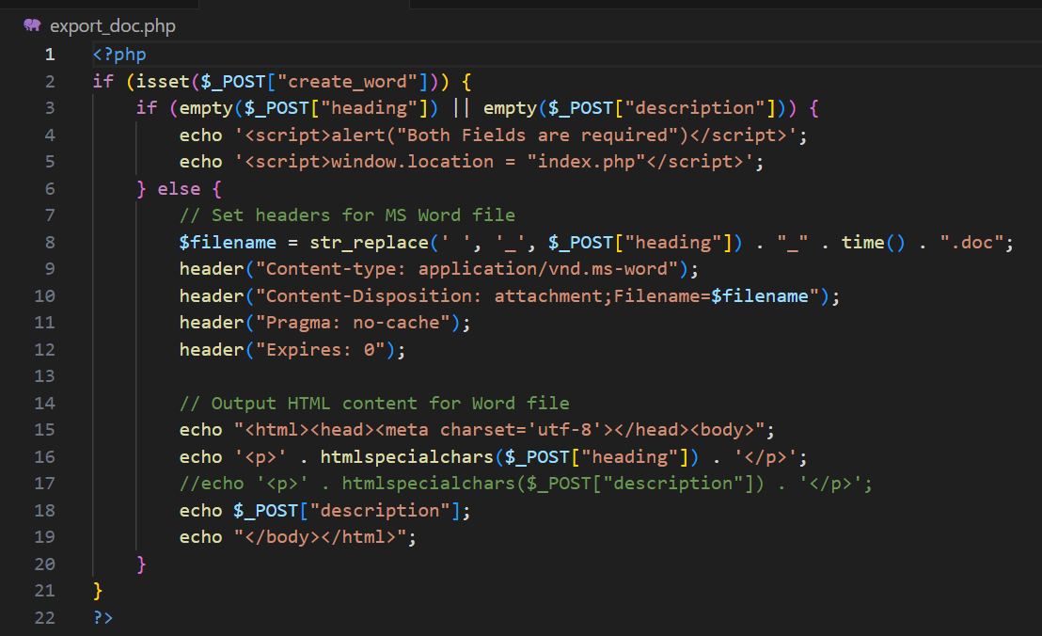
- Requirements updated for the current build in word editor should be fetched and change notice to be generated
Solution:
Provide an option for the user to select different versions
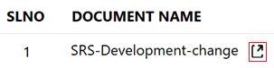
Provide an option to display a list of available versions that can be selected to copy the document.

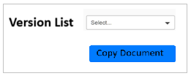
Copy the document from a previous version to a new version by inserting the records into the corresponding tables.
Tables that are affected
- tagged_doc
- document_section
- requirements
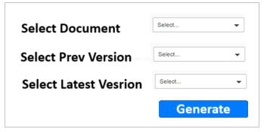
Provide an option for the user to select a document and two different versions. Upon clicking the "Generate" button, the required content should be retrieved from the requirement table based on the selected document_id and version_id and displayed on the screen as shown below.

for example,
7.6.14 ABECFM101: [requirement content goes here, requirement content goes here, requirement content goes here, requirement content goes here]
7.6.18 ABECFM101: [requirement content goes here, requirement content goes here, requirement content goes here, requirement content goes here, modified content goes here]

Option should be provided to download the content as an MS Word (.doc) file.

Here is a simple PHP script to export HTML to MS Word. Please modify this script to export data from the "document_section" table for a specific document_id in PMS application.
Filename: index.php

Filename: export_doc.php


- After creating a requirement tag, tags are getting duplicated
Solution: 1
Define a Unique Constraint: Ensure that the requirement_tag column in the requirements table is unique within the same document.
Use a UNIQUE Index: Apply a unique index on the combination of document_id and requirement_tag.
Solution: 2
Use controller logic to avoid duplicate insertion
$result_set = “SELECT ^ FROM requirements WHERE document_id = $doc_id AND requirement_tag = $new_tag”;

If(empty($result_set)){
“INSERT INTO requirements TABLE GOES HERE”
}

- After creating a tag in PM tool database, requirement contents are not found for the tag
Solution:
Validate the content before inserting it into the document_section table by removing all special characters. Ensure that only clean and properly formatted content is stored.

- Unable to delete the tag of the previous tagged requirement
Solution: To delete the tag, the entire content along with requirement tag should be selected and click on Untag Requirement icon
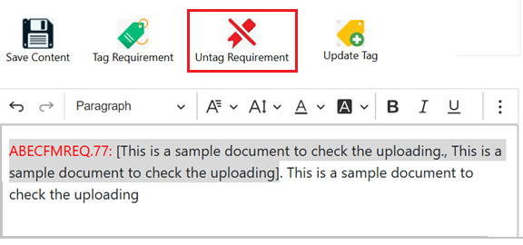

- Unable to update the requirement content for the existing tag
Solution: To update the tag, the entire content along with requirement tag should be selected and click on update tag icon
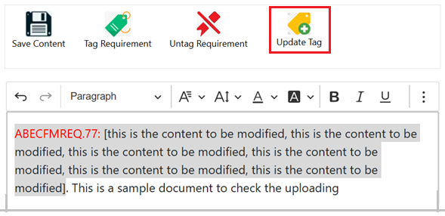

- Section no. for all the sections to be corrected in word editor
Solution:
To correct the entire section numbers of the document, first, update the section numbers within the document itself. Then, upload the updated document to the tool to ensure that the corrected section numbers are properly reflected.

- App para numbers should be given as para number (eg x.x.x.1) for sec no (x.x.x) and further sub para to be given as (x.x.x.1.1)
Solution:
Trupti, one of the developers, implemented this, ensuring that all sub-paragraphs are formatted as (x.x.x.1.1) when the section number begins with (x.x.x).
This feature is now available in the tool. When the user clicks on the section number, they can see the format displayed as (x.x.x.1.1)

- Comments given for SRS document not getting saved properly even after it shows data saved successfully
Solution: comments are stored in the comments table, Validate the content before inserting it into the comments table by removing all special characters. Ensure that only clean and properly formatted content is stored.

- Unable to edit the document properly, many times
Solution: After editing the document, the user must click the "Save" button; otherwise, the document content will not be saved.
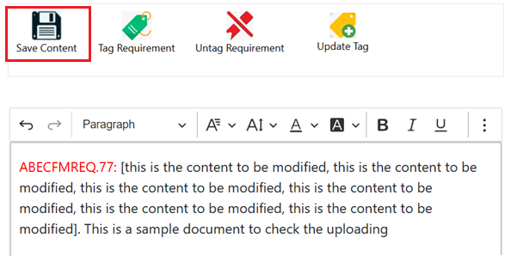
Observation in PM tool
- Baseline requirements – Tag that has to be baseline is not listing in “Tags” drop down menu. In create baseline window, for the tags that are generated through word editor and approved
Solution: All the tags are fetched from the tags tables, check the query that is used to display the tags in the dropdown box that are baselined check for the conditions

Note: ”tags” column in the requirements table should be updated with the parent tag number (ABECFMREQ) when the requirement gets created

- While creating child task, some old parent tags with tags is not getting listed in parent tags selection option, but same tags appear in requirements list window as baselined
Solution: All tags are fetched from the tags table. Verify the query used to list the parent tag selection options, ensuring that only valid parent tags are displayed based on the required conditions.

