(PMS) Project Plan Documentation

---------------------------------------------------------------------------------------------------------------------------

Table Of Contents

1. Project Details

1.1. Project Objective

2. PMS application requirements

3. Project Scope

4. Approach

4.1 Define System Architecture

4.2 Database Schema Design

4.3 Frontend UI/UX Design

4.4 Backend code

4.5 Version Control

5 Environment Setup

5.1 Installation at MicroGenesis

5.1.2 Deployment of PMS application

5.1.3 Startup / Shutdown

5.2 Installation at ADA Campus

5.2.1 System configuration

5.2.2 Deployment of PMS application through CD

6. Agile Development & Implementation

7. Testing & Validation

8. Post-Deployment Support & Maintenance

9. Development Tools used for Process Management Web Application

10 Resource allocation for Process Management Web Application

11. Architecture Diagram

12. Environment setup timeframe

13. Project Deliverables

13.1 Key Modules

13.1.1 Module Deliverables (Dashboard Management System (DMS))

13.1.2 Module Deliverables (User Management System (UMS))

13.1.3 Module Deliverables (Requirement Management System (RMS))

13.1.4 Module Deliverables (Scheduling Management System (SMS))

13.1.5 Module Deliverables (Activity Management System (AMS))

13.1.6 Module Deliverables (Configuration and Deployment Management System (CDMS))

13.1.7 Module Deliverables (Document Management System (DOMS))

13.1.8 Module Deliverables (Database Management System (DBMS))

14. Communication Plan

---------------------------------------------------------------------------------------------------------------------------

1. Project details

Name: Process Management System (PMS)

1.1 Project Objective:

ADA has developed an in-house process work flow tool based on DO-2167A which is being used for embedded and simulated software development. The main features of the work flow namely Requirements management, Task Scheduling, Activity tracking and management, Report generation, User management etc are used by approx. 50 users across multiple projects. The work flow tool is integrated with Clear case for Configuration control and Rational Publishing Engine (RPE) for the report generation.
To address the tool obsolescence the entire tool needs to be migrated to the new software framework
The application after migration will manage all Software Development Life Cycle (SDLC) phases efficiently, ensuring seamless workflow from requirement gathering to deployment. It eliminates dependency on licensed tools, provides role-based dashboards, ensures requirement traceability, and automates reporting.

2. PMS application requirements:
- An intuitive role-based dashboard to track project progress.
- Manage users, roles, and access permissions effectively.
- Maintain requirement traceability throughout the SDLC.
- Automate scheduling, task assignment, and tracking of activities.
- Enable testing and validation processes.
- Ensure a centralized document repository for easy access to project-related files.
- Generate automated reports on performance, activities, and project progress.
- Support versioning and deployment of finalized software builds.

3. Project Scope
The scope of the project includes:
- New system architecture design
- Use of React technology for frontend UI / UX
- Use of Laravel PHP framework for backend technology
- Use of GIT repository for version control
- Review and optimization of the Database
- Modern UI / UX design to optimize user interaction
- Reuse of existing application code / logic
- Setup of development / testing environment at MicroGenesis
- Setup of integration / testing environment at ADA

4. Approach
The development approach for the Process Management Web Application will follow an Agile Methodology, ensuring flexibility, continuous feedback, and incremental progress.

4.1 Define System Architecture
Frontend: React 19
Backend: PHP Laravel 11
Database: MySQL

4.2 Database Schema Design:
- The existing database tables and data will be reused so that the existing application will work without any issue
- Alias names will be used for existing tables and columns to follow standard naming conventions
- New columns will be added to the tables to establish foreign key relationships between them
- Write scripts to update the new columns
- Scripts to automate database backup / recovery
- Schedular for database backup / recovery

4.3 Frontend UI/UX Design:
- Modern UI / UX screens will be designed.
- Screen components to be developed using React
- Screen navigation optimization (no of screens, no of clicks)
- Create wireframes for different screens
- Define React component structure
- Install Node JS for rendering react components
- Develop react components for individual screens
- Develop frontend API (JSON) for individual screens

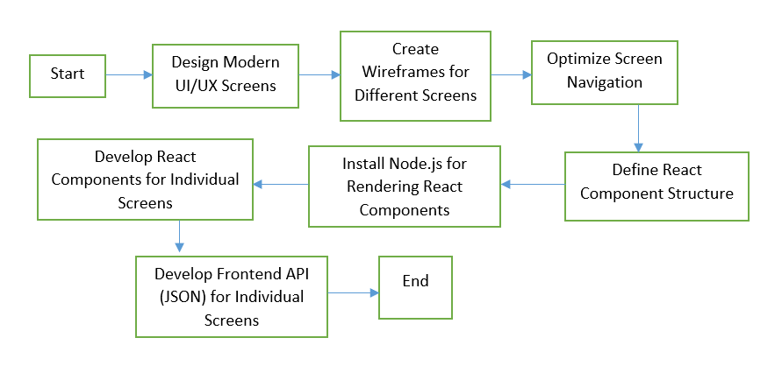

4.4 Backend code:
- Develop backend API using PHP to communicate with the frontend.
- Interface database tables using alias names for better readability and maintainability.
- Create respective Laravel models for each table
- Separate list for models from business logic
- Develop business logic inside controllers
- Implement authentication and authorization mechanisms for secure API access.
- Optimize API responses to enhance performance.
- Ensure proper error handling, debugging and monitoring.
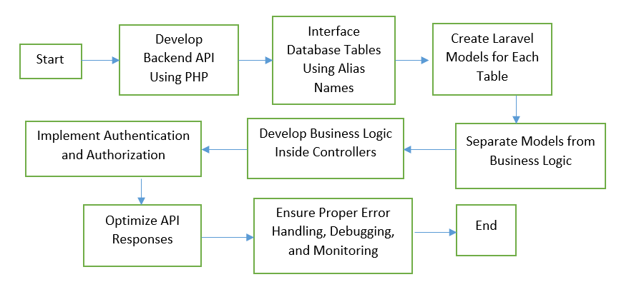

4.5 Version Control:
Replace existing Clearcase version tool to GitLab

5 Environment Setup:

5.1 Installation at MicroGenesis

5.1.1 System configuration
- CPU: 4 vCPUs
- RAM: 16 GB
- Storage: 100 GB SSD (or more depending on the project size)
- OS: Windows Server 2019/2022 or Windows 10/11 (for local development)
- Web Server: Apache (Apache is commonly used with PHP)
- Database: MySQL
- PHP Version: PHP 8.x Laravel 11 Framework
- Node.js
- Docker
- kubernetes
- Gitlab
- Composer
- OpenProject

5.1.2 Deployment of PMS application:
GitLab will be used for version control and deployment will be made from GitLab

5.1.3 Startup / Shutdown
Scripts will be generated to startup and shutdown of all following applications
- Apache
- MySQL
- React client-side app
- Laravel server- side app

5.2 Installation at ADA Campus

5.2.1 System configuration
- Laravel 11 Framework
- Node.js
- Gitlab
- Docker
- kubernetes
- Composer

5.2.2 Deployment of PMS application through CD:
- All the related code
- Database schema design
- Startup / Shutdown scripts
- Minor changes will be sent by email

6. Agile Development & Implementation
- Sprint-Based Development – Implement functionalities in iterative cycles.
- Develop modules – As per sequence
- Backend API Development – Build REST APIs using Laravel for seamless frontend-backend communication.
- Frontend Integration – Develop React components and integrate them with APIs.
- Implementing Security & Authentication – Role-based access control using JSON Web Tokens / Session handling.

7. Testing & Validation
Unit Testing
Integration Testing.
User Acceptance Testing (UAT)
Performance Testing – Optimize for speed, reliability, and scalability using JMeter tool

8. Post-Deployment Support & Maintenance
- Bug Fixes & Enhancements – Address issues and improve features.
- Performance Monitoring – Track system usage and optimize workflows.
- Regular Updates & Security Patches – Maintain system integrity.
- User Training & Documentation – Provide a user manual for smooth adoption.

9. Development Tools used for Process Management Web Application:
- VS Code – Primary IDE for development (React, PHP Laravel 11, JavaScript, etc.).
- Git Repository – Version control for managing source code and tracking changes.
- Database Workbench / XAMPP – Used for designing, managing, and querying the database.
- Docker
- Kubernetes

10 Resource allocation for Process Management Web Application:
- 1 Project Manager (PM) – Oversees the entire project, requirement approvals, and stakeholder communication.
- 1 Team Lead (TL) – Manages task assignment, reviews implementation, and coordinates development efforts.
- 3 PHP Developers – Responsible for backend development using Laravel framework, database management, and API creation.
- 1 React Developer – Develops the frontend interface, ensuring smooth UI/UX and integration with the backend.
- 1 Report Generation Specialist – Handles the creation and formatting of reports, including performance, MOM, and project status reports.

11. Architecture Diagram

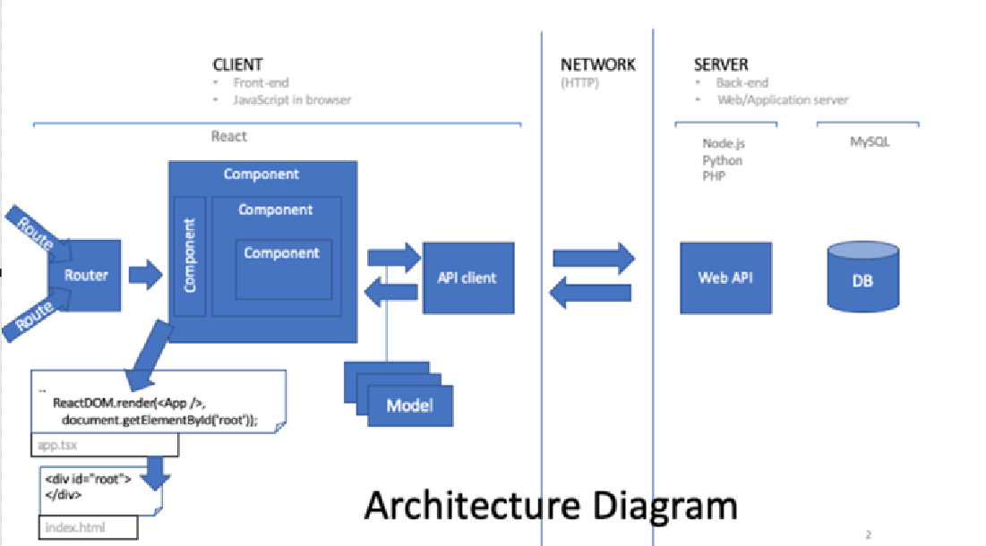

12. Environment setup timeframe
Deliverable | Description | Due Date
System Preparation | OS updates, dependencies installation | 13-02-2025
Git Installation | Install and configure Git | 13-02-2025
PHP Installation | Install PHP and verify setup | 13-02-2025
MySQL Installation | Install MySQL and configure root user | 13-02-2025
Docker Installation | Install Docker and verify functionality | 13-02-2025
Kubernetes Installation | Install Kubernetes | 13-02-2025
Environment Configuration & Testing | Set up environment variables, test containers | 13-02-2025

13. Project Deliverables

13.1 Key Modules

Dashboard Management System (DMS): Provides role-based dashboards to track project status, team performance, and ongoing activities.

User Management System (UMS): Manages user roles (PM, TL, TM) and access permissions.

Requirement Management System (RMS): Handles requirement collection, tagging, approval, and updates, ensuring full traceability.

Scheduling Management System (SMS): Converts approved requirements into scheduled tasks assigned to team leaders and members.

Activity Management System (AMS): Manages task breakdown, assignment, validation, testing, and integration.

Configuration and Deployment Management System (CDMS): Manages software versioning and final deployment of executables and supporting files.

Document Management System (DOMS): Automates document generation, including performance reports, MOMs, and compliance reports.

Database Management System (DBMS): Stores and organizes all project-related data efficiently.

13.1.1 Module Deliverables (Dashboard Management System (DMS))
Deliverable | Description | Due Date
Dashboard Management System (DMS) | Detailed requirements specification | 00-00-2025
UI/UX Design | Wireframes and design prototypes | 00-00-2025
Frontend Development | React.js-based frontend implementation | 00-00-2025
Backend Development | Laravel 11 (PHP) with database integration | 00-00-2025
Testing & QA | Functional and security testing | 00-00-2025
Deployment | System deployment on server | 00-00-2025

13.1.2 Module Deliverables (User Management System (UMS))
Deliverable | Description | Due Date
User Management System (UMS) | Detailed requirements specification | 13-02-2025
UI/UX Design | Wireframes and design prototypes | 14-02-2025
Frontend Development | React.js-based frontend implementation | 17-02-2025
Backend Development | Laravel 11 (PHP) with database integration | 19-02-2025
Testing & QA | Functional and security testing | 20-02-2025
Deployment | System deployment on server | 20-02-2025

13.1.3 Module Deliverables (Requirement Management System (RMS))
Deliverable | Description | Due Date
Requirement Management System (RMS) | Detailed requirements specification | 25-02-2025
UI/UX Design | Wireframes and design prototypes | 04-03-2025
Frontend Development | React.js-based frontend implementation | 06-03-2025
Backend Development | Laravel 11 (PHP) with database integration | 12-03-2025
Testing & QA | Functional and security testing | 13-03-2025
Deployment | System deployment on server | 14-03-2025

13.1.4 Module Deliverables (Scheduling Management System (SMS))
Deliverable | Description | Due Date
Scheduling Management System (SMS) | Detailed requirements specification | 17-03-2025
UI/UX Design | Wireframes and design prototypes | 19-03-2025
Frontend Development | React.js-based frontend implementation | 20-03-2025
Backend Development | Laravel 11 (PHP) with database integration | 21-03-2025
Testing & QA | Functional and security testing | 24-03-2025
Deployment | System deployment on server | 24-03-2025

13.1.5 Module Deliverables (Activity Management System (AMS))
Deliverable | Description | Due Date
Activity Management System (AMS) | Detailed requirements specification | 09-04-2025
UI/UX Design | Wireframes and design prototypes | 14-04-2025
Frontend Development | React.js-based frontend implementation | 17-04-2025
Backend Development | Laravel 11 (PHP) with database integration | 22-04-2025
Testing & QA | Functional and security testing | 23-04-2025
Deployment | System deployment on server | 24-04-2025

13.1.6 Module Deliverables (Configuration and Deployment Management System (CDMS))
Deliverable | Description | Due Date
Configuration and Deployment Management System (CDMS) | Detailed requirements specification | 25-04-2025
UI/UX Design | Wireframes and design prototypes | 28-04-2025
Frontend Development | React.js-based frontend implementation | 29-04-2025
Backend Development | Laravel 11 (PHP) with database integration | 30-04-2025
Testing & QA | Functional and security testing | 31-04-2025
Deployment | System deployment on server | 01-05-2025

13.1.7 Module Deliverables (Document Management System (DOMS))
Deliverable | Description | Due Date
Document Management System (DOMS) | Detailed requirements specification | 05-05-2025
UI/UX Design | Wireframes and design prototypes | 06-05-2025
Frontend Development | React.js-based frontend implementation | 07-05-2025
Backend Development | Laravel 11 (PHP) with database integration | 08-05-2025
Testing & QA | Functional and security testing | 09-05-2025
Deployment | System deployment on server | 09-05-2025

13.1.8 Module Deliverables (Database Management System (DBMS))
Deliverable | Description | Due Date
Database Management System (DBMS) | Detailed requirements specification | 25-03-2025
UI/UX Design | Wireframes and design prototypes | 26-03-2025
Frontend Development | React.js-based frontend implementation | 27-03-2025
Backend Development | Laravel 11 (PHP) with database integration | 28-03-2025
Testing & QA | Functional and security testing | 31-03-2025
Deployment | System deployment on server | 31-03-2025

Project Management
Deliverable | Description | Due Date
Database Management System (DBMS) | Detailed requirements specification | 01-04-2025
UI/UX Design | Wireframes and design prototypes | 02-04-2025
Frontend Development | React.js-based frontend implementation | 02-04-2025
Backend Development | Laravel 11 (PHP) with database integration | 04-04-2025
Testing & QA | Functional and security testing | 07-04-2025
Deployment | System deployment on server | 08-04-2025

14. Communication Plan
Communication Type | Frequency | Participants
Weekly Team Meetings | Weekly | All team members
Progress Reports | Bi-weekly | Project Manager, Stakeholders
Sprint Reviews | End of each sprint | Developers, QA, Manager
Client Updates | Monthly | Project Manager, Client Representatives

Note – The model delivery dates are tentative and it might vary based on the complexities.

