# experimental determination of fission product decontamination factors for plutonium separated by purex FROM low-burnup, fast-neutron irradiated duo2

## Abstract

Experimental investigations to determine how fission products (FP) and actinides (uranium and plutonium) separate from each other in each of the process steps while employing the Plutonium Uranium Redox Extraction (PUREX) process to purify plutonium in neutron irradiated uranium targets were conducted. The sample processed was low-burn-up (4.93 ± 0.132 GWd/tHM) depleted uranium dioxide (DUO2) surrogate (0.28 ± 0.002 wt.% 235U). Distribution ratios for U, Pu, Mo, Ru, Ce, Sm, Sr, Pm, Eu, Nd, Pd, Cd and Sn for the 30 vol.% tri-n-butyl phosphate in a kerosene diluent co-decontamination step at low uranium concentrations in 4 molar nitric acid were determined and varied in value from 0.01 to 0.2 for the fission products and were 26.8 ± 0.5 and 11.56 ± 0.5 for U and Pu, respectively. These values were characteristic of previously reported values (Stoller and Richards 1961) and were used to estimate decontamination factors for a PUREX cycle. These estimates were then verified with mass spectrometry and gamma spectroscopy.

INTRODUCTION

Fission product decontamination factors and actinide recovery as a function of PUREX steps were applied to a low-burnup (< 5000 MWd/MTU) depleted uranium dioxide (DUO2) surrogate (0.28 ± 0.002 wt.% 235U) irradiated in a pseudo fast neutron spectrum. The DUO2 surrogate containing FP and weapons grade plutonium were subjected to three PUREX decontamination cycles and the process solutions analyzed at each step with high resolution gamma spectroscopy, and Inductively Coupled Plasma-Mass Spectrometry (ICP-MS). The experimental work sought to develop laboratory scale methods to isolate a large percentage of plutonium, determine distribution ratios, and first iteration decontamination factors as part of development of forensic radiochemical analytical capabilities at Texas A&M.

The significance of the project comes from the methodology development that will aid in identifying the origins of plutonium processing even if dealing with less than a significant quantity (8 kg of plutonium), which is a valuable deterrence capability.

Specifically, this analysis of distribution coefficients between used fuel dissolved in aqueous solution and TBP was conducted. Then decontamination factors were estimated and experimentally determined for PUREX processed fuel and verified with experiment and measurement. Some decontamination factors and distribution coefficients have been previously reported for either select isotopes, or for batch processes, but this project seeks to expand that knowledge base.

## Experiment

12.9 mg of irradiated depleted uranium was dissolved in 15.43 M HNO3, about 10% of the aliquot was further diluted to 3.95 M HNO3 and PUREX ensued with 1/100th of the pellet in 0.5 ml aliquots. This was known as the stock solution. U(VI) and Pu(IV) were extracted and decontaminated by contacting the stock solution with a solution of 30 vol.% tri-n-butyl phosphate with a kerosene diluent. Plutonium was then reduced to Pu(III) and extracted and separated from uranium by contacting the tri-n-butyl phosphate solution with a solution of dilute HNO3 acid 0.024 M ferrous sulfamate solution via oxidation of Fe(II). Pu(III) was converted to Pu(IV) via the addition of sodium nitrite and further decontamination/extraction ensued by repeating the process.

The pellet both prior to dissolution and after, were counted on a standard Canberra electrode coaxial Ge detector model number CC4018 which was connected to a Canberra Lynx MCA. GENIE software was used to analyze spectrum and samples were typically encased in a lead tomb. Inductively coupled plasma mass spectrometry (ICP-MS) was also conducted for some samples with use of the University of Missouri’s PerkinElmer NexION 300X quadrupole ICP-MS operated in standard mode by Dr. James McKamey. A Canberra Passivated Implanted Planar Silicon (PIPS) detector coupled with an alpha spectrometer a MCA and a vacuum pump were also used qualitatively to verify plutonium separation of co-precipitated plutonium.

Detailed three dimensional models of Oakridge National Laboratories’ (ORNL) High Flux Isotope Reactor (HFIR) were developed using the Monte Carlo transport computer code, MCNP, coupled with the burn-up/depletion computer code, CINDER90. These were used to model the irradiation of a DUO2 surrogate pellet so that expected activities and concentrations could be determined. A measured 12.9 ± 0.05 mg of DUO2 was irradiated over the course of three months with two shut down periods in the HFIR flux spectrum to a calculated 3000 MWd/t. This produced 0.237 ± 0.001 mg of Pu.

After the short lived radioisotopes had opportunity to decay, the irradiated DUO2 pellet was weighed in a weighing boat on an electronic balance and transferred to a round bottom flask. 5 ml of 8 M HNO3 was added to the round bottom flask and the flask was heated at 50°C with constant 100 rpm stirring for two hours. The dissolution apparatus is shown in Figure 1.2.1.

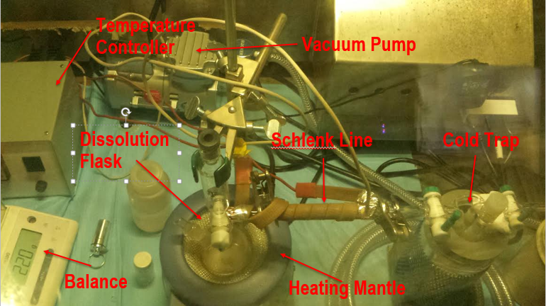

Figure 1.2.1 Dissolution of the irradiated DUO2 Pellet.

The round bottom flask was connected to a cold trap with the help of a schlenk line. The fission product gases such as H2, CO2, Kr, Br, I and N2O were captured in the cold trap inside the molecular sieves which were chilled by liquid nitrogen. The 5 ml concentrated 8 M HNO3 solution was transferred from the round bottom flask to a 20 ml glass scintillation vial and kept heavily shielded. This solution is referred to as the “dissolution solution”.

In order to reduce the amount of activity per sample, 500 μl from the dissolution solution was diluted to 5 ml and the concentration was changed to 4 M HNO3. This was subsequently called the, “stock solution”. The activity concentration of the stock solution was about .08 μCi/μL. The stock solution was stored in its own 20 ml glass scintillation vial in a lead pig inside the glovebox. Each PUREX process used 500 μL aliquots from this stock solution.

The flow chart for a PUREX cycle for the experiments is shown in Figure 1.2.2 below. The step titled, “Diluted to 5 ml with 4 M HNO3” has been previously described in this section. Each experiment started with transferring a 500 μl aliquot of stock solution along with 0.5 mg of NaNO2 with subsequent stirring, and covering in a 15 ml centrifuge tube. This produces NO2 gas. The solution was left overnight so that NO2 gas completely oxidized Pu(III) to Pu(IV).

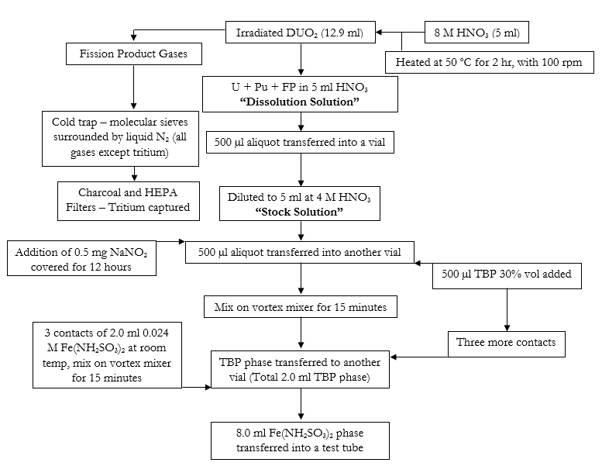

Figure 1.2.2 Flow chart for experiment.

This 500 μl aliquot was then contacted by TBP, and diluted in kerosene at room temperature. The volume of TBP varied with experiment, but the concentration remained the same with 30 % by volume TBP diluted with kerosene. When a larger volume of TBP was contacted with stock solution the extra was added to reduce the chance of accidentally pipetting HNO3. Similarly, comparable contact volumes were used during the plutonium and uranium separation.

The excess of TBP used was usually 0.2 ml. For example, each aliquot of HNO3 stock solution was 0.5 ml, and if an excess of 0.2 ml TBP was used as an intermediary, then 0.7 ml of TBP would be initially added to the stock solution and 0.5 ml would be removed for the TBP collection vial. Subsequent contacts would proceed with the addition of 0.5 ml of TBP to keep the overall volume of TBP at 0.7 ml in the mixing solution.

Both sets of extractions had the aqueous and organic phase mixed on a vortex mixer for 15 minutes at 1500 rpm, and then allowing the two phases to settle and separate. An example of the settled phases are shown in Figure 1.2.3.

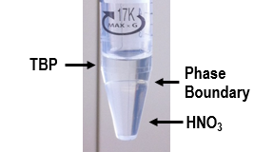

Figure 1.2.3 HNO3 and TBP phase separation.

With the help of a centrifuge and *careful* pipetting, the two phases were physically separated into two different vials. Subsequent contacts occurred to ensure the quantitative recovery of heavy metal from the stock solution with the TBP collected in a single vial.

Two concentrations of HNO3 were used in the ferrous sulfamate. The first was 0.75 M and the second 4 M. These two concentrations were used to determine differences in uranium separation, which I don’t know why different nitric acid concentrations have different uranium separations.

After the back extraction of Pu(III) the solution was prepped for another cycle of Pu decontamination with the addition of NaNO2. Dry runs of the above described experiment were conducted with natural uranium to ensure that uranium is removed from the “stock solution” and does not make its way to the product solution. Each of the above steps were analyzed with gamma spectroscopy. The aqueous phases were additionally quantified by ICP-MS analysis.

## Methods

### Distribution coefficient

The distribution ratio determination took into consideration the different volumes of contacted solution. Although the distribution ratio does not depend on volume, the volume of the two species being mixed will determine the mass of solute in each phase – and because the measurements were recorded in mass concentrations, a relationship between concentration, mass and distribution ratio was used and is shown in Equation 1.3.1.

Equation 1.3.1 Distribution ratio in terms of mass and volumes.

|  |  |  |
| --- | --- | --- |
|  | $$DR=\frac{m_{TBP}}{V_{TBP}}\frac{V_{HNO_{3}}}{m_{HNO_{3}}}=\frac{PPB_{TBP}ρ_{TBP}}{PPB_{HNO_{3}}ρ_{HNO_{3}}}$$ | Equation 1.3.1 |

where $m$ is the mass of solute, $V$ represents the volume, $PPB$ refers to the parts per billion of solute to total solution, and $ρ$ corresponds to the density of solution. Due to the fact that direct measurements of concentration of TBP were not possible with our MS methods, total mass of solute initially in solution was used and the mass in TBP was determined by taking the difference in solute concentration from the initial and final solutions of HNO3. This can be done by noting that the concentration of solute in HNO3 does not change even when the volume of TBP changes to 0.2 ml because the system was in equilibrium. For multiple contacts, calculating the distribution ratio becomes increasingly difficult due to the 0.2 ml TBP left in the stock vial and therefore distribution ratios were only calculated for a single contact – which required a simple correction. This calculation will ignore decomposition effects from irradiation, the partial solubility of nitrate in TBP, and any density changes in the solutions.



Figure 1.3.1 Mass percent of solute in TBP as a function of volume ratio for a single contact.

The mass percent deposition in the TBP phase as a function of volumes is derived by rearranging Equation 1.3.1 into Equation 1.3.2 with the assumption that mass is conserved. This is for a single contact of TBP. Using literature values for distribution ratios between 2 M HNO3 at 0 % uranium saturation and 30 vol.% TBP, Figure 1.3.1 was produced with Equation 1.3.2 (Stoller and Richards 1961). The sharp increase of uranium and plutonium in TBP at low volume ratios is due to its DR being greater than one for the actinides. This figure shows that as the volume of TBP in each contact increases, the percent mass extraction increases for all species.

Equation 1.3.2 Percent deposition in TBP.

|  |  |  |
| --- | --- | --- |
|  | $$TBP_{m\%}=\frac{1}{1+\frac{1}{DR}\frac{V_{HNO_{3}}}{V_{TBP}}}$$ | Equation 1.3.2 |

Although Figure 1.3.1 was determined for a single contact of TBP, the trend generally follows for mutiple contacts. Namely, as the volume of total TBP that contacts the stock solution increases, the distribution of mass in the product TBP will shift more and more to the organic phase. This is not exactly true because subsequent contacts change the form of the mathmatical representation in an increasingly complicated way.



Figure 1.3.2 Concentration of solute in TBP as a function of distribution ratio and volume fractions.

To illustrate, Figure 1.3.2 is a plot showing the total mass deposited in the TBP solution as a function of distribution ratio. The lines increasing thickness indicates a decreasing volume ratio, the black/green dotted lines correspond to a single contact of TBP and the red/green dashed lines correspond to two contacts of TBP, this is also indicated in the legend with a “1C” and a “2C”. Both single and double contacts correspond to the same sum total volume of TBP. The green sets of lines corresponds to a volume ratio of one and will be the subject of some discussion.

As will be shown in the next section, if product yield were not a major concern, large decontamination factors could be accomplished relatively simply by contacting a very small amount of TBP. This is highlighed in the lower right portion of Figure 1.3.2, where less than 10% of plutonium is extracted, but with very minimal fission products.

The highlighted green line shows the approximate situation for the experimental procedure followed. Due to laboratory limiations, the most feasible method for liquid-liquid extraction and back extraction were with comparable volumes of TBP and HNO3. Given this limitation, the green lines shows that multiple contacts – as opposed to a single large contact, is more benefical for extracting the maximium amount of plutonium while maintaining that the fission products are left in the waste stream. This is highlighted by recalling that plutonium and uranium reside on the right side of Figure 1.3.2, while the fission products reside mostly on the left.

It should be noted that even though the values for the distribution ratio are calculated at steady state conditions, process PUREX cycles that utilize countercurrent and/or continuous flow can utilize these numbers to determine reasonable estimates of elemental decontamination factors (Stoller and Richards 1961, Benedict, Levi et al. 1982).

Could also talk about the second contact (plotted below) – which is kind of cool – but also kind of sad for our experiment. Notice how at the 1 point we are getting a lower percentage of Pu and U than we are getting Ru and Zr (at the point where the volume ratios are equal) We probably are still getting more overall mass Pu and U, but not percentage wise, anyway that’s what is killing our decontamination factor. Oh well – live and learn.



Figure 1.3.3 Mass percent of solute in TBP second contact as a function of volume ratio.

### Decontamination Factors

The whole cycle followed in this project is shown in section 1.2. As was noted previously, laboratory constraints largely dictated how the experiment was conducted. For some conceptual grounding on how decontamination factors can be related to distribution ratios, the following is provided.

Recall that the decontamination factor is a ratio of concentration ratios. To relate the decontamination factor to the previous discussion on distribution ratios it is convenient to write it in the form of Equation 1.3.3, where $m$ corresponds to the mass of solute, the $i$ subscript corresponds to the initial mass, the $f$ subscript corresponds to the final mass, and $j$ is a subscript corresponds to the contaminate. Coupling this equation with section 1.4.1 analysis, Figure 1.3.4 can be produced, which shows the decontamination factors for various elements at 0% uranium saturation and 30 vol.% TBP for a single contact of TBP. Note that the mass of Pu is determined by assuming that its distribution ratio is 10, and uses the values calculated in the last section.

Equation 1.3.3 Decontamination factor in terms of mass.

|  |  |  |
| --- | --- | --- |
|  | $$DF_{j}=\frac{m_{j,i}}{m_{j,f}}∙\frac{m_{Pu,f}}{m_{Pu,i}}$$ | Equation 1.3.3 |



Figure 1.3.4 Decontamination factors as a function of volume ratios for first and second contact.

Figure 1.3.4 shows the decontamination factors for one and two contacts of TBP with the same volume ratio between both contacts. This plot assumes that the second contact of TBP is combined with the first contact. Different elements were plotted with their distribution ratios and the sum of each all four elements is given in the black line with x’s. The lower line in each case is the second contact, which will be discussed. Notice how extremely large decontamination factors can be achieved with minimal TBP solution. The caveat is that a small amount of plutonium is removed from the stock solution. This plot also shows that in this system, a volume ratio of 0.1 provides a large removal of plutonium, while keeping decontamination factors roughly of the same magnitude.



Figure 1.3.5 Second contact of TBP decontamination factors.

The isolated second contact decontamination factors for TBP are shown in Figure 1.3.5. This calculation assumed that the volume ratios for both passes were equal, and that the TBP was not combined with the first pass. These numbers are two orders of magnitude lower in decontamination factor than the initial contact. The reason for the left most peak is due to the small amount of plutonium removed in the first contact, and the middle peak around 0.1 volume fraction is due to the turnover in the previous plot, namely that around 0.1 volume fraction, the largest amount of plutonium is removed for the smallest amount of fission product. This is emphasized by plotting the mass percent of solute in TBP for the first and second contacts on a log-linear scale, shown in Figure 1.3.6.

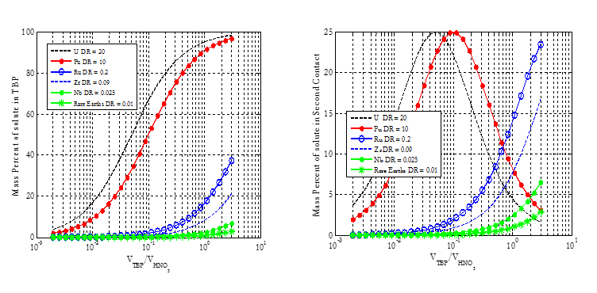

Figure 1.3.6 Mass percent of solute deposited in TBP for first and second contacts.

The optimal volume for decontamination factors for plutonium is 0.1 because the distribution ratio used for these calculations was 10, and the optimum volume occurs at its inverse. This is verified with the uranium peak at a 0.05 optimum volume ratio, which is the inverse of 20. Notice in Figure 1.3.6 and Figure 1.3.4 how the first contact removes about 50% of the plutonium and gives a certain decontamination factor, while the second contact removes about 25% of the plutonium and decreases the decontamination factor by a factor of about two. With our experimental setup, and this contacting scheme, the optimum volume to remove 75% of the plutonium without increasing the decontamination factor by a large portion would be around 50 μl. This is not how we conducted the experiment in order to simplify the chemistry. Due to the fact that the projects goal was to extract as much plutonium as possible, the previous was not optimized on, just used for reference, as the distribution ratios for this experiment were expected to be different.

The summed line assumed that each of the elements had equal mass in the stock solution, which is why the summed line acts like a line with a decontamination factor of 0.08125 – which is an average of the four elements. In order to say that decontamination factor is precisely an average of all the decontamination factors in the system this would need to be mathematically proven. Elements with larger mass fractions in the solution will therefore contribute most towards the overall decontamination factor in the product solution. This also highlights how overall decontamination factors can be approximated.

## Results

### Distribution Ratios

The distribution ratio for our experiment was determined via Equation 1.4.1, where the subscript “o” represents original aliquot and “w” represents the waste aliquot. Because both the original and waste solutions are the same composition the density cancels out from the equation in the last section.

Equation 1.4.1 Distribution ratio as a function of procut concentrations.

|  |  |  |
| --- | --- | --- |
|  | $$DR=\left(\frac{PPB_{o}}{PPB_{w}}-1\right)\frac{V_{HNO_{3}}}{V_{TBP}}$$ | Equation 1.4.1 |

The distribution ratios for several elements are listed in Table 1.4.1.

Table 1.4.1 Distribution ratios for the experiment.

|  |  |  |
| --- | --- | --- |
| Element | Distribution Ratio | ± |
| Cd | 0.047728 | 0.08 |
| Ce | 0.051329 | 0.015 |
| Eu | 0.09172 | 0.026 |
| Mo | 0.228117 | 0.104 |
| Nd | 0.048476 | 0.006 |
| Pd | 0.016026 | 0.007 |
| Pm | 0.07055 | 0.007 |
| Ru | 0.014349 | 0.001 |
| Sm | 0.076159 | 0.003 |
| Sn | 0.013914 | 3.19 |
| Sr | 0.002942 | 4E-04 |
| Cs | 0.004716 | 0.001 |
| Pu | 16.2 | 2.3 |
| U | 37.2 | 5.3 |

Sample calculation for Ce140.

Using f value for 0.04617 (percent in HNO3 – from DR).

Can estimate the percent of original Ce140 in HNO3 after four contacts at. 0.5601

The measured value was 0.5861744.

Another sample calculation to estimate the decontamination factor at a single contact and four contacts (shown for two contacts in the last section).

### Decontamination Factors Results

Share the results for a single contact, then for multiple. Do this for both the uranium, plutonium and the FP.

We calculated the DF from one contact and 4 contacts. They both yield similar distribution ratios.

This is helpful as a proof of concept.

Decontamination factors listed below.

Check sig figs. What are the columns, give the columns a proper name

|  |  |  |  |  |  |  |  |
| --- | --- | --- | --- | --- | --- | --- | --- |
| Element | 1 Contact TBP/ 1 Contact Fe | ± | % | 4 Contact TBP/ 3 Contact Fe | ± | % | Gamma Spectroscopy |
| Mo | 4.42 | 0.09 | 2.04% | 1.03 | 0.031 | 3.02% |  |
| Ru | 49 | 1.9 | 3.93% | 2.84 | 0.111 | 3.91% |  |
| Ce | 15.1 | 0.45 | 2.98% | 2.98 | 0.263 | 8.84% |  |
| Sm | 9.94 | 0.25 | 2.48% | 2.5 | 0.19 | 7.73% |  |
| Pu | 1.32 | 0.02 | 1.60% | 1.07 | 0.1 | 9.14% |  |
| Sr | 233.5 | 12.74 | 5.46% | 38.26 | 2.23 | 5.82% | 36.9 |
| Cd | 81 | 47.1 | 58.15% | 3.2 | 1.31 | 40.94% |  |
| Eu | 8.4 |  | 0.00% | 1.7 |  | 0.00% |  |
| Nd | 15.2 | 1.429 | 9.40% | 8.6 | 3.4 | 39.53% |  |
| Pd | 48.6 | 48.65 | 100.10% |  |  | #DIV/0! |  |
| Pm | 10.7 |  | 0.00% | 3.3 |  | 0.00% |  |
| Sn | 24.4 | 237.2 | 972.13% | 5.635 | 5.404 | 95.90% |  |
| Cs | 146 |  | 0.00% | 11.6 |  | 0.00% |  |

## Discussion

### Distribution Ratios

The distribution ratios follow the trend showed previously from literature values.

They are different because at different experimental conditions.

Can be used to estimate the process for the decontamination factors.

These are the more important values because they will help you design a cycle that will work.

Talk about the results. Compare with literature values that are available. Let this discussion lead you into the decontamination factor.

Look at the chemistry, explain why some of the elements are better than others.

### Decontamination Factors

Talk about how we were able to extract most of the plutonium. Maybe read the flow sheet more closely on the extraction process. To be honest, I don’t like…at all flow sheets, they are really annoying Give the results. Analyze the results. This is a longer sentence designed to check for indentation.

First separation (the mess up)

93.2 % U extraction. And 46.6% Pu recovery

Experiment done for Matt

First cycle

94% U separation

91.3% Pu recovery

Second cycle

94% U separation

94.4 Pu production (91.3*94.4 = total pu that passes)

Third cycle

Crap because of Fe(II) half-life. I hate you

REFERENCES

Benedict, M., H. Levi and T. Pigford (1982). "Nuclear chemical engineering." Nucl. Sci. Eng. **82**(4).

Stoller, S. and R. Richards (1961). "Reactor Handbook, Volume II, Fuel Reprocessing." Inter science Publishers, Inc., New York.