**Fission Product decontamination factors for plutonium separated by PUREX from a low-burnup, pseudo-fast-neutron irradiated DUO2**

Sunil S. Chirayath, Charles M. Folden III, and Paul M. Mendoza

Nuclear Security Science and Policy Institute (NSSPI)

Cyclotron Institute and Department of Nuclear Engineering

Texas A&M University, College Station, TX 77843

Abstract

Experimental investigations to determine fission product (FP) and actinide (uranium and plutonium) separation while employing the Plutonium Uranium Redox Extraction (PUREX) process to purify plutonium in neutron-irradiated uranium dioxide targets were conducted. The sample processed was low-burn-up (4.93 ± 0.132 GWd/tHM) depleted uranium dioxide (DUO2) surrogate pellet (0.28 ± 0.002 wt.% 235U). Distribution ratios for U, Pu, Mo, Ru, Ce, Sm, Sr, Pm, Eu, Nd, Pd, Cd and Sn for the 30 vol.% tri-n-butyl phosphate in a kerosene diluent co-decontamination step at low uranium concentrations in 4 M nitric acid were determined. These values were consistent with of previously reported values and were used to estimate decontamination factors for each of the above listed elements for a PUREX cycle. These estimates were then verified with mass spectrometry and gamma spectroscopy. The laboratory scale PUREX cycle employed had an overall 91.3 % Pu recovery with an overall activity decontamination factor of ~20 (if I am lucky after I fix for the activity mess).

1. Introduction

Various literature sources provide information about overall process or cycle decontamination factors (DF) for PUREX (Gresky 1950, Arker 1954, Chandler 1954). These values are typically reported via gross gamma or beta counts with values ranging from 106 to 108. While distribution coefficients (DC) for the various process steps of PUREX have been previously reported, details about elemental DF for PUREX cycles have been largely limited to the major activity contributors, such as ruthenium and zirconium. Although a DC, coupled with process information, can be used to calculate a reasonable estimate of DF (Colburn 1939, Sherwood and Pigford 1952, Perry and Green 2008), variability of DCs under different system conditions give rise to uncertainty in calculated results. Due to recent proposals suggesting that investigation of PUREX processed plutonium for trace contaminates could give indication of material origins, DF for a broader sweep of elements were deemed necessary (Chirayath, Osborn et al. 2015).

Fission product DFs and actinide recovery as a function of coupled extraction/back-extraction PUREX steps were applied to a low-burnup (< 5000 MWd/MTU) depleted uranium dioxide (DUO2) surrogate pellet (0.28 ± 0.002 wt.% 235U) irradiated in a pseudo fast neutron spectrum. The DUO2 surrogate pellet, containing FP and weapons grade plutonium were subjected to three PUREX decontamination steps and the aqueous process solutions analyzed at each step with Inductively Coupled Plasma-Mass Spectrometry (ICP-MS). The experimental work sought to develop laboratory scale methods to isolate a large percentage of plutonium, determine DC, and three step DFs as part of development of forensic radiochemical analytical capabilities at Texas A&M.

1. Background

DCs, defined as the ratio of grams per liter of solute in the organic solution over grams per liter of solute in the aqueous solution, shown in Equation 1, describe the steady state distribution of any species in the system (Benedict, Levi et al. 1982). To be expected, DCs are different from element to element, and vary widely with concentrations, and temperatures of solvents. They are also affected by saturation of uranium and plutonium in the system and even time since preparation of the solution (Stoller and Richards 1961, Michael and Jack 2010).

Equation 1 Distribution coefficient.

|  |  |  |
| --- | --- | --- |
|  | $$DC=\frac{concentration of contaminant in org. phase}{concentration of contaminant in aq. phase}$$ | 1 |

For PUREX, the mass deposition in the TBP phase, assuming equal contact volumes is derived by assuming that mass is conserved, and is shown in Equation 2.

Equation 2 Percent deposition in the TBP phase.

|  |  |  |
| --- | --- | --- |
|  | $$TBP_{m\%}=\frac{1}{1+\frac{1}{DC}}$$ | 2 |

After several cycles of plutonium extraction/decontamination are complete, the measured effectiveness of a PUREX cycle is described by the decontamination factor (DF), which are fundamentally determined by DCs and measures the effectiveness with which a contaminant is removed from a product. With plutonium shown as the product, this is shown in Equation 3, where $C$ represents concentration, $Pu$ represents plutonium, and $j$ represents the contaminant. It should be noted that as long as the concentrations are of the same kind, then it does not matter whether they are reported in mass or atomic units.

Equation 3 Decontamination factor for a single contaminate.

|  |  |  |
| --- | --- | --- |
|  |  | 3 |

DFs are also characteristic of different process cycles, and will have much greater numerical values in industrial systems. Most industrial processes report DFs on the order of 107 for an *overall* DF. An overall DF ($DF_{overall}$), by definition, would be described with Equation 4, where j is summed over all contaminants. Therefore industrial processes are more inclined to report DF with regard to total gamma or total beta activity, where an overall concentration is more easily determined. Otherwise, to be precise, each particular contaminant, or fission product, should be measured and quantified. Typically blanket DF values, with no reference towards specific contaminants or method are listed. This is a problem, because $DF_{overall}$ is a strong function of the pool of contaminants used for the calculation.

Equation 4 Over-all decontamination factor.

|  |  |  |
| --- | --- | --- |
|  |  | 4 |

To show this, Equation 4 is rewritten in Equation 5 and Equation 6. The relation between individual DFs and $DF_{overall}$ is depicted in Equation 5, where $i$ loops over all contaminants. It is important to realize two things, first, that DFs are additive, and second, that the parenthetical statement of Equation 4 represents a percentage, where if $DF_{j}$ were removed from the equation, then the summation would be precisely 1.

Equation 6 utilized Equation 2 and Equation 3 and shows $DF_{overall}$ for an equal volume liquid-liquid separation between nitric acid and TBP. The numerator inside the large summation for Equation 6 is constant across all contaminants and the largest initial concentrations are shown to contribute the most towards the overall DF.

Equation 5 Over-all DF in terms of indicidual DFs.

|  |  |  |
| --- | --- | --- |
|  |  | 5 |

Equation 6 Decontamination factor for a single contact of TBP.

|  |  |  |
| --- | --- | --- |
|  | $$DF_{overall}=\left(1+\frac{1}{DC_{Pu}}\right)\sum_{j=1}^{J}{\frac{c_{j,initial} }{\sum_{i=1}^{I}{\frac{c_{i,initial}}{1+1/DC_{j} }}}}$$ | 6 |

These equations highlight the fact that the contaminants used for the calculation have a large influence on what the value of $DF_{overall}$ is. Noting that $DF_{overall}$ is driven mostly by contaminants with the largest *initial* concentration followed by contaminants with large DCs. The above statements seem obvious, but their impact can be substantial. For example, if Equation 6 were used to calculate $DF_{overall}$ for 30 contaminants each with a DC of 0.001 and perfect plutonium recovery, then $DF_{overall}$ would be 1000. If a single contaminant DC value were changed to 0.01, then $DF_{overall}$ would be 772, which is a 25% decrease in $DF_{overall}$ for a single step. This effect increases as the number of contaminants accounted for decreases, which is why individual decontamination factors are necessary. $DF_{overall}$ with respect to gamma counts and elemental DFs will be reported, but will not be calculated from each other for reasons stated above.

To stress other factors that affect DFs and give context for the DF values provided in this paper, Figure 1 was produced. Figure 1 shows calculated decontamination factors for one and two contacts of TBP with the same volume ratio between both contacts with the assumptions of constant DC across all volume ratios and a DC for plutonium of 10. This plot assumes that the second contact of TBP is combined with the first contact. Different elements have different DC, which is why several values are shown on the graph. The lower line in each case is the second contact.

Although different volume ratios will affect how close uranium is to the solubility limit, and affects the DC for various elements, two concept effects are emphasized with Figure 1. The first is that volume plays a significant role in DF - notice how extremely large DF can be achieved with minimal TBP solution. The second is that each contact of TBP reduces DFs by a large fraction at larger volumes of TBP. The experiment utilized four contacts at a volume ratio 1.4.



Figure 1 Decontamination factors as a function of volume ratios for first and second contact.

1. Literature Review

Descriptions for various PUREX variations are provided in many sources (Reas 1957, Stoller and Richards 1961, Benedict, Levi et al. 1982) with explanations of chemistry, flow sheets, and process. These sources report overall gamma DFs of ~108 with plutonium recoveries of 99.7 % for industrial scale reprocessing facilities. Further, DC values for TBP and nitric acid are provided for U, Pu, Zr, Nb, Ru, and the rare earth elements. DCs are disclosed in numerical and graphical format and vary with nitric acid concentration and uranium saturation in TBP. These sources also derive mathematical correlations between DC and DF, but experimental PUREX DFs for individual elements were not provided.

A compilation of distribution data for PUREX extraction process provide DC information for uranium thorium, and plutonium in a variety of concentrations (Prout 1957). DC for Zr, rare earth metals, plutonium, and thorium, have been provided in the “Tri-n-butyl phosphate as an extracting solvent for inorganic nitrates” series (Alcock, Bedford et al. 1957, Best, McKay et al. 1957, Hesford, McKay et al. 1957, Scargill, Alcock et al. 1957, Alcock, Best et al. 1958, Best, Hesford et al. 1959, Hesford, Jackson et al. 1959). This information will be extremely useful for verifying trends between the different DF produced in this experiment.

Understandably, DC for elements of the alkali and alkaline earth metals have not been extensively reported, because these elements are not appreciably extracted into organic solvents. DF for these elements are important to know because Cs and Ba concentrations are useful for determining reactor parameters. Gallium, conversely, has been studied for separation (Collins, Campbell et al. 2000) because it is a common contaminate in weapons grade plutonium.

Over cycle DF for PUREX has been reported for Ru, Zr, and Nb, but literature review has failed to produce DFs for the vast majority of elements.

(if you can find DC for alkali earth metals somewhere, I should add them here)

(Further studies have been done about recovering fission products from the waste stream – should I mention that?). (Swift 1961, Weaver 1963, Gupta, Singh et al. 2009)

1. Experiment

How was the sample prepared? I was not on the project at this point

How was the sample irradiated? I was not on the project at this point

How were the chemical acquired? I was not on the project at this point

12.9 mg of irradiated depleted uranium dioxide was dissolved in 15.43 M HNO3, about 10% of the aliquot was further diluted to 3.95 M HNO3 and PUREX ensued with 1/100th of the pellet in 0.5 ml aliquots. This was known as the stock solution. U(VI) and Pu(IV) were extracted and decontaminated by contacting the stock solution with a solution of 30 vol.% tri-n-butyl phosphate with a kerosene diluent. Plutonium was then reduced to Pu(III) and extracted and separated from uranium by contacting the tri-n-butyl phosphate solution with dilute HNO3 acid in a 0.024 M ferrous sulfamate solution via oxidation of Fe(II). Pu(III) was converted to Pu(IV) via the addition of sodium nitrite and further decontamination/extraction ensued by repeating the process.

The pellet, both prior to dissolution and after, was counted on a standard Canberra electrode coaxial Ge detector model number CC4018 which was controlled by a Canberra Lynx MCA. GENIE software was used to analyze spectrum and samples were typically encased in a lead tomb. Inductively coupled plasma mass spectrometry (ICP-MS) was also conducted for some samples with use of the University of Missouri’s PerkinElmer NexION 300X quadrupole ICP-MS. A Canberra Passivated Implanted Planar Silicon (PIPS) detector coupled with an alpha spectrometer a MCA and a vacuum pump were also used qualitatively to verify plutonium separation of co-precipitated plutonium. Quantitative measurement for this method proved difficult due to smearing of alpha energies by filter paper.

Detailed three dimensional models of Oak Ridge National Laboratories’ (ORNL) High Flux Isotope Reactor (HFIR) were developed using the Monte Carlo transport computer code, MCNP, coupled with the burn-up/depletion computer code, CINDER90. These were used to model the irradiation of a DUO2 surrogate pellet so that expected activities and concentrations could be determined. A measured 12.9 ± 0.05 mg of DUO2 was irradiated over the course of three months with two shut down periods in the HFIR flux spectrum to about 3000 MWd/t. The burn-up was determined by measuring 137Cs activity and through the MCNP calculation. This produced 0.237 ± 0.001 mg of Pu.

After the short lived radioisotopes had opportunity to decay, the irradiated DUO2 pellet was weighed in a weighing boat on an electronic balance and transferred to a round bottom flask. 5 ml of 8 M HNO3 was added to the round bottom flask and the flask was heated at 50°C with constant 100 rpm stirring for two hours. The dissolution apparatus is shown in Figure 2.

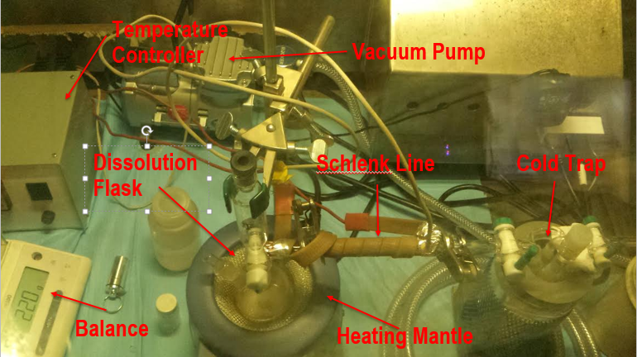

Figure 2 Dissolution of the irradiated DUO2 pellet.

The round bottom flask was connected to a cold trap with the help of a Schlenk line. The fission product gases such as H2, CO2, Kr, Br, I and N2O were captured in the cold trap inside the molecular sieves which were chilled by liquid nitrogen. The 5 ml concentrated 8 M HNO3 solution was transferred from the round bottom flask to a 20 ml glass scintillation vial and kept heavily shielded. This solution is referred to as the “dissolution solution”.

In order to reduce the amount of activity per sample, 500 μl from the dissolution solution was diluted to 5 ml and the concentration was changed to 4 M HNO3 with the addition of deionized water. This was subsequently called, “stock solution”. The activity concentration of the stock solution was about 80 μCi/ml. The stock solution was stored in its own 20 ml glass scintillation vial in a lead pig inside a glovebox. Each PUREX process used 0.5 ml aliquots from this stock solution.

The flow chart for a PUREX cycle for the experiments is shown in Figure 3 below. The step titled, “Diluted to 5 ml with 4 M HNO3” has been previously described in this section. The flow chart has boxed numbers to help make the steps clearer. Each experiment started with transferring a 500 μl aliquot of stock solution along with 0.5 mg of NaNO2 with subsequent stirring, and covering in a 15 ml centrifuge tube. This produces NO2 gas. The solution was left overnight so that NO2 gas completely oxidized Pu(III) to Pu(IV).

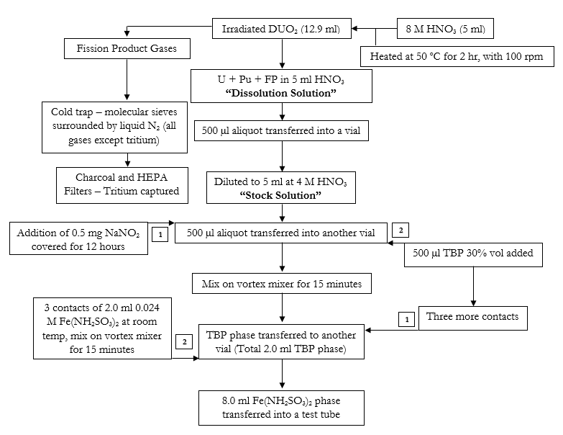

Figure 3 Flow chart for experiment.

This 500 μl aliquot was then contacted by TBP at room temperature. The volume of TBP was kept as close to 500 μl as possible, but usually an additional 200 μl was added. The concentration remained the same with 30 % by volume TBP diluted with kerosene. When a larger volume of TBP was contacted with stock solution the extra was added to reduce the chance of accidentally pipetting HNO3. Similarly, comparable contact volumes were used during the plutonium and uranium separation.

Both sets of extractions had the aqueous and organic phase mixed on a vortex mixer for 15 minutes at 1500 rpm, and then allowing the two phases to settle and separate. The sample was additionally centrifuged and carefully pipetted to physically separate the two phases into two different vials. For the PUREX cycles, TBP was contacted with stock solution multiple times to ensure the quantitative recovery of heavy metal from the stock solution with the TBP collected in a single vial.

Two concentrations of HNO3 were used in the ferrous sulfamate solution. The first was 0.75 M and the second 4 M. These two concentrations were used to determine differences in uranium separation, which occurs because NO3- concentrations affect the distribution ratio for uranium.

After the back extraction of Pu(III) the solution was prepped for another cycle of Pu decontamination with the addition of NaNO2. Dry runs of the above described experiment were conducted with natural uranium to ensure that uranium is removed from the “stock solution” and does not make its way to the product solution. Each of the above steps were analyzed with gamma spectroscopy for fission products. The aqueous phases were additionally quantified by ICP-MS analysis.

1. Results
2. Distribution Ratios

The distribution ratio determination took into consideration the different volumes of contacted solution. The distribution ratio for the experiment were determined with Equation 7, where the subscript “o” represents original aliquot, “w” represents the waste aliquot, and V represents volume. Because both the original and waste solutions are the same composition so the density cancels out.

Equation 7 Distribution ratio as a function of procut concentrations.

|  |  |  |
| --- | --- | --- |
|  | $$DR=\left(\frac{C_{o}}{C_{w}}-1\right)\frac{V_{HNO_{3}}}{V_{TBP}}$$ | Equation 7 |

The distribution ratios for several elements are listed in Table 1.

Table 1 Distribution ratios for the experiment.

|  |  |  |
| --- | --- | --- |
| Element | Distribution Ratio | ± |
| Cd | 0.048 | 0.08 |
| Ce | 0.051 | 0.015 |
| Eu | 0.091 | 0.026 |
| Mo | 0.228 | 0.104 |
| Nd | 0.048 | 0.006 |
| Pd | 0.016 | 0.007 |
| Pm | 0.070 | 0.007 |
| Ru | 0.014 | 0.001 |
| Sm | 0.076 | 0.003 |
| Sn | 0.013 | 3.19 |
| Sr | 0.003 | 4E-04 |
| Cs | 0.005 | 0.001 |
| Pu | 16.2 | 2.3 |
| U | 37.2 | 5.3 |

1. Decontamination Factors Results

The decontamination factors for

Share the results for a single contact, then for multiple. Do this for both the uranium, plutonium and the FP.

We calculated the DF from one contact and 4 contacts. They both yield similar distribution ratios.

This is helpful as a proof of concept.

Decontamination factors listed below.

Check sig figs. What are the columns, give the columns a proper name

|  |  |  |  |  |
| --- | --- | --- | --- | --- |
| Element | 1 Contact TBP/ 1 Contact Fe | ± | 4 Contact TBP/ 3 Contact Fe | ± |
| Mo | 4.42 | 0.09 | 1.03 | 0.031 |
| Ru | 49 | 1.9 | 2.84 | 0.111 |
| Ce | 15.1 | 0.45 | 2.98 | 0.263 |
| Sm | 9.94 | 0.25 | 2.5 | 0.19 |
| Pu | 1.32 | 0.02 | 1.07 | 0.1 |
| Sr | 233.5 | 12.74 | 38.26 | 2.23 |
| Cd | 81 | 47.1 | 3.2 | 1.31 |
| Eu | 8.4 |  | 1.7 |  |
| Nd | 15.2 | 1.429 | 8.6 | 3.4 |
| Pd | 48.6 | 48.65 |  |  |
| Pm | 10.7 |  | 3.3 |  |
| Sn | 24.4 | 237.2 | 5.635 | 5.404 |
| Cs | 146 |  | 11.6 |  |

1. Discussion
2. Distribution Ratios

The distribution ratios follow the trend showed previously from literature values.

They are different because at different experimental conditions.

Can be used to estimate the process for the decontamination factors.

These are the more important values because they will help you design a cycle that will work.

Talk about the results. Compare with literature values that are available. Let this discussion lead you into the decontamination factor.

Look at the chemistry, explain why some of the elements are better than others.

1. Decontamination Factors

Talk about how we were able to extract most of the plutonium. Maybe read the flow sheet more closely on the extraction process. To be honest, I don’t like…at all flow sheets, they are really annoying Give the results. Analyze the results. This is a longer sentence designed to check for indentation.

First separation (the mess up)

93.2 % U extraction. And 46.6% Pu recovery

Experiment done for Matt

First cycle

94% U separation

91.3% Pu recovery

Second cycle

94% U separation

94.4 Pu production (91.3*94.4 = total pu that passes)

Third cycle

Crap because of Fe(II) half-life. I hate you

REFERENCES

Alcock, K., F. Bedford, W. Hardwick and H. McKay (1957). "Tri-n-butyl phosphate as an extracting solvent for inorganic nitrates—I: Zirconium nitrate." Journal of Inorganic and Nuclear Chemistry **4**(2): 100-105.

Alcock, K., G. Best, E. Hesford and H. McKay (1958). "Tri-n-butyl phosphate as an extracting solvent for inorganic nitrates—V: Further results for the tetra-and hexavalent actinide nitrates." Journal of Inorganic and Nuclear Chemistry **6**(4): 328-333.

Benedict, M., H. Levi and T. Pigford (1982). "Nuclear chemical engineering." Nucl. Sci. Eng. **82**(4).

Best, G., E. Hesford and H. McKay (1959). "Tri-n-butyl phosphate as an extracting agent for inorganic nitrates—VII: The trivalent actinide nitrates." Journal of Inorganic and Nuclear Chemistry **12**(1): 136-140.

Best, G., H. McKay and P. Woodgate (1957). "Tri-n-butyl phosphate as an extracting solvent for inorganic nitrates—III The plutonium nitrates." Journal of Inorganic and Nuclear Chemistry **4**(5): 315-320.

Chirayath, S. S., J. M. Osborn and T. M. Coles (2015). "Trace Fission Product Ratios for Nuclear Forensics Attribution of Weapons-Grade Plutonium from Fast and Thermal Reactors." Science & Global Security **23**(1): 48-67.

Colburn, A. P. (1939). "Simplified calculation of diffusional processes." general consideration of two-film resistances **35**: 211-236.

Collins, E., D. Campbell and L. Felker (2000). "Measurement of achievable plutonium decontamination from gallium by means of PUREX solvent extraction." ORNL/TM-1999/312, Oak Ridge National Laboratory.

Gupta, K. K., S. Singh, G. A. Inamdar, A. Madhusudan and S. C. Tripathi (2009). "Studies on decontamination of spent ion exchange resin used for plutonium purification in PUREX stream." Journal of Radioanalytical and Nuclear Chemistry **281**(3): 609-614.

Hesford, E., E. Jackson and H. McKay (1959). "Tri-n-butyl phosphate as an extracting agent for inorganic nitrates—VI Further results for the rare earth nitrates." Journal of Inorganic and Nuclear Chemistry **9**(3-4): 279-289.

Hesford, E., H. McKay and D. Scargill (1957). "Tri-n-butyl phosphate as an extracting solvent for inorganic nitrates—IV Thorium nitrate." Journal of Inorganic and Nuclear Chemistry **4**(5): 321-325.

Michael, F. S. and D. L. Jack (2010). Nuclear Fuel Reprocessing - INL/EXT-10-17753, Idaho National Laboratory (INL)

Sponsoring Organization: DOE - NE.

Perry, R. H. and D. W. Green (2008). Perry's chemical engineers' handbook. 8th ed, New York : McGraw-Hill, [2008]

8th ed. / prepared by a staff of specialists under the editorial direction of editor-in-chief, Don W. Green, late editor, Robert H. Perry.

Prout, W. (1957). EQUILIBRIUM DISTRIBUTION DATA FOR PUREX AND SIMILAR EXTRACTION PROCESSES.

Reas, W. (1957). THE PUREX PROCESS-A SOLVENT EXTRACTION REPROCESSING METHOD FOR IRRADIATED URANIUM.

Scargill, D., K. Alcock, J. Fletcher, E. Hesford and H. McKay (1957). "Tri-n-butyl phosphate as an extracting solvent for inorganic nitrates—II Yttrium and the lower lanthanide nitrates." Journal of Inorganic and Nuclear Chemistry **4**(5): 304-314.

Sherwood, T. K. and R. L. Pigford (1952). Absorption and extraction. 2d ed, New York : McGraw-Hill, 1952.

2d ed.

Stoller, S. and R. Richards (1961). "Reactor Handbook, Volume II, Fuel Reprocessing." Inter science Publishers, Inc., New York.

Swift, W. (1961). THE RECOVERY OF FISSION PRODUCT RARE EARTH SULFATES FROM PUREX 1WW.

Weaver, B. (1963). RECOVERY OF FISSION PRODUCTS FROM WASTE SOLUTIONS BY SOLVENT EXTRACTION**:** 39.