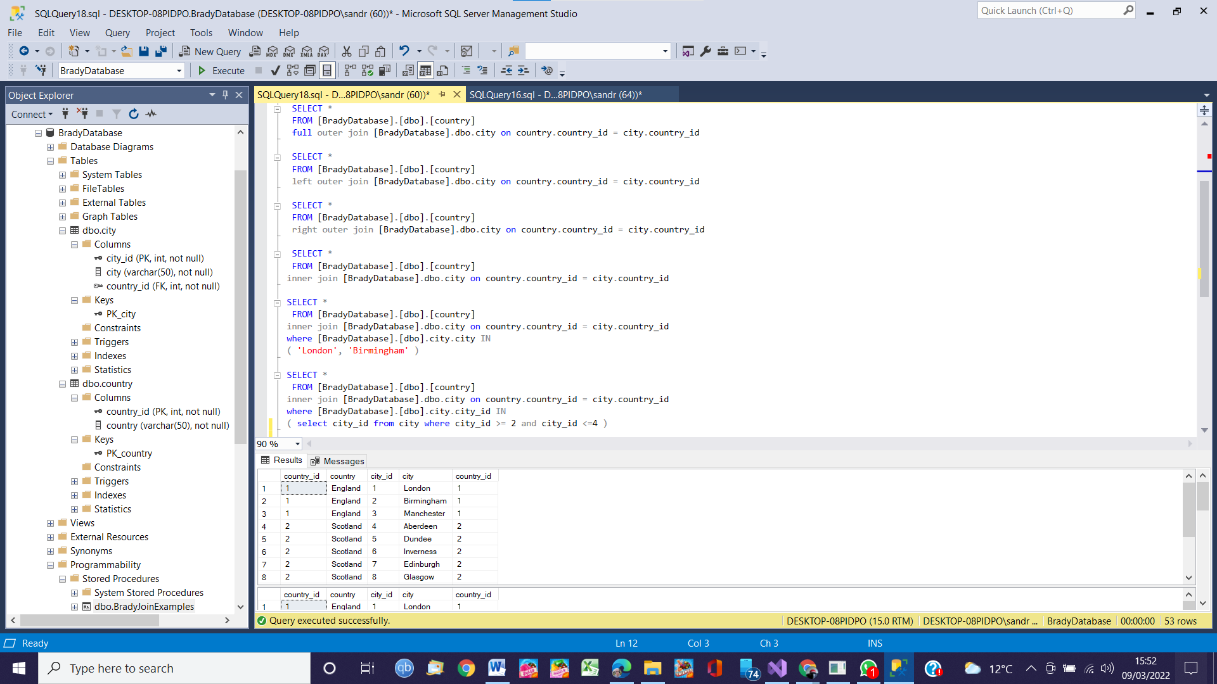
The two tables are related by the country_id column as a country has many cities and a city can only have one country.
With no FK constraint it is possible to have a city present that does not have a country as in the New York example.
It is also possible to have a country with no cities as in the France example.
A full outer join will return nulls where this is no related row in the joined table from either side.
A left outer join will return all rows from cities and nulls where no country exists.
A right outer join will return all rows from countries and nulls where no cities exist.
A inner join will return rows where there are matching rows from both sides.

