TOD Readiness Study Report
This study followed the outlines given in Achieving Outcomes for Transit Oriented Development: An Analysis of Readiness, which was prepared for FDOT by Renaissance Planning. Before reading this report, it will be very helpful to read the original guide. Many parts of the process we followed are omitted due to following the approach outlined by the guide almost exactly. Since the guide is somewhat vague on where data is taken from, the data sources used will be outlined here. Internal data was used for major roads, bus stops, greenway lines, bikeway lines, city boundaries, building outlines, parcel data, zoning, and land permits. ACS, Census, and LEHD data were used where specified in the guide, and to calculate statistics for the proposed BRT routes outlined later in the report. CNT’s All Transit Tool, HTA Index Tool, and Walk Score’s tool at walkscore.com were all used where specified in the guide. To save time and to be within the scope of this study, we decided to skip scoring all policy measures outlined in the guide, instead focusing on data readily available to us. In that vein, we skipped including Transit Service and Infrastructure (Measure 12 of 20) in the final score, as there is no preexisting infrastructure for BRT within the area. Including this measure weighted the results towards downtown Little Rock and North Little Rock, areas already served by public transit, and shifted the focus away from other potential TOD areas. We also skipped scoring Financial Incentives for Development (Measure 9 of 20), as we did not have a financial study for each of the nearly 25,000 potential station areas examined in this study. Additionally, we undertook some small changes to Path Connectivity (Measure 14 of 20) as we did not have the bandwidth to individually examine each station area. To calculate this measure, we took all blocks within a ½ mile radius of the station centroid (extracted from street network data) and calculated the minimum square bounding geometry of each block. From this point on, this radius will be referred to as the station area. Blocks that had 90% or more of the area of their minimum bounding geometry were considered as square blocks. Then, the percentage of blocks that were square per station area was used to calculate part of the score for Path Connectivity. The purpose of this score was to determine if the station area had a street like grid, or a suburban like grid, the latter being scored lower. The scoring criteria is outlined in Table 1.
Table 1: Path Connectivity Custom Scoring Threshold for Block Squareness
Least Ready ----------------------------------------------------------------------------- Most Ready
1 | 2 | 3
0% to 50% are square blocks | 50% to 75% are square blocks | More than 75% are square blocks

Then, for all minimum bounding geometries within the station area, the mean area and standard deviation of area was calculated. The ratio of the standard deviation over the mean was then calculated for each station. The resulting percentage was then used to calculate the other part of the score for Path Connectivity. The purpose of this score was to ensure the blocks were similar in size, and not just grid-like, which should promote a more walkable environment. The scoring criteria is outlined in Table 2.
Table 2: Path Connectivity Custom Scoring Threshold for Similar Sizes
Least Ready ----------------------------------------------------------------------------- Most Ready
0 | 1 | 2
Ratio greater than 25% | Ratio between 15% and 25% | Ratio less than 15%

There are many flaws to this approach, but it approximated the original scoring criteria well enough to, in our opinion, remove the human element for this scoring measure.
We also slightly modified the scoring for Civic and Education Uses (Measure 18 of 20). To remove the human element of determining regional vs local significance, if any Museum, Library, or cultural performance hall existed within the station area, two points would be added to the score for this measure.
The last scoring criteria that was modified was Community Events and Branding (Measure 19 of 20). This scoring criteria was heavily modified to eliminate the human element necessary to score the original criteria. Two criteria were kept in our version of this measure: the station area having a well-known name or identity, and the station area taking advantage of any unique or cultural attributes. To calculate if the station had a well-known name or identity, a buffer representing each station area was calculated. Then, the clipping feature of these buffers with design overlay districts from LR & NLR zoning was calculated. For each station area, if 5% or more of the original station buffer area was in the clipped feature, then the station was said to meet the first criteria outlined. An almost identical process was followed for the second criteria, the only difference being that instead of overlay districts being used for the clipping step, historic districts were used. The scoring criteria is outlined in Tables 3 and 4.
Table 3: Community Events and Branding Custom Scoring for Identity
Least Ready ----------------------------------------------------------------------------- Most Ready
0 | 1
Less than 5% of station area in feature | 5% or more of station area in feature

Table 4: Community Events and Branding Custom Scoring for Unique Attributes
Least Ready ----------------------------------------------------------------------------- Most Ready
0 | 1
Less than 5% of station area in district | 5% or more of station area in district

This total score replaced the score of the original measure, with a maximum of 2 points being possible.
Lastly, when calculating the final score, we decided that some measures should be weighed more importantly than others. The following formula was used to calculate the final score for each station area:
(Diversity of Existing Uses within Walking Distance * 5) + (Transit Travel Shed * 4) + (Redevelopment Potential * 4) + (Real Estate Values * 3) + (Trends in Income and Educational Attainment Data * 3) + (Recent Development Activity * 3) + (Housing and Transportation Affordability Index * 3) + (Bicycle Comfort * 2) + (Path Connectivity * 2) + (Block Size * 2) + (Community Events and Branding * 1) + (Civic and Educational Uses * 1) + (Community Gathering Places * 1)
Since we were interested in which areas in Little Rock and North Little Rock would be the ripest for TOD, we decided to calculate every feasible area within the city boundaries. To do this, a grid of 350 feet by 350 feet squares was generated using the city boundaries as the limiting extent. After this, grids that intersected with the Pulaski County floodplain were removed. Finally, grids that had their center in areas of 15% or more slope (calculated using a Pulaski County elevation raster) were also removed. A separate layer of centroid geometries for the grid was calculated to be used in the rest of the study.
After the total score was calculated for each station area, the score was normalized (with the maximum possible value as 167) to a scale of 100, and Figure 1 was created to show the data.
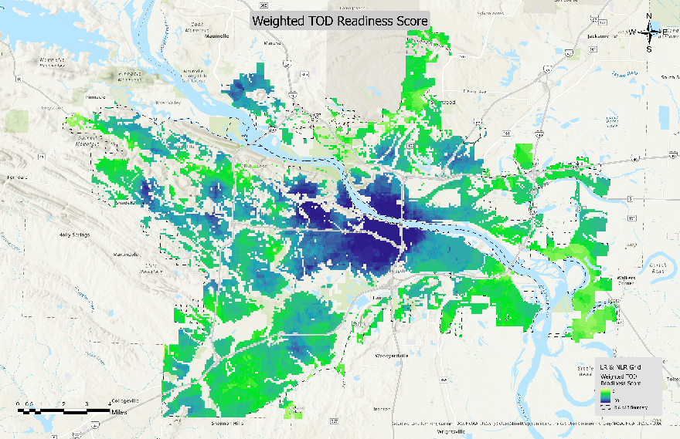
Figure 1: Weighted TOD Readiness Score
It is important to note that Figure 1 shows the areas that are currently most ripe for TOD, but not what has the greatest future potential for TOD. To better understand what areas have high future potential for TOD, we used the Redevelopment Potential measure to create Figure 2 and focused on areas outside of downtown Little Rock and North Little Rock.
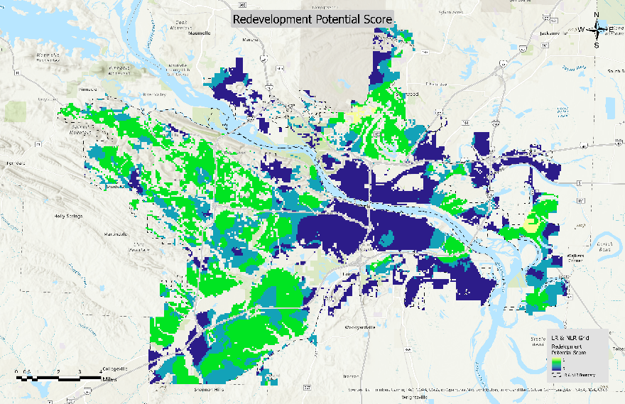
Figure 2: Redevelopment Potential Score
Using both Figures 1 and 2, we decided to create a theoretical BRT system. We chose to focus on areas outside of downtown Little Rock and North Little Rock, as both of these areas are currently well served by public transit, and rather draw attention to the growing areas in west Little Rock and along I-30. To create these routes, we focused on prioritizing proposed bus routes that stayed on the same road, and connecting hotspots identified on Figures 1 and 2. To filter out potential routes, the roads classified as minor arterial to state highway were extracted from a road network shapefile, and potential routes were drawn along said roads. The system was designed with connecting the most areas in mind, which is why there are some stretches of the system that do not cover hotspots. There are also some routes which may look questionable at first, but will be explained in further detail later. Additionally, high potential TOD areas were identified along the suggested routes, which are not ripe for TOD as of now, but showed up as hotspots in Figure 2 and are connected to the proposed BRT routes. Figure 3 was created to show the different routes and proposed areas.
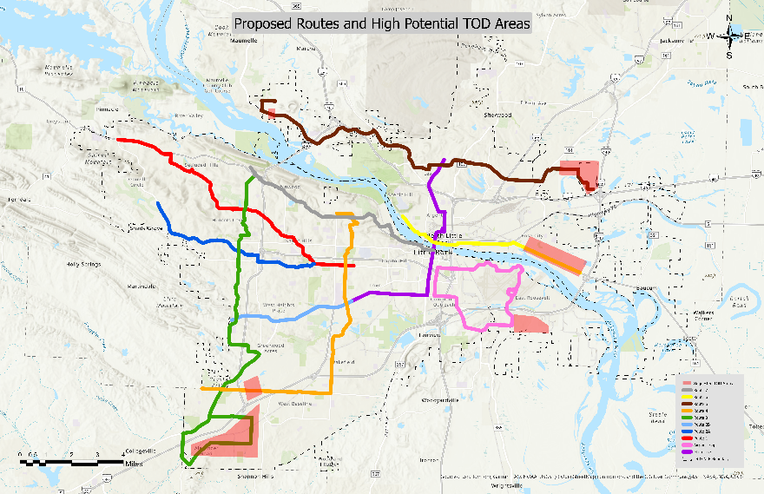
Figure 3: Proposed Routes and High Potential TOD Areas
Additionally, we thought it would be interesting to see the coverage of the lines for recent population and jobs data. So, the number of jobs within a ¼ mile radius and the population within a ½ mile radius from each proposed route was calculated. Both were divided by the length in miles of the proposed route to better show the true reach of each proposed route. Both of these fields were used to create Figures 4 and 5.
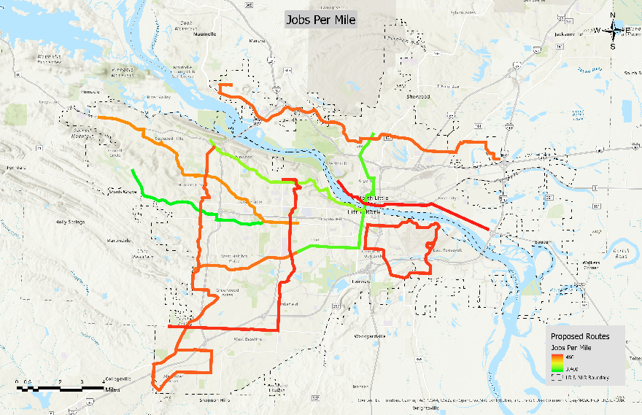
Figure 4: Jobs Per Mile
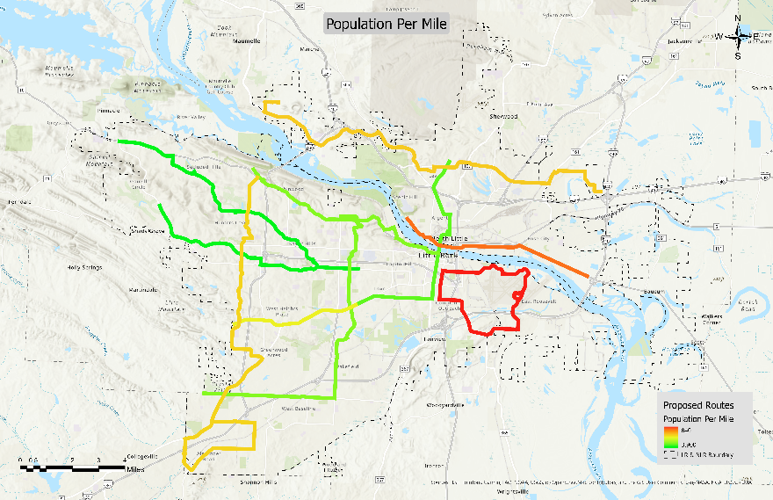
Figure 5: Population Per Mile
It is important to note that the routes cluster together in different groups, so the coloration of Figures 4 and 5 do not entirely show the true nature of each proposed line. To help better show the data collected, Figure 6 was created.
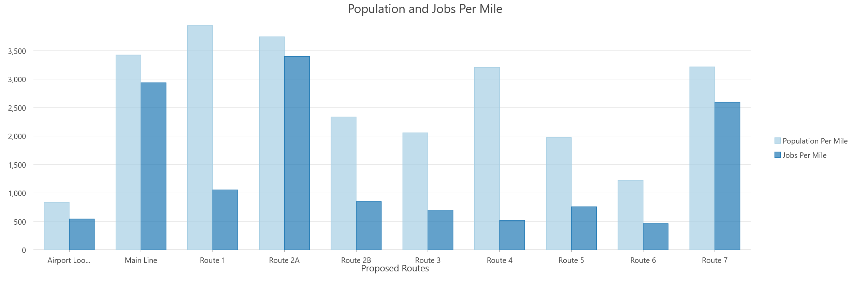
Figure 6: Bar Chart of Population and Jobs Per Mile
It can be seen from these figures that the worst performing lines, by far, are the airport loop and Route 6 in North Little Rock. Route 6 is primarily a residential route that would connect to the main line, getting people to jobs that way. There is currently not as much development to support the demand the route would need to be feasible, but if development were to occur along the high potential TOD area, population served would likely increase significantly. It is a very similar story for the green and orange lines that reach far down into the southwest corner of Figure 3. There is currently not much development along the corridor, but if investment was made, these proposed routes would make more sense. Lastly, the airport line is suggested simply to connect the airport to downtown, so the results from population and jobs served are less important than the other proposed routes. However, we still identified an area around College Station which has high potential for TOD if the proposed airport route were to drop down to that area, although with the industrial development in the area this may not be very appealing.
Near the end of the study, we decided to also use infill data that we previously made a report for to help identify better high potential areas for TOD. The link to the infill layer used in this study can be found here: Infill Opportunity Sites. The previous infill data was parcels of land that were identified as vacant or undeveloped, that were in areas where infill development would be possible to help transition to a more urban environment. The LR & NLR grid feature was clipped by the infill data feature, and the area of each of the grid squares in the new feature was calculated. The ratio of clipped area to original area was normalized on a scale of 1 to 5, and this was used as the Infill Development score. Any squares in the LR & NLR grid feature that did not intersect with the infill data feature were given an Infill Development score of zero. A new total weighted score was calculated for each station area using the Infill Development score and the other scores gathered from the aforementioned methodology. Importantly, any score that received an Infill Development score of zero, received a total weighted score of zero. Like the previous methodology outlined, each of the scores was weighted, with the new Infill Development score receiving a weight of six. The formula below was used to calculate the new total weighted score.
(Infill Development * 6) + (Diversity of Existing Uses within Walking Distance * 5) + (Transit Travel Shed * 4) + (Redevelopment Potential * 4) + (Real Estate Values * 3) + (Trends in Income and Educational Attainment Data * 3) + (Recent Development Activity * 3) + (Housing and Transportation Affordability Index * 3) + (Bicycle Comfort * 2) + (Path Connectivity * 2) + (Block Size * 2) + (Community Events and Branding * 1) + (Civic and Educational Uses * 1) + (Community Gathering Places * 1)
This new score was used to create Figure 6. Hopefully, this figure is able to provide more insight as to what areas have high potential for TOD development besides the ones outlined in Figure 3.

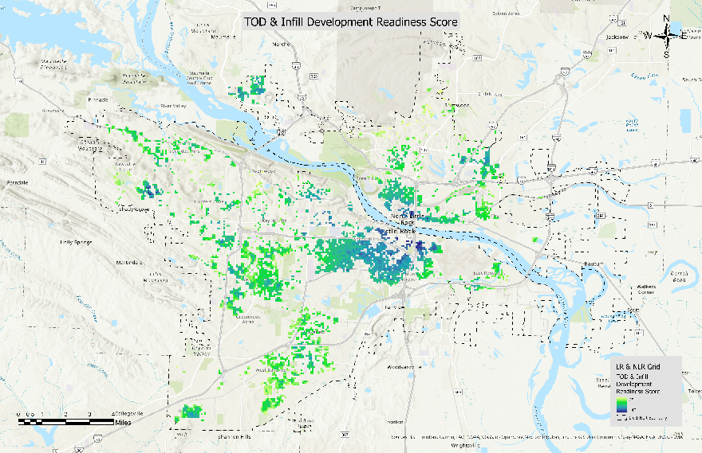
Figure 6: TOD & Infill Development Readiness Score
At the end of the day, the proposed routes are only a guide to where we think a future BRT system might flourish the most, and much more intense research would be needed to identify a viable system. The most important information is found in Figure 1, which highlights areas that are currently ripe for TOD development, and currently growing hotspots for TOD development. If a more detailed report is needed for specific station areas, with the scores for each measure included in a similar style outlined in the original guide, please let us know.

