COMP9016 Assignment #1
  - (John) Paul Nagle, R00065426

Task Environment
The 2D world that has been implemented is a fully observable (i.e. we know the final state of the grid), deterministic (i.e. actions have predictable effect on state), sequential (actions affect future outcomes i.e. the location of the agent changes), discrete (i.e. it is turn based, time taken doesn’t matter) and static (i.e. the env does not change) 2D grid of configurable height and depth.

There is one “Winning” block in the grid. If the agent lands on the “Winning” block, they are awarded 100 points, the game is declared Won, and the game is over. The goal-state is that the Agent location = the Winning square location.

There are a random number of “Penalty” block in the game. If the agent lands on a “Penalty” block, they are penalised 50 points.

There is one Obstacle block in the game on to which the agent cannot move, and must navigate around.

The agent cannot move outside the boundaries of the grid.

They can move one square per move in any of “up”, “down”, “left” or “right”, provided that the above restrictions are met.

Each move has a cost associated with it, which is the sum of the x and y coordinates of the square.

The game is considered Lost if the agent has not found the Winning block in the number of steps allowed.
When the game starts, the all “Things” are positioned at random locations.

1.1 Building Your World

Agent Types and PEAS Descriptions
 | Performance | Environment | Actuators | Sensors
Random | +100 on winning block and Win game, -50 on penalty block, -(x+y) per move, Lose game if Winning block not found in S steps | 2D grid of width w and depth d, with winning block, penalty block and obstacle block. | Move (Up, Down, Left, Right) | Current position. Percepts are ignored.
Reflex | As above | As above | As above | Current position, receives percepts with available directions and associated costs (not including penalty block costs)
Table | As above | As above | As above | As per Reflex Agent. Decides movement based on internal table.
Goal | As above | As above | As above | As above. Decides movement based on heuristic.

Advantages/Disadvantages of the different agents
 | Advantages | Disadvantages
Random | Very fast  Easy implementation  Effective in small grids | non-rational  Non optimised  Scales badly
Reflex | Low computational overhead  Rational  Performs better than Random | Poor performance in large grids  Inconsistent performance  Non optimised
Table | Makes informed decisions  Performs better in larger grids that the other agents | Requires computational overhead  Optimal implementation is difficult, how to decide how to build the table?  No proper Search or Goal Based decisions
Goal | Finds the goal 80%+ of the time. Finds efficient path towards winning goal. Dependent on good heuristic. | 3x slower than a random agent.

Ability to perform
Random (random_move) | This produces very erratic results, and is impossible to characterise in any rational way. The more steps this agent is allowed, the higher likelihood it has of winning. Win rates of ~40% were common.
Reflex (cheapest_move) | This agent always tends to move to (0,0) and oscillate between it and (1,0), as these are the cheapest moves in this game. If either happen to be a penalty square, the cost can be huge. If the Winning square is not between the original location of the agent and (0,0) then this agent will never win. Win rates of <20% were common for this agent.
Table (table_action) | This agent moves in a predictable fashion, but it is down to chance as to whether the Winning square is within the set list of moves that this agent will make. Win rates of <15% were common for this agent.
Goal | Best agent for winning games, win rates of >80% were common.

Suitability to operate in worlds of varying sizes
To evaluate this, I ran 500 games per agent in worlds of 6x6, 9x9 and 12x12.

Time
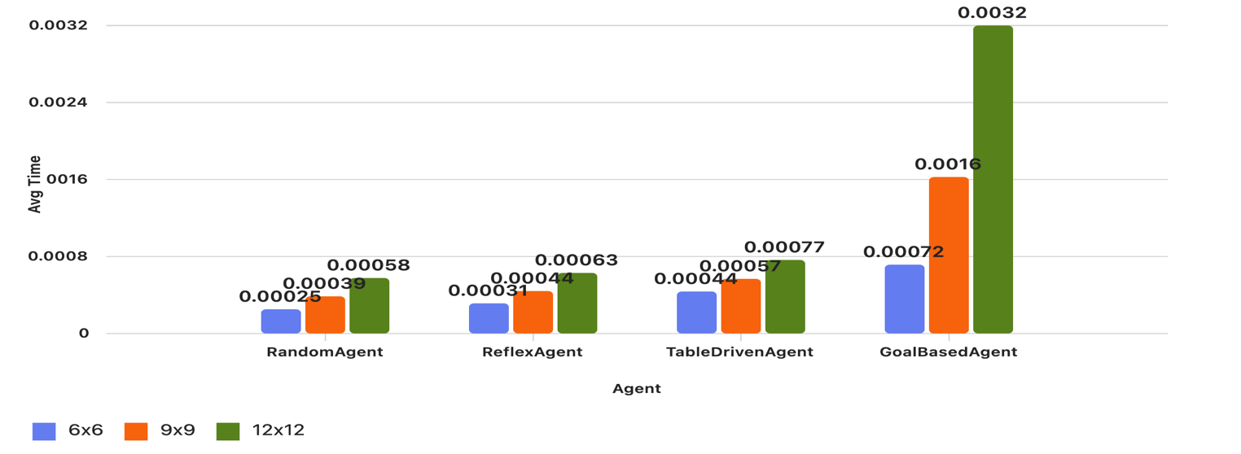
As grid size increases, all agents show rising average time, with the Goal Based Agent increasing the most—indicating a trade-off between performance and computational cost.

% Games Won
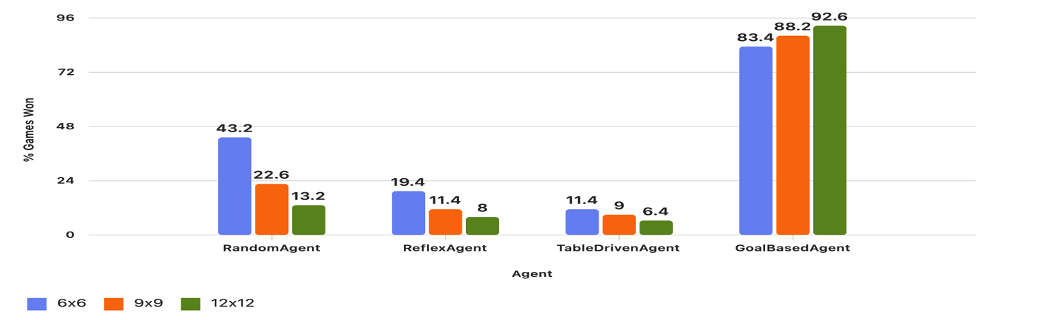
The Goal Based Agent outperformed the others massively across all grid sizes. The other agents effectiveness declines sharply as grid size increases, highlighting the Goal Based Agents superior adaptability and strategic effectiveness.

Cost/Performance
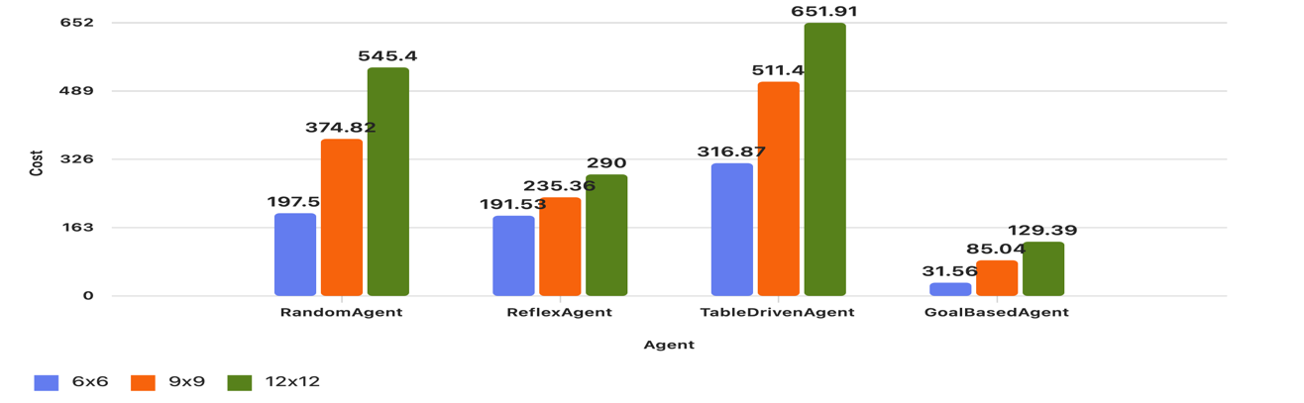
Again the best performing agent was the Goal Based Agent. The agent’s heuristic consistently produced the most efficient path.

1.2 Searching Your World

Problem Formulation
Formulate a well defined problem statement and identify a goal-state under which
your game is complete. Why is this important to search? As part of your solution you
should be including the initial state, the set of actions, the transition model, a goal test
function and a path cost function.

Uninformed Search Techniques
Select three uninformed search techniques and discuss their appropriateness to your
world under appropriate headings for evaluating problem-solving performance. Im-
plement the uninformed search techniques and discuss the results

Informed Search Techniques
Select three informed search techniques and discuss their appropriateness to your
world under appropriate headings for evaluating problem-solving performance. Im-
plement the informed search techniques and discuss the results.

Performance Evaluation
Write a clear and concise report detailing the search techniques performance in your agent-
based game for the relevant agent types. The purpose of this is to articulate an understanding
of the underlying concepts, and limitations, being implemented both from a theoretical and
practical perspective.

Conclusion
- Summarize key findings
- Reflect on agent suitability and search efficiency
- Suggest improvements or future work

