### Title

Replace STAT0002 in the header above on the left with the code of your module. The header will be in black when you save to PDF format.

You can edit this template to alter the appearance of your examination paper. For example, you can change the fonts, font sizes, margins, title and heading styles, content of the header.

The accompanying R markdown file gives examples of creating a plot using R and importing a graphic.

Tables?

## Heading 2

Use

## Heading name

in R

* Bullet point 1
* Bullet point 2

### Heading 3

Use

### Heading name

in R

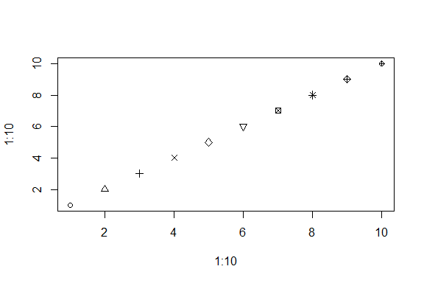

Figure