**Ground Preparation**

**Bedding Row Mapping**

Intelescope’s row detection technology, iROW™, is able to detect and map each bedding row. iROW™ ability to capture the bedding row enables in-depth analysis of post site preparation.

The service is based on imagery from satellite, aerial photography or Drones and utilizes Intelescope’s proprietary row detection algorithms.

**Key Features & Benefits**

* Ability to map the straightness of each bedding row
* Ability to map the distance between bedding rows
* Better understand bedding orientation to assist in future planning

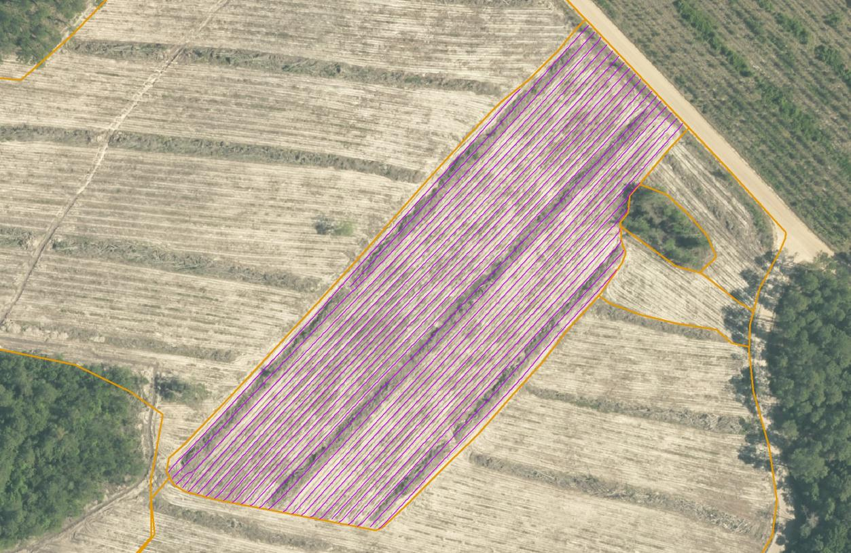

**Stand Border Updates**

Software updates plot borders to accurately represent today’s reality of your forest. Accurate stand borders allow forester to plan efficiently and precisely.

The service is based on imagery from satellite, aerial photography or Drones.

**Key Features & Benefits**

* Ability to update your stand area database quickly and efficiently
* Ability to extract numbers using actual and correct stand area

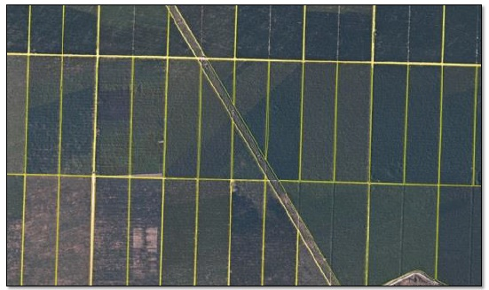

**Silviculture**

**(all silviculture applications utilize Drone imagery)**

**Survivability Mapping**

Utilizing Intelescope’s proprietary tree detection algorithms, survivability mapping is a service aimed to provide tree count after plantation, pruning, thinning and field work done by contractors that impacts the stand’s tree count. Using Intelescope’s algorithms, you are able to get an exact stem count, thereby, reflecting the reality on the ground. This allows re-planting in areas where there has been mortality, thereby, improving the overall yield simply by maximizing the usage of the land- among others.

The service is based on imagery captured from almost any commercial Drones

**Key Features & Benefits**

* Maps and counts trees within a specific stand/sub-stand
* Verifies your contractor reports based on your entire forest stands area (census)
* Accuracy: ±5% stems per stand at 90% of stands (10 hectares or larger).

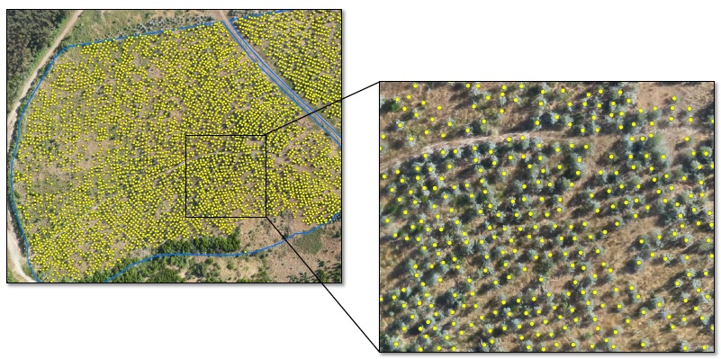

**Gap (failure) Analysis**

Intelescope gap analysis is a service aiming at supporting your assessment of utilizing non-planted areas within your stand, helping you make smarter stand maintenance decisions.

The service is based on imagery captured from almost any commercial drone and utilizes Intelescope proprietary tree and row detection algorithms.

**Key Features & Benefits**

* Maps non-planted areas (polygons) according to classes determined by size.
* Base your stand maintenance and utilization decisions on your entire forest stand area.

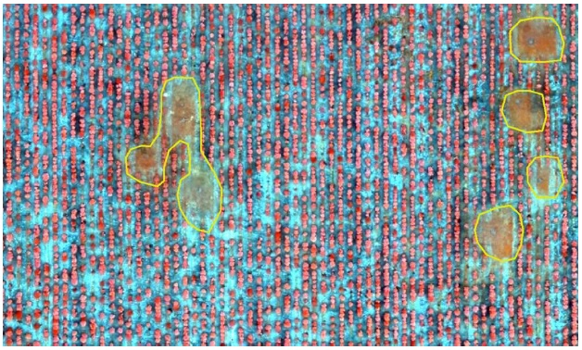

**Stem Density Mapper**

Intelescope stem density mapping is a service aimed to support your assessment of survivability and help you make smarter re-planting decisions.

The service is based on imagery captured from almost any commercial Drones and utilizes Intelescopes proprietary tree detection algorithm.

**Key Features & Benefits**

* Maps stem density in a grid of 25meters X 25meters cells according to four classes
* Base you re-planting decisions on a full census of your stands’ stem densities
* Measure your survivability rates at detailed 0.0625 hectares sub-stand areas resolution
* Accuracy: ±10% at 90% of cells

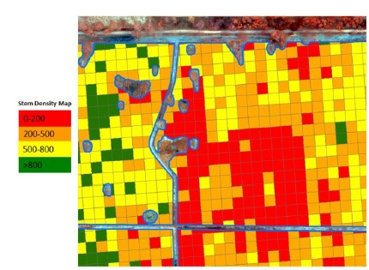

**Weeds Mapper**

Intelescope weeds mapping is a service aimed to support your assessment of forest weed control and help you make smarter herbicide applications decisions. Intelescope’s image analysis algorithms can automatically measure the difference between the general green (weeds) and the trees canopies, thereby classifying the weed patches in each forest stand. This enables cost effective differential application of herbicides to save costs while improving plants growth.

The service is based on imagery captured from almost any commercial Drones and utilizes Intelescopes proprietary tree detection algorithm.

**Key Features & Benefits**

* Base your herbicide application decision on analysis of your entire forest stand area (census)
* Maps weeds coverage percentage in a grid of 50meters X 50meters cells according to 4 classes for aerial herbicide application
* Alternatively, each plantation row can also be classified according to weeds coverage for ground herbicide application
* Takes into consideration planted trees and ignores their canopies
* Accuracy: ±15% coverage at 90% of cells

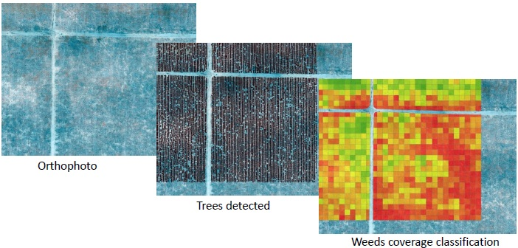

**Competition Mapper**

Intelescope competition mapping is a service aimed to support your assessment of cutting down non-crop competition trees, helping you make smarter stand maintenance decisions.

The service is based on imagery captured from almost any commercial Drones and utilizes Intelescopes proprietary tree detection and row detection algorithms.

**Key Features & Benefits**

* Maps competition trees areas represented by polygons according to classes determined by intensity
* Base your competition tree removal decision on your entire forest stand area (census)

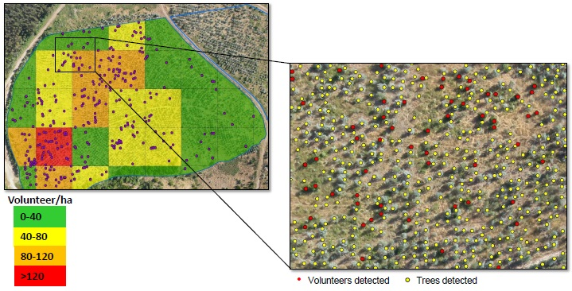

**Coppice Regrowth Stratification**

Intelescope’s algorithms allow for a very accurate stocking map of a plantation to be made to assist making arbitrary decisions about where the stocking of coppice is inadequate for a second rotation. An added advantage is that the data also provides an accurate stump count that can be used as a basis of payment for coppice thinning contractors, rather than relying on the stump counts from the contractors.

The service is based on imagery captured from almost any commercial Drones and utilizes Intelescopes proprietary tree detection and row detection algorithms.

**Key Features & Benefits**

* Increased accuracy, removing arbitrary decision making and replacing with sophisticated image analysis technology
* Provides auditing assistance to monitor contractors work

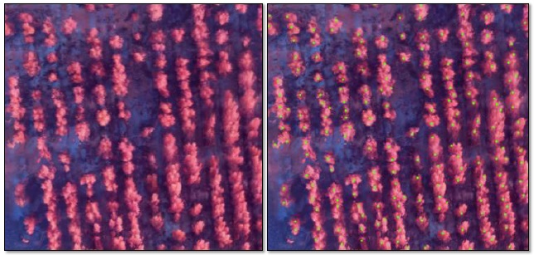

**Planting Row Quality Analysis**

Intelescopes algorithms enables foresters to quality control the planting rows after planting and therefore to better plan the mechanized maintenance activities.

The service is based on imagery captured from almost any commercial Drones and utilizes Intelescopes proprietary tree detection and row detection algorithms.

**Key Features & Benefits**

* Improve operational efficiency of planting machinery by having a map of the planted rows
* Precisely analyze the accuracy of the planting

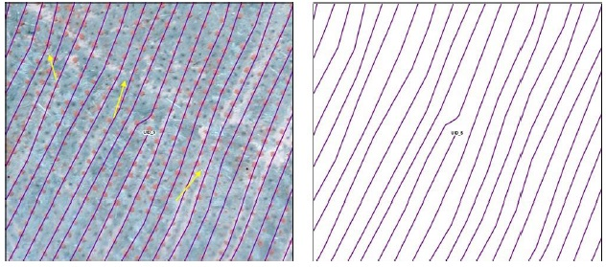

**Stand Border Updates**

Software updates plot borders to accurately represent today’s reality of your forest. Accurate stand borders allow forester to plan efficiently and precisely.

The service is based on imagery from satellite, aerial photography or Drones.

**Key Features & Benefits**

* Ability to update your stand area database quickly and efficiently
* Ability to extract numbers using actual and correct stand area



**Juvenile (~5 – 10yrs old)**

**Juvenile Density Stratification**

Juvenile Density Stratification enables the stratification of juvenile stands into homogenous, non-overlapping strata, based on density, to facilitate tree density inventories and to allow reduction of sampling effort while achieving the same level of precision.

The service is based on imagery from satellite, aerial photography or Drones.

**Key Features & Benefits**

* Allow reduction of manual labor when sampling Juvenile stands
* Stratification is used to increase the precision of population estimates and to avoid estimation bias.

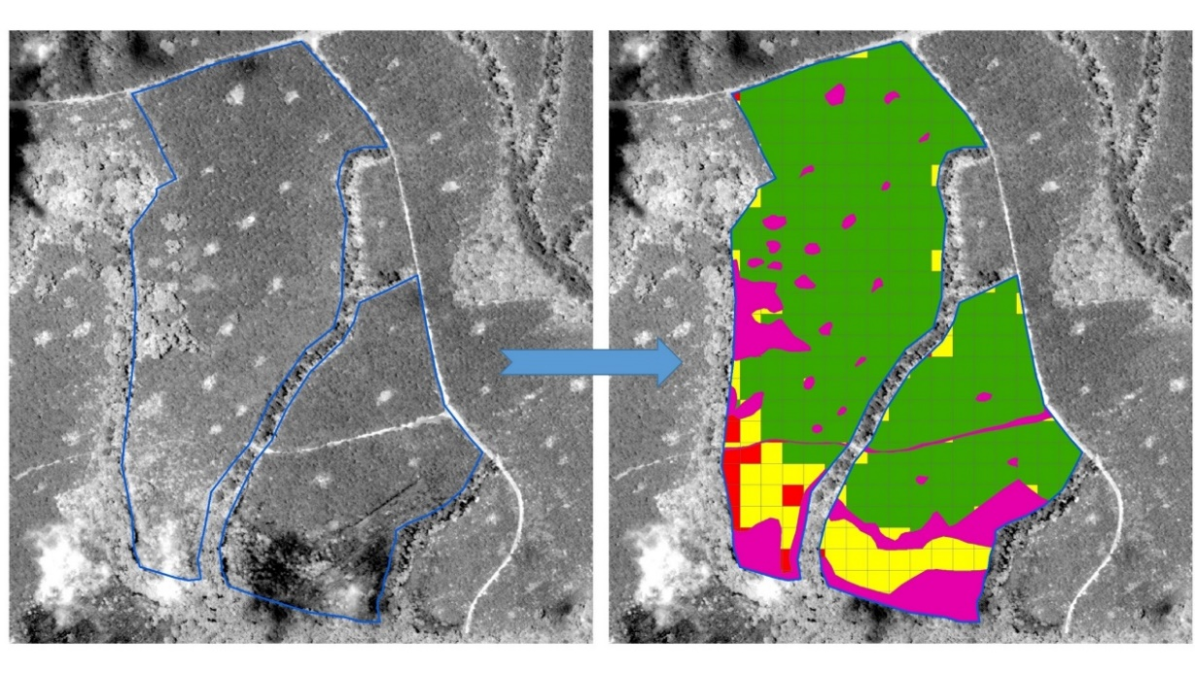

**Stand Border Updates**

Software updates plot borders to accurately represent today’s reality of your forest. Accurate stand borders allow forester to plan efficiently and precisely.

The service is based on imagery from satellite, aerial photography or Drones.

**Key Features & Benefits**

* Ability to update your stand area database quickly and efficiently
* Ability to extract numbers using actual and correct stand area



**iROW™**

Intelescope iROW™ is a service aimed to detect forest plantation rows and measure their length, thereby enabling cost/effective row-sampling for accurate and consistent forest inventory.

The service is based on imagery from satellite, aerial photography or Drones and utilizes Intelescope proprietary row detection algorithms.

**Key Features & Benefits**

* Detects plantation rows.
* Row-sampling has been shown to improve accuracy and decrease labor
* Segments planted rows into stocked and un-stocked segments
* Accuracy: ±5% of total length per forest stand (larger than 10 hectares).

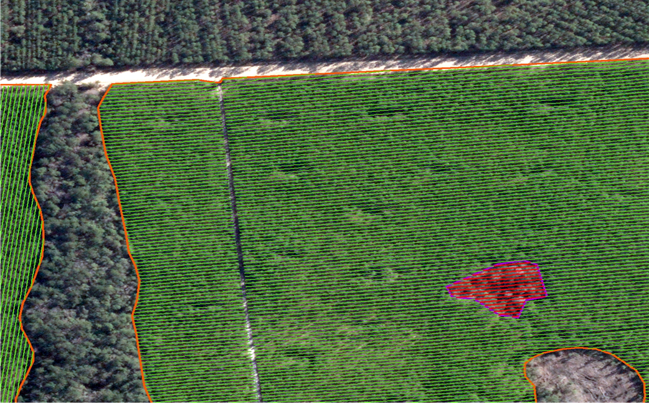

**Pruning/Thinning (~10yrs - Harvest)**

**iROW™**

Intelescope iROW™ is a service aimed to detect forest plantation rows and measure their length, thereby enabling cost/effective row-sampling for accurate and consistent forest inventory.

The service is based on imagery from satellite, aerial photography or Drones and utilizes Intelescope proprietary row detection algorithms.

**Key Features & Benefits**

* Detects plantation rows.
* Row-sampling has been shown to improve accuracy and decrease labor
* Segments planted rows into stocked and un-stocked segments
* Accuracy: ±5% of total length per forest stand (larger than 10 hectares).



**Stand Border Updates**

Software updates plot borders to accurately represent today’s reality of your forest. Accurate stand borders allow forester to plan efficiently and precisely.

The service is based on imagery from satellite, aerial photography or Drones.

**Key Features & Benefits**

* Ability to update your stand area database quickly and efficiently
* Ability to extract numbers using actual and correct stand area



**Harvesting**

**Harvest Row Planning**

Intelescopes row detection technology, iROW™, detects the planted rows just before harvesting, providing the necessary information for precise harvest planning. Due to the expensive nature of harvesting, it is critical that the planner knows in which direction the rows go and where to place the logging docks.

The service is based on imagery from satellite, aerial photography or Drones.

**Key Features & Benefits**

* Improve operational efficiency of Harvesting
* Provides deep insight into harvest planning route

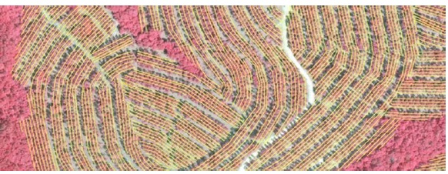

**Natural Forest Harvest Support**

Intelescopes has developed software to classify the forest by species. This is critical in helping support decisions of where to send commercial logging teams in the forest. What was once done arbitrarily, is now exact.

The service is based on a combination of Drone imagery and Satellite imagery where Intelescope uses a small sample of high resolution Drone imagery to train the algorithm to work with Satellite + Aerial imagery which is more suitable when covering larger amounts of land.

**Key Features & Benefits**

* Improve operational efficiency of Harvesting vast areas
* Know exactly where in the forest to send your commercial logging teams

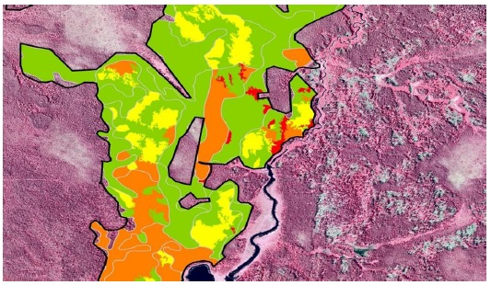

**Wood Resource Mapping**

Intelescope is able to accurately detect and delineate the area of planted timber in your forest. By updating the stand boundaries as well as delineating all non-stocked areas, Intelescope is able to report back the precise stocked area.

The service is based on imagery from satellite, aerial photography or Drones.

**Key Features & Benefits**

* No longer overestimate or underestimate amount of harvestable wood in your forest
* No longer lose Mill productivity because of lack of supply

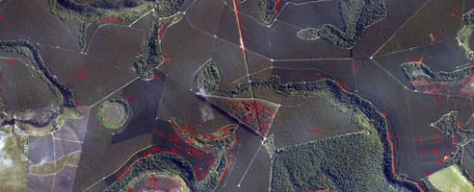

**Stand Border Updates**

Software updates plot borders to accurately represent today’s reality of your forest. Accurate stand borders allow forester to plan efficiently and precisely.

The service is based on imagery from satellite, aerial photography or Drones.

**Key Features & Benefits**

* Ability to update your stand area database quickly and efficiently
* Ability to extract numbers using actual and correct stand area

