

Republic of the Philippines

Western Mindanao State University

**COLLEGE OF COMPUTING STUDIES**

DEPARTMENT OF INFORMATION TECHNOLOGY

**TITLE**

A CAPSTONE PROJECT

Presented to the Faculty of the

Institute of Computer Studies

Western Mindanao State University

In Partial Fulfillment

of the Requirements for the Degree

Bachelor of Science in Information Technology

By

MEMBERS

(LAST NAME, FIRST NAME, MI)

NAME OF ADVISER

Faculty Adviser

DATE

|  |
| --- |
| WESTERN MINDANAO STATE UNIVERSITY  Zamboanga City, 7000 Philippines  ________________________________________  Institute of Computer Studies  Information Technology Department      **CERTIFICATE OF PANEL APPROVAL**    The Capstone Project, attached hereto, entitled **“ INSINYAR: A MOBILE-BASED LEARNING APPLICATION WITH AUGMENTED REALITY FOR MTB MLE CHAVACANO LEARNERS ”,** prepared and submitted by **JHEHAN I. ABDAL, RICALYN B. CARIAL, NUR-RADIA G. LAGOYO** in partial fulfillment of the requirements for the degree **BACHELOR OF SCIENCE IN INFORMATION TECHNOLOGY,** is hereby recommended for approval.    **ENGR, CEED JEZREEL B. LORENZO, MIT**  Chairperson  **___________**  Date      **MR. LEIRRAND CHRISTIAN A. OCHOTORENA**  Member  **___________**  Date      **MR. WHESLEY C. TIMPANGCO**  Member  **___________**  Date      **AIDA A. ESCORIAL, MIT**  Adviser  **_________**  Date    This Capstone Project is approved in partial fulfillment of the requirements for the degree **BACHELOR OF SCIENCE IN INFORMATION TECHNOLOGY**    **JOHN ED AUGUSTUS A. ESCORIAL, MIT DR. RODERICK P. GO**  Department Head, IT Director, ICS  **_________ _________**  Date Date |

**EXECUTIVE SUMMARY**

**DEDICATION**

**ACKNOWLEDGEMENT**

**TABLE OF CONTENTS**

**Page**

**TITLE ………………………………………………………………………………… i**

**APPROVAL SHEET ………………………………………………………………….. ii**

**EXECUTIVE SUMMARY …………………………………………………………….. iii**

**DEDICATION ………………………………………………………………………… iv**

**ACKNOWLEDGEMENT ……………………………………………………………... v**

**LIST OF TABLES ……………………………………………………………………... xi**

**LIST OF FIGURES …………………………………………………………………… xii**

**LIST OF APPENDICES ……………………………………………………………….. xiii**

**LIST OF ABBREVIATIONS …………………………………………………………. xiv**

**CHAPTER**

**1 INTRODUCTION 1**

1.1 Project Context 1

1.2 Purpose and Description 2

1.3 Project Objectives 3

1.3.1 General Objectives 4

1.3.2 Specific Objectives 5

1.4 Scope and Limitations 6

1.5 Significance of Study 7

1.6 Definition of Terms 8

**2 REVIEW OF RELATED LITERATURE 9**

2.1 Introduction 9

2.2 Summary 10

2.3 Synthesis 11

**3 TECHNICAL BACKGROUND 12**

3.1 Conceptual Framework 12

3.2 Software and/or Hardware Requirements 13

**4 DESIGN AND METHODOLOGY 16**

4.1 Introduction 16

4.2 Requirement Analysis 17

4.2.1 Context Diagram 18

4.2.2 Data Flow Diagram 19

4.2.3 Flowchart 20

4..2.4 Use Case 21

4.3 Requirement Specification 22

4.3.1 Functional Requirements 22

4.3.1.1 Software Functionality 23

4.3.1.2 User Characteristics 24

4.3.2 Non-Functional Requirements 25

4.3.2.1 Technical Requirements 25

4.3.2.2 Performance Requirements 26

4.3.2.3 Assumptions and Dependencies 27

4.3.2.4 Security Requirements 28

4.2 System Design 29

4.3 ERD 29

4.3 Database Design 30

4.3 Database Fields 31

4.4 User Interface Design 32

**5 DEVELOPMENT AND TESTING 33**

5.1 Development 33

5.2 Integration of Technology 34

5.3 Testing 35

5.3.1 Alpha Testing 35

5.3.2 Beta Testing 36

5.3.3 User Acceptance Testing 37

5.4 Implementation Plan 38

5.4.1 Infrastructure/Deployment 38

5.4.2 Processes/Policies/Personnel 39

**6 RESULT AND DISCUSSIONS 40**

6.1 Introduction 40

6.2 Summary of Findings 41

**7 CONCLUSION AND RECOMMENDATIONS 42**

7.1 Conclusions 42

7.2 Recommendations 43

**REFERENCES 44**

**APPENDICES 45**

**CURRICULUM VITAE 46**

**LIST OF TABLES**

**Table Page**

2.3 Synthesis 11

6.1 Number of Respondents 36

# **LIST OF FIGURES**

**Figure Page**

3.1 Conceptual Framework14

4.1 Software Development Life Cycle 17

4.2 Flowchart 18

4.3 Use Case 19

4.4 Context Diagram 23

4.5 Data Flow Diagram 23

# **LIST OF APPENDICES**

**Appendix Page**

Appendix A: Data Gathering 53

Appendix B: Source Code 54

Appendix C: Testing 55

Appendix D: Evaluation Form 57

Appendix E: Gantt Chart 60

Appendix F: Use Case 61

# **CHAPTER 1**

**INTRODUCTION**

* 1. **Project Context**

*(Discuss the background of the project, the processes involved in the area  
being studied.)*

* 1. **Purpose and Description**

*(Discuss the problems encountered that made the proponents to conduct or  
to proposed solutions to addressed the problem being studied.)*

* 1. **Project Objectives**

*(Discuss the general objective of the project as well as the specific objectives  
that the proponent will take to meet the general objective.)*

This section presents the general objective and the specific objectives of the study.

**a. General Objective**

**b. Specific Objectives**

* 1. **Scope and Limitations**

*(Discuss the coverage of the project, its functionalities, the target users and  
their access levels, the development platform to be used, the deployment  
environment. Moreover, state the project limitations including the functions  
that are not intended.)*

**1.5 Significance of the Study**

**1.6 Definition of Terms**

**CHAPTER 2**

**REVIEW OF RELATED LITERATURE**

**2.1 Introduction**

**2.2 Summary**

**2.3 Synthesis**

**CHAPTER 3**

**TECHNICAL BACKGROUND**

*(After a thorough evaluation of the proposal defense, this section may include a conceptual framework that illustrate the different technology and components of the approved project. Discuss also the solutions being taken to address the problems and needs specified in the previous chapters.)*

**3.1 Conceptual Framework**

**3.2 Software and Hardware Requirements**

**CHAPTER 4**

**DESIGN AND METHODOLOGY**

This chapter presents the design process and methodology of the development of the project.

**4.1 Introduction**

**CHAPTER 5**

**DEVELOPMENT AND TESTING**

**CHAPTER 6**

**RESULTS AND DISCUSSIONS**

**CHAPTER 7**

**CONCLUSION AND RECOMMENDATIONS**

**REFERENCES**

**APPENDIX A**

**DATA GATHERING**

**APPENDIX B**

**SOURCE CODE**

**APPENDIX C**

**TESTING**

**APPENDIX D**

**EVALUATION FORM**

**APPENDIX E**

**GANTT CHART**

**APPENDIX F**

**USE CASES**

**CURRICULUM VITAE**

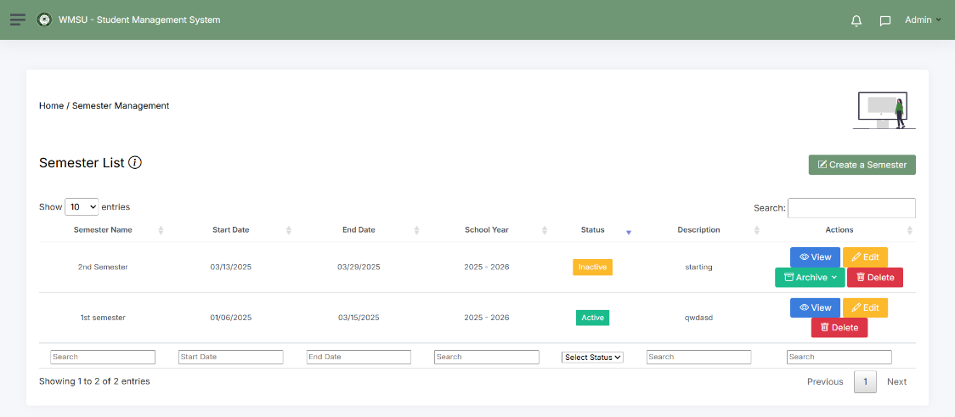

This feature allows the admin to manage semester details. The interface provides to create a semester and assign classes to the semester.

**View Semester**

* Upon accessing the Semester Management section, a list of available semesters will be displayed.
* If no semesters are available, the page will display a message indicating “No Semester available.”

**Creating a Semester:**

* The admin can click on the “Create a Semester” button to begin the process of adding a new semester to the system.
* Upon clicking, the admin will be directed to a form where the semester details can be inputted.

**Navigating the System:**

* Admin can easily navigate back to the dashboard or other sections using the sidebar on the left. The system provides the current date and time for easy reference.

**Archive of Semester**

* The system will automatically archive the status of the semester when the term is done.

This feature allows the admin to manage semester details such as view, edit, delete button to navigate and control the semester.

**View Semester**

* Upon accessing the Semester Management section, you can view the semester created to clarify or to check if there are any errors to change onwards.

**Edit Semester:**

* The admin can click on the “Edit Semester” button to begin the process of editing or updating any information in the semester created.
* If all of the requirements are completed you can go to this button in click “make active” to activate the semester created

**Delete the Semester:**

* Admin can easily delete the semester created.

**Archiving;**

* In this section the admin can manually archived the semester created.
* But if the users want automatically archived the semester, the system can automatically archived based on the end date of the semester.

This section allows the admin to create a subject for the semester

* To create a subject click the “create subject” and manually input all the information’s needed such as “subject name”, “subject code”, “subject type”, if it is laboratory or lecture, “meeting days”, the “start time and end time”

