1. Introduction
- My application will have the functionality of sending youtube videos. In it, the user posts a video link and, when added, when returning to the main page, the video can be viewed.

2. User Interface Design and Prototype

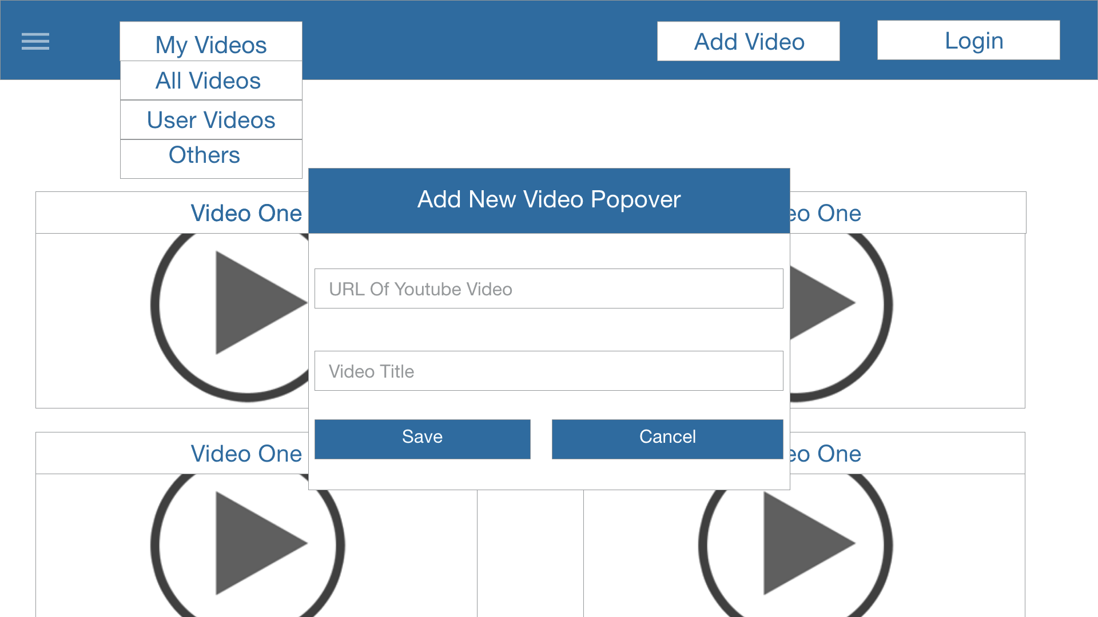
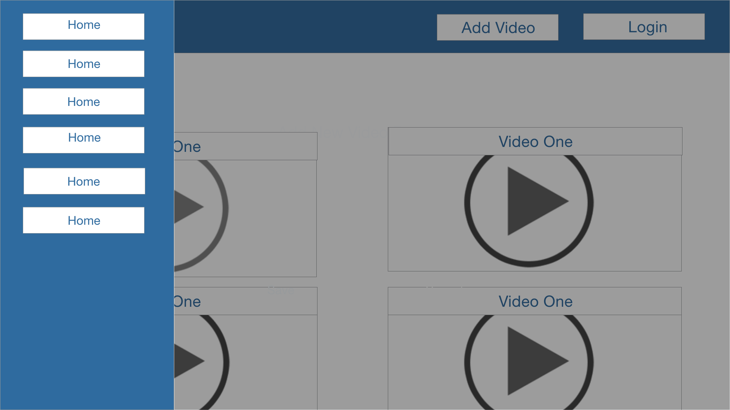
- Other users can view and comment on this video, as well as give notes for the video viewed. Each video will have its own page, that is, when viewing the video on the main page, by clicking on it, the user will be directed to the video viewing page of this video.

3. Navigation Structure
- There will be a top navigation bar, which has several function buttons, for example: a login button, a video filtering button, a button to add new videos and a button to open the side menu. The side menu is slider type, ie it will slide from left to right, moving over a small screen area and will have navigation functions between the pages.

4. References
- For this work, I am used the Adobe Experience Design: https://creative.adobe.com/products/download/experience-design?promoid=41Y3B1RT&mv=other
References:
http://www.webdesign-inspiration.com/
https://www.youtube.com/watch?v=wrMBuqjtjpk
http://getbootstrap.com/components/
http://www.w3schools.com/angular
http://www.w3schools.com/howto/default.asp

