Multimidia Youtube

1. Introduction
- A brief introduction to your project and the expected features:

My project is a multimedia system, in which it is allowed to post youtube links. Once posted a link, some logged in user can comment on the videos. Any user can view the videos posted.

2. Design and Implementation
2.1 The REST API Specification
- Give the details of your REST API, the various REST API end points and the operations to be supported on these end points:

// **************** START routes **********************

//isloged
app.use('/isloged',require('./server/routes/isloged.js'))

//logout
app.use('/logout',require('./server/routes/logout.js'))

//signup
app.use('/signup',require('./server/routes/signup.js'))

//login
app.use('/login',require('./server/routes/login.js'))

//video
app.use('/api_videos',require('./server/routes/videos.js'))

//error messages
app.use('/error',require('./server/routes/error.js'))

//sucess messages
app.use('/sucess',require('./server/routes/sucess.js'))

// **************** END routes **********************

//error router
router.get('/signup', function(req,res,next){
res.json({error:'signup'})
} )

router.get('/login', function(req,res,next){
res.json({error:'login'})
} )

//islogged
router.get('/' , isLogged , function(req, res , next){
res.json([{message: true , user: req.user}])
}); //check if user is logged

//loggin router
router.post('/', passport.authenticate('local-login', {
successRedirect : '/sucess/login', // redirect to the secure profile section
failureRedirect : '/error/login', // redirect back to the signup page if there is an error
failureFlash : true // allow flash messages
})
)

//logout router
router.get('/', function(req, res) {
req.logout();
res.json([{message:'sucess'}]);
});

//signup
router.post('/', passport.authenticate('local-signup' ,
{
successRedirect : '/sucess/signup', // redirect to the secure profile section
failureRedirect : '/error/signup', // redirect back to the signup page if there is an error
failureFlash : true // allow flash messages
})
)

//sucess
router.get('/signup', function(req,res,next){
res.json({sucess:'signup'})
} )

router.get('/login', function(req,res,next){
res.json({sucess:'login'})
} )

//the video and comment router:
//get all
router.get('/', function(req, res , next) {
Video.find({}, function(err, videos) {
if (!err){
res.json(videos);
}
else {next(err)}
})
.populate('_author') //populate creator with user info
.exec(function (err, video) {
if (err) return handleError(err);
console.log('The _author is %s', video._author);
// prints "The creator is Aaron"
}
);
});

//get specific video
router.get('/:id', function(req, res , next) {
var id = req.params.id;

Video.findOne({_id:id}, function(err, video) {
if (!err){
res.json([video]);
}
else {next(err)}
})
.populate('_author') //populate creator with user info
.exec(function (err, video) {
if (err) return handleError(err);
console.log('The _author is %s', video._author);
// prints "The creator is Aaron"
}
);

});

//get comments
router.get('/:idVideo/comments', function(req, res , next) {
var id = req.params.idVideo;

Comment.find({_video:id}, function(err, comments) {
if (!err){
res.json(comments);
}
else {next(err)}
})
.populate('_creator') //populate creator with user info
.exec(function (err, comment) {
if (err) return handleError(err);
console.log('The creator is %s', comment._creator);
// prints "The creator is Aaron"
});
});

//post comments
router.post('/:idVideo/comments', function(req, res , next) {
var id = req.params.idVideo;
if (!req.body) return res.sendStatus(400);

Video.findOne({_id:id}, function(err, video) {

if(err) next(err);

var CommentInstance = new Comment(req.body);

CommentInstance.save(function(err, comment) {
if(err) next(err);

res.json(comment);
});

});

});

//delete comments
router.delete('/:idVideo/comments/:idComment', function(req, res , next) {
var idComment = req.params.idComment;

Comment.remove({_id: idComment} , function(err){
if(err) res.json({message: "Error: " + err})

res.json({message: "sucess"})
})

});

//update comments
router.put('/:idVideo/comments/:idComment', function(req, res , next) {
var idComment = req.params.idComment;

Comment.findOneAndUpdate({_id:idComment}, req.body, function (err, comment) {
if(err) res.json({message: "Error: " + err});

res.send({message: "sucess"});
});

});

//save new videos if is logged
router.post('/', isloged ,function(req, res , next) {
if (!req.body) return res.sendStatus(400)

var VideoInstance = new Video(req.body);

VideoInstance.save(function(err,video){
if(err) next(err);

res.json(video);
});
});

2.2 Front-end Architecture Design
- Give some details of the architecture and structure of your front-end, both web application and hybrid mobile application, in a format that you consider suitable, You may choose to use any formal languages or structure diagrams to express the details.

Land Page:

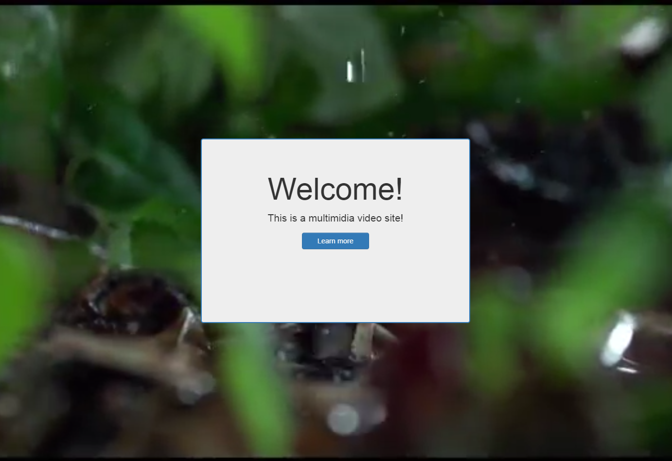

Home:

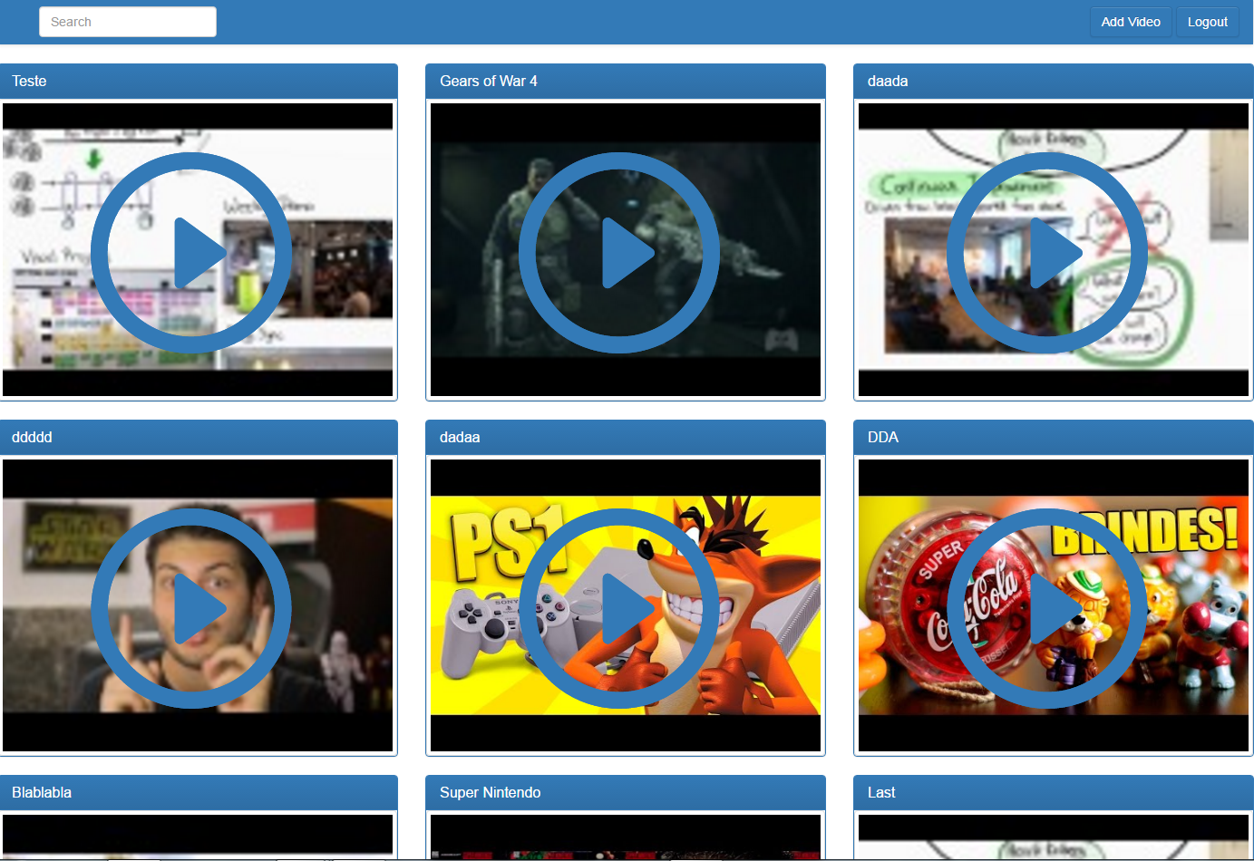

Video Page:

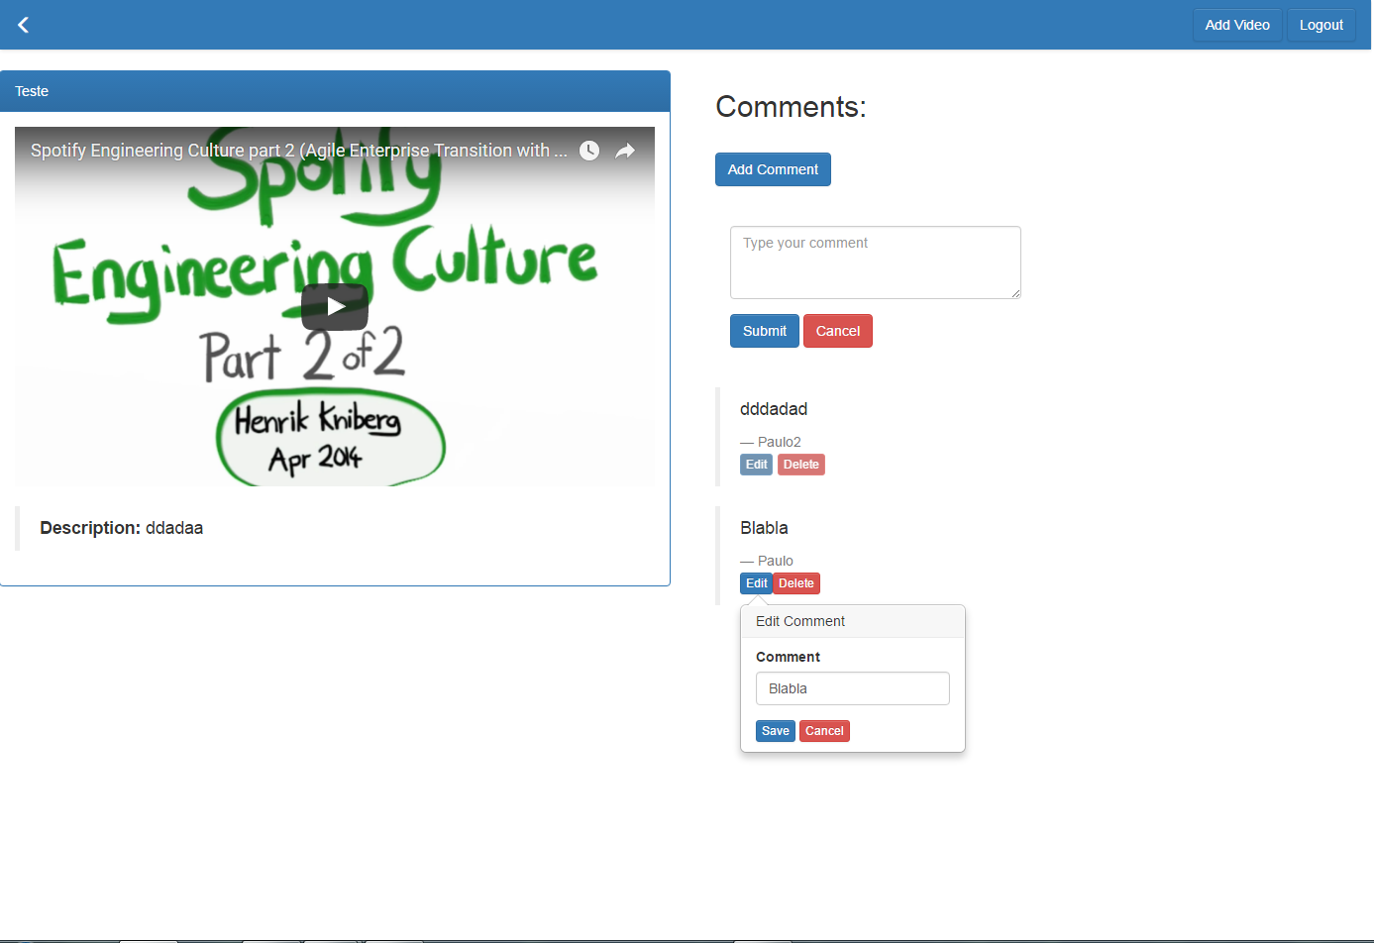

Mobile Home:
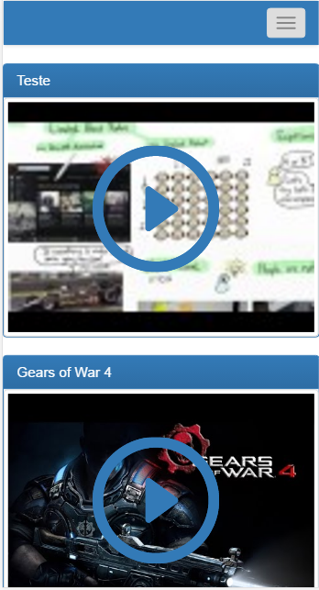

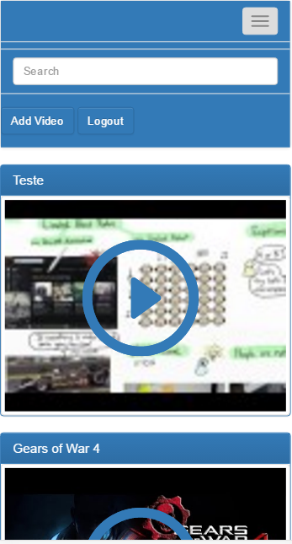

2.3 Database Schemas, Design and Structure
- Give any details of the database schema and the structure of your database storage (documents etc.).:

Comment:

var CommentSchema = new Schema({
_creator : { type: Schema.ObjectId, ref: 'User' , required: true },
comment: { type: String, required: true},
date: { type: Date, default: Date.now },
_video: { type: Schema.ObjectId, ref: 'Video' , required: true }
});

Video:

var VideoSchema = new Schema({
title: String,
url: String,
_author : { type: Schema.Types.ObjectId, ref: 'User' },
description: String,
comments: [{ type: Schema.Types.ObjectId, ref: 'Comment' }],
date: { type: Date, default: Date.now }
});

User:

var UserSchema = new Schema({
username: String,
email: String,
password: String,
date: { type: Date, default: Date.now }
});

2.4 Communication
- Give the structure of the messages to be communicated between the front-end and the back-end.:

Comment:

//update comment on the server
$scope.put = function($index , comment , video){

var Comment =
$resource('http://localhost:8080/api_videos/:idVideo/comments/:idComment',
{idVideo: video._id , idComment: comment._id},
{'update': { method:'PUT' }} //select the RESTful method
);

var CommentInstance = new Comment();
CommentInstance.comment = $scope.currentComment.comment;//update comment

Comment.update({ _id:comment._id }, CommentInstance , function(instance){

$scope.isOpen[$index] = false; //close popover
});
}

//save new comment
$scope.save = function(form , video){

var Comment = $resource('http://localhost:8080/api_videos/:idVideo/comments',{idVideo: video._id});
var CommentInstance = new Comment();

//fill the comment instance
CommentInstance.comment = $scope.obj.comment;
CommentInstance._creator = $rootScope.user._id;
CommentInstance._video = video._id;

Comment.save(CommentInstance , function(commentObj){

if(CommentInstance){

//update view
if($scope.comments){

//inject username in real time
var comment = {};
comment.comment = $scope.obj.comment;
comment._id = commentObj._id;
comment._creator = {};
comment._creator._id = $rootScope.user._id;
comment._creator.username = $rootScope.user.username;
$scope.comments.push(comment);

//reset the form
$scope.obj.comment = "";
}
}
})
}

//delete the comment
$scope.delete = function(comment , video){
var Comment =
$resource('http://localhost:8080/api_videos/:idVideo/comments/:idComment')
.delete({idVideo: video._id, idComment: comment._id},
function(err,response){
if(err) console.log(err)

if(response){

var index = $scope.comments.indexOf(comment);

if(index > -1){
$scope.comments.splice(index, 1);
}
}
}
);

}

Video:

//add new video
$scope.submit = function(form){
$uibModalInstance.dismiss();

var Video = $resource('http://localhost:8080/api_videos/');

var VideoInstance = new Video();
VideoInstance.description = form.description;
VideoInstance.title = form.title;
VideoInstance.url = form.url;

VideoInstance._author = $rootScope.user._id;

//save video instance
Video.save(VideoInstance , function(){

if(VideoInstance){

//update view
if($rootScope.videos){

var path = VideoInstance.url.split('?v=');
var thumb = 'http://img.youtube.com/vi/'
+ path[1]
+ '/'
+ parseInt(Math.random()*4)
+ '.jpg';

//set the video author
VideoInstance.thumb = thumb;

$rootScope.videos.push(VideoInstance);
}
}
})

}

//get all videos
function getAllVideos(){
var promise = $resource('http://localhost:8080/api_videos/');
var entry = promise.query(function(){
$scope.videos = entry;

$rootScope.videos = entry;

$scope.videos.forEach(function(video){
var path = video.url.split('?v=');
var thumb = 'http://img.youtube.com/vi/'
+ path[1]
+ '/'
+ parseInt(Math.random()*4)
+ '.jpg';
video.thumb = thumb;
})

});
}

User:

//login user
$scope.submit = function(user){
//$uibModalInstance.dismiss();

$scope.vSubmit = false; //disable button
console.log(user)

var User = $resource('http://localhost:8080/login/');

var UserInstance = new User();

UserInstance.email= user.email;
UserInstance.password = user.password;

//try update the server and get the response
User.save(UserInstance)
.$promise
.then(
function(value){

if(value.error){
$scope.errorPassword = value.error;

$scope.vSubmit = true;
}
else { //sucess
$scope.errorLogin = null;
$uibModalInstance.dismiss();//dismiss the modal

$rootScope.logged = true;
}

},//sucess
function(error){
$scope.errorLogin = error;

}//error
)
}

//register new user
$scope.save = function(user){
$scope.vRegister = false;//disable button

var User = $resource('http://localhost:8080/signup/');

var UserInstance = new User();

UserInstance.username = user.name;
UserInstance.email= user.email;
UserInstance.password = user.password;

//try update the server and get the response
User.save(UserInstance)
.$promise
.then(
function(value){
$scope.errorRegister = null;

$uibModalInstance.dismiss();//dismiss the modal
},//sucess
function(error){
$scope.errorRegister = error;
}//error
)
}

3. Conclusions
- Briefly state what results you expect from your project. Write a summary of your project architecture design and structure.

I am very satisfied with the work done. I was able to complete what I wanted and I still hope to add new features until the final application. Regarding design, my version is still simple. I want to add transition effects between pages and other features. As for the structure, there are only a few pages to navigate, only navigating between the home page, the main page and the video pages.

4. References
- Give references to any material / websites / books etc. relevant to your project

W3Schools: http://www.w3schools.com/default.asp
Angular: https://angularjs.org/
Bootstrap: http://getbootstrap.com/
Ionic: https://ionicframework.com/

