Online Enrolment with SMS Notification for Concepcion Ecumenical School Foundation Inc.

R.M.F. Relosa, *BSIT WMA*

J.R.P. Aquino, *BSIT WMA*

E.B. Sumbilla Jr., *BSIT WMA*

M.P.DC. Gonzales, *BSIT WMA*

I.Introduction

Internet interconnects the computer networks and enables them to communicate directly with each other throughout the world. This global interconnection of governments, education and business led to computer networks becoming more accessible to the public to provide quality information, education and entertainment for humanity. The World Wide Web appeared as the result of the need to integrated many disparate information systems.

Most schools used the primitive way of handling their processes. In registering their students, the way they make it is by pen and paper. Inputting grades of students also made use of pen and are written on their report card. The school has not yet implemented the K-12 curriculum; however, the school is using the manual process for their day-to-day operations. The principal’s office is filled with papers, containing important documents in the school. Without proper storage, these papers are prone to either be damaged or lost. According to the principal, every time they conduct enrolment in the school the children and parent formed a long line just to enrol.

The proponents will make a system for the school that would aid them in their processes, including an online registration, which would transform the manual process of registration, and an SMS notification, which would help parents on monitoring the performance of their kids.

II. Project Context

The current process of the school in regards to registering the students is by manual process wherein the students will go to the institution and fill a form so they could be registered. Currently, the process of inputting of grades is through the report of the card and the parents should be the one who will get them.

The proposed system will automatethe manual process of registering students to expose them on how to deal with the online process of registering through the web. In addition, the proposed system will put both students and parents at ease, because they do not have to go to the school in order to fulfil the requirements needed for registration. In the grading system, the proposed will transform the manual process of inputting grades in a report card by using a portal, in which the student will easily view their grades on the web. Plus, parents will be also be informed through SMS notification about the grades and overall performance of their children within the school. The process of their enrolment will be adopted as the uniqueness of the system to other system that have been produced or published.

III. Purpose and Description

As a solution to the stated problem, the proponents will make a study entitled Online Enrolment System with Sms Notification. The central concern of this research is aid the teachers on making their work much faster in Registering the student and to help the parents monitor their child about their performance. The system has five intended users, the admin which is the principal, the registrar, the cashier, the teachers, and the students and parent.

For Admin, the proposed system will help to ease the job of the admin by providing an avenue for organizing and managing the files of the teachers and students.

For Registrar, the proposed system will help the registrar in managing the students who are enrolled. Registrar does not need to organize the cards of the students just to enlist them in their perspective section so their advisers have their official list

For Cashier, the proposed system is to organize and make her work more easy just in case their students will pay in method they used to be he or she can just search for the students LRN number and he or she could see its record about its tuition fee.

For Teacher, the proposed system will help the teachers in calculating the grades of students with corresponding general weighted average and easily determine the honors or top performing students.

For Students, the proposed system will help the students by providing them an online platform for viewing their grades and even printing them, as well as, for the parents will be notified via SMS Notification on the performance of their kids.

IV. Objectives of the Study

The main objective is to design and develop an Online Enrolment with SMS Notification for Concepcion Ecumenical School Foundation Inc. to facilitate viewing of student’s grades and online registration. Specially aimed to:

1. To design and develop “Online Enrolment System with SMS Notification for Concepcion Ecumenical School Foundation Inc.”

2. To create a web based system with the following module:

2.1 Admin Module

2.1.1 Faculty accounts and load management

2.1.2 Student accounts

2.1.3 and Management

2.2 Registrar Module

2.2.1 Student information

2.2.2 Paypal

2.2.3 Students balance

2.3Teacher’s Module2.3.1 Input Student grades

2.3.2 And Teacher’s schedule

2.4 Student/Parents Module

2.4.1 Class schedule

2.4.2 Viewing grades and registers

2.4.3 Tuition fee Balance

3. To evaluate the project based on the following:

3.1 User/Admin

3.1.1 Functionality

3.1.2 Graphical User Interface, and

3.1.3 Ease of Use

3.2 IT Expert

3.2.1 Database Management and

3.2.3 Security

V. Scope and Limitation

The proposed system will provide a web-based interface for the principal, registrar, teachers and the students. The system will allow the students to perform an online enrolment for easy operation of the registration process. In contrast to the online registration, the student has a student portal, where they can view their grades, schedule, balance and subject list, and also print their grades. Teachers can input grades, records and post the students’ grades unto their respective accounts. The admin is responsible for the content management of the school. He or she is responsible for the data in the database. The registrar is responsible for the information of the students. The request of a certain document from a student will be handled by the registrar. The parents will be notified via SMS notification for the performance of their child and the teacher’s feedback.

Only registered students may use the student portal. The proposed system is composed of different modules but depending on the user type, the functionality of each module is specified. The users may only update certain profile information like email address and phone number.The proposed system supports online payment feature, through PayPal account.

VI. Related Studies

This section provides the following literature and studies that established what needed knowledge and give deeper interpretation of the developed study. It consists of other studies and supporting documents that are similarity of the study.

*Foreign Literature*

According to Souvik and Venkateswaran (2014) online shopping is retrieval of product information via the Internaet and issue of purchase order through electronic purchase request, filling of credit or debit cards information and shipping of product by mail order or home delivery by courier.[1]

In the article about it stated that the e-commerce has been popular around the world where you can pay online. In the system that the proponents that is proposed they will use an E-commerce of paying the tuition of the students that are enrolled by using PayPal. However, their payments is connected to their account during the enrolment process.

According to the researchers of Ajman University, the online Registration System allows students, through interne, to register, drop or add courses within the registration period and the advisor to do advising for the students by approving or rejecting requested courses by the students or recommending some others.[2]

In the article of the researchers of the mentioned university, the proponents agreed that online registration is so broad and there are a lot of thing you can do like adding subjects but in this system where the proponents are developing it is regards for an institution which has no tertiary level. The proponents stated that more of the students are prone to the internet.

According to the website of SchoolMint.com 2013 an online enrolment system can collect all the information into a central hub, making it easy to access and modify. Registration information is instantly added to the database without the need to enter information into a registry by hand. This dramatically speeds up the registration process, fees up employees to do more useful tasks and increases accuracy by cutting doen on the number of data entry errors. Errors that could cause problem faced by the Boston school district- such as flase addresses and students who have relocated- can be caught immediately.[6]

In the article of 2013 in the internet, the proponents research is related but not as super advance because in the system of the researchers in they only transform the manual process of enrolling the students in their locale and the enrolment process of the locale is adopted.

*Local literature*

According to the thesis documents made by Ibay, Villegas, madisa, clemen and Abenes 920140 applying the automation of the enrollment system of a school will significantly help the staffs and management in organizing the information of the students. This system will help officials to look for certain information in just a matter of few clicks without having to look for under a drawer with piles of papers. In an educational institution, a smooth-flowing method of data recording is essential.[4]

In the article stated above it says that in just clicking the students will be enrolled and instead of finding mattered information in the drawer of pile of papers the system will make it easy. In implementing digital or web-based enrolment system, this will help and make the staff’s work easily like in inputting grade in just clicking and post it is done. In students registering in the web pages make their process more efficient and effective as millennial today are prone to internet.

According to Floremie A. Badoria, Online student portal with grades notification via SMS will decrease the number of manpower and time needed to acquire the data featured in the student portal. It also gives less hassle for the students, because they will not go to the registrar, accounting and bulletin.[5]

Based on the statement of Floremie A. Badoria Student portal may decrease the time and man power that is needed. The student portal is easier for students to view their grades via SMS notification the student will be informed and the work of their parents will not interrupt. Because some of the parents during the manual process of getting or viewing grades of their child do not attend due to their work.

In the article of Je-Paul Bejo, there are institution that are still using not fully automated databases record keeping and the distribution of information. Moreover, they are still studying on developing a system that was fully accommodate the needs of the students and slowly converting the manual way into computerized banking system.[10]

Basically there are still institution that are not yet implemented a system for recording information of students but by slowly converting the manual process into computerized the teachers amount of time consumed in their work will be lessen. As technology have been more advanced the process of the teachers work in inputting and encoding the students information will make it more innovative.

*Foreign Studies*

In the study of Firkhan Ali Bin Hamid Ali1 , Ali Abdullah Manea Alqushaibi2; Now days, the web-based system are spread over the entire world. The manual system suffers from so many faults. It’s very difficult to run the whole information and to do the desired operations on database, huge information cannot be managed and the search process for specific data is not easy. These factors and others affect the feasibility of the Yemen culture attaché manual system. The web-based system has a lot of advantages such as more manageable, cross platform, compatibility; reduce cost, quick search and others. All this can consider for good features for the web-based system. Yemen culture attach does not have electronic database system for Yemen students whose are studying in Malaysia. They have just a manual archive system. This is not easy for searching, selecting and archiving the databases for student’s information. Then, it makes all the communication become difficult between Yemen government and the students.[3]

In relation of the study the proponents are also promoting digital process of enrolling students but the proponents study it has the payment process. Some teachers may suffer from faults of inputting grades and sometimes students are cheating their parents just to say that their grades are high to have more allowance. The proponents study will help teachers and parents.

In the study of Manisha K, Alekhya K, T Manikanta, B Ramya, and S. Sai Kumar (2016), Student information management system is mainly designed for the use of students. If a student is absent on a particular day then he is unable to know the notifications that are passed on that day in college. So by using our web based system a student will be able to view the events that are going to take place in a college. This increases the efficiency of college record management because previously the college is dependent on paper records only. The time required is less when compared with the paper records. For example generating the eligibility list for students based on the companies requirements will consume more time because the list differs from company to company, by using SIMS it can be generated easily and reduces the man power to do this.[8]

The study that is stated above has a bit comparison to the proponents proposed system the difference is the proponents focus only on the students information grades and transforming the manual process of enrolling them and for teachers the system will make their work more easy and it also reduce manpower in writing students’ grades on their report cards.

In the study of S.R.Bharamagoudar1 , Geeta R.B.2 , S.G.Totad3 (2013) The design and implementation of comprehensive student information system and user interface is to replace the current paper records. College Staff are able to directly access all aspects of a student’s academic progress through a secure, online interface embedded in the college’s website. The system utilizes user authentication, displaying only information necessary for an individual’s duties.[9]

In relation to the study, the proponents proposed system also transformed the process of enrolment in Concepcion Ecumenical School Foundation Inc.(CESFI) because the process of their enrolment is in a certain form that the children must fill up. In the proponents study, the system they proposed is also to fill up the forms but it is transformed in computerized basis but the process of enrolment made in convenient way for students and administration work.

*Local Studies*

In the study of Ramil G. Lumauag (Ed.D) (2016), SMS have been developed with different demands and create a new approach for interaction and communication. As we know SMS alert system is useful in some cases for delivering alerts in emergency and there are some applications are developed as pre-disaster warning devices. Educational institutions are expected to extend their services through mobile phones by providing easy access of information to students, teachers, as well as parents. The development of School Event Notification through SMS offers a remarkable improvement of communication between students, parents, teachers, and school through timely delivered SMS messages[7]

In relation to the proponents study the primary objective of online enrolment with sms notification for CESFI development is to notify students and parents about upcoming school activities like enrolment and uploading of grades, and other broadcasted school information.

Based on the researcher, a web-based enrolment system for Veritas Parochial School (VPS) in Web Based enrolment system, Manila was developed to help its students enrol in a more efficient way without the hassles of waiting long hours in filling out forms, which sometimes become redundant, or to stand in line and pay at the cashier. It is with the Web-based Enrolment System for VPS that this new style of enrolment may be achieved. This new type of system offers its students new options for enrolling at VPS. By logging on to VPS website, one can register and enrol subjects for a school year. With these, all the students are required to fill out certain forms that do not take more than a few minutes to accomplish. The system stores its records in the school database for future references. Confirmation of the transaction made by the students need to be verified, the payment of tuition fees must be made in the schools registrar. [11]

In relation to the study, the proponents proposed system also transformed the process of enrolment in Concepcion Ecumenical School Foundation Inc.(CESFI) because the process of their enrolment is in a certain form that the children must fill up. In the proponents study, the system they proposed is also to fill up the forms but it is transformed in computerized basis but the process of enrolment made in convenient way for students and administration work.

These major concerns are affecting the efficient enrolment system of students. Security of the students records were found to be at high risk. The current system may fail to protect some important documents. It has also untimely and inefficient report generation.

According to Carlo Valencia, CEO of Klaseko, Online enrollment significantly cut the time that families spend on the enrollment process. He said that it take couple of hours or sometimes day to process the enrollment of their child. He also said that the time that they spend on enrollment process can be spending on other valuable things.[12]

In the study by Carlo Valencia, CEO of Klaseko, he viewed the online enrollment has been a huge help in cutting time in the enrollment process. The proposed system has online enrollment feature, which allows students to enroll anywhere they like, as long as they have an Internet connection, and save time for more important things. Enrollment is important, but it does not mean that it should take a whole day just for the enrollment to finish. This is one of the reasons why the proponents are developing the system to CESFI.

Conceptual Framework

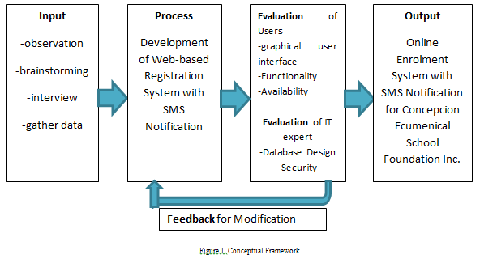

Fig.1. shows the conceptual framework that sets the example of the proposed system attached progress of the Online Registration System with SMS Notification for Concepcion Ecumenical School Foundation Inc. in order to create the system the figure above must be followed. Observation refers to the process of observing something to gain information, brainstorming; is the process wherein the proponents have to express their ideas and analyse to come up with a title for a certain system, they also conduct interview to consider the problems on the locale to gather data in terms of online enrolment and student portal. After coming up with the processes that would prone to difficulties, it comes the proper development by putting in an application for the proposed solution with the features of the system. Evaluation will be implemented when the proposed system would be first deployed in the school; graphical user interface, functionality and availability will evaluate by the users. IT experts can check the database design and the security of the system. When the first deployment is done, the feedback that has been receive from the system will be modified and the proponents go back in the input process where it will be the analysis and design to conduct changes if it is needed. If there are changes in in all phases, the proponents go back again and the process will take loop formation until the needed suggestions and opinions will pleased.

VII. Design and Methodology

1. Locale

The proponent’s locale is Concepcion Ecumenical School Foundatio1n Inc. located at Concepcion St., Isabel Subd., San Nicolas, Concepcion, Tarlac 2316, beside the school it has a church which is The United Methodist Church that describes the school as Methodist institution.

Originally, the school is composed of pre-school, elemetary and High School. The school have not been implemented the senior high.

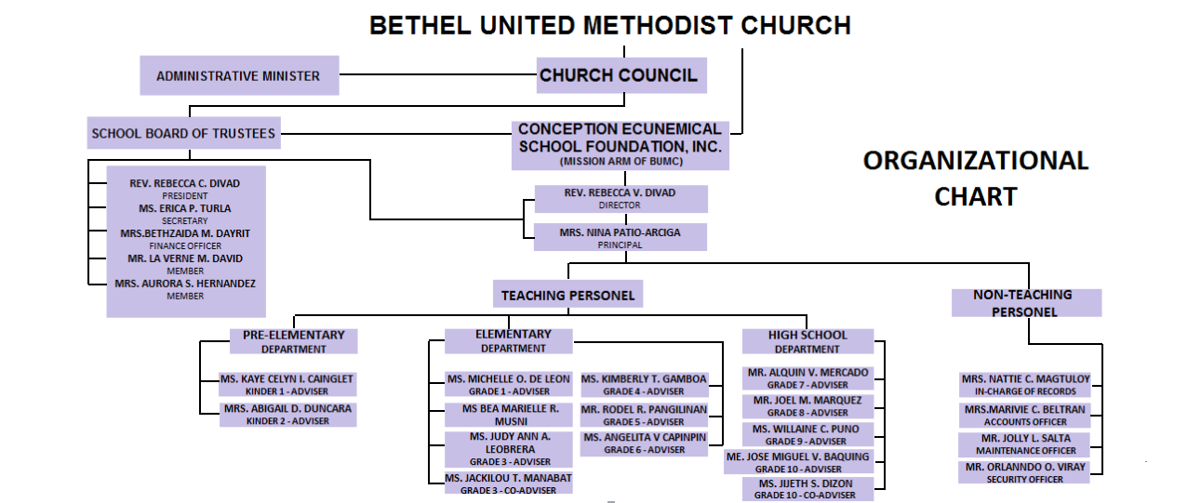Organizational Chart

Figure 2. Organizational Chart

Figure 2 shows the Organizational Chart of Concepcion Ecumenical School Foundation Inc. for basic Education.

*Economical Feasibility*

Table I

MONTHLY OPERATIONAL COST OF MANUAL PROC

Table I. shows the items that were used by the school in its manual process. The ball pen was use when filing up forms and others report and the bond paper was used for the paper forms that need to fill up by the students.

*Technical Feasibility*

Table II

HARDWARE RESOURCES

|  |  |  |
| --- | --- | --- |
| HARDWARE | LOCATION | DESCRIPTION |
| PC/Laptop  - Windows 7 ( 32- or 64-bit)  - 1 GB of RAM ( 2GB will be better)  Smart Phone/Tablet/Ipad  - Android/IOS  - 1 GB of RAM | Concern Offices and units all over the Tarlac State University | This where the system will be used by the students and Concern Office and unit at the Conception Ecumenical School Foundation Inc |

Table 2 shows the available hardware resource in the local that will use in the system; in testing and in implementing the system.

Table III

HARWARE AND SOFTWARE REQUIREMNETS

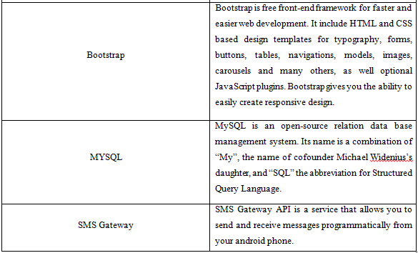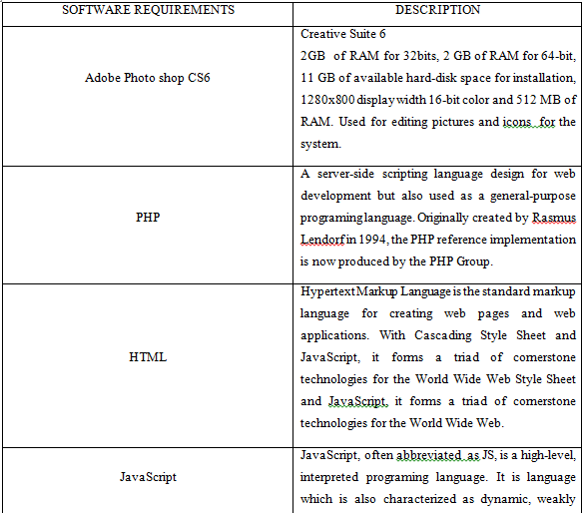

Table 3 shows the needed hardware and software to develop for the system. Like different languages and software that are usable for developing and designing what does the system needed.

1. *System Development Methodology*

This focuses on the methods and procedures used by the proponents in able to gather information that benefits for them to complete the study. The proponents decided to use the Agile Scrum methodology for well-organized and flexible on the development and data gathering, because it is the most effective method for the system because it will help the proponents to collaborate and make decisions together quickly.

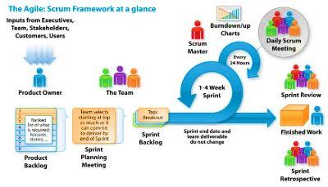

*Figure 3.*

*Agile Scrum Methodology*

Figure 3 shows the Agile Scrum Methodology which is an innovative approach in development cycle. The methodology used different steps, necessary in achieving and accomplishing the final deliverable output.

The proponent’s main objectives which are to design and develop an Online Registration System with SMS notification for Concepcion Ecumenical School Foundation Inc. the proponents used this method because this method can be divided in increment. The increment can be divided depends on how many sprints would it be; per sprint the proponents may able to identify on things that needs to be changed, improved, or removed for the whole benefit of the system. It has also given a chance to let the proponents know feedback of the users to gain information on further enhancement and early adjustments to the system.

*Methods of Gathering*

Different method of research will use to obtain the objectives of the project that will come up with a defenite information need for the developed system.

Library Reasearch method

This method is the most common technique used to gather dats and information needed; the proponents used the library to find some relevant materials and information to do the system. This method helped the proponents to collect data that need to complete and precise gathering of information connected to the study. The proponents gather some necessary information at TSU-San Isidro campus Library to conform the information used.

Internet

Internet is a very useful method for searching related studies in foreign literature and studies. The proponents use internet websites to search for their resources for their proposed system. It is used also for communicating each other to combined the idea that is relevant to the study.

Interview

This method of gathering data involves oral-verbal stimuli and reply. The proponents conducted an interview with the principal and the registrar of Concepcion Ecumenical School Foundation Inc. The interview grant the proponents to form intuition from people who gives information to identify or determine the problems encountered through the manual process of things that are not express with words.

Questionaires

Also called survey set of questions given to a sample of the population. The proponents will conduct questions that can be used to collects information that comes from the respondents. This method will conduct when the system was ready for an evaluation.

Observation

The proponents used the observation method to the locale on how or what is the process or transactions of the school. This gave the proponents a chance to analyse the actual working environment.

1. Project Schedule

TABLE IV

Gantt Chart

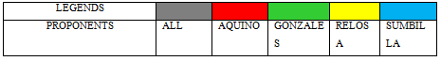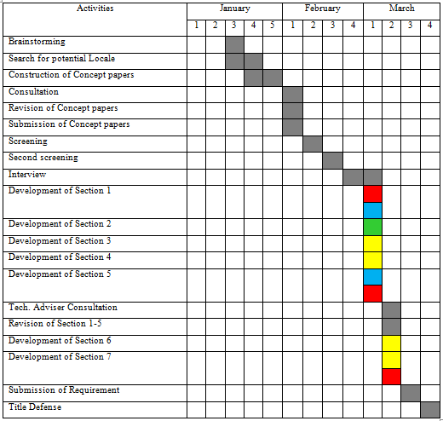

Table 4, shows the starting date, duration of each activity and the end date. The table shows the schedule time for the proponents to follow for them to develop the said system on time.

1. *Sampling technique and population*

The proponents decided ro use the formula of Weighted Mean and grand mean to determine the satisfaction of IT experst and users to the proposed sytem; proponents will use survey questions to see their ratings on different features of the sytem.

$\frac{∑fx}{N}=grand mean$

$\frac{\left(5\left(F\right)\right)+\left(4\left(F\right)\right)+\left(3\left(F\right)\right)+\left(2\left(F\right)\right)+(1\left(F\right))}{N}=$ Weighted mean

Where

F= Frequency

N= number of repondents

x= index

Population

*Figur 4 Population*

Figure 4 showa the student and faculty population of the school year. At the school year 2015-2016 the total population of the students is 213, however the school year 2016-2017 it increases 20 students, school year 2017-2018 it decreases; but tin the current school year it decrease again and still counting as stated by the in-charge of the records.

*Flow Chart*

Figure 4 Flowchart Diagram

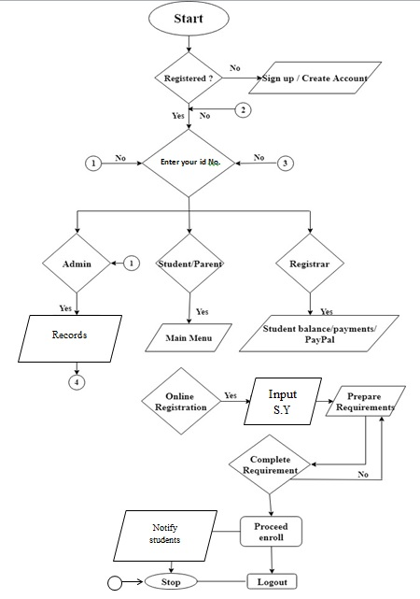

Figure 4

Fig 4 shows the flowchart; where the process will start first the system will analyse if the inputted number is a student/ parents, admin, or cashier. If the user is already registered he or she could log in. For students they can precede to the enrolment process, if not yet they could sign up for them to create account and log in to proceed on the enrolment process. The students who are registered or already created their accounts, they can access the student portal and enrolment website.

*Context Diagram*

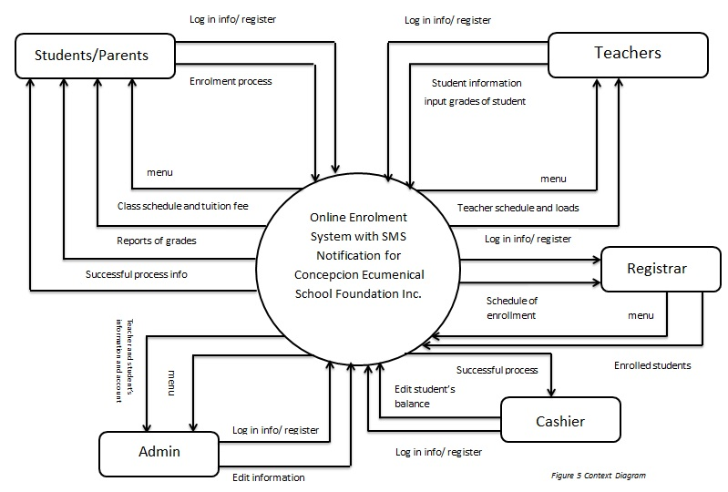

Figure 5 show the context diagram of the proposed system. The context diagram shows the flow of every users inside the system. Its explains what does the system have and what is the event inside the system.

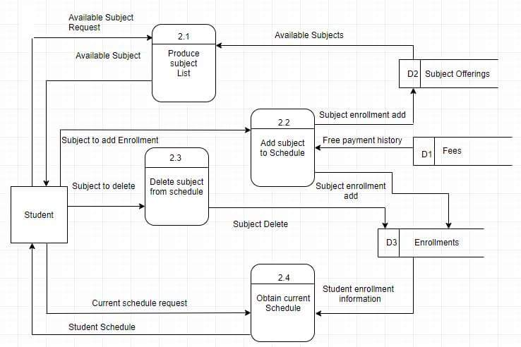Data flow Diagram

Figure 6 Data flow Diagram

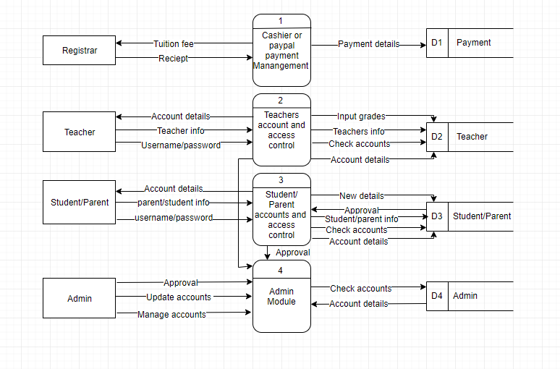

*Figure 6.1*

*Figures 6 and 6.1* shows the data flow diagram of the system; It is the enlarge form of context diagram and shows process for the student or parents, teacher, registrar, and admin. It shows the relationship of the cashier or PayPal payment management which manages the payment. Teachers account and access control with handle inputting grades and account details. Student or parents accounts and access control with handle students or parents information and account details. Admin module take in charge of manage and update account.

*Network/ Communication Architecture*

The system will use a LAN-based client-server network. It was the suitable network design preference for the system due to the facility utilized by the locale. It enables multiple pc connecting to each other. Client-server refers to a popular model for computer networking that utilizes both client hardware devices and servers, each with specific functions. This is the network architecture that the proponents use to connect the pc of the admin to every pc’s that will use by the users which are the student, parents and teachers. The server which is the IT personnel or record in-charge will receive notification from the clients who are the students, parents and teachers when they add or perform operation or process in the system. These notifications are recorded at the user log of the admin.

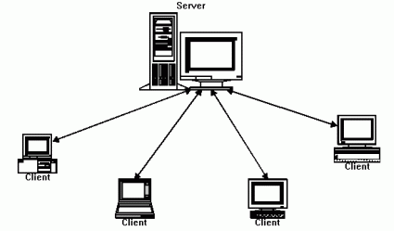

*Figure 7*

*Client Server Network*

*References*

*[1] https://ieeexplore.ieee.org/abstract/document/6804449/ Souvik Roy1 and P. Venkateswaran2 Department of Electronics & Tele-Communication Engineering Jadavpur University, Kolkata-700032, India (souvikece31@gmail.com1 ,* [*pvwn@ieee.org2-*](mailto:pvwn@ieee.org2-) *2014 IEEE Students’ Conference on Electrical, Electronics and Computer Science ----) – foreign literature*

*[2]* <https://www.ajman.ac.ae/en/it-department-service/for-students/online-registration-system-1.html>

[3]https://pdfs.semanticscholar.org/85d0/f85025a0dec6ab3d47967f2b722c81db49a6.pdf International Journal of Information Technology Infrastructure Available Online at <http://warse.org/pdfs/2013/ijiti02212013.pdf>

[4]<http://www.academia.edu/20047798/Web_based_Enrollment_and_Billing_System_Chapter_II>

[5]<https://www.academia.edu/28464670/ONLINE_STUDENT_PORTAL_WITH_GRADES_NOTIFICATIONS_VIA_SMS_THE_PROBLEM_AND_ITS_SCOPE>?

[6] <http://www.academia.edu/20047798/Web_based_Enrollment_and_Billing_System_Chapter_II>

[7] <http://www.apjmr.com/wp-content/uploads/2016/09/APJMR-2016.4.4.09.pdf>

SENT SMS : School Event Notification Through SMS Ramil G. Lumauag (Ed.D) Iloilo Science and Technology University Miagao Campus, Miagao Iloilo Philippines ramilglumauag@gmail.com Date Received: July 8, 2016; Date Revised: September 1, 2016

[8]<http://ijarcsse.com/Before_August_2017/docs/papers/Special_Issue/NCRTIT2K16/NCRTIT_12.pdf>

Volume 6, Issue 3, March 2016 ISSN: 2277 128X International Journal of Advanced Research in Computer Science and Software Engineering

Student Information Management System 1Manisha K, 2Alekhya K, 3T Manikanta, 4B Ramya, 5 S. Sai Kumar 1, 2, 3, 4 IV/IV B.Tech, IT, PVPSIT, Andhra Pradesh, India 5Assistant Professor, Department of Information Technology, PVPSIT, Andhra Pradesh, India

[9]<https://www.ijarcce.com/upload/2013/june/4-shobha%20bharamaoudar-WEB%20BASED%20STUDENT%20INFORMATION.pdf>

“Web Based Student Information Management System” by S.R. Bharamagoudar, Geeta R.B, S.G.Totad, 2013 International Journal of Advanced Research in Computer and Communication Engineering..

[[10]<https://www.slideshare.net/Notre-Dame-of-Kalamansig-online>-grade-inquiry-system

[11]<http://thesisbook.readthedocs.io/en/latest/Chapter%20II.html>

[12] <http://www.techinasia.com/klaseko-philippines-online-enrollment>