Sumário

1 - sub_param.py 2

2 - remove_put_post_delete.py 3

3 - remove_erros.py 4

4 - muda_description_get.py 5

# 1 - sub_param.py

This script groups all parameters, GET (RETRIEVAL Operations), POST (CREATION Operations), DELETE (DELETION Operations) and PUT (MODIFICATION Operations)

1 - Select the source file (ex: topology2.yaml) through the window box.

2- A file will be generated in the same directory as the source file with the name: filename.changed (ex: topology2.yaml.changed)

# 2 - remove_put_post_delete.py

This script uses the SED command to remove the PUT, POST and DELETE parameters.

1 - Select the source file (ex: topology2.yaml.changed) through the window box.

2- A file will be generated in the same directory as the source file with the name: filename.onlyget (ex: topology2.yaml.changed_onlyget)

# 3 - remove_erros.py

This script removes errors generated by the YAML file in the swagger editor 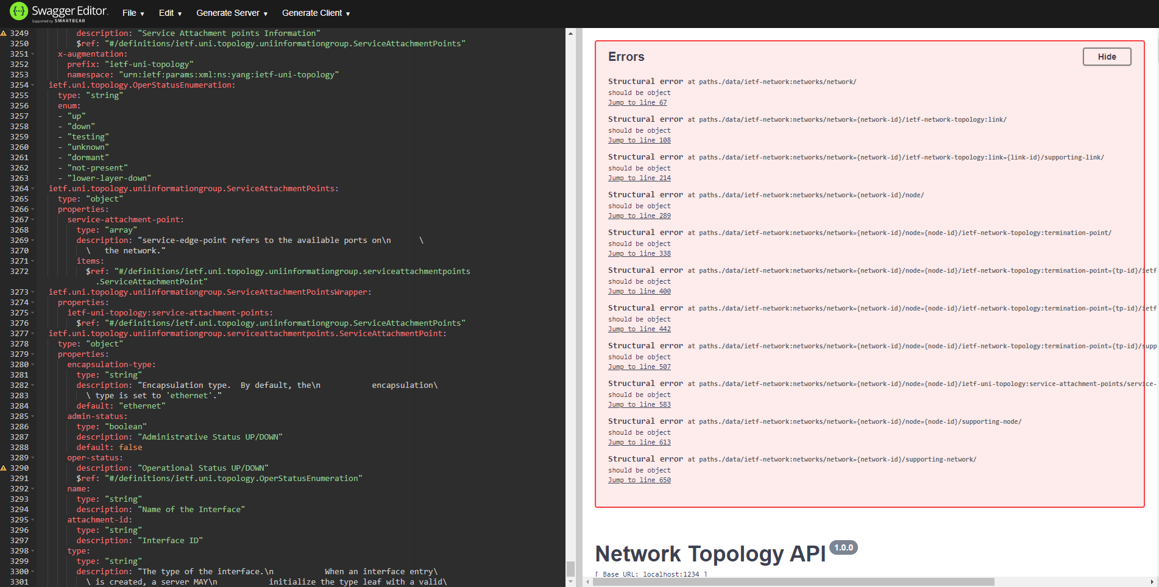

1 - Copy the errors generated in swagger to a text file (ex: error.txt) 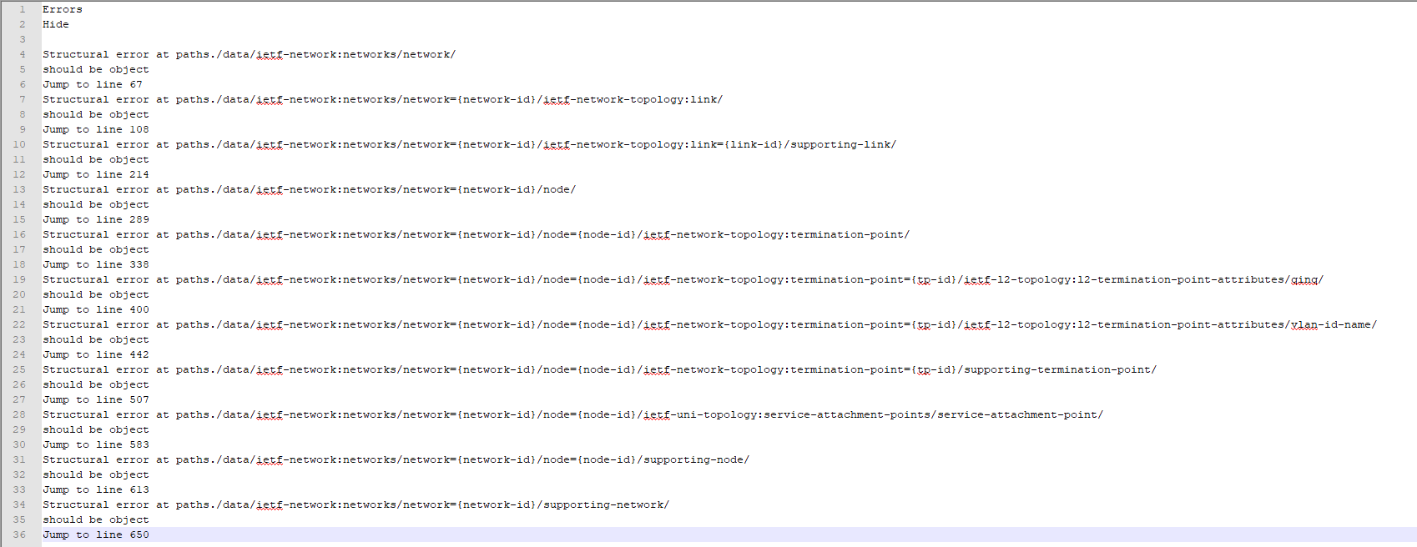

2 - Run the script, the first window will ask for the source file (ex: topology2.yaml.changed_onlyget) and then the error file (ex: error.txt).

3 - A file will be generated in the same directory as the source file with the name: filename_no_error (ex: topology2.yaml.changed_onlyget_no_error)

# 4 - muda_description_get.py

This script searches the YAML file and finds all parameters (eg get) to change the description by asking in a text window.

1 - Select the source file (ex: topology2.yaml.changed_onlyget_no_error) through the window that appears.

2 - All parameters found will be shown according to the figure below, with parameter path and summary. Replace all necessary parameters.

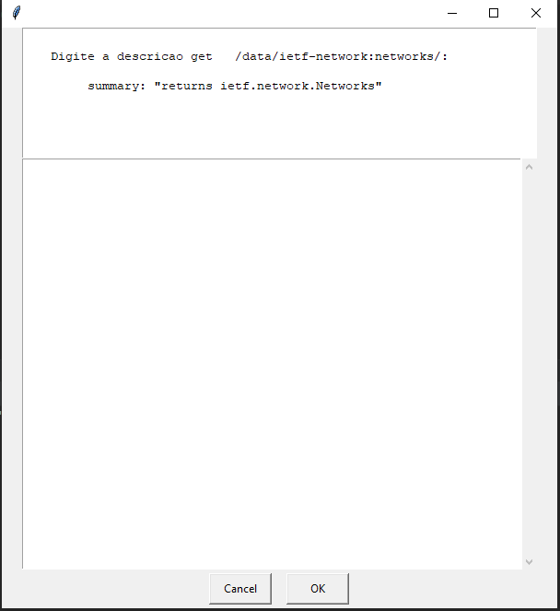

3- A file will be generated in the same directory as the source file with the name: filename. changed_get (ex: topology2.yaml.changed_onlyget_no_error.changed_get)