 Tarefa

Módulo 6

Atividade 6.a – Alterar parâmetros do Autovacuum
Edite o arquivo de configurações e altere os parâmetros para fornecerem o seguinte comportamento:
- Ter apenas 1 Worker;
- Autovacuum espere por 50ms quando atingir o limite de custo;
- Autovacuum trabalhe até um custo 10.

#------------------------------------------------------------------------------
# AUTOVACUUM
#------------------------------------------------------------------------------

#autovacuum = on # Enable autovacuum subprocess? 'on'
# requires track_counts to also be on.
#log_autovacuum_min_duration = -1 # -1 disables, 0 logs all actions and
# their durations, > 0 logs only
# actions running at least this number
# of milliseconds.
autovacuum_max_workers = 1 # max number of autovacuum subprocesses
# (change requires restart)
#autovacuum_naptime = 1min # time between autovacuum runs
#autovacuum_vacuum_threshold = 50 # min number of row updates before
# vacuum
#autovacuum_vacuum_insert_threshold = 1000 # min number of row inserts
# before vacuum; -1 disables insert
# vacuums
#autovacuum_analyze_threshold = 50 # min number of row updates before
# analyze
#autovacuum_vacuum_scale_factor = 0.2 # fraction of table size before vacuum
#autovacuum_vacuum_insert_scale_factor = 0.2 # fraction of inserts over table
# size before insert vacuum
#autovacuum_analyze_scale_factor = 0.1 # fraction of table size before analyze
#autovacuum_freeze_max_age = 200000000 # maximum XID age before forced vacuum
# (change requires restart)
#autovacuum_multixact_freeze_max_age = 400000000 # maximum multixact age
# before forced vacuum
# (change requires restart)
autovacuum_vacuum_cost_delay = 50ms # default vacuum cost delay for
# autovacuum, in milliseconds;
# -1 means use vacuum_cost_delay
autovacuum_vacuum_cost_limit = 10 # default vacuum cost limit for
# autovacuum, -1 means use
# vacuum_cost_limit

As alterações exigem restart ou apenas reload?

Exigem restart

Atividade 6.b – Monitorar o Autovacuum

Crie uma nova base chamada benchmark (remova a anterior se necessário);
postgres=# create database benchmark;
CREATE DATABASE
postgres=# \l
List of databases
Name | Owner | Encoding | Collate | Ctype | Access privileges
--------------+----------+----------+-------------+-------------+-----------------------
benchmark | postgres | UTF8 | en_US.UTF-8 | en_US.UTF-8 |
curso | postgres | UTF8 | en_US.UTF-8 | en_US.UTF-8 |
pgbench | postgres | UTF8 | en_US.UTF-8 | en_US.UTF-8 |
postgres | postgres | UTF8 | en_US.UTF-8 | en_US.UTF-8 |
sis_contabil | gerente | UTF8 | en_US.UTF-8 | en_US.UTF-8 |
template0 | postgres | UTF8 | en_US.UTF-8 | en_US.UTF-8 | =c/postgres +
| | | | | postgres=CTc/postgres
template1 | postgres | UTF8 | en_US.UTF-8 | en_US.UTF-8 | =c/postgres +
| | | | | postgres=CTc/postgres
(7 rows)

Popule a base com o pgbench.
$ pgbench -i -s 10 benchmark

postgres@debian10:~$ pgbench -i -s 10 benchmark
dropping old tables...
NOTICE: table "pgbench_accounts" does not exist, skipping
NOTICE: table "pgbench_branches" does not exist, skipping
NOTICE: table "pgbench_history" does not exist, skipping
NOTICE: table "pgbench_tellers" does not exist, skipping
creating tables...
generating data (client-side)...
1000000 of 1000000 tuples (100%) done (elapsed 4.00 s, remaining 0.00 s)
vacuuming...
creating primary keys...
done in 9.10 s (drop tables 0.01 s, create tables 0.01 s, client-side generate 4.16 s, vacuum 1.46 s, primary keys 3.46 s).

Criar a função para gerar strings aleatórias para popular a base:
$ psql -d benchmark < /curso/scripts/random_string.sql

postgres@debian10:~$ psql -d benchmark < random_string.sql
CREATE FUNCTION

Execute o script do pgbench disponível em “/curso/scripts/atualizacao.sql”
$ pgbench -c 10 -T 60 -n -f /curso/scripts/atualizacao.sql benchmark

postgres@debian10:~$ pgbench -c 10 -T 60 -n -f atualizacao.sql benchmark
transaction type: atualizacao.sql
scaling factor: 1
query mode: simple
number of clients: 10
number of threads: 1
duration: 60 s
number of transactions actually processed: 35878
latency average = 16.734 ms
tps = 597.580101 (including connections establishing)
tps = 597.599299 (excluding connections establishing)

Com o pg_activity, verifique se há execuções do Autovacuum durante ou após os testes.

Durante os testes
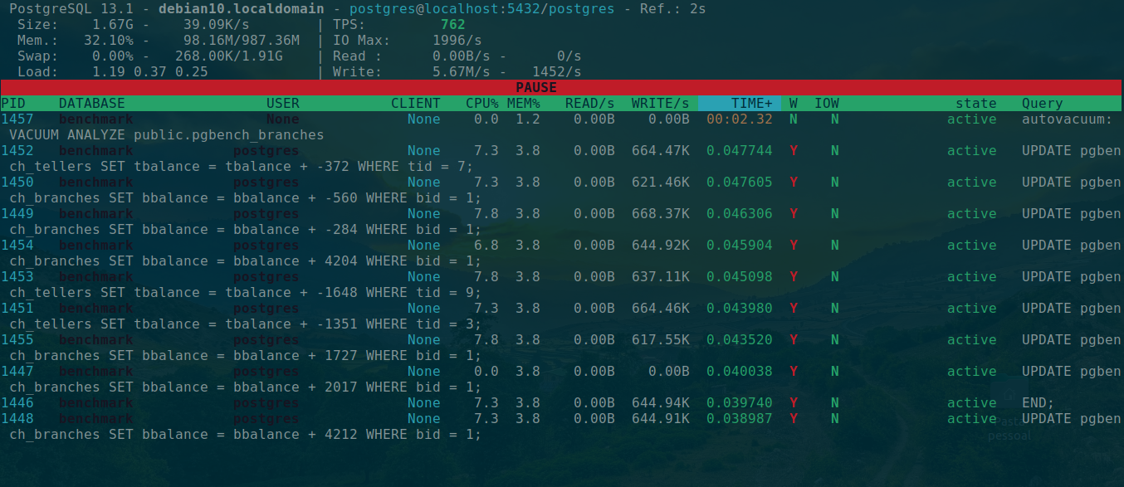
Após os testes
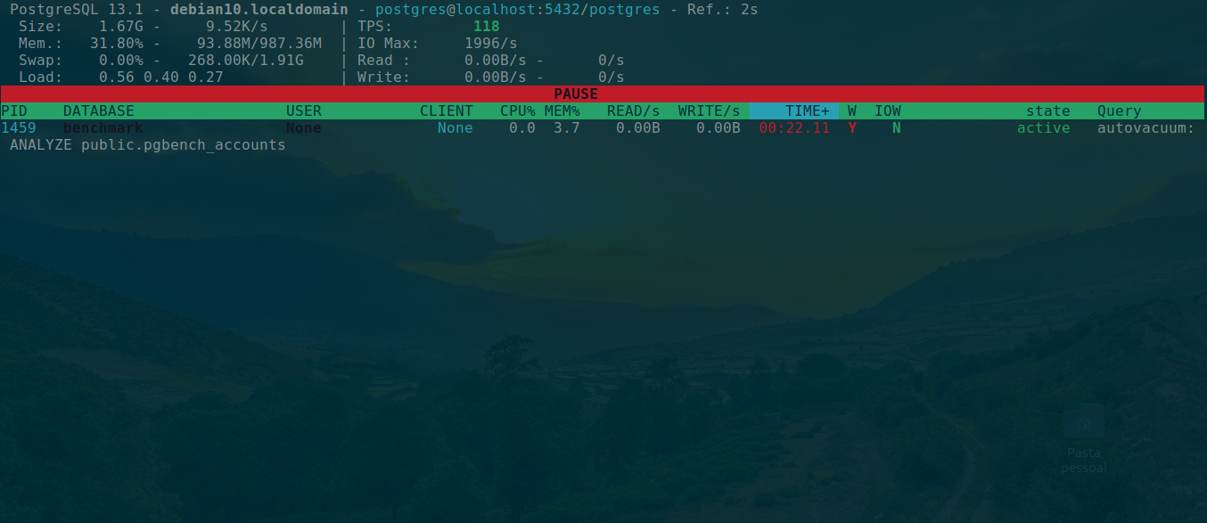

Atividade 6.c – Vacuum com estatísticas

Conecte na base benchmark:

Consulte os dados de dead tuples no catálogo pg_stat_user_tables;

benchmark=# select relid, relname, n_dead_tup, vacuum_count, autovacuum_count, analyze_count, autoanalyze_count
from pg_stat_user_tables;
relid | relname | n_dead_tup | vacuum_count | autovacuum_count | analyze_count | autoanalyze_count
-------+------------------+------------+--------------+------------------+---------------+-------------------
41006 | pgbench_tellers | 0 | 1 | 7 | 1 | 7
41009 | pgbench_accounts | 2028 | 3 | 0 | 3 | 1
41003 | pgbench_history | 0 | 3 | 6 | 3 | 6
41012 | pgbench_branches | 30 | 1 | 7 | 1 | 7
(4 rows)

Execute um Vacuum com saída detalhada e atualização estatística na tabela pgbench_history;

benchmark=# vacuum verbose analyze pgbench_history;
INFO: vacuuming "public.pgbench_history"
INFO: "pgbench_history": found 0 removable, 6 nonremovable row versions in 1 out of 913 pages
DETAIL: 0 dead row versions cannot be removed yet, oldest xmin: 162716
There were 0 unused item identifiers.
Skipped 0 pages due to buffer pins, 0 frozen pages.
0 pages are entirely empty.
CPU: user: 0.00 s, system: 0.00 s, elapsed: 0.00 s.
INFO: analyzing "public.pgbench_history"
INFO: "pgbench_history": scanned 913 of 913 pages, containing 142048 live rows and 0 dead rows; 30000 rows in sample, 142048 estimated total rows
VACUUM

Faça o mesmo para a tabela pgbench_accounts;

benchmark=# vacuum verbose analyze pgbench_accounts;
INFO: vacuuming "public.pgbench_accounts"
INFO: scanned index "pgbench_accounts_pkey" to remove 150 row versions
DETAIL: CPU: user: 0.02 s, system: 0.00 s, elapsed: 0.02 s
INFO: "pgbench_accounts": removed 150 row versions in 144 pages
DETAIL: CPU: user: 0.00 s, system: 0.00 s, elapsed: 0.00 s
INFO: index "pgbench_accounts_pkey" now contains 1000000 row versions in 2745 pages
DETAIL: 150 index row versions were removed.
0 index pages have been deleted, 0 are currently reusable.
CPU: user: 0.00 s, system: 0.00 s, elapsed: 0.00 s.
INFO: "pgbench_accounts": found 1885 removable, 100067 nonremovable row versions in 1741 out of 16494 pages
DETAIL: 0 dead row versions cannot be removed yet, oldest xmin: 162717
There were 1993 unused item identifiers.
Skipped 0 pages due to buffer pins, 0 frozen pages.
0 pages are entirely empty.
CPU: user: 0.05 s, system: 0.00 s, elapsed: 0.05 s.
INFO: analyzing "public.pgbench_accounts"
INFO: "pgbench_accounts": scanned 16494 of 16494 pages, containing 1000000 live rows and 0 dead rows; 30000 rows in sample, 1000000 estimated total rows
VACUUM

Houve diferenças na saída? Por quê?
Na tabela pgbench_accounts foram encontrados dead tuples
Atividade 6.d – Cluster de tabela

Abra dois terminais.
No primeiro::
- Apague a base benchmark e crie-a novamente

postgres=# drop database benchmark;
DROP DATABASE
postgres=# create database benchmark;
CREATE DATABASE
postgres=#

- Popule a base com pgbench
$ pgbench -i -s 100 benchmark

postgres@debian10:~$ pgbench -i -s 100 benchmark
dropping old tables...
NOTICE: table "pgbench_accounts" does not exist, skipping
NOTICE: table "pgbench_branches" does not exist, skipping
NOTICE: table "pgbench_history" does not exist, skipping
NOTICE: table "pgbench_tellers" does not exist, skipping
creating tables...
generating data (client-side)...
10000000 of 10000000 tuples (100%) done (elapsed 66.42 s, remaining 0.00 s)
vacuuming...
creating primary keys...
done in 181.27 s (drop tables 0.02 s, create tables 0.01 s, client-side generate 66.53 s, vacuum 69.62 s, primary keys 45.09 s).
postgres@debian10:~$

- Crie um índice nas colunas bid e aid da tabela pgbench_accounts;

benchmark=# CREATE INDEX idx_accounts_bid_aid ON pgbench_accounts(bid,aid);
CREATE INDEX

- Faça o cluster da tabela por esse novo índice;

benchmark=# cluster pgbench_accounts using idx_accounts_bid_aid;
CLUSTER

- Durante a execução do cluster, passe para o item 2.

Enquanto isso, no segundo terminal:
- Acesse a base benchmark e tente fazer um select na tabela.
- Consulte o consumo de recursos do processo, o IO Wait etc.;

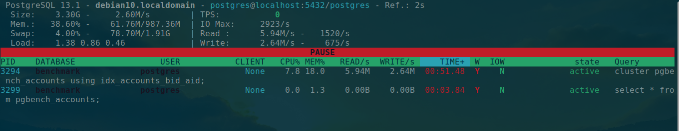

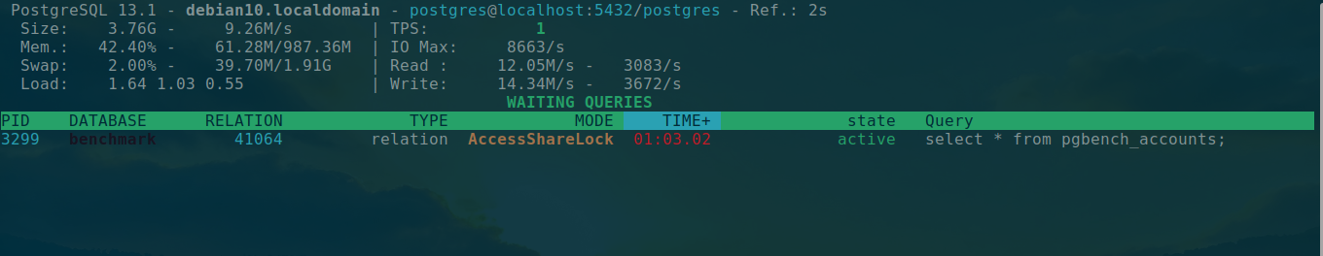
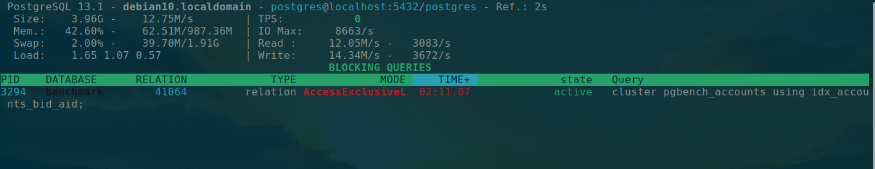

- Verifique o espaço em disco sendo consumido
$ du -h /db/data

postgres@debian10:~$ du -h /db/data
132K /db/data/pg_subtrans
4.0K /db/data/pg_logical/snapshots
4.0K /db/data/pg_logical/mappings
16K /db/data/pg_logical
12K /db/data/pg_multixact/offsets
12K /db/data/pg_multixact/members
28K /db/data/pg_multixact
44K /db/data/pg_xact
4.0K /db/data/pg_twophase
4.0K /db/data/pg_stat
4.0K /db/data/pg_serial
157M /db/data/log
4.0K /db/data/pg_commit_ts
568K /db/data/global
4.0K /db/data/pg_replslot
4.0K /db/data/pg_dynshmem
4.0K /db/data/pg_wal/archive_status
1009M /db/data/pg_wal
4.0K /db/data/pg_tblspc
4.0K /db/data/pg_snapshots
4.0K /db/data/pg_notify
7.4M /db/data/base/24598
4.0K /db/data/base/pgsql_tmp
7.5M /db/data/base/12662
7.3M /db/data/base/1
1.5G /db/data/base/32786
7.3M /db/data/base/12661
7.7M /db/data/base/16396
1.7G /db/data/base/41026
3.2G /db/data/base
68K /db/data/pg_stat_tmp
4.4G /db/data

Atividade 6.e – Vacuum Full

Execute o mesmo procedimento feito para Cluster para o Vacuum Full na mesma tabela.

postgres@debian10:~$ vacuumdb -t pgbench_accounts -d benchmark
vacuumdb: vacuuming database "benchmark"

Atividade 6.f – Vacuum em toda instância

Execute através do utilitário um vacuum em todas as bases, com saída detalhada e atualização de estatísticas.

postgres@debian10:~$ vacuumdb -a
vacuumdb: vacuuming database "benchmark"
vacuumdb: vacuuming database "curso"
vacuumdb: vacuuming database "pgbench"
vacuumdb: vacuuming database "postgres"
vacuumdb: vacuuming database "sis_contabil"
vacuumdb: vacuuming database "template1"

Atividade 6.g – Acelerar Vacuum

Execute um teste com o pgBench para forçar atualização de registros:
$ pgbench -T 60 benchmark

postgres@debian10:~$ pgbench -T 60 benchmark
starting vacuum...end.
transaction type: <builtin: TPC-B (sort of)>
scaling factor: 100
query mode: simple
number of clients: 1
number of threads: 1
duration: 60 s
number of transactions actually processed: 1387
latency average = 43.262 ms
tps = 23.115039 (including connections establishing)
tps = 23.119130 (excluding connections establishing)

- Execute um vacuum com 4 trheads, exibindo informações detalhadas para capturar o tempo de execução, na base benchmark

postgres@debian10:~$ vacuumdb -j 4 benchmark
vacuumdb: vacuuming database "benchmark"

- Execute um teste com o pgBench novamente
$ pgbench -T 60 benchmark

postgres@debian10:~$ pgbench -T 60 benchmark
starting vacuum...end.
transaction type: <builtin: TPC-B (sort of)>
scaling factor: 100
query mode: simple
number of clients: 1
number of threads: 1
duration: 60 s
number of transactions actually processed: 2944
latency average = 20.387 ms
tps = 49.051938 (including connections establishing)
tps = 49.061744 (excluding connections establishing)

- Agora execute o vacuum não paralelo

postgres@debian10:~$ vacuumdb -v -d benchmark
vacuumdb: vacuuming database "benchmark"
INFO: vacuuming "public.pgbench_accounts"
...
DETAIL: 0 dead row versions cannot be removed yet, oldest xmin: 167098
There were 0 unused item identifiers.
Skipped 0 pages due to buffer pins, 0 frozen pages.
0 pages are entirely empty.
CPU: user: 0.00 s, system: 0.00 s, elapsed: 0.00 s.

- Houve grande diferença de tempo de execução? Porque?

Não consegui observar a diferença

Atividade 6.h – Reconstrução de Índice
- Conecte na base benchmark;

postgres@debian10:~$ psql
psql (13.1)
Type "help" for help.

postgres=# \c benchmark
You are now connected to database "benchmark" as user "postgres".

- Faça a reconstrução do índice criado na atividade 6.4.
benchmark=# REINDEX INDEX public.idx_accounts_bid_aid;
REINDEX

