1. **Topic and Rationale**

Our team has decided to dive into the financial data world and create an App that will serve as visual solution for representing historical valuations for specific cryptocurrencies and the number of confirmed cases of the corona virus pandemic in the present year. We are searching for a relationship between the increment of the pandemic and with the price of the Bitcoin cryptocurrency

1. **Links to data set**

* We will be retrieving our cryptocurrency data from the CoinAPI website <https://www.coinapi.io/> and as of which follows to available API Documentation <https://docs.coinapi.io/?java#rest-api>
* We will be retrieving our corona virus data from a database

1. **Insipring Visualizations**

Candlestick

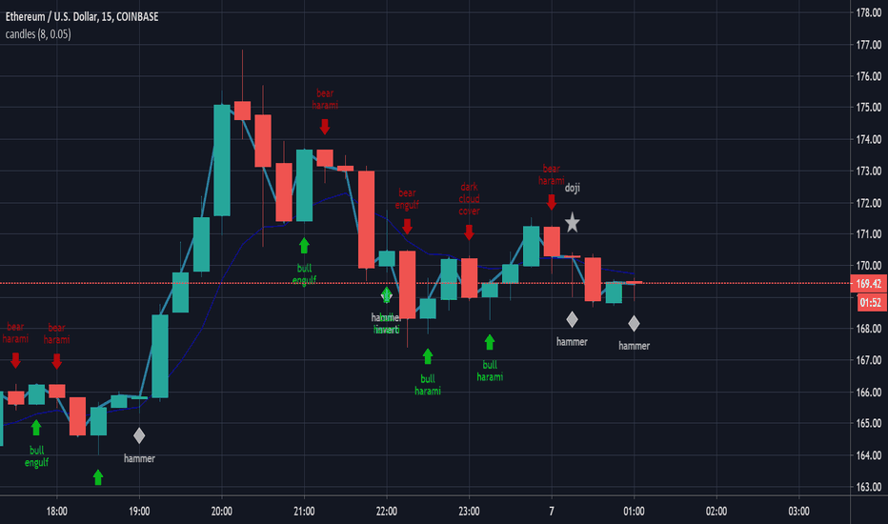

Design Interface

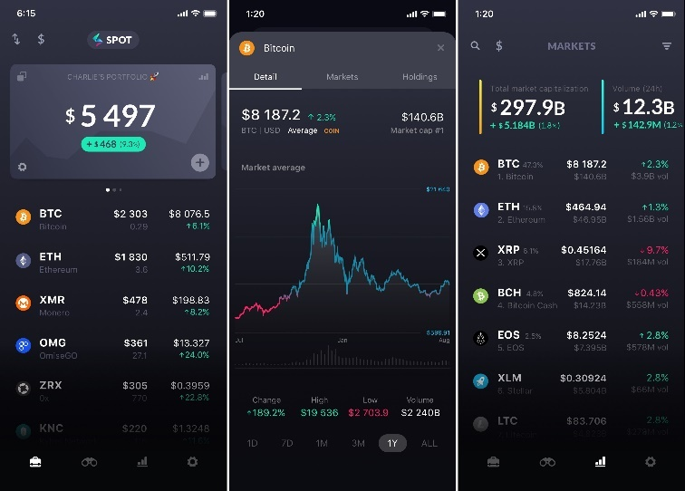

1. **Final Design**
2. **GitHub Repository**

<https://github.com/paulobetoy/project2>