Capstone Project Report
Paulo Bolinhas - 110976
Rui Martins - 110890

Management and Administration of IT Infrastructures and Services



Introduction
The project’s objective is to implement a simple and functional web application based on microservices. This type of architecture allows each service to manage its own distinct business logic while maintaining flexibility and scalability. The solution must be deployed on a cloud platform, ensuring it’s easily reproducible. The project is divided into two stages, the first involves creating a basic functional system, while the second focuses on adding advanced features to enhance the solution.
That said, Bank46 is our cloud-powered banking web application, entailing the use of automation tools, designed to manage core microservices such as Insurance, Loan, and Transaction processing.

Video link: ---

System Design and Architecture

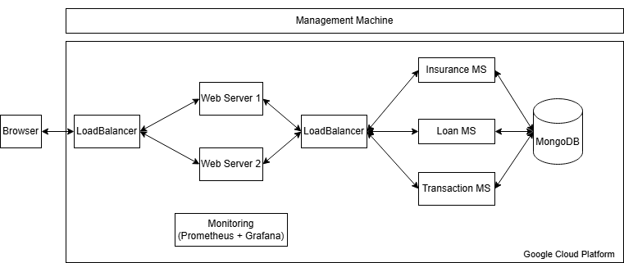
Image 1: Bank46 Architecture

The architecture of Bank46 follows a web microservices-based design (Step 1 - Building a Web Application), hosted on GCP (Step 2 - Deploying Foundational Resources), managed through a combination of tools including Vagrant, Terraform and Ansible (Step 3 - Infrastructure as Code (IaC)), data stored with MongoDB (Advanced Component #2) and monitored using Prometheus and Grafana (Step 4 - Operations Tooling for Monitoring).

Vagrant is used to create a virtual management machine (mgmt), where Terraform initializes and deploys all the others, including the web servers, microservices, balancer, monitors and the database within GCP. Ansible then ensures the proper configuration of these machines running the respective playbooks. For monitoring, Prometheus and Grafana are used to track the system health and performance metrics.

The frontend is handled by 2 web servers, which load the microservices JavaScript templates to the browser. A load balancer (Advanced Component #2) manages traffic distribution across these web servers, optimizing performance. This load balancing also applies to the backend microservices, ensuring smooth handling of requests under varying loads.

The backend consists of three key microservices: Insurance, Loan, and Transaction. These are responsible for all the browser endpoints business logic (JavaScript) and each of them communicate with the MongoDB instance for proper data storage.
…

Deployment Method
(Advanced Component #2)
Bank46's deployment follows advanced practices to ensure high availability.

Part I – Load Balancing
Traffic is managed using load balancing across both web servers and microservices, implemented with HAProxy using the roundrobin mechanism. This is set up via an Ansible playbook on the load balancer machine, which is deployed using Terraform, that calls the haproxy config file. The load balancer distributes requests efficiently, ensuring optimal performance and availability.
Part II - Database backend service with persistent storage
A database backend service with persistent storage is employed to store data. Terraform deploys a MongoDB instance, which is then configured via an Ansible playbook. Each microservice connects to the database using individual Mongoose connections and schemas, since the business logics are different. This ensures that all endpoints are interrelated and can interact with the database.

Evaluation
Includes a throughput and latency study of the system as the number of clients generating requests increases + images.

Conclusion
In building and deploying Bank46, we’ve applied class knowledge in cloud infrastructure, microservices and automation to create a robust banking platform. The architecture is fully modular, with business logic broken down into microservices for Insurance, Loan, and Transaction, ensuring that each service can be developed and deployed independently. By using Vagrant for managing the development environment, Terraform for deploying resources on GCP and Ansible for configuration management, we’ve ensured that the entire system is automated and easy to manage.
The load balancing across both the frontend web servers and backend microservices ensures high availability and optimized traffic handling. The choice of MongoDB as a database backend provides persistent storage, ensuring that data durability and availability are never compromised.
To keep everything running smoothly, we’ve integrated Prometheus and Grafana to monitor system performance, offering insights into throughput, latency and overall health metrics in real-time. This monitoring setup ensures we can identify and address any issues before they impact the end-user experience.
Ultimately, the combination of these tools and design choices allows Bank46 to handle increased traffic efficiently, maintain high uptime and provide a smooth user experience - all while being highly easy to manage.

