Brief Communication

AI agents can perform accurate bioinformatics analyses through a computational workbench
[Authors: author list]
[Authors: affiliations]
[Authors: corresponding author and e-mail]

Word counts: abstract 69; main text 1007; figure legends 271; main-text references 224 (11 references); total 1571. Methods 2383 (5 further references). Display items: 2 figures. Supplementary Information: 11 Supplementary Figures, 6 Supplementary Tables and 3 Supplementary Notes; Supplementary Data 1 and 2; Source Data for Figs. 1 and 2.

Abstract
Artificial intelligence (AI) agents can perform bioinformatics analyses, but benchmarks test only agents that write their own code. To address this gap, we connected agents to the Galaxy workbench and compared them with agents writing custom code on 160 tasks from three benchmarks with four models. Accuracy was similar, Galaxy recorded every tool, parameter and dataset, and agent traces guided interface improvements that more than halved Galaxy's token use.

Artificial intelligence (AI) agents that plan and run analyses are increasingly used in biomedical research^{1–4}, and benchmarks now test whether they can complete whole bioinformatics analyses^{5,6}. These benchmarks evaluate agents as programmers: each agent writes and runs its own code. However, custom code often lacks a structured record of the software versions and parameters used, which makes analyses difficult to review and reproduce^{7,8}. Scientific workbenches such as Galaxy^{9,10} address this problem for scientists by providing versioned tools, managed compute and histories that record the inputs, parameters and outputs of every step and can be shared, turned into workflows and rerun¹¹. Whether agents can use a workbench to complete bioinformatics tasks as accurately as they write code has not been tested.
To address this gap, we connected AI agents to Galaxy through Model Context Protocol (MCP) servers and compared them with agents writing custom code (Fig. 1a). The MCP servers give agents access to Galaxy's main capabilities: tool search, parameter descriptions, history inspection, job submission and monitoring, and user-defined tools (UDTs) for operations that no installed tool covers. In the Galaxy condition, all scientific computation had to run as Galaxy jobs on usegalaxy.org; in the custom-code condition, which served as the baseline, the agent installed software and wrote its own code. Four model configurations in the Codex agent harness attempted each of 160 tasks three times per condition, for 3,840 runs: 50 tasks from BixBench-Verified-50⁵, 100 from CompBioBench⁶ and 10 derived from workflows of the Intergalactic Workflow Commission (IWC; https://github.com/galaxyproject/iwc). Because the IWC-derived tasks come from Galaxy workflows and could favour Galaxy, we report them separately.
Agents were similarly accurate in the two conditions on the two platform-neutral benchmarks. On BixBench-Verified-50, 87.2% of custom-code runs and 87.7% of Galaxy runs were accepted (Fig. 1b), a difference of +0.5 percentage points (95% confidence interval (CI) −3.9 to 4.8). On CompBioBench, 86.7% and 87.0% of runs agreed with the answer key (Fig. 1c; +0.3; 95% CI −1.8 to 2.5). For both benchmarks, the 90% CI of the difference lay within ±5 percentage points, a margin set after the analysis (Methods). No per-model difference was significant after Holm adjustment (smallest adjusted P = 0.19), although 4 of the 8 per-model intervals extended beyond ±5 points (Supplementary Fig. 1). The pooled differences stayed within one point of zero after we removed tasks with audited benchmark-side problems, questionable CompBioBench campaigns, runs exposed to benchmark answers or Galaxy runs that computed outside Galaxy (Supplementary Figs. 2 and 3). On the IWC-derived tasks, mean output agreement was 0.95 with custom code and 0.99 with Galaxy (+0.036; 95% CI 0.006 to 0.073; exact paired P = 0.055), and three tasks with a zero-scored run accounted for most of this difference (Fig. 1d).
Next, we asked why runs failed. An audit of the execution traces of all 151 incorrect BixBench-Verified-50 runs found that Galaxy itself caused 3 failures (Fig. 2a). Most failures, 107 (71%), came from the benchmark: an under-specified task or reference answer (94) or a scorer that rejected a valid answer (13). The agent caused 37, and 4 runs submitted no answer. The two main causes were linked, because in 74 of the 94 under-specified runs the agent also did not validate its answer. Under-specification was systematic: 85 of the 94 runs were in replicate groups in which all three runs were wrong. In contrast, missing validation, the main agent-side cause, was largely random: 16 of its 32 cases occurred in groups whose other two replicates were correct. Notably, at least one replicate was correct in 85–94% of replicate groups, yet a majority vote added at most 2.3 points (Fig. 2b, Supplementary Fig. 4 and Supplementary Table 1). Thus, a validation step that selects a correct replicate could recover more errors than voting.
Galaxy also recorded each analysis in a structured form that can be audited (Fig. 2c and Supplementary Fig. 5). All 37,498 analysis steps in Galaxy runs recorded the tool and its version, the parameters and the output datasets, and the Galaxy history was retrieved for 1,871 of 1,908 runs. In contrast, custom-code runs retained the 55,380 commands that they ran but no structured record of software versions, parameters or outputs. This record came at a cost: across the main runs, Galaxy used 4.2, 2.7 and 0.92 times the tokens of custom code on BixBench-Verified-50, CompBioBench and the IWC-derived tasks (Supplementary Table 2 and Supplementary Fig. 6). Agent traces showed that, in the first-round GPT-5.5 batch, Galaxy runs took 2.66 times as many steps as custom-code runs, and each step reread 2.2 times as much context (Methods). Treating the agents as virtual users, we changed the interface to reduce these overheads and reran BixBench-Verified-50 (Fig. 2d). Combining job submission, waiting and checking into one MCP call, among other changes, reduced Galaxy tokens by 55.2% (95% CI 44.9–62.8%) with GPT-5.5. Compact replies and longer waits between checks reduced them by a further 55.6% (46.4–63.0%) with GPT-5.6 Sol, to 1.53 times custom code, while 137 of 150 runs remained correct (136 before). Thus, much of Galaxy's token cost came from its interface, and agent traces showed how to reduce it.
Together, these results show that AI agents can perform bioinformatics analyses through a computational workbench with accuracy similar to that of custom code, while leaving a record that people can inspect and rerun. Galaxy could also make rigor-improving practices inexpensive for agents, such as comparing several methods for one step or validating results before reporting them, but we did not test this here. This study has several limitations. First, it covers four model configurations and three benchmarks, and models change quickly. Second, prompts, time limits and runtime environments differed between conditions, so we compared the conditions as deployed (Supplementary Table 3). Third, the IWC comparison rests on ten Galaxy-derived tasks, the cause audit covers BixBench-Verified-50 only, and the interface rounds were not a controlled ablation. Future work will add a validation layer to the agent interface and test whether it improves accuracy. More broadly, agent traces could become a routine source of usability evidence for scientific software.

References
1. Gao, S. et al. Empowering biomedical discovery with AI agents. Cell 187, 6125–6151 (2024).
2. Huang, K. et al. Autonomous biomedical research with an artificial intelligence agent. Science 393, eadz4351 (2026).
3. Alber, S. et al. CellVoyager: AI CompBio agent generates new insights by autonomously analyzing biological data. Nat. Methods 23, 749–759 (2026).
4. Miao, J., Davis, J. R., Zhang, Y., Pritchard, J. K. & Zou, J. Reimagining research papers as interactive and reliable AI agents. Nature https://doi.org/10.1038/s41586-026-11044-y (2026).
5. Mitchener, L. et al. BixBench: a comprehensive benchmark for LLM-based agents in computational biology. Preprint at https://doi.org/10.48550/arXiv.2503.00096 (2025).
6. Nair, S. et al. Agentic systems are adept at solving well-scoped, verifiable problems in computational biology. Preprint at bioRxiv https://doi.org/10.64898/2026.04.06.716850 (2026).
7. Sandve, G. K., Nekrutenko, A., Taylor, J. & Hovig, E. Ten simple rules for reproducible computational research. PLoS Comput. Biol. 9, e1003285 (2013).
8. Grüning, B. et al. Practical computational reproducibility in the life sciences. Cell Syst. 6, 631–635 (2018).
9. Goecks, J., Nekrutenko, A., Taylor, J. & The Galaxy Team. Galaxy: a comprehensive approach for supporting accessible, reproducible, and transparent computational research in the life sciences. Genome Biol. 11, R86 (2010).
10. The Galaxy Community. The Galaxy platform for accessible, reproducible, and collaborative data analyses: 2024 update. Nucleic Acids Res. 52, W83–W94 (2024).
11. Wratten, L., Wilm, A. & Göke, J. Reproducible, scalable, and shareable analysis pipelines with bioinformatics workflow managers. Nat. Methods 18, 1161–1168 (2021).

Methods

Benchmarks
We evaluated agents on 160 tasks from three benchmarks that each require a complete bioinformatics analysis (Supplementary Table 3). BixBench-Verified-50 is a curated subset of 50 questions from 33 data capsules of BixBench⁵, reviewed with domain experts for the correctness of the ground truth, the sufficiency of the supplied context and the clarity of the expected answer; 17 of the 50 questions were revised relative to the original release. Each question comes with a data capsule and an evaluation mode (17 string, 13 range and 20 language-model verifiers). Agents received the question and input data but not the reference notebook or answer. The inputs were frozen before evaluation and archived on Zenodo (record 21115010). CompBioBench v1 comprises 100 computational biology tasks with objectively gradable answers in genomics, transcriptomics, epigenomics, single-cell analysis, human genetics and machine learning⁶; agents received the question and input files, and the analytical route was not prescribed. The IWC-derived tasks are ten analyses derived from workflows of the Intergalactic Workflow Commission, the Galaxy community's collection of reviewed workflows; agents received the task inputs and a description of the expected outputs, but not the workflow.

Galaxy interface
In the Galaxy condition, agents worked through MCP servers (https://modelcontextprotocol.io) that we wrote as Python wrappers around the Galaxy application programming interface (API). For each run, the servers were launched locally inside the run's Docker container, communicated with the agent over standard input and output (stdio) and were configured through the run's Codex configuration file (config.toml). They called the API of usegalaxy.org (Galaxy 26.1.2.dev0) with an API key, through BioBlend¹² and REST requests, and exposed Galaxy operations as agent tools: searching installed tools, retrieving a tool's parameter descriptions, inspecting histories and datasets, submitting jobs and waiting for them, and defining and running UDTs, which run agent-written code as Galaxy jobs in a declared container. Some runs also called the Galaxy API directly through BioBlend or REST instead of the MCP tools (Supplementary Note 1). Analyses used tools from the Galaxy ToolShed¹³. Task inputs were preloaded into seed histories, and each run copied its seed history into a new history before it started, so independent runs began from identical datasets. The main runs used the second-round interface, in which one call submits a job, waits for it, checks the resolved inputs and parameters against the request and returns a compact result. UDTs were not offered on the IWC-derived tasks. [Authors: repository URL, version and licence of the Galaxy MCP servers and agent skills].

Models and agent harness
We ran four model configurations in the Codex agent harness: GPT-5.5, GPT-5.6 Sol and DeepSeek V4 Pro at high reasoning effort, and GPT-5.6 Luna at maximum reasoning effort. The GPT models used the fast service tier, and DeepSeek V4 Pro was served through the DeepSeek API as a Codex model provider. Settings were identical in the two conditions for each model. The main runs used the Codex command-line interface (CLI) version 0.146.0: the BixBench-Verified-50 runs of GPT-5.6 Sol, GPT-5.6 Luna and DeepSeek V4 Pro, and all CompBioBench and IWC-derived runs [Authors: Codex CLI version of the BixBench-Verified-50 GPT-5.5 runs]. The third-round interface runs used version 0.156.0 (Token accounting and interface rounds). [Authors: reason for maximum reasoning effort on GPT-5.6 Luna].

Execution conditions
We ran every task in two execution conditions. In the custom-code condition, the agent could write and run code, use command-line programs, install software and retrieve external resources. In the Galaxy condition, the prompt added an execution policy: scientific computation had to run in Galaxy, local code was limited to orchestrating Galaxy, staging inputs and extracting the answer from Galaxy outputs, and the prompt specified history use, permitted tools, UDT rules and interface timeouts. Galaxy prompts were therefore longer than custom-code prompts on BixBench-Verified-50 (median 707 versus 366 words) and CompBioBench (938 versus 227), but not on the IWC-derived tasks (333 versus 344). Runtime environments and time limits also differed. CompBioBench Galaxy runs executed in containers and custom-code runs in a host conda environment; IWC runs had a 6-h or 12-h wall-clock limit depending on start time; CompBioBench custom-code prompts stated a 120-min budget; and no budget was recorded for the other runs (Supplementary Table 3). Agents in both conditions could reach the internet. Galaxy runs shared usegalaxy.org accounts, so agents could see other runs' histories (Supplementary Note 1). We therefore compare the conditions as deployed, not as an isolated effect of the workbench.

Experimental design
Each model configuration attempted each task three times in each condition: 160 tasks × 4 configurations × 2 conditions × 3 replicates = 3,840 runs (1,200 on BixBench-Verified-50, 2,400 on CompBioBench and 240 on the IWC-derived tasks). Replicates were independent runs that began from a fresh workspace or history, and replicate indices were not matched between conditions. Comparisons between conditions were paired by task, the unit that both conditions share. Runs that ended without a scoreable answer were scored as incorrect.

Answer evaluation
We kept each benchmark's own endpoint and did not pool scores across benchmarks. We used the per-run scores displayed on the project's public results site (https://goeckslab.github.io/galaxy-agent-benchmark/) and confirmed on 14 October 2026 that every score and answer used here matched the site. Accuracy per benchmark, model and condition is in Supplementary Table 4. BixBench-Verified-50 runs were scored by the benchmark's verifiers [Authors: model, version and provider of the language-model verifier]. The results site corrected the scoring of two questions after the original evaluation (bix-53-q2, accepting equivalent statements of an increase, and bix-43-q2, with platform-dependent numerical results under a two-decimal rule), which regraded 27 runs. CompBioBench withholds its reference answers, so runs were scored against a reconstructed answer key in which 54 references were inferred from recorded scores and 46 from predicted answers; the per-run grades reproduce the official leaderboard score of every replicate. After a review on 5 October 2026, 53 CompBioBench Galaxy runs whose key analyses had run outside Galaxy or whose tool timeouts needed verification were rerun, and the reruns replaced the original runs (Supplementary Note 2). The IWC-derived tasks were scored by the agreement (0–1) of the output files with the curated workflow outputs; we report mean agreement and, for counts of correct runs, treat agreement ≥ 0.99 as correct. Two IWC-derived tasks need care (Supplementary Note 3). The host-read removal task is scored from each run's run record, and its reference output is identical to the output of one run. On 12 October 2026, the results site replaced all 24 runs of the mitochondrial genome assembly task with reruns on a second read set (ERR12833637); we use their scores and token counts, and the trace-based analyses exclude the task because the archive holds no traces of the reruns.

Failure-cause audit
We assigned each of the 151 incorrect BixBench-Verified-50 runs one primary cause and, where present, one secondary cause from its execution trace, outputs and Galaxy history: an under-specified task or reference answer; a scorer that rejected a valid answer; no validation of the answer; wrong biological or statistical knowledge; a fault of Galaxy itself; or no answer submitted. We assigned causes with AI assistance. An independent AI-assisted second rater agreed with the primary cause for 35 of 45 sampled runs (κ = 0.56). [Authors: describe the human review of the audit: who reviewed which cases and how disagreements were resolved]. Four bix-43-q2 runs regraded as incorrect by the results site after the audit take the cause of the task-level audit. CompBioBench and the IWC-derived tasks have no trace-based cause audit. Supplementary Figs. 7–11 summarize how Galaxy runs used Galaxy, execution errors, answer agreement between replicates, tool use and recovery from failed steps.

Replicate agreement and consensus
A replicate group is the three replicates of one task, model and condition. From the existing runs we estimated the accuracy of three strategies: a majority vote (a group is correct if at least two replicates are correct, which assumes that correct answers agree), selection of a correct replicate whenever one exists (at least one of three correct) and a majority over all 12 runs of a task in a condition (ties counted as incorrect). A vote on the submitted answers, compared as normalized text, is reported in Supplementary Table 1. None of these strategies was run.

What each condition records
We counted the elements that the archived run evidence retains for each analysis step. Galaxy analysis steps are Galaxy jobs; custom-code analysis steps are the agent's shell commands that the run evidence labels as analysis. For each step we recorded whether its command, tool and version, parameters and output datasets were retained, and for each Galaxy run whether its history contents were retrieved. Software versions that custom-code runs printed in their logs are not counted as structured records.

Token accounting and interface rounds
Token counts are those that the model provider reported for each run and that the Codex harness recorded at the end of the run: input, including cached context, plus output, with reasoning counted in output. Main-run totals per benchmark and model are those published on the results site; for CompBioBench they include the 53 runs that the reruns replaced, and 14 CompBioBench runs have no usage record. In the July first-round batch, cached input was 95% of Galaxy tokens and output under 1.5%; Galaxy runs took 2.66 times as many agent steps (37.9 versus 14.2 per run), each carrying 2.2 times as much cached context.
The interface rounds used BixBench-Verified-50 (Supplementary Table 5). In July 2026, with GPT-5.5, we compared runs with the first-round interface (shorter skill text and prompt guidance; 150 runs per condition) with the archived runs of the second-round interface (one call to submit a job, wait and check the resolved inputs and parameters; automatic record keeping and parameter checks; live tool search). In October 2026, with GPT-5.6 Sol, we compared the archived second-round runs with a third-round interface (replies capped at 4 KiB per output and 8 KiB per reply, an 'unchanged' notice instead of repeated content, parameter templates, fewer false parameter warnings and pre-submission checks for UDTs), run once over the 50 tasks, and with the third-round interface plus instructions to wait 5–30 min before rechecking a running job (three replicates; 150 runs). Tokens are reported per complete 50-task run, averaged over replicates; ratios are Galaxy over custom-code totals, and the change in Galaxy tokens is paired by task. The rounds changed several features at once, the model changed between July and October and the Codex command-line interface changed for round 3 (0.156.0 versus 0.146.0), so the stages are not a controlled ablation. Earlier single-run measurements of the original interface are not reported because their run records are not archived.

Answer integrity
Because benchmark answers can leak into evaluations¹⁴, we scanned the traces of all 4,443 archived run folders with 19 rule detectors and read the trace of every case in which fetched content contained the task's answer (Supplementary Note 1 and Supplementary Table 6). In the primary set, 15 runs copied an answer: 3 BixBench-Verified-50 runs printed the answer field of the public benchmark dataset, and 12 CompBioBench runs submitted another agent's answer from a public trace dataset; 11 of the 15 were graded correct. Exposure tiers based on what each run fetched identified 94 runs with verified or probable exposure; excluding them changed the BixBench-Verified-50 and CompBioBench differences to +0.6 and +0.2 points (Supplementary Fig. 3). The audit also flagged 43 Galaxy runs whose traces show that local analysis produced the submitted answer or that had no successful Galaxy job (automatic detections); excluding them changed the differences to −0.04 (95% CI −4.7 to 4.4) and +0.4 (−1.8 to 2.6) points.

Statistics and reproducibility
We computed differences as Galaxy minus custom code for each benchmark. Intervals are 95% percentile cluster-bootstrap intervals (20,000 resamples; seed 20261002)¹⁵ that resample BixBench source capsules, whose questions share data, or tasks, with all their models, replicates and conditions. P values come from paired cluster sign-flip tests on each cluster's summed difference (200,000 random sign vectors, or exact enumeration for 16 or fewer clusters, as for the IWC-derived tasks) and were Holm-adjusted¹⁶ across the 12 benchmark × model comparisons. The equivalence check was defined after the analysis: we report the 90% cluster-bootstrap interval of each pooled difference, which corresponds to two one-sided tests at α = 0.05, against a ±5-percentage-point margin. With ten IWC-derived tasks, bootstrap intervals are too narrow, so we report exact P values. Sensitivity populations were defined retrospectively. All tests were two-sided. No statistical method was used to predetermine sample size. Analyses used Python 3.12 with NumPy 2.5.3, pandas 3.0.6 and SciPy 1.18.1; the figure scripts record every value they draw, so each figure can be regenerated from the archive.

Use of AI tools
AI coding assistants were used during this study to assist with analysis and figure code and with drafting and editing the text [Authors: name the assistants, models and versions]. Every number in the paper was computed by archived scripts and checked against the source tables. [Authors: confirm or edit: The authors determined the study design, performed and validated the reported analyses, interpreted the results, and reviewed and verified all AI-assisted outputs.] The agents evaluated in this study are its subject and did not contribute to the analysis or the writing.

Reporting summary
Further information on research design is available in the Nature Portfolio Reporting Summary linked to this article.

Data availability
Supplementary Data 2 lists every run with links to its agent trace, its page on the results site (https://goeckslab.github.io/galaxy-agent-benchmark/) and, for Galaxy runs, its usegalaxy.org history: the 3,840 primary runs, the 77 runs replaced by reruns and the 450 interface-round runs of Fig. 2d. The agent traces of both conditions, with prompts, submitted answers, token usage and evaluation records, are in the Hugging Face dataset goeckslab/galaxy-agent-benchmark-run-traces [Authors: the dataset currently requires authorization; make it public or state how readers obtain access, and deposit a snapshot with a DOI]. On 20 October 2026, 2,281 of the 2,285 Galaxy histories opened without an account; the other 4, of DeepSeek V4 Pro runs on BixBench-Verified-50, are not shared [Authors: make these four histories importable]. Per-run scores and token counts are also on the results site. BixBench-Verified-50 inputs are archived on Zenodo (record 21115010). The run archive and analysis tables are at https://github.com/paulocilasjr/Galaxy_benchmark [Authors: release DOI]. CompBioBench reference answers are not redistributed. Source data are provided with this paper.

Code availability
Analysis and figure code are at https://github.com/paulocilasjr/Galaxy_benchmark and https://github.com/goeckslab/agent-galaxy-benchmark-manuscript [Authors: tagged release, DOI and licence]. The Galaxy MCP servers and agent skills are at [Authors: repository URL, version and licence].

Methods references
12. Sloggett, C., Goonasekera, N. & Afgan, E. BioBlend: automating pipeline analyses within Galaxy and CloudMan. Bioinformatics 29, 1685–1686 (2013).
13. Blankenberg, D. et al. Dissemination of scientific software with Galaxy ToolShed. Genome Biol. 15, 403 (2014).
14. Kapoor, S. & Narayanan, A. Leakage and the reproducibility crisis in machine-learning-based science. Patterns 4, 100804 (2023).
15. Davison, A. C. & Hinkley, D. V. Bootstrap Methods and their Application (Cambridge Univ. Press, 1997).
16. Holm, S. A simple sequentially rejective multiple test procedure. Scand. J. Stat. 6, 65–70 (1979).

Acknowledgements
[Authors: funding and acknowledgements]

Author contributions
[Authors: contributions]

Competing interests
[Authors: competing interests]

Additional information
Supplementary information is available for this paper. Correspondence and requests for materials should be addressed to [Authors: corresponding author].

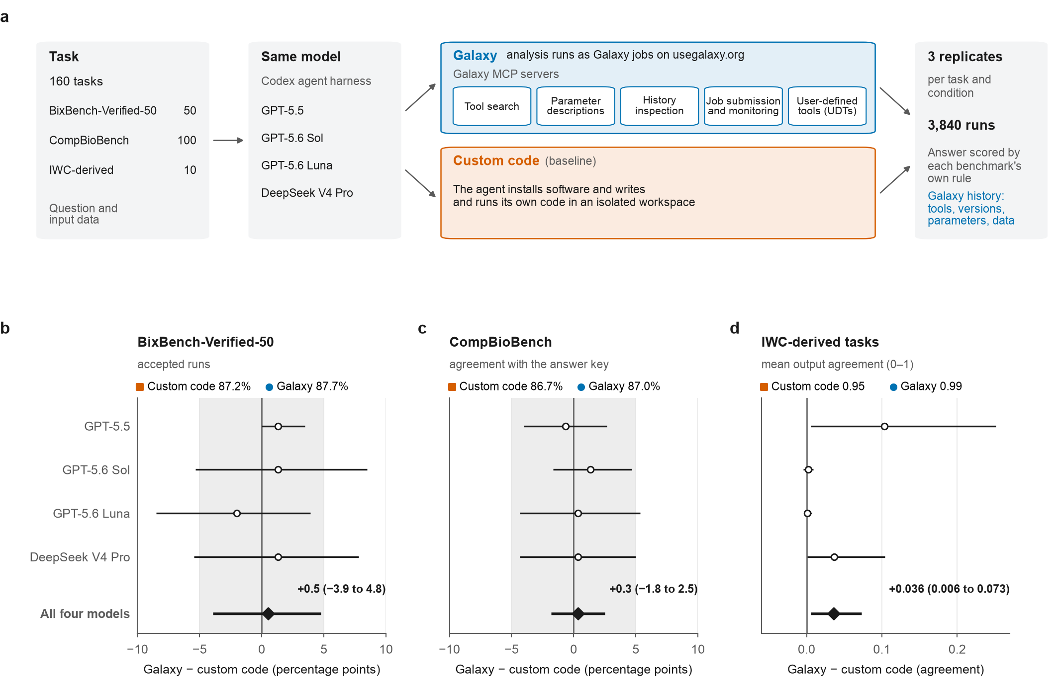
Fig. 1 | Agents performed with similar accuracy in Galaxy and with custom code. a, Study design: four model configurations attempted each of 160 tasks three times in each condition. b–d, Galaxy minus custom code for each model (open circles) and pooled (filled diamonds) on BixBench-Verified-50 (b; accepted runs), CompBioBench (c; agreement with the answer key) and the IWC-derived tasks (d; mean output agreement); condition values above each panel. Grey bands, ±5 percentage points. Error bars, 95% cluster-bootstrap CIs (clusters: BixBench source capsules or tasks); n = 150 (b), 300 (c) and 30 (d) runs per model and condition. With ten IWC-derived tasks the interval is too narrow; the exact paired P of the pooled difference is 0.055.

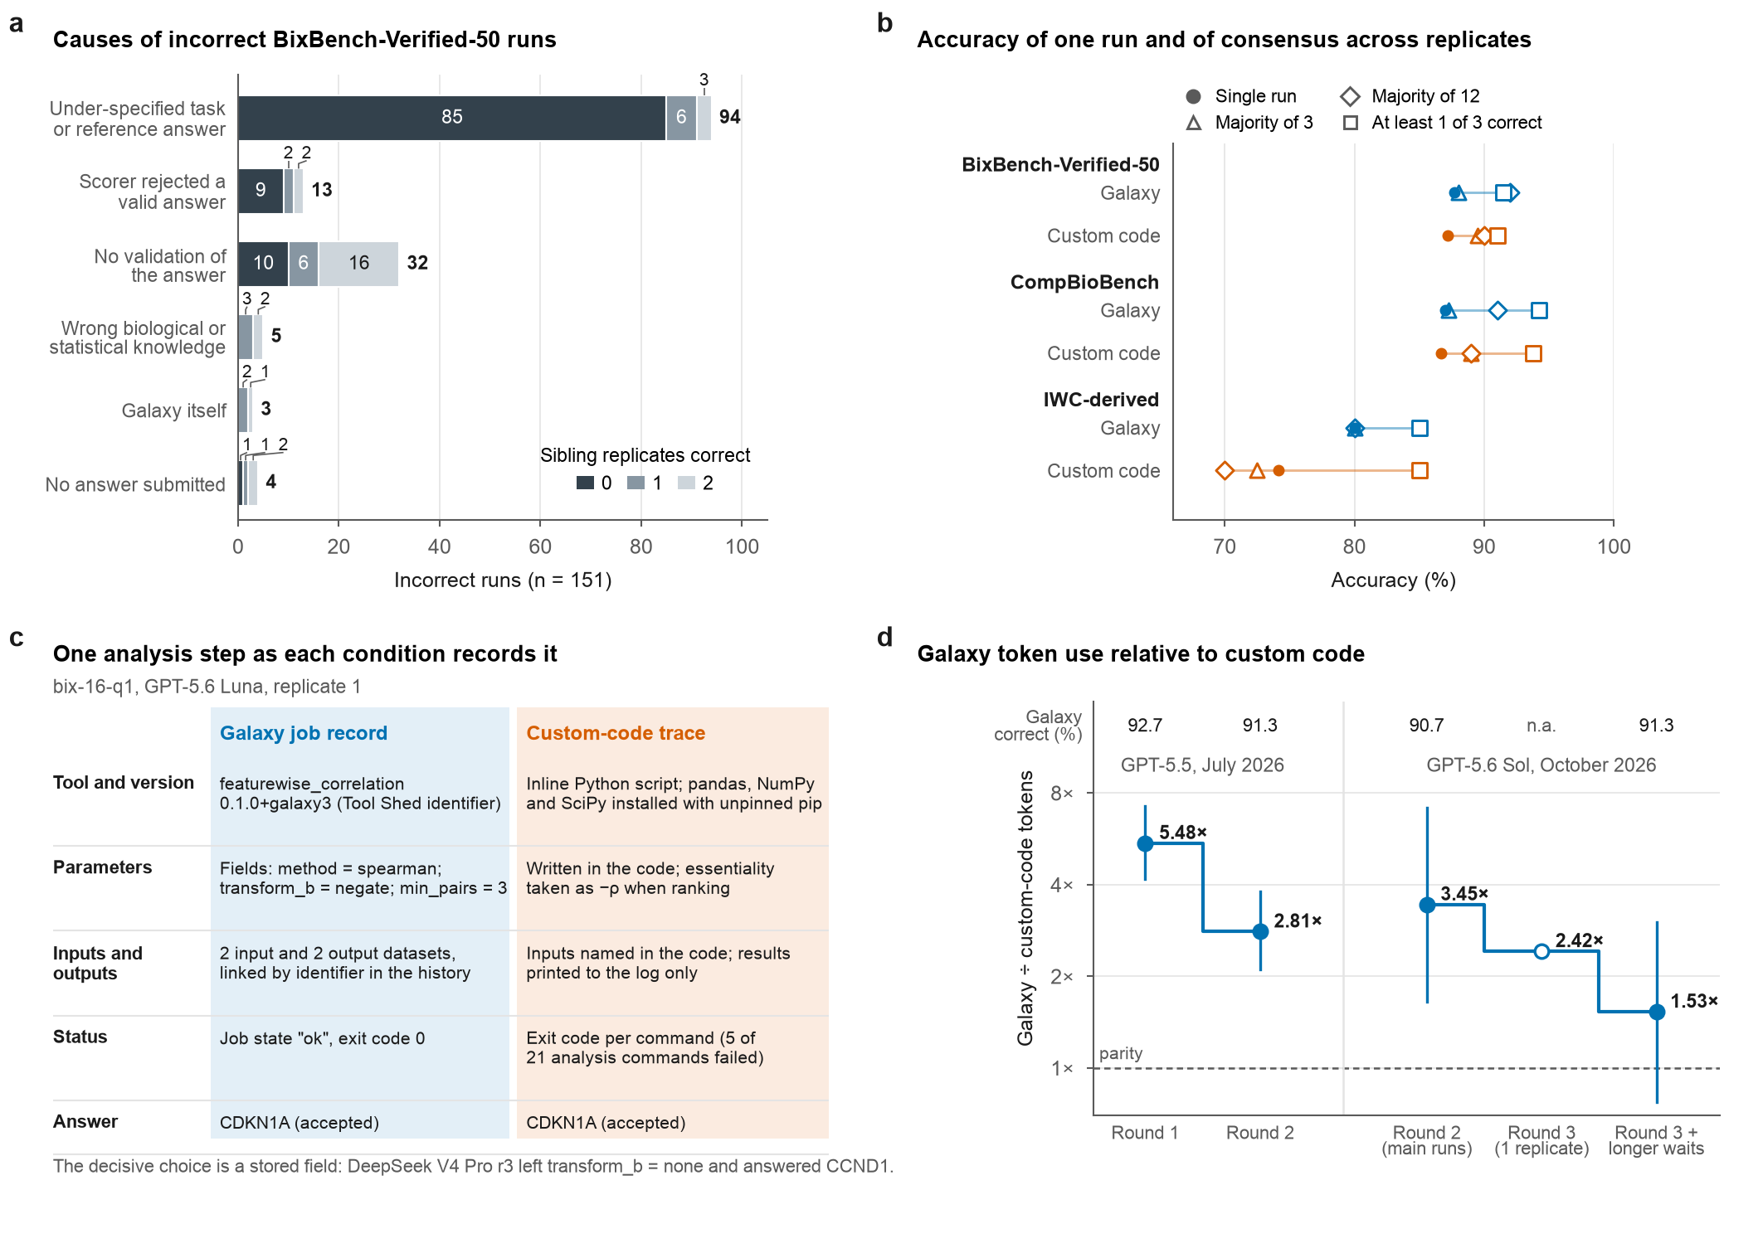
Fig. 2 | Most errors came from the benchmark, voting recovered few of them, and interface changes reduced Galaxy's token use. a, Primary causes of the 151 incorrect BixBench-Verified-50 runs (both conditions), from execution traces, by the number of correct sibling replicates (the other two runs of the same task, model and condition). b, Accuracy of a single run, a majority of 3 replicates, a majority of all 12 runs of a task and at least 1 of 3 correct (the ceiling for selecting a correct replicate), four models pooled; IWC-derived runs are correct at output agreement ≥ 0.99. A vote on the submitted answers is in Supplementary Table 1. c, One analysis step as recorded by the Galaxy job and by the custom-code trace; both runs answered correctly. d, Galaxy ÷ custom-code tokens per 50-task BixBench-Verified-50 run across interface rounds, with the percentage of Galaxy runs correct. Error bars, 95% cluster-bootstrap CIs; open circle, a single replicate.

