Benchmarking biomedical agent reliability in Galaxy and open-ended code
[Authors: author list, affiliations and corresponding author]

Abstract
AI agents are increasingly used to perform biomedical data analyses, but their analyses can be difficult to verify and costly to run. To understand how an execution environment shapes agent analyses, we compared agents working in the Galaxy workbench with agents writing open-ended code. Four model configurations attempted each of 160 tasks from three benchmarks three times in each environment. Agents performed similarly in both, and Galaxy runs more often solved a task in all three attempts. An audit of every failing task showed that most failing analyses lacked adequate verification, whereas missing domain knowledge and Galaxy faults were uncommon. Galaxy runs used 2.7–4.3 times more input tokens than open-ended code on question-answering tasks, and interface traces linked this overhead to tool discovery, rejected requests and failures without diagnostics. These results identify verification as the main barrier to reliable agent analyses and define concrete improvements for agent-ready workbenches.
AI agents are increasingly used to perform biomedical data analyses from start to finish. Systems such as Biomni, Paper2Agent and CellVoyager connect large language models to analysis software, literature and datasets, and computational biology benchmarks now measure how often agents reach correct answers.^{1–5} Despite this progress, agent analyses can be difficult to trust. An agent can choose an inappropriate method, mishandle an input or accept an unchecked result and still report a plausible answer. As AI tools take on more of the analysis, such errors become harder to see and more important to catch.⁶
Trustworthy agent analyses have three requirements that answer-level benchmarks rarely measure. First, the analysis must be executed faithfully and recorded so that others can inspect and repeat it.^{7,8} Second, the agent must check that its analysis supports its conclusion. Third, the analysis must be affordable, because agents consume model context with every interaction. Galaxy meets the first requirement for human users: analyses run as installed, versioned tools, and each step is recorded in a history with its tool, parameters and data.^{9,10} Whether these strengths carry over to AI agents, and at what cost, is not known. Critical benchmarking can show where added infrastructure delivers value and where simpler alternatives suffice.¹¹
To address this gap, we compared agents working in Galaxy with agents writing open-ended code on three biomedical benchmarks and analysed their answers, execution records and token use. We show three main results. First, agents performed similarly in both environments. Second, failures most often reflected analyses that agents did not verify, rather than missing biological or Galaxy knowledge. Third, Galaxy's token overhead was concentrated in specific interface interactions that can be improved. Together, these results define what agent-ready workbenches need and show how benchmarks can guide their development.

Results

1. A paired benchmark of biomedical agents in Galaxy and open-ended code
We assembled an archive of 4,240 agent runs on three benchmarks: BixBench-Verified-50, CompBioBench and ten workflows from the Galaxy Intergalactic Workflow Commission (IWC) (Fig. 1). Four Codex model configurations—GPT-5.5, GPT-5.6 Sol, GPT-5.6 Luna and DeepSeek V4 Pro—attempted every task three times in each environment, yielding 3,840 assigned runs. In the open-ended code environment, agents installed software and wrote their own analysis code. In the Galaxy environment, agents ran installed tools and could also run their own code as user-defined tools (UDTs). We excluded 100 code-only Astra runs and 300 runs from a superseded harness. One IWC task lacked comparable scores between environments, leaving 3,816 runs for endpoint analyses; all 160 tasks remain in the interface analyses.
Each benchmark keeps its own endpoint. BixBench uses acceptance by the original evaluator. CompBioBench uses agreement with a reconstructed answer key, in which 54 references were inferred from recorded scores and 46 from predicted answers. IWC uses continuous agreement (0–1) with curated workflow outputs on nine tasks. We also recorded model input tokens, including cached context that the model rereads, and every call that agents made to Galaxy.
The two environments differ by design. Galaxy prompts add execution policy, including history use, permitted tools, UDT rules and interface timeouts. They were longer than code prompts on BixBench (707 versus 366 median words) and CompBioBench (938 versus 227) but not on IWC (333 versus 344). Time budgets, runtime environments and campaign histories also differ (Methods). Our comparisons therefore describe each environment as deployed—agent, prompt and execution environment together—rather than an isolated effect of Galaxy.

2. Agents perform similarly in Galaxy and open-ended code
We first asked whether working in Galaxy changes how often agents reach the correct answer. Overall performance was similar in the two environments (Fig. 2). On BixBench-Verified-50, acceptance was 85.2% with open-ended code and 86.5% with Galaxy, a difference of +1.3 (−3.5 to 6.4) percentage points (estimate and 95% cluster-bootstrap interval; Fig. 2a). On CompBioBench, agreement with the reconstructed key was 86.7% and 87.1%, a difference of +0.4 (−1.6 to 2.4) points (Fig. 2b). Both differences stayed within about one point of zero when we removed 15 BixBench tasks with audited benchmark-side problems (−1.0 (−3.4 to 1.0)) or 66 CompBioBench task–configuration cells containing Galaxy runs from campaigns named for wrong answers or target scores (−0.3 (−2.2 to 1.6); Fig. 2d,e). On IWC, output agreement was 0.940 with code and 0.980 with Galaxy (+0.040 (0.009 to 0.078); Fig. 2c), and three tasks containing a zero-scored run accounted for most of this difference (+0.004 (0.000 to 0.010) without them; Fig. 2f).
The best model configuration depended on the benchmark. GPT-5.5 had the highest BixBench acceptance in both environments (89.3% in Galaxy), Sol had the highest CompBioBench agreement in both environments (92.0% in Galaxy), and Sol and DeepSeek V4 Pro had the highest IWC agreement with code (0.988) and Galaxy (0.999), respectively (Fig. 2a–c). The leading configurations differed by less than their intervals, so these are changes in rank rather than a demonstrated model-by-benchmark interaction. These results show that no single configuration was best for every benchmark and that configurations should be evaluated on the intended workload.
Galaxy runs reached the correct answer more consistently across repeated attempts. The share of task–configuration sets in which all three attempts were accepted rose from 79.5% to 82.5% on BixBench and from 77.3% to 80.5% on CompBioBench. The point estimate favoured Galaxy for every configuration on both benchmarks, although each configuration's interval included or touched zero (Fig. 3a,b). This gain came from fewer sporadic failures: sets with one or two rejected attempts fell from 19 to 15 on BixBench and from 66 to 53 on CompBioBench. Persistent failures, in contrast, recurred in both environments. Of the 22 code and 20 Galaxy BixBench sets rejected in all three attempts, 17 were the same task and configuration in both environments; on CompBioBench, 15 of 25 coincided (Fig. 4d). Pooled Galaxy/code ratios of discordant sets were 0.79 (0.38 to 1.78), 0.80 (0.60 to 1.07) and 0.36 (0.00 to 0.80) for BixBench, CompBioBench and IWC (Fig. 3c), although discordance rose for DeepSeek on BixBench and for Sol on CompBioBench.
Agents also ran their own code in Galaxy, creating UDTs in 225 of 600 BixBench and 808 of 1,200 CompBioBench Galaxy runs, and at least one UDT job completed in 223 and 572 of these runs, respectively (Fig. 3d,e). UDT use ranged from under 10% of DeepSeek BixBench runs to nearly 90% of GPT-5.5 CompBioBench runs. Runs with a completed UDT job were accepted at 92.8% on BixBench, compared with 82.7% for runs without UDTs, and at 88.6% on CompBioBench. In contrast, the 235 CompBioBench runs whose UDT jobs never completed were accepted at 81.7%. Because agents chose when to write UDTs, these are associations rather than effects. Together, these results show that agents perform similarly in Galaxy and in open-ended code and that, in Galaxy, they combine installed tools with their own code.

3. Failures reflect insufficient verification more than missing knowledge
Benchmark scores show how often agents fail, but not why. To find the causes of failure, we audited every task on which at least one run was rejected: 22 BixBench and 51 CompBioBench tasks among the primary configurations, together with seven IWC workflows and tasks that failed only in other archived configurations (93 tasks in total; Methods). For each task, an AI-assisted review of traces and outputs assigned one primary cause and non-exclusive tags. Among the 73 failing binary-benchmark tasks, the primary cause was agent analysis in 42 (57.5%), the benchmark's reference, scoring or answer provenance in 23 (31.5%) and Galaxy platform or wrapper behaviour in 7 (9.6%; Fig. 4a). Benchmark-side causes dominated BixBench (13 of 22 tasks) and, because they tended to fail every attempt, accounted for 51.8% of all rejected primary runs.
Insufficient verification was the most common feature of failing analyses. It was tagged in 42 of the 73 failing tasks (57.5%) and in 34 of 42 agent-analysis tasks (81.0%; Fig. 4b). Domain knowledge was implicated in 21 tasks, 17 of them together with insufficient verification, and alone accounted for only 4 (5.5%). These results indicate that missing biological or Galaxy knowledge seldom explained failure on its own. More often, agents did not check whether their analysis supported their answer.
Replicate patterns distinguish two kinds of failure. When one or two of three attempts fail, the same agent can succeed or fail on the same task, depending on the analysis path it takes; when all three fail, the failure repeats. Persistent failures recurred in both environments (Fig. 4d) and were enriched for benchmark-side causes: 12 of the 25 tasks with a set rejected three times had a reference, scoring or provenance cause, compared with 11 of the 48 tasks with only sporadic failures (Fig. 4c). Sporadic failures were mostly agent analysis (30 of 48) and included 6 of the 7 tasks with a Galaxy platform cause, which other attempts overcame. Insufficient verification occurred in both groups (13 of 25 and 29 of 48). Thus, three failures in three attempts often signal an ambiguous task, reference or scorer, or a consistent analysis mistake, whereas one or two failures point to divergent analysis paths that can be compared across sibling traces.
Execution traces show which checks were missing (Fig. 4e). For bix-52-q2, a digits-only chromosome filter silently dropped W and Z, and the run accepted the reduced denominator; another run asserted the expected 20 groups and avoided the error. In variant-status-q1, apparent alternate alleles came from read ends; two Sol Galaxy runs audited allele support by read position and rejected the artifact. In exogenous-mix-reads-q1, code and Galaxy runs fitted and scored a classifier on the same reference reads, whereas a correct run held out read groups. Agents also ran checks and then ignored them. On histone-chip-q1, a DeepSeek Galaxy run retained a candidate after its own overlap check returned near-zero agreement, and on the IWC mitogenome task, circularity and self-mapping were taken as evidence of organellar identity. The same mistakes occurred in both environments.
For Galaxy runs, histories recorded the tools, parameters and job states behind each decision, which located where the analysis went wrong; successful execution, however, did not establish that an analysis was appropriate. Together, these results show that verification is the main barrier to reliable agent analyses: agents need task-specific checks and stopping rules that change the conclusion when a check fails.

4. Galaxy's token overhead is concentrated in addressable interface costs
Agents consume model context with every interaction, so token use drives the cost of an agent analysis. Galaxy runs used more input tokens than open-ended code runs on the two question-answering benchmarks, but not on the workflow benchmark (Fig. 5g). Total Galaxy input divided by total code input over paired task–configuration cells was 4.25 (3.25 to 5.66) on BixBench and 2.70 (2.21 to 3.32) on CompBioBench, but 0.90 (0.46 to 2.88) on IWC. On IWC, some code runs consumed very large inputs—a mean of 30.3 million tokens per code run on the ATAC-seq task, compared with 7.9 million in Galaxy—and Galaxy used less total input for three of four configurations. When we excluded cached context, Galaxy's point estimate exceeded code in all 12 benchmark–configuration comparisons (pooled uncached ratios 2.65 (2.23 to 3.15), 3.44 (2.99 to 3.97) and 1.42 (1.06 to 2.23)). The median of within-task ratios, which weights each task equally, gave higher estimates (5.17 (4.06 to 6.88), 4.42 (3.53 to 5.41) and 1.75 (0.71 to 5.18)). Within discordant sets, rejected and accepted attempts used similar input (Fig. 5h).
Model choice affected resource use as much as the environment did (Fig. 5a–f). On tasks with complete records in all eight model–environment groups, GPT-5.5 lay on the point-estimate accuracy–token frontier in 6 of six benchmark–environment views and Sol in 5. Sol gave the highest CompBioBench agreement in both environments and the highest IWC agreement with code, at higher input than GPT-5.5. In contrast, Luna was dominated in every view and DeepSeek V4 Pro in five, using more input without higher accuracy. The Galaxy/code ratio also varied with configuration, from 2.82 (2.12 to 3.81) for GPT-5.5 to 6.33 (4.04 to 9.71) for Luna on BixBench (Fig. 5g). These results show that selecting an efficient model configuration is a first-order way to reduce cost in either environment.
To find where Galaxy's additional context came from, we analysed every Galaxy interface call. The four configurations made 66,316 calls, and the input of each Galaxy run closely tracked its number of interface calls and shell commands (Spearman ρ = 0.89, 0.86 and 0.83 for BixBench, CompBioBench and IWC). Three interface problems stood out (Fig. 6). First, tool discovery was the largest burden. Search and tool inspection made up 46.7%, 43.5% and 53.5% of calls and 69.1%, 43.5% and 50.8% of returned text (Fig. 6a,b). Searches rarely failed but often did not lead to a usable tool: 45.1–53.0% of the tools inspected in a run were never run in that run, and 417 calls failed because the requested tool identifier did not exist.
Second, many requests were rejected before a job ran. Of 7,354 failed Galaxy calls, 3,155 (42.9%) failed at this stage, most often because a tool schema required history context (1,119) or a parameter value failed validation (769; Fig. 6c). Third, failures often came without an explanation. Another 3,341 calls (45.4%) failed during execution, and the largest class of these, 1,601 calls, returned a job error without diagnostic text. UDTs were the most failure-prone operation: 50.6% of 4,960 UDT calls returned ok (Fig. 6a,d), and 64.6% of failed UDT jobs failed before execution without diagnostic text (Fig. 6e). Without a stated reason, agents resubmitted an identical request after 50.0% of such failures, and 78.4% of these resubmissions failed again (Fig. 6e). In 43.5% of CompBioBench Galaxy runs, agents wrote probe or preflight UDTs to diagnose the environment themselves.
Each problem points to a concrete improvement to the Galaxy interface: relevance-ranked tool search with reusable tool inventories; history-scoped schemas that return only the parameters relevant to a request; preflight checks of UDT dependencies and dispatch with actionable failure messages; and compact responses that keep complete records retrievable rather than in the model's context. Each improvement has a measurable target in this archive and a quality safeguard—correct tool retrieval, agreement between requested and resolved parameters, and reporting of failure diagnostics. Together, these results show that much of Galaxy's token overhead is linked to specific interface costs that can be addressed.
Token-reduction intervention: RESULTS PENDING. This paragraph and Fig. 6f are placeholders until the intervention results are confirmed and finalized. The planned result will close the loop from benchmark to infrastructure in two parts. First, it will report the development rounds that preceded the archived runs—condensed prompts and skills, then consolidation of the Model Context Protocol (MCP) interface, with combined submission and waiting, automated records and parameter checks, and compact returns—with their cohorts, interface versions and Galaxy/code ratios under the definition used here. Second, it will report a prospective comparison on BixBench-Verified-50 of a frozen baseline, prompt and skill changes, MCP changes and both, run alongside a contemporaneous code arm. That comparison will count tokens per assigned attempt, failures included, with accuracy, parameter fidelity and diagnostic completeness as safeguards. The archived GPT-5.5 BixBench ratio of total input, 2.82 (2.12 to 3.81), is the reference point. [Authors: insert measured reductions with intervals, cohorts and interface versions once finalized].

Discussion
AI agents can now perform biomedical analyses from start to finish, but it has been difficult to know whether their analyses can be trusted and what a workbench contributes. This study addresses this gap by comparing agents working in Galaxy with agents writing open-ended code across three benchmarks and by tracing the causes of every failing task. Agents performed similarly in both environments, and Galaxy runs reached the correct answer more consistently across repeated attempts. Galaxy histories also recorded analyses in enough detail to locate where they went wrong.
Our failure analysis identifies verification, rather than knowledge, as the main barrier to reliable agent analyses. Failing analyses were seldom explained by missing domain knowledge or by the platform, and most lacked a check that would have exposed the error—an identifier assertion, a held-out evaluation, a read-level artifact test or a response to contradictory evidence. Similar problems are well documented in machine-learning-based science, where leakage between training and evaluation data is a major source of overoptimistic results,¹² and the growing use of AI in science increases the need for such safeguards.⁶ About a third of failing tasks traced to benchmark references or scoring, and these failures often persisted across attempts and environments. Benchmark curation and agent verification are therefore both needed to interpret agent accuracy.
Galaxy's resource cost was real but specific. On question-answering tasks, Galaxy runs consumed several times more input, and interface traces linked this overhead to tool discovery, rejected requests and failures without diagnostics. These are properties of the interface rather than inherent costs of a workbench, and on workflow tasks Galaxy did not use more total input than open-ended code. Benchmarks that record interface activity can therefore guide workbench development toward specific improvements and then test whether those improvements reduce tokens while preserving accuracy and provenance.
Despite these strengths, this study has several limitations. First, it is retrospective, and the environments differed in prompts, time budgets, runtime environments and campaign histories, including CompBioBench Galaxy runs drawn from campaigns named for wrong answers or target scores. Second, the CompBioBench endpoint uses a reconstructed key, and some IWC references were calibrated from agent runs. Third, the failure audit covers every failing task, but its labels are AI-assisted and await blinded expert adjudication, and its tags do not test knowledge directly. Finally, recorded tokens are not provider cost, and retained records have not yet been replayed independently or on a second Galaxy deployment.
Future work will extend this study in several directions. We will test the interface improvements identified here in the controlled comparison specified above and confirm the results on a second benchmark. Blinded expert review and replay on a second Galaxy deployment are needed to validate the audit and the records. Finally, agent workflows should include task-specific verification steps, so that agents test their analyses before reporting an answer. These directions build on Galaxy's strengths in accessibility, reproducibility and provenance to make agent analyses more reliable.

Figure legends
Fig. 1 | Experimental setup and analysis populations. a, Each task and shared model configuration is assigned to open-ended code and to Galaxy, with three attempts per arm. In Galaxy, agents use installed tools and can write user-defined tools (UDTs). b, Benchmark-specific endpoints and primary run counts. c, Analysis populations. Of 4,240 archived runs, 3,840 assigned runs form the primary paired design; the IWC host-removal task is excluded from endpoint and matched-token analyses but retained in interface analyses. Galaxy prompts add execution policy and differ from code prompts in every one of 1,920 primary pairs (0 identical); budgets, runtime environments and campaign histories also differ (Methods).
Fig. 2 | Performance by benchmark. a–c, Mean endpoint for each configuration and pooled across configurations. Blue circles, Galaxy; vermillion squares, open-ended code. Bars are 95% percentile cluster-bootstrap intervals (20,000 resamples; clusters are BixBench source capsules, otherwise tasks). Primary arm sample sizes are 600, 1,200 and 108 runs. d–f, Galaxy minus code differences for the primary population (filled circles) and retrospective sensitivity populations (open diamonds): BixBench without 15 tasks with benchmark-side audit categories; CompBioBench without 66 task–configuration cells containing runs from outcome-named campaigns; IWC without three tasks with a zero-scored run, without the ATAC-seq task, or restricted to 63 equal-budget replicate pairs. Binary differences are percentage points; IWC differences are agreement units.
Fig. 3 | Repeatability and user-defined tools. a,b, Galaxy minus code difference in the share of task–configuration sets with all three attempts accepted, by configuration (50 BixBench and 100 CompBioBench sets per arm and configuration). c, Pooled ratio of discordant-set proportions (Galaxy/code) with 200, 400 and 36 sets per arm. Binary discordance means mixed acceptance; IWC discordance means a within-set score range greater than 0.05. d,e, Share of Galaxy runs with an observed UDT attempt (grey) and with at least one UDT job that completed (blue); 150 runs per configuration on BixBench and 300 on CompBioBench, of which 12 CompBioBench traces are missing. The IWC interface did not expose UDTs. Intervals as in Fig. 2.
Fig. 4 | Causes of failure in every failing task. a, Primary cause for every BixBench and CompBioBench task with at least one rejected run among the four primary configurations. Benchmark, reference or provenance groups equivalent-answer, scoring, unstated-reference and provenance categories. b, Non-exclusive insufficient-verification and domain-knowledge tags, for all failing tasks and for agent-analysis tasks. c, Primary cause for tasks with at least one set rejected in all three attempts (persistent) and tasks whose sets had at most one or two rejected attempts (sporadic); colours as in a. d, Number of rejected attempts (of three) for the same task and configuration in code (rows) and Galaxy (columns). e, Five cases with recorded decision evidence; case summaries, trace locators and line hashes are in Source Data. Labels are task-level, AI-assisted annotations; blinded expert adjudication is pending. No private CompBioBench answer is displayed.
Fig. 5 | Model trade-offs and token overhead. a–f, Median single-run input tokens against mean endpoint on tasks with complete records in all eight model–arm groups (50 BixBench, 86 CompBioBench and nine IWC tasks). Filled markers lie on the point-estimate accuracy–token frontier within each benchmark and arm; open markers are dominated. Bars are 95% cluster-bootstrap intervals; token axes are logarithmic. g, Galaxy/code ratio of total input tokens (filled circles, primary measure) and of total uncached input (open diamonds) by benchmark and configuration, with the median of within-cell ratios (orange ticks) for comparison; 200, 386 and 36 paired task–configuration cells. h, Within discordant binary sets, median rejected/accepted sibling input ratios (19, 15, 66 and 52 sets in the order shown). Input includes cached context; these measures are not monetary costs. Astra is excluded.
Fig. 6 | Interface costs, failure modes and the pending intervention study. a, Galaxy interface calls by operation in the four primary configurations across all 160 tasks (66,316 calls in 1,908 traced runs); dark segments and labels give failed calls. b, Tool search plus inspection as shares of calls and of returned text, and the share of tools inspected within a run that were never run in that run. c, Classes of the 7,354 failed calls, grouped by whether the request was rejected before a job ran or the job failed during execution. d, Mutually exclusive outcomes of UDT calls; diagnostic text means returned standard error, standard output or a traceback. e, Failed UDT jobs without diagnostic text that failed before execution; identical resubmissions following a failed job without diagnostic text; and resubmissions that failed again. f, Results placeholder: intervention results are pending confirmation and finalization. No achieved reduction is plotted.

References
1. Huang, K. et al. Autonomous biomedical research with an artificial intelligence agent. Science 393, eadz4351 (2026).
2. Miao, J., Davis, J. R., Zhang, Y., Pritchard, J. K. & Zou, J. Reimagining research papers as interactive and reliable AI agents. Nature https://doi.org/10.1038/s41586-026-11044-y (2026).
3. Alber, S. et al. CellVoyager: AI CompBio agent generates new insights by autonomously analyzing biological data. Nat. Methods 23, 749–759 (2026).
4. Mitchener, L. et al. BixBench: a comprehensive benchmark for LLM-based agents in computational biology. Preprint at https://doi.org/10.48550/arXiv.2503.00096 (2025).
5. Nair, S. et al. Agentic systems are adept at solving well-scoped, verifiable problems in computational biology. Preprint at bioRxiv https://doi.org/10.64898/2026.04.06.716850 (2026).
6. Messeri, L. & Crockett, M. J. The uncritical adoption of AI in science is alarming — we urgently need guard rails. Nature 653, 675–676 (2026).
7. Wratten, L., Wilm, A. & Göke, J. Reproducible, scalable, and shareable analysis pipelines with bioinformatics workflow managers. Nat. Methods 18, 1161–1168 (2021).
8. Heil, B. J. et al. Reproducibility standards for machine learning in the life sciences. Nat. Methods 18, 1132–1135 (2021).
9. The Galaxy Community. The Galaxy platform for accessible, reproducible, and collaborative data analyses: 2024 update. Nucleic Acids Res. 52, W83–W94 (2024).
10. Goecks, J., Nekrutenko, A., Taylor, J. & The Galaxy Team. Galaxy: a comprehensive approach for supporting accessible, reproducible, and transparent computational research in the life sciences. Genome Biol. 11, R86 (2010).
11. Ahlmann-Eltze, C., Huber, W. & Anders, S. Deep-learning-based gene perturbation effect prediction does not yet outperform simple linear baselines. Nat. Methods 22, 1657–1661 (2025).
12. Kapoor, S. & Narayanan, A. Leakage and the reproducibility crisis in machine-learning-based science. Patterns 4, 100804 (2023).

Methods

Archive, populations and eligibility
This is a retrospective analysis of retained run summaries, evaluator grades, interface call records and audit notes. No new benchmark agent, Galaxy job or independent deployment was executed. Primary runs are the four shared Codex configurations in both arms, with three attempts per task and arm. Excluded Astra runs have no Galaxy counterpart; the superseded runs used a different harness. Endpoint summaries retain every assigned run with an available endpoint; UDT use in a missing trace is reported as unknown. The IWC task with incomparable arm scores is excluded from endpoints and performance–token matching but retained for interface activity. Source Data records run, task, configuration, replicate and bootstrap cluster identifiers.
The arms differ in recorded conditions. Galaxy prompts add execution policy, and no primary Galaxy–code prompt pair is identical. IWC runs had 6-h or 12-h wall-clock limits that depended on start time, with equal limits in 73 of 120 archived replicate pairs (63 of the nine-task primary population); CompBioBench code prompts stated a 120-min budget, and no budget is recorded for CompBioBench Galaxy or BixBench runs. CompBioBench Galaxy runs executed in containers and code runs on the host. CompBioBench replicate vectors are composites: 387 of 1,200 Galaxy runs and 101 of 1,300 code runs came from campaigns other than the largest in their vector, and 86 Galaxy runs came from campaigns whose names refer to wrong answers or target scores. [Authors: document the selection rule for the CompBioBench Galaxy campaigns named for wrong answers or target scores]. Exact model snapshots and complete interface commits are not uniformly preserved.

Benchmark scores and sensitivity analysis
BixBench-Verified-50 comprises 50 binary evaluator-scored tasks with dependence within source capsules; we reuse fixed submitted-answer grades. CompBioBench comprises 100 tasks scored against a reconstructed key; its 54 score-inferred and 46 predicted references require validation with the official evaluator, and submitted and reference answers are withheld here. IWC uses nine continuous workflow-output agreement scores; ATAC-seq route references include calibration from agent runs. Scores are not pooled across benchmarks or dichotomized for IWC.
The BixBench sensitivity excludes the 15 tasks with primary audit categories C1, C2, C3 or C6. The CompBioBench sensitivity excludes every task–configuration cell in which any Galaxy replicate comes from an outcome-named campaign (66 cells), retaining 1,002 runs per arm; a campaign name flags potential selection without establishing it. IWC sensitivities exclude the three tasks with a zero-scored run, exclude the ATAC-seq task, or keep only replicate pairs with equal recorded time limits. These sensitivity populations were defined retrospectively.

Statistical summaries and repeatability
Arm endpoints are means over eligible assigned runs, multiplied by 100 for binary percentages; differences are Galaxy minus code. Intervals are 95% percentile cluster-bootstrap intervals from 20,000 resamples (seed 20261002), resampling BixBench source capsules or tasks and retaining all configurations, replicates and arms of a sampled cluster.¹³ Intervals describe clustered sampling variation within this archive, not design confounding or reference uncertainty. Model and sensitivity comparisons are exploratory; no equivalence, non-inferiority or multiplicity-adjusted claim is made.
A replicate set is one task × configuration × arm with three attempts. All-three-correct requires three accepted grades; binary discordance requires both accepted and rejected grades; IWC discordance requires a within-set agreement range greater than 0.05. Discordance ratios use matched sets and clusters. Cross-arm transitions compare the number of rejected attempts in the code and Galaxy sets of the same task and configuration. All-three-correct is a grade-based measure, not exact answer-text identity.

UDT observations
UDT observations use the reconciled interface call table for the primary configurations. We distinguish an observed UDT call, a returned job record, a job in state ok and an ok interface return. Run-level trajectories do not infer absence from a missing trace. Run-level acceptance by trajectory is descriptive and may be confounded by task difficulty, configuration and retries.

Failure audit
The audit covers every BixBench task with a rejected run in any archived configuration (33 tasks, including all 22 with a rejected primary run), every CompBioBench task with a run deviating from the reconstructed key (53 tasks, including all 51 with a rejected primary run), six IWC workflows with a low-agreement run and one in which near-perfect agreement concealed a changed significant-gene set. The build verifies that every BixBench and CompBioBench task with a rejected primary run is audited and that the BixBench audit equals the set of tasks with any rejected run. Census analyses use the 73 binary-benchmark tasks with a rejected primary run. Each task has one of eight primary categories and non-exclusive tags, including insufficient verification and domain knowledge. Cause groups are agent analysis (C5); benchmark, reference or provenance (C1 equivalent answer, C2 scoring artifact, C3 reference depending on an unstated choice, C6 provenance or answer exposure); Galaxy platform or wrapper (C4); and other (C7, C8). A task is persistent if any primary set was rejected in all three attempts and sporadic otherwise. Labels are task-level; run-level shares weight tasks by their rejected primary runs.
Annotations were made with AI assistance from traces, outputs and audit notes; blinded expert review with inter-rater agreement is pending. Tags are not knowledge tests, and missing reasoning is not coded as absent validation. For five illustrative cases, we located positive decision and check evidence in retained reasoning or command records and verified each source line by SHA-256 hash; contrasting runs identify a check in a sibling run without establishing that the check alone caused success. Source Data includes locators and hashes without private CompBioBench answers.

Token measurements and model trade-offs
Input is the recorded usage field including cache reads; uncached input subtracts cached input; output is retained separately. These measures exclude unrecorded external or subagent usage and do not estimate provider cost. A paired cell is a task × configuration with three recorded usages in each arm and positive code usage. The primary arm measure is the ratio of total Galaxy to total code input over eligible cells, which reflects aggregate consumption; its interval resamples clusters with both arms. The median across cells of the ratio of three-run medians, which weights each task equally, is reported as a secondary measure.
The performance–resource comparison uses tasks with complete scores and input in all eight configuration–arm groups. A configuration is on the point-estimate frontier if no other configuration in the same benchmark and arm has both no lower mean endpoint and no greater median single-run input, with one strict improvement; a sensitivity analysis repeats this with mean input. Frontier status describes point estimates, not significant dominance. Within discordant binary sets, sibling ratios compare median input of rejected and accepted attempts; intervals crossing one do not establish equal use.

Interface operations and failure classes
Interface analyses include Galaxy interface namespaces and exclude 307 calls to other tool servers. A call failed if the retained extractor flagged it or its client or item status was failed; this union gives 7,354 failures among 66,316 primary calls (7,987 among 69,505 across the archive). Failed calls were classified by ordered text rules into classes covering requests rejected before a job ran (A1–A8), job failures during execution (B1–B5) and other exceptions. Mutually exclusive UDT outcomes are an ok return, a job error with diagnostic text (standard error, standard output or a traceback), a job error without diagnostic text, or another non-ok return. Trace-level measures over the primary Galaxy traces count distinct tools inspected and never run within a run, the next call after a failed job without diagnostic text (identical or modified payload and its status), and UDTs whose identifier names a probe, preflight, smoke, sanity, render or diagnostic job. Returned characters describe response size, not tokenizer counts. Per-run actions are interface calls plus shell commands.

Prospective token-reduction study
The planned study freezes task and input hashes, model and reasoning settings, prompts, budgets, runtime catalogue, interface commits, evaluator and answer extraction, then compares a baseline, prompt and skill changes, MCP changes and both, with randomized block order, isolated workspaces and a contemporaneous frozen code arm. Replication will be set by registered clustered power simulations. The primary outcome is input tokens per assigned attempt, retaining failures and timeouts, summarized both as reduction relative to the baseline and as Galaxy/code ratio of totals. Accuracy, appropriate methods, parameter and dataset fidelity and complete diagnostics are guardrails, with non-inferiority margins justified before outcomes are observed. Historical ratios from earlier development rounds will be reported only with their cohorts, versions and token definitions.

Data availability
Figure summaries, observations, eligibility flags and a column dictionary accompany the manuscript as Source Data, with machine-readable analysis tables. No private CompBioBench submitted or reference answer is included. Full archive access and release identifiers: [Authors: archive DOI and Hugging Face dataset identifier]. Access conditions: [Authors: confirm access conditions]. A source-hash manifest identifies the inputs used to build the figures.

Code availability
Analysis scripts, figure generation, Source Data export and validation are provided with a single build entry point; exact package versions and source hashes are recorded with the output. Public repository and release identifiers: [Authors: repository URL and release DOI].

Methods references
13. Davison, A. C. & Hinkley, D. V. Bootstrap Methods and their Application (Cambridge Univ. Press, 1997).

Acknowledgements
[Authors: funding and acknowledgements]

Author contributions
[Authors: contributions]

Competing interests
[Authors: competing interests]

Additional information
AI coding assistants were used for archive analysis, figure generation and drafting. [Authors: name the assistants, versions and dates, document human verification and confirm responsibility for the content]. Audit adjudication: [Authors: describe the human review of the AI-assisted audit, including who reviewed which cases and how disagreements were resolved]. Relationship to other manuscripts: [Authors: companion manuscript citation].

Fig. 1
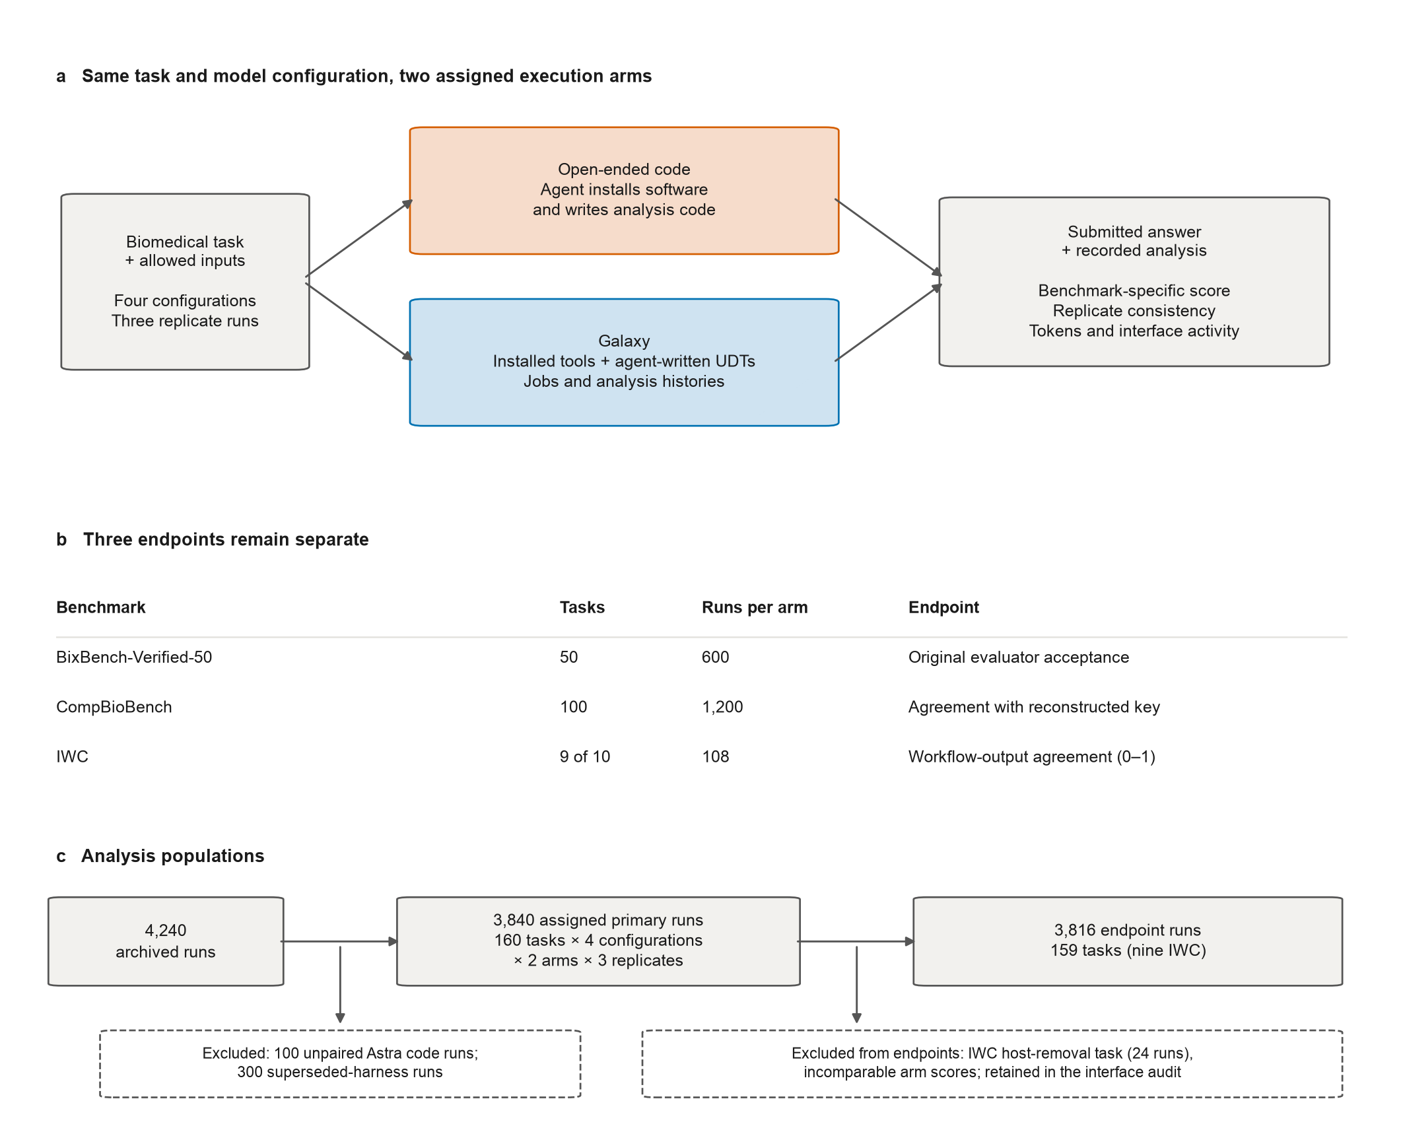

Fig. 2
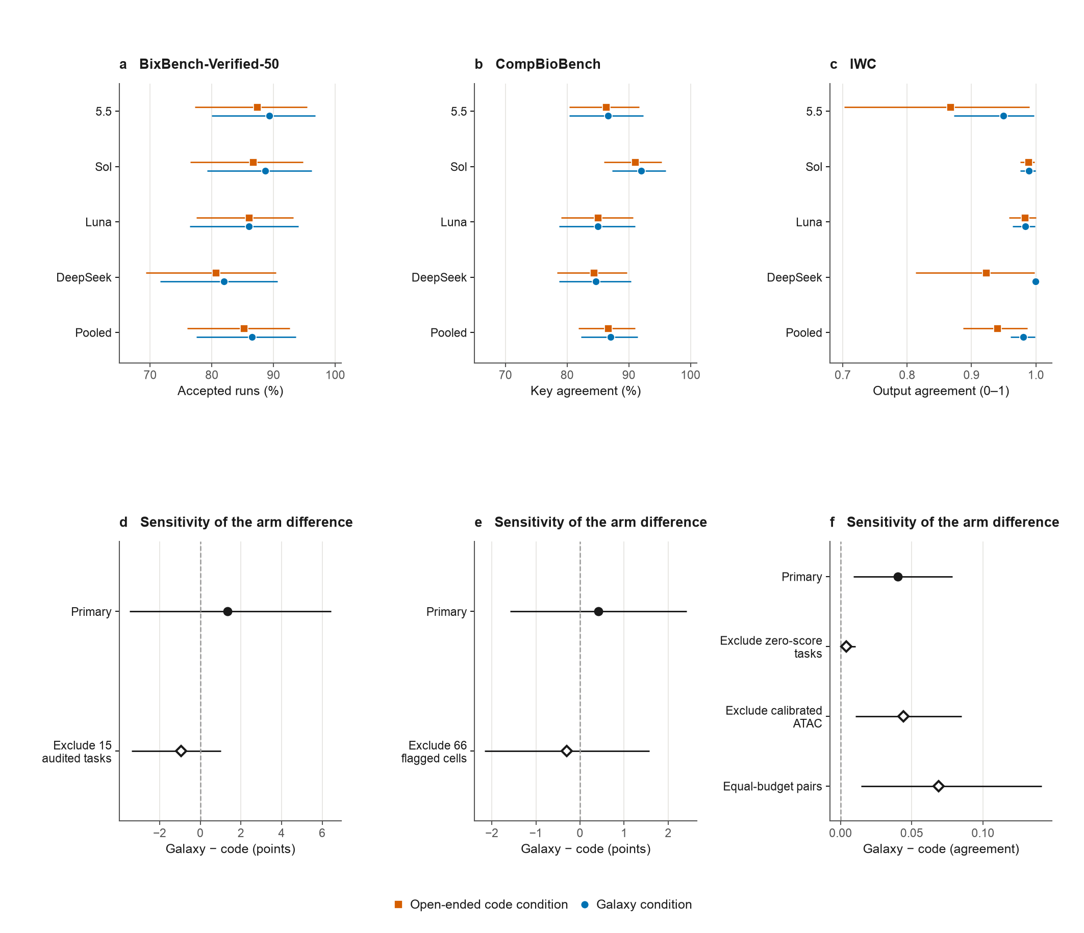

Fig. 3
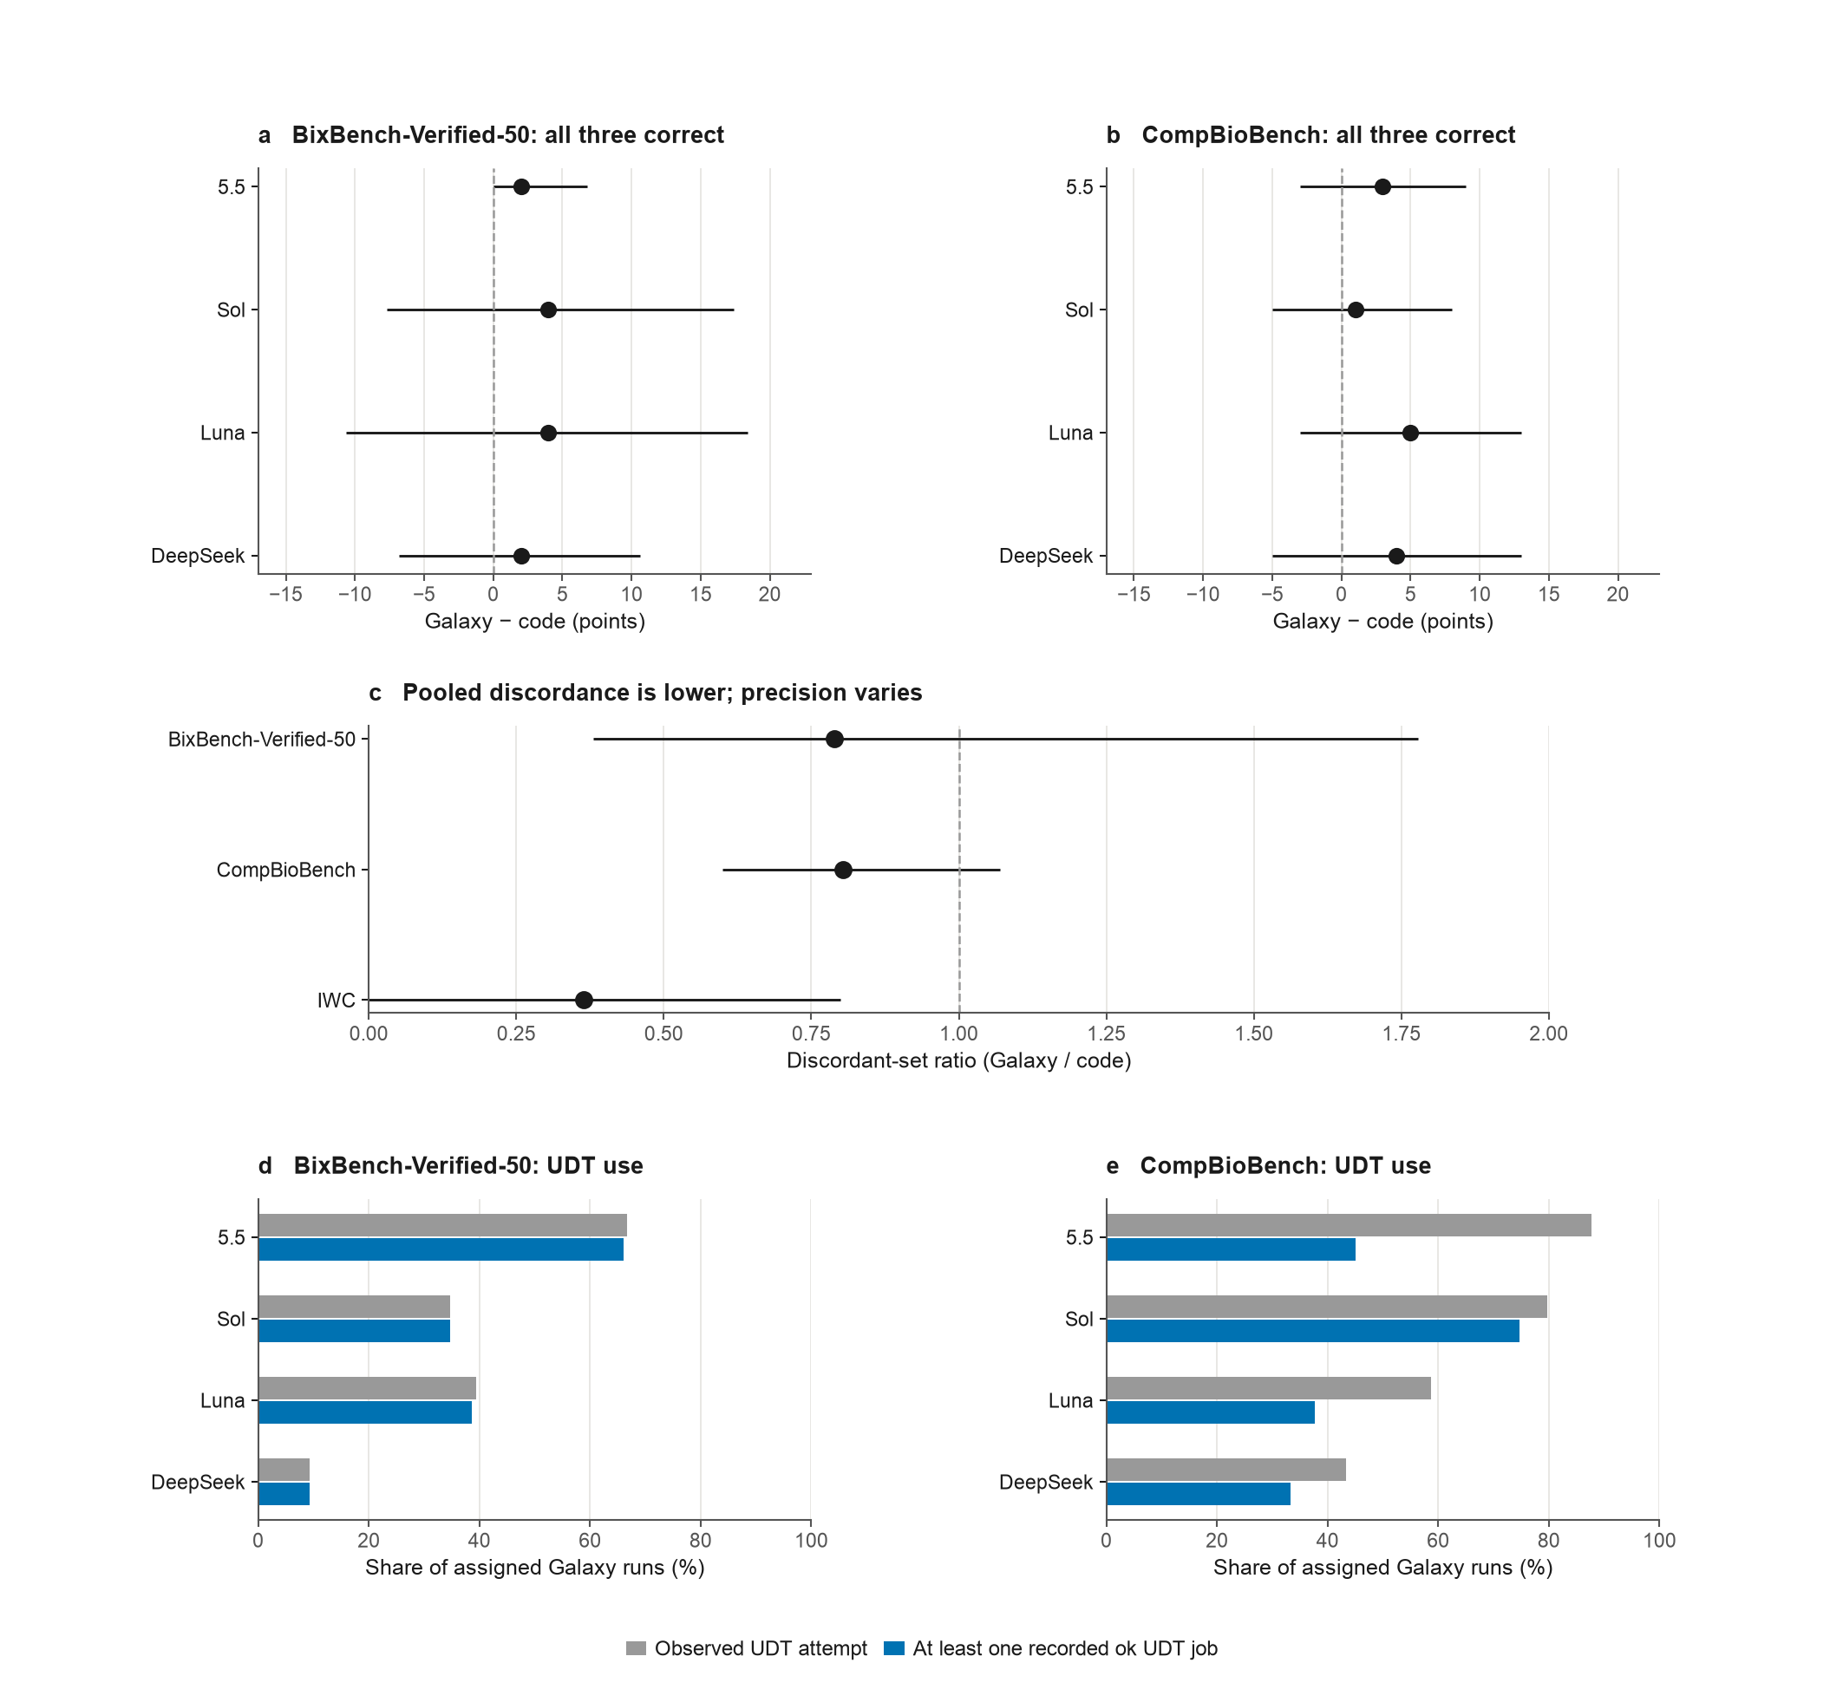

Fig. 4
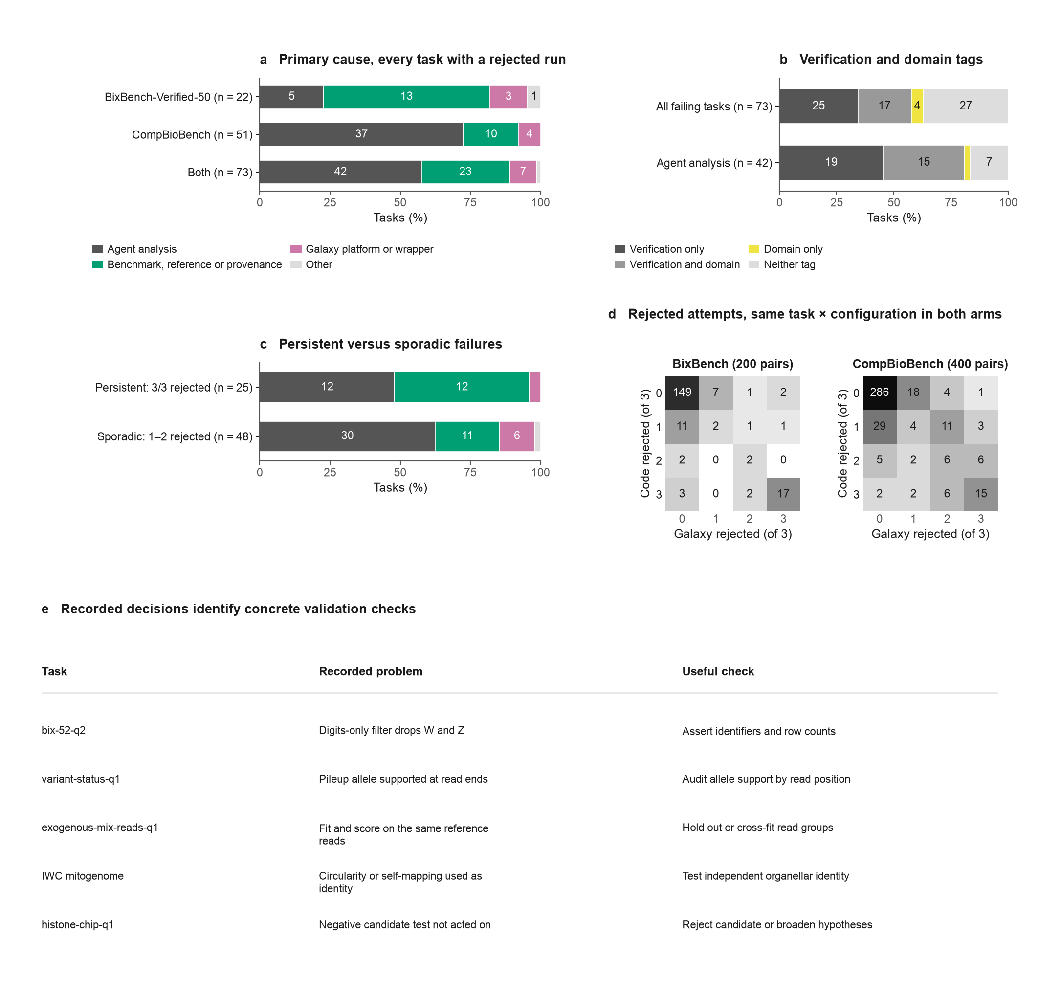

Fig. 5
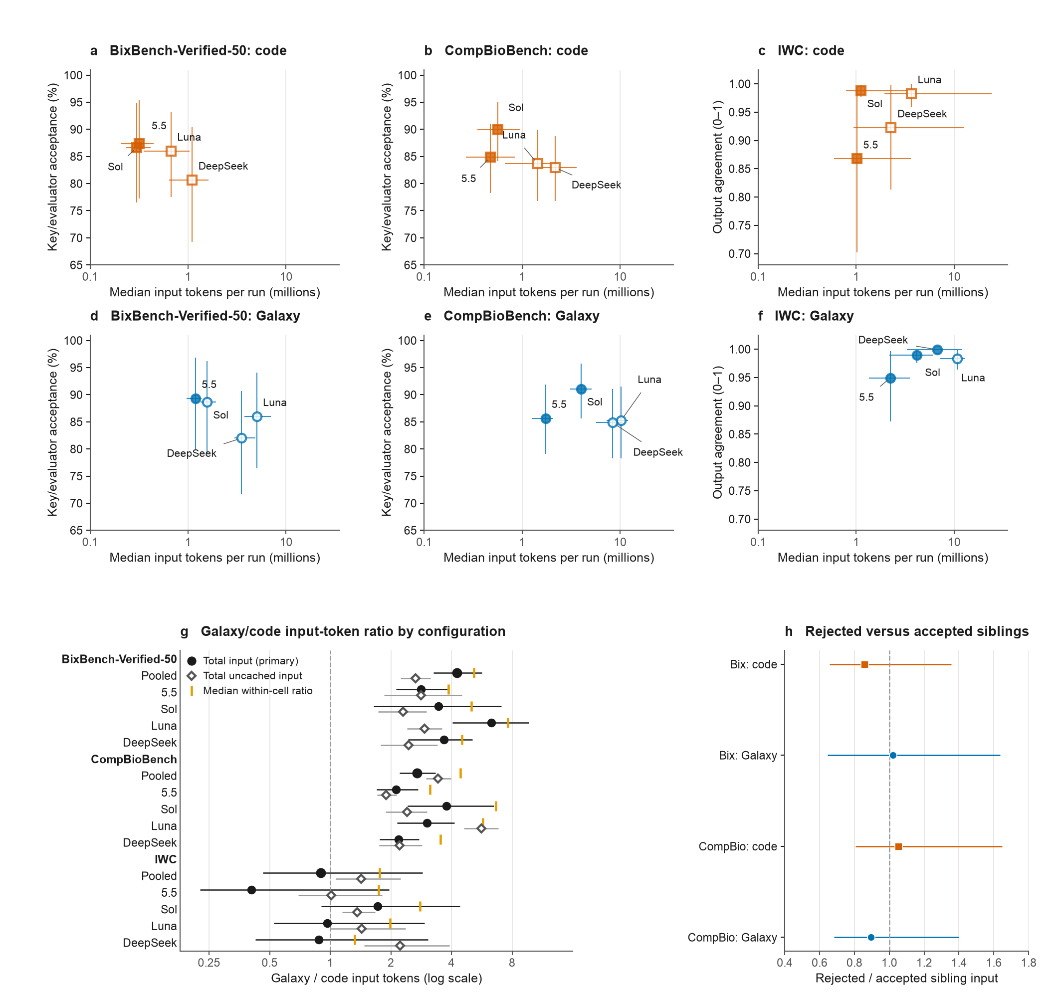

Fig. 6
