Execution environments shape the reliability of biomedical AI agents
[Authors: author list, affiliations and corresponding author]
Analysis

Abstract
AI agents now run computational biology analyses, yet users rarely know whether the agent's execution environment changes what they receive. We compared archived runs of four model configurations on 160 tasks from three benchmarks, with every task run three times in an open-ended code environment and three times through Galaxy, a workbench of installed, versioned tools that records provenance. Observed accuracy was similar on BixBench-Verified-50 (86.5% versus 85.2%) and on CompBioBench graded against a reconstructed key (87.1% versus 86.7%). On workflow-derived IWC tasks, output agreement was higher through Galaxy (0.980 versus 0.940) because fewer runs failed. Galaxy replicate sets had fewer discordant scored outcomes in all three benchmarks, but only the IWC interval excluded equality. Galaxy runs used a median 1.9 to 5.2 times as many input tokens. Prompts, budgets and run campaigns also differed between arms, so these differences belong to the assigned arms, not to Galaxy alone.
AI agents built on large language models now plan analyses, write and run code, call bioinformatics tools and report biological conclusions with little human direction^{1–6}. Benchmarks of these systems mostly ask whether a run reaches a reference answer^{7–10}. Recent benchmarking studies have shown that conclusions about computational methods depend on the endpoint, the reference and the baseline chosen^{11–14}. A biologist who delegates an analysis to an agent also needs to know whether a second run would give the same result and whether a reviewer could see how the result was reached. Computational biology treats both as conditions for trusting a result^{15–18}.
Agents usually execute in an open-ended code environment, an unrestricted shell in which the agent installs software and writes its own scripts. Two runs can install different versions, implement a statistic differently and preserve different execution artifacts. The alternative is a scientific workbench. In Galaxy, analyses are composed from installed tool wrappers with pinned versions, and each step is recorded in an analysis history with its tool, version, parameters, inputs and outputs^{19–21}. Workbenches and workflow managers were built to make human analyses reproducible^{16,22}. Comparative evidence about what they change for an agent user remains limited.
Here we report a retrospective, paired analysis of an archive in which the same model configurations performed the same tasks, three times each, in an open-ended code arm and in a Galaxy arm. Our question is user-facing: does the assigned execution arm change benchmark accuracy, the repeatability of scored outcomes across replicate runs, the evidence left for review and the cost of a run? Each benchmark keeps its own endpoint, and we report the design differences between arms beside every estimate. A companion manuscript analyses the same archive from the workbench side, covering interface failures, semantic fidelity, context use and agent-readiness requirements [Authors: companion manuscript citation]. The two papers share some descriptive measures, such as token use, but answer different questions with different primary endpoints.

Results

Paired arms, benchmark-specific endpoints and design differences
The archive holds 4,240 runs (Fig. 1a,b). The primary population is 3,840 runs: four model configurations under the Codex agent harness (GPT-5.5, GPT-5.6 Sol, GPT-5.6 Luna and DeepSeek V4 Pro), 160 tasks, two arms and three replicate runs. The IWC endpoint uses the nine tasks scored in both arms, so the endpoint analyses use 3,816 runs. We report separately 300 BixBench-Verified-50 runs of DeepSeek V4 Pro under a superseded Claude Code harness, and we exclude 100 unpaired GPT-6 Astra runs. In the Galaxy arm, the agent reached usegalaxy.org (https://usegalaxy.org) through an interface built on the Model Context Protocol (https://modelcontextprotocol.io). It searched and inspected installed tools, ran them as Galaxy jobs and inspected its analysis history. On two benchmarks it could also submit user-defined tools, agent-written code that Galaxy runs as a job in a declared container. A local shell remained available for staging inputs and extracting answers.
Each benchmark has its own endpoint, and the endpoints are not pooled (Fig. 1c). BixBench-Verified-50 uses acceptance by the original evaluator⁷. CompBioBench uses agreement with a reference key reconstructed from official leaderboard scores⁸: 54 items were inferred and 46 predicted. It reproduces all 24 official paired replicate scores, but independent scientific adjudication and validation against an official item key remain absent. IWC uses output agreement (0–1) with the published Galaxy workflow output (https://github.com/galaxyproject/iwc).
The arms differed in more than the execution environment (Supplementary Table 1). Galaxy and code prompts were never identical (0 of 2,070 task–configuration–replicate pairs). Galaxy prompts added execution policy and were longer: median 702 versus 368 words on BixBench-Verified-50 and 938 versus 227 on CompBioBench. CompBioBench code prompts stated a 120-minute limit; Galaxy prompts stated none. IWC runs had a 6- or 12-hour limit that depended on start time, and the two arms had equal limits in 73 of 120 replicate pairs. CompBioBench Galaxy runs executed in a container, whereas code runs executed in a host conda environment. Finally, 86 CompBioBench Galaxy runs, and no code runs, came from run campaigns whose names refer to wrong answers or target scores. Every estimate below is therefore a difference between assigned arms that includes all of these differences, not an effect of Galaxy alone. Extended Data Fig. 1 gives each user-facing measure as a Galaxy ÷ code ratio.

Similar observed benchmark accuracy
On BixBench-Verified-50, 86.5% of Galaxy runs and 85.2% of code runs were accepted, a difference of +1.3 percentage points (95% confidence interval −3.5 to 6.3; Fig. 2a). The four configurations differed by 0.0 to +2.0 points, and most tasks had similar numbers of correct runs in both arms (Extended Data Fig. 2a). After removing 15 tasks flagged by the audit for reference, grading or answer-exposure problems, the difference was −1.0 (−3.4 to 1.0). One such task, bix-30-q3, illustrates both problems. Its reference holds only when raw values are analysed, and code runs that reproduced the source paper's normalization reached a defensible alternative answer. In addition, all three DeepSeek V4 Pro Galaxy runs on this task read the benchmark row containing the reference answer before answering. Under the superseded harness, accuracy was 80.0% versus 69.3%, a difference of +10.7 (1.4 to 21.2) points. That harness differed from the primary one in more than its environment, and we do not generalize from it.
On CompBioBench, 87.1% of Galaxy runs and 86.7% of code runs agreed with the reconstructed key (+0.4; −1.6 to 2.4; Fig. 2b). The difference was similar in three sensitivity analyses: scoring one task against an alternative key, +0.4 (−1.6 to 2.4); removing the two audited tasks with predicted keys, +0.4 (−1.6 to 2.5); and keeping only the 53 tasks with any run that deviated from the key, +0.8 (−3.0 to 4.6). Removing the 66 task–configuration cells that contained a run from an outcome-named campaign reversed its sign, to −0.3 (−2.2 to 1.6).
On the nine IWC tasks, mean output agreement was 0.980 in the Galaxy arm and 0.940 in the code arm (+0.040; 0.010 to 0.078; Fig. 2c). Leaving out one task at a time gave +0.025 to +0.045. The difference came from a few failed runs (Fig. 2d): without the 3 tasks that contained a zero-scored run, it was +0.004 (0.000 to 0.010). Two further checks qualify the score. First, the ATAC-seq route references were calibrated from agent runs for 10 of 12 code and 2 of 12 Galaxy runs, so that task partly scores runs against themselves. Removing it gave +0.044 (0.011 to 0.085). Second, restricting to the 63 replicate pairs with equal time limits gave +0.069 (0.014 to 0.141). The headline score also omits components that matter biologically (Fig. 2e). For example, the RNA-seq composite does not include the set of significant genes: a Galaxy run that reported 37 significant genes, against 13 in the reference, scored 0.994. IWC scores therefore measure agreement with a reference route; they do not establish scientific validity.

Fewer discordant scored outcomes across replicate runs
A user who runs an analysis once needs that run to be representative. We called a replicate set discordant when one or two of its three runs were scored correct; for IWC, when its three scores spanned more than 0.05. Galaxy sets were discordant less often in every benchmark (Fig. 3a–c): 15 of 200 versus 19 of 200 on BixBench-Verified-50, a ratio of 0.79 (0.38 to 1.78); 53 of 400 versus 66 of 400 on CompBioBench, 0.80 (0.60 to 1.07); and 4 of 36 versus 11 of 36 on IWC, 0.36 (0.00 to 0.80). Only the IWC interval excluded equality. Paired transitions ran in both directions: of 200 BixBench-Verified-50 task–configuration pairs, 18 had a better set outcome in Galaxy and 11 a worse one; on CompBioBench the counts were 44 and 32 of 400 (Fig. 3a).
The share of tasks solved by all three runs was higher in Galaxy for 8 of 8 configuration–benchmark pairs, by 1 to 5 points. Pooled, it was 82.5% versus 79.5% on BixBench-Verified-50, a difference of +3.0 (−4.1 to 10.8) points, and 80.5% versus 77.3% on CompBioBench, +3.3 (−0.5 to 7.0) points (Fig. 3d). Normalized answer agreement showed no consistent Galaxy advantage. Replicate pairs matched at similar rates (87.8% versus 88.3% on BixBench-Verified-50 and 87.3% versus 85.9% on CompBioBench, Galaxy first; Extended Data Fig. 2b). These are measures of repeatability within one arm and configuration. They do not show reproducibility by another team or on another deployment.

Implementation and version differences behind divergent and stable results
To see why replicate runs diverged, we compared each scored-incorrect run in a discordant BixBench-Verified-50 set with its scored-correct siblings (Fig. 4a). In the code arm, 15 of 23 such runs differed by a hand-written method or a different software version, against 1 of 21 in Galaxy. Galaxy divergences more often arose from final-step errors, from no answer and from interface traps (4 of 21), a mechanism the code arm cannot have. The superseded harness showed the same contrast (15 of 22 versus 4 of 15).
Individual tasks show how a fixed implementation can make a result stable, whether right or wrong (Fig. 4b–d). On bix-55-q1, two code runs installed BUSCO 5.7.1²³ instead of reading the supplied BUSCO 5.8.0 outputs and reported 100 complete genes; all 12 Galaxy runs reported the reference, 101. On bix-45-q1, all 12 Galaxy runs and four code runs returned 1.52 × 10⁻⁵⁶. Ten of these Galaxy runs used the wrapper and two used user-defined tools; across all five configurations the counts were 13 and 2. This is the value under the current PhyKIT definition²⁴ and is scientifically defensible. The reference instead encodes the definition of PhyKIT 2.0.3, which eight code runs reproduced, mostly by dating the input files. The wrapper did not show which PhyKIT version it ran. On encode-atac-pipeline-q1, two Galaxy runs executed the ENCODE ATAC-seq pipeline (https://github.com/ENCODE-DCC/atac-seq-pipeline) in its official container as a Galaxy job and reproduced the reference. Eleven code runs executed it outside the container and reported nearby values; host-library differences are an untested explanation. Seven Galaxy runs computed untrimmed outputs after staging removed file extensions; another copied an untrimmed answer from a pilot history after its own jobs failed.
On IWC, five of 117 scored code runs and three of 120 Galaxy runs scored below 0.5 (Fig. 4e). Two code-run mechanisms did not occur in Galaxy runs: a hand-written multiple-testing correction²⁵ and sample identifiers lowercased from folder names. Submitting the wrong contig as a mitochondrial genome occurred in both arms. Two Galaxy runs were scored against a route other than the one they followed. These cases are consistent with installed tools reducing implementation variance, but they come from a small number of tasks and do not test that mechanism.

What each arm leaves for review
Execution traces were retrieved for 1,920 of 1,920 code runs and 1,908 of 1,920 Galaxy runs in the primary population (Fig. 5a). Only Galaxy runs also had analysis histories recording tools, parameters and job states: 1,883 of 1,920 primary runs and 2,030 of 2,070 of all Galaxy runs. Histories are therefore not available for every run. Execution errors per run were similar in the two arms on BixBench-Verified-50, higher in Galaxy on CompBioBench and lower on IWC, and they differed in type (Extended Data Fig. 3). The interface compared requested with resolved non-dataset parameters in 84.4% (14,503 of 17,180) tool-run calls. The remaining calls lack a recorded comparison; success alone cannot certify their parameter fidelity. Provenance records let a reviewer see what ran. They do not by themselves reproduce a result: we replayed no history and re-executed no analysis.
A targeted, AI-assisted trace audit reviewed tasks with wrong, scored-incorrect or low-scoring runs and one near-perfect IWC workflow with changed significant genes (93 cases; Fig. 5b). The primary cause was an agent analysis error in 52 cases, a reference that depends on an unstated choice in 20, the Galaxy platform, a wrapper or the server in 8, an equivalent answer in another notation in 6, a scoring artifact in 4 and another cause in 3. The audit was not exhaustive and did not split causes by arm.
The arm label records the assignment, not where computation ran (Fig. 5c). A screen found shell commands naming an analysis program in 37.8%, 26.3% and 56.7% of Galaxy runs on the three benchmarks. These are unvalidated screening signals; false positives and missed computation are possible. The audit confirmed four kinds of departure, which we count as observed cases, not prevalence. First, 18 CompBioBench Galaxy answers were computed in the local shell after user-defined-tool execution became unavailable (15 scored correct). Second, 2 answers were copied across runs through the shared Galaxy account. Third, Galaxy-arm agents sometimes called the Galaxy API directly from the shell, bypassing the interface's checks; the companion study quantifies this. Fourth, in 26 task cases, agents in either arm retrieved or tried to retrieve benchmark answers online.

Resource use and user strategies
Within the same task and configuration, Galaxy runs used a median 5.2 (4.1 to 6.9), 4.4 (3.5 to 5.4) and 1.9 (0.8 to 4.9) times the input tokens of code runs on the three benchmarks (Fig. 6a). These ratios cover the cells with token records in both arms: 200 of 200, 386 of 400 and 40 of 40. Most of the excess was cached context re-read on each turn. Uncached input rose 2.4 (2.1 to 3.4), 2.9 (2.6 to 3.3) and 1.6 (1.2 to 1.9) fold, and output tokens 2.2 (1.8 to 2.8), 2.1 (1.8 to 2.2) and 1.1 (0.7 to 1.5) fold.
A user can also run an agent three times and take the majority answer. We applied outcome-blind voting rules retrospectively (Methods). Under rule A, which compares numbers to ten significant digits, voting changed BixBench-Verified-50 accuracy from 85.2% to 84.5% in the code arm and from 86.5% to 85.5% in Galaxy. On CompBioBench it changed accuracy from 86.7% to 89.0% and from 87.1% to 87.0% (Fig. 6b). Under rule B, which compares numbers to three significant digits, BixBench-Verified-50 voting reached 87.0% in code and 87.5% in Galaxy (Extended Data Fig. 4). Three code runs used a median 1.41 and 3.36 million input tokens, fewer than one Galaxy run (2.21 and 4.55 million). Whether code voting matches one Galaxy run depends on the benchmark and matching rule. Code runs retain their transcripts; voting adds no workflow provenance.
Galaxy runs also took 2.0 to 2.9 and 1.8 to 3.0 times as many actions as code runs on BixBench-Verified-50 and CompBioBench (Holm-adjusted P < 0.05 for 4 of 4 and 4 of 4 configurations) and 1.6 to 1.9 times as many on IWC (0 of 4; Fig. 6c). Galaxy also produced failure mechanisms of its own (Fig. 6d). The audit attributed 31 scored-incorrect Galaxy runs, across all five configurations, to 6 Galaxy-specific mechanisms, and four of them raised no job error. They include the undisplayed PhyKIT version on bix-45-q1, whose 15 Galaxy answers are scientifically defensible but were scored incorrect.

Discussion
For a user choosing between an agent that writes its own code and one that works through Galaxy, this archive shows similar observed benchmark accuracy and more replicate sets with consistent scored outcomes through Galaxy. Galaxy runs also kept analysis histories, at several times the token cost. The accuracy estimates were sensitive to how the reference was built and which runs were included. The CompBioBench difference changed sign without the outcome-named campaigns, and the BixBench-Verified-50 difference changed sign without the tasks flagged for reference, grading or answer-exposure problems. The repeatability difference had the same direction in all three benchmarks and in most configurations, but its interval excluded equality only for IWC. Because prompts, budgets, runtime environments and run campaigns differed between arms, these are differences between assigned arms. We cannot assign them to Galaxy alone.
The case analyses suggest one mechanism that a user can act on. Installed tools constrain implementation choices; matching tool names alone does not ensure matching parameters or outputs. Most code-arm divergence on BixBench-Verified-50 came from re-implementing a method or installing a different version. The mechanism cuts both ways. On bix-45-q1, every Galaxy run returned the current PhyKIT definition. That answer is scientifically defensible, but it was scored incorrect because the reference used a retired version, and the wrapper did not show which version it ran. A stable answer is useful only when the user can confirm that the pinned version is the intended one.
Repeatability, reproducibility and provenance are different properties, and this study measures them unevenly. We measured repeatability of scored outcomes within an arm, the coverage of execution records and, through a targeted audit, what those records allowed a reviewer to attribute. We did not replay histories, re-execute runs on another deployment or ask domain experts to judge scientific validity without knowing the arm. Supplementary Note 1 gives a protocol for these prospective steps. It specifies matched prompts and budgets, fixed campaigns, blinded expert review, independent replay of Galaxy histories and code transcripts, and a second Galaxy deployment.
The study has further limitations. It is retrospective, replicate labels are not matched random seeds, and the four configurations represent a period in which models changed quickly. CompBioBench grades depend on a private key, nearly half of which was predicted rather than inferred. The IWC headline score includes circular ATAC-seq references and omits components that matter biologically. All Galaxy runs used one public server, one interface and one shared account, and the shared account allowed answers to be copied between runs. The trace audit was AI-assisted, and its counts of local computation, copying and answer retrieval are observed cases, not prevalence. Agents in both arms sometimes retrieved benchmark answers online, so all three benchmarks may be partly contaminated.
The observed accuracy differences were small and sensitive to exclusions; equivalence and non-inferiority remain untested. Galaxy histories enabled attribution of scientific errors, version dependencies and departures from the assigned arm, at higher token use. Independent replay and review-time measurements are needed to determine the value of those records to users.

References
1. Gao, S. et al. Empowering biomedical discovery with AI agents. Cell 187, 6125–6151 (2024).
2. Boiko, D. A., MacKnight, R., Kline, B. & Gomes, G. Autonomous chemical research with large language models. Nature 624, 570–578 (2023).
3. M. Bran, A. et al. Augmenting large language models with chemistry tools. Nat. Mach. Intell. 6, 525–535 (2024).
4. Huang, K. et al. Autonomous biomedical research with an artificial intelligence agent. Science 393, eadz4351 (2026).
5. Alber, S. et al. CellVoyager: AI CompBio agent generates new insights by autonomously analyzing biological data. Nat. Methods 23, 749–759 (2026).
6. Miao, J., Davis, J. R., Zhang, Y., Pritchard, J. K. & Zou, J. Reimagining research papers as interactive and reliable AI agents. Nature https://doi.org/10.1038/s41586-026-11044-y (2026).
7. Mitchener, L. et al. BixBench: a comprehensive benchmark for LLM-based agents in computational biology. Preprint at https://doi.org/10.48550/arXiv.2503.00096 (2025).
8. Nair, S. et al. Agentic systems are adept at solving well-scoped, verifiable problems in computational biology. Preprint at bioRxiv https://doi.org/10.64898/2026.04.06.716850 (2026).
9. Chan, J. S. et al. MLE-bench: evaluating machine learning agents on machine learning engineering. Preprint at https://doi.org/10.48550/arXiv.2410.07095 (2024).
10. Jimenez, C. E. et al. SWE-bench: can language models resolve real-world GitHub issues? In Proc. 12th International Conference on Learning Representations (ICLR, 2024).
11. Luecken, M. D. et al. Benchmarking atlas-level data integration in single-cell genomics. Nat. Methods 19, 41–50 (2022).
12. Ahlmann-Eltze, C., Huber, W. & Anders, S. Deep-learning-based gene perturbation effect prediction does not yet outperform simple linear baselines. Nat. Methods 22, 1657–1661 (2025).
13. Miller, H. E. et al. Deep learning perturbation models can outperform baselines on calibrated metrics. Nat. Biotechnol. https://doi.org/10.1038/s41587-026-03307-w (2026).
14. Saez-Rodriguez, J., Schäfer, P. S. L., Kalavros, N. & Stolovitzky, G. Benchmarking biomedical foundation models. Nat. Methods 23, 1724–1733 (2026).
15. Sandve, G. K., Nekrutenko, A., Taylor, J. & Hovig, E. Ten simple rules for reproducible computational research. PLoS Comput. Biol. 9, e1003285 (2013).
16. Nekrutenko, A. & Taylor, J. Next-generation sequencing data interpretation: enhancing reproducibility and accessibility. Nat. Rev. Genet. 13, 667–672 (2012).
17. Grüning, B. et al. Practical computational reproducibility in the life sciences. Cell Syst. 6, 631–635 (2018).
18. Heil, B. J. et al. Reproducibility standards for machine learning in the life sciences. Nat. Methods 18, 1132–1135 (2021).
19. Goecks, J., Nekrutenko, A., Taylor, J. & The Galaxy Team. Galaxy: a comprehensive approach for supporting accessible, reproducible, and transparent computational research in the life sciences. Genome Biol. 11, R86 (2010).
20. The Galaxy Community. The Galaxy platform for accessible, reproducible, and collaborative data analyses: 2024 update. Nucleic Acids Res. 52, W83–W94 (2024).
21. Blankenberg, D. et al. Dissemination of scientific software with Galaxy ToolShed. Genome Biol. 15, 403 (2014).
22. Wratten, L., Wilm, A. & Göke, J. Reproducible, scalable, and shareable analysis pipelines with bioinformatics workflow managers. Nat. Methods 18, 1161–1168 (2021).
23. Manni, M., Berkeley, M. R., Seppey, M., Simão, F. A. & Zdobnov, E. M. BUSCO update: novel and streamlined workflows along with broader and deeper phylogenetic coverage for scoring of eukaryotic, prokaryotic, and viral genomes. Mol. Biol. Evol. 38, 4647–4654 (2021).
24. Steenwyk, J. L. et al. PhyKIT: a broadly applicable UNIX shell toolkit for processing and analyzing phylogenomic data. Bioinformatics 37, 2325–2331 (2021).
25. Benjamini, Y. & Hochberg, Y. Controlling the false discovery rate: a practical and powerful approach to multiple testing. J. R. Stat. Soc. B 57, 289–300 (1995).

Figure legends
Fig. 1 | Comparison design, analysed populations and primary endpoints. a, Each task was run by the same model configuration and agent harness in two assigned arms: an open-ended code arm with an unrestricted shell, and a Galaxy arm working through a Galaxy interface to usegalaxy.org. Prompts, budgets, runtime environment and run campaigns also differed between arms (Supplementary Table 1). b, Archived runs, the primary paired population (four Codex model configurations × 160 tasks × 2 arms × 3 replicate runs) and the runs reported separately or excluded. c, Benchmark-specific endpoints, the provenance of their references and the primary estimates (four Codex model configurations). Discordant replicate sets have one or two of three runs scored correct; for IWC, three scores spanning more than 0.05. Intervals are 95% percentile cluster-bootstrap intervals (20,000 resamples) over source capsules (BixBench-Verified-50) or tasks.
Fig. 2 | Benchmark accuracy by execution arm, with reference and evaluator sensitivity. a–c, Mean score over tasks for each model configuration × replicate (vermillion squares, open-ended code; blue circles, Galaxy), arm means (vertical ticks) and the Galaxy − code difference with its 95% cluster-bootstrap interval (black circles) per model configuration and pooled; open diamonds show pooled sensitivity analyses. The BixBench sensitivity excludes reference, grading or answer-exposure problems (C1–3, C6; Methods). a, BixBench-Verified-50, acceptance by the original evaluator (n = 600 runs per arm; superseded harness, 150 per arm). b, CompBioBench, agreement with the reconstructed key (n = 1,200 runs per arm). c, IWC, mean output agreement over nine tasks (n = 108 runs per arm). d, Galaxy − code difference in task mean output agreement for each IWC task (filled circles coloured by the arm the difference favours); the note gives the leave-one-task-out range and the ATAC-seq reference caveat. e, Biological output components for three IWC tasks, per run. RNA-seq significant-gene Jaccard is omitted from its headline composite.
Fig. 3 | Outcome repeatability across replicate runs. a, Paired replicate-set outcomes for each task × model configuration: rows give the code-arm outcome and columns the Galaxy-arm outcome (all three runs correct, discordant, none correct); blue cells mark a better and vermillion cells a worse Galaxy outcome (BixBench-Verified-50, n = 200 pairs; CompBioBench, n = 400). b, Discordant replicate sets per model configuration (vermillion squares, code; blue circles, Galaxy), with the pooled ratio (Galaxy ÷ code) and its 95% cluster-bootstrap interval. c, Range of output agreement within each IWC replicate set (n = 36 sets per arm; ranges of zero are drawn at 0.0001); the dashed line marks the 0.05 threshold. d, Share of tasks whose three replicate runs were all scored correct, per model configuration and pooled.
Fig. 4 | Implementation and version differences behind divergent and stable results. a, Mechanism by which each scored-incorrect run in a discordant BixBench-Verified-50 replicate set differed from its scored-correct siblings, by arm and harness. b–d, Submitted answers (b, c) and agreement categories (d) for the four Codex model configurations (12 runs per arm); filled symbols match the reference and open symbols do not; annotations give the traced explanation. b, bix-55-q1. c, bix-45-q1; the Galaxy answers follow the current PhyKIT definition and are scientifically defensible. d, encode-atac-pipeline-q1; numeric answers are withheld pending reference-key disclosure authorization. e, Every IWC run with output agreement below 0.5, by traced cause (open-ended code, 5 of 117 scored runs; Galaxy, 3 of 120).
Fig. 5 | What each arm leaves for review, and what the audit found. a, Evidence available for review in the primary population: execution traces (both arms), detailed analysis histories, tool-run calls in which the interface compared requested with resolved non-dataset parameters, and Galaxy jobs whose tool identifier records a wrapper version. b, Primary cause of each of the 93 task cases in the targeted, AI-assisted trace audit, by benchmark. c, Galaxy-arm runs whose shell commands named an analysis program (an unvalidated screen, not confirmed execution), and the departures from the assigned arm that the audit confirmed (observed cases, not prevalence).
Fig. 6 | Observed resource use and retrospective answer-voting strategies. a, Galaxy ÷ code ratio of input tokens (filled circles; including cached input), uncached input (open diamonds) and output tokens (open squares): median over task × model configuration cells with records in both arms of the within-cell ratio of medians, with 95% cluster-bootstrap intervals. b, Accuracy against observed median input tokens per task for one run (open symbols) and for three runs combined by the outcome-blind majority vote, rule A (filled symbols). c, Actions per run, Galaxy ÷ code, per model configuration (median ratio with 95% interval; filled diamonds, Holm-adjusted P < 0.05, two-sided Wilcoxon signed-rank test on per-task medians). d, Scored-incorrect Galaxy runs whose decisive cause in the audit was Galaxy-specific, by mechanism (all five configurations); mechanisms above the dashed line raised no job error.

Methods

Archive and analysed populations
We analysed an archive of 4,240 agent runs on 160 tasks: BixBench-Verified-50 (50 questions from 33 source capsules; 1,500 runs)⁷, CompBioBench (100 tasks; 2,500 runs)⁸ and IWC (10 tasks derived from published Galaxy workflows; 240 runs). The archive preserves execution traces, submitted answers or outputs, evaluator records and retrieved Galaxy analysis histories where available. No agent code was re-run, no Galaxy job was submitted and no file in the repository's ground-truth directory was opened for this analysis. Supplementary Table 2 lists the analysed population, the eligible units and the numerator and denominator for every measure.
The primary population comprises four model configurations under the Codex agent harness: GPT-5.5, GPT-5.6 Sol, GPT-5.6 Luna (maximum reasoning effort; the others, high) and DeepSeek V4 Pro. Configuration names are archive labels; exact runtime model snapshots and interface commits are incompletely recorded. Each configuration ran every task three times per arm. DeepSeek V4 Pro also ran BixBench-Verified-50 under a superseded Claude Code harness; these 300 runs are reported separately. GPT-6 Astra ran CompBioBench once per task in the code arm only and enters no comparison.

Execution arms and recorded design differences
In the open-ended code arm, the agent worked in a shell and could install and run any software. In the Galaxy arm, the agent reached usegalaxy.org through an interface implemented as a Model Context Protocol server. The interface exposed tool search, tool inspection, history and dataset inspection, job submission and waiting and, on BixBench-Verified-50 and CompBioBench, user-defined tools. Before submitting a job, the interface validated the request; after the job, it compared the requested non-dataset parameters with those Galaxy resolved. Galaxy-arm prompts required evidence-bearing computation to run in Galaxy and reserved the local shell for staging and answer extraction.
Design differences between arms were extracted read-only from the archive. We recorded prompt hashes and lengths, time limits, harness and container labels, runtime model identifiers, run dates, exposed tools and run campaigns (Supplementary Table 1; derived/design/ in the code release). For each CompBioBench run, its campaign was taken from its archived workspace path and checked against the official score-vector registry. Campaigns whose names refer to wrong answers or target scores (wrong19, wrongset, fastwrong, target84, near84) are called outcome-named.

Endpoints and grading
BixBench-Verified-50 runs keep their original binary evaluator decisions; no run was regraded. CompBioBench archives no per-run grades. We graded each run as correct when its submitted answer, after removing leading and trailing white space, exactly matched the reconstructed key. One label substitution was applied before matching: the text "Proximal enhancer,EH38E1957012" was replaced with "pELS,EH38E1957012". No case, spacing or numeric normalization was applied in grading; those rules apply only to the answer grouping described below. The key comes from the lab results repository goeckslab/galaxy-agent-benchmark (private; commit bdc00429f559). Answers for 54 items were inferred from official leaderboard scores (file SHA-256 prefix 959dd3f2), and answers for 46 items were predicted (57a6a92d). Official scores (055cfb18) were used for verification. The grading script checks each file against its SHA-256 and stops unless the grades reproduce all 24 official paired replicate scores. Two archived replicate scores used in earlier summaries are one point lower than our grades. The key files are kept outside the repository because agents run from it, so CompBioBench grades cannot be regenerated without access to the private key; Source Data give grades and replicate outcomes but no answers. IWC uses the archived output agreement score (0–1), which is task-specific and defined against the published workflow output. Condition comparisons use the nine tasks scored in both arms. The host-read-removal task was excluded because three code runs followed unsupported routes and two Galaxy runs had conflicting scores.

Sensitivity analyses
These sensitivity analyses are retrospective and exploratory; they were not preregistered. For BixBench-Verified-50, we excluded 15 tasks coded C1, C2, C3 or C6: equivalent answers, scoring artifacts, underspecified references or reference/answer-exposure problems. For CompBioBench, we made four changes: we scored genome-coords-q1 against an alternative key D; excluded the two audited tasks with predicted keys; kept only the 53 tasks with any run that deviated from the key; and excluded every task–configuration cell containing a run from an outcome-named campaign. For IWC, we excluded the ATAC-seq task, whose route references were calibrated from agent runs, as recorded in each run's evaluation record. We also excluded the tasks containing a zero-scored run, restricted the comparison to replicate pairs with equal time limits and left out one task at a time. IWC components (Fig. 2e) were read from each run's evaluation record.

Replicate sets, repeatability and answer agreement
A replicate set is the three replicate runs of one task, model configuration and arm. For binary endpoints, a set is all correct, discordant (one or two correct) or none correct. For IWC, a set is discordant when its three output-agreement values span more than 0.05; nine-task counts are primary, and Supplementary Table 2 gives all-ten-task counts (11 of 39 vs 5 of 40). Unanimous accuracy is the share of tasks with an all-correct set. Answer agreement is the share of the three replicate-run pairs in a set whose answers match: decimal numbers within a relative 10⁻⁴, integers exactly and other text after removing case and spaces.

Outcome-blind majority vote
Answers were grouped without grades: surrounding white space, case and spaces were normalized. Rule A compared numbers to ten significant digits; rule B used three. Percentage units remained distinct. A group of at least two selected its earliest-replicate answer; no consensus counted as incorrect. We reused that representative's archived grade rather than regrading. Selection is independent of outcomes, but this surrogate depends on the original grading; groups with inconsistent member grades are flagged in Source Data. The share of sets with at least two correct runs is an oracle shown only for comparison.

Divergence mechanisms, targeted audit and execution location
For each scored-incorrect run in a discordant BixBench-Verified-50 set, we compared its trace with those of its scored-correct siblings. The decisive difference was assigned to one mechanism: a hand-written method or a different software version, a domain convention, a final-step error, a Galaxy interface trap, or no answer or benchmark source files read. The targeted audit reviewed the traces of every task with at least one wrong, scored-incorrect or low-scoring run, plus one IWC workflow whose near-perfect score concealed a changed significant-gene set (93 task cases). Each case received one primary cause and cross-cutting flags for local computation, cross-run reuse and answer retrieval (individual_error_analysis.md, with trace line references). The audit and the divergence comparisons were performed with an AI assistant, and every assignment cites trace lines that a reader can check [Authors: describe the human review of the AI-assisted audit, including who reviewed which cases and how disagreements were resolved]. The execution-location screen flagged Galaxy-arm runs whose shell commands named an analysis program. This screen is unvalidated and can miss local computation or flag staging commands.

Execution errors, tokens and actions
An execution error is a shell command with a non-zero exit code, excluding exit code 1 with no message (such as a search with no match), or a Galaxy job in the error state. Error types come from one ordered set of rules applied to shell output and Galaxy job messages (Extended Data Fig. 3). An error is counted as occurring in a run that ended correct when its run was scored correct; we do not interpret this as repair of the error. Input tokens include cached input; uncached input is input minus cached input. An action is one agent tool call. Token and action ratios are medians, over task × model configuration cells with records in both arms, of the ratio of the Galaxy to the code median.

Statistics
Intervals are 95% percentile cluster-bootstrap intervals with 20,000 resamples²⁶. Resampling units are source capsules for BixBench-Verified-50 and tasks for CompBioBench and IWC, which preserves the pairing of arms within a cluster. Intervals taken from the archived analyses (BixBench-Verified-50 and IWC accuracy differences) used seed 20260922, and new intervals used seed 20261002. Action comparisons used two-sided Wilcoxon signed-rank tests on per-task medians with Holm adjustment²⁷. All intervals are pointwise and exploratory; we make no equivalence, non-inferiority or causal claim. Values are rounded half away from zero.

Use of AI tools
An AI assistant helped perform the targeted trace audit, write analysis and figure code and draft text. Documented independent human verification remains pending [Authors: name the assistants, versions and dates, document human verification and confirm responsibility for the content].

Figures and reporting
Open-ended code is shown first, in vermillion squares, and Galaxy second, in blue circles, from the Okabe–Ito palette²⁸. Every figure, Source Data workbook and number in the text is generated by scripts/make_figures.py, which writes the numbers to numbers.json. Each Source Data workbook includes a data dictionary sheet. Further information on research design is available in the Nature Portfolio Reporting Summary linked to this article.

Data availability
The run archive, execution traces, Galaxy analysis-history snapshots and derived tables are available at [Authors: archive DOI and Hugging Face dataset identifier]. Source Data are provided with this paper. The CompBioBench reference key is held in a private repository, as described in Methods, and access conditions remain to be established [Authors: confirm access conditions].

Code availability
Analysis and figure code is in manuscript_narrative/ of the project repository [Authors: repository URL and release DOI]. manuscript_narrative/build_all.sh rebuilds figures, workbooks and documents from frozen archived summaries and per-call tables using the pinned environment. Without the private CompBioBench key, it reuses archived per-run grades rather than independently regenerating them. Input and artifact hashes are recorded in release_manifest.json.

Methods references
26. Davison, A. C. & Hinkley, D. V. Bootstrap Methods and their Application (Cambridge Univ. Press, 1997).
27. Holm, S. A simple sequentially rejective multiple test procedure. Scand. J. Stat. 6, 65–70 (1979).
28. Wong, B. Points of view: color blindness. Nat. Methods 8, 441 (2011).

Extended Data figure legends
Extended Data Fig. 1 | Galaxy ÷ code for user-facing measures. Ratio (Galaxy ÷ open-ended code) and 95% cluster-bootstrap interval for accuracy, repeatability, error/outcome association and uncached input tokens (four Codex model configurations; IWC accuracy and discordant sets over nine tasks). Blue circles favour Galaxy and vermillion squares favour code; open symbols mark intervals that include 1. Grey associations are descriptive and do not measure error repair. Columns give each arm's value and the ratio.
Extended Data Fig. 2 | Task-level accuracy and answer agreement. a, Runs scored correct per task (of 12) in each arm (BixBench-Verified-50, 50 tasks; CompBioBench, 100 tasks); symbol area is the number of tasks at a point; blue circles favour Galaxy, vermillion squares favour code and grey circles are ties. b, Share of replicate-run pairs that submitted the same answer, per arm (vermillion squares, code; blue circles, Galaxy), with the Galaxy − code difference and 95% cluster-bootstrap interval.
Extended Data Fig. 3 | Execution errors by type and arm. Mean execution errors per run, by error type, benchmark and arm (four Codex model configurations; errors are shell commands with a non-zero exit code or Galaxy jobs in the error state).
Extended Data Fig. 4 | Majority voting under declared answer-matching rules. Accuracy of one run (open circles), the oracle with at least two of three runs scored correct (grey squares), and the outcome-blind majority vote under rule A (black diamonds; numbers to ten significant digits) and rule B (black triangles; three significant digits), per model configuration, benchmark and arm.

Supplementary information
Supplementary Tables 1–5 (supplementary/Supplementary_Tables.xlsx): 1, design differences between arms; 2, analysed populations, eligibility and measure definitions; 3, CompBioBench reference-key layers and sensitivity analyses; 4, codebooks for divergence mechanisms, audit causes, execution-error types and voting rules; 5, the number provenance of every value quoted in the text. Supplementary Note 1 (supplementary/Supplementary_Note_1_prospective_validation.md): protocol for prospective replay, blinded expert review and a matched-arm rerun.

Acknowledgements
[Authors: funding and acknowledgements]

Author contributions
[Authors: contributions]

Competing interests
[Authors: competing interests]

Fig. 1
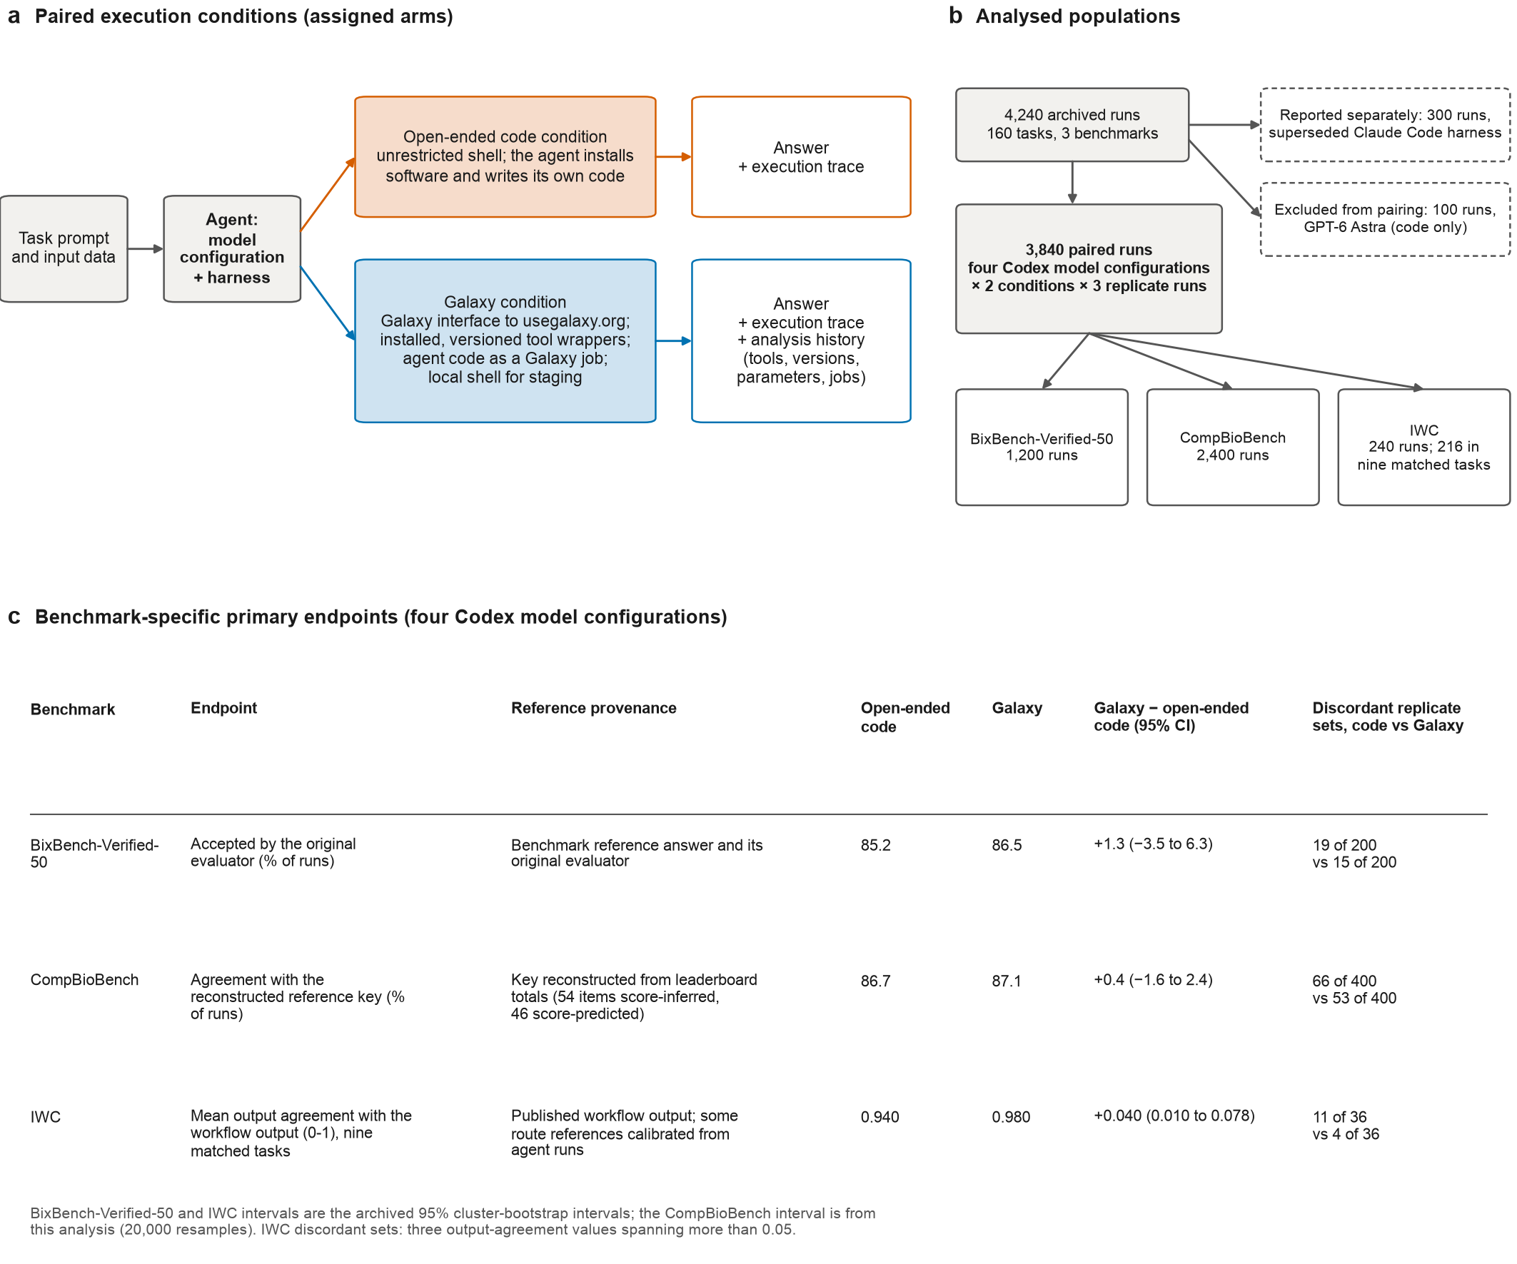

Fig. 2
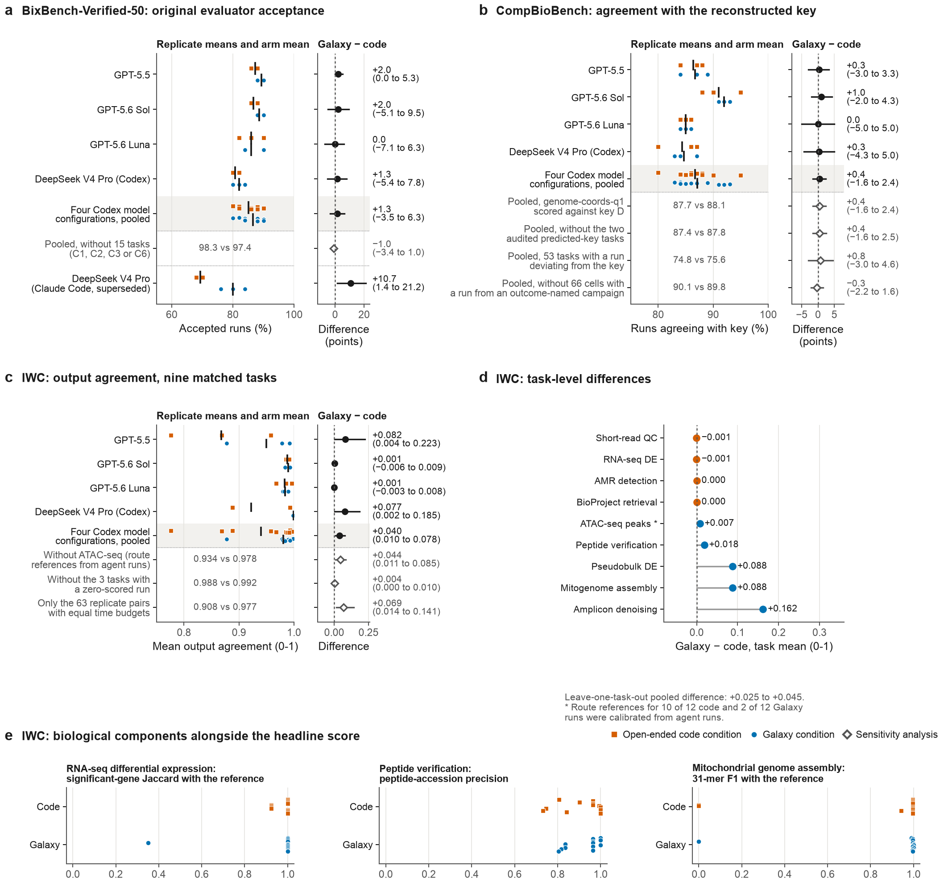

Fig. 3
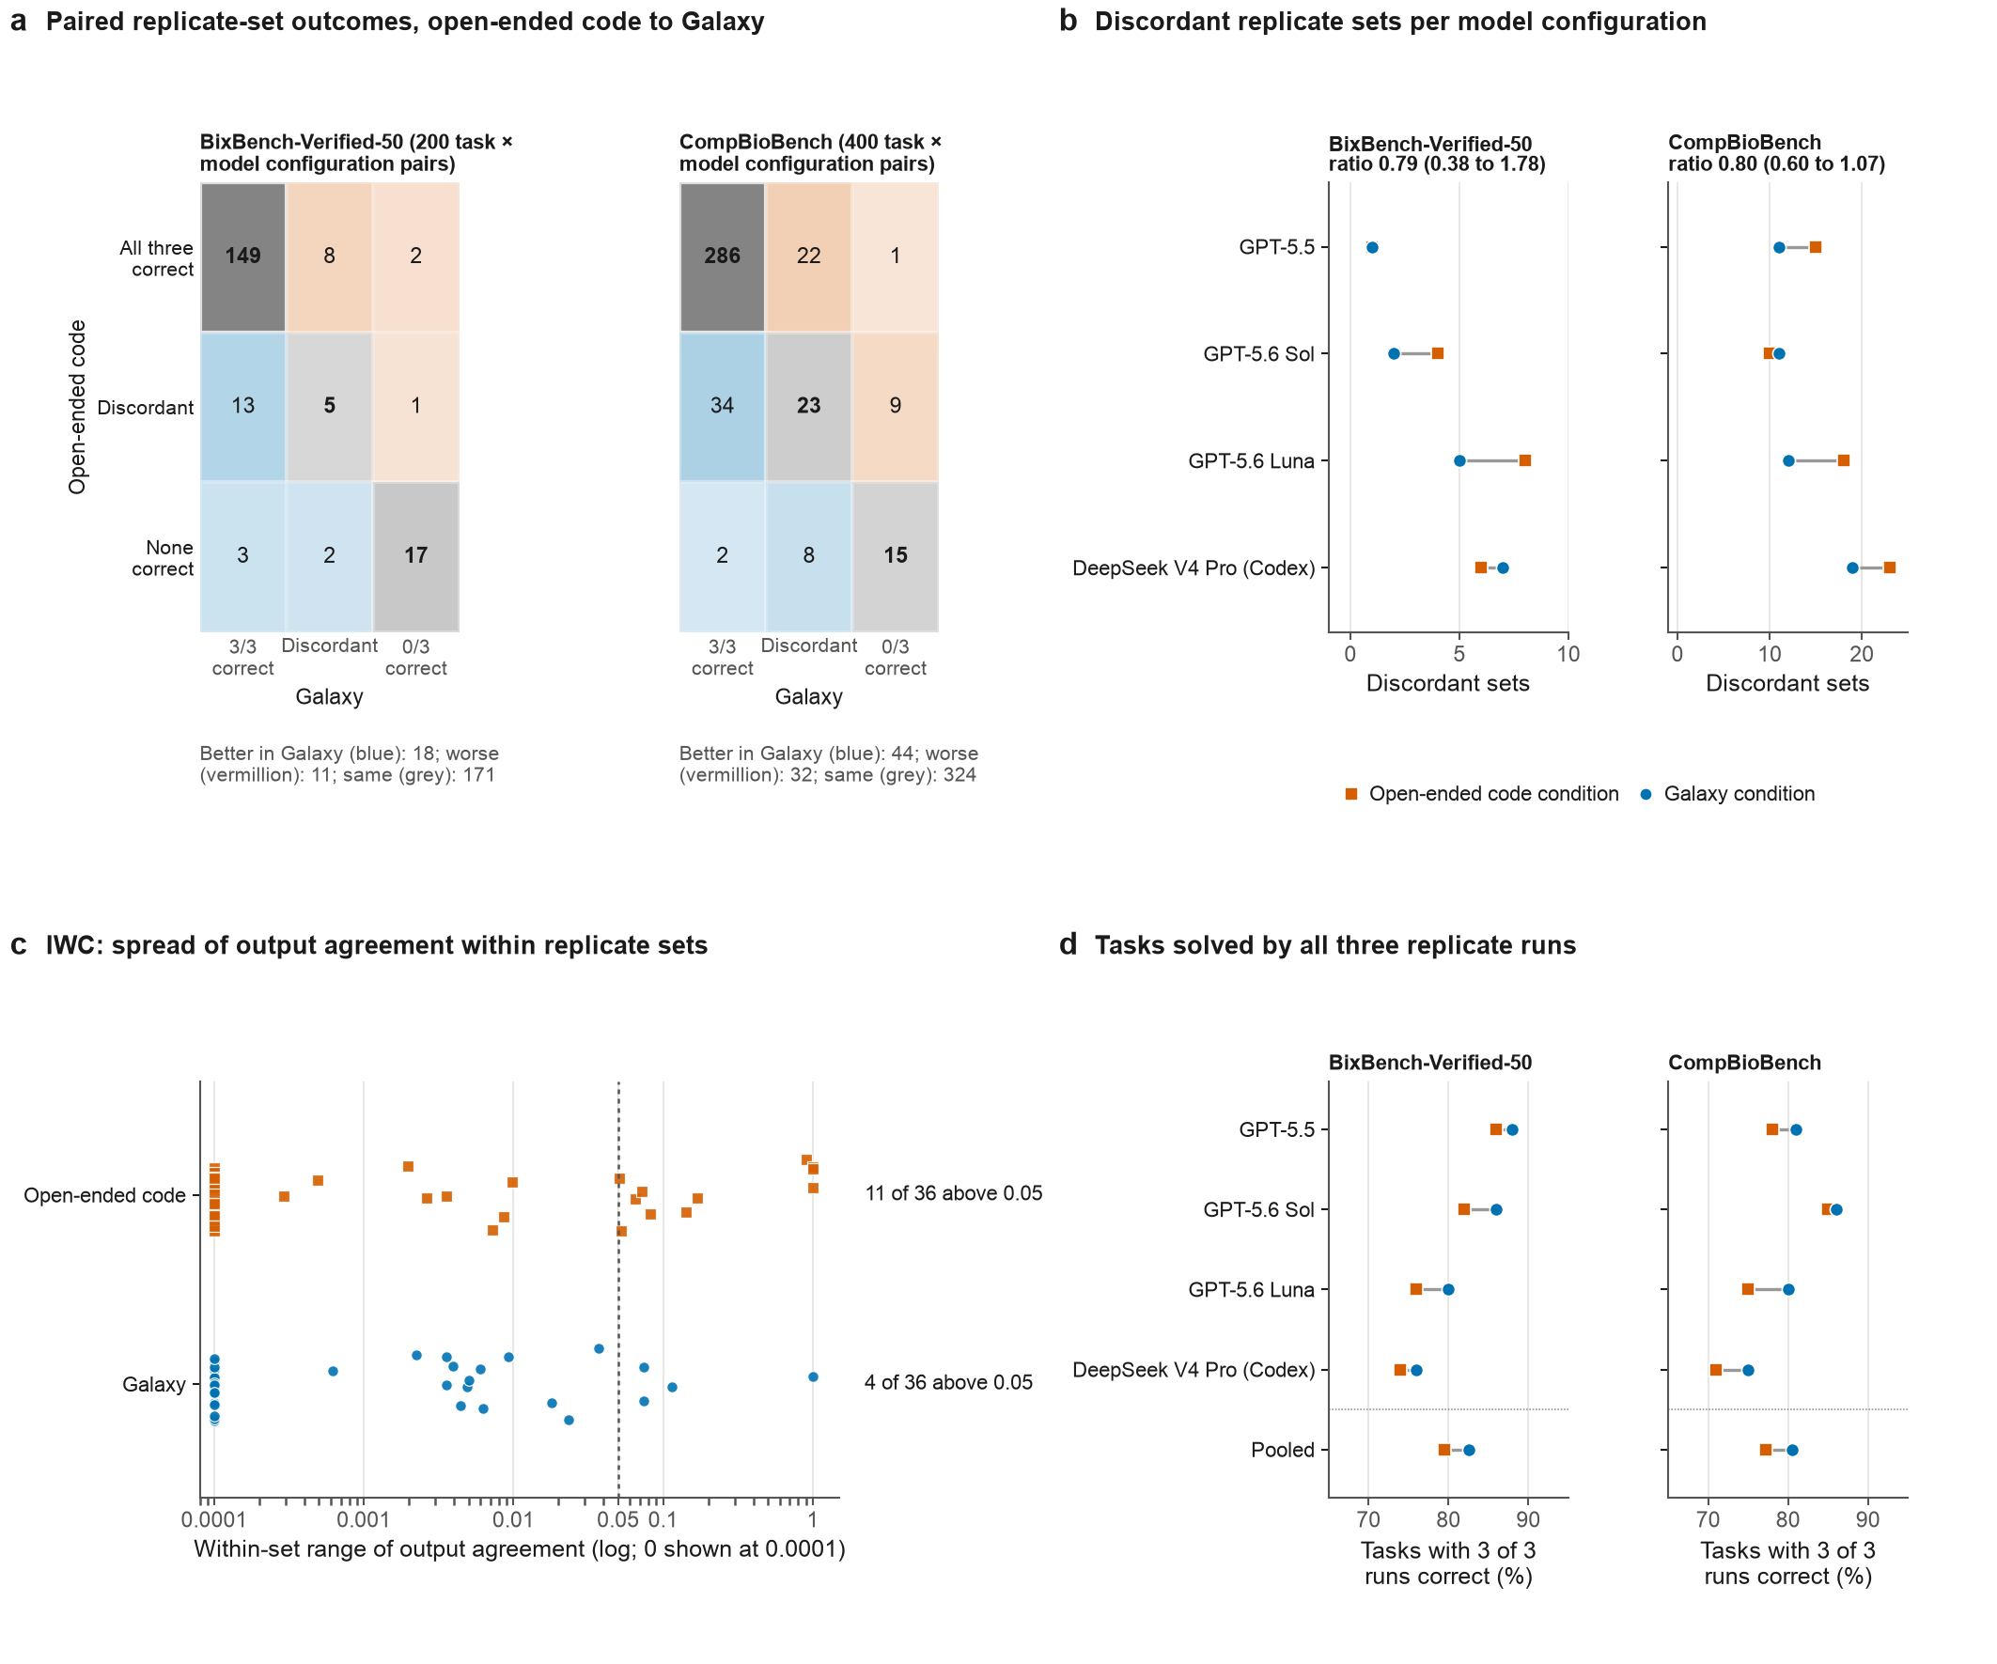

Fig. 4
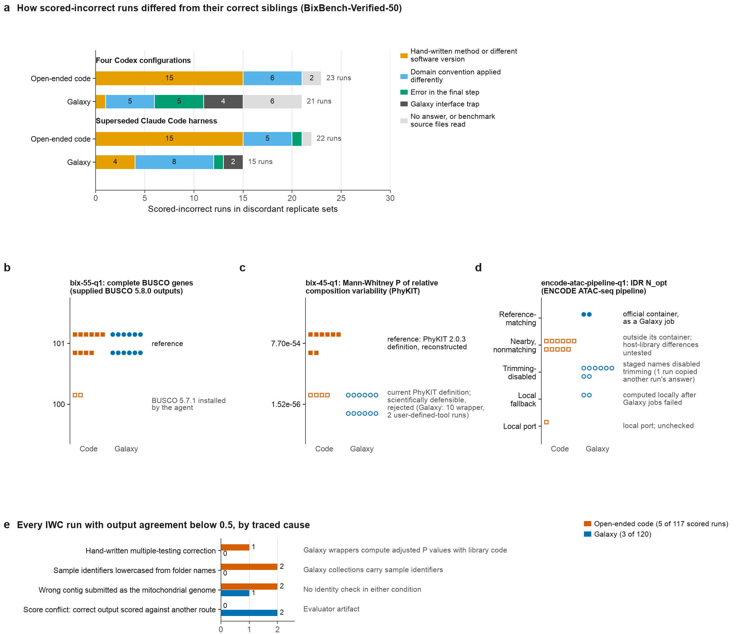

Fig. 5
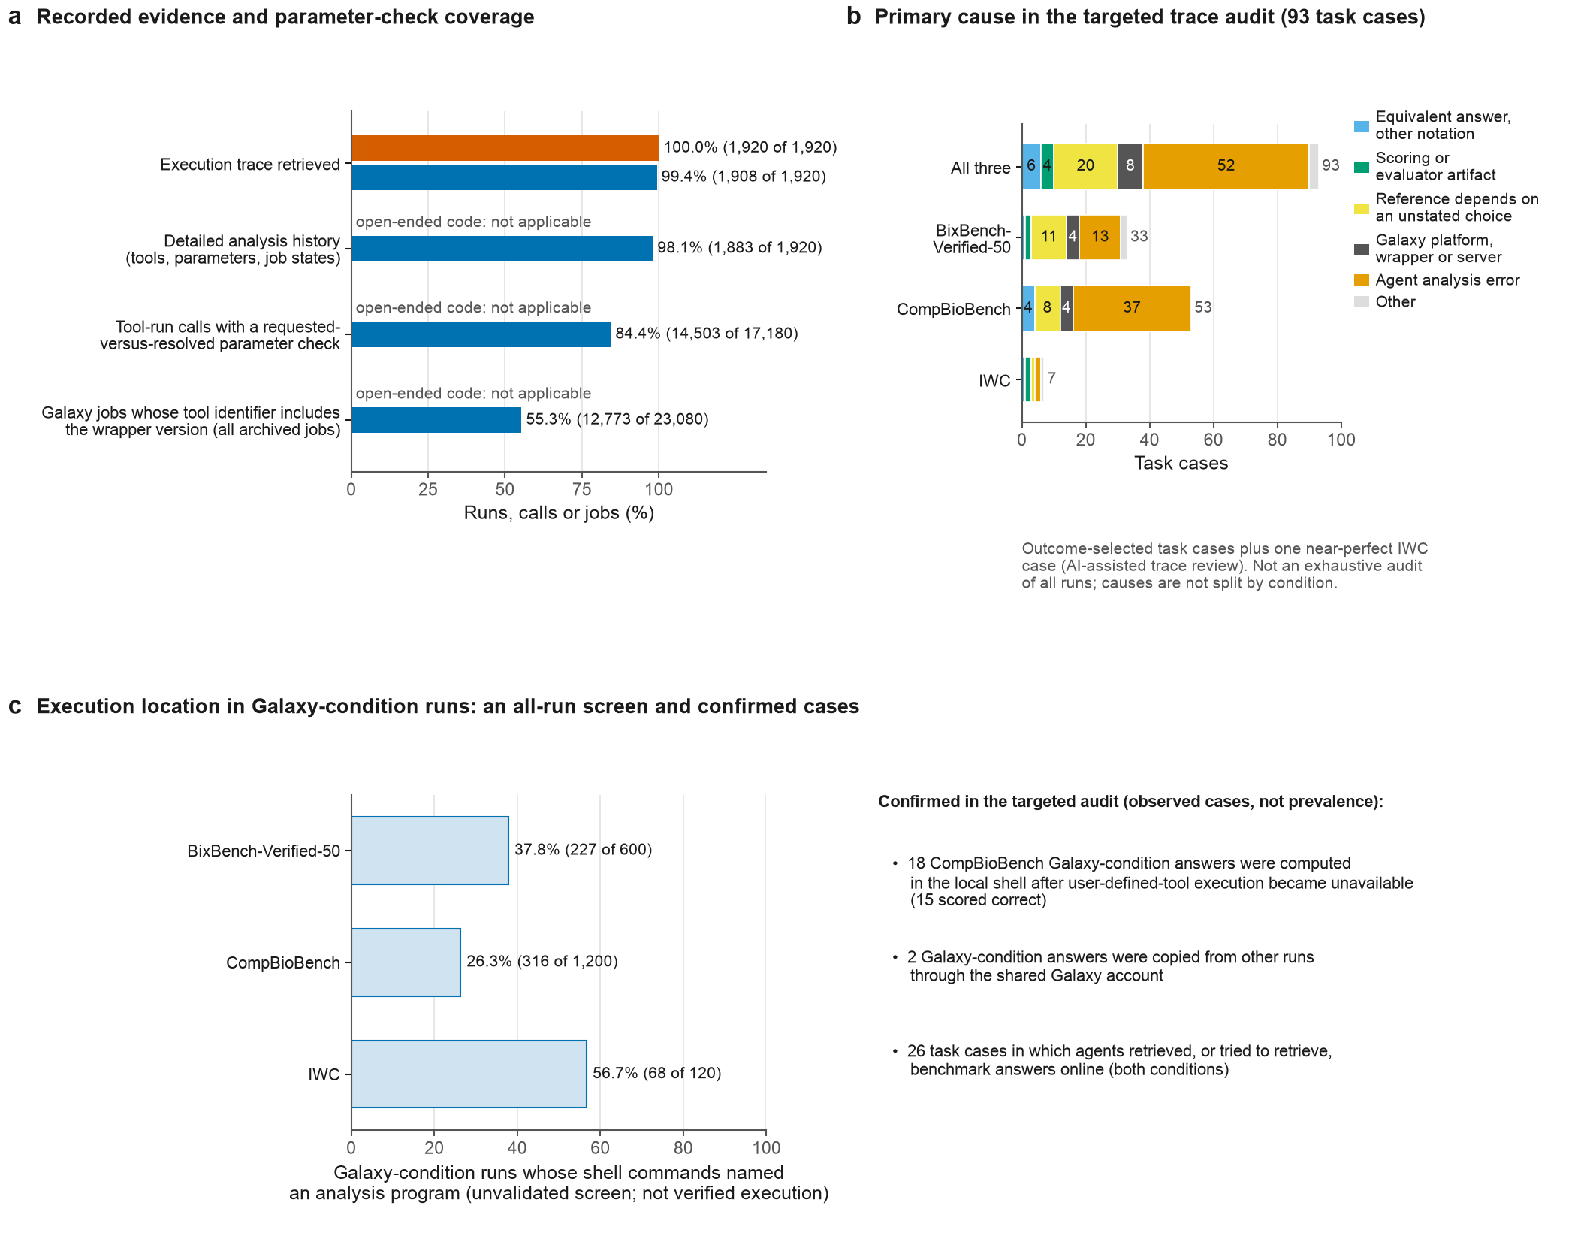

Fig. 6
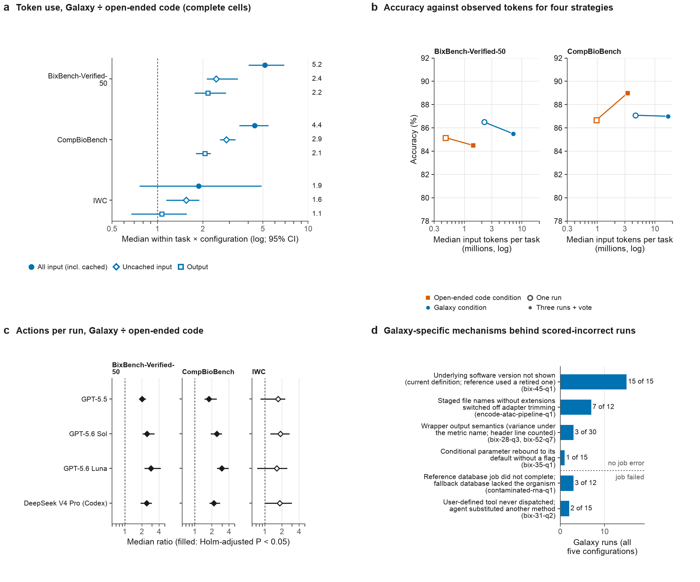

Extended Data Fig. 1
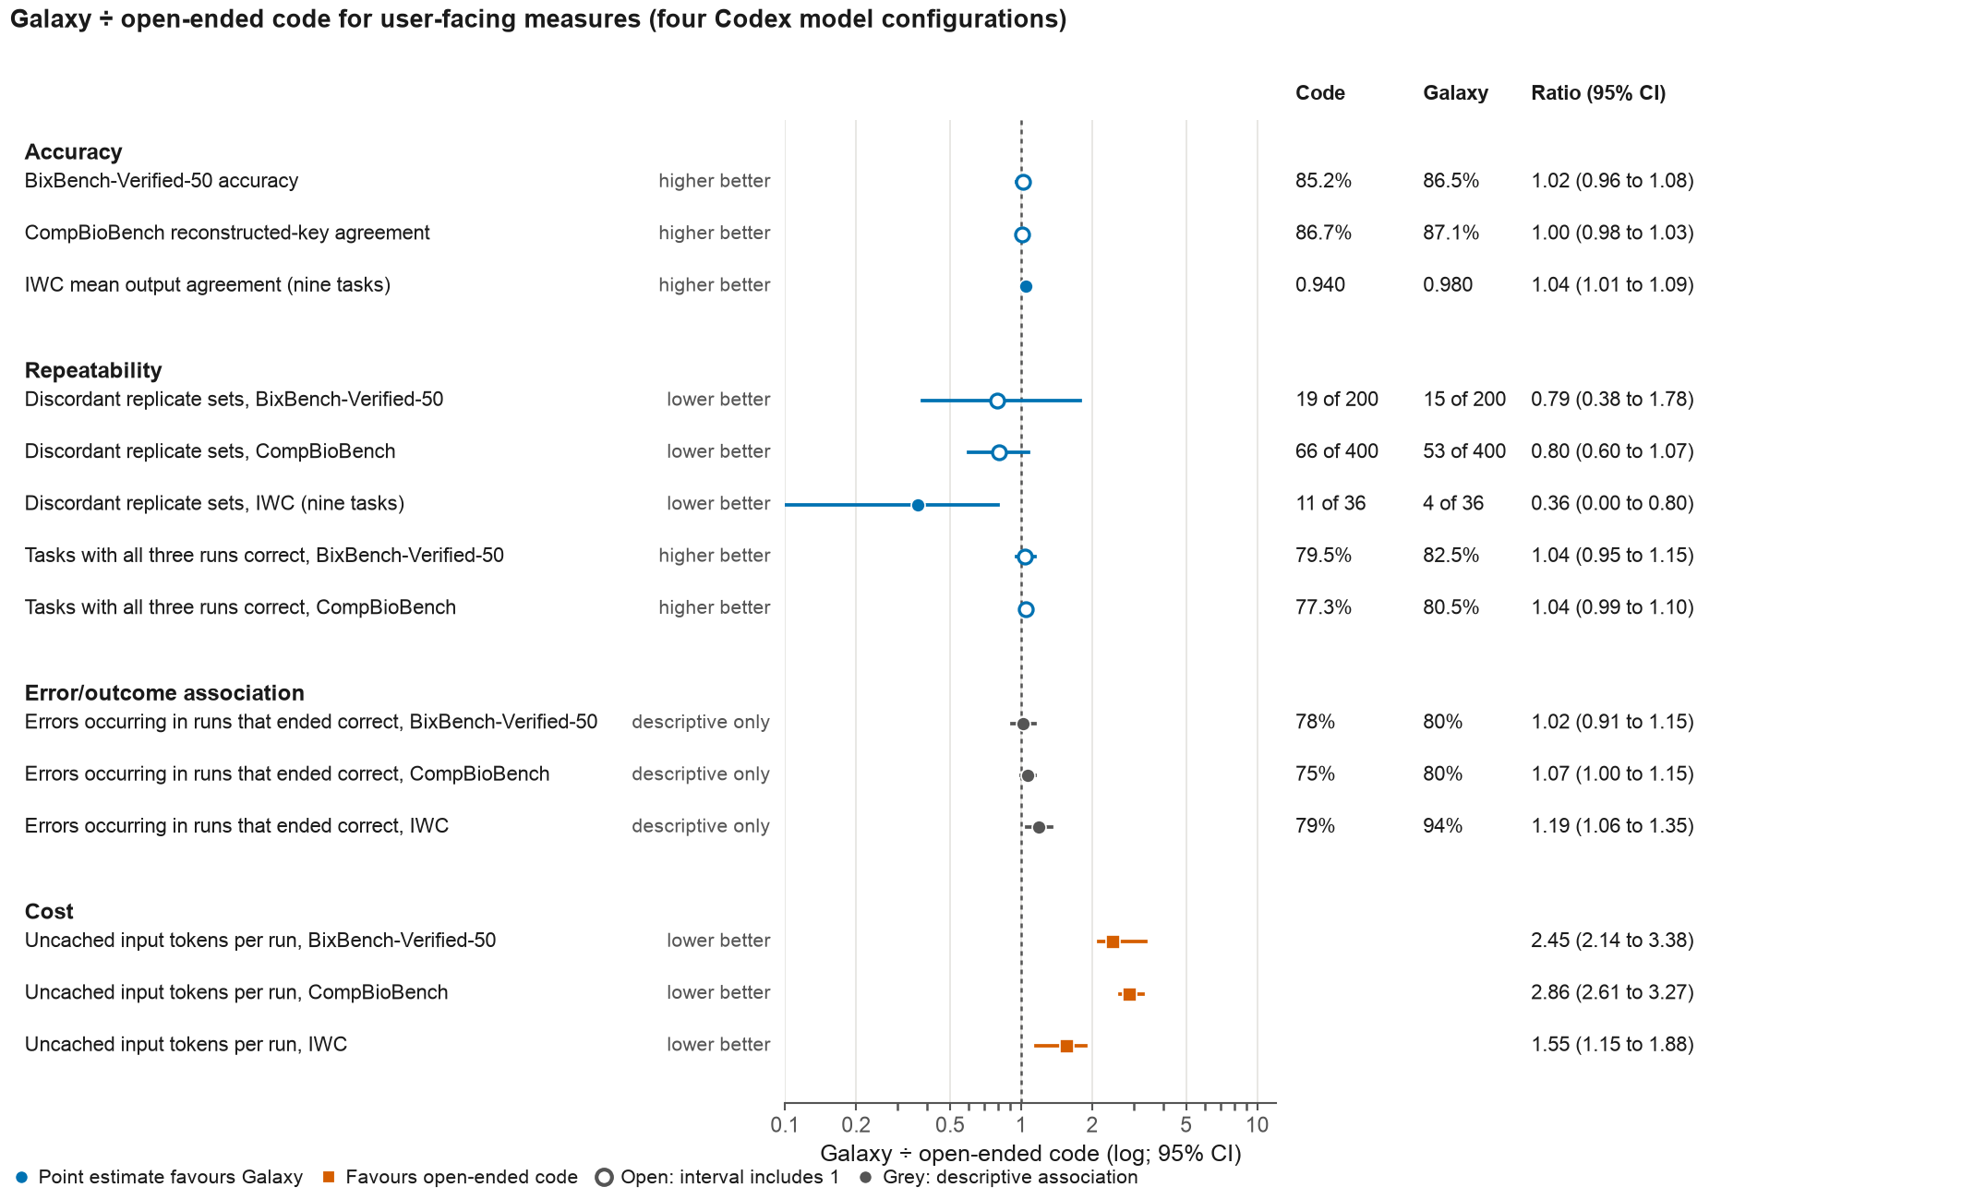

Extended Data Fig. 2
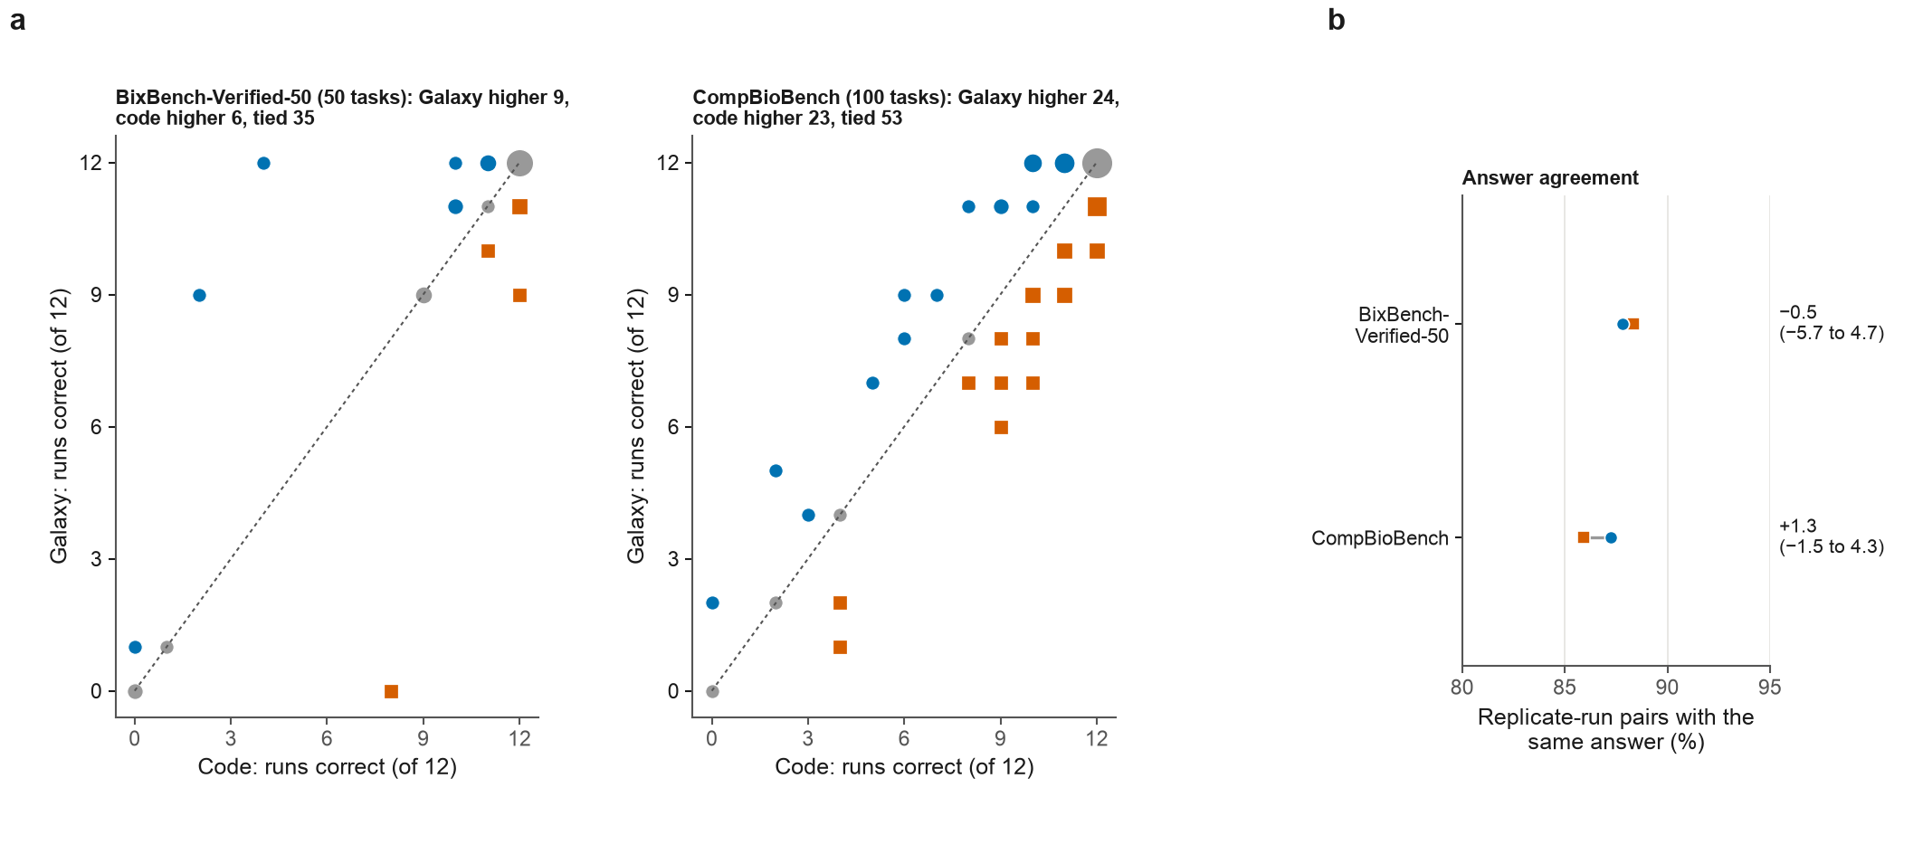

Extended Data Fig. 3
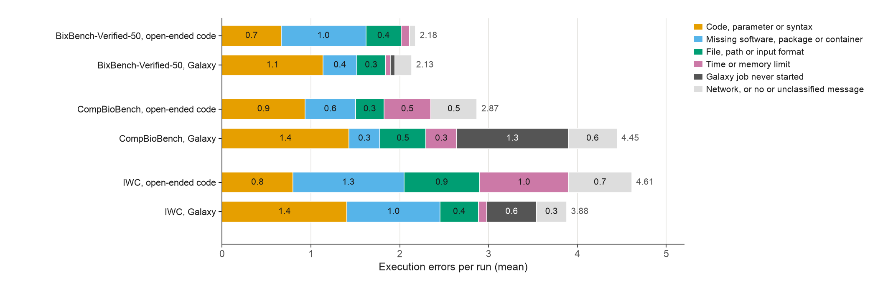

Extended Data Fig. 4
