Supplementary Information

AI agents can perform accurate bioinformatics analyses through a computational workbench
[Authors: author list]

Contents
Supplementary Fig. 1 | Agents show similar observed benchmark performance in Galaxy and custom code.
Supplementary Fig. 2 | Failure causes and sensitivity of the accuracy comparison.
Supplementary Fig. 3 | Independent checks of the audits and of benchmark integrity.
Supplementary Fig. 4 | Accuracy of single runs, a majority of three and at least one correct run of three, by model.
Supplementary Fig. 5 | Galaxy records analyses as structured provenance and uses more input tokens on question-answering tasks.
Supplementary Fig. 6 | Token use by model, outcome and action count.
Supplementary Fig. 7 | Galaxy provides a structured environment for agent analyses.
Supplementary Fig. 8 | Task status, execution errors and final correctness.
Supplementary Fig. 9 | Answer agreement and tool use vary across model configurations.
Supplementary Fig. 10 | Tool inventory, route similarity, answer matching, difficulty and UDT methods.
Supplementary Fig. 11 | Verification, recovery and selected cases.
Supplementary Table 1 | Replicate agreement and consensus estimates.
Supplementary Table 2 | Tokens used in the main runs, by benchmark and model.
Supplementary Table 3 | Design and run selection by benchmark and condition.
Supplementary Table 4 | Accuracy by benchmark, model and condition.
Supplementary Table 5 | Interface rounds on BixBench-Verified-50.
Supplementary Table 6 | Integrity audit of the primary runs.
Supplementary Note 1 | Answer integrity and shared Galaxy accounts
Supplementary Note 2 | CompBioBench answer key, campaigns and reviewed reruns
Supplementary Note 3 | IWC-derived tasks
Supplementary Data 1 | Source data of Supplementary Figs. 1–11 (Excel workbook, one sheet per figure; provided separately).
Supplementary Data 2 | Run index: every run with links to its agent trace, its results-site page and, for Galaxy runs, its Galaxy history, with the result of an access check (Excel workbook; provided separately).

In the Supplementary Figures, IWC denotes the IWC-derived tasks and custom code the condition in which the agent installed software and wrote its own code. A run is correct when accepted (BixBench-Verified-50), when it agrees with the answer key (CompBioBench) or at output agreement ≥ 0.99 (IWC-derived tasks). Supplementary Tables 1–6 are also provided as an Excel workbook.

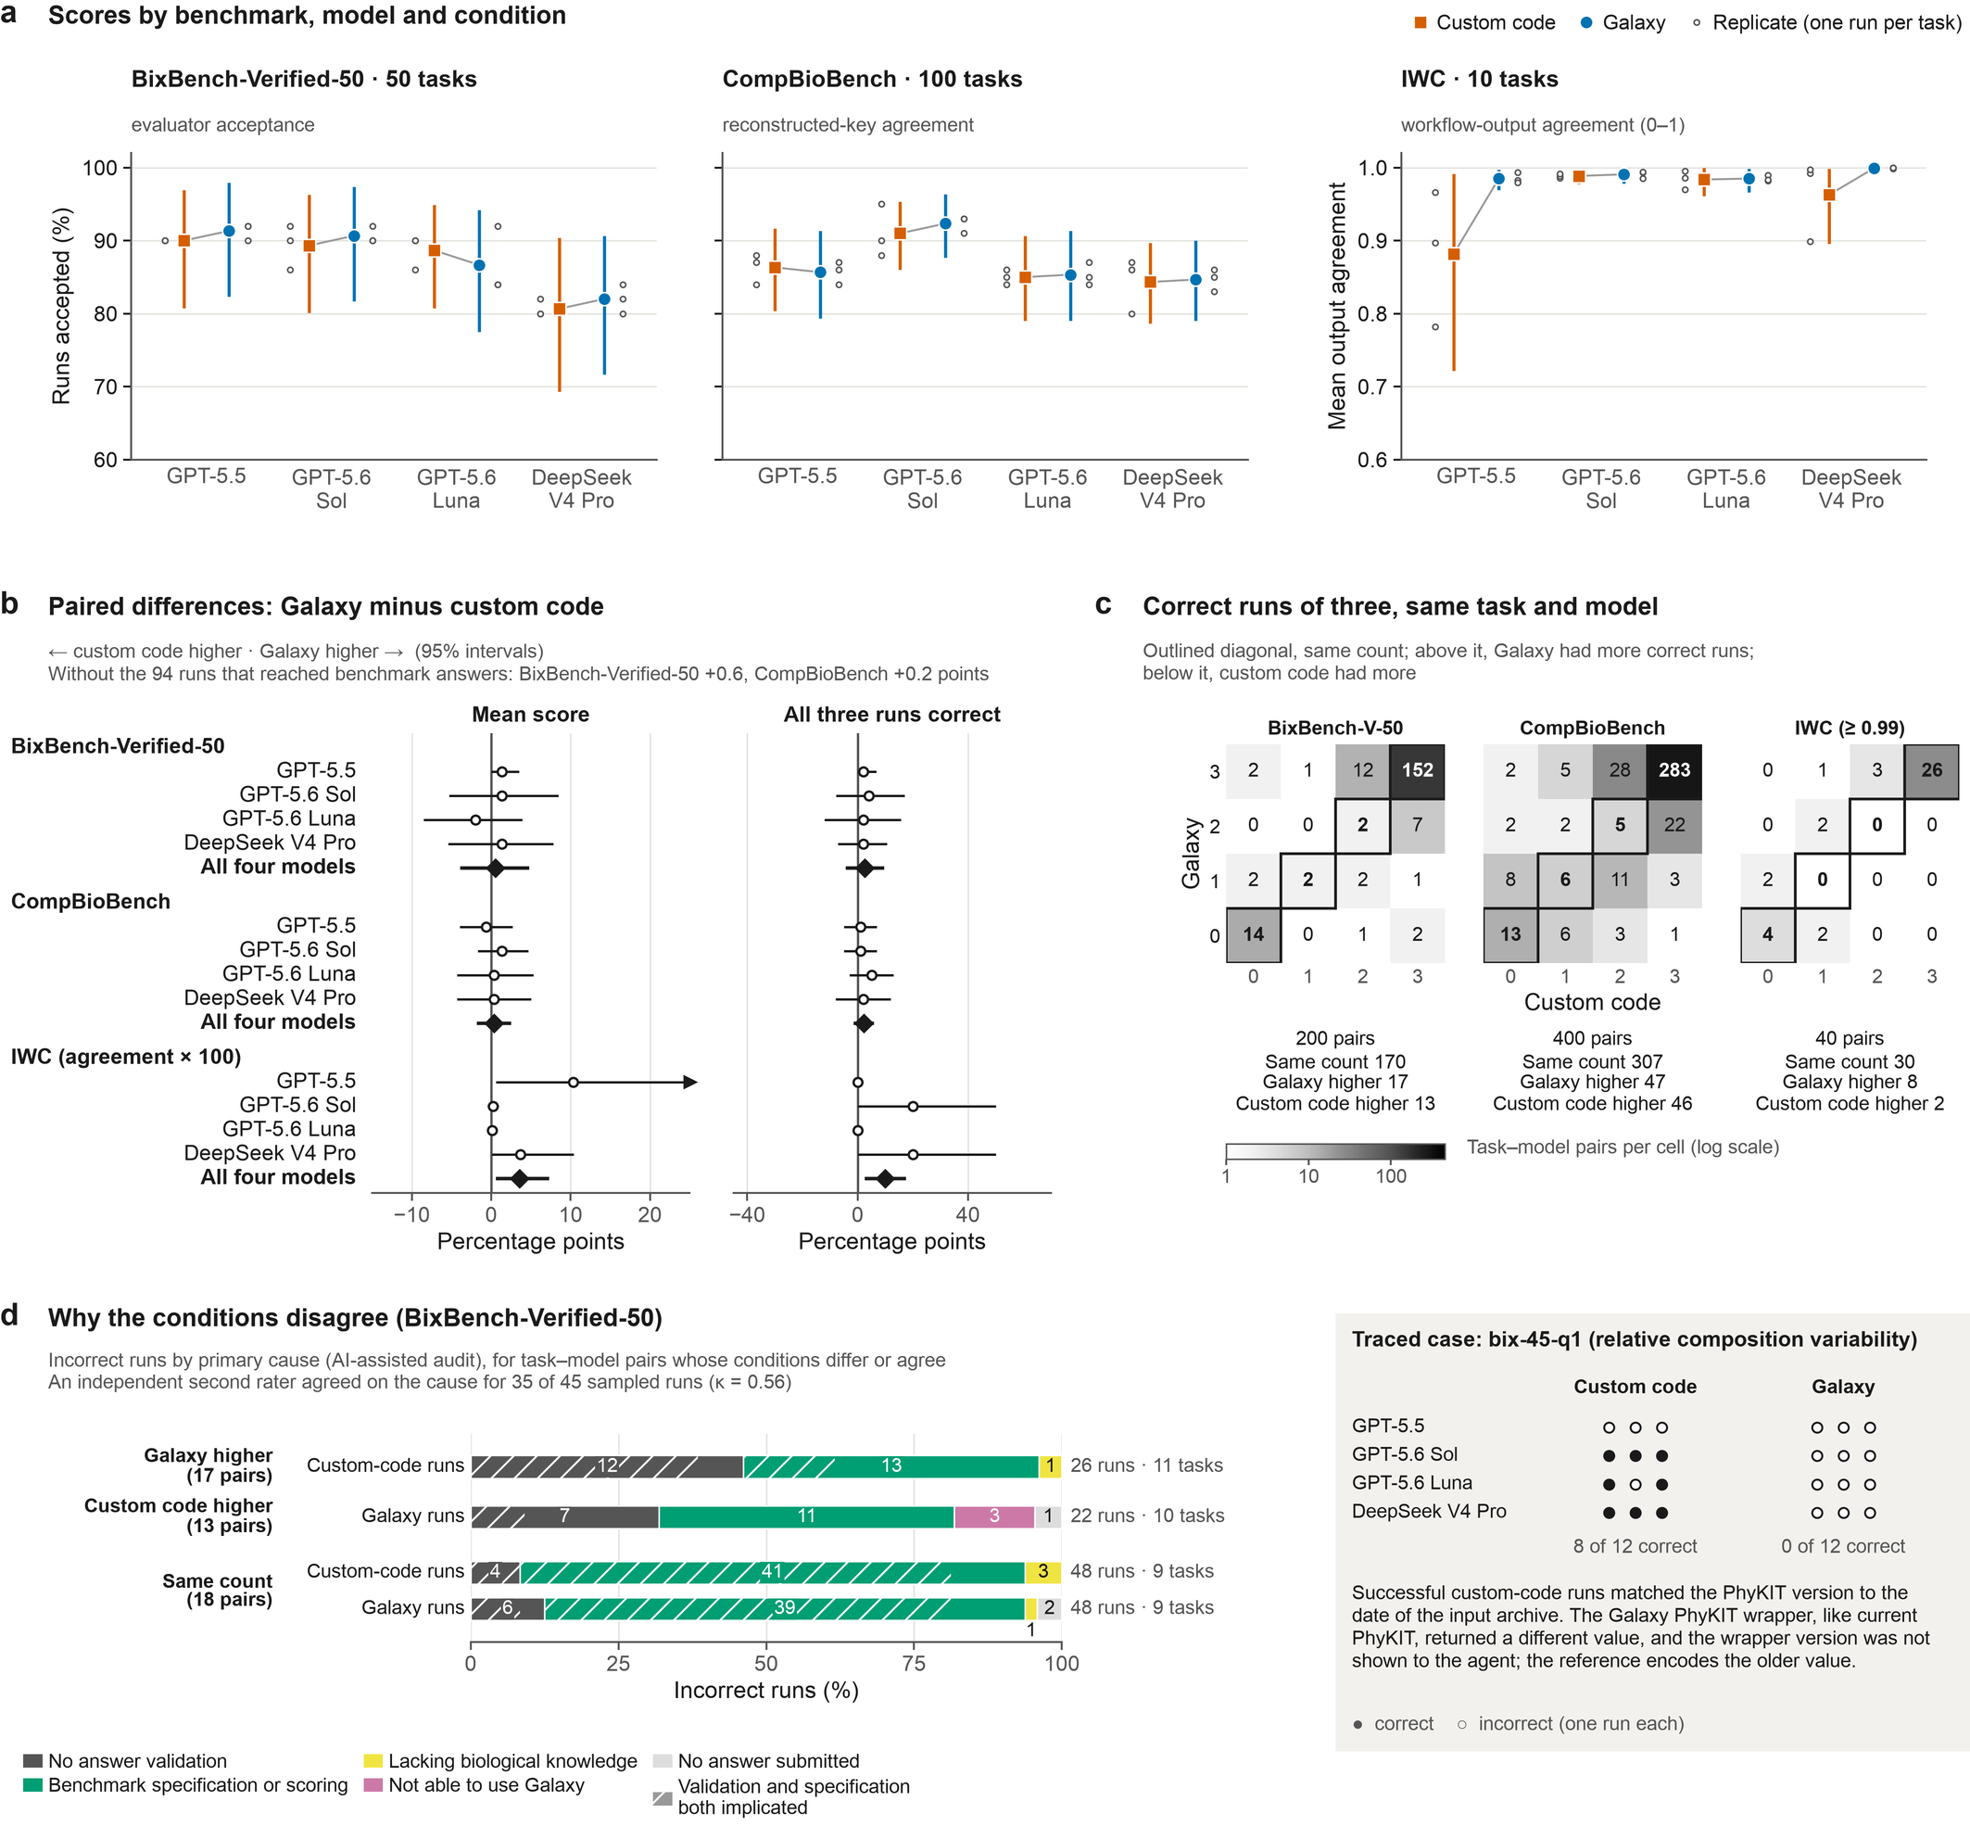
Supplementary Fig. 1 | Agents show similar observed benchmark performance in Galaxy and custom code.
a, Score of each model in the custom-code (squares) and Galaxy (circles) conditions, under each benchmark's scoring contract: acceptance as graded on the results site, that is, by the original evaluator with bix-53-q2 and bix-43-q2 regraded (BixBench-Verified-50; 150 runs per point), agreement with a reconstructed answer key (CompBioBench; 300 runs) and mean agreement with curated workflow outputs on a 0–1 scale (IWC, 10 tasks including host-read removal; 30 runs).
Dots, replicates.
b, Galaxy minus custom code for each model and for the four models pooled (diamonds), for two estimands kept apart: the mean score (IWC agreement × 100) and the share of replicate sets (one task × model × condition, three runs) with all three runs correct (IWC, agreement ≥ 0.99).
No difference was significant after Holm adjustment (smallest adjusted P = 0.19, GPT-5.5 on IWC); this does not establish equivalence, and no equivalence margin was prespecified.
With ten IWC tasks, bootstrap intervals are too narrow: the pooled IWC agreement difference, +3.6 points (0.6 to 7.3), has an exact P of 0.055.
c, Correct runs of three for each task–model pair in custom code (columns) and Galaxy (rows), per benchmark; outlined cells have equal counts.
Equal counts mean equal replicate success, not identical answers or methods.
d, Primary cause of incorrect BixBench-Verified-50 runs, from an AI-assisted run-level audit. The runs are grouped by pair type: pairs in which Galaxy had more correct runs (the custom-code runs that failed), pairs in which custom code had more (the Galaxy runs that failed), and pairs with the same count.
Four bix-43-q2 runs graded incorrect only by the site's regrade take the task-level audit's cause (benchmark specification or scoring).
Hatching marks runs for which the audit named answer validation and the benchmark specification as primary and secondary causes.
The seven incorrect runs of the better condition in discordant pairs are in Supplementary Data 1.
Right, a traced discordant case.
A run is correct when accepted or, for IWC, at ≥ 0.99 agreement.
Intervals are 95% percentile cluster-bootstrap intervals (20,000 resamples; clusters are BixBench source capsules, otherwise tasks). P values come from paired cluster sign-flip tests (200,000 draws; exact for IWC).
Supplementary Figs. 2 and 3: cause census, sensitivity analyses (including answer exposure) and a second audit.

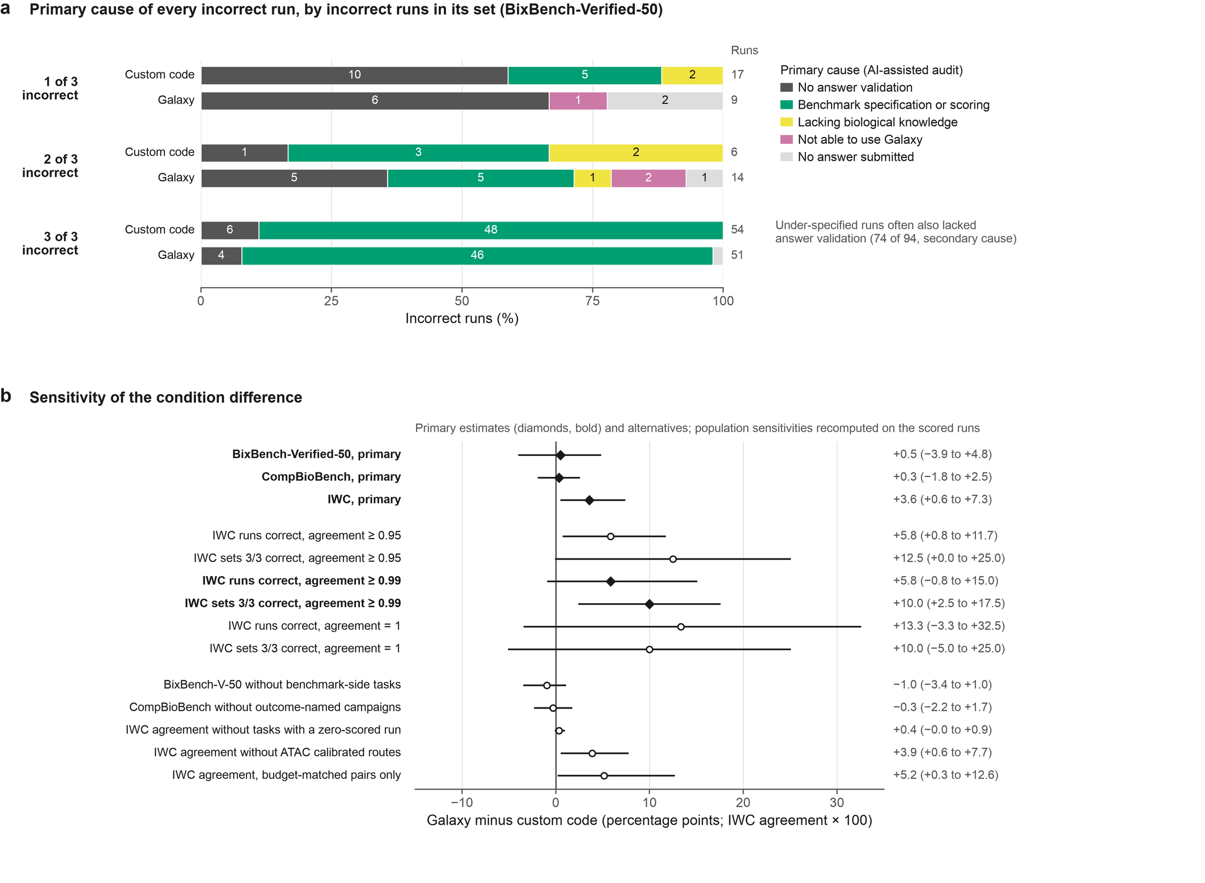
Supplementary Fig. 2 | Failure causes and sensitivity of the accuracy comparison.
a, Primary cause of each of the 151 incorrect BixBench-Verified-50 runs, graded as on the results site, by how many runs of its replicate set were incorrect (the census shown in the first version of Supplementary Fig. 1d).
Causes come from an AI-assisted run-level audit; under-specified runs often also lacked answer validation (secondary cause). Four bix-43-q2 runs graded incorrect only by the site's regrade take the task-level audit's cause (benchmark specification or scoring).
b, Galaxy minus custom code under alternative definitions.
Primary estimates (diamonds) are the mean score of each benchmark; IWC agreement is × 100.
IWC runs and replicate sets (10 tasks, including host-read removal) are also shown as correct at three agreement thresholds (≥ 0.95, ≥ 0.99, the threshold used elsewhere, and = 1).
The last five rows are the archive's population sensitivities, recomputed on these scores with the primary estimator (the archive's accuracy_sensitivities.csv in the run archive used its own grades and nine IWC tasks):
– BixBench-Verified-50 without the tasks whose failures the audit attributes to the benchmark;
– CompBioBench without runs from campaigns whose names reference target scores or wrong answers;
– IWC without tasks that had a zero-scored run;
– IWC without the agent-calibrated ATAC routes;
– IWC restricted to replicate pairs with matching time budgets.
Intervals are 95% percentile cluster-bootstrap intervals (clusters are BixBench source capsules, otherwise tasks). With ten or fewer IWC clusters these intervals are too narrow, so the sign-flip P values in Supplementary Data 1 (exact for IWC) should be preferred.

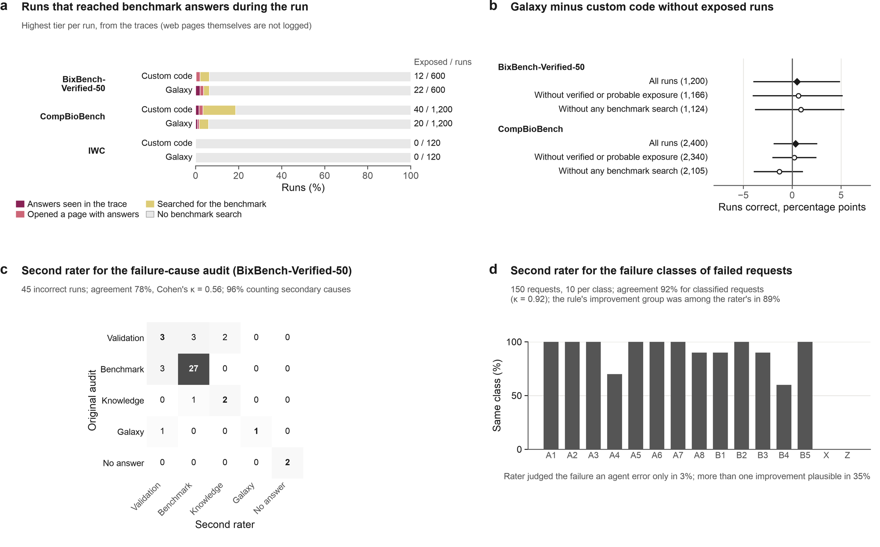
Supplementary Fig. 3 | Independent checks of the audits and of benchmark integrity.
a, Runs that reached a source of benchmark answers during the run, from their traces, by highest tier:
– answers seen: a command or connector output contained the task's reference answer, or other agents' recorded answers;
– page with answers: the run opened the public BixBench dataset or a published archive of other agents' traces (the page content is not logged);
– search: the run searched the web for the benchmark or the task;
– none.
Numbers are runs with answers seen or a page with answers, over all scored runs.
Most exposure came from DeepSeek V4 Pro and GPT-5.6 Luna runs, in both conditions.
b, Galaxy minus custom code in runs correct with all runs, without runs in the two exposure tiers, and without any run that searched for the benchmark, with 95% cluster-bootstrap intervals.
c, Primary cause of 45 BixBench-Verified-50 runs graded incorrect at the time of the audit (stratified by the original cause and condition) from the original audit and from an independent second rater. The second rater, an AI coder blind to the audit, saw the run's transcript, submitted answer and reference answer.
Causes are grouped as in Supplementary Fig. 1d.
Seven of the 45 runs (six on bix-53-q2, one on bix-43-q2) are graded correct after the regrades of those tasks; both raters attributed all seven to the benchmark.
d, The same check for the failure classes of 150 failed Galaxy requests (10 per class). The coder assigned a class and the changes that would plausibly have prevented the failure, without seeing the rule-based class.
The share of requests whose rule-linked improvement group was among the coder's choices is computed over the 120 requests in classes that have a group (B3, X and Z have none).
X (other exceptions) and Z (unclassified) have no rule definition to reproduce.
Both checks are AI-assisted second ratings, not human validation; codebooks and coded data are in figures/annotations/ of the run archive.

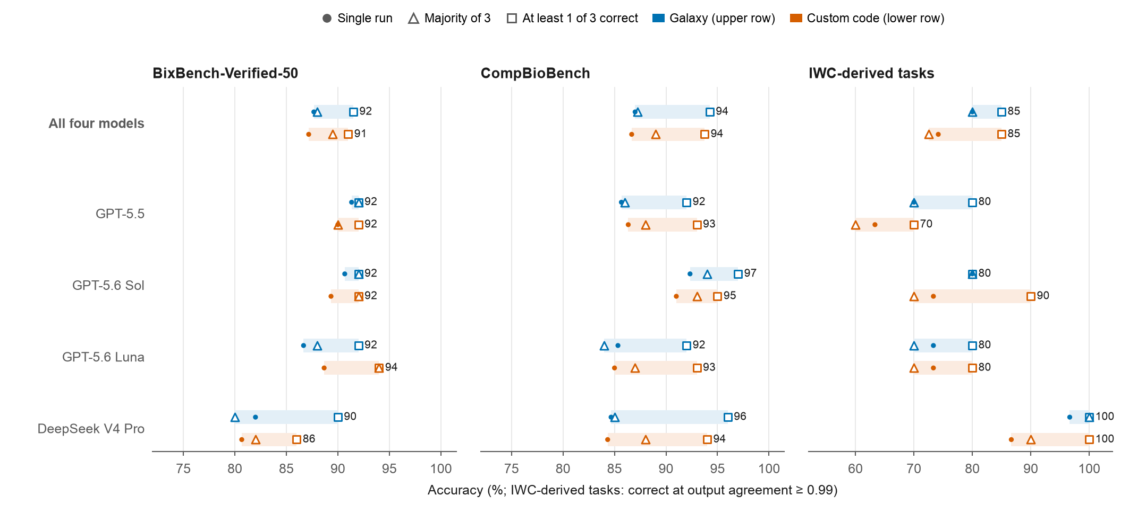
Supplementary Fig. 4 | Accuracy of single runs, a majority of three and at least one correct run of three, by model.
A replicate group is the three replicates of one task, model and condition. For each benchmark, model and condition: single run (filled circles), the share of runs correct; majority of 3 (triangles), the share of groups with at least two correct runs, which assumes that correct answers agree; at least 1 of 3 correct (squares, value printed), the share of groups with a correct run, the accuracy that a validation step that always selected a correct replicate would reach. Shading spans the three values. For each model, Galaxy (blue, upper row) and custom code (lower row); "All four models" pools the models.
A run is correct when accepted (BixBench-Verified-50), when it agrees with the answer key (CompBioBench) or at output agreement ≥ 0.99 (IWC-derived tasks). n = 50, 100 and 10 replicate groups per model and condition on BixBench-Verified-50, CompBioBench and the IWC-derived tasks. None of these strategies was run; the values are computed from the existing runs (Supplementary Table 1). Source data are in Supplementary Data 1.

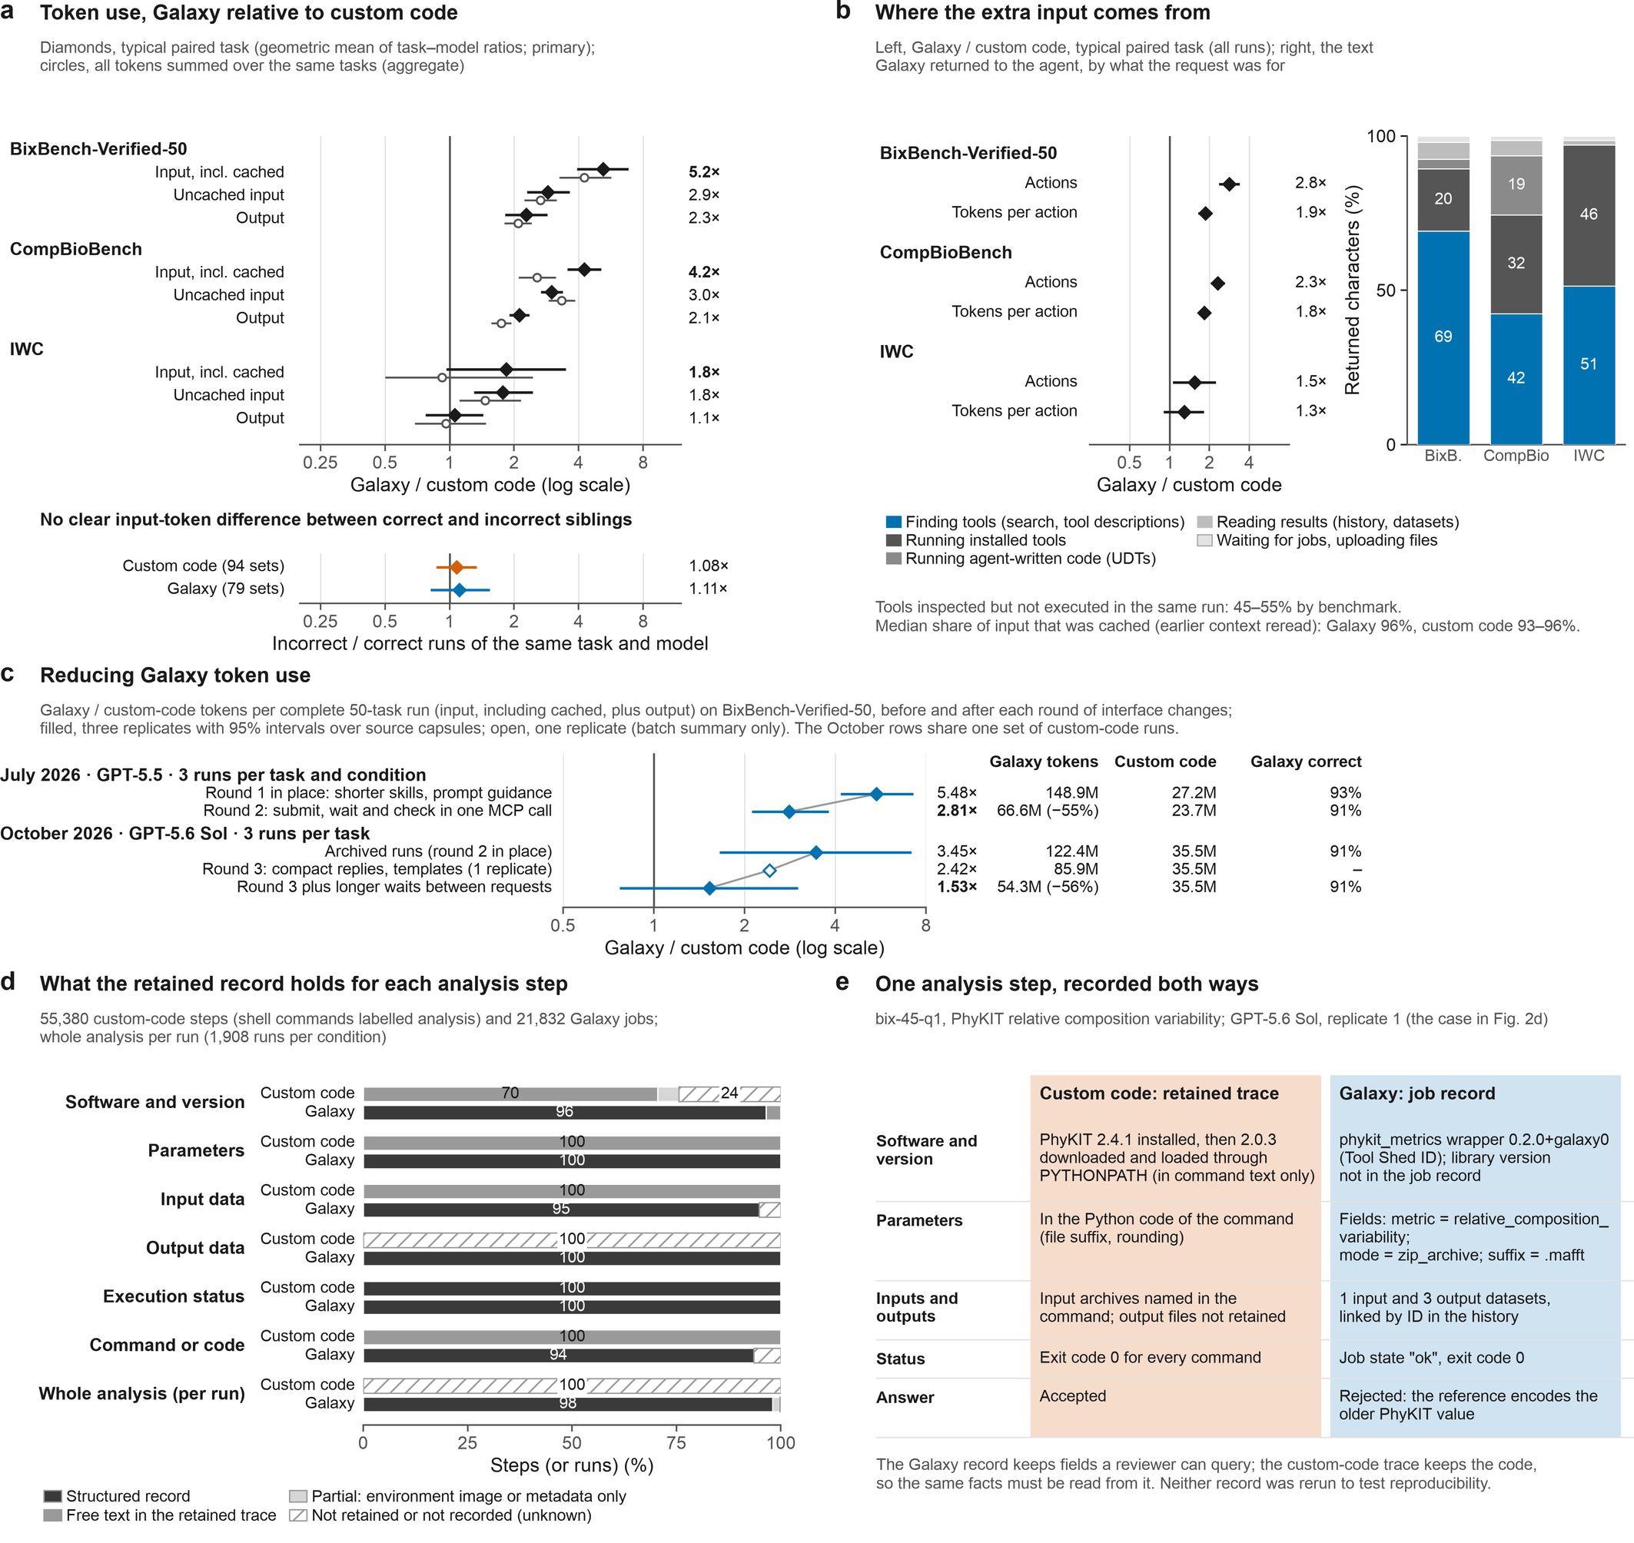
Supplementary Fig. 5 | Galaxy records analyses as structured provenance and uses more input tokens on question-answering tasks.
a, Galaxy relative to custom code in input (including cached context), uncached input and output tokens, per benchmark.
Diamonds (primary), the geometric mean over task–model cells of the ratio of median tokens per run; circles, the ratio of total tokens over the same cells.
On IWC, Galaxy did not use clearly more input (1.8×, 95% interval 0.97–3.5; aggregate 0.92×).
Below, incorrect relative to correct runs of the same task and model.
Ratios are not monetary costs.
b, Left, Galaxy relative to custom code in actions (tool calls) and input tokens per action.
Right, characters Galaxy returned to the agent, by request type (1,896 traced runs); a reply enters the context once, then is reread from cache.
c, Galaxy / custom-code tokens per complete 50-task BixBench-Verified-50 run, before and after rounds of interface changes, in two separate comparisons.
July (GPT-5.5; round 1, shorter skills and prompt guidance, in place): round 2 moved submission, waiting and parameter checks into one call that returns compact results; both conditions were rerun.
October (GPT-5.6 Sol; archived custom-code runs): round 3 shortened and deduplicated replies and added submission templates, then longer waits between model requests.
Batch comparisons, not effects of single changes; the agent CLI version also changed.
d, What the retained record holds for each analysis step (Galaxy jobs; custom-code shell commands labelled as analysis): structured, a field in the Galaxy job record (for UDTs, a versioned container) or, for exit codes, the agent trace; free text, commands or printed output in the trace; partial, an environment image or history metadata only; not retained, evidence the benchmark did not keep, such as custom-code output files (unknown, not absent).
The whole-analysis row counts runs with a retrieved Galaxy history; nothing was rerun.
e, One analysis step recorded in both conditions.
A run is correct when accepted on the results site or, for IWC, at ≥ 0.99 output agreement.
Intervals, 95% percentile cluster-bootstrap (clusters are BixBench source capsules, otherwise tasks). P values (Supplementary Data 1) come from paired cluster sign-flip tests (200,000 draws; exact for IWC).

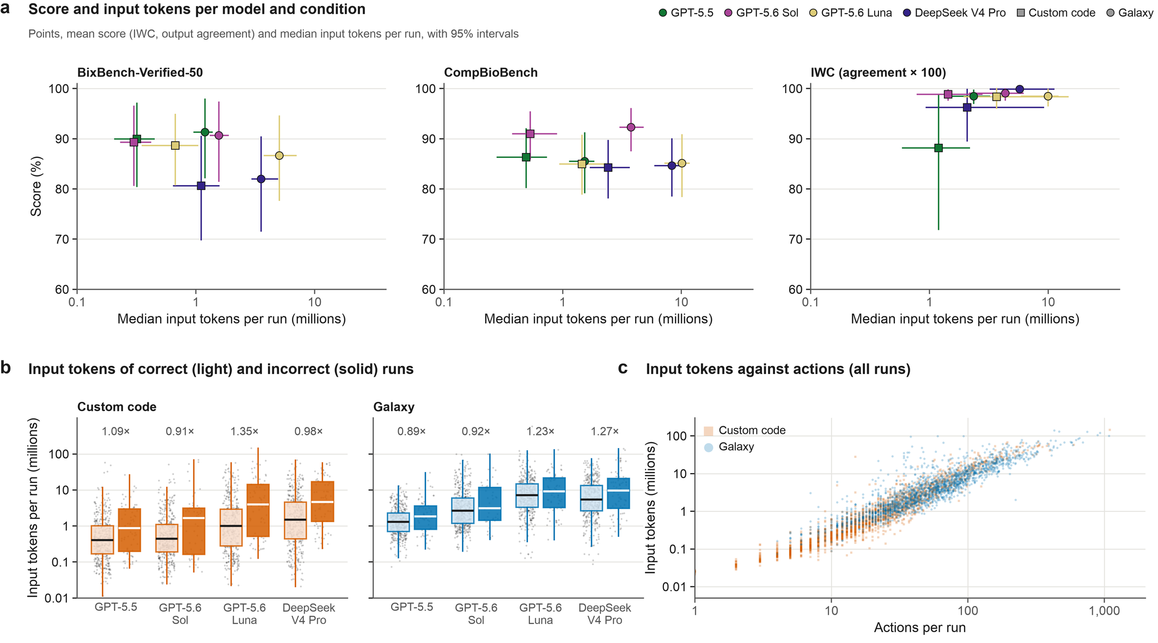
Supplementary Fig. 6 | Token use by model, outcome and action count.
a, Mean score against median input tokens per run, including cached context, for each model and condition (squares, custom code; circles, Galaxy), by benchmark; IWC shows mean output agreement × 100.
Error bars, 95% cluster-bootstrap intervals (2,000 resamples) for both quantities.
b, Input tokens of correct (light) and incorrect (solid) runs by model and condition.
Boxes show the middle 50% and the median, whiskers extend to 1.5 times the interquartile range, and dots are runs.
Numbers give the incorrect / correct ratio within replicate sets that have both outcomes (Supplementary Fig. 5a pools the models).
c, Input tokens against actions for every run with a token count.
Cumulative input grows with the number of actions because each later call carries the retained context, so this association is not a decomposition of cost.

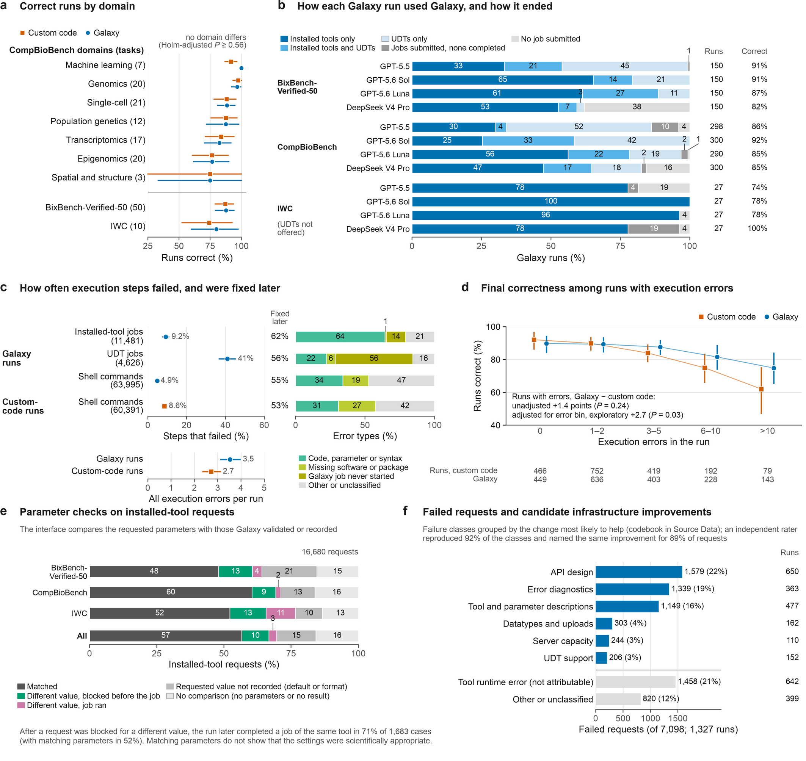
Supplementary Fig. 7 | Galaxy provides a structured environment for agent analyses.
a, Runs correct (accepted, not merely completed) by domain (squares, custom code; circles, Galaxy): CompBioBench domains (spatial and structure merged), BixBench-Verified-50 and IWC; tasks in parentheses.
No domain differs after Holm adjustment.
b, How each traced Galaxy run used Galaxy, from the jobs it submitted through the agent interface: completed jobs of installed tools, of user-defined tools (UDTs; agent-written code run as a Galaxy job) or of both; jobs that all failed; or no job.
Right, traced runs and the share of scored runs correct.
Route–correctness associations are descriptive; twelve CompBioBench runs have no trace.
c, Share of execution steps that failed: Galaxy jobs of installed tools and of UDTs, and shell commands (a silent exit code 1 is not counted) in each condition, with the number of steps in parentheses.
Fixed later, failed steps later re-run without error in the same run (for shell commands, named analysis programs only; Supplementary Fig. 11b).
Below, errors per run; right, error types (all seven in Supplementary Fig. 8b).
d, Runs correct by the number of execution errors in the run (failed shell commands plus Galaxy jobs in the error state; 3,767 runs with records).
Final correctness is not recovery from each failure, and error counts are outcomes of the run.
The unadjusted difference among runs with errors is the primary estimate; the error-bin adjustment was chosen after inspecting the bins and is exploratory.
e, Parameter checks on 16,680 installed-tool requests, comparing the requested parameters with those Galaxy validated before the job or recorded after it.
A value not recorded has no counterpart in Galaxy's record, as with defaults or reformatting.
f, Failed Galaxy requests (four model configurations) by failure class, grouped by the change most likely to prevent them (codebook in Supplementary Data 1, checked by an independent AI rater; Supplementary Fig. 3d). Right, runs with at least one such failure; grey groups cannot be attributed.
Intervals, 95% percentile cluster-bootstrap (20,000 resamples; clusters are BixBench source capsules, otherwise tasks). P values come from paired cluster randomization tests (200,000 draws).

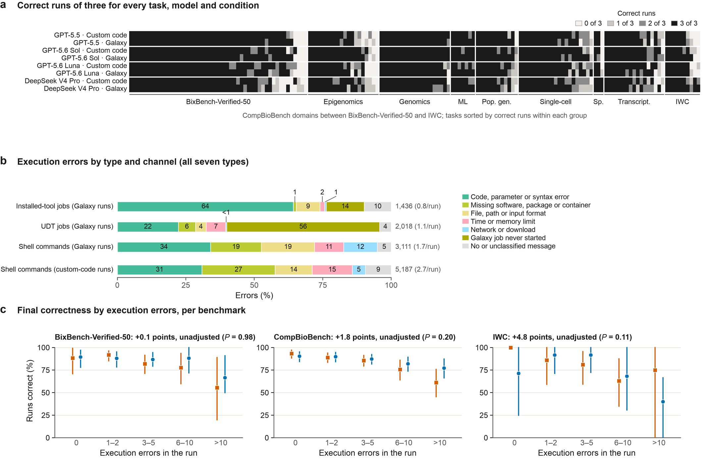
Supplementary Fig. 8 | Task status, execution errors and final correctness.
a, Correct runs of three for every scored task (columns) and every model configuration in each condition (rows).
Groups, in order: BixBench-Verified-50, then the CompBioBench domains, then IWC.
Within each group, tasks are sorted by correct runs.
b, Execution errors by all seven types and by channel (Supplementary Fig. 7c groups them into four).
Right, errors and errors per run (1,859 Galaxy and 1,908 custom-code runs with records).
c, Runs correct by the number of execution errors in the run, for each benchmark (squares, custom code; circles, Galaxy). Titles give the unadjusted Galaxy minus custom-code difference among runs with errors and its paired cluster randomization P value (200,000 draws).
Intervals are 95% percentile cluster-bootstrap intervals; bins with fewer than five runs are omitted.

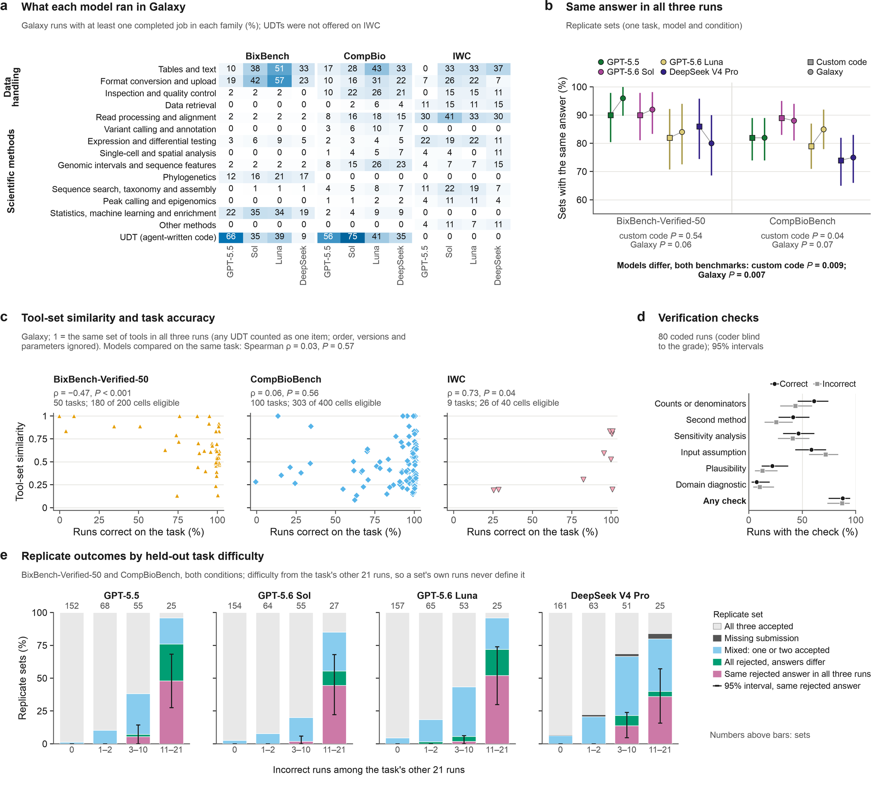
Supplementary Fig. 9 | Answer agreement and tool use vary across model configurations.
a, Share of each model's traced Galaxy runs with at least one completed job in each method family, by benchmark.
Families group 397 installed tools (codebook in Supplementary Data 1). User-defined tools (UDTs; agent-written code run as Galaxy jobs) form one row; their methods are in Supplementary Fig. 10e.
b, Share of replicate sets whose three submitted answers agreed (a replicate set is three runs of one task by one model in one condition; squares, custom code; circles, Galaxy; 50 or 100 sets per point).
Numbers agree within the benchmark verifier's tolerance (otherwise 0.1%), lists are compared as sets, and case and spacing are ignored.
A missing submission does not agree; agreement is not correctness.
The primary tests (bold) pool both benchmarks within each condition and permute model labels within tasks (20,000 permutations; Holm over two); the per-benchmark tests are secondary (Holm over four).
c, Tool-set similarity of each task against the share of its 24 runs that were correct.
Similarity is the mean pairwise Jaccard index of the three replicate runs' sets of installed tools, plus one item for any UDT, over task–model cells in which all three Galaxy runs completed a job.
It ignores order, versions and parameters (sensitivity analyses in Supplementary Fig. 10b); correlations are descriptive.
d, Verification checks in 80 runs (sampled at 10 per benchmark × condition × outcome; 41 correct and 39 incorrect under the current grades) coded by AI coders blind to the grade; 95% Wilson intervals (by condition, Supplementary Fig. 11a).
e, Outcome of every BixBench-Verified-50 and CompBioBench replicate set (both conditions) by held-out difficulty, the number of incorrect runs among the task's other 21 runs.
Error bars, 95% intervals for the share with the same rejected answer in all three runs.
A repeated rejection can reflect an agent's error, an ambiguous reference or the scorer, so on its own it does not measure rigor.
A run is correct when accepted or, for IWC, at ≥ 0.99 output agreement.
Other intervals, 95% percentile cluster-bootstrap (20,000 resamples; clusters are BixBench source capsules, otherwise tasks); Spearman P values from permutation tests.

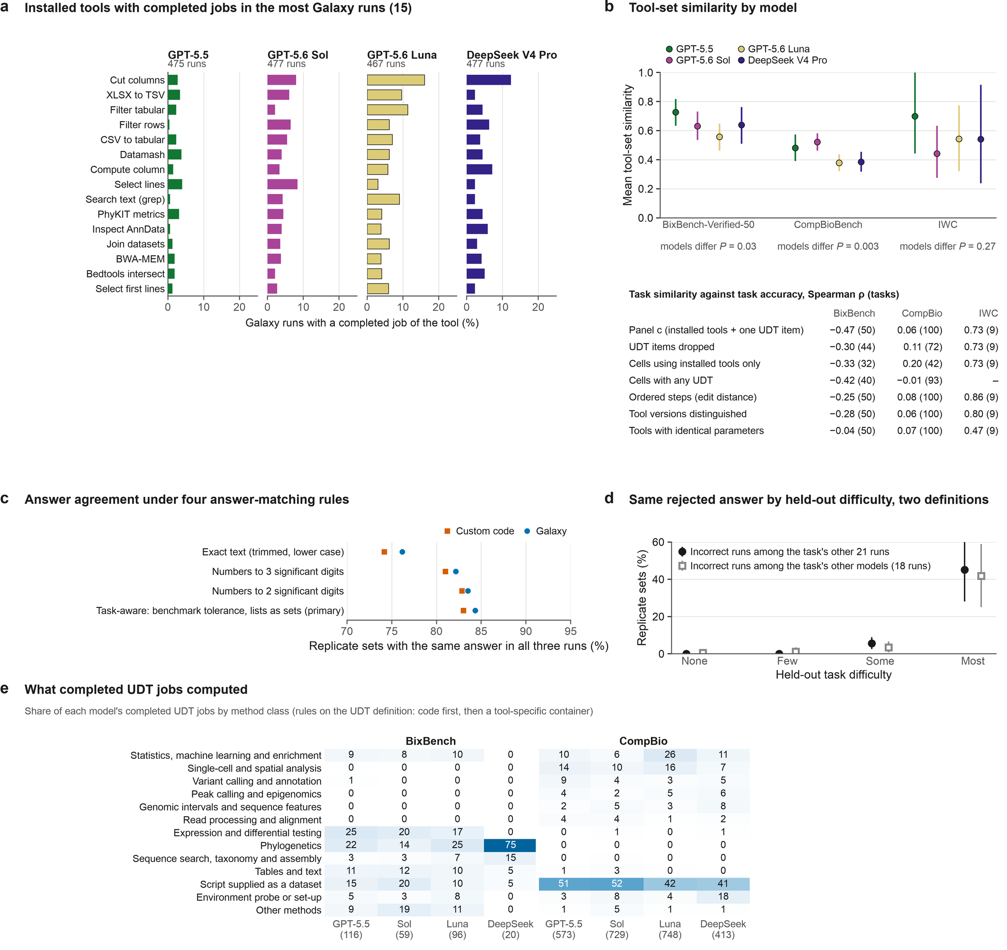
Supplementary Fig. 10 | Tool inventory, route similarity, answer matching, difficulty and UDT methods.
a, The 15 installed Galaxy tools with completed jobs in the most Galaxy runs, with each model's share of its traced Galaxy runs.
b, Mean tool-set similarity by model and benchmark, with P values for a model effect (model labels permuted within tasks, 20,000 permutations).
The table gives the Supplementary Fig. 9c correlation under alternative route definitions:
– UDT items dropped;
– cells whose runs used only installed tools, or any UDT;
– ordered steps, as one minus the normalised edit distance between job sequences;
– tools distinguished by version;
– tools with identical non-dataset parameters.
Correlations that account for order or versions stay negative on BixBench-Verified-50; once parameters are included, the BixBench-Verified-50 correlation is close to zero.
c, Share of replicate sets with the same answer in all three runs under four answer-matching rules (600 sets per condition).
Rounding to three significant digits merged distinct numeric answers in three sets; the primary task-aware rule does not.
d, Share of replicate sets with the same rejected answer in all three runs, by held-out difficulty computed in two ways: from the task's other 21 runs (as in Supplementary Fig. 9e) and from the other three models' 18 runs.
e, Method classes of completed UDT jobs (figures in parentheses are jobs per column).
Classes come from deterministic rules applied to the UDT definition (figures/udt_methods.csv in the run archive). The rules use the code where the definition contains it, otherwise a container named after a specific tool.
Many CompBioBench UDTs ran a script supplied as a separate dataset. Their method is kept in the Galaxy history but not in the request, so they are not classified.
Intervals are 95% percentile cluster-bootstrap intervals.

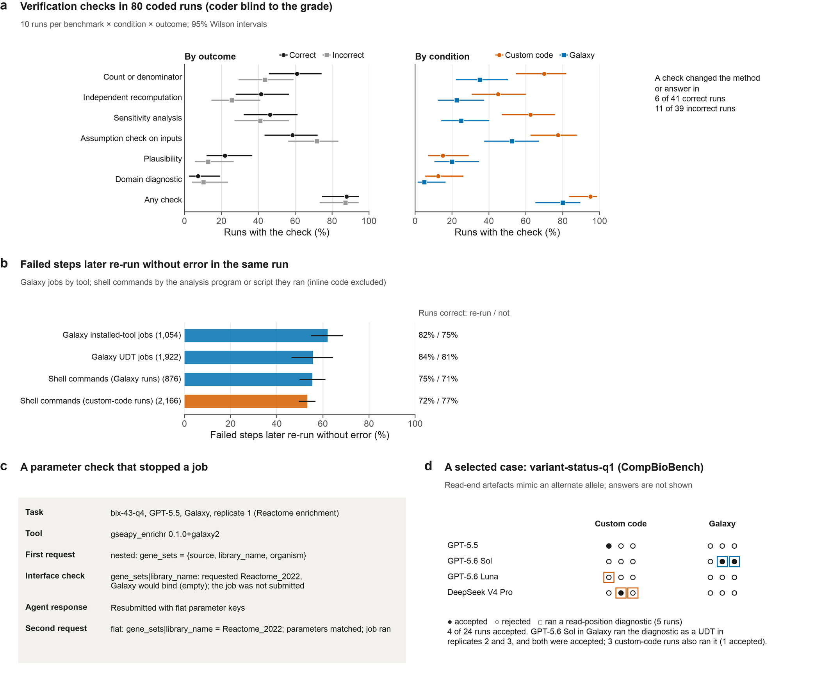
Supplementary Fig. 11 | Verification, recovery and selected cases.
a, Verification checks in 80 runs sampled at 10 per benchmark (BixBench-Verified-50, CompBioBench) × condition × outcome, coded by AI coders blind to the grade (the condition is visible in a transcript).
Outcome is the current grade: one run sampled as incorrect (bix-53-q2) is correct after that task's regrade, so the groups hold 41 correct and 39 incorrect runs.
A check counts when the agent explicitly tested something its answer depended on: counts or denominators; recomputation by a second method; sensitivity to a parameter or definition; an input assumption; plausibility; or a domain diagnostic.
Right, runs in which a check changed the method or the answer.
Intervals, 95% Wilson intervals.
b, Failed steps later re-run without error in the same run.
A Galaxy job in the error state counts as resolved when a later job of the same tool (or a later UDT job) completed. A failed shell command counts as resolved when a later command of the same analysis program or script exited 0; inline code, file inspection and downloads are excluded.
Right, the share of runs that ended correct, for resolved and unresolved failures.
Resolution means the step later ran without error, not that the error was understood or the result was right.
Intervals are 95% cluster-bootstrap intervals over tasks.
c, A parameter check from the agent interface. The first request nested the gene-set library name, which Galaxy would have bound to an empty value; the job was not submitted, and the agent resubmitted with flat keys.
d, A selected CompBioBench case in which read-end artefacts mimic an alternate allele: the outcome of each of the 24 runs, and the runs that ran a read-position diagnostic (a UDT in Galaxy, or a command in custom code).
Answers are not shown.

Supplementary Table 1 | Replicate agreement and consensus estimates.
A replicate group is the three replicates of one task, model and condition (four models pooled). Single run, share of runs correct. Majority of 3, share of groups with at least two correct runs (assumes that correct answers agree). Answer vote of 3, share of groups in which an answer submitted by at least two replicates, compared as normalized text, was correct (n.a. for the IWC-derived tasks, whose outputs are files). At least 1 of 3, share of groups with a correct run. Majority of 12, share of tasks in which more than half of the 12 runs in the condition were correct (ties counted as incorrect). Groups 3/2/1/0 of 3, share of groups with that many correct runs. Incorrect runs in all-wrong groups, incorrect runs whose two sibling replicates were also incorrect. A run is correct when accepted, when it agrees with the answer key or at output agreement ≥ 0.99 (IWC-derived tasks). None of these strategies was run.
Benchmark | Condition | Runs | Replicate groups | Single run (%) | Majority of 3 (%) | Answer vote of 3 (%) | At least 1 of 3 (%) | Majority of 12 (%) | Groups 3/2/1/0 of 3 (%) | Incorrect runs | Incorrect runs in all-wrong groups
BixBench-Verified-50 | Galaxy | 600 | 200 | 87.7 | 88.0 | 86.5 | 91.5 | 92.0 | 83.5 / 4.5 / 3.5 / 8.5 | 74 | 51
BixBench-Verified-50 | Custom code | 600 | 200 | 87.2 | 89.5 | 85.5 | 91.0 | 90.0 | 81.0 / 8.5 / 1.5 / 9.0 | 77 | 54
CompBioBench | Galaxy | 1200 | 400 | 87.0 | 87.2 | 87.2 | 94.2 | 91.0 | 79.5 / 7.8 / 7.0 / 5.8 | 156 | 69
CompBioBench | Custom code | 1200 | 400 | 86.7 | 89.0 | 88.5 | 93.8 | 89.0 | 77.2 / 11.8 / 4.8 / 6.2 | 160 | 75
IWC-derived tasks | Galaxy | 120 | 40 | 80.0 | 80.0 | n.a. | 85.0 | 80.0 | 75.0 / 5.0 / 5.0 / 15.0 | 24 | 18
IWC-derived tasks | Custom code | 120 | 40 | 74.2 | 72.5 | n.a. | 85.0 | 70.0 | 65.0 / 7.5 / 12.5 / 15.0 | 31 | 18

Supplementary Table 2 | Tokens used in the main runs, by benchmark and model.
Total tokens (input, including cached context, plus output; millions) over all main runs of each benchmark, model and condition, as published on the results site, and their ratio (Galaxy ÷ custom code). CompBioBench totals include the 53 Galaxy runs that reviewed reruns replaced; 14 CompBioBench runs have no usage record. Ratios are not monetary costs.
Benchmark | Model | Custom code (M tokens) | Galaxy (M tokens) | Galaxy ÷ custom code
BixBench-Verified-50 | GPT-5.5 | 71.2 | 199.9 | 2.81
BixBench-Verified-50 | GPT-5.6 Sol | 106.5 | 367.2 | 3.45
BixBench-Verified-50 | GPT-5.6 Luna | 181.5 | 1,142.4 | 6.29
BixBench-Verified-50 | DeepSeek V4 Pro | 334.9 | 1,228.1 | 3.67
BixBench-Verified-50 | All models | 694.2 | 2,937.7 | 4.23
CompBioBench | GPT-5.5 | 422.6 | 873.7 | 2.07
CompBioBench | GPT-5.6 Sol | 732.6 | 2,759.2 | 3.77
CompBioBench | GPT-5.6 Luna | 1,902.3 | 5,860.3 | 3.08
CompBioBench | DeepSeek V4 Pro | 2,127.8 | 4,660.1 | 2.19
CompBioBench | All models | 5,185.2 | 14,153.2 | 2.73
IWC-derived tasks | GPT-5.5 | 215.6 | 83.1 | 0.39
IWC-derived tasks | GPT-5.6 Sol | 111.4 | 196.3 | 1.76
IWC-derived tasks | GPT-5.6 Luna | 310.3 | 330.6 | 1.07
IWC-derived tasks | DeepSeek V4 Pro | 269.4 | 225.1 | 0.84
IWC-derived tasks | All models | 906.7 | 835.0 | 0.92

Supplementary Table 3 | Design and run selection by benchmark and condition.
Archived runs, all runs in the archive; primary runs, the four model configurations compared here; scored runs, primary runs with a benchmark score. Prompts differ between conditions for every task, model and replicate (0 identical prompt files of 2,070 pairs), and Galaxy prompts add the execution policy. Values come from the read-only design extraction of the run archive.
Field | BixBench-Verified-50, custom code | BixBench-Verified-50, Galaxy | CompBioBench, custom code | CompBioBench, Galaxy | IWC-derived tasks, custom code | IWC-derived tasks, Galaxy
Archived runs | 750 | 750 | 1300 | 1200 | 120 | 120
Excluded from the comparison | DeepSeek V4 Pro through Claude Code (superseded harness) (150) | DeepSeek V4 Pro through Claude Code (superseded harness) (150) | GPT-6 Astra (custom code only) (100)
Primary runs | 600 | 600 | 1200 | 1200 | 120 | 120
Scored runs | 600 | 600 | 1200 | 1200 | 120 | 120
Scored tasks | 50 | 50 | 100 | 100 | 10 | 10
Where the analysis ran | Docker container (bixbench-galaxy-agent image; tag recorded per run) | Docker container; analysis as usegalaxy.org jobs through MCP | Host conda environment (no container; environment not exported) | Docker container (galaxy-eval-agent); analysis as usegalaxy.org jobs through MCP | Docker container (image digest recorded) | Docker container (same digest); analysis as usegalaxy.org jobs through MCP
Tools | Software the agent installs | Installed Galaxy tools; UDTs except on IWC | Software the agent installs | Installed Galaxy tools; UDTs except on IWC | Software the agent installs | Installed Galaxy tools; UDTs except on IWC
Prompt words, median (range) | 366 (325–910) | 707 (661–1260) | 227 (162–356) | 938 (600–1068) | 344 (186–640) | 333 (196–586)
Distinct prompt files | 100 | 100 | 203 | 210 | 24 | 10
Time budget | None stated | None stated | 120 min stated (1194 runs); 240 min stated (3 runs); 480 min stated (3 runs) | None stated | 6 h or 12 h wall clock (65 runs at 6 h, 55 runs at 12 h) | 6 h or 12 h wall clock (60 runs at 6 h, 60 runs at 12 h)
Selection note |  |  | Composite campaigns: some replicate vectors combine runs from different campaigns | Composite campaigns: some replicate vectors combine runs from different campaigns | Host-read removal scored from run_record.json, the value the results site shows; VGP mitogenome assembly scored from the 24 runs the site published on 2026-10-12 (read set ERR12833637; not archived here, so its design values describe the superseded runs) | Host-read removal scored from run_record.json, the value the results site shows; VGP mitogenome assembly scored from the 24 runs the site published on 2026-10-12 (read set ERR12833637; not archived here, so its design values describe the superseded runs)

Supplementary Table 4 | Accuracy by benchmark, model and condition.
Runs accepted (BixBench-Verified-50; 150 runs per model and condition), runs agreeing with the answer key (CompBioBench; 300 runs) and mean output agreement × 100 (IWC-derived tasks; 30 runs), with 95% cluster-bootstrap intervals (20,000 resamples; clusters are BixBench source capsules, otherwise tasks). Difference, Galaxy minus custom code (percentage points). P, paired cluster sign-flip test (200,000 random sign vectors; exact for the IWC-derived tasks); in parentheses, Holm-adjusted across the 12 model comparisons. Pooled condition values are given in the main text.
Benchmark | Model | Custom code (95% CI) | Galaxy (95% CI) | Difference (95% CI) | P (Holm-adjusted)
BixBench-Verified-50 | GPT-5.5 | 90.0 (80.7 to 96.9) | 91.3 (82.3 to 98.0) | 1.3 (0.0 to 3.5) | 0.500 (1.00)
BixBench-Verified-50 | GPT-5.6 Sol | 89.3 (80.1 to 96.3) | 90.7 (81.7 to 97.4) | 1.3 (−5.3 to 8.5) | 0.859 (1.00)
BixBench-Verified-50 | GPT-5.6 Luna | 88.7 (80.8 to 94.9) | 86.7 (77.5 to 94.2) | −2.0 (−8.5 to 3.9) | 0.696 (1.00)
BixBench-Verified-50 | DeepSeek V4 Pro | 80.7 (69.3 to 90.4) | 82.0 (71.6 to 90.7) | 1.3 (−5.4 to 7.8) | 0.837 (1.00)
BixBench-Verified-50 | All four (pooled) |  |  | 0.5 (−3.9 to 4.8) | 0.877
CompBioBench | GPT-5.5 | 86.3 (80.3 to 91.7) | 85.7 (79.3 to 91.3) | −0.7 (−4.0 to 2.7) | 0.853 (1.00)
CompBioBench | GPT-5.6 Sol | 91.0 (86.0 to 95.3) | 92.3 (87.7 to 96.3) | 1.3 (−1.7 to 4.7) | 0.530 (1.00)
CompBioBench | GPT-5.6 Luna | 85.0 (79.0 to 90.7) | 85.3 (79.0 to 91.3) | 0.3 (−4.3 to 5.3) | 1.000 (1.00)
CompBioBench | DeepSeek V4 Pro | 84.3 (78.7 to 89.7) | 84.7 (79.0 to 90.0) | 0.3 (−4.3 to 5.0) | 1.000 (1.00)
CompBioBench | All four (pooled) |  |  | 0.3 (−1.8 to 2.5) | 0.825
IWC-derived tasks | GPT-5.5 | 88.2 (72.2 to 99.2) | 98.5 (96.9 to 99.8) | 10.3 (0.6 to 25.1) | 0.016 (0.19)
IWC-derived tasks | GPT-5.6 Sol | 98.9 (97.8 to 99.8) | 99.1 (97.8 to 100.0) | 0.2 (−0.4 to 0.9) | 0.562 (1.00)
IWC-derived tasks | GPT-5.6 Luna | 98.4 (96.1 to 100.0) | 98.5 (96.6 to 99.9) | 0.1 (−0.3 to 0.7) | 0.891 (1.00)
IWC-derived tasks | DeepSeek V4 Pro | 96.3 (89.5 to 99.9) | 99.9 (99.8 to 100.0) | 3.7 (0.1 to 10.4) | 0.055 (0.60)
IWC-derived tasks | All four (pooled) |  |  | 3.6 (0.6 to 7.3) | 0.055

Supplementary Table 5 | Interface rounds on BixBench-Verified-50.
Tokens (input, including cached context, plus output; millions) per complete 50-task run, averaged over replicates; ratio, Galaxy ÷ custom code, with 95% cluster-bootstrap intervals; Galaxy correct, share of Galaxy runs accepted. The July comparison reran both conditions; the October stages share the archived custom-code runs of GPT-5.6 Sol. Round 3 without longer waits was run once over the 50 tasks (50 runs; no interval). Change in Galaxy tokens, paired by task: July, −55.2% (95% CI −62.8 to −44.9%); October, from the archived runs to round 3 plus longer waits, −55.6% (−63.0 to −46.4%). The rounds changed several features at once and the Codex command-line interface changed for round 3 (0.156.0 versus 0.146.0), so the stages are not a controlled ablation.
Comparison | Model | Interface | Galaxy runs | Custom code (M tokens) | Galaxy (M tokens) | Ratio (95% CI) | Galaxy correct (%)
July 2026 | GPT-5.5 | Round 1: shorter skill text and prompt guidance | 150 | 27.2 | 148.9 | 5.48 (4.17–7.26) | 92.7
July 2026 | GPT-5.5 | Round 2: one call submits a job, waits and checks the resolved inputs and parameters; automatic record keeping; live tool search | 150 | 23.7 | 66.6 | 2.81 (2.11–3.80) | 91.3
October 2026 | GPT-5.6 Sol | Round 2 (archived main runs) | 150 | 35.5 | 122.4 | 3.45 (1.65–7.15) | 90.7
October 2026 | GPT-5.6 Sol | Round 3: replies capped at 4 KiB per output and 8 KiB per reply, unchanged notices, parameter templates, fewer false parameter warnings, UDT pre-submission checks | 50 | 35.5 | 85.9 | 2.42 | n.a.
October 2026 | GPT-5.6 Sol | Round 3 plus instructions to wait 5–30 min before rechecking a job | 150 | 35.5 | 54.3 | 1.53 (0.77–3.01) | 91.3

Supplementary Table 6 | Integrity audit of the primary runs.
Rule breaks and departures from the spirit of the benchmark detected by 19 rule detectors in the 3,816 archived primary runs (3,804 with a trace; the 24 replacement runs of the mitochondrial genome assembly task are not archived), as distinct runs per category; a run can appear in several categories. Verification: trace read, every run in the category checked by reading its trace; automatic, rule-based detections whose evidence should be read before citing a run. The audit also scanned 627 superseded, replaced, extra-configuration and token-batch runs, which are not counted here. Source: analysis/integrity_audit/ of the run archive (scan of 14 October 2026). See Supplementary Note 1.
Group | Category | Severity | Runs | BixBench-Verified-50 | CompBioBench | IWC-derived | Galaxy condition | Verification
Answer integrity | Copied the answer from another agent's trace or a published reference | critical | 15 | 3 | 12 | 0 | 7 | trace read
Answer integrity | Opened a source of reference or other agents' answers (this task's answer not found in what came back) | high | 59 | 12 | 44 | 3 | 14 | automatic
Answer integrity | Used another agent's answer, then checked it | high | 12 | 2 | 10 | 0 | 7 | trace read
Answer integrity | Saw the answer in outside content after computing its own | high | 12 | 3 | 9 | 0 | 6 | trace read
Answer integrity | Saw this task's answer in outside content but submitted a different answer | high | 6 | 1 | 5 | 0 | 3 | trace read
Answer integrity | Searched the filesystem for answer or benchmark files | high | 2 | 1 | 1 | 0 | 2 | trace read
Answer integrity | Searched the web or code hosts for the benchmark, the task or its answer | medium | 437 | 81 | 350 | 6 | 130 | automatic
Answer integrity | Probed benchmark infrastructure (leaderboard, evaluator, question catalog, harness repository) | medium | 232 | 5 | 227 | 0 | 61 | automatic
Answer integrity | Tried to open a source of reference or other agents' answers (blocked or nothing returned) | medium | 64 | 27 | 37 | 0 | 18 | automatic
Answer integrity | Fetched the reference IWC workflow the task was derived from | low | 6 | 0 | 0 | 6 | 2 | automatic
Reuse of other runs | Read other runs' Galaxy histories | high | 4 | 0 | 4 | 0 | 4 | trace read
Reuse of other runs | Listed the Galaxy account's histories, jobs or datasets (other runs visible) | medium | 139 | 59 | 79 | 1 | 126 | automatic
Reuse of other runs | Used account-connected tools the benchmark did not provide (GitHub, personal Galaxy, Hugging Face) | medium | 33 | 0 | 33 | 0 | 33 | automatic
Galaxy condition | Computation ran outside Galaxy (trace evidence: local analysis produced the submitted answer) | medium | 38 | 24 | 14 | 0 | 38 | automatic
Galaxy condition | Answered without any successful Galaxy analysis job | medium | 5 | 1 | 4 | 0 | 5 | automatic
Galaxy condition | Ran a Galaxy tool the prompt forbids | medium | 1 | 0 | 1 | 0 | 1 | trace read
Galaxy condition | Tried to run jobs in the seed history (rejected by Galaxy) | low | 7 | 7 | 0 | 0 | 7 | automatic
Procedure | Used BioBlend or the raw Galaxy API instead of the provided Galaxy tools | low | 104 | 104 | 0 | 0 | 104 | automatic
Sandbox and credentials | Read harness or agent configuration outside the workspace | medium | 105 | 67 | 38 | 0 | 99 | automatic
Sandbox and credentials | Listed or searched the filesystem outside the workspace | low | 277 | 119 | 158 | 0 | 173 | automatic
Sandbox and credentials | Looked for credentials or dumped the environment | low | 154 | 69 | 85 | 0 | 147 | automatic
Sandbox and credentials | Put the Galaxy API key in command text or printed it | low | 44 | 31 | 9 | 4 | 39 | automatic

Supplementary Note 1 | Answer integrity and shared Galaxy accounts
Agents in both conditions could reach the internet, and Galaxy runs shared usegalaxy.org accounts. We therefore audited every archived run for rule breaks and for actions against the spirit of the benchmark. The audit normalized the traces of 4,443 run folders (the 3,816 archived primary runs, 3,804 of them with a trace, and 627 superseded, replaced, extra-configuration and token-batch runs) into agent actions and applied 19 rule detectors. It recorded where each submitted answer first appeared in any tool output and whether each Galaxy run had a successful Galaxy analysis job, from the trace or the archived Galaxy job ledger. Exposure was counted as verified when content that the agent fetched contained the task's answer: the reference answer, the submitted answer, the BixBench "ideal" field next to the question, or another agent's recorded answer in a trace file of the same task. Every run whose fetched content contained the answer was checked by reading its trace. Supplementary Table 6 lists all categories for the primary runs.
Answers taken from outside the run. Fifteen primary runs copied an answer. Three BixBench-Verified-50 runs (DeepSeek V4 Pro, Galaxy condition, all three replicates of bix-30-q3) printed the "ideal" field of the public BixBench dataset and submitted it. Twelve CompBioBench runs (9 DeepSeek V4 Pro, 2 GPT-5.6 Luna and 1 GPT-5.6 Sol) read another agent's trace for the same task in a public Hugging Face dataset of agent traces and submitted that agent's answer. Eleven of the 15 were graded correct. A further 12 runs used another agent's answer and then checked it with their own analysis (10 graded correct), 12 saw the answer only after computing their own, and 6 saw another agent's answer but submitted a different one. All 45 of these runs used DeepSeek V4 Pro, GPT-5.6 Luna or GPT-5.6 Sol; none used GPT-5.5.
Looking for answers. In 447 primary runs the agent searched for, probed or opened sources of answers: 359 of the 2,400 CompBioBench runs, 82 of the 1,200 BixBench-Verified-50 runs and 6 of the 216 archived IWC-derived runs (DeepSeek V4 Pro 244, GPT-5.6 Luna 91, GPT-5.5 57 and GPT-5.6 Sol 55 runs). These were web and code searches for the benchmark name, task identifier or question text (437 runs), probes of the CompBioBench leaderboard, evaluator, question catalogue and runner repository (232 runs) and attempts on private submission and result datasets, which failed. Grouping runs by the most informative source they reached, 94 primary runs had verified or probable exposure (34 BixBench-Verified-50 and 60 CompBioBench runs). Excluding them changed the Galaxy minus custom-code differences from +0.5 to +0.6 percentage points (95% CI −4.0 to 5.1) on BixBench-Verified-50 and from +0.3 to +0.2 (−2.0 to 2.4) on CompBioBench (Supplementary Fig. 3b).
Other runs' work. In 139 primary runs the agent listed the Galaxy account's histories, jobs or datasets, and the output showed other runs' histories. Four primary runs read another run's history: two GPT-5.6 Luna runs of encode-atac-pipeline-q1 (one read a pilot run of the same task, the other inspected four other runs' histories), one GPT-5.6 Luna run of saluki-setup-optimize-q1, which read a dataset from another history, and one GPT-5.5 rerun of lung-cancer-sc-q1, which fetched this project's results page for the task and imported a dataset from another history through a personal Galaxy connector. Thirty-three CompBioBench Galaxy runs used account-connected tools that the benchmark did not provide (GitHub, personal Galaxy connectors and Hugging Face). Separately, the traces of two GPT-5.6 Sol Galaxy runs of bix-11-q1 (replicates 2 and 3) both work in one Galaxy history, which the results site links to both runs (Supplementary Data 2).
Computation outside Galaxy. A manual review on 5 October 2026 found 30 CompBioBench Galaxy runs whose key analyses ran outside Galaxy; they were rerun and replaced (Supplementary Note 2). The audit's detector for local computation flagged 28 of those 30 runs. In the primary set it flagged 38 further Galaxy runs in which local analysis produced the submitted answer (24 BixBench-Verified-50 and 14 CompBioBench), and 5 Galaxy runs submitted an answer without a successful Galaxy analysis job. These 43 detections are automatic. Excluding them changed the differences to −0.04 (95% CI −4.7 to 4.4) and +0.4 (−1.8 to 2.6) percentage points. In addition, 104 BixBench-Verified-50 Galaxy runs searched tools, submitted jobs or polled jobs through BioBlend or the Galaxy API instead of the MCP tools; in 58 DeepSeek V4 Pro runs this was because a Codex setting hid the Galaxy tools from the model. These runs still executed their analyses as Galaxy jobs.
Limits. Codex traces do not log the content of web pages opened with the browsing tool, so such pages can only be counted as opened. Short or common answers were matched only in context. Twelve CompBioBench Galaxy runs and the 24 replacement runs of the mitochondrial genome assembly task have no archived trace. The audit code, the per-run findings and the evidence for each row are in analysis/integrity_audit/ of the run archive.

Supplementary Note 2 | CompBioBench answer key, campaigns and reviewed reruns
Answer key. CompBioBench withholds its reference answers and item-level evaluator scores. We scored runs against a reconstructed key in which 54 references were inferred from recorded per-run scores and 46 from predicted answers. With this key, the per-run grades reproduce the official leaderboard score of all 24 replicates (four models × two conditions × three replicates). Reference and submitted answers are not redistributed; the grading inputs are held outside the public archive.
Campaigns. CompBioBench runs were collected in named campaigns, and the final answer vector of a replicate can combine runs from several campaigns, including continuation and recovery campaigns, so replicates are not documented first attempts. Some Galaxy campaigns had names that referred to wrong answers or target scores. Removing the 66 task–model pairs (396 runs, both conditions) that contained runs from such campaigns changed the Galaxy minus custom-code difference from +0.3 to −0.3 percentage points (95% CI −2.2 to 1.7; Supplementary Fig. 2b).
Reviewed reruns. After a manual review of CompBioBench Galaxy runs on 5 October 2026, 53 runs were rerun: 30 whose key analyses had run outside Galaxy and 23 in which tool timeouts or failed routes left the result in need of verification. The reruns replaced the original runs, and every other run kept its result. Twenty-two answers and 17 grades changed (8 runs became correct and 9 incorrect). The rerun manifest, the original runs and a check that no other record changed are in runs/CompBio/reruns_20261005/ of the run archive. Main-run token totals on the results site include the replaced runs.

Supplementary Note 3 | IWC-derived tasks
Tasks and scoring. The ten tasks were derived from workflows of the Intergalactic Workflow Commission: short-read quality control and trimming; RNA-seq differential expression and visualization; host-read removal; amplicon denoising with DADA2; ATAC-seq chromatin accessibility; mitochondrial genome assembly (Vertebrate Genomes Project); antimicrobial-resistance gene detection; clinical metaproteomics peptide verification; pseudobulk single-cell differential expression; and BioProject metadata and sequence retrieval. Agents received the task inputs and a description of the expected outputs, but not the workflow, and UDTs were not offered in the Galaxy condition. Runs were scored by the agreement (0–1) of their output files with the curated workflow outputs. Runs had a 6-h or 12-h wall-clock limit depending on when they started (Supplementary Table 3).
Caveats. First, because the tasks come from Galaxy workflows, the tools that the workflows use are installed on usegalaxy.org, which could favour the Galaxy condition. Second, the host-read removal task is scored from each run's run record, as on the results site, and its minimap2 reference output is identical to the output submitted by one run (GPT-5.5, custom code, replicate 3), so that run's score is self-referential. Third, some references of the ATAC-seq task were calibrated from agent runs, and the RNA-seq composite score does not include the set of significant genes; Supplementary Fig. 2b shows the difference without the calibrated ATAC-seq routes. Fourth, on 12 October 2026 the results site replaced all 24 runs of the mitochondrial genome assembly task with reruns on a second read set (ERR12833637). We use their scores and token counts; the archive holds no traces of these reruns, so trace-based analyses exclude the task.
Where the difference comes from. Three tasks had at least one run with zero agreement: amplicon denoising, mitochondrial genome assembly and pseudobulk differential expression. Without them, the Galaxy minus custom-code difference in mean agreement was +0.0036 (Supplementary Fig. 2b), compared with +0.036 for all ten tasks.

