PIÑATA
PROTOTYPE GDD
Gameplay & Production Specification • Three.js / HTML5
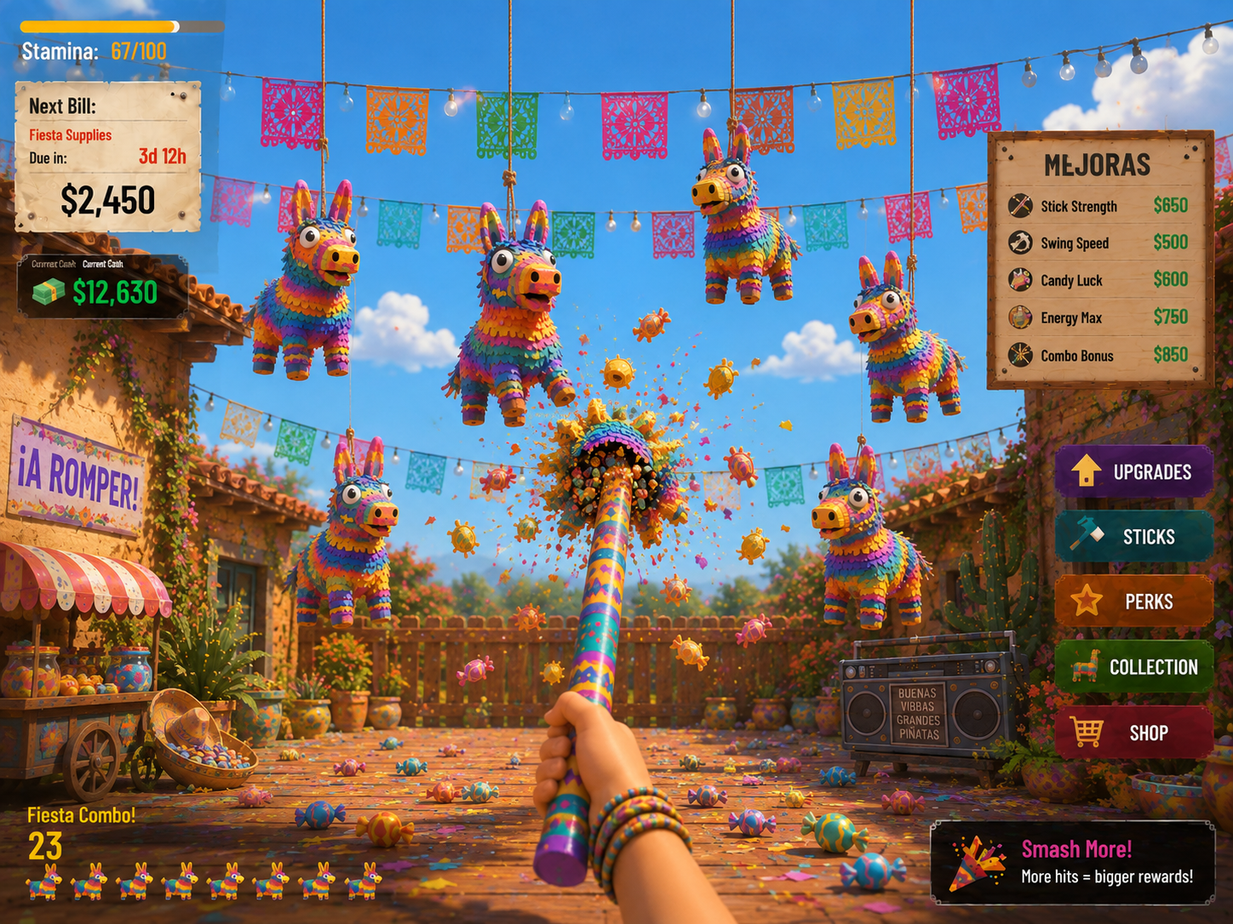
Prototype thesis A 10–15 minute active incremental game where the player automatically swings upward at moving piñatas, harvests candy, fulfills escalating Fiesta Orders, and buys upgrades that turn careful aiming into joyful high-speed destruction.

Browser • 10–15 min • ~5 rounds • Mouse-position auto-attack • Candy economy • Near-orthographic bottom-up camera

1. Prototype Goals
The prototype is not intended to prove the full metagame. It must prove that the bottom-up piñata interaction is readable, satisfying, scalable, and meaningfully differentiated from the tabletop piggy-bank reference while preserving the clarity of an active incremental game.
Question to Answer | Prototype Evidence
Is aiming upward fun without clicking? | Mouse targeting feels immediate; auto-swings land predictably; moving targets create constant micro-decisions.
Does the camera preserve fairness? | All target piñatas remain at nearly equal apparent size and are individually selectable without severe depth/occlusion problems.
Does progression feel dramatic in 10–15 minutes? | Round 1 is deliberate and single-target; Round 5 is fast, broad, candy-filled chaos.
Does the theme stand on its own? | Candy, Fiesta Orders, hanging targets, upward strikes, bright sky, and party-space framing make the game read as its own fantasy.
Are four upgrades enough for a prototype? | Power, Swing Speed, Stamina, and Hit Radius create visibly different pacing and power growth.

Success condition By the end of Round 5, the player should feel that the same simple mouse movement has evolved from precise target selection into controlled arcade chaos—without losing the ability to understand what they are hitting.

2. Core Loop
- Enter smashing round with a fixed Stamina pool.
- Move the mouse over hanging piñatas; the character automatically swings toward the current target.
- Damage piñatas until they burst and shower the play space with candy.
- Stamina drains continuously with time, creating a round timer rather than an attack cost.
- When Stamina reaches zero, the smashing round ends.
- Spend collected candy between rounds on upgrades and/or the current Fiesta Order.
- Fulfill the order, advance to the next round, and face a higher candy requirement with denser/faster target movement.
Resource tension Candy serves both progression and obligation. Spending aggressively on upgrades makes the next round stronger, but the player still needs enough candy to fulfill the Fiesta Order. This preserves the “upgrade now vs. survive the bill” tension without requiring literal money.

3. Recommended “Bill” Retheme: Fiesta Orders
Replace financial bills with Fiesta Orders: commitments to supply candy for increasingly ambitious parties. Each order requires a candy value before the player can advance. The fiction is immediately connected to the action—piñatas produce the exact resource the event needs—and keeps the same pressure structure without feeling like a reskin of debt.
Round | Order | Flavor | Target Candy
1 | Birthday Bags | Fill candy bags for a small backyard birthday. | 500
2 | School Fiesta | Supply the neighborhood school celebration. | 1,400
3 | Block Party | A much bigger crowd is coming. | 3,500
4 | Grand Fiesta | Decorations are ready; the candy table is not. | 8,000
5 | Fiesta Finale | Over-the-top final order; empty the rafters. | 18,000

Prototype terminology: “Fiesta Order” is the system name; the HUD card can read “NEXT ORDER,” “CANDY NEEDED,” and “READY!” once fulfilled. Avoid a cash conversion layer in the first prototype unless playtesting shows that candy-as-currency is confusing.

Alternative themes if “orders” feel too commercial
- Party Prep: candy fills a preparation meter for the next celebration. Softer, but creates less economic tension.
- Fiesta Goals: abstract candy quotas. Extremely clear, but weaker fiction.
- Candy Contracts: stronger pressure and progression language, but more business-like.
Recommendation: use Fiesta Orders for the prototype because it explains both the escalating quota and why excess candy can be reinvested.

4. Player Interaction & Targeting

4.1 Input
- Mouse position defines the desired target point in screen space.
- No click is required. If a valid piñata is under/near the targeting point and the attack cooldown is ready, the player automatically swings.
- The weapon originates from the lower portion of the frame and strikes upward, reinforcing the piñata fantasy.
- The cursor should be minimal or replaced by a soft targeting reticle that clearly communicates which piñata will receive the next hit.

4.2 Target selection
Use screen-space selection rather than relying on raw world-space proximity. This keeps aiming consistent under the compressed camera.
Rule | Prototype Behavior
Acquire | Select the piñata whose projected screen-space hit region contains the cursor/reticle.
Overlap | Prefer the target whose projected center is closest to the cursor; use stable target locking for ~100–150 ms to prevent flicker.
Miss | If no target is valid, the weapon can idle/follow aim but does not create a damaging hit.
Auto-swing | Attack whenever cooldown <= 0 and a target is valid.
Feedback | Target squash, paper tear, candy flecks, impact flash, sound, small camera/weapon impulse.

5. Camera & Playfield
Non-negotiable Piñatas must remain approximately the same apparent size. No target should gain protagonism simply because it is closer to the camera, and foreground targets must not routinely hide targets behind them.

The camera sits low, near floor level, and points upward so the blue sky is a major background element. Perspective should be heavily compressed—visually close to orthographic—while retaining just enough perspective to sell the upward strike and courtyard depth.
Parameter | Prototype Direction
Projection | Start with PerspectiveCamera using a narrow FOV; test OrthographicCamera if equal-size readability is still insufficient.
Suggested FOV | ~12–20° vertical FOV as a starting range, with camera distance increased to maintain framing.
Target depth band | Keep all active piñatas inside a shallow depth slab; depth exists for animation/parallax, not gameplay advantage.
Apparent size | Target variation <10% across the active field whenever practical.
Vertical framing | Targets occupy upper/middle play area; hand/weapon owns lower center; UI stays outside the primary target field.
Occlusion | Spawn/movement system actively avoids sustained screen-space overlap between piñatas.

5.1 Piñata movement
Piñatas hang from visually readable ropes but move as active targets. Their motion should feel playful rather than physically realistic: horizontal sway, vertical bob, and diagonal drift. The rope can stretch/angle to support movement, but target readability wins over strict pendulum simulation.
- Move left/right, up/down, and diagonally within assigned lanes/regions.
- Do not move significantly toward/away from camera; depth motion would undermine equal apparent size.
- Use independent phases/speeds so targets do not move as a synchronized wall.
- Before accepting a new position, test projected overlap against nearby piñatas and redirect if necessary.

6. Stamina, Combat & Piñata Health
Stamina is the round timer. It drains continuously regardless of whether the player is currently hitting a target. This creates urgency without punishing high attack speed.
Variable | Starting Prototype Value | Notes
Max Stamina | 30 sec equivalent | Tune so Round 1 lasts ~30 sec before upgrades.
Drain Rate | 1 stamina/sec | Represent stamina in seconds internally for easy tuning.
Base Power | 10 damage/hit | Damage per successful impact.
Base Swing Rate | 2.0 hits/sec | Automatic while a target is acquired.
Base Hit Radius | 1.0x | Screen-space target forgiveness / impact radius scalar.
Basic Piñata HP | 30 | ~3 starting hits; easy to read and tune.

A round ends immediately when Stamina reaches zero. Finish the current hit animation, freeze target damage, tally candy, then transition to the between-round screen within ~1 second.

7. Candy Economy
Candy is both the reward burst and the prototype currency. Physical candy pieces should explode outward for spectacle, but collection should be automatic so the player never stops aiming to vacuum loot manually.
Event | Candy Value | Presentation
Normal hit | 0–2 | Tiny pieces/flecks; mostly impact feedback.
Piñata break | 20–35 | Main candy burst; several visible candy shapes.
Combo / streak bonus | +5–20% | Floating multiplier and richer burst.
Round tally | All earned candy | Count-up into inventory after stamina expires.

Prototype simplification Use one numerical Candy currency even if the VFX contains many candy colors/shapes. Candy rarity and collection sets are out of scope until the core loop is proven.

8. Upgrade System
Four upgrade lines are enough to demonstrate distinct growth vectors. Upgrades are purchased between rounds using Candy. Each line should have 4–5 prototype levels, with costs rising sharply enough that the player cannot max everything in one run.
Upgrade | Effect | Suggested Levels | Design Purpose
Power | +35% damage / level | 10 → 13.5 → 18 → 24 → 32 | Fewer hits per piñata; clearest strength fantasy.
Swing Speed | +25% attacks/sec / level | 2.0 → 2.5 → 3.1 → 3.9 → 4.9 | Turns aiming into increasingly frantic destruction.
Stamina | Alternating Max / Efficiency improvements | 30s → 36s → 43s → 50s → 60s effective | Extends each round; supports more total output.
Hit Radius | +18% screen-space forgiveness / level | 1.0 → 1.18 → 1.39 → 1.64 → 1.94 | Makes fast moving targets easier and creates “bigger swing” fantasy.

For Stamina, the UI may expose a single upgrade line while internally alternating between increased maximum Stamina and reduced drain rate. This lets the prototype test both behaviors without adding another visible stat.

9. Five-Round Prototype Progression
Round | Targets | Movement | HP | Order Pressure | Desired Feel
1 | 5–6 | Slow, mostly horizontal | 30 | Low | Learn aiming; satisfying 3-hit breaks.
2 | 7–8 | Add vertical bob | 38 | Moderate | First meaningful upgrade payoff.
3 | 9–10 | Faster mixed axes | 50 | Moderate+ | Target switching becomes important.
4 | 10–12 | Fast, larger travel | 65 | High | Build identity becomes obvious.
5 | 12–14 | Dense but overlap-managed | 80 | Final spike | High-speed candy storm; still readable.

Round targets are tuning starting points, not fixed balance. The key is that density rises without violating equal apparent size or target separation.

10. HUD & Flow
State | Required UI
During round | Stamina bar/time, Candy earned this round, current Fiesta Order progress, target reticle, optional combo.
Round end | Candy earned, piñatas broken, order progress, clear Continue button.
Between rounds | Four upgrade cards/rows, Candy balance, Fiesta Order contribution/fulfillment, Start Next Round.
Prototype end | 5-round summary: total candy, total breaks, upgrade levels, best break rate, order completion.

Keep the center/upper-middle target field clean. Unlike the concept art, the prototype should avoid permanent upgrade/shop panels during active play; those are visually attractive but compete with aiming. Use compact edge HUD during the round and a dedicated between-round upgrade state.

11. Visual & Audio Direction
Use the approved bright daytime piñata art direction as the visual baseline: saturated party colors, blue sky, warm stucco/wood, papel picado, candy/confetti, chunky rounded 3D forms, and goofy multicolored donkey piñatas. Avoid the earlier dark/nighttime Día de Muertos mood.
Area | Direction
Piñatas | Same gameplay scale; strong silhouette; bright fringe layers; oversized goofy eyes; damage shown with tears/open seams.
Environment | Sunny courtyard / party space; decorative detail frames the edges rather than cluttering the target field.
Weapon | Decorated striking stick enters from bottom center; exaggerated upward follow-through.
Impact | Paper burst, confetti, candy spray, squash/stretch, short hit-stop, bold score feedback.
Lighting | Bright warm daylight, soft readable shadows, saturated but not dark.
Audio | Papery thwack + hollow body hit; escalating crackle; explosive candy burst; upbeat combo stingers.

12. Three.js / HTML5 Technical Plan
System | Prototype Approach
Rendering | Three.js WebGLRenderer; target stable 60 FPS on desktop browser.
Camera | PerspectiveCamera at narrow FOV first; OrthographicCamera A/B option behind a debug toggle.
Input | Pointer move → normalized screen coordinates → raycast / projected hit testing.
Targets | Object pool of piñata entities with health, motion state, screen-space bounds, and candy value.
Movement | Deterministic sinusoidal/steering motion in a shallow 3D slab; screen-space overlap avoidance.
Combat | Global attack cooldown; current target resolved each frame; hit event applies Power and feedback.
Stamina | Time-based scalar drained by deltaTime × drainRate; independent of attacks.
VFX | Pooled candy/confetti particles; cap active pieces; fake distant pieces with sprites if needed.
Persistence | None required beyond current 5-round session; in-memory state only.
Responsive | Prototype tuned for 16:9 desktop; scale HUD with viewport, preserve gameplay framing.

12.1 Performance budgets
- Target 60 FPS; consider prototype failed technically if normal gameplay spends sustained time below 50 FPS on a representative laptop.
- Keep active 3D candy/confetti bounded (e.g. ~150–250 pieces); recycle aggressively.
- Use shared materials/geometries and instancing where practical for candy and repeated decorative props.
- Avoid expensive real-time shadows on every particle/target; prioritize readable contact/character shadows.

13. MVP Content Requirements
Category | Minimum
Piñata | 1 donkey model, 3–5 palette variants, intact + damaged/broken presentation.
Weapon | 1 stick/bat, 1 hand/arm rig or procedural swing presentation.
Environment | 1 bright courtyard arena with sky, banners, ropes, edge dressing.
VFX | Hit burst, break burst, candy, confetti, floating value/combo text.
UI | Round HUD, Fiesta Order card, upgrade screen, round-end tally, final summary.
Audio | At least 3 hit variations, break sound, candy pickup/tally, upgrade purchase, UI, short music loop.
Rounds | 5 tuned rounds with increasing density/movement/HP/order targets.

14. Explicitly Out of Scope
- Multiple piñata species with unique abilities
- Weapon collection / multiple sticks
- Candy rarity or inventory collection
- Prestige / bankruptcy / permanent meta-progression
- Bosses
- Mobile/touch controls
- Full shop economy
- Narrative campaign
- Online features
- Complex physics-based rope simulation

15. Playtest Instrumentation & Success Criteria
Metric | What to Record | Healthy Prototype Signal
Hit rate | Swings attempted vs. successful hits | High enough to feel responsive; misses mainly caused by movement, not camera ambiguity.
Target switching | Targets acquired/minute | Rises across rounds as swing speed/density increase.
Occlusion failures | Seconds where target centers overlap materially | Rare and brief.
Round output | Candy + breaks per round | Strong upward curve after upgrades.
Upgrade choice | Levels purchased by line | At least 2–3 viable-looking paths across testers.
Session time | Start → Round 5 complete | 10–15 minutes median.
Frame rate | FPS / frame time | Stable near 60 FPS during peak candy burst.

Playtest questions
- Did you ever feel a piñata was harder to hit only because of where it was in depth?
- Could you always tell which piñata the next swing would hit?
- Did moving the mouse without clicking feel satisfying or too passive?
- Which upgrade produced the most noticeable change?
- Did Stamina feel like useful pressure or simply an arbitrary timer?
- Did Fiesta Orders make intuitive sense as the reason you need candy?
- At what point did the game begin to feel powerful/chaotic?
- Was the final round exciting while still readable?

16. Recommended Implementation Order
- Camera test scene: 8 identical hanging targets; validate equal apparent size, aim fairness, and occlusion before building progression.
- Mouse targeting + automatic upward swing + hit feedback.
- Piñata health/break/candy burst.
- Stamina timer and round start/end.
- Four upgrade lines and between-round screen.
- Fiesta Order economy and five-round progression.
- Movement escalation + overlap avoidance.
- Juice pass: animation, VFX, sound, combo feedback.
- Instrumentation, performance pass, and playtest tuning.
Highest-risk item Camera/target readability should be solved first. If the near-orthographic bottom-up view cannot keep targets equally hittable and unoccluded, progression tuning is premature.

17. Tuning Variables to Expose in Debug UI
Group | Variables
Camera | FOV / orthographic size, camera height, pitch, target depth slab, target scale.
Movement | Horizontal speed, vertical speed, travel range, direction-change rate, overlap padding.
Combat | Power, swing rate, hit radius, hit-stop, target lock grace.
Stamina | Max, drain/sec.
Economy | Candy per hit/break, upgrade costs, Fiesta Order targets.
Round | Target count, HP, movement multiplier, spawn distribution.

All of these should be editable without changing gameplay code. A simple lil-gui/dat.GUI-style internal panel is sufficient for the prototype.
Prototype north star: equal-size targets + bottom-up striking + candy escalation + readable chaos.

