This is a project for phase 3
Name: Diogo Paulo from Vodafone Portugal .

Akash Kale did an excellent job on this phase, the explanations were very clear and the examples used for demonstration were real application examples.

The first step was to create and run a project with Eureka server
Eureka Server

The Eureka server is a centralized service registry for service discovery used in microservices.
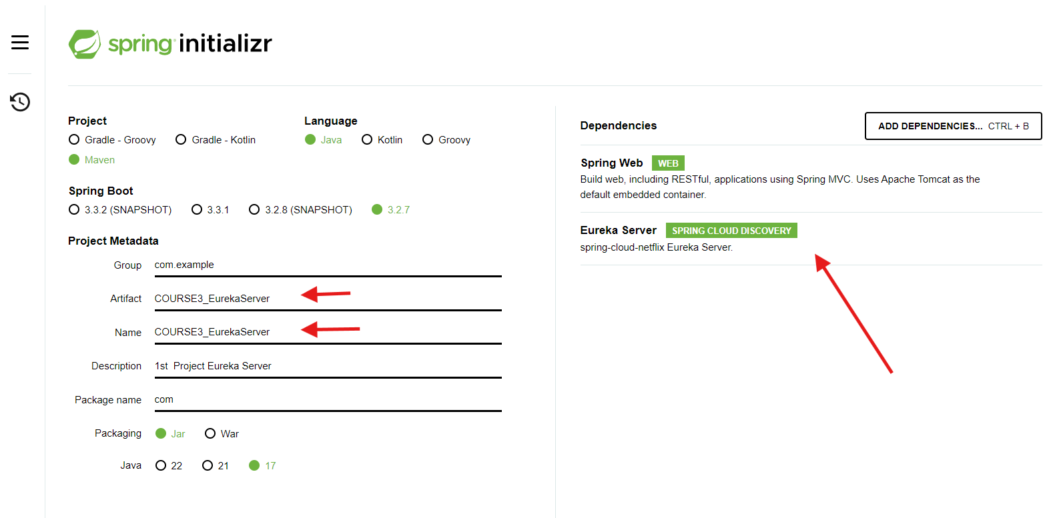
In the Eclipse IDE importing the Eureka Server project
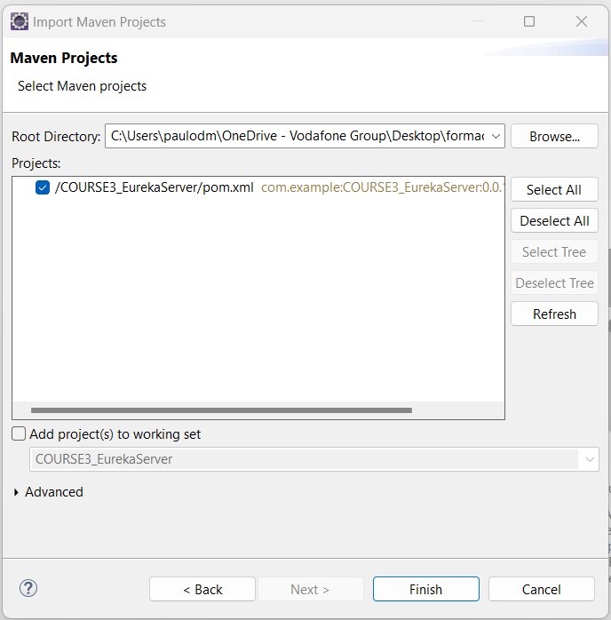

To run Eureka as a server we need to define the port number for the server and these two properties .

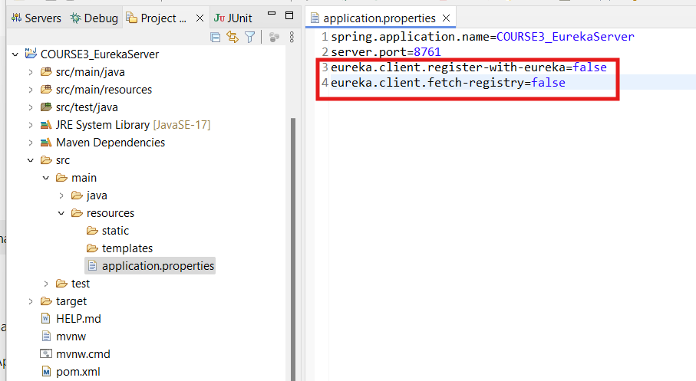

The main class is created and the annotation @EnableEurekaServer was added.

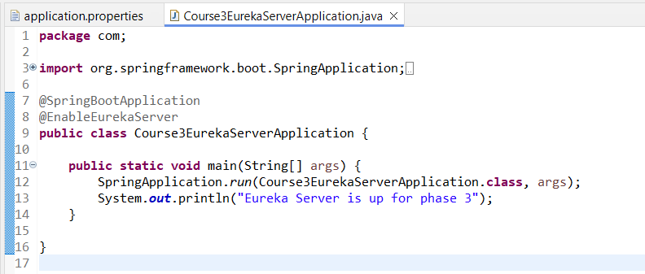

Running eureka server

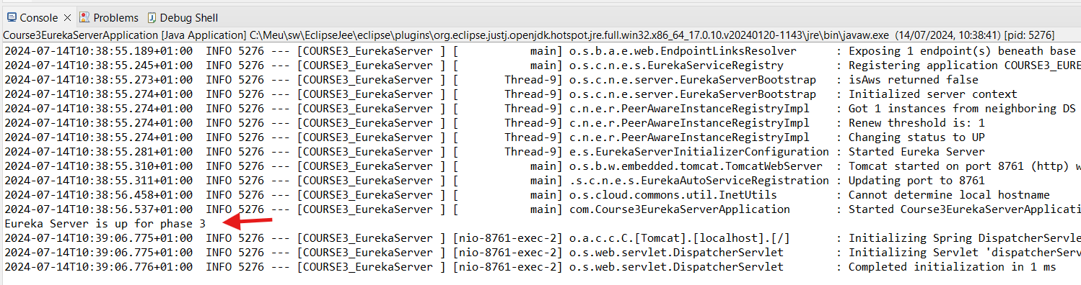

Testing the Eureka server without any microservice registered

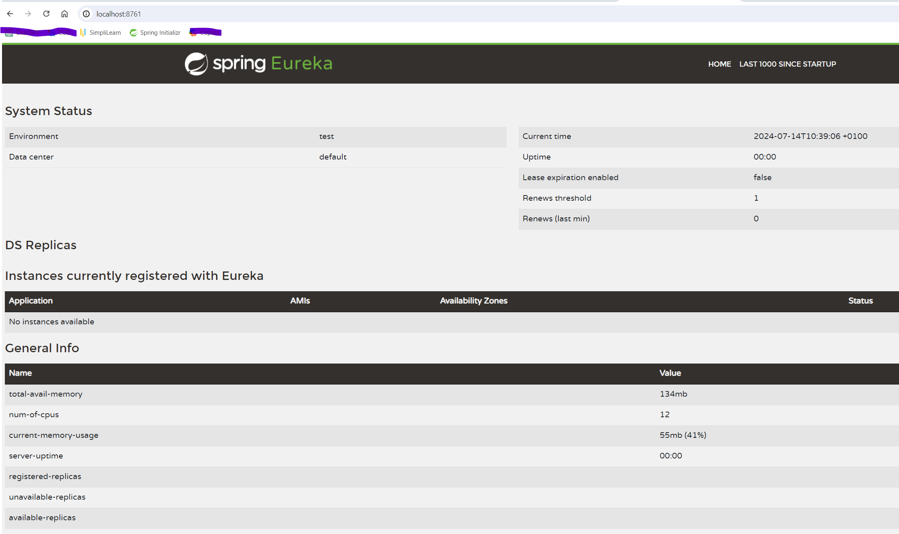

The second step is
Microservice project for booking the cab

Maven project creation using spring initializr with all starters needed for this implementation

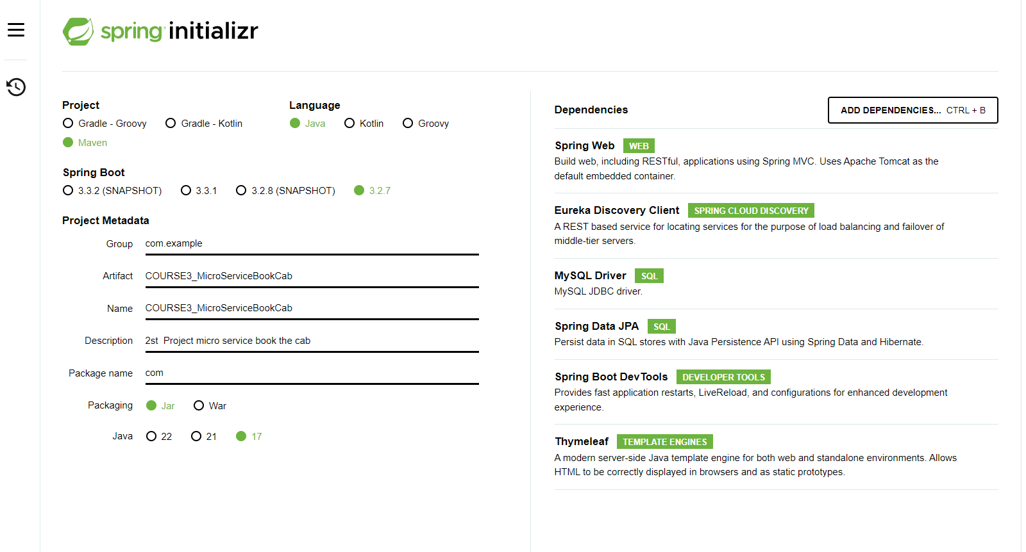

Importing project in eclipse

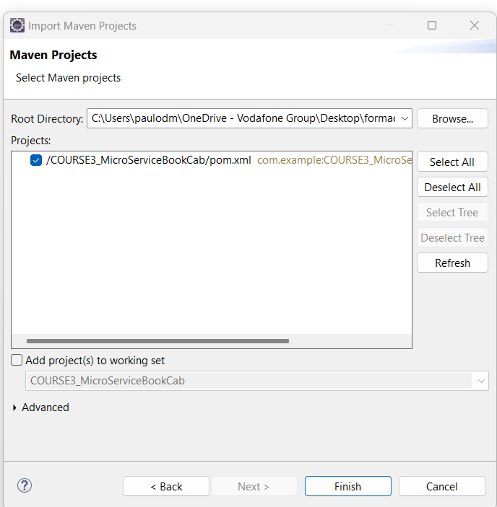

Crete database
CREATE DATABASE course3_project;
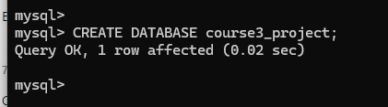

Properties where we define the database connectivity and behavior for JPA to create the tables based on the entity class

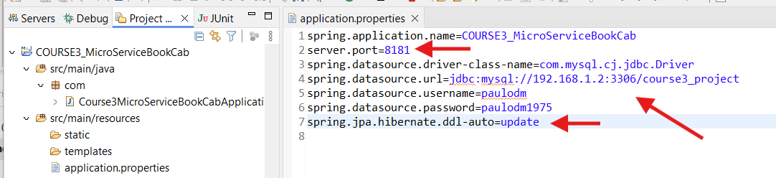

Start the project
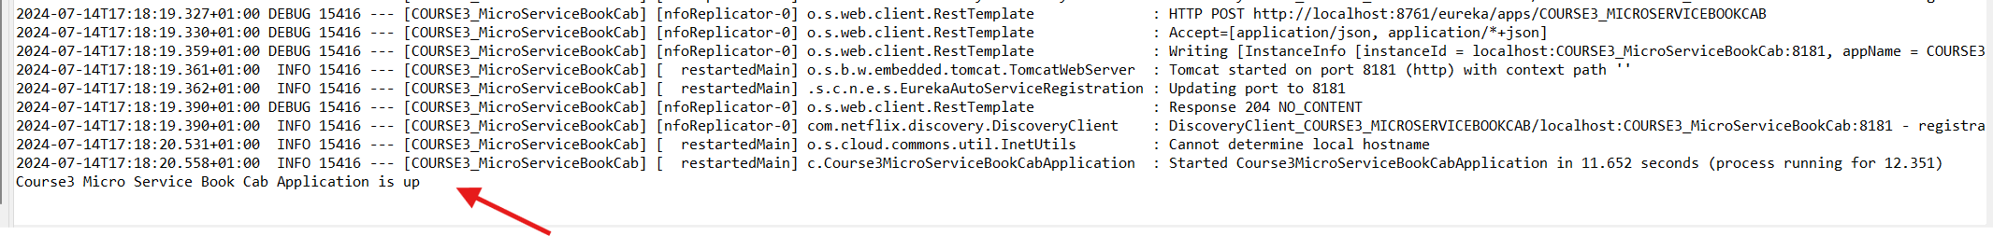

Db creation automatically after startup based on the entity class

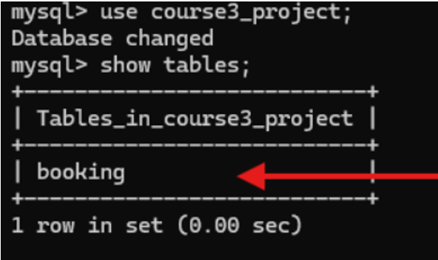

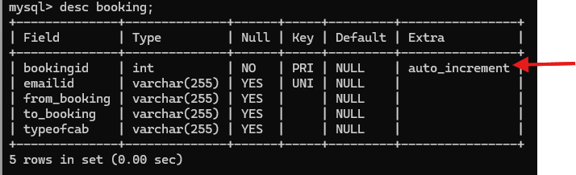

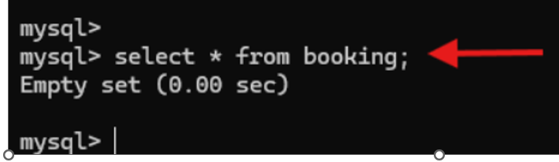

Index page
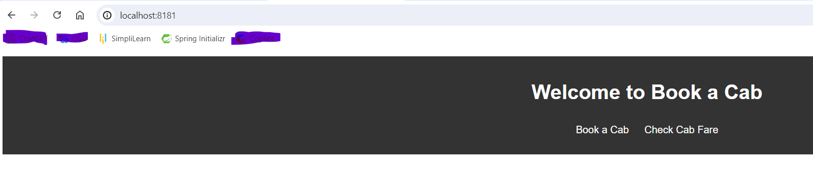

Example of booking creation
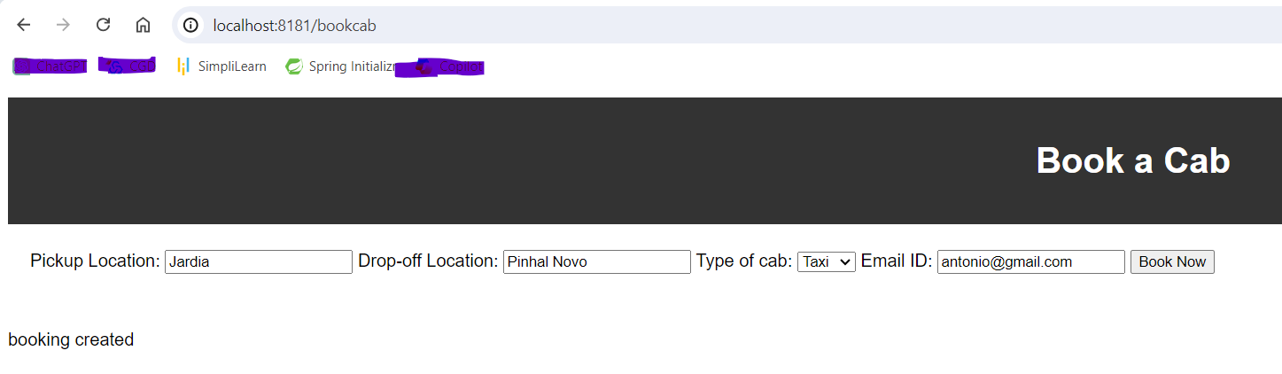

Example if we try to book a cab with the same email ID

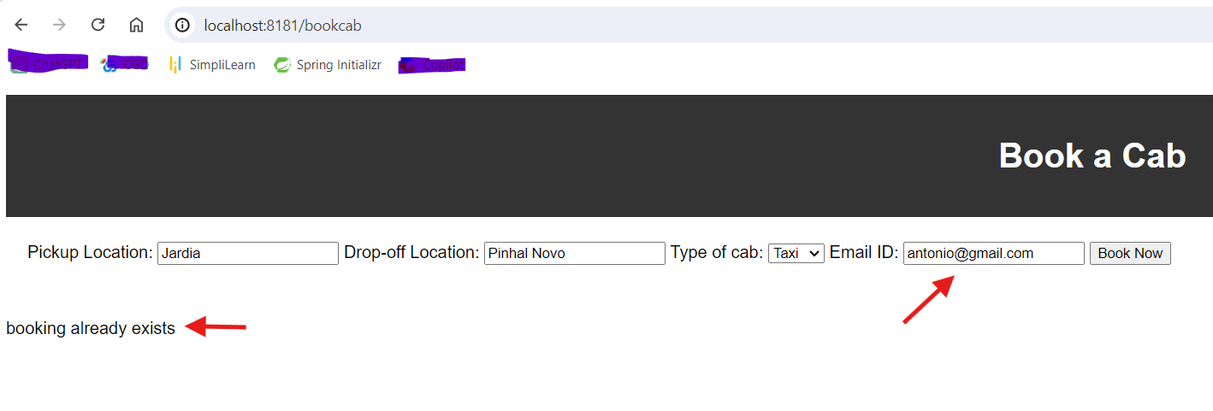
Cab fare needs the next microservice to be fully working

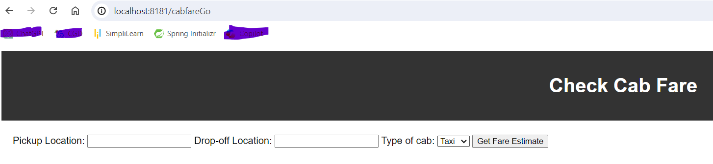
Step 3 is to create a microservice for cab fare
Microservice project for cab fare
Create a project and import it to Eclipse

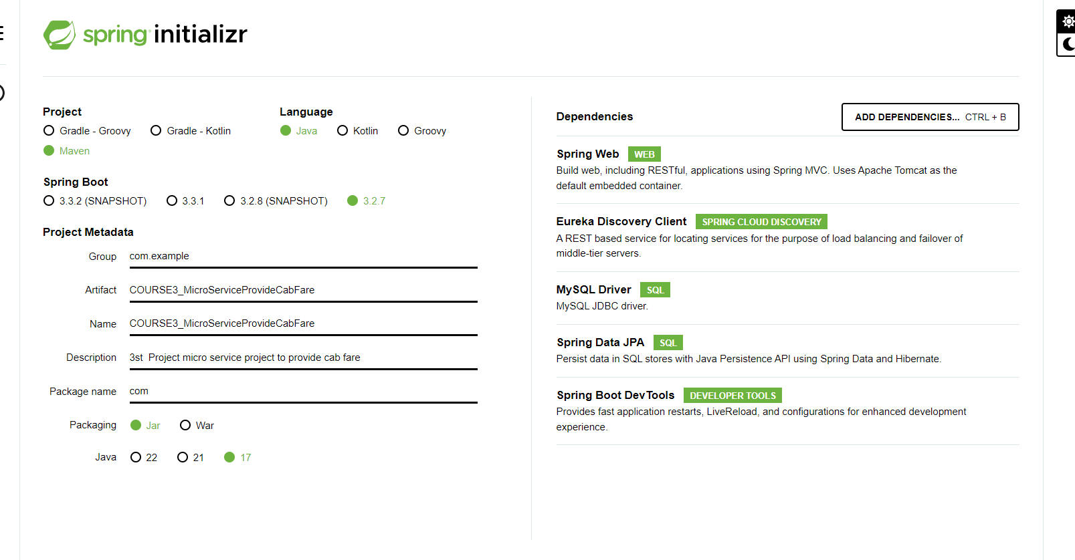

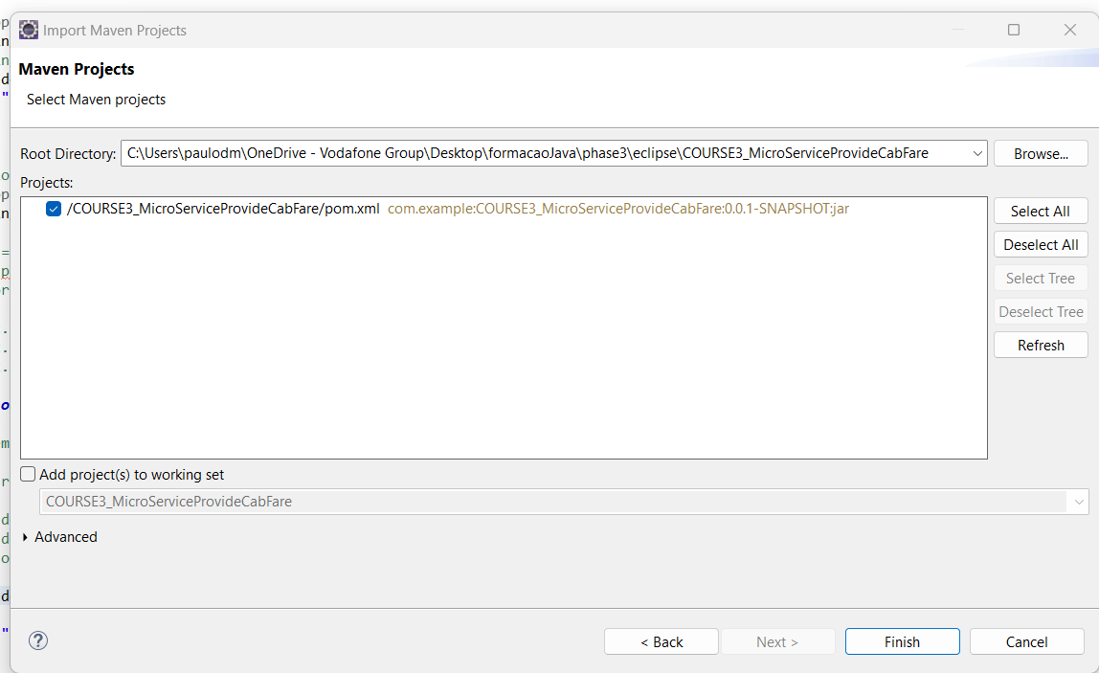

Application properties
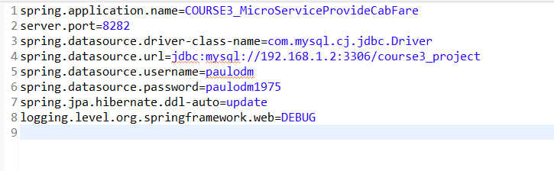

After start the application

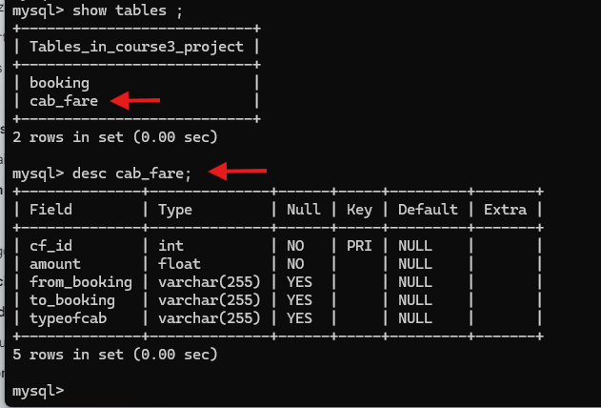

Creating a cab fare with rest API

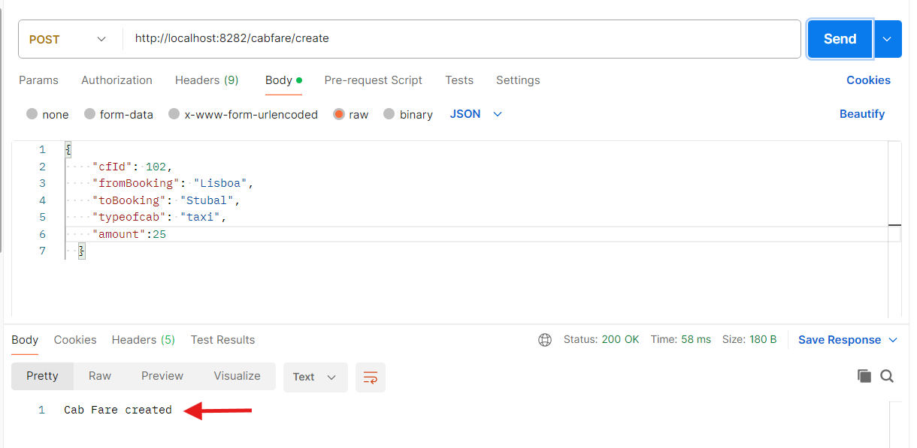

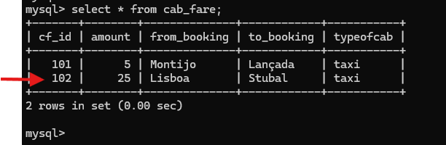

E
Example for repeated ID in creating cab fare.

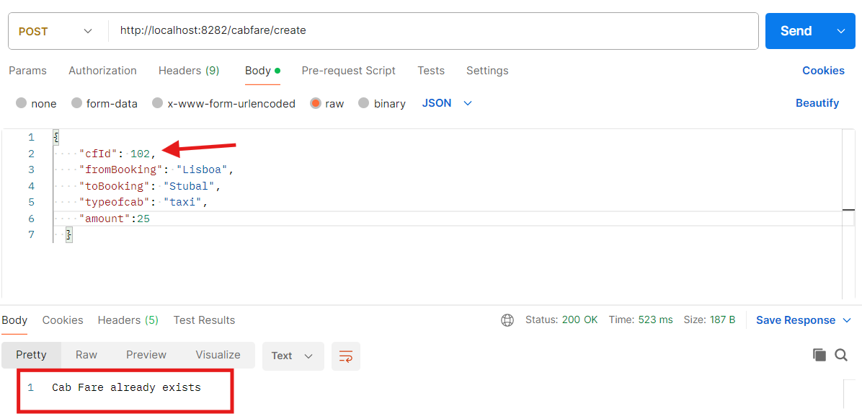

Get cab fare using rest API

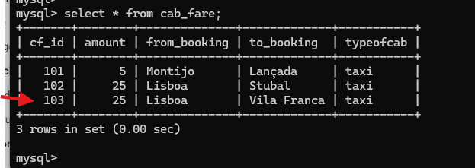

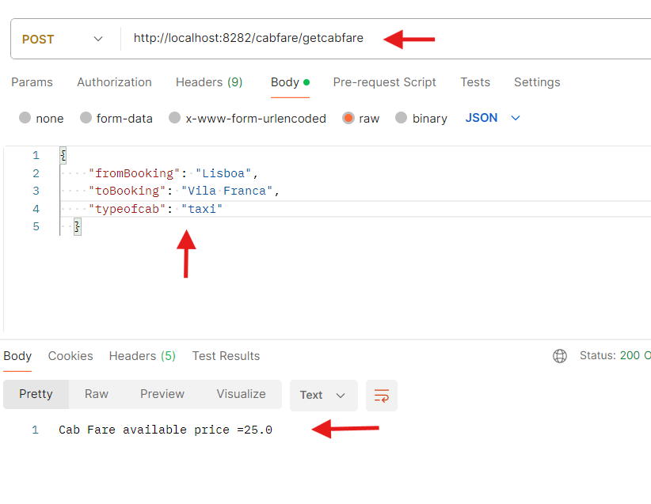

Example If cab fare is not available

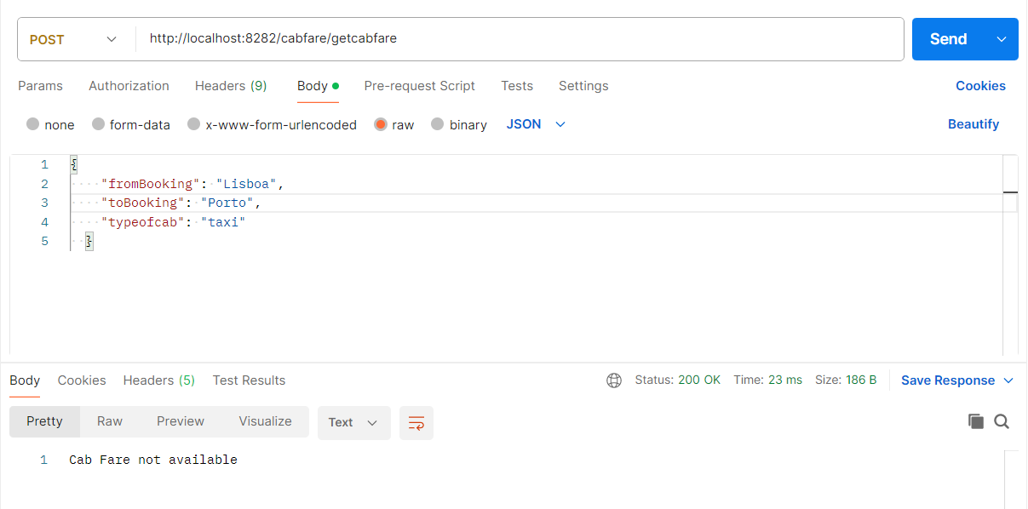

Eureka server with 2 microservices registered

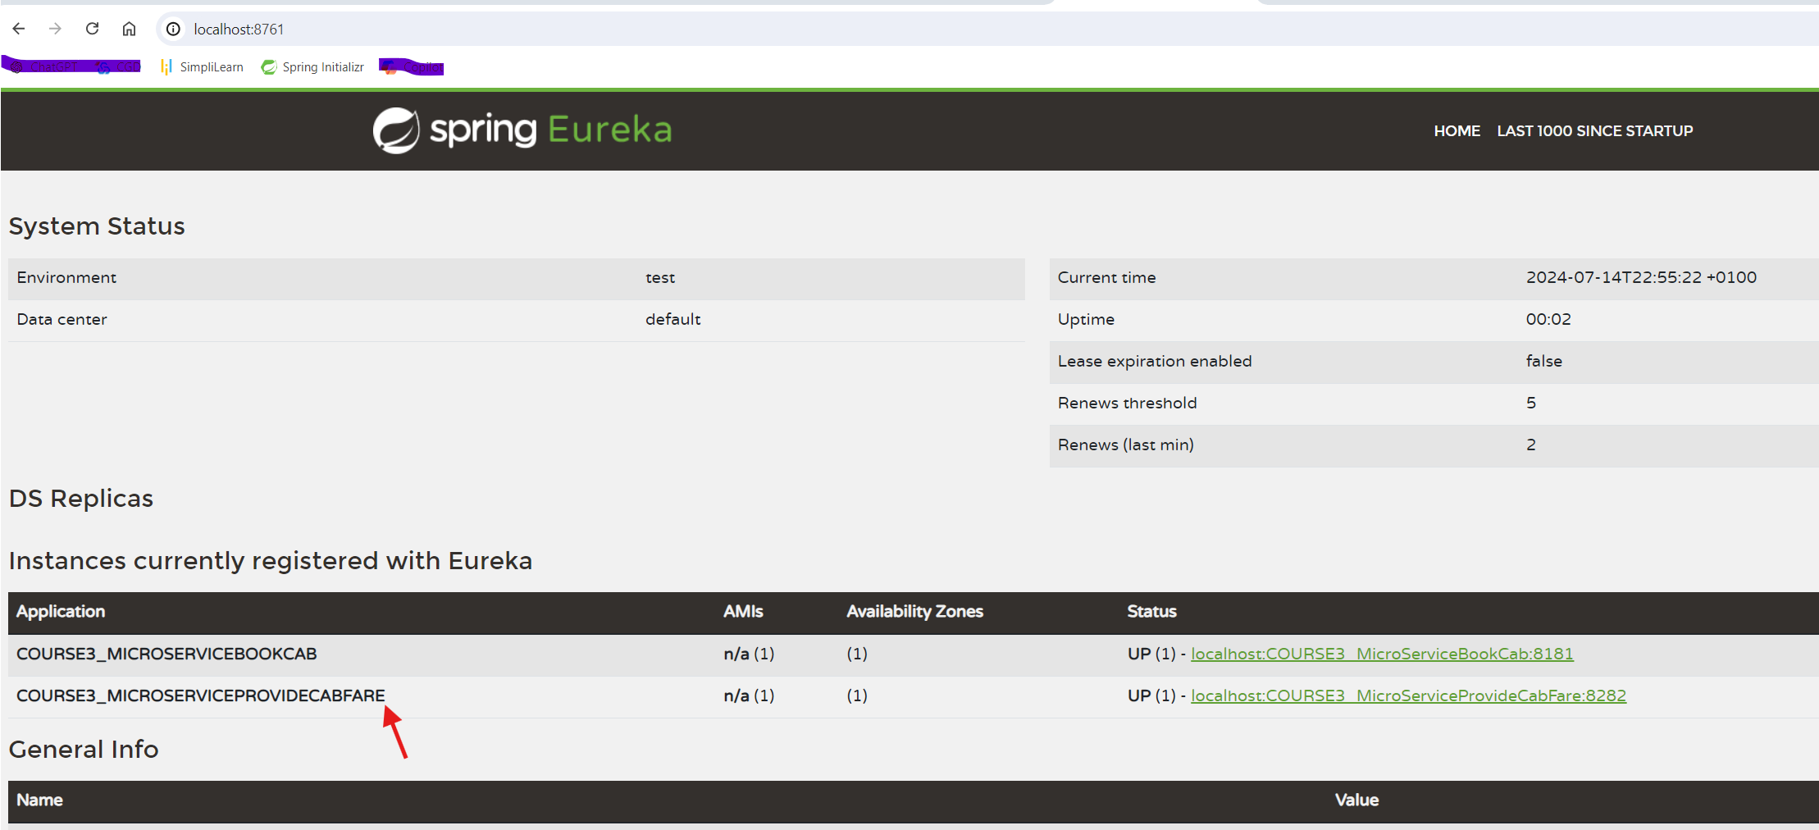

Get cab fare using RestTemplate to call a microservice

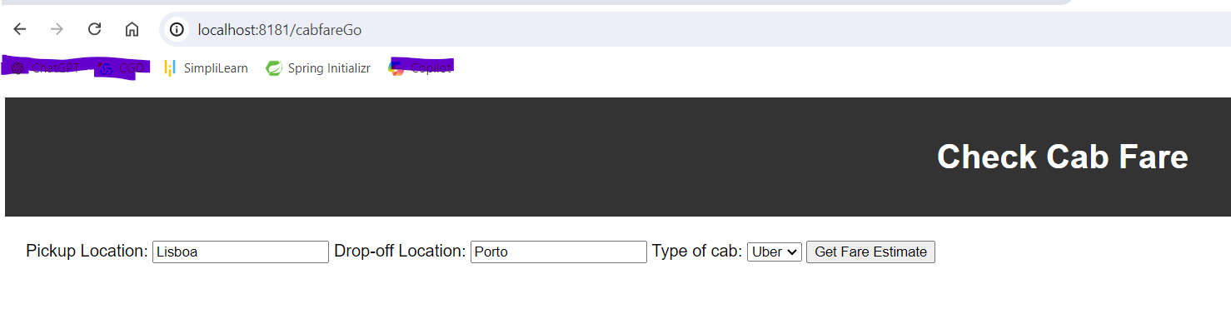
Using project with thymeleaf
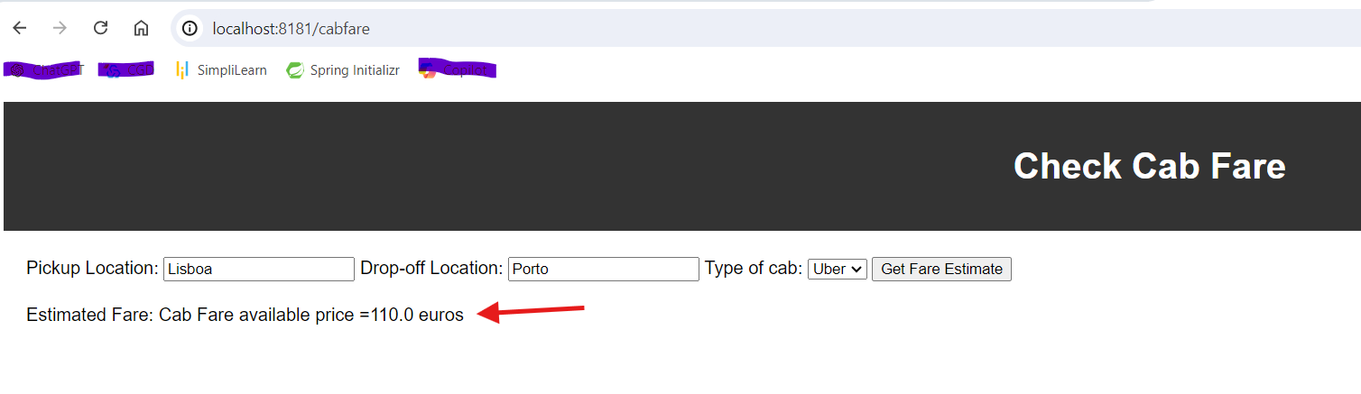

Using postman rest request
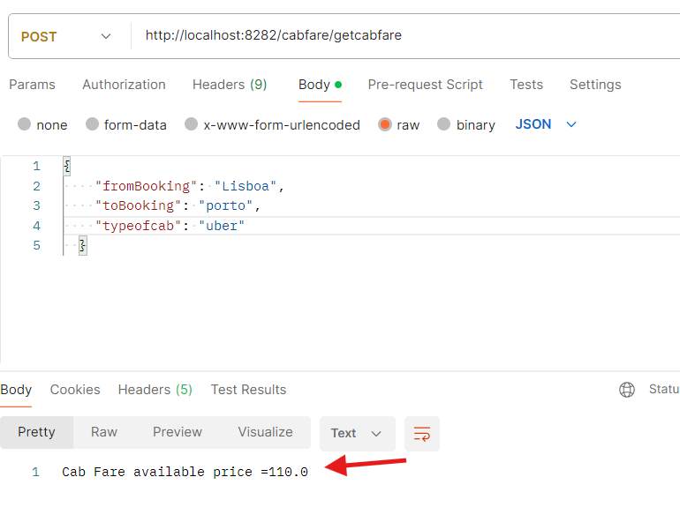

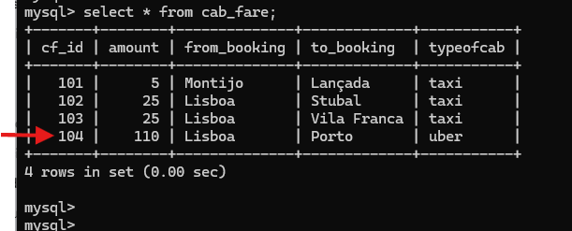

Junit implementation

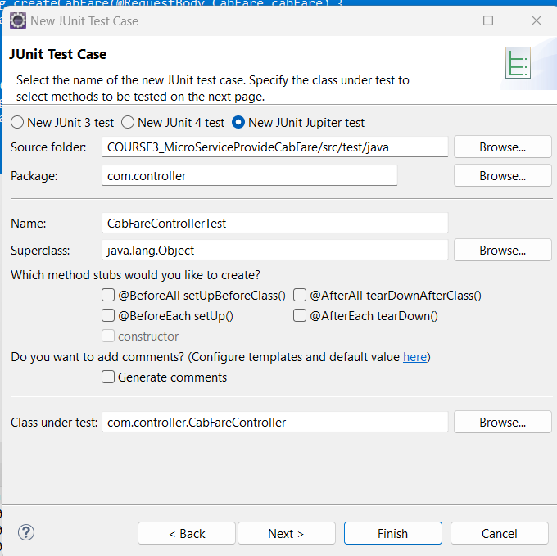

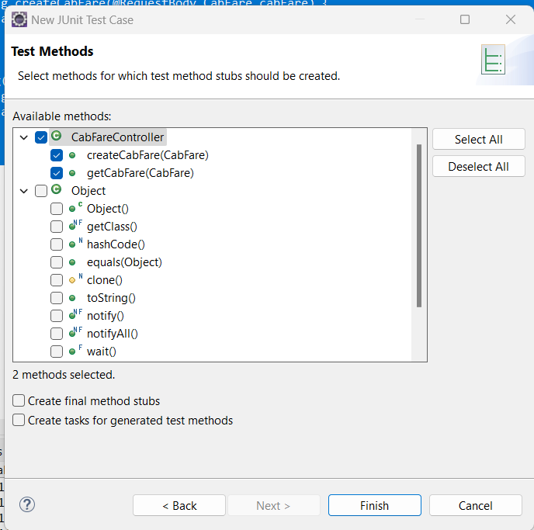

jUnit was implemented only for testCreateCabFare() in project /COURSE3_MicroServiceProvideCabFare
Junit successfully pass
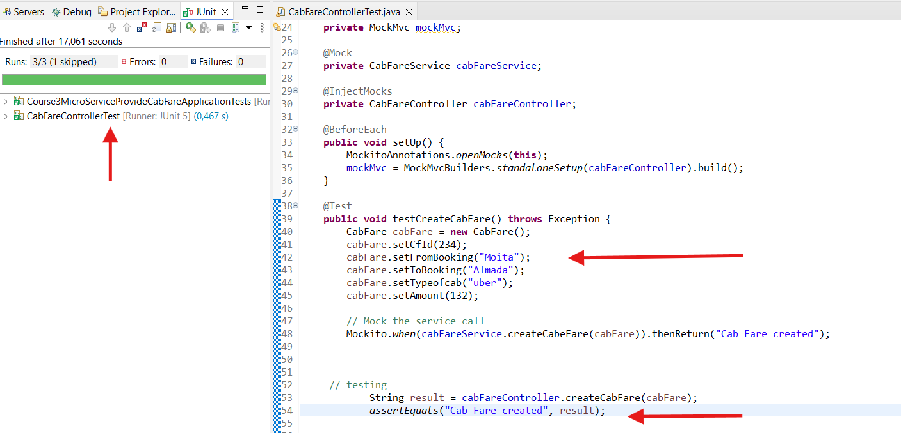

Junit failed example:
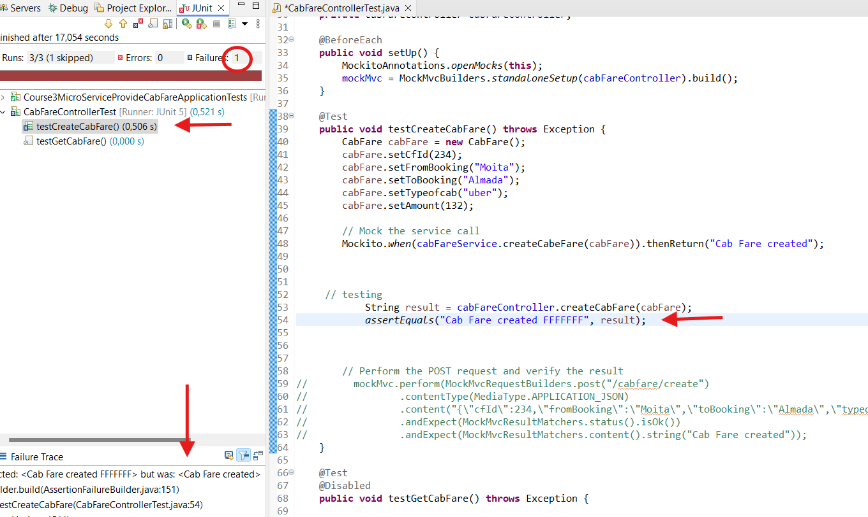

These are the 3 projects. Jar files are sent in the zip file
