

**CCO-1-2020-1-ATIVIDADE-02**

Paulo Emanuel Madeira de Freitas – 202003566

UNIFG – Boa Vista

CCO I – Sistemas Digitais

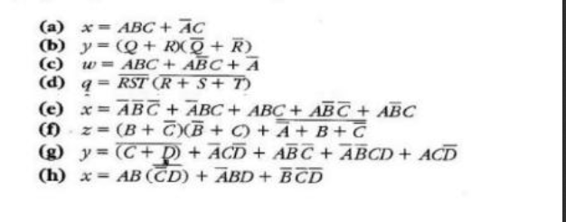

A) A.B.C + A’.C

***REGRA 11: C(A’ + B)***

***LEI ASSOCIATIVA: C(AB + A’)***

***LEI DISTRIBUTIVA: A’C+BC***

B) (Q + R).(Q’ + R

***REGRA 8: RQ’ + QR’***

***LEI DISTRIBUTIVA: QQ’ + RQ’ + RR’ + QR’***

***LEI ASSOCIATIVA: R + Q***

C) ABC + A’BC + ABC + AB’C’ + AB’C

***REGRA 6: AC + A’***

***REGRA 11: A’+C***

***LEI DISTRIBUTIVA: AC(B + B’) + A’***

D) (RST)’. (R + S + T)’

***LEI COMUTATIVA: (R’ + S’ + T’) R’S’T’***

***LEI DISTRIBUTIVA: R’R’S’T’+ S’R’S’T’ + T’R’S’T’***

***LEI DA IDENTIDADE: R’S’T’+R’S’T+R’S’T’***

***LEI ASSOCIATIVA: R’S’T***

E) A’B’C’ + A’BC + ABC + AB’C + AB’C

***LEI ASSOCIATIVA: A’B’C’ + BC (A + A’) + AB(C+C’)***

***REGRA 6: A’B’C’ + BC + AB’***

***REGRA 6 A: BC + B’ (A’ + C’)***

***LEI DISTRIBUTIVA: BC + B’ (A + A’C’)***

***LEI DISTRIBUTIVA: BC + B’A + B’C***

***LEI ASSOCIATIVA: AB’ + (B + C)’***

F) (B + C’) (B’ + C) + (A’ + B + C’)’

***REGRA 6: B’ (C’ + AC) + BC***

***LEI ASSOCIATIVA E COMUTATIVA: B’+C’ + AB***

***LEI DISTRIBUTIVA: BB’ + BC + B’C’ + CC’ + AB’C***

***LEI DISTRIBUTIVA: B’C’ + B’A + BC***

G) (C + D)’ + ACD’ + AB’C’ + AB’CD + ACD’

***LEI DISTRIBUTIVA: C’D’ + CD’(A+A’) + AB’C’ + A’B’CD***

***LEI ASSOCIATIVA: D’ (C+ C’) + B’ (A + A’) (C’ + C) D***

***LEI ASSOCIATIVA: C’D’ + CD’ + AB’C’ + A’B’CD***

***LEI DISTRIBUTIVA: D’+B’ (A + C***

H) AB.(C’D)’ + A’BD +B’C’D’

***Regra 6: A + A’ = 1***

***Regra 8: A * A’ = 0***

***Regra 11: A + A’*B = A + B***

***LEI COMUTATIVA: AB(C+D’) + A’BD + B’C’D’***

***LEI ASSOCIATIVA E COMUTATIVA: ABC + ABD’ + A’BD + B’C’D’***

***LEI ASSOCIATIVA: ABC + A (BD’ + BD) + B’C’D’***

***LEI COMUTATIVA: ABC + A(B+D) + B’C’D***