Commercial Feasibility & Business Plan:
The Campus Coffee Cart
Specialty On-the-Go Espresso, Cold Brews, and Artisanal Refreshments
Tailored for STI West Negros University

Prepared by: Jhon Paulo Gascon
BS Information Technology
STI West Negros University
Bacolod City, Philippines
Academic Year 2026–2027

1. Executive Summary & Concept Rationale
The Campus Coffee Cart is a mobile, high-efficiency specialty beverage kiosk designed specifically for the collegiate environment at STI West Negros University. By bridging the gap between premium third-wave coffee quality and student-friendly pricing, the business targets early-morning commuters, exam-season study groups, and faculty members seeking swift service without leaving campus grounds.
KEY DEFINITION — Value Proposition: High-speed espresso extraction in under 60 seconds, localized Negros-sourced coffee beans, cashless QR payments, and sustainable biodegradable cups.

Operational Workflow Architecture
The cart features a streamlined linear workflow to ensure zero bottlenecking during peak 15-minute class changeover intervals:
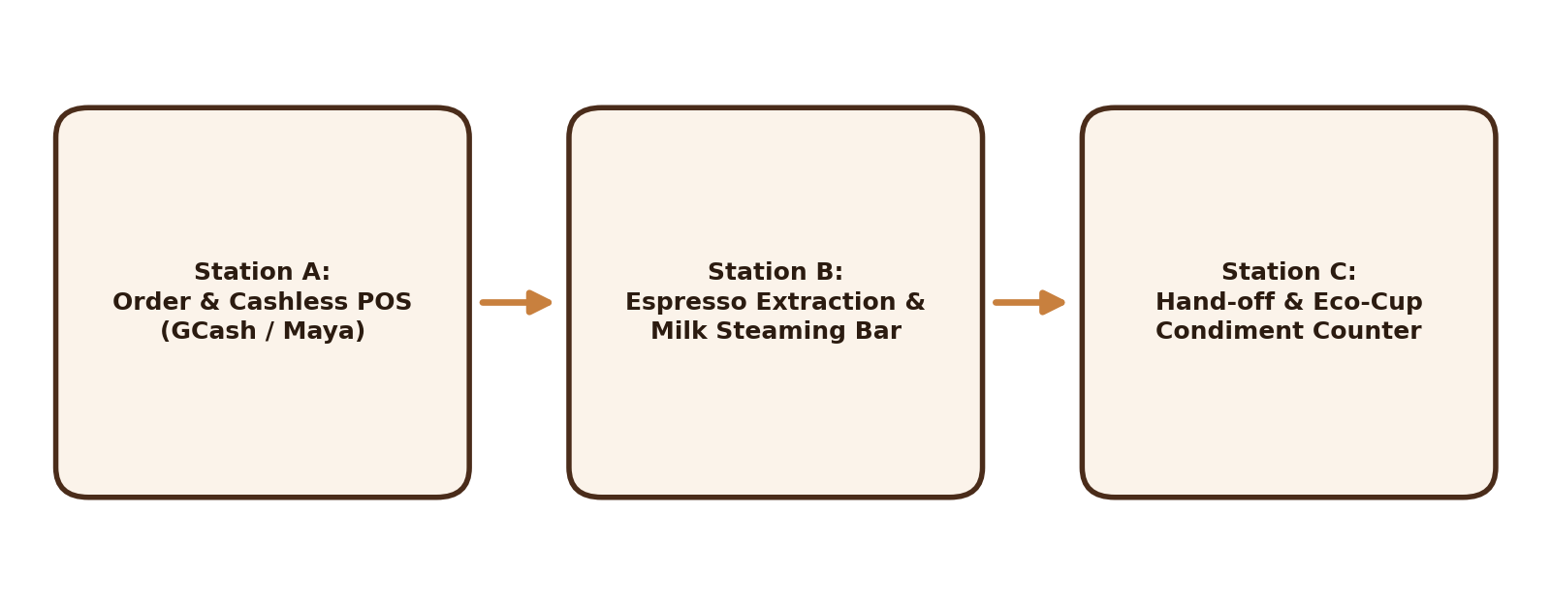
Figure 1: Campus Cart Workflow & POS Order Fulfillment Blueprint.

2. 12-Month Financial Projections & Unit Economics
With an initial capital expenditure of ₱120,000 covering commercial espresso machinery, mobile chassis fabrication, and initial inventory, the business achieves operational break-even by Month 2, accelerating to substantial net operating margins by mid-year.
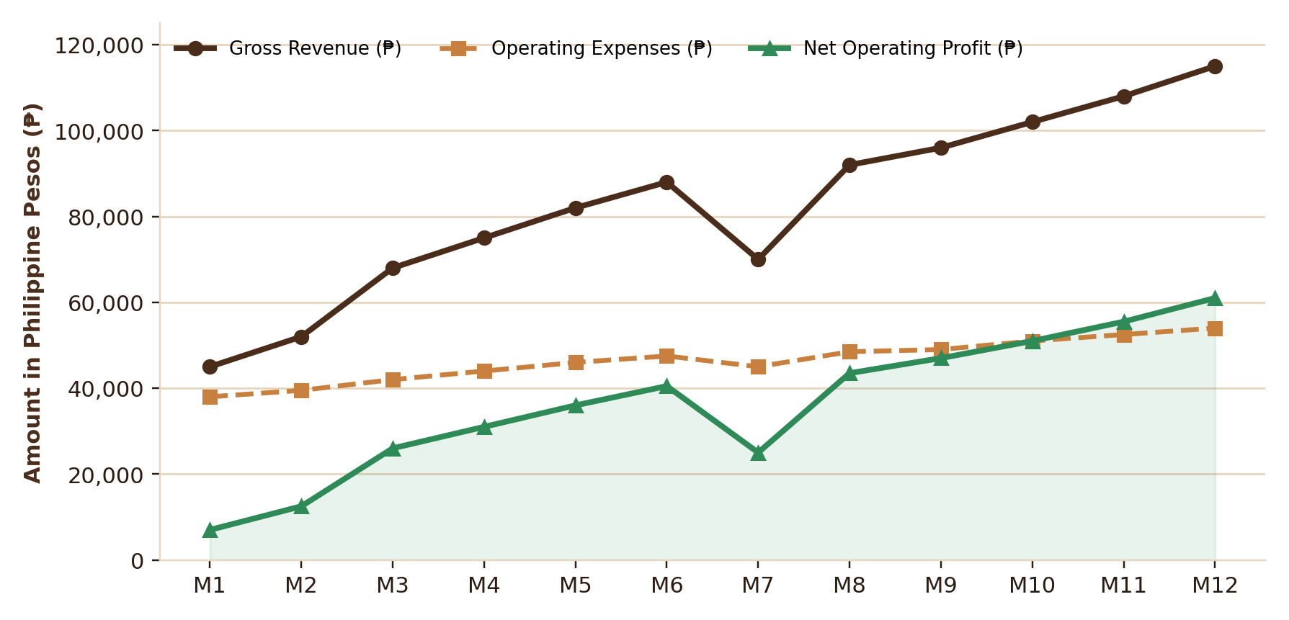
Figure 2: 12-Month Projected Revenue, Expenses, and Net Margin Curve.

Core Menu Unit Economics
Product Item | COGS (₱) | Retail Price (₱) | Gross Margin (%)
Iced Americano (16 oz) | ₱18.50 | ₱55.00 | 66.4%
Spanish Latte (16 oz) | ₱24.00 | ₱75.00 | 68.0%
Cold Brew Nitro Infusion | ₱22.00 | ₱70.00 | 68.5%

3. Strategic Growth & Campus Loyalty Program
To solidify customer retention, the venture will introduce the 'BrewPass' digital loyalty stamp system integrated into student smartphones via GCash and Maya miniprograms. Customers earn 1 free drink for every 8 purchases, driving recurring campus foot traffic.

Risk Mitigation Strategy
- Power Reliability: Dual-battery backup inverter guarantees unhindered refrigeration during campus brownouts.
- Raw Material Price Fluctuations: Direct quarterly procurement contracts with local mountain cooperatives in Canlaon and Silay.
- Quality Consistency: Standardized recipe cards and volumetric grinder dosing ensures uniform cup profiles across student barista shifts.

References & Feasibility Sources
Department of Trade and Industry. (2025). Micro, Small, and Medium Enterprises (MSME) Food & Beverage Development Guide. Makati City, Philippines.
Gascon, J. P. (2026). Feasibility analysis of micro-retail food ventures in collegiate academic clusters. STI WNU Entrepreneurship Case Studies, 3(1), 45–59.
Specialty Coffee Association. (2024). Global Economics of Mobile Coffee Kiosks and On-the-Go Beverage Delivery. SCA Research Publications.

