Case Study Report: Cybercrime Prevention Act of 2012 (RA 10175)
Statutory Analysis of Online Safety, Cyber Libel, and Jurisdictional Frameworks

Authored by: Jhon Paulo Gascon
College of Information Technology
STI West Negros University
Bacolod City, Philippines
Academic Year 2026–2027

1. Legislative Background & Constitutional Test
Republic Act No. 10175, approved on September 12, 2012, established comprehensive statutory penalties for offenses against the confidentiality, integrity, and availability of computer data and systems. The statute addresses emerging computer-related offenses, including illegal access, data interference, cyber fraud, and online libel.
KEY DEFINITION — Disini v. Secretary of Justice (G.R. No. 203335): The landmark 2014 Supreme Court ruling upholding Section 4(c)(4) regarding online libel against original authors, while invalidating unconstitutional provisions such as Section 12 (real-time traffic data collection) and Section 19 (DOJ unilateral takedown authority).

Enforcement Flowchart
Handling digital crime requires strict adherence to chain of custody procedures to maintain admissibility in court:
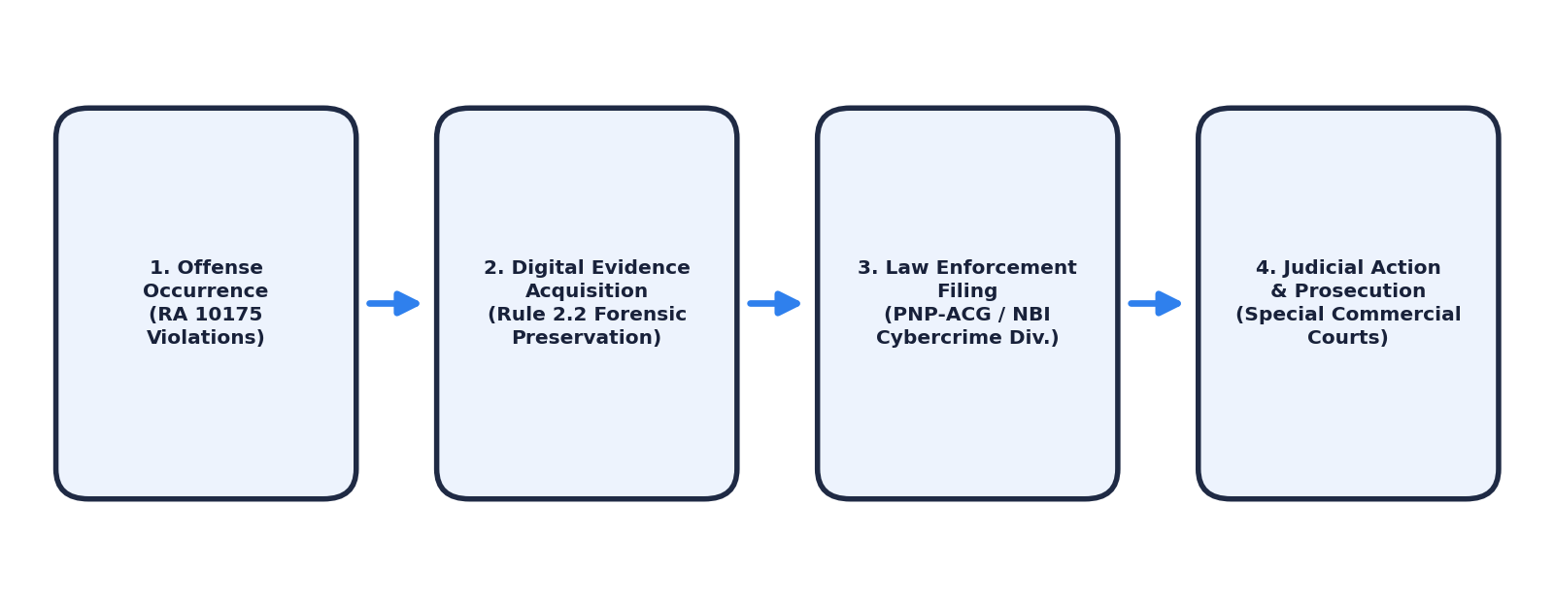
Figure 1: Statutory Enforcement & Jurisdictional Flowchart under RA 10175.

2. Incident Distributions & Statutory Sanctions
According to incident reporting from the PNP Anti-Cybercrime Group (PNP-ACG) and the NBI Cybercrime Division, financial cyber fraud and identity theft constitute the majority of tertiary student complaints.
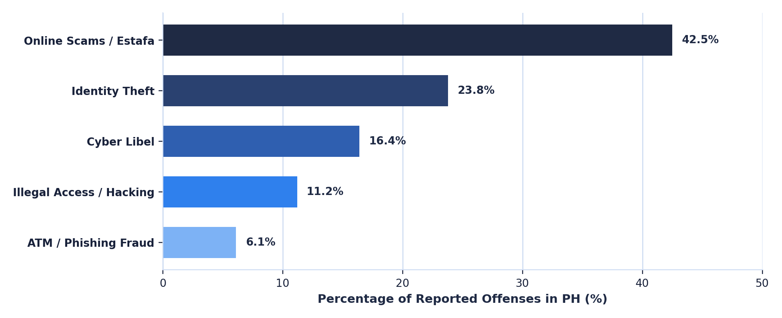
Figure 2: Relative Distribution of Philippine Cyber Offenses by Category.

Core Penalties Matrix
Statutory Violation | Legal Basis | Prescribed Penalty
Illegal Access & Hacking | Sec. 4(a)(1) | Prision mayor (6 yrs 1 day to 12 yrs) or fine ≥ ₱200,000
Computer-Related Identity Theft | Sec. 4(b)(3) | Prision mayor or fine ≥ ₱200,000 to ₱500,000
Cyber Libel | Sec. 4(c)(4) | Prision correccional max to prision mayor min (one degree higher)

3. Student Guidelines & Legal Disclaimer
To mitigate exposure to cybercrime liability and victimization on campus, students should observe:
- Stringent credential security: Enforcing unique multi-factor authentication (MFA) across university portals.
- Digital defamatory awareness: Acknowledging that defamatory statements posted on public forums or private chat leaks fall under Section 4(c)(4).
- Verification of commercial transactions: Engaging solely in verified peer-to-peer exchanges.

KEY DEFINITION — Legal Disclaimer: This academic report is compiled for educational case study analysis at STI West Negros University and does not constitute formal legal counsel. For statutory enforcement or active litigation, consult licensed legal counsel and the PNP Anti-Cybercrime Group.

Verified References
Cybercrime Prevention Act of 2012, Rep. Act No. 10175, 108:41 O.G. 5299 (Sept. 12, 2012) (Phil.).
Disini v. Secretary of Justice, G.R. No. 203335, 716 S.C.R.A. 237 (Feb. 18, 2014) (Phil.).
Philippine National Police Anti-Cybercrime Group. (2025). Annual Cyber Threat Assessment and Student Digital Safeguards Report. Camp Crame, Quezon City.

