Internship Narrative Report & Technical Practicum
486 Hours of On-the-Job Training in Full-Stack Web Development, UI/UX Engineering, and Cloud DevOps

Submitted by: Jhon Paulo Gascon
Bachelor of Science in Information Technology
College of Information Technology
STI West Negros University
Academic Year 2026–2027

1. Host Training Establishment & Objectives
This narrative report summarizes the 486-hour industry practicum undertaken at a premier enterprise software and creative design agency in Western Visayas. As an IT Practicum Trainee, the author contributed to real-world client sprints spanning front-end interface implementation, RESTful API integration, and continuous integration pipelines.
KEY DEFINITION — Practicum Objective: To synthesize academic computer science coursework with enterprise agile software workflows, mastering collaborative git version control, reactive UI design, and production deployment protocols.

Practicum Deployment Architecture
Daily engineering tasks centered on containerized microservices and automated deployment workflows:
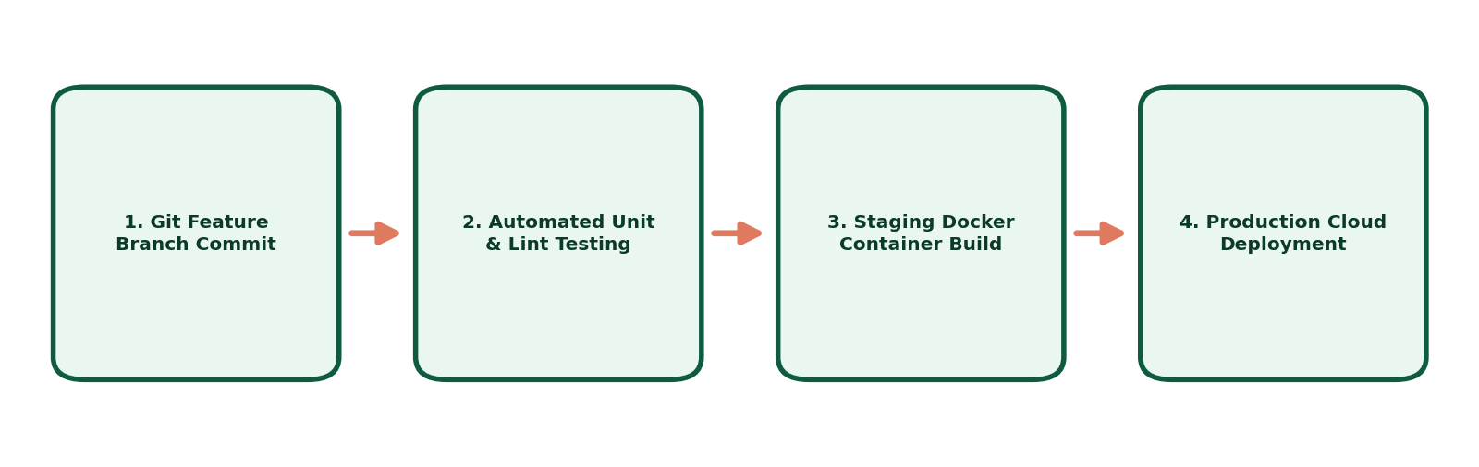
Figure 1: Full-Stack CI/CD Pipeline Implemented During Industry Practicum.

2. Summary of Weekly Milestones & Deliverables
The 486 hours were distributed across four distinct milestone phases, progressing from onboarding environment configuration to leading feature releases.

Practicum Milestone Log
Sprint Phase | Core Focus Area | Hours Completed | Key Technical Deliverable
Phase 1 (Wk 1–3) | Environment & UI Auditing | 120 Hours | Component library refactor in Figma
Phase 2 (Wk 4–6) | Frontend Development | 130 Hours | Responsive dashboard built with HTML5/CSS3/JS
Phase 3 (Wk 7–9) | API & Database Integration | 126 Hours | REST endpoints connecting PostgreSQL DB
Phase 4 (Wk 10–12) | QA & Staging Deployment | 110 Hours | Dockerized container deployment with CI pipeline

3. Professional Takeaways & Technical Insights
The practicum bridged theoretical coursework with enterprise expectations. The most profound learning occurred during cross-functional code reviews, where writing maintainable, well-documented code took precedence over rapid, unverified implementations.

Key Professional Takeaways
- Communication in Agile Teams: Active participation in morning standups resolved blockers before they escalated into release delays.
- Resilient Error Handling: Transitioning from happy-path development to anticipating edge cases and latency degradation.
- User-Centric Design Thinking: Recognizing that intuitive UI ergonomics directly determine customer conversion rates.

Verification & Sign-off
Certified true and complete report of 486 rendered on-the-job training hours in fulfillment of the Bachelor of Science in Information Technology curriculum at STI West Negros University.

