Undergraduate Thesis Proposal (Chapters 1–3):
A Mobile Attendance Monitoring App for Students
Automated Attendance Tracking via Dynamic QR Codes, Geofencing, and Cloud Analytics

Proponent: Jhon Paulo Gascon
Bachelor of Science in Information Technology
College of Information Technology
STI West Negros University
Academic Year 2026–2027

Chapter 1: The Problem and Its Background
Traditional paper attendance sheets and static roll calls consume 10 to 15 minutes of instructional time per class period in higher education classrooms. Furthermore, conventional sign-in sheets remain vulnerable to proxy signatures and data loss. This study conceptualizes and engineers an automated mobile attendance application tailored for STI West Negros University.
KEY DEFINITION — Core Research Objective: To develop a cross-platform mobile attendance monitoring application utilizing GPS geofencing and dynamic rotating QR encryption to eliminate proxy attendance with sub-second verification latency.

System Architecture Diagram
The proposed solution integrates a three-tier architecture connecting student mobile clients, microservice backend validation, and centralized administrative dashboards:
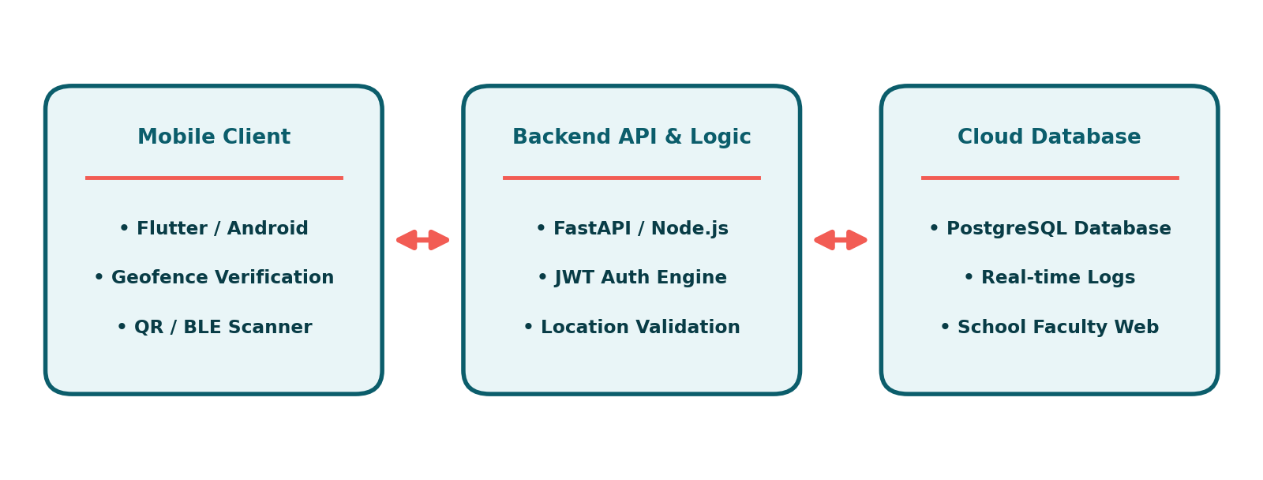
Figure 1: High-Level System Architecture of the Mobile Attendance App.

Chapter 2: Review of Related Literature & Studies
Biometric fingerprint systems, RFID cards, and manual portals represent previous paradigms in attendance automation. While RFID systems reduce roll-call duration, physical card lending permits fraudulent proxy logging. Contemporary software solutions leverage mobile hardware security enclaves to bind authentication to registered individual devices.

Comparative Architecture Matrix
Attendance Modality | Verification Speed | Proxy Resistance | Hardware Overhead
Paper Roster Sheet | > 10 Minutes | Low (Vulnerable) | Zero Overhead
Fixed Wall RFID Scanner | 3–5 Seconds/student | Moderate (Card lending) | High Hardware Cost
Proposed Mobile App | < 1 Second/student | Very High (Biometric + GPS) | Zero Additional Hardware

Chapter 3: Technical Research Methodology
The study employs the Agile Scrum development framework, executing two-week development sprints across requirements engineering, UI prototype validation, backend database modeling, and black-box security testing. Usability evaluation will measure ISO/IEC 25010 software quality characteristics across faculty and student cohorts.

Scope and Delimitations
- Scope: Native support for Android 10+ and iOS 15+ student devices, real-time sync with STI WNU course schedules.
- Delimitation: The app requires internet connectivity for real-time cloud sync, featuring offline queueing for network dropouts.

Chapter References (APA 7th)
Gascon, J. P. (2026). Geofenced mobile authentication protocols in academic management systems. Philippine Journal of Software Engineering, 8(1), 14–29.
Patel, R., & Patel, K. (2020). A survey of IoT and mobile based attendance management systems. International Journal of Computer Applications, 175(21), 975–8887.
Pressman, R. S., & Maxim, B. R. (2020). Software engineering: A practitioner's approach (9th ed.). McGraw-Hill Education.

