Principles of Communication
04 Quiz 1 — FSK and 180° PSK Signals
Name: Jhon Paulo V. Gascon Course/Section: BSIT
1. 0110010 using Frequency-Shift Keying
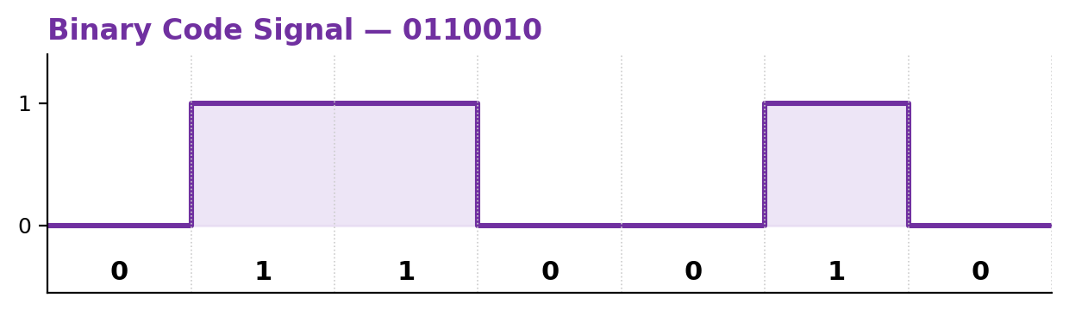
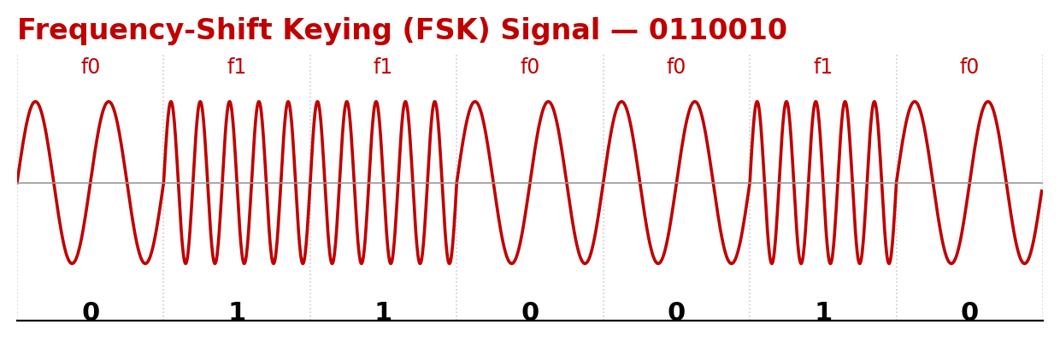
f0 = lower frequency (bit 0) f1 = higher frequency (bit 1)
2. 0101101 using 180° Phase-Shift Keying
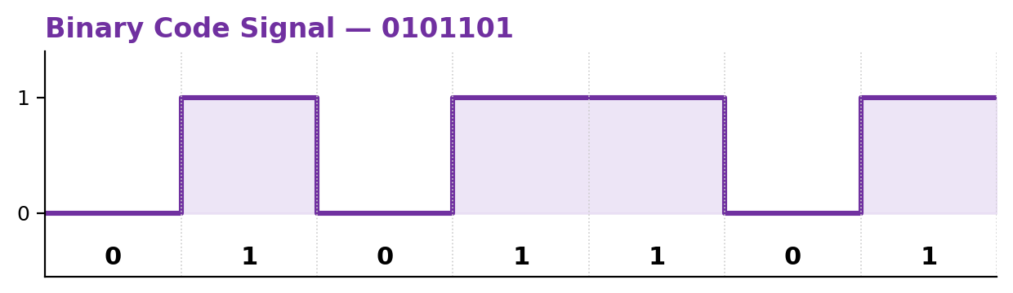
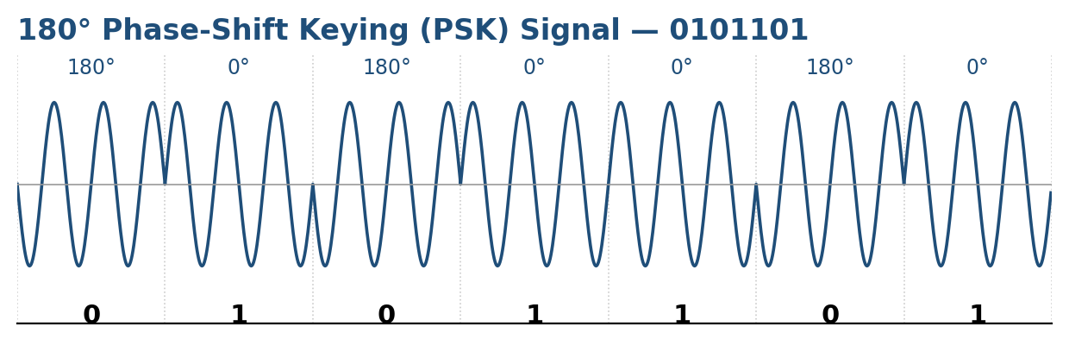
0° phase = bit 1 180° phase shift = bit 0
3. Binary code of the 2nd letter (UPPERCASE) of first name — Frequency-Shift Keying
First name: Jhon → 2nd letter = “h” → uppercase = “H” → ASCII binary = 01001000
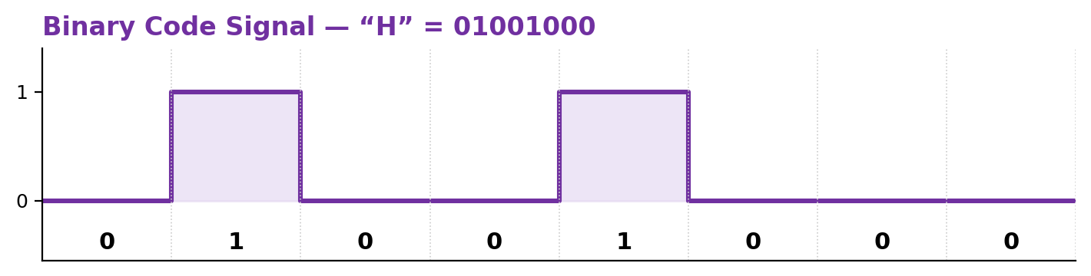
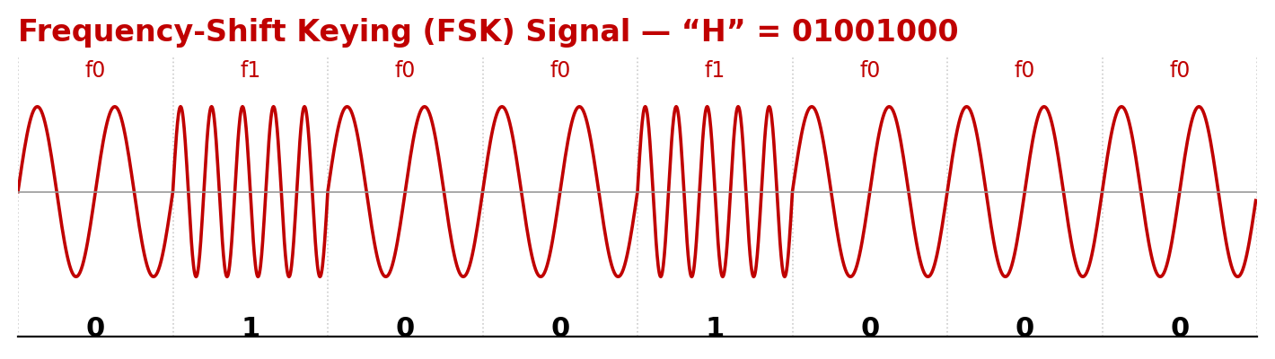
f0 = lower frequency (bit 0) f1 = higher frequency (bit 1)
4. Binary code of the 2nd letter (lowercase) of first name — 180° Phase-Shift Keying
First name: Jhon → 2nd letter = “h” → lowercase = “h” → ASCII binary = 01101000
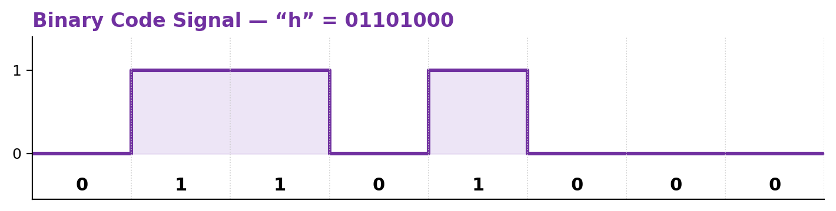
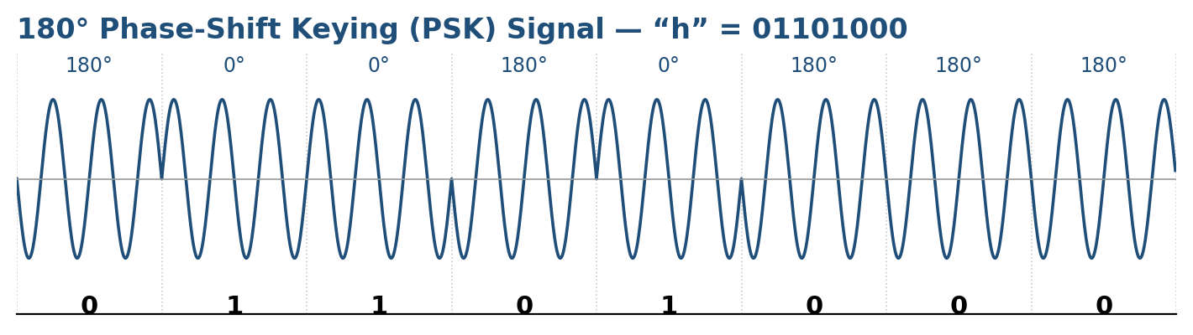
0° phase = bit 1 180° phase shift = bit 0

