IT ELECTIVE 1 · WEB DEVELOPMENT
Membership Form Activity — Step 10 Browser Checks
Jhon Paulo V. Gascon — BSIT 2G
Screenshots of the browser's validation checks, taken while testing membership.html in Chrome.

Test 1 — Click Join with everything empty
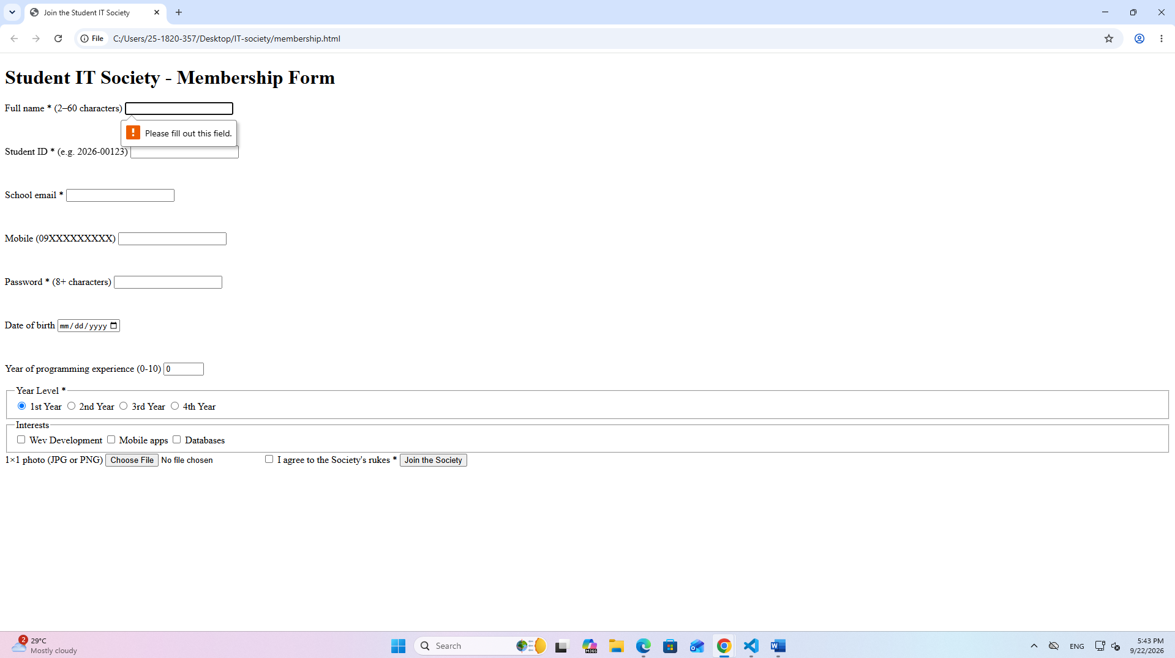
What Chrome said: Please fill out this field. (shown under Full name, the first required box)

Test 2 — Email: juan@example
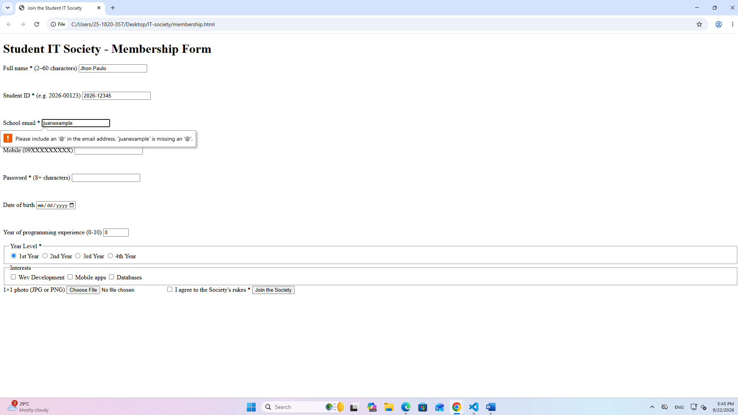
What Chrome said: Please include an '@' in the email address. 'juanexample' is missing an '@'.

Test 3 — Student ID: 2026-123
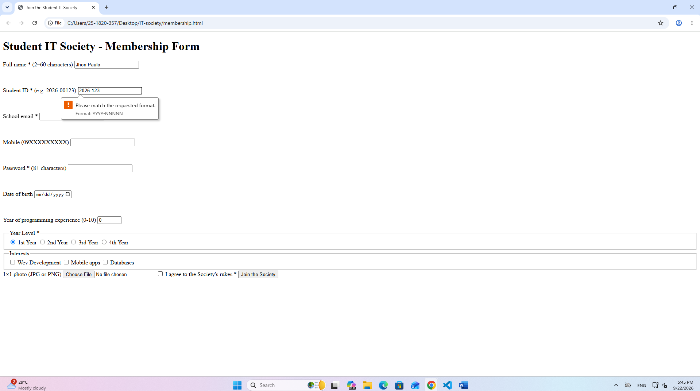
What Chrome said: Please match the requested format. Format: YYYY-NNNNN

Test 4 — Mobile: 0917123
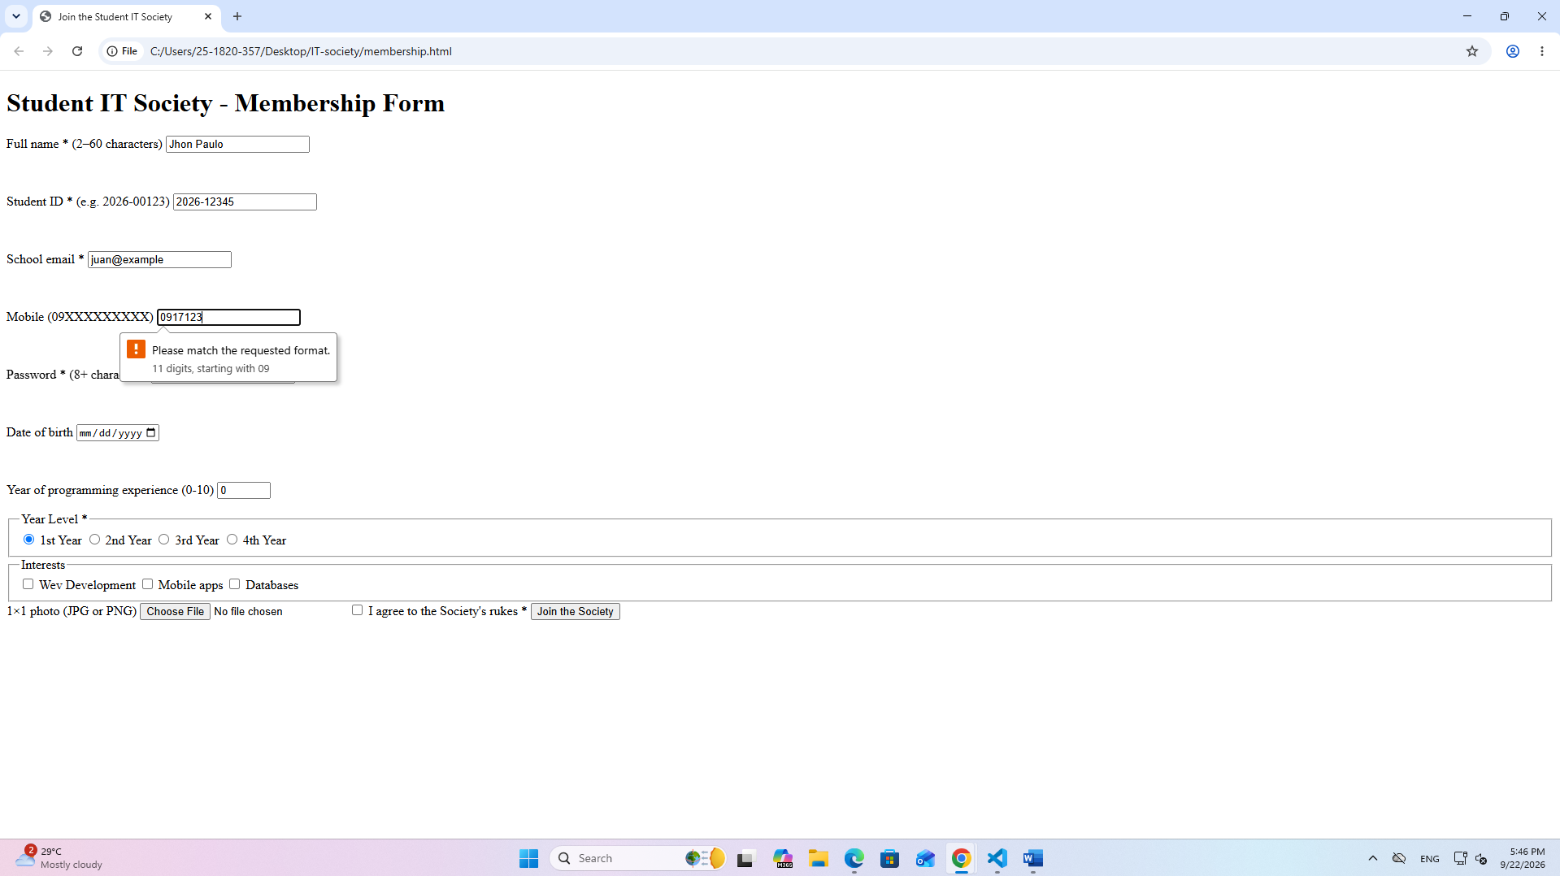
What Chrome said: Please match the requested format. 11 digits, starting with 09

Test 5 — Password: 5 characters
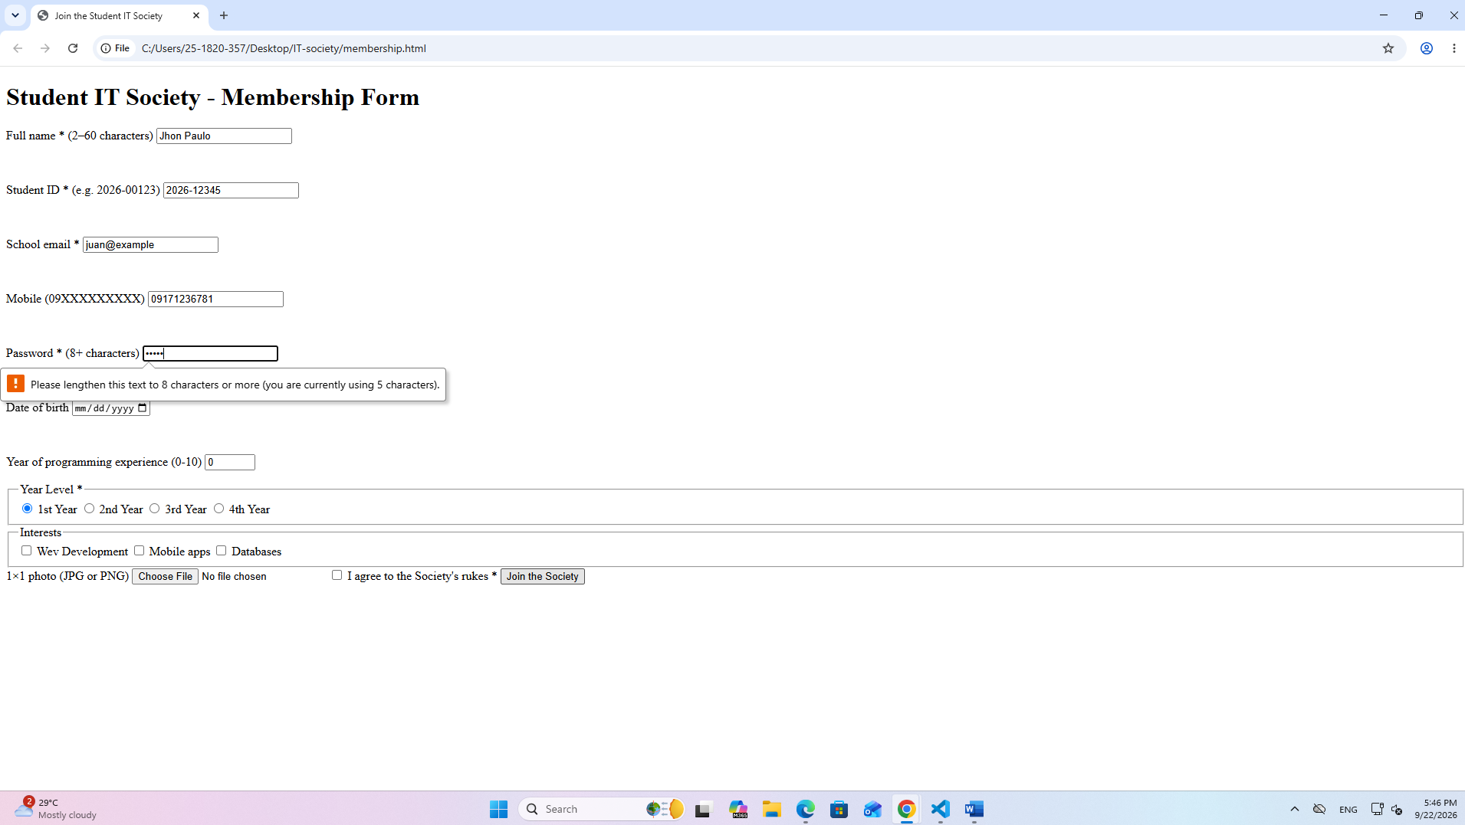
What Chrome said: Please lengthen this text to 8 characters or more (you are currently using 5 characters).

Test 6 — Experience: -1
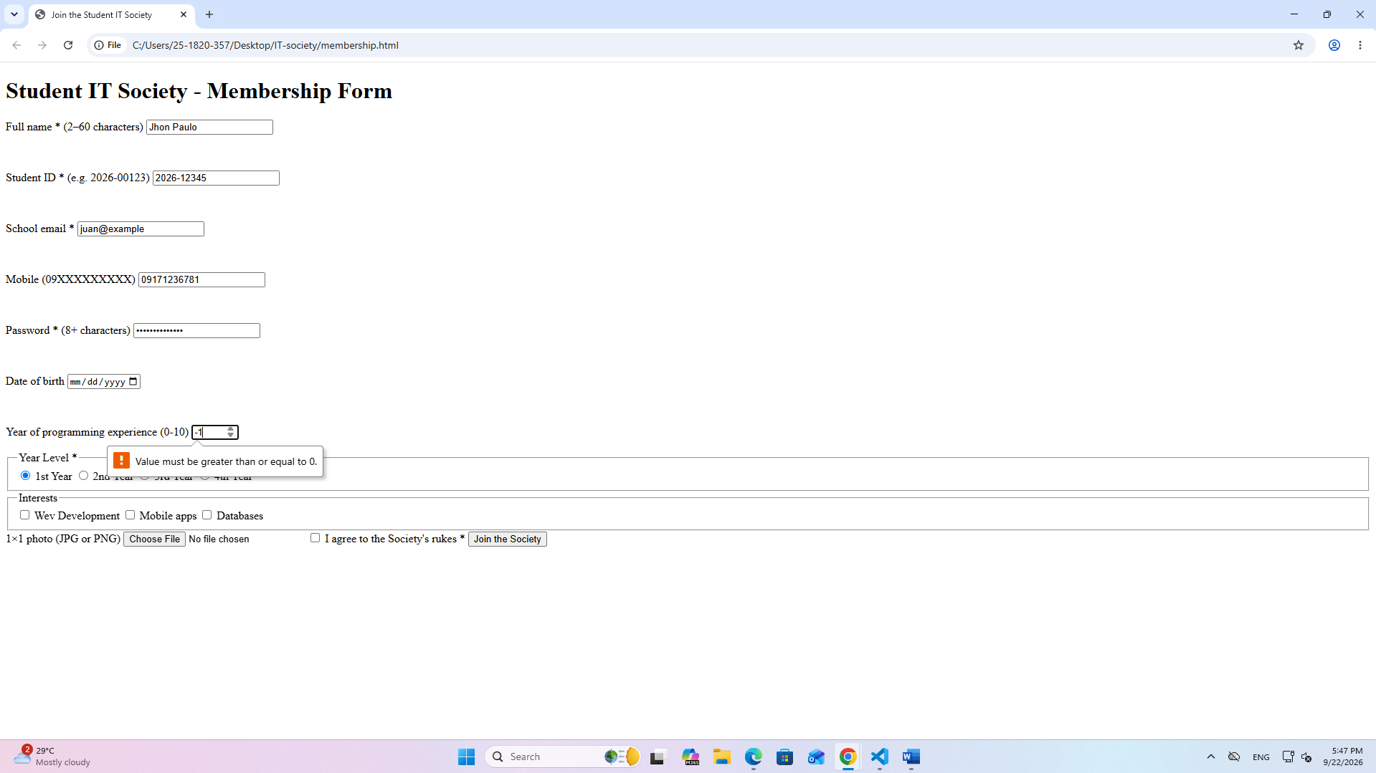
What Chrome said: Value must be greater than or equal to 0.

Test 7 — Click 2nd year — does 1st year un-pick?
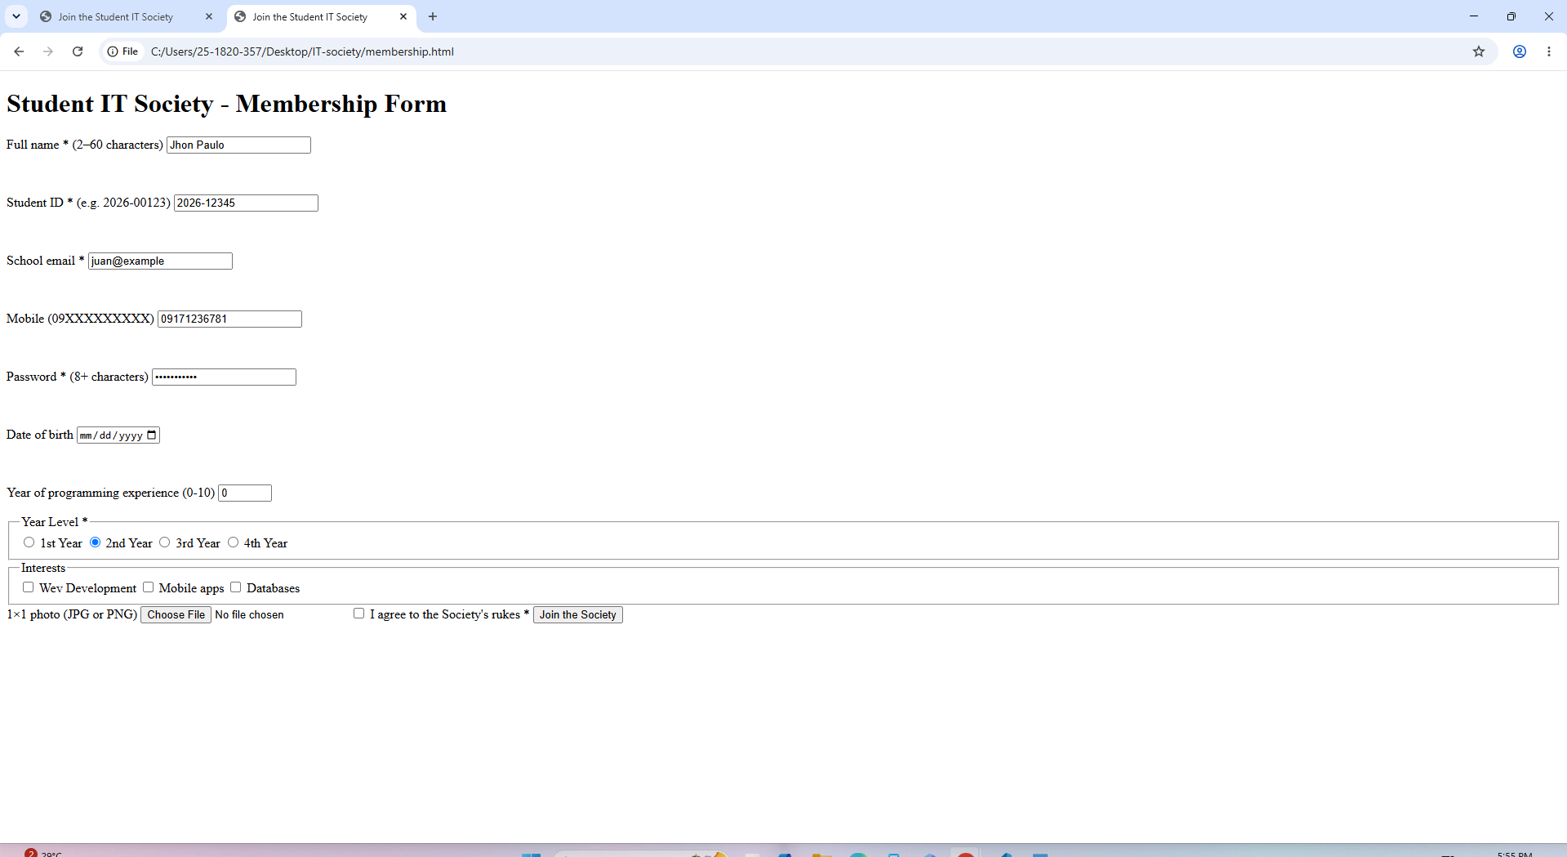
What Chrome said: Yes — selecting 2nd Year automatically un-picked 1st Year. No error message; this just confirms the radio group works (only one option can be selected at a time).

Test 8 — Leave I agree unticked, click Join
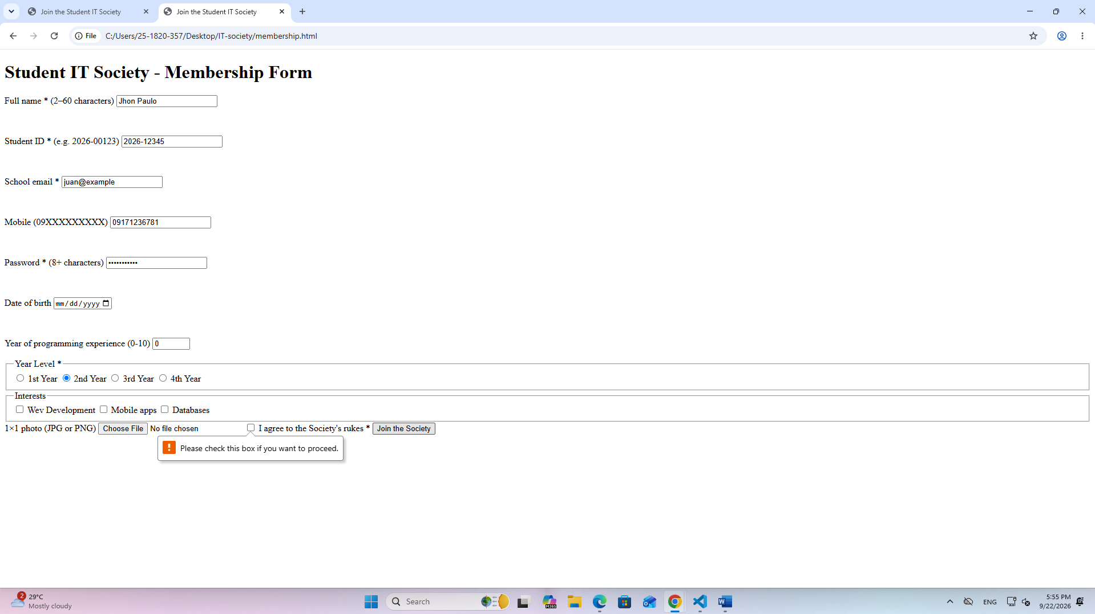
What Chrome said: Please check this box if you want to proceed.

