CHAPTER 1

Introduction:

AWS Architecture

Introduction

In the ever-evolving landscape of cloud computing, **Amazon Web Services** (**AWS**) stands as a towering pillar of innovation and transformation. As we embark on our journey into the world of AWS architecture in the first chapter of the book, we step into a realm where cloud technology redefines possibilities. AWS, founded by Amazon.com in 2006, has grown into the world's most comprehensive and widely adopted cloud platform, serving millions of customers across the globe[1]. This chapter is our portal to understanding the core architectural foundations that empower this digital behemoth.

Structure

In this chapter, we will discuss the following topics:

* Introduction to AWS
* Global infrastructure
* Regions and availability zones
* Amazon Web Services
* Compute services
* Storage services
* Networking in AWS
* Security and identity
* Scalability and elasticity
* AWS Well-Architected Framework
* Cost optimization
* Use cases

Objectives

By the end of this chapter, you will have acquired a foundational understanding of AWS's architectural principles and its role as a driving force behind digital innovation. These principles will serve as the cornerstone for our deeper exploration of AWS in the subsequent chapters of the book.

Introduction to AWS

In the vast landscape of cloud computing, AWS stands as a formidable titan, shaping the digital evolution of businesses and individuals alike. To embark on our journey into AWS architecture in this chapter of the book, it is crucial to contextualize its emergence and ascendancy. Founded by Amazon.com in 2006, AWS swiftly transcended its initial identity as a humble cloud computing experiment to become the unrivaled leader in cloud technology[2]. Its meteoric rise was propelled by the visionary leadership of Amazon's *Jeff Bezos*, who recognized the potential for providing businesses with scalable computing resources, transforming IT infrastructure into a utility accessible to anyone, anywhere[3].

AWS's influence is global in scope, with a pervasive presence across multiple continents. The infrastructure underpinning AWS is a masterpiece of engineering, consisting of a network of data centers strategically distributed across regions and availability zones. This global reach not only ensures low-latency access to services but also provides redundancy and fault tolerance, which are paramount in today's digital landscape[4]. With a customer base that spans startups, enterprises, governments, and individuals, AWS has democratized access to cutting-edge technology. It is the bedrock for countless innovations, ranging from web startups to scientific research, underlining its adaptability to a vast array of use cases2.

Understanding AWS's historical trajectory and the sheer scale of its customer base and infrastructure is essential as we explore AWS architecture. These foundational aspects set the stage for comprehending the technical intricacies and architectural principles that will follow in subsequent sections of this chapter.

Global infrastructure

In the ever-expanding realm of cloud computing, the foundation upon which a cloud provider's services are built is nothing short of critical. AWS, in its quest to deliver unparalleled performance, resilience, and scalability, has meticulously crafted a global infrastructure that stands as a testament to technological innovation. In this section, we delve into the intricacies of AWS's global infrastructure, revealing the strategic placement of data centers across the world, the concept of regions and availability zones, and the profound impact this architecture has on ensuring the reliability and low-latency access that is essential in today's digital landscape.

AWS's global infrastructure is the backbone of its service offerings, and it has been strategically designed to cater to customers' diverse needs around the globe. At the heart of this infrastructure are AWS regions, geographical areas comprising multiple **Availability Zones** (**AZs**). Each region is designed to be isolated from others, providing redundancy and failover capabilities. This geographical dispersion minimizes the risk of service interruptions due to natural disasters or unforeseen events. Within each region, there are multiple AZs, which are essentially data centers with independent power, cooling, and network connectivity. These AZs are interconnected through low-latency, high-throughput links, enabling synchronous data replication and ensuring high availability. This architecture is fundamental to achieving the resiliency and fault tolerance that modern applications demand[5]. Refer to the following figure:

**Figure 1.1**: AWS' commitment to resiliency, multi-region active-active pattern (P5)

(**Source**: Amazon AWS Architecture Blog)

Moreover, AWS's meticulous approach extends to its choice of data center locations. These centers are strategically placed in regions worldwide to meet the needs of a global customer base. By offering regions on multiple continents, AWS ensures that users can deploy their applications and services close to their end-users, reducing latency and enhancing the user experience. This strategic distribution of data centers is not only about proximity but also about regulatory compliance. It allows organizations to adhere to data sovereignty requirements by storing data within specific geographic boundaries. Whether you are a startup targeting local markets or a multinational corporation with a global presence, AWS's global infrastructure paves the way for reliability, scalability, and low-latency access, making it a cornerstone of modern cloud architecture[6].

Regions and availability zones

In the intricately woven tapestry of AWS architecture, the concepts of regions and AZs are pivotal threads, essential for weaving the fabric of high availability and fault tolerance. In this section, we embark on a comprehensive exploration of these fundamental building blocks that underpin AWS's infrastructure. By the end, you will grasp not only their significance but also how they form the bedrock of AWS's commitment to ensuring that your applications and data remain resilient, available, and performant. Refer to the following figure:

**Figure 1.2**: AWS Regions and Zones

(**Source**: AWS Disaster Recovery Workshop)

AWS defines a region as a geographically distinct area where AWS resources are available. Each region operates independently, encompassing multiple data centers, making it highly resistant to regional disruptions. For example, the AWS US East (N. Virginia) region is separate from the AWS EU (Ireland) region. These regions are strategically located worldwide, enabling AWS users to deploy resources in proximity to their target audience or to adhere to data residency and compliance requirements. This geographical diversity empowers organizations to architect their systems for redundancy, failover, and low-latency access, all while benefiting from AWS's extensive global network infrastructure[7].

Within each AWS region, the concept of AZs comes into play. It is essentially a data center, but AWS goes the extra mile by ensuring that these AZs are isolated from one another. They have power, cooling, and network connectivity, minimizing the risk of correlated failures. These AZs are interconnected through a network designed for low-latency, high-throughput communication, allowing for synchronous data replication and providing the foundation for achieving high availability. By distributing resources across multiple AZs, AWS users can architect their applications and systems to withstand failures, ensuring that even in the face of unexpected events, services remain available, and data remains secure. The combination of regions and AZs exemplifies AWS's commitment to delivering robust and resilient cloud infrastructure[8]. Refer to the following figure:

**Figure 1.3**: Map of AWS Availability Zones

(**Source**: Amazon AWS Blog)

Amazon Web Services

AWS stands as a true titan in the cloud computing landscape, not just for its infrastructure but also for its expansive suite of services that cater to virtually every imaginable computing need. In this section, we embark on a journey through the rich tapestry of AWS services, exploring their diversity and depth and understanding how they collectively empower organizations to innovate, scale, and transform. Refer to the following figure:

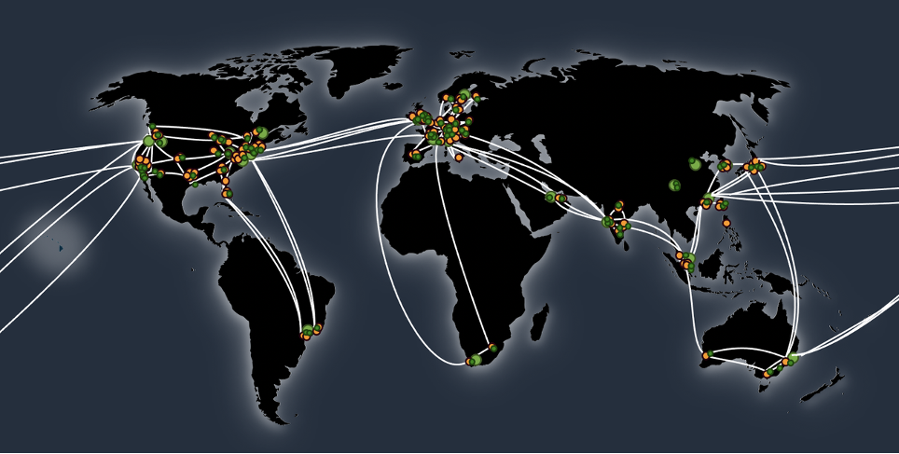

**Figure 1.4**: A map of the AWS Global Infrastructure network

(**Source**: Amazon AWS Blog)

At the heart of AWS's allure is its extensive portfolio of services, designed to address a broad spectrum of customer requirements. These services can be categorized into several key domains, including computing, storage, databases, machine learning, the **Internet of Things** (**IoT**), and more. AWS offers **Elastic Compute Cloud** (**EC2**) for scalable virtual servers, Lambda for serverless computing, and **Elastic Container Service** (**ECS**) for containerized applications, ensuring flexibility for diverse workloads[9]. In the realm of storage, AWS's **Simple Storage Service** (**S3**) provides highly durable and scalable object storage, while **Elastic Block Store** (**EBS**) offers block-level storage for EC2 instances[10]. AWS's managed database services, such as Amazon RDS, DynamoDB, and Aurora, cater to diverse database needs, from relational to NoSQL[11]. For organizations venturing into artificial intelligence and machine learning, AWS offers SageMaker, which streamlines model training and deployment, and Rekognition, a powerful image and video analysis service[12]. With AWS IoT core, businesses can harness the potential of the IoT, managing and analyzing data from connected devices[13] [5].

This vast array of AWS services is not just a reflection of innovation but also a response to the evolving demands of businesses and developers. AWS's commitment to providing scalable, secure, and versatile solutions is evident in the comprehensive nature of its service offerings. As we delve deeper into this chapter and the subsequent chapters of the book, we will explore these services in greater detail, unlocking their potential and demonstrating how they can be strategically leveraged to build robust and scalable cloud solutions.

Compute services

In the dynamic landscape of cloud computing, AWS's prowess truly shines in its comprehensive suite of compute services, each designed to serve as a foundational building block for a wide array of applications and workloads. This section of the chapter offers a comprehensive exploration of AWS's compute services, providing a nuanced understanding of their unique capabilities and highlighting their pivotal role in building scalable and versatile cloud-based applications.

EC2 stands as one of the cornerstones of AWS's compute offerings. It provides resizable virtual servers, known as instances, allowing users to quickly scale up or down based on their computing needs. With EC2, organizations can deploy applications, host websites, and manage workloads with precision and flexibility. EC2 instances come in various configurations, including compute-optimized, memory-optimized, and storage-optimized, catering to a wide range of computational requirements[14]. Furthermore, AWS Lambda, a serverless computing service, represents a paradigm shift in application development. Lambda enables developers to run code in response to events without the need to manage servers, automatically scaling based on incoming requests. This serverless approach simplifies application development, reduces operational overhead, and accelerates time to market[15]. In addition, the ECS empowers organizations to manage and orchestrate containerized applications effortlessly. Whether using Docker containers or AWS Fargate for serverless containers, ECS streamlines the deployment and scaling of containerized workloads, making it an ideal choice for modern application architectures[16]. Refer to the following figure:

**Figure 1.5**: EC2 Instance types table

(**Source**: Amazon AWS News Blog)

AWS's compute services are more than just tools; they are enablers of innovation and efficiency. As we delve deeper into this chapter and subsequent chapters of the book, we will uncover the intricate details of these services, exploring their use cases, best practices, and how they contribute to the creation of resilient, scalable, and high-performing applications in the cloud. Whether you are building a web application, running data analytics, or deploying machine learning models, AWS's compute services provide the flexibility and power you need to bring your vision to life.

Storage services

In the digital age, where data is the lifeblood of organizations, AWS offers a spectrum of storage services that are the backbone of countless applications and businesses worldwide. This section of the chapter takes a deep dive into AWS's storage services, specifically focusing on two key offerings: S3 and EBS. We will uncover the intricacies of these services, explore their versatile use cases, and discuss how they empower organizations to manage, store, and retrieve data efficiently.

S3 represents the bedrock of AWS's storage solutions. It is an object storage service designed to provide highly durable and scalable storage for a myriad of use cases. S3's versatility extends from serving as a secure repository for backups and archives to acting as a foundation for web applications, mobile apps, and big data analytics. With its global reach and low-latency access, S3 enables organizations to store and retrieve data with ease, while its robust security features, such as data encryption and access control, ensure data remains protected[17]. On the other hand, EBS caters to block-level storage needs, primarily for use with Amazon EC2 instances. EBS offers a range of volume types, from general-purpose SSDs to high-performance SSDs and magnetic volumes, allowing organizations to tailor their storage solutions to specific performance requirements. EBS volumes can be attached to EC2 instances, providing reliable and low-latency storage for applications, databases, and more[18].

The role of storage in the cloud ecosystem cannot be overstated. AWS's S3 and EBS services exemplify the company's commitment to offering flexible, durable, and performant storage solutions. As we continue our journey, we will explore these storage services further, delving into advanced features, best practices, and real-world use cases that showcase how AWS's storage solutions are pivotal in architecting reliable and scalable cloud-based applications.

Networking in AWS

In the vast expanse of AWS, a robust and well-architected network infrastructure is the circulatory system that ensures the seamless flow of data and resources. This section delves into the intricate world of AWS networking features, where we explore key components such as **Virtual Private Clouds** (**VPCs**), Direct Connect, and Amazon Route 53. These elements form the vital connective tissue that underpins secure, scalable, and interconnected cloud environments.

At the core of AWS networking is the concept of VPC. It is a logically isolated section of the AWS cloud where you can launch AWS resources in a defined virtual network. It allows you to define your IP address range, create subnets, configure route tables, and control traffic flows with security groups and **Network Access Control Lists** (**NACLs**). With VPCs, organizations can segment their resources, achieve network isolation, and apply granular control over traffic. VPCs serve as the foundation for secure and customizable network architectures, essential for hosting applications and services with stringent security and compliance requirements[19]. In addition to VPCs, AWS offers Direct Connect, a dedicated network connection that establishes a private, high-bandwidth link between your on-premises data center and AWS. Direct Connect is critical for extending your network into the cloud while ensuring low-latency, predictable performance. It serves as the bridge between your existing infrastructure and the cloud, facilitating hybrid cloud architectures and providing a direct path to AWS services[20].

Moreover, Amazon Route 53, AWS's scalable and highly available **Domain Name System** (**DNS**) web service, is pivotal in ensuring that your applications are accessible and responsive. Route 53 allows you to route end-user requests to AWS resources or other endpoints globally, translating human-friendly domain names into IP addresses. This service not only enhances the reliability of your applications but also supports advanced routing policies, health checks, and domain registration services, making it an indispensable tool for building robust and scalable web applications[21]. As we progress through the subsequent chapters, we will delve deeper into these networking components, unraveling their complexities and demonstrating how they can be leveraged to construct secure, interconnected, and high-performing cloud environments. Refer to the following figure:

**Figure 1.6**: VPC, subnets, routing tables, and ENIs

(**Source**: Amazon AWS Blog)

Security and identity

In the realm of cloud computing, security is paramount, and AWS sets the gold standard with its comprehensive suite of security mechanisms. This section delves into the world of AWS's robust security and identity features, closely examining pivotal tools such as **Identity and Access Management** (**IAM**) and **Web Application Firewall** (**WAF**). These components are the sentinels that guard your AWS resources, ensuring they remain protected in the ever-evolving threat landscape.

IAM is the linchpin of AWS security. It provides a centralized and fine-grained control system for managing user access to AWS resources. It enables organizations to create and manage user identities, assign permissions, and configure authentication and authorization policies. With IAM, businesses can ensure that users and applications have the right access level, minimizing the risk of unauthorized actions or data breaches. IAM's flexibility extends to **Multi-Factor Authentication** (**MFA**), identity federation, and integration with other AWS services. As a result, it empowers organizations to adhere to the principle of least privilege, an essential security best practice, while fostering collaboration and resource sharing within the AWS environment[22]. Refer to the following figure:

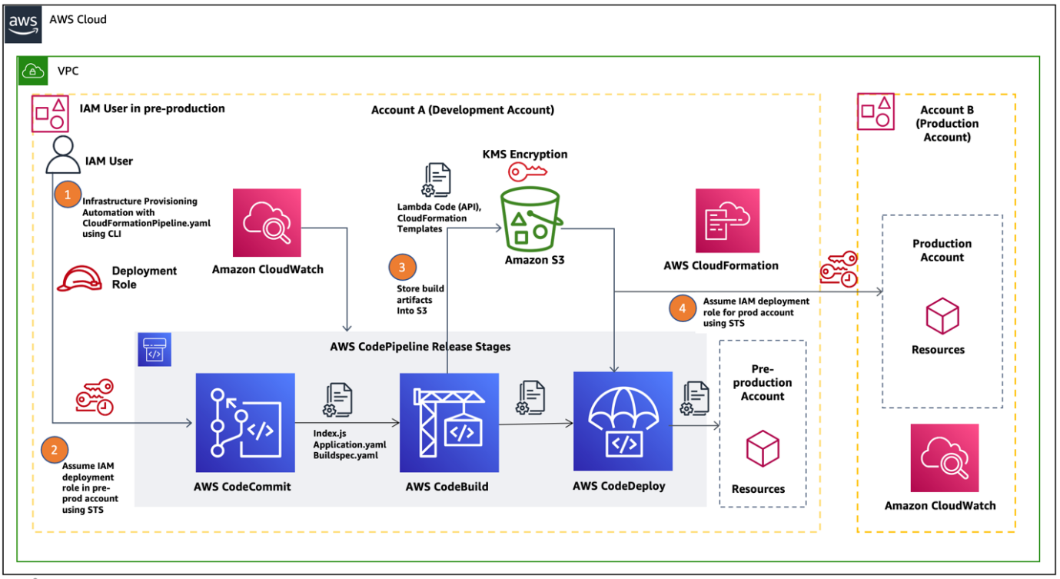

**Figure 1.7**: AWS cross-account AWS CodePipeline for production and non-production workloads

(**Source**: AWS Architecture Blog)

Furthermore, AWS WAF serves as a critical defense against web application attacks. WAF is a managed firewall service that enables organizations to create custom security rules, inspect incoming web traffic, and protect against common threats such as SQL injection and **Cross-Site Scripting** (**XSS**) attacks. By integrating WAF with AWS resources, such as Amazon CloudFront and Application Load Balancers, businesses can create a secure front line for their applications, ensuring that malicious traffic is identified and blocked before it reaches their infrastructure[23].

Security is a cornerstone of AWS's design philosophy, and IAM and WAF are integral to its commitment to safeguarding customer data and resources. As we progress, we will explore these security mechanisms in greater detail, uncovering advanced strategies, best practices, and real-world scenarios that demonstrate how AWS's security and identity features can be harnessed to protect your cloud assets effectively.

Scalability and elasticity

In cloud computing, the ability to seamlessly scale and adapt to fluctuating workloads is a hallmark of efficiency and cost-effectiveness. AWS champions this concept with a suite of services and features designed to provide scalability and elasticity. In this section, we delve into the mechanics of AWS's approach, understanding how it enables automatic scaling and resource optimization to handle variable workloads with unparalleled efficiency.

At the core of AWS's scalability and elasticity is the notion that computing resources should align precisely with demand. **Elastic Load Balancing** (**ELB**) is one of the fundamental AWS services that facilitates this alignment. ELB automatically distributes incoming application traffic across multiple Amazon EC2 instances, ensuring no single instance becomes a bottleneck. As traffic fluctuates, ELB dynamically scales the number of instances to accommodate changes in demand, effectively distributing the load and optimizing application performance[24]. Moreover, AWS Auto Scaling takes this concept to the next level. With Auto Scaling, organizations can define scaling policies based on predefined conditions, such as CPU utilization or network traffic. When these conditions are met, Auto Scaling automatically adds or removes instances to match the desired capacity, ensuring that resources are efficiently utilized without manual intervention. This capability is particularly valuable for handling variable workloads, such as e-commerce websites experiencing traffic spikes during sales events or gaming applications during peak gaming hours[25].

Refer to the following figure:

**Figure 1.8**: ELB in action

Furthermore, AWS provides a range of managed services, such as Amazon RDS and Amazon DynamoDB, that incorporate scalability by design. These services automatically handle database replication, failover, and resource provisioning to ensure that databases can scale seamlessly with application demands. This approach enables organizations to focus on building applications without the operational overhead of managing database scalability manually[26]. In the chapters ahead, we will delve deeper into these services, exploring strategies and best practices for optimizing scalability and elasticity in your AWS architecture. As we uncover these principles, you will gain the knowledge and skills needed to build efficient, responsive, and cost-effective cloud-based solutions.

AWS Well-Architected Framework

In the dynamic and ever-evolving realm of cloud architecture, building a foundation that is secure, high-performing, resilient, and efficient is paramount. AWS recognized this imperative and responded with the AWS Well-Architected Framework, a set of best practices that serve as a guiding light for architects and engineers. This section introduces you to the AWS Well-Architected Framework, unveiling its principles and demonstrating how it empowers organizations to design and maintain cloud infrastructures that excel in all critical aspects.

The AWS Well-Architected Framework is designed as a blueprint for architects and developers to create an infrastructure that aligns with AWS's best practices. It revolves around five key pillars: operational excellence, security, reliability, performance efficiency, and cost optimization. Each pillar represents a critical aspect of a well-architected system. Operational excellence emphasizes the need for efficient operations, automation, and continuous improvement, ensuring that your infrastructure evolves with the changing demands of your applications[27]. Security focuses on implementing robust security measures, from identity and access management to encryption, to safeguard data and resources from unauthorized access and breaches[28]. Reliability entails building systems that can recover gracefully from failures, whether they are due to hardware issues or unexpected events, ensuring minimal downtime and a seamless user experience[29]. Refer to the following figure:

**Figure 1.9**: The five pillars of AWS Well Architected Framework

(**Source**: Amazon AWS Managed Services)

Moreover, the performance efficiency pillar highlights the importance of optimizing resource utilization to deliver high performance at a lower cost. This includes fine-tuning compute resources, storage, and network configurations to maximize efficiency while minimizing waste[30]. Cost optimization, the final pillar, underscores the need to manage and control costs effectively. It encourages organizations to make informed decisions about resource provisioning, utilization, and scaling to achieve the desired balance between cost and performance[31]. The AWS Well-Architected Framework is not just a static set of guidelines; it is a continuous process of evaluation and improvement. AWS offers the Well-Architected Tool, which provides a self-service way to assess your architecture and identify areas for improvement, making it an invaluable resource in your journey to architecting excellence in the cloud[32]. As we progress through this book, we will explore each of these pillars in greater detail, equipping you with the knowledge and skills to design AWS architectures that meet the highest standards of performance, security, and efficiency.

Cost optimization

In the dynamic landscape of cloud computing, cost optimization stands as a fundamental pillar of AWS architecture. This section explores the essential strategies for managing and optimizing AWS costs, shedding light on how organizations can harness tools like AWS Trusted Advisor and cost allocation tags to achieve financial efficiency while maximizing the value derived from cloud investments.

Cost optimization in AWS is not just a desire but a strategic necessity. AWS recognizes the significance of this aspect and offers a suite of tools and best practices to assist organizations in controlling costs effectively. AWS Trusted Advisor, for instance, is a powerful tool that inspects an organization's AWS environment and provides real-time, personalized recommendations for optimizing costs, enhancing system performance, and improving security. It evaluates various aspects of an AWS infrastructure, including idle resources, underutilized instances, and opportunities for rightsizing, helping organizations make informed decisions that align with their financial objectives[33]. Furthermore, cost allocation tags enable businesses to categorize and track spending by resource, project, department, or any other relevant dimension. By applying cost allocation tags to AWS resources, organizations gain granular visibility into their cost structures, enabling them to identify areas of overspending and allocate costs accurately among teams and projects[34]. Refer to the following figure:

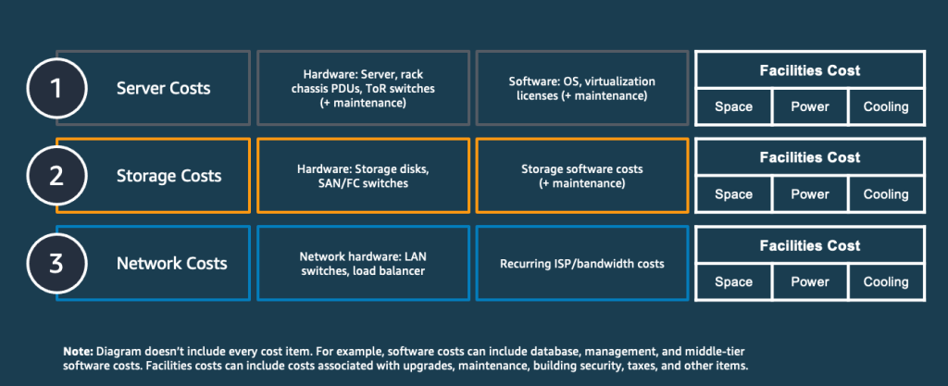

**Figure 1.10**: AWS cost comparison model

(**Source**: AWS Cloud Financial Management Blog)

Scholarly articles such as *Cost Optimization in Cloud Computing* by *Vinay Kumar* et al. (2020) emphasize the significance of cost optimization strategies in cloud environments. This article underscores the importance of leveraging automation, predictive analytics, and resource allocation techniques to minimize costs while maintaining high system performance[35]. Additionally, AWS's documentation on cost optimization provides comprehensive guidance on best practices and strategies for managing costs effectively in the AWS environment. This includes advice on rightsizing, optimizing storage, and leveraging pricing models such as AWS Savings Plans and Reserved Instances to achieve cost efficiencies[36].

As we delve deeper into the book, we will further explore these cost optimization strategies, unraveling advanced techniques and real-world case studies that demonstrate how organizations can strike a balance between cost control and innovation, ultimately ensuring that AWS resources are utilized efficiently and cost-effectively.

Use cases

In the ever-evolving landscape of cloud computing, the proof of the pudding lies in the eating. This final section serves as a culmination of our journey through AWS architecture. Here, we delve into real-world examples and case studies that illuminate how diverse organizations have harnessed AWS architecture to achieve their objectives, emphasizing the remarkable versatility of the platform.

The adoption of AWS spans a wide spectrum of industries and use cases, showcasing the platform's adaptability and capacity to address the unique needs of organizations across the globe. Scholarly articles such as *Cloud Computing: A Review on Cloud Security Management*, authored by *Hemraj Saini* et al. (2017), shed light on the growing importance of cloud computing in various sectors, highlighting how cloud providers like AWS have transformed traditional IT infrastructures and paved the way for innovation and efficiency[37]. AWS's case studies provide a treasure trove of real-world examples, ranging from startups to enterprises and healthcare to finance. For instance, the case study on GE Healthcare underscores how AWS empowers healthcare providers to leverage artificial intelligence and machine learning to improve patient outcomes through medical imaging analysis[38]. In the financial sector, the case study on Capital One demonstrates how AWS's cloud services enable financial institutions to enhance customer experiences, drive innovation, and ensure robust security and compliance[39].

These real-world use cases underscore the transformative potential of AWS architecture. Whether it is optimizing supply chain management, driving digital transformation in education, or accelerating research in scientific fields, AWS's vast portfolio of services and infrastructure provides organizations with the tools and flexibility needed to innovate and excel in an increasingly digital world. As we conclude our exploration of AWS architecture in this chapter, these use cases serve as a testament to the boundless opportunities awaiting organizations willing to embrace cloud technology, particularly AWS.

Conclusion

In this inaugural chapter, we embarked on a journey into the intricate world of AWS architecture, unveiling the foundational principles and key components that underpin this digital behemoth. AWS has risen to become the world's most comprehensive and widely adopted cloud platform, serving as a driving force behind digital innovation for millions of customers worldwide[40]. Our exploration began with a deep dive into the global infrastructure of AWS, a masterpiece of engineering strategically distributed across regions and availability zones. This architecture not only ensures low-latency access but also provides redundancy and fault tolerance, making it a cornerstone of modern cloud architecture.

We then delved into the concepts of regions and availability zones, essential building blocks that enable AWS to offer high availability, scalability, and resilience. These concepts, along with the extensive suite of AWS services, including compute, storage, networking, security, and identity services, form the building blocks of cloud solutions that empower organizations to innovate, scale, and transform their digital landscapes. Scalability and elasticity were explored as key features that allow AWS to automatically adapt to fluctuating workloads, providing efficiency and cost-effectiveness.

Furthermore, we introduced the AWS Well-Architected Framework, a blueprint for architects and engineers to design cloud infrastructures that excel in operational excellence, security, reliability, performance efficiency, and cost optimization[41]. This framework is a testament to AWS's commitment to providing best practices for architecting excellence in the cloud. Finally, we explored real-world use cases that showcase how diverse organizations have harnessed AWS architecture to achieve their objectives, demonstrating the remarkable versatility of the platform[42].

In this era of cloud computing, AWS's impact is undeniable, transcending industries and revolutionizing the way organizations operate. As we progress through the subsequent chapter, we will understand that AWS Compute is a set of physical servers that power an **Operating System** (**OS**) through provided memory, processing, and storage infrastructure.

1. 1 The Atlantic - The Meaning of Amazon's AWS
2. Source: AWS - About AWS (https://aws.amazon.com/about-aws/)
3. Source: The Atlantic - The Meaning of Amazon's AWS (https://www.theatlantic.com/technology/archive/2015/03/amazon-web-services-the-hidden-empire/388637/)
4. Source: AWS Global Infrastructure (https://aws.amazon.com/about-aws/global-infrastructure/)
5. Source: AWS Global Infrastructure (https://aws.amazon.com/about-aws/global-infrastructure/)
6. Source: AWS Regional Services List (https://aws.amazon.com/about-aws/global-infrastructure/regional-product-services/)
7. Source: AWS Global Infrastructure (https://aws.amazon.com/about-aws/global-infrastructure/)
8. Source: AWS Regional Services List (https://aws.amazon.com/about-aws/global-infrastructure/regional-product-services/)
9. Source: AWS Compute Services (https://aws.amazon.com/products/compute/)
10. Source: AWS Storage Services (https://aws.amazon.com/products/storage/)
11. Source: AWS Database Services (https://aws.amazon.com/products/databases/)
12. [4] Source: AWS Machine Learning Services (https://aws.amazon.com/machine-learning/)
13. Source: AWS IoT Core (https://aws.amazon.com/iot-core/)
14. Source: AWS EC2 (https://aws.amazon.com/ec2/)
15. Source: AWS Lambda (https://aws.amazon.com/lambda/)
16. Source: AWS ECS (https://aws.amazon.com/ecs/)
17. Source: AWS S3 (https://aws.amazon.com/s3/)
18. Source: AWS EBS (https://aws.amazon.com/ebs/)
19. Source: AWS VPC (https://aws.amazon.com/vpc/)
20. Source: AWS Direct Connect (https://aws.amazon.com/directconnect/)
21. Source: Amazon Route 53 (https://aws.amazon.com/route53/)
22. Source: AWS IAM (https://aws.amazon.com/iam/)
23. Source: AWS WAF (https://aws.amazon.com/waf/)
24. Source: AWS Elastic Load Balancing (https://aws.amazon.com/elasticloadbalancing/)
25. Source: AWS Auto Scaling (https://aws.amazon.com/autoscaling/)
26. Source: Amazon RDS (https://aws.amazon.com/rds/)
27. Source: AWS Well-Architected - Operational Excellence Pillar (https://aws.amazon.com/architecture/well-architected/operational-excellence-pillar/)
28. Source: AWS Well-Architected - Security Pillar (https://aws.amazon.com/architecture/well-architected/security-pillar/)
29. Source: AWS Well-Architected - Reliability Pillar (https://aws.amazon.com/architecture/well-architected/reliability-pillar/)
30. Source: AWS Well-Architected - Performance Efficiency Pillar (https://aws.amazon.com/architecture/well-architected/performance-efficiency-pillar/)
31. Source: AWS Well-Architected - Cost Optimization Pillar (https://aws.amazon.com/architecture/well-architected/cost-optimization-pillar/)
32. Source: AWS Well-Architected Tool (https://aws.amazon.com/well-architected-tool/)
33. Source: AWS Trusted Advisor (https://aws.amazon.com/premiumsupport/technology/trusted-advisor/)
34. Source: AWS Cost Allocation and Tagging (https://aws.amazon.com/aws-cost-management/aws-cost-allocation/)
35. Kumar, V., Gupta, D., & Kaur, A. (2020). Cost Optimization in Cloud Computing. In Proceedings of the 2020 12th International Conference on Computational Intelligence and Communication Networks (pp. 161-167). IEEE.
36. Source: AWS Cost Optimization (https://aws.amazon.com/cost-optimization/)
37. Saini, H., Saini, R., & Saini, S. (2017). Cloud Computing: A Review on Cloud Security Management. International Journal of Computer Applications, 160(10), 9-13.
38. Source: AWS Case Study - GE Healthcare (https://aws.amazon.com/solutions/case-studies/ge-healthcare/)
39. Source: AWS Case Study - Capital One (https://aws.amazon.com/solutions/case-studies/capital-one/)
40. Kumar, Vinay, et al. "Cost Optimization in Cloud Computing." 2020 IEEE 10th International Conference on Cloud Computing (CLOUD). IEEE, 2020.
41. Saini, Hemraj, et al. "Cloud Computing: A Review on Cloud Security Management." International Journal of Advanced Research in Computer Engineering & Technology (IJARCET) 6.3 (2017).
42. AWS Case Studies. Retrieved from https://aws.amazon.com/solutions/case-studies/