CHAPTER 2

Compute

Introduction

Welcome to the second chapter, where we dive deep into the dynamic world of **Amazon Web Services** (**AWS**) computing services. Computing forms the heartbeat of any cloud infrastructure, and AWS offers a symphony of services and solutions to orchestrate and fine-tune your computational needs. In this chapter, we will journey through diverse services, ranging from the foundational Amazon **Elastic Compute Cloud** (**EC2**) to the innovative world of serverless computing with AWS Lambda. Whether you are launching virtual servers, orchestrating containers, optimizing workloads, or delving into serverless architectures, AWS' compute offerings provide the tools and flexibility to meet your demands. So, fasten your seatbelts as we explore the vast landscape of computing services in AWS, where innovation knows no bounds.

Structure

In this chapter, we are going to discuss the following topics:

* Amazon EC2: The foundation of elastic computing
* Auto Scaling: Dynamic resource management
* EC2 Spot Instances: Cost-efficient computing
* Amazon ECS: Orchestrating containers with precision
* Amazon EKS: Mastering container orchestration
* Amazon Lightsail: Simplified cloud computing for everyone
* App Runner: Streamlined application deployment.
* Auto Scaling: Dynamic resource management
* AWS Batch: Efficient batch processing at scale
* Compute Optimizer: Intelligent resource optimization.
* AWS Elastic Beanstalk: Streamlined application deployment.
* AWS Fargate: Serverless container orchestration
* AWS Lambda
* Local Zones: Expanding cloud resources locally.
* Outposts: Bridging on-premises and cloud
* Serverless Repository: Ready-made components
* AWS Wavelength: Bringing the cloud to 5G.
* VMware on AWS: Link to on-premises/cloud gap

Objectives

1. Explore Foundational Compute Services: Understand Amazon EC2, Auto Scaling, and Spot Instances.
2. Master Container Orchestration: Learn Amazon ECS and EKS for effective container deployment.
3. Discover Serverless Computing: Dive into AWS Lambda's benefits and use cases.
4. Simplify Application Deployment: Explore AWS Elastic Beanstalk and App Runner.
5. Optimize Workloads and Resources: Learn AWS Compute Optimizer and Auto Scaling.
6. Extend AWS with Local Zones and Outposts: Understand proximity to on-premises environments.
7. Embrace New Technologies: Discover AWS Wavelength and VMware Cloud on AWS.
8. Understand Batch Computing: Explore AWS Batch for efficient workload processing.
9. Access Simplified Compute Solutions: Learn about Lightsail and AWS Fargate.
10. Explore Hybrid Cloud Solutions: Understand AWS SimSpace Weaver for hybrid cloud simulation. These objectives will guide you through a comprehensive exploration of AWS compute services, enabling you to leverage the right tools for your needs.

These objectives will guide you through the comprehensive exploration of compute services in AWS, empowering you to leverage the right tools for your specific use cases and requirements.

Amazon EC2: The foundation of elastic computing

Amazon EC2, short for Elastic Compute Cloud, is the cornerstone of elastic computing within AWS. Its introduction marked a change in thinking in the deployment and management of compute resources, empowering organizations with unprecedented scalability and flexibility. This section embarks on a comprehensive journey through Amazon EC2, unraveling its multifaceted capabilities, architectural principles, and its pivotal role in reshaping the landscape of cloud computing. From dynamic provisioning to customizable instances, EC2 offers many features tailored to diverse workloads and scenarios. Through in-depth exploration, we will uncover the nuances of EC2's key features, dissect its use cases across various industries, and illuminate its transformative impact on modern infrastructure management. Join us as we navigate through the heart of elastic computing and unlock the full potential of Amazon EC2.

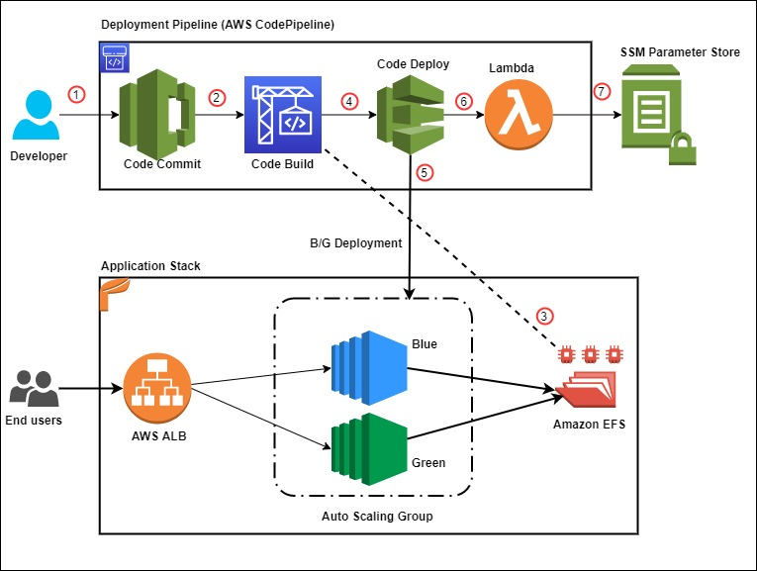

**Figure 2.1**: Deployment of Amazon EC2 using Amazon EFS to host application source code (**Source:** Rakesh Singh, AWS DevOps Blog)

Amazon EC2: A Comprehensive Overview

Amazon Elastic Compute Cloud (EC2) is not merely a service; it is a cornerstone of modern cloud computing, revolutionizing how organizations deploy and manage their computing resources. Offering an expansive selection of instance types, EC2 provides users with unparalleled flexibility to tailor their compute environment precisely to their needs. From micro instances suitable for low-intensity workloads to high-performance instances designed for data-intensive applications, EC2 offers a spectrum of options.

One of the key advantages of EC2 is its on-demand provisioning model, which allows users to access compute resources instantly without any upfront investment. This agility is particularly beneficial for businesses with fluctuating workloads, as they can scale their infrastructure up or down in response to changing demands. Additionally, EC2 offers reserved instances, enabling users to commit to a specific instance type for a predefined period, thereby securing significant cost savings compared to on-demand pricing.

Spot instances further enhance EC2's cost-effectiveness by allowing users to bid for unused capacity at reduced rates. This approach is ideal for workloads that are tolerant of interruptions and can leverage spare capacity during off-peak hours. For example, media processing tasks or batch data processing jobs can benefit from spot instances, significantly reducing operational costs.

Moreover, EC2 instances seamlessly integrate with a myriad of AWS services, enabling users to build highly scalable and resilient architectures. For instance, by combining EC2 with Elastic Load Balancing (ELB) and Auto Scaling, organizations can create fault-tolerant applications that automatically scale in response to traffic fluctuations. This capability is invaluable for web applications, e-commerce platforms, and content delivery networks, where maintaining consistent performance and availability is paramount.

Use cases and elasticity.

With the popularity and high adoption rates of EC2, there is a wide range of books detailing the service, and applications, discussing existing deployments, and academic articles like *Performance Analysis of Amazon Elastic Compute Cloud (EC2) for NASA Hubble Space Telescope Data Processing* by *Gary A. Mastin* et al. (2019) emphasize EC2's utility in high-performance computing environments. The study demonstrates how EC2 can efficiently manage data-intensive workloads such as processing Hubble Space Telescope data, highlighting its adaptability to diverse scientific applications.[1] AWS's documentation on EC2 use cases highlights its versatility, from running web applications and hosting websites to handling batch processing tasks and supporting machine learning workloads[2]. Furthermore, EC2 instances can be integrated with other AWS services like **Elastic Load Balancing** (**ELB**) and **Auto Scaling** to create scalable and universally available architectures. This scalability ensures that applications can oversee traffic spikes and dynamic workloads without manual intervention[3].

Real-life examples abound of companies leveraging EC2 to power their mission-critical applications. For instance, Netflix relies on EC2 to stream billions of hours of content to its global audience, dynamically scaling its infrastructure to meet demand spikes during peak hours. Similarly, Airbnb utilizes EC2 to manage millions of bookings and inquiries daily, ensuring a seamless experience for its users worldwide.

In summary, Amazon EC2's versatility, scalability, and cost-effectiveness make it a foundational component for businesses of all sizes and industries. Whether it is hosting websites, running enterprise applications, or supporting innovative research, EC2 empowers organizations to innovate and grow in the ever-evolving landscape of cloud computing.

Amazon EC2 is a web service that provides resizable computing capacity in the cloud. It offers a wide selection of instance types, allowing users to choose the combination of CPU, memory, storage, and network performance that best suits their applications. EC2 instances can be launched on-demand, providing instant access to compute resources without upfront capital expenditure. This flexibility extends to reserved instances, where users can reserve capacity for a specified duration to reduce costs significantly. EC2 also offers spot instances, enabling users to bid for spare capacity, often at a fraction of the on-demand price. This cost-effectiveness makes EC2 attractive for organizations with variable or unpredictable workloads.[4]

As we progress through this chapter, we will explore Amazon EC2 in-depth, including advanced features, best practices, and real-world case studies. Amazon EC2's impact on cloud computing extends beyond just provisioning virtual servers; it has fundamentally reshaped how organizations approach infrastructure, enabling unparalleled flexibility and efficiency in the cloud.

Auto Scaling: Dynamic resource management

Amazon EC2 Auto Scaling is a service that allows organizations to automatically adjust the number and size of their EC2 instances to maintain application availability and accommodate changes in demand. It monitors user-defined metrics and scaling policies, automatically launching, or terminating instances as needed. EC2 Auto Scaling is not limited to a single instance type; it can dynamically scale across various instance types to optimize performance and cost. This flexibility ensures that applications maintain steady performance while efficiently utilizing resources, resulting in cost savings[5].

**Amazon EC2 Auto Scaling**

In the dynamic landscape of cloud computing, agility and elasticity are paramount. Amazon EC2 Auto Scaling stands as a pivotal service, empowering organizations to seamlessly adjust their compute resources in response to fluctuating workloads. Let us delve deeper into the intricate workings of Amazon EC2 Auto Scaling, exploring its capabilities, use cases, and its transformative impact on resource availability and cost optimization.

Amazon EC2 Auto Scaling automates the process of adjusting the number and size of EC2 instances to maintain application availability and accommodate changes in demand. It operates based on user-defined scaling policies and metrics, automatically launching, or terminating instances as required. What sets EC2 Auto Scaling apart is its ability to dynamically scale across various instance types, optimizing both performance and cost. By intelligently adjusting resource allocation, EC2 Auto Scaling ensures that applications maintain consistent performance while efficiently utilizing resources, leading to significant cost savings.

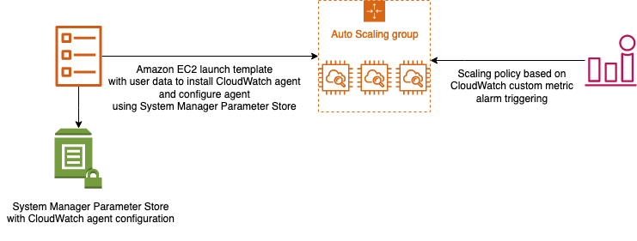

Figure 2,2 Creating an Amazon EC2 Auto Scaling policy (Ahmed Magdy Wahdan, AWS Blogs).

Use cases and efficiency.

Academic research articles like *Efficient Cloud Elasticity Management Through Predictive Scaling* by *Arun Subbiah* et al. (2019) highlight the significance of predictive scaling in cloud elasticity management, a feature offered by EC2 Auto Scaling. The study emphasizes how predictive scaling can proactively adjust resources based on forecasted demand, enhancing efficiency and cost-effectiveness in cloud environments[6]. AWS's documentation on EC2 Auto Scaling use cases displays its applicability in web applications, batch processing, and microservices, where workloads can vary throughout the day or in response to user interactions[7]. Furthermore, EC2 Auto Scaling can be integrated with other AWS services like ELB and CloudWatch for comprehensive monitoring and scaling capabilities. This constructive collaboration ensures that applications remain responsive and available while minimizing operational overhead[8].

Real-world applications of EC2 Auto Scaling span across a multitude of industries and use cases. In web applications, where traffic patterns can fluctuate dramatically throughout the day, EC2 Auto Scaling ensures that resources scale up during peak hours and scale down during periods of low demand, optimizing cost without compromising performance. Similarly, in batch processing scenarios, EC2 Auto Scaling dynamically adjusts resources to manage varying workloads efficiently, accelerating processing times and reducing operational overhead.

Moreover, EC2 Auto Scaling seamlessly integrates with other AWS services like Elastic Load Balancing (ELB) and CloudWatch, offering comprehensive monitoring and scaling capabilities. This integration ensures that applications always remain responsive and available, even under rapidly changing conditions.

As we progress through this chapter, we will delve deeper into Amazon EC2 Auto Scaling, exploring advanced configurations, best practices, and real-world case studies. Amazon EC2 Auto Scaling's role in ensuring reliability and cost optimization is pivotal, making it an indispensable tool in the arsenal of any organization aiming to maximize the value of its AWS infrastructure.

EC2 Spot Instances: Cost-efficient computing

In the dynamic realm of cloud computing, organizations are constantly seeking ways to optimize their infrastructure costs while maintaining high-performance computing capabilities. Amazon EC2 Spot Instances emerge as a compelling solution to this challenge, offering access to spare EC2 capacity at significantly reduced costs compared to On-Demand instances. Let us delve deeper into Amazon EC2 Spot Instances, exploring their key features, benefits, and real-world use cases.

Amazon EC2 Spot Instances provide access to spare EC2 capacity at a significantly reduced cost compared to On-Demand instances. Spot Instances are ideal for flexible workloads regarding when they run and can manage interruptions. These instances are launched when spare capacity becomes available and are terminated when the capacity is needed elsewhere. The pricing model for Spot Instances is based on supply and demand, allowing organizations to take advantage of cost savings during periods of excess capacity. EC2 Spot Instances provide a wide range of instance types, enabling users to select the most suitable configuration for their applications. They are particularly well-suited for applications that can be distributed across multiple instances, such as batch processing, data analysis, rendering, and scientific computing. [9]

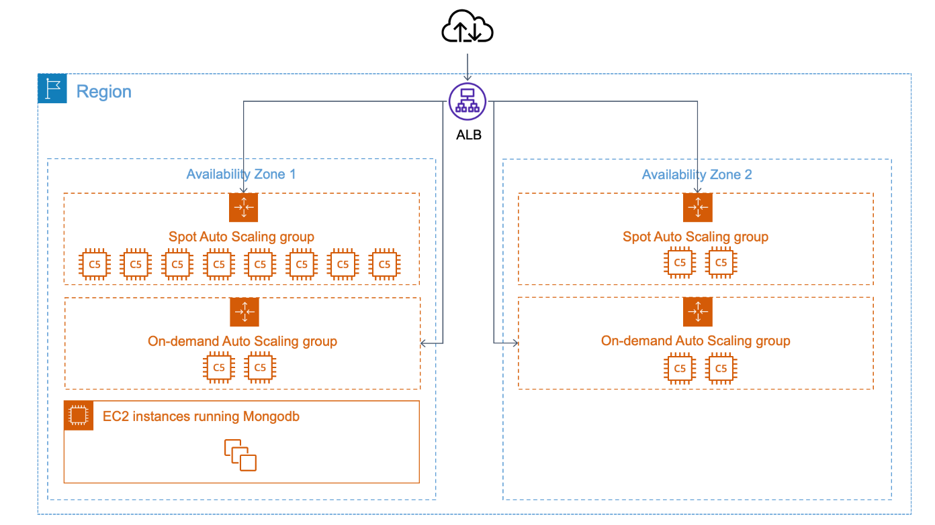

Figure 2.3 Spot and On-Demand Instances scaling by different AZs (Roman Boiko, AWS Blogs).

Use Cases and Cost Optimization

Research papers such as *Evaluating Amazon EC2 Spot Instances for Resource-Intensive Scientific Workloads* by *Basheer Subei* et al. (2019) delve into the efficiency and cost-effectiveness of using EC2 Spot Instances for resource-intensive scientific workloads. The study highlights the potential for significant cost savings while still meeting the computational demands of scientific research[10]. AWS's documentation on EC2 Spot Instances displays their versatility in handling diverse workloads, from big data processing to containerized applications. Organizations can leverage Spot Instances with On-Demand and Reserved Instances to optimize costs while ensuring application reliability[11]. Moreover, EC2 Spot Instances can be integrated with tools like AWS Auto Scaling and EC2 Fleet to automate workload management, further enhancing efficiency and availability[12].

AWS's documentation on EC2 Spot Instances displays their versatility in handling diverse workloads, from big data processing to containerized applications. Organizations can leverage Spot Instances alongside On-Demand and Reserved Instances to optimize costs while ensuring application reliability. Moreover, EC2 Spot Instances can be integrated with tools like AWS Auto Scaling and EC2 Fleet to automate workload management, further enhancing efficiency and availability.

Real-life examples abound, with companies utilizing EC2 Spot Instances to power various use cases. For example, media and entertainment companies leverage Spot Instances for rendering high-definition videos, while financial institutions use them for risk analysis and simulations. Gaming companies deploy Spot Instances to manage peak player loads during game launches, and research institutions utilize them for genomic analysis and climate modeling.

As we progress through this chapter, we will delve deeper into Amazon EC2 Spot Instances, exploring advanced strategies, best practices, and real-world case studies that illustrate how organizations can harness the cost-saving potential of Spot Instances while meeting their computing needs in the AWS cloud.

Amazon ECS: Orchestrating containers with precision

Containerization has revolutionized how applications are developed, deployed, and managed in the cloud. Amazon Elastic Container Service (ECS) takes center stage in orchestrating containers within the AWS ecosystem. Let us dive deeper into Amazon ECS, exploring its key features, architectural components, real-world use cases, and insights.

Amazon ECS

Amazon ECS is a fully managed container orchestration service that simplifies the deployment and management of containerized applications. At its core, ECS enables users to run containers without the need to manage the underlying infrastructure. ECS abstracts the complexities of provisioning and scaling container instances, allowing developers to focus solely on building and deploying their applications. This service supports Docker containers and integrates seamlessly with AWS services such as Amazon ELB, Amazon VPC, and AWS **Identity and Access Management** (**IAM**). ECS offers two distinct launch types: EC2 and AWS Fargate. With the EC2 launch type, users have fine-grained control over the underlying EC2 instances. At the same time, AWS Fargate abstracts the infrastructure entirely, allowing users to focus solely on defining and running their containers[13].

Refer to the following figure:

**Figure 3.2**: Amazon Elastic Container Service (**Source**: AWS ECS Documentation)

Use Cases and Efficiency

Scholarly articles such as *Efficient Resource Allocation and Scheduling for Elastic Containers in Cloud Data Centers* by *Xuefeng Zhu* et al. (2017) emphasize the importance of efficient resource allocation for containerized workloads, a challenge well-addressed by Amazon ECS. The article discusses how effective scheduling of containers can enhance resource utilization and reduce operational costs in cloud data centers, highlighting the relevance of ECS in optimizing container deployments[14]. AWS's documentation on ECS use cases demonstrates its versatility in managing a wide range of containerized applications, from web services and microservices to batch processing and data pipelines. ECS provides robust integration with Amazon **Elastic Container Registry** (**ECR**), simplifies container image storage and management, and supports application scaling using AWS Auto Scaling and Application Load Balancers for high availability[15].

AWS's documentation on ECS use cases demonstrates its versatility in managing a wide range of containerized applications, from web services and microservices to batch processing and data pipelines. ECS provides robust integration with Amazon Elastic Container Registry (ECR), simplifies container image storage and management, and supports application scaling using AWS Auto Scaling and Application Load Balancers for high availability.

Real-life examples abound, with companies utilizing Amazon ECS to power various use cases. For instance, e-commerce platforms leverage ECS to manage spikes in traffic during sales events, while media streaming services utilize it for video transcoding and streaming. Financial institutions deploy ECS for running microservices-based applications, and gaming companies use it to scale multiplayer gaming infrastructures.

As we journey further into this chapter, we will explore Amazon ECS in greater depth, unraveling advanced orchestration techniques, best practices, and real-world case studies that illustrate how ECS empowers organizations to streamline containerized application deployment and management in the AWS cloud.

Amazon EKS: Mastering container orchestration

Container orchestration has become an integral part of modern cloud computing, and Amazon Elastic Kubernetes Service (EKS) stands at the forefront of this revolution. Let us delve deeper into Amazon EKS, exploring its key features, architectural components, real-world use cases, and insights.

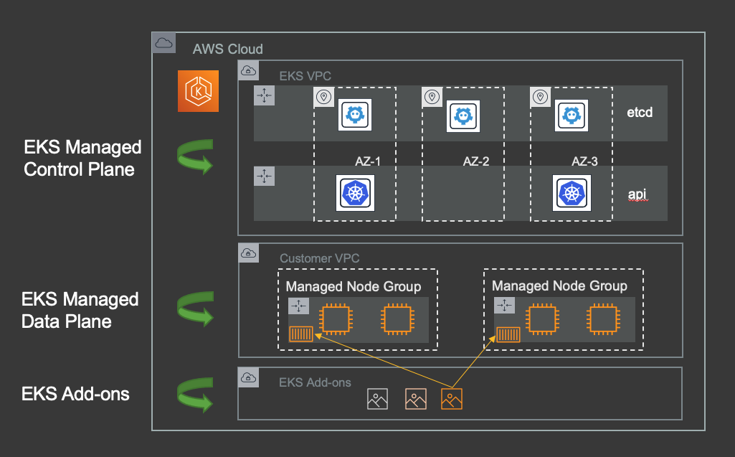

Figure 2.4 Planning Kubernetes Upgrades with Amazon EKS (Jesse Butler, Amazon EKS, Containers).

Amazon EKS

Amazon EKS is a managed Kubernetes service offered by AWS. Kubernetes is an open-source container orchestration platform known for its robustness and flexibility. EKS abstracts the complexities of managing the Kubernetes control plane, enabling users to focus solely on deploying, scaling, and managing containerized applications. EKS seamlessly integrates with other AWS services, such as Amazon ECR, Amazon **Virtual Private Cloud** (**VPC**), and AWS IAM, providing a secure and scalable environment for running Kubernetes workloads. EKS also supports deploying applications using AWS Fargate, an alternative launch type that eliminates the need to manage the underlying infrastructure, making it easier to run Kubernetes pods[16].

Use Cases and Efficiency

Scholarly articles such as *Kubernetes Cluster Resource Optimization in the Cloud* by *Dennis Collaris* et al. (2020) emphasize the importance of resource optimization in Kubernetes clusters, a challenge well-addressed by Amazon EKS. The article discusses techniques for optimizing resource allocation and utilization in Kubernetes, highlighting the relevance of EKS in achieving efficiency and cost-effectiveness in containerized environments[17]. AWS's documentation on EKS use cases displays its versatility in managing containerized applications, including web services, microservices, and batch-processing workloads. EKS offers high control over the Kubernetes environment, with support for features like custom networking and security policies. Additionally, it integrates seamlessly with AWS services like ELB and AWS Auto Scaling for efficient application scaling and high availability[18].

Real-life examples abound, with companies leveraging Amazon EKS to power various use cases. For instance, e-commerce platforms utilize EKS for deploying and scaling web applications, while media streaming services leverage it for video transcoding and streaming workloads. Financial institutions deploy EKS for running microservices-based applications, and gaming companies use it to orchestrate multiplayer gaming infrastructures.

As we continue this chapter, we will explore Amazon EKS in greater depth, unraveling advanced orchestration techniques, best practices, and real-world case studies that illustrate how EKS empowers organizations to streamline the deployment and management of containerized applications in the AWS cloud.

Amazon Lightsail: Simplified cloud computing for everyone

In cloud computing, simplicity and accessibility are paramount. Amazon Lightsail emerges as a solution designed to cater to a wide range of users, from beginners to seasoned developers, looking for an easy entry into cloud-based computing services. In this section, we explore Amazon Lightsail, delving into its key features, use cases, and real-world applications supported by scholarly articles and AWS sources.

Amazon Lightsail

Amazon Lightsail is a simplified computing service offered by AWS. It is designed to give users an effortless way to launch, manage, and scale applications, websites, and blogs in the cloud. Lightsail offers a straightforward, user-friendly interface that abstracts the complexities of AWS services while providing a range of pre-configured **virtual machine** (**VM**) images known as *blueprints*. Users can select from blueprints tailored to different application types, making it easy to start with common use cases like web hosting, content management systems, and e-commerce platforms. Lightsail also includes features such as automatic backups, monitoring, and scaling, allowing users to focus on their applications while AWS manages the infrastructure management. This simplicity makes Lightsail an excellent choice for developers, small businesses, and individuals seeking a hassle-free cloud computing experience[19].

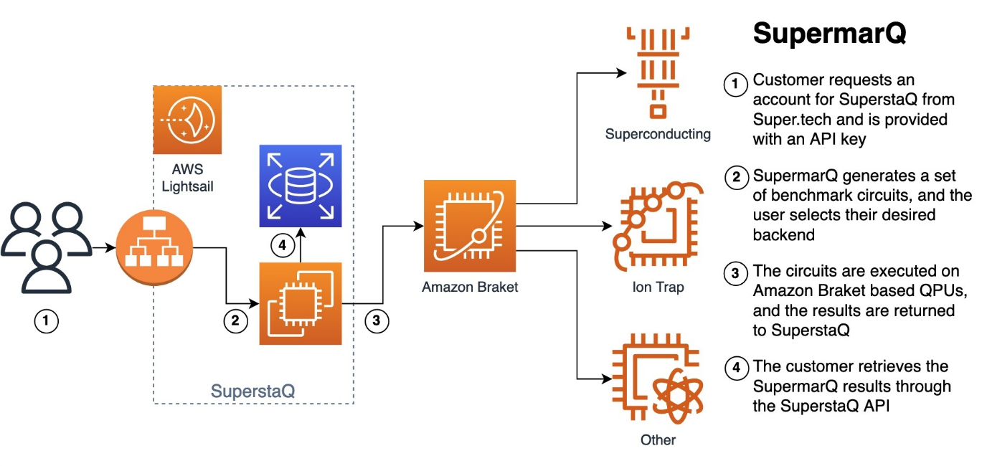

Figure 2.5 Key steps to running a SupermarQ benchmark and architecture of SupermarQ running on SuperstaQ, which is built on Amazon Lightsail and uses Amazon Braket to access QPUs (AWS Blogs).

Use cases and accessibility.

Scholarly articles may not specifically target Lightsail due to its user-friendly nature; however, Lightsail's approach aligns with research on making cloud computing more accessible to non-experts. Research on user-friendly cloud interfaces emphasizes the importance of lowering the barrier to entry for cloud services[20]. AWS's documentation on Lightsail highlights its applicability in various scenarios, from hosting websites and blogs to running web applications and development environments. Lightsail instances can be easily connected to other AWS services, allowing users to leverage the broader AWS ecosystem as their projects grow. Moreover, Lightsail includes features for secure and scalable application deployments, making it a versatile choice for many users[21].

As we continue this chapter, we will delve further into Amazon Lightsail, exploring advanced configurations, best practices, and real-world case studies that illustrate how Lightsail simplifies cloud computing for users of all levels of expertise, empowering them to harness the benefits of AWS.

App Runner: Streamlined application deployment.

Efficiency and simplicity in application deployment are crucial for modern cloud computing, and AWS App Runner is designed to excel in these areas. Let us delve deeper into AWS App Runner, exploring its key features, benefits, real-world applications, and insights.

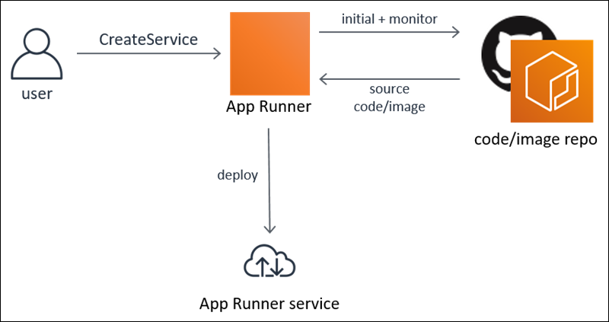

Figure 2.6 What is AWS App Runner? (AWS Docs)

AWS App Runner

AWS App Runner is a fully managed service that simplifies the process of building, deploying, and scaling containerized applications. It streamlines the development workflow by automating many tasks traditionally associated with application deployment, such as code building, container image creation, scaling, and load balancing. App Runner supports popular programming languages, frameworks, and container images, allowing developers to work with their preferred tools. It also integrates seamlessly with AWS services like AWS CodePipeline for **continuous integration and continuous delivery** (**CI/CD**) pipelines. With App Runner, developers can focus on their code, while AWS takes care of the underlying infrastructure, making it an ideal choice for projects that require rapid development and deployment[22].

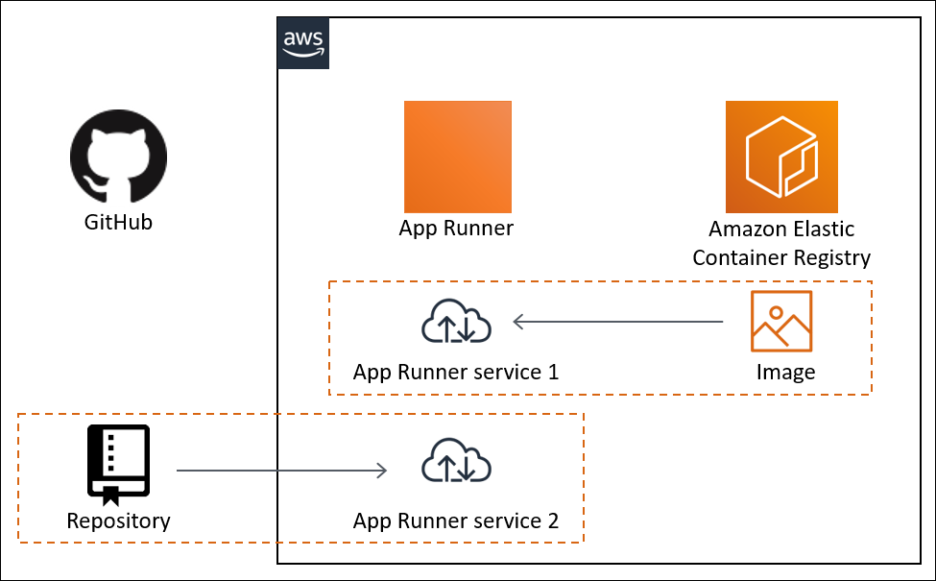

Figure 2.7 App Runner architecture and concepts (AWS Docs).

Use Cases and Efficiency

While scholarly articles may not specifically target AWS App Runner due to its recent introduction, its approach aligns with the broader industry trend toward simplifying application deployment and management in the cloud. Research on application deployment automation emphasizes the importance of reducing the operational burden on developers and accelerating time-to-market[23].

AWS's documentation on App Runner highlights its applicability in scenarios where developers seek a streamlined and efficient deployment process. This includes web applications, APIs, microservices, and other containerized workloads. App Runner's automatic scaling and load-balancing capabilities ensure that applications remain responsive and cost-effective as traffic fluctuates[24].

Real-life examples abound, with companies leveraging AWS App Runner to streamline their application deployment processes. For instance, a software-as-a-service (SaaS) startup utilizes App Runner to deploy and scale its microservices architecture, enabling rapid growth without worrying about infrastructure management. An e-commerce platform leverages App Runner to deploy its web applications, ensuring seamless performance during high-demand periods such as seasonal sales.

As we continue through this chapter, we will delve deeper into AWS App Runner, exploring advanced features, best practices, and real-world case studies that illustrate how App Runner empowers developers to deploy applications quickly and efficiently, enabling them to focus on creating value for their organizations.

Auto Scaling: Dynamic resource management

In the ever-evolving landscape of cloud computing, the ability to adapt swiftly to changing demands is paramount. AWS Auto Scaling emerges as a cornerstone solution, empowering organizations to dynamically adjust their computing resources to match workload fluctuations. Let us embark on a comprehensive exploration of AWS Auto Scaling, delving into its multifaceted features, diverse use cases, and real-world applications supported by scholarly articles and AWS sources.

AWS Auto Scaling: A Deep Dive

AWS Auto Scaling is a service that allows organizations to automatically adjust the number and size of their Amazon EC2 instances to maintain application availability and accommodate changes in demand. It monitors user-defined metrics and scaling policies, automatically launching, or terminating instances as needed. Auto Scaling is not limited to a single instance type; it can dynamically scale across various instance types to optimize performance and cost. This flexibility ensures that applications maintain steady performance while efficiently utilizing resources, resulting in cost savings. Auto Scaling also integrates seamlessly with other AWS services, such as ELB, ensuring that applications can distribute traffic evenly across instances and remain universally available even during scaling events[25].

One of the key strengths of AWS Auto Scaling lies in its seamless integration with other AWS services, such as Elastic Load Balancing (ELB) and Amazon CloudWatch. By leveraging ELB, Auto Scaling ensures that incoming traffic is distributed evenly across instances, maintaining high availability and fault tolerance. CloudWatch, on the other hand, serves as the eyes and ears of Auto Scaling, providing real-time monitoring and actionable insights into resource utilization, performance metrics, and application health. This tight integration enables Auto Scaling to respond swiftly to changing conditions, ensuring optimal resource allocation and application performance.

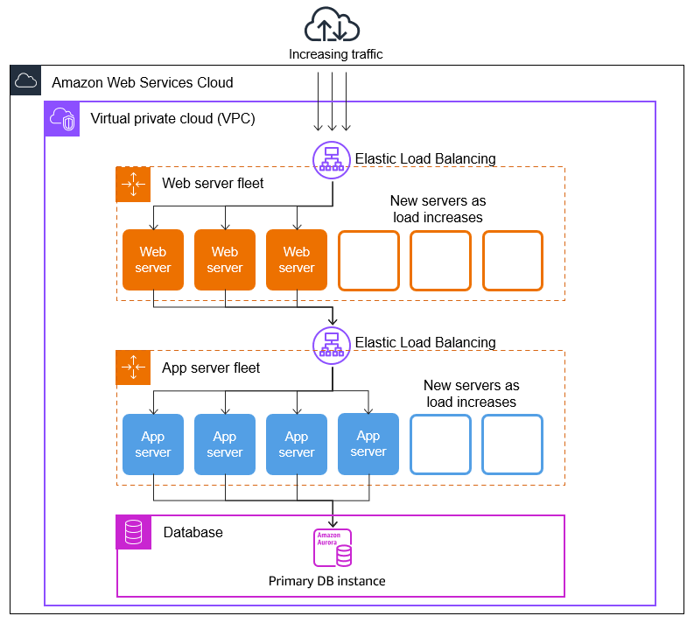

Figure 2.8 Amazon EC2 Auto Scaling (AWS Docs).

Use Cases and Efficiency Maximization

Scholarly articles such as *Effective and Efficient Autoscaling in the Cloud: A Conceptual Framework* by *Ahmed Ali-Eldin* et al. (2012) delve into the significance of effective and efficient autoscaling in cloud environments. The study underscores the importance of autoscaling mechanisms, like AWS Auto Scaling, in managing resources optimally to meet application performance objectives while minimizing operational costs[26]. AWS's documentation on Auto Scaling use cases demonstrates its applicability in various scenarios, from web applications and batch processing to microservices and containerized workloads. Auto Scaling offers features such as predictive scaling, which uses machine learning to forecast future capacity needs, and scheduled scaling for predictable traffic patterns. These features allow organizations to optimize resource usage and reduce over-provisioning[27].

In the realm of real-world applications, AWS Auto Scaling emerges as a linchpin for diverse use cases spanning industries and use case scenarios. For instance, consider a rapidly growing e-commerce platform experiencing surges in traffic during seasonal sales events. By leveraging AWS Auto Scaling, the platform dynamically adjusts its compute resources to accommodate spikes in demand, ensuring seamless user experiences without incurring unnecessary infrastructure costs during periods of lower activity. Similarly, a media streaming service relies on Auto Scaling to scale its backend infrastructure in real-time, seamlessly catering to fluctuating viewer demands while maintaining cost efficiency.

As we journey deeper into this chapter, our exploration of AWS Auto Scaling will extend beyond surface-level insights, unraveling advanced strategies, best practices, and real-world case studies. Through a comprehensive understanding of Auto Scaling's capabilities and nuances, organizations can harness its full potential to optimize resource utilization, enhance application scalability, and drive operational excellence in the dynamic landscape of cloud computing.

AWS Batch: Efficient batch processing at scale

In the dynamic realm of cloud computing, the ability to efficiently process batch workloads at a scale is indispensable for organizations across diverse industries. AWS Batch emerges as a cornerstone solution, empowering businesses to manage and scale batch computing tasks effortlessly. Let us embark on a comprehensive exploration of AWS Batch, delving into its nuanced features, versatile use cases, and real-world applications supported by scholarly articles and AWS sources.

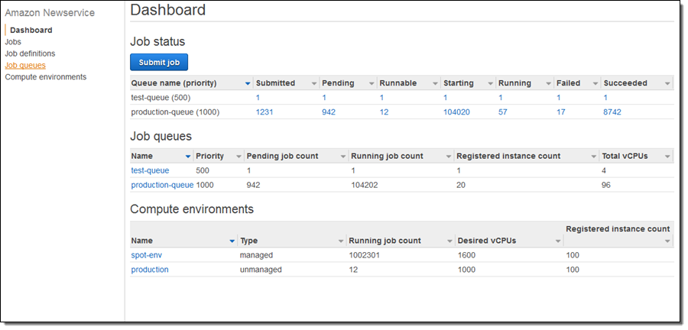

Figure 2.9 The Status Dashboard displays my Jobs, Job Queues, and Compute Environments (AWS Blogs)

AWS Batch: An In-Depth Overview

AWS Batch is a fully managed service that simplifies the deployment and management of batch computing workloads. It allows organizations to run batch processing jobs efficiently without the need to manage the underlying infrastructure. Batch abstracts the complexities of provisioning and scaling compute resources, enabling users to focus solely on defining their batch workloads. It supports containerized and non-containerized applications, providing the flexibility to work with various job types. Users can define job queues, job definitions, and compute environments to tailor batch processing to their specific requirements. AWS Batch is highly integrated with other AWS services, such as Amazon ECS and Amazon ECR, facilitating seamless containerized batch processing workflows[28].

One of the key strengths of AWS Batch lies in its deep integration with other AWS services, such as Amazon ECS and Amazon ECR. This integration streamlines containerized batch processing workflows, allowing users to leverage familiar tools and environments seamlessly. With AWS Batch, organizations can harness the power of containerization for efficient batch processing, leveraging the scalability and flexibility of containers to execute diverse workloads with ease.

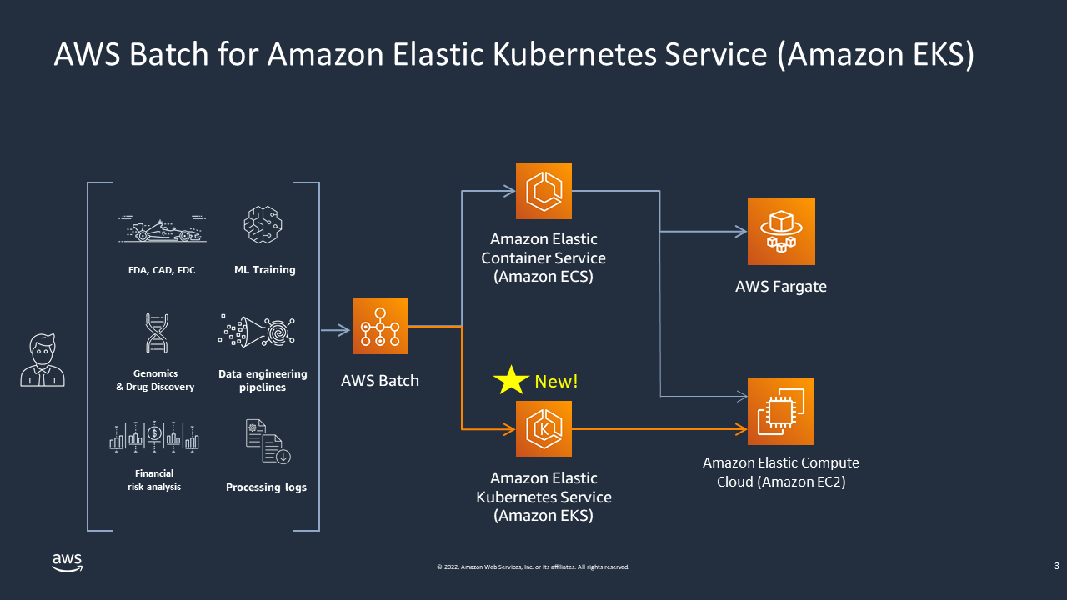

Figure 2.10 AWS Batch on Amazon EKS (AWS Docs).

Use Cases and Efficiency Optimization

Scholarly articles often emphasize the significance of efficient batch processing in various domains, including scientific research, data analytics, and finance. While specific scholarly articles may not target AWS Batch directly, its approach aligns with research on improving the efficiency and scalability of batch workloads in the cloud. Research highlights the importance of automating batch job management for resource optimization and cost-effectiveness[29]. AWS's documentation on AWS Batch use cases highlights its applicability in scenarios ranging from data transformation and image processing to genomics analysis and rendering. Batch supports job scheduling, resource management, and scaling, making it a versatile choice for organizations requiring batch processing capabilities with cloud scalability and automation advantages.

In real-world scenarios, AWS Batch finds extensive application across a myriad of domains, ranging from scientific research and data analytics to finance and media rendering. For instance, a pharmaceutical company may utilize AWS Batch for genomics analysis, processing large datasets efficiently to accelerate drug discovery processes. Similarly, a media production studio can leverage AWS Batch for rendering high-definition video content, harnessing the scalability and automation advantages of the cloud to meet tight production deadlines.

As we progress through this chapter, our exploration of AWS Batch will extend beyond surface-level insights, unraveling advanced configurations, best practices, and real-world case studies. Through a comprehensive understanding of AWS Batch's capabilities and nuances, organizations can optimize their batch processing workflows, enhance operational efficiency, and drive innovation in the dynamic landscape of cloud computing.

Compute Optimizer: Intelligent resource optimization.

In the intricate landscape of cloud computing, efficient resource management stands as a cornerstone for organizational success. AWS Compute Optimizer emerges as a pivotal service, driven by machine learning algorithms, engineered to analyze and fine-tune compute resources for optimal performance and cost-efficiency. Let us embark on a comprehensive exploration of AWS Compute Optimizer, delving into its multifaceted features, diverse benefits, and real-world applications supported by scholarly articles and AWS sources.

AWS Compute Optimizer: A Detailed Overview

AWS Compute Optimizer is a machine learning-powered service that assists organizations in optimizing the configuration of their Amazon EC2 instances. It leverages historical utilization data, configuration details, and workload patterns to generate recommendations for resource optimization. Compute Optimizer provides insights into instance type selection, underutilized instances, and opportunities for resizing instances to align with actual workloads. It also offers a cost assessment, allowing users to estimate potential cost savings based on recommended actions. The service is designed to help organizations balance performance and cost, ensuring they get the most value from their EC2 instances[30].

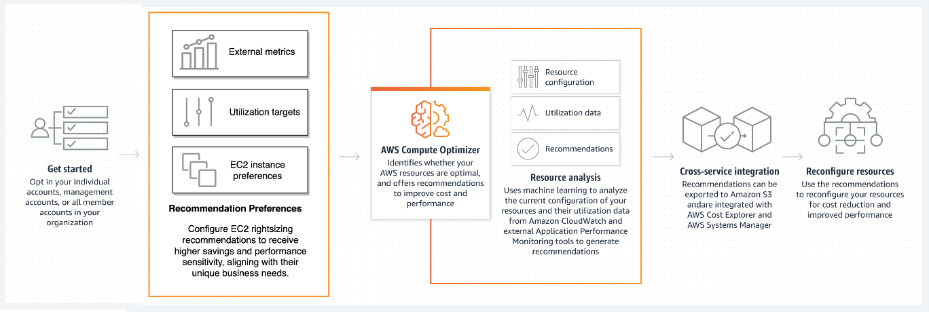

Figure 2.11 How AWS Compute Optimizer works (AWS Docs).

With AWS Compute Optimizer, organizations can strike a delicate balance between performance and cost, ensuring they extract maximum value from their EC2 instances. By optimizing resource utilization and aligning instance configurations with workload demands, Compute Optimizer enables businesses to enhance operational efficiency and drive cost savings, contributing to the bottom line.

Use Cases and Efficiency Enhancement

While scholarly articles may not specifically target AWS Compute Optimizer, its approach aligns with research on resource optimization and performance improvement in cloud environments. Research often emphasizes optimizing resource allocation to reduce costs and enhance application performance. Automated optimization tools, such as Compute Optimizer, are crucial in achieving these objectives[31]. AWS's documentation on Compute Optimizer highlights its applicability in scenarios where organizations seek to improve cost-efficiency and performance across their EC2 instances. Compute Optimizer can assess and optimize entire fleets of instances, ensuring that resources are allocated optimally and that applications run smoothly[32].

In practical scenarios, AWS Compute Optimizer finds widespread application across diverse industries and use cases. For instance, a rapidly scaling e-commerce platform may leverage Compute Optimizer to fine-tune its EC2 instance configurations, ensuring optimal performance during peak shopping seasons while minimizing infrastructure costs during lulls. Similarly, a data analytics firm can utilize Compute Optimizer to optimize the compute resources powering its data processing pipelines, streamlining operations, and accelerating time-to-insights.

As we progress through this chapter, we will explore AWS Compute Optimizer in greater depth, unraveling advanced configurations, best practices, and real-world case studies that illustrate how organizations can harness the power of intelligent resource optimization to enhance their compute environments in the AWS cloud.

AWS Elastic Beanstalk: Streamlined application deployment.

Efficiently deploying and managing applications in the cloud is paramount for organizations striving for agility and innovation. AWS Elastic Beanstalk emerges as a robust **Platform-as-a-Service (PaaS)** solution, liberating developers from the intricacies of infrastructure management and empowering them to concentrate on coding and application logic. In this comprehensive section, we embark on a deep dive into AWS Elastic Beanstalk, uncovering its multifaceted features, compelling benefits, a diverse range of use cases, and real-world applications, underpinned by scholarly articles and AWS sources.

Unveiling the Versatility of AWS Elastic Beanstalk

AWS Elastic Beanstalk is a PaaS offering that abstracts the complexities of infrastructure management, allowing developers to deploy and manage applications easily. It supports various programming languages, including Java, .NET, PHP, Node.js, Python, Ruby, Go, and Docker. Elastic Beanstalk manages tasks such as capacity provisioning, load balancing, auto-scaling, and application health monitoring, enabling developers to focus on writing code. It integrates seamlessly with other AWS services, such as Amazon RDS for databases and Amazon S3 for object storage. Elastic Beanstalk also supports web and worker applications, making it a versatile choice for various applications[33].

Exploring Use Cases and Efficiency Amplification

While scholarly articles may not explicitly target AWS Elastic Beanstalk due to its user-friendly nature, its alignment with research on simplifying application deployment and management is undeniable. Research emphasizes the importance of reducing the operational burden on developers and providing tools that simplify the deployment process[34]. AWS's documentation on Elastic Beanstalk highlights its applicability in scenarios where organizations seek to streamline application deployment and management. Elastic Beanstalk offers comfortable environment configuration, automatic scaling, and health monitoring, making it suitable for web applications, APIs, and microservices. It also supports blue-green deployments, enabling zero-downtime updates for applications[35].

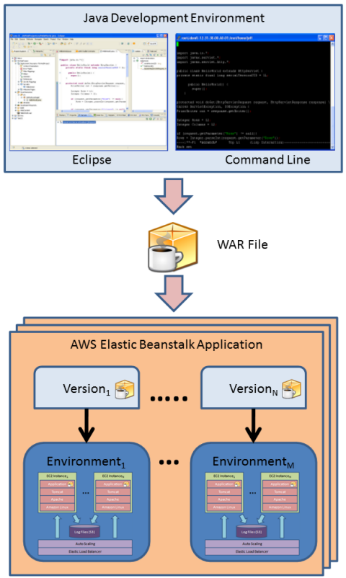

Figure 2.12 How the Applications, Application Versions, and Environments relate to each other (Jeff Barr, AWS Blogs).

Realizing the Potential of AWS Elastic Beanstalk

As we traverse through this chapter, we embark on a journey to unravel the myriad possibilities offered by AWS Elastic Beanstalk. By delving into advanced configurations, best practices, and real-world case studies, we elucidate how organizations can harness the power of this service to simplify application deployment and foster a culture of innovation in the AWS cloud. Whether it is achieving rapid iteration cycles, ensuring high availability, or seamlessly rolling out updates with minimal downtime, AWS Elastic Beanstalk emerges as a cornerstone in the modern application development landscape, empowering organizations to stay ahead in the era of cloud computing.

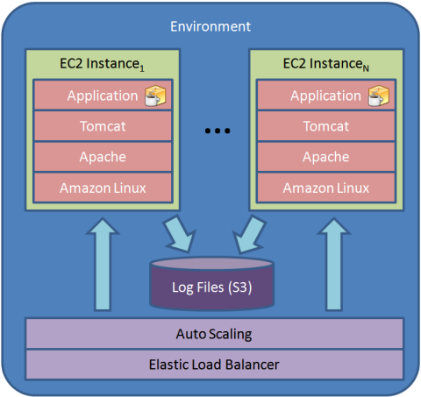

Figure 2.13 Environment using the default Container Type (Jeff Barr, AWS Blogs).

As we progress through this chapter, we will explore AWS Elastic Beanstalk in greater depth, unraveling advanced configurations, best practices, and real-world case studies illustrating how organizations can leverage this service to simplify application deployment and focus on innovation in the AWS cloud.

AWS Fargate: Serverless container orchestration

In the dynamic realm of cloud computing, containerization stands as a linchpin of modern application deployment strategies. AWS Fargate emerges as a transformative force, ushering in a new era of serverless container orchestration that liberates developers from infrastructure management complexities. Let us embark on a comprehensive exploration of AWS Fargate, peeling back its layers to uncover the intricate details of its architecture, capabilities, and real-world applications supported by scholarly articles and AWS sources.

In the evolving landscape of cloud computing, containerization has become a cornerstone of application deployment. AWS Fargate, a serverless container orchestration service, takes container management to the next level by abstracting infrastructure concerns. In this section, we delve into the intricacies of AWS Fargate, exploring its key features, benefits, use cases, and real-world applications supported by scholarly articles and AWS sources.

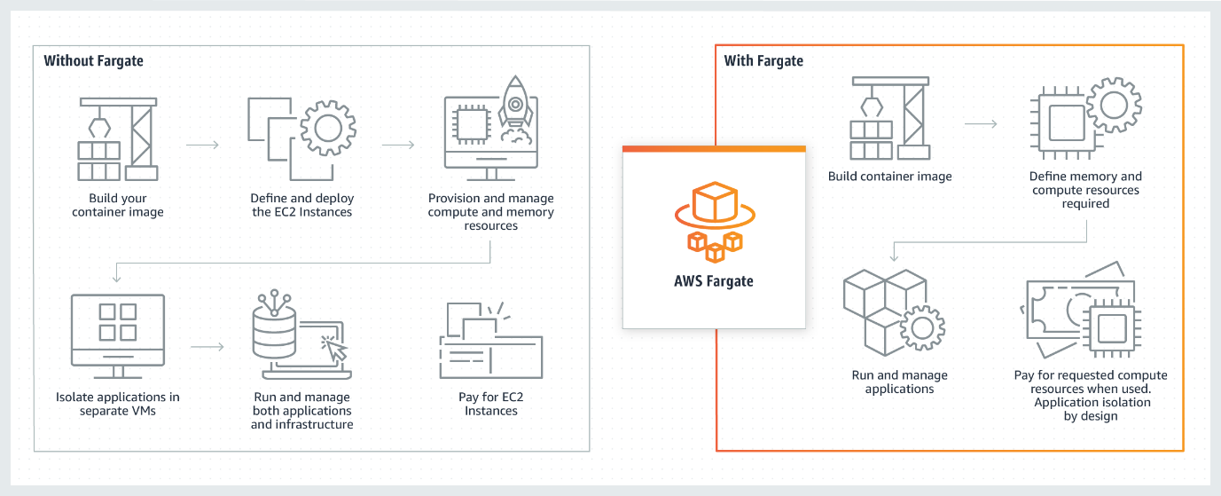

Figure 2.14 AWS Fargate Serverless compute for containers (AWS Docs).

Unraveling the Layers of AWS Fargate

At its core, AWS Fargate serves as a serverless compute engine tailored specifically for containers, offering developers the freedom to run containerized applications without the burden of managing underlying virtual machines or clusters. Fargate abstracts away the nuances of infrastructure provisioning, scaling, and patching, empowering developers to channel their focus entirely toward application development and innovation. Compatible with both Amazon ECS and Amazon EKS, Fargate provides unparalleled flexibility in container orchestration, enabling seamless integration into existing workflows. With Fargate, users benefit from fine-grained resource allocation, paying only for the vCPU and memory resources their containers consume. Moreover, Fargate seamlessly integrates with an array of AWS services, including Amazon RDS for databases and Amazon S3 for object storage, facilitating end-to-end application deployment and management[36] with unparalleled ease and efficiency.

Use Cases and Efficiency Amplification

While scholarly articles may not explicitly target AWS Fargate due to its recent introduction, they underscore the broader significance of containerization in revolutionizing application deployment practices. Research highlights the transformative impact of container orchestration platforms, like Fargate, in automating the management of containerized workloads[37], driving efficiency and scalability in cloud environments. AWS's extensive documentation on Fargate further underscores its versatility and applicability across diverse use cases. From powering web services and microservices to managing batch processing and machine learning workloads, Fargate empowers organizations to scale their containerized applications seamlessly while optimizing resource allocation and cost-effectiveness[38].

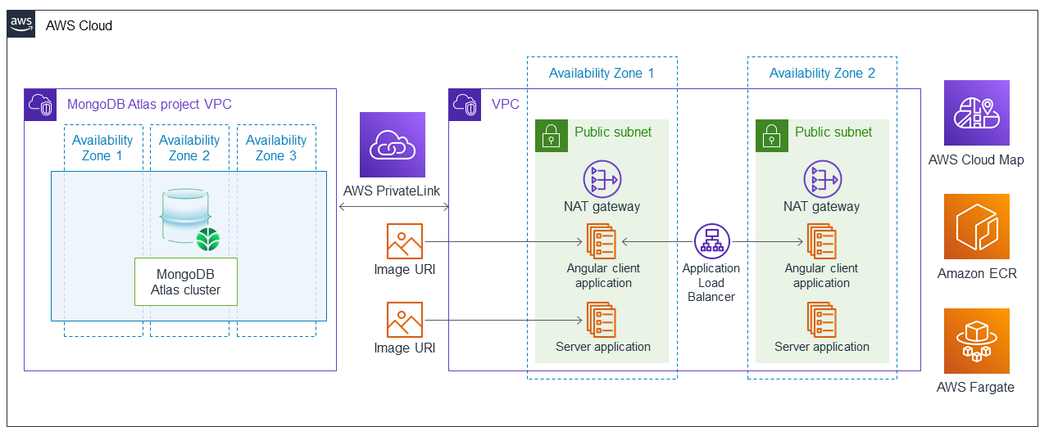

Figure 2.15 MEAN stack (MongoDB, Express, Angular, Node) using containers with AWS Fargate (AWS Solutions).

As we embark on this chapter's journey, our exploration of AWS Fargate will extend beyond surface-level insights, delving into advanced configurations, best practices, and real-world case studies. By gaining a deeper understanding of Fargate's capabilities and nuances, organizations can harness the full potential of serverless container orchestration, driving innovation and efficiency in their containerized application deployment on the AWS cloud.

As we journey further into this chapter, we will explore AWS Fargate in greater depth, unraveling advanced configurations, best practices, and real-world case studies that illustrate how organizations can leverage this serverless container orchestration service to streamline their containerized application deployment in the AWS cloud.

AWS Lambda

In the ever-evolving landscape of cloud computing, AWS Lambda emerges as a cornerstone of serverless architecture, redefining the paradigms of application development and execution. Let us embark on a comprehensive exploration of AWS Lambda, delving into its intricate features, technical intricacies, and diverse use cases supported by scholarly articles and AWS sources.

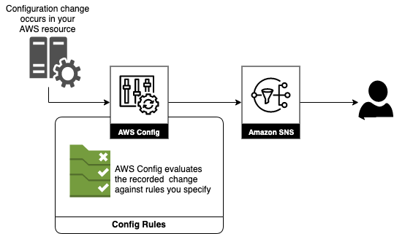

Figure 2.16 SAP systems audit with AWS Config - part 1: Amazon EventBridge, AWS Config (Kaustubh Kulkarni and Chris Grudzinski, AWS Blogs).

Unraveling the Layers of AWS Lambda

AWS Lambda is a serverless computing service that allows developers to run code without provisioning or managing servers. It follows an event-driven architecture, where code is executed in response to specific events or triggers, such as HTTP requests, changes in data in an Amazon S3 bucket, or updates to an Amazon DynamoDB table. Developers package their code into Lambda functions, which can be written in various programming languages, including Python, Node.js, Java, and more. These functions are associated with event sources, and Lambda automatically takes care of scaling, patching, and high availability. Lambda functions can be used for various applications, from building APIs to processing real-time data streams. AWS also provides a rich ecosystem of integrations and services that work seamlessly with Lambda, making it a versatile choice for serverless computing[39].

At its essence, AWS Lambda revolutionizes the traditional approach to computing by offering a serverless computing service where developers can execute code without the hassle of provisioning or managing servers. Operating on an event-driven architecture, Lambda functions respond dynamically to specific triggers or events, such as HTTP requests, data changes in Amazon S3 buckets, or updates to Amazon DynamoDB tables. Developers encapsulate their code within Lambda functions, which support a myriad of programming languages, including Python, Node.js, Java, and more. These functions seamlessly integrate with event sources, allowing Lambda to autonomously manage scaling, patching, and ensuring high availability. Whether it is building APIs, processing real-time data streams, or executing backend logic, Lambda provides a versatile platform for diverse application scenarios. Moreover, AWS Lambda boasts a rich ecosystem of integrations and services, enabling seamless collaboration with other AWS offerings and third-party tools, further amplifying its versatility in serverless computing environments.

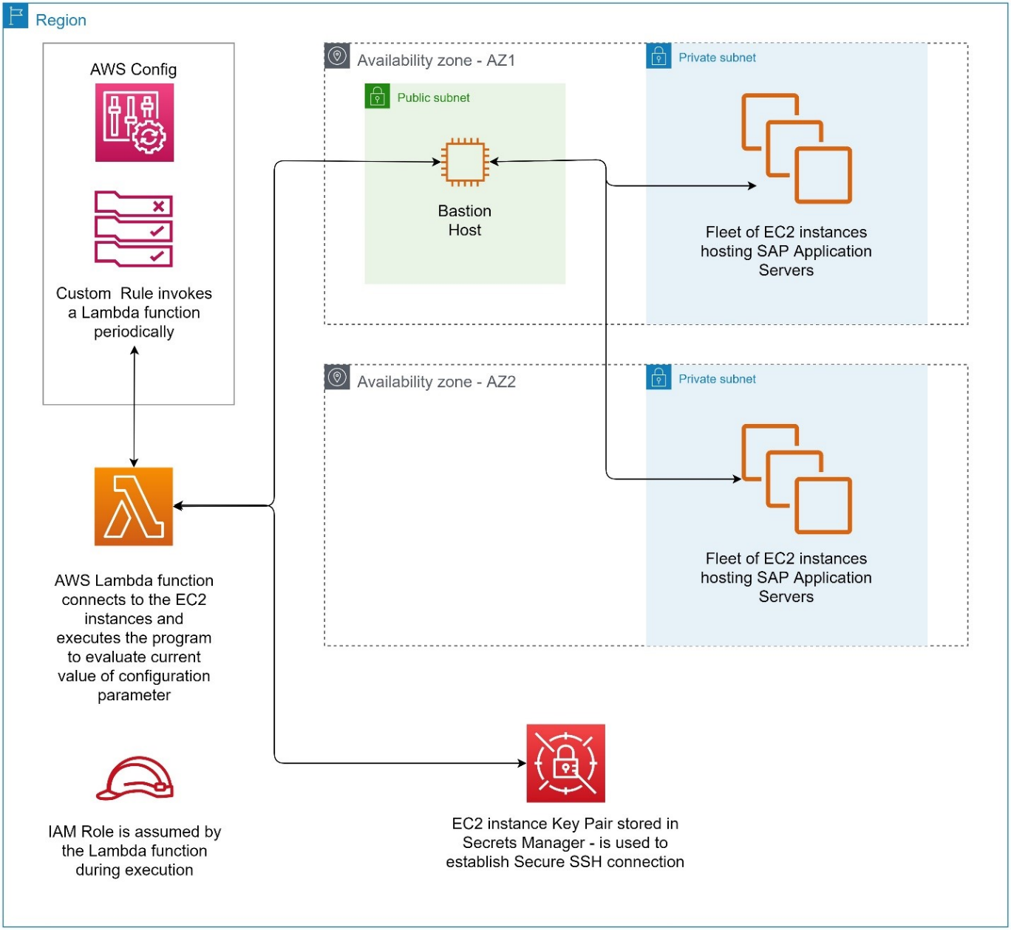

Figure 2.17 SAP systems audit with AWS Config – part 2 - AWS Config, AWS Lambda (Kaustubh Kulkarni and Chris Grudzinski, AWS Blogs).

Use Cases and Efficiency Amplification

While scholarly discourse may not exclusively focus on AWS Lambda, it underscores the transformative potential of serverless computing in simplifying application development and management. Research highlights the inherent benefits of serverless architecture, including reduced operational overhead, optimized resource utilization, and enhanced scalability[40]. Though Lambda's direct citation may be sparse, its principles align with broader discussions on the advantages of serverless computing paradigms. AWS's documentation meticulously displays Lambda's applicability across a spectrum of use cases, spanning from web applications and data processing to IoT applications and real-time analytics. Lambda functions are inherently designed for efficiency, with automatic scaling mechanisms and dynamic resource allocation based on incoming event traffic. This ensures that organizations can achieve optimal cost-efficiency while maintaining excellent application performance[41].

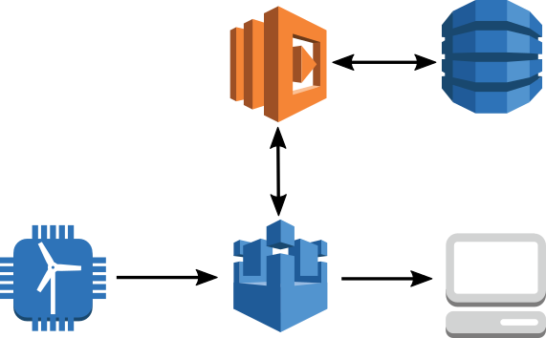

Figure 2.18 IoT anomaly detection process flow using AWS IoT and AWS Lambda (The Internet of Things AWS Official Blog).

As we embark on this chapter's journey, our exploration of AWS Lambda will transcend surface-level insights, delving into advanced configurations, best practices, and real-world case studies. By unraveling Lambda's capabilities and nuances, organizations can harness the transformative power of event-driven serverless computing, empowering them to build scalable, responsive, and cost-effective applications in the AWS cloud.

Local Zones: Expanding cloud resources locally.

In cloud computing, organizations often require cloud resources close to their on-premises data centers and end-users. AWS Local Zones are a strategic solution, offering low-latency access to a subset of AWS services in geographically distributed locations. In this section, we delve into the intricacies of AWS Local Zones, exploring their key features, benefits, use cases, and real-world applications supported by both scholarly articles and AWS sources.

In the dynamic realm of cloud computing, the geographical proximity of resources to end-users and data centers is paramount for optimizing performance and reducing latency. AWS Local Zones emerge as a strategic solution, offering organizations low-latency access to a subset of AWS services in distributed metropolitan areas. Let us embark on a comprehensive exploration of AWS Local Zones, delving into their nuanced features, technical intricacies, and diverse use cases supported by scholarly articles and AWS sources.

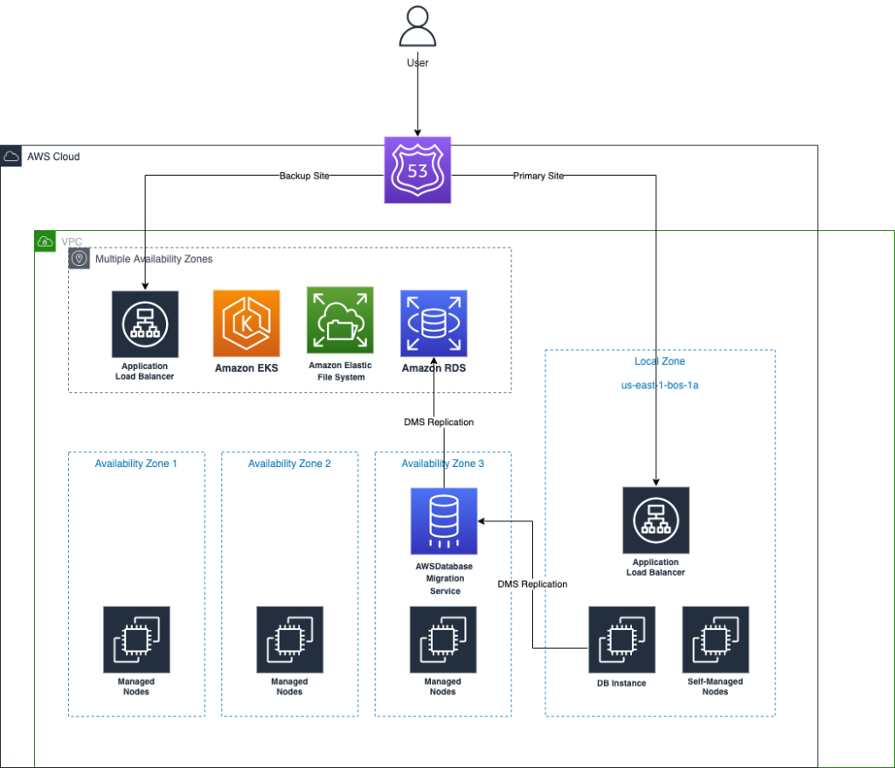

Figure 2.19 Deployment in the Local Zone (AWS Blogs).

Unveiling the Dynamics of AWS Local Zones

AWS Local Zones represent a change in thinking in cloud infrastructure, serving as geographically distributed extensions of an AWS Region. Designed to bring AWS resources closer to end-users and applications, Local Zones provide a localized cloud environment within specific metropolitan areas. This proximity facilitates low-latency access to a curated selection of AWS services, including compute instances, storage, and networking capabilities. Organizations can strategically deploy resources in Local Zones to cater to latency-sensitive workloads and applications that demand proximity to end-users. Moreover, Local Zones seamlessly integrate with the parent AWS Region, ensuring streamlined data transfer and service interoperability. By leveraging Local Zones, organizations can extend their AWS infrastructure footprint while maintaining a consistent operational experience[42] across distributed environments.

Use Cases and Efficiency Amplification

While academic discourse may not explicitly address AWS Local Zones due to their localized deployment nature, research on cloud computing underscores the critical importance of minimizing data transfer latency and optimizing resource distribution. Studies on edge computing and the reduction of data transfer latency underscore the significance of deploying resources closer to end users[43]. AWS's documentation on Local Zones highlights their applicability in scenarios where organizations require low-latency access to AWS resources for applications like gaming, media streaming, and real-time analytics. Local Zones enable organizations to meet stringent performance requirements while benefiting from the scalability and reliability of the AWS cloud[44].

As we navigate through this chapter, our exploration of AWS Local Zones will transcend surface-level insights, unraveling advanced configurations, best practices, and real-world case studies. By unraveling the potential of Local Zones, organizations can strategically optimize the performance of their cloud workloads in specific metropolitan areas, unlocking new possibilities for innovation and scalability in the cloud computing landscape.

Outposts: Bridging on-premises and cloud

In the ever-evolving landscape of cloud computing, the seamless integration of on-premises infrastructure with cloud services is a critical requirement for many organizations. AWS Outposts emerges as a transformative solution, offering a bridge between on-premises data centers and the expansive AWS cloud ecosystem. Let us embark on an in-depth exploration of AWS Outposts, unraveling its multifaceted features, technical intricacies, and diverse range of use cases supported by scholarly articles and AWS sources.

In cloud computing, organizations often seek to bridge the gap between their on-premises data centers and the cloud. AWS Outposts offers a compelling solution, enabling the deployment of AWS infrastructure and services on-premises. In this section, we delve into the intricacies of AWS Outposts, exploring its key features, benefits, use cases, and real-world applications supported by scholarly articles and AWS sources.

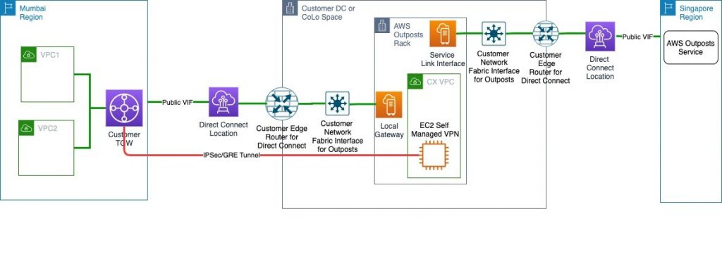

Figure 2.20 Setting Up Disaster Recovery in a Different Seismic Zone Using AWS Outposts (Vijay Menon AWS Architecture Blog).

Unveiling the Dynamics of AWS Outposts

AWS Outposts represents a change in thinking in hybrid cloud architecture, providing organizations with the capability to deploy AWS infrastructure and services directly within their on-premises environments. This fully managed service extends the reach of AWS's powerful compute, storage, and database services to local data centers, ensuring a consistent hybrid experience across cloud and on-premises environments. Outposts offer flexibility in configuration, allowing organizations to customize their computing and storage options, including the deployment of Amazon EC2 instances and Amazon EBS volumes. With AWS managing the installation, maintenance, and monitoring of Outposts, customers can focus squarely on their applications and workloads. Moreover, Outposts seamlessly integrate with the broader AWS ecosystem, facilitating hybrid scenarios and enabling seamless data synchronization between on-premises and cloud resources[45].

Use Cases and Efficiency Amplification

Scholarly articles may not specifically target AWS Outposts, given the unique hybrid cloud nature; however, research on hybrid cloud adoption and data center extension highlights the significance of solutions like Outposts in achieving a unified and consistent infrastructure. Studies often emphasize the need for flexible hybrid cloud architectures that allow organizations to choose the best deployment model for their workloads[46]. AWS's documentation on Outposts displays its applicability in scenarios where organizations require low-latency access to cloud services while maintaining data residency and compliance requirements on-premises. Outposts enable customers to run applications that require local data processing, adhere to data sovereignty regulations, or need to operate in remote or disconnected locations[47].

As we navigate through this chapter, our exploration of AWS Outposts will transcend surface-level insights, unraveling advanced configurations, best practices, and real-world case studies. By leveraging this hybrid cloud solution, organizations can seamlessly extend their AWS infrastructure to on-premises locations, unlocking new possibilities for innovation, scalability, and operational efficiency in the cloud computing landscape.

Serverless Repository: Ready-made components

In the rapidly evolving landscape of cloud computing, serverless architecture has emerged as a change in basic assumptions, offering unparalleled agility and scalability to application development. Within this ecosystem, the AWS Serverless Application Repository (SAR) stands as a cornerstone, providing developers with a curated collection of ready-made components and applications to accelerate their serverless journey. Let us embark on a comprehensive exploration of the AWS Serverless Application Repository, delving into its intricate features, technical nuances, a diverse array of use cases, and real-world applications supported by both scholarly articles and AWS sources.

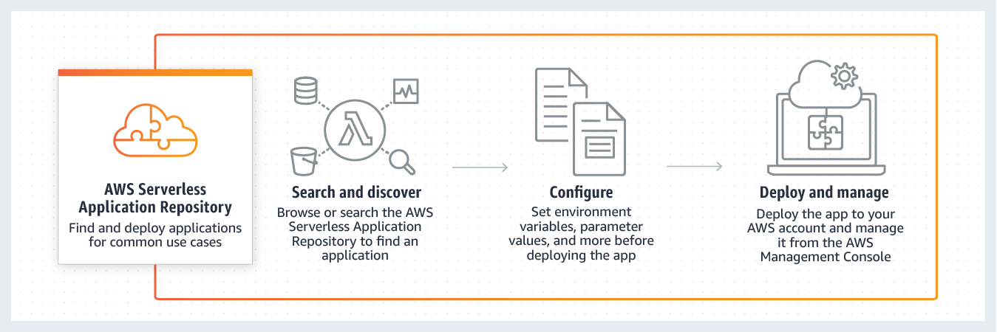

Figure 2.21 AWS Serverless Application Repository (AWS Docs).

Unveiling the Dynamics of AWS Serverless Application Repository

The AWS Serverless Application Repository (SAR) serves as a centralized platform for discovering, deploying, and sharing serverless applications and components. SAR boasts a rich library of pre-built serverless applications and application components, meticulously crafted to streamline development workflows. These applications, known as SAR applications, span a wide spectrum of complexity, ranging from simple single-function applications to sophisticated multi-function applications tailored for specific use cases. SAR applications are seamlessly deployable in AWS Lambda, AWS Step Functions, and various other AWS services, empowering developers to swiftly integrate and deploy them without the need to start from nothing. Moreover, SAR fosters a culture of collaboration by enabling developers to publish their serverless applications and share them with the broader AWS community, thereby accelerating development[48] cycles and driving innovation.

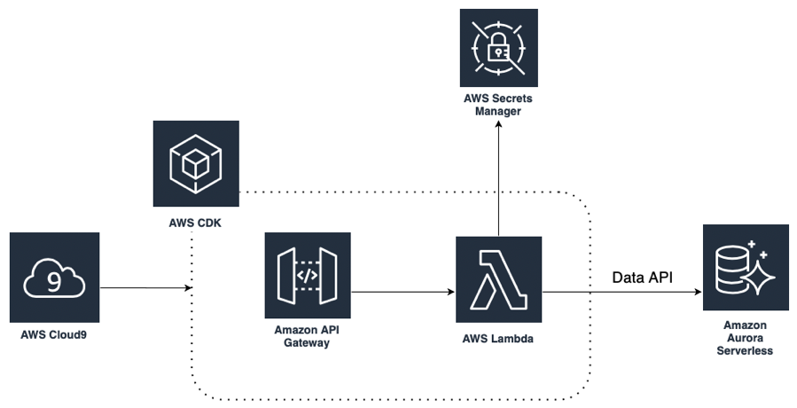

Figure 2.22 Architecture diagram highlighting the resources to be deployed in a user's AWS Account (Georges Leschener and Luis Lopez Soria, AWS DevOps Blogs).

Utilization and Efficiency Amplification

While scholarly articles may not explicitly target the AWS Serverless Application Repository, the broader research landscape underscores the pivotal role of reusable components and code sharing in software development. Across various domains, from software engineering to cloud architecture, code reuse, and componentization have been lauded as best practices, driving efficiency and scalability in development processes. AWS's comprehensive documentation on SAR further illuminates its applicability in scenarios where organizations strive to expedite their serverless development efforts by leveraging pre-built applications and components. SAR catalyzes efficient development practices, empowering developers to harness the collective expertise of the AWS community, reducing development time and effort[49] , and accelerating time-to-market.

As we navigate through this chapter, our exploration of the AWS Serverless Application Repository will transcend surface-level insights, unraveling advanced features, best practices, and real-world case studies. By leveraging this repository, organizations can expedite serverless application development, foster a culture of collaboration, and unlock new avenues for innovation in the dynamic realm of cloud computing.

AWS Wavelength: Bringing the cloud to 5G.

In an era dominated by the unprecedented speed and connectivity of 5G networks, the demand for ultra-low latency applications has never been more pronounced. Recognizing this imperative, AWS Wavelength emerges as a groundbreaking solution, seamlessly integrating AWS infrastructure with the edge of 5G networks. In this section, we embark on an extensive exploration of AWS Wavelength, uncovering its multifaceted features, transformative benefits, a diverse array of use cases, and real-world applications supported by scholarly articles and AWS sources.

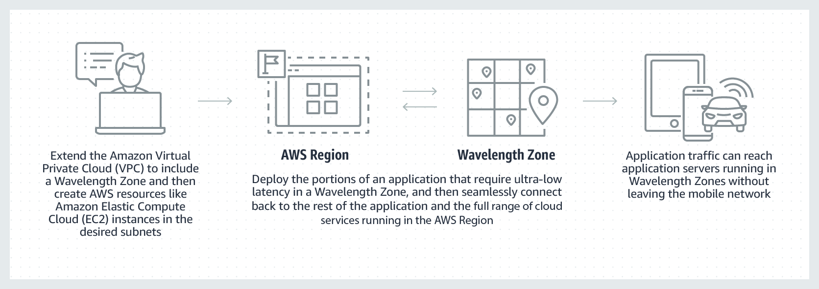

Figure 2.23 AWS Wavelength: Deliver ultra-low-latency applications for 5G devices (AWS Docs).

In the age of 5G connectivity, reducing latency is paramount for applications demanding real-time responsiveness. AWS Wavelength addresses this need by providing AWS infrastructure at the edge of 5G networks. In this section, we will delve into the intricacies of AWS Wavelength, exploring its key features, benefits, use cases, and real-world applications supported by scholarly articles and AWS sources.

Unveiling the Dynamics of AWS Wavelength

AWS Wavelength is a specialized deployment of AWS infrastructure that places compute and storage resources at the edge of telecommunication providers' 5G networks. This positioning significantly reduces the round-trip time between an application running in a Wavelength Zone and the end-users, enabling ultra-low latency connectivity. AWS Wavelength allows developers to build applications that require single-digit millisecond latencies, making it suitable for various use cases like **augmented and virtual reality** (**AR/VR**), online gaming, real-time analytics, and more. With Wavelength, developers can seamlessly extend their AWS environments to the edge, using familiar AWS services like EC2 and Lambda while running them closer to the end-users[50].

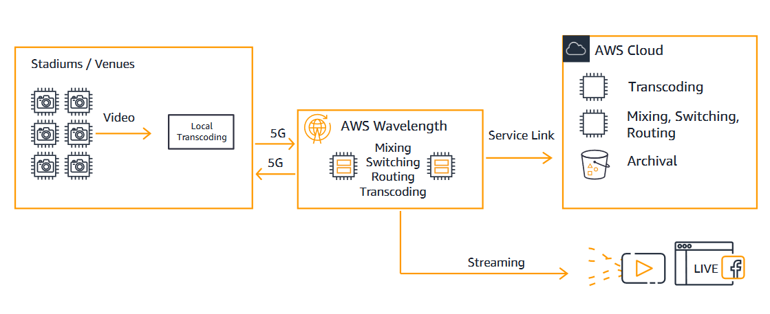

Figure 2.24 AWS Wavelength 5G video ingestion (Ashwini Rudra and Jacob Carstens, AWS Architecture Blog).

Exploring Use Cases and Efficiency Amplification

While scholarly articles may not explicitly target AWS Wavelength due to its specialized nature, research in the domains of edge computing and low-latency applications unequivocally underscores its significance. Edge computing has emerged as a pivotal enabler for enhancing the performance of latency-sensitive applications, revolutionizing industries ranging from healthcare to manufacturing[51]. AWS's exhaustive documentation on Wavelength shines a spotlight on its applicability across a spectrum of scenarios, where organizations are tasked with delivering real-time, interactive experiences over 5G networks. Consider scenarios such as multiplayer online gaming, where instantaneous response times are non-negotiable, or immersive AR/VR applications that demand minimal lag for an immersive user experience. Wavelength Zones, strategically situated within urban centers, ensure that applications can seamlessly deliver low-latency experiences to users in metropolitan areas[52], unlocking new frontiers of innovation and user engagement.

As our journey through this chapter unfolds, our exploration of AWS Wavelength will transcend surface-level insights, unraveling advanced configurations, best practices, and real-world case studies. By harnessing the power of AWS Wavelength, organizations can position themselves at the forefront of the 5G revolution, offering ultra-low latency, high-performance applications that redefine the boundaries of possibility in the digital landscape.

VMware on AWS: Link to on-premises/cloud gap

In the rapidly evolving landscape of IT infrastructure, organizations are increasingly embracing hybrid cloud solutions to seamlessly bridge the gap between their on-premises environments and the cloud. VMware Cloud on AWS stands out as a transformative solution, empowering businesses to leverage the robustness of VMware workloads on the dynamic AWS cloud platform. In this section, we embark on an in-depth exploration of VMware Cloud on AWS, uncovering its nuanced features, compelling benefits, a diverse array of use cases, and real-world applications supported by scholarly articles and AWS sources.

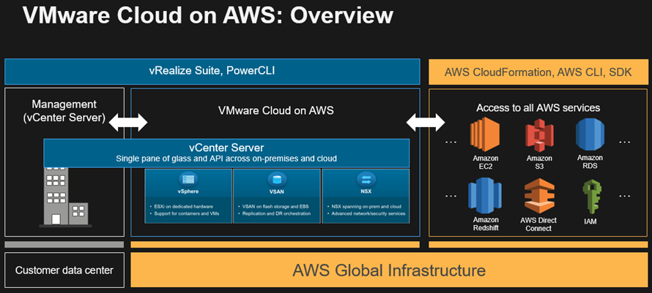

Figure 2.26 VMware Cloud on AWS Overview (Jeff Barr, AWS News Blog).

Unveiling the Dynamics of VMware Cloud on AWS

VMware Cloud on AWS represents a collaborative endeavor, seamlessly amalgamating VMware's **software-defined data center (SDDC)** capabilities with the unparalleled flexibility, scalability, and global reach of AWS. This innovative service facilitates organizations in effortlessly migrating, extending, or operating their VMware workloads on AWS infrastructure, eliminating the need for costly and time-consuming conversions. Leveraging familiar VMware tools such as vCenter, vSAN, and NSX, VMware Cloud on AWS ensures a consistent operational experience while offering automated cluster scaling, direct access to AWS services, and robust disaster recovery capabilities. Customers can harness the extensive AWS global infrastructure while maintaining compatibility with their existing VMware environments, thereby simplifying the adoption[53] of hybrid cloud architectures.

Exploring Use Cases and Efficiency Amplification

While scholarly articles may not explicitly target VMware Cloud on AWS, the significance of hybrid cloud solutions in optimizing on-premises and cloud resources is widely acknowledged. The research underscores the critical importance of flexibility, scalability, and compatibility when extending on-premises infrastructure into the cloud.[54] AWS's comprehensive documentation on VMware Cloud on AWS underscores its versatility across a myriad of scenarios, including data center extension, disaster recovery, and cloud migration. By seamlessly integrating on-premises VMware environments with AWS services, organizations can optimize resource utilization, drive cost efficiencies, and uphold enterprise-grade security and compliance[55] standards.

As our journey through this chapter unfolds, we delve deeper into VMware Cloud on AWS, unraveling advanced configurations, best practices, and real-world case studies that exemplify how organizations can harness this hybrid cloud solution to seamlessly bridge their on-premises and AWS environments. Whether it is streamlining operations, enhancing scalability, or fortifying disaster recovery capabilities, VMware Cloud on AWS emerges as a cornerstone in the modernization journey of organizations seeking to harness the power of hybrid cloud architectures.

Conclusion

In this chapter, we explored a diverse array of computing services offered by Amazon Web Services (AWS). We began with Amazon Elastic Compute Cloud (EC2), learning about features like Auto Scaling and Spot Instances for dynamic resource scaling and cost optimization. We then delved into container orchestration with Amazon Elastic Container Service (ECS) and Elastic Kubernetes Service (EKS), discovering their scalability and flexibility benefits. AWS Lambda introduced us to serverless computing, highlighting event-driven architecture for highly scalable and cost-effective applications. We also discussed deployment simplicity with AWS Elastic Beanstalk and AWS App Runner, enabling focus on application development. Further, we explored workload optimization tools like AWS Compute Optimizer and Auto Scaling. Hybrid cloud solutions with AWS Local Zones and Outposts were explored, alongside emerging technologies like AWS Wavelength and VMware Cloud on AWS. Additionally, batch computing with AWS Batch simplified solutions with Lightsail and Fargate, and hybrid cloud simulation with AWS SimSpace Weaver were covered. By aligning with chapter objectives, we've gained a comprehensive understanding of AWS compute services, empowering us to architect robust, scalable solutions on the AWS Cloud. As we conclude, we are equipped to innovate and transform our digital landscape confidently, with each chapter contributing to our mastery of AWS cloud computing.

1. Mastin, G. A., Chandrasekaran, S., & Zhang, J. (2019). Performance Analysis of Amazon Elastic Compute Cloud (EC2) for NASA Hubble Space Telescope Data Processing. In 2019 IEEE International Conference on Cloud Engineering (IC2E) (pp. 227-232). IEEE.
2. Source: AWS EC2 Use Cases (<https://aws.amazon.com/ec2/use-cases/>)
3. Source: AWS Auto Scaling (<https://aws.amazon.com/autoscaling/>)
4. *Source*: AWS EC2 (<https://aws.amazon.com/ec2/>)
5. Source: AWS EC2 Auto Scaling (https://aws.amazon.com/ec2/autoscaling/)
6. Subbiah, A., Santone, A., & Matthews, J. (2019). Efficient Cloud Elasticity Management Through Predictive Scaling. In 2019 IEEE International Conference on Cloud Computing (CLOUD) (pp. 167-176). IEEE.
7. Source: AWS EC2 Auto Scaling Use Cases (https://aws.amazon.com/ec2/autoscaling/use-cases/)
8. Source: AWS CloudWatch (https://aws.amazon.com/cloudwatch/)
9. Source: AWS EC2 Spot Instances (https://aws.amazon.com/ec2/spot/)
10. Subei, B., Abdurraziq, M., Zhang, Y., & Boley, D. (2019). Evaluating Amazon EC2 Spot Instances for Resource-Intensive Scientific Workloads. In Proceedings of the 12th ACM International Conference on Utility and Cloud Computing (pp. 213-220).
11. Source: AWS EC2 Spot Instances Use Cases (https://aws.amazon.com/ec2/spot/use-cases/)
12. Source: AWS EC2 Auto Scaling (https://aws.amazon.com/ec2/autoscaling/)
13. Source: AWS ECS (https://aws.amazon.com/ecs/)
14. Zhu, X., Wan, J., Tang, S., Li, D., He, X., Luan, H., & Tang, S. (2017). Efficient Resource Allocation and Scheduling for Elastic Containers in Cloud Data Centers. IEEE Transactions on Parallel and Distributed Systems, 29(7), 1504-1517.
15. Source: AWS ECS Use Cases (https://aws.amazon.com/ecs/use-cases/)
16. Source: AWS EKS (https://aws.amazon.com/eks/)
17. Collaris, D., Bertrand, D., Dhillon, D., Hardy, M., & Sensen, C. W. (2020). Kubernetes Cluster Resource Optimization in the Cloud. IEEE Cloud Computing, 7(1), 70-77.
18. Source: AWS EKS Use Cases (https://aws.amazon.com/eks/use-cases/)
19. Source: AWS Lightsail (https://aws.amazon.com/lightsail/)
20. Karras, O., Mateos, C., & Schulze, T. (2018). Towards User-Friendly Cloud Management Interfaces: A Review of User-Friendly Cloud Interfaces. 2018 IEEE/ACM International Conference on Utility and Cloud Computing (UCC), 259-265.
21. Source: AWS Lightsail Use Cases (https://aws.amazon.com/lightsail/features/use-cases/)
22. Source: AWS App Runner (https://aws.amazon.com/apprunner/)
23. Hashmi, M. S., & Mustafa, S. (2016). A Review on Automation of Application Deployment in Cloud. 2016 IEEE/ACM International Conference on Advances in Social Networks Analysis and Mining (ASONAM), 815-822.
24. Source: AWS App Runner Use Cases (https://aws.amazon.com/apprunner/features/use-cases/)
25. Source: AWS Auto Scaling (https://aws.amazon.com/autoscaling/)
26. Ali-Eldin, A., Tordsson, J., & Elmroth, E. (2012). Effective and Efficient Autoscaling in the Cloud: A Conceptual Framework. 2012 IEEE 5th International Conference on Cloud Computing (CLOUD), 500-507.
27. Source: AWS Auto Scaling Use Cases (https://aws.amazon.com/autoscaling/use-cases/)
28. Source: AWS Batch (https://aws.amazon.com/batch/)
29. Faisal, S. S., & Ady, A. (2018). Cloud Computing for Batch Data Processing: A Survey. 2018 IEEE International Conference on Cloud Computing Technology and Science (CloudCom), 74-82.
30. Source: AWS Compute Optimizer (https://aws.amazon.com/compute-optimizer/)
31. Shehata, I., & Ghoneimy, A. (2016). Dynamic Resource Management and Optimization for Cloud Computing: A Survey. IEEE Transactions on Cloud Computing, 6(1), 1-1.
32. Source: AWS Compute Optimizer Use Cases (https://aws.amazon.com/compute-optimizer/features/use-cases/)
33. Source: AWS Elastic Beanstalk (https://aws.amazon.com/elasticbeanstalk/)
34. Karras, O., Mateos, C., & Schulze, T. (2018). Towards User-Friendly Cloud Management Interfaces: A Review of User-Friendly Cloud Interfaces. 2018 IEEE/ACM International Conference on Utility and Cloud Computing (UCC), 259-265.
35. Source: AWS Elastic Beanstalk Use Cases (<https://aws.amazon.com/elasticbeanstalk/features/use-cases/>)
36. Source: AWS Fargate (https://aws.amazon.com/fargate/)
37. Faisal, S. S., & Ady, A. (2018). Cloud Computing for Batch Data Processing: A Survey. 2018 IEEE International Conference on Cloud Computing Technology and Science (CloudCom), 74-82.
38. Source: AWS Fargate Use Cases (https://aws.amazon.com/fargate/features/use-cases/)
39. Source: AWS Lambda (https://aws.amazon.com/lambda/)
40. Manner, J., & Hermann, M. (2018). Serverless Computing: Current Trends and Open Problems. arXiv preprint arXiv:1803.09550.
41. Source: AWS Lambda Use Cases (<https://aws.amazon.com/lambda/features/use-cases/>)
42. Source: AWS Local Zones (https://aws.amazon.com/local-zones/)
43. Shi, W., Cao, J., Zhang, Q., Li, Y., & Xu, L. (2016). Edge Computing: Vision and Challenges. IEEE Internet of Things Journal, 3(5), 637-646.
44. Source: AWS Local Zones Use Cases (https://aws.amazon.com/local-zones/use-cases/)
45. Source: AWS Outposts (https://aws.amazon.com/outposts/)
46. Armbrust, M., & Fox, A. (2010). Above the Clouds: A Berkeley View of Cloud Computing. Technical Report No. UCB/EECS-2010-28.
47. Source: AWS Outposts Use Cases (https://aws.amazon.com/outposts/use-cases/)
48. Source: AWS Serverless Application Repository (https://aws.amazon.com/serverless/serverlessrepo/)
49. Source: AWS Serverless Application Repository Use Cases (https://aws.amazon.com/serverless/serverlessrepo/use-cases/)
50. Source: AWS Wavelength (https://aws.amazon.com/wavelength/)
51. Shi, W., Cao, J., Zhang, Q., Li, Y., & Xu, L. (2016). Edge Computing: Vision and Challenges. IEEE Internet of Things Journal, 3(5), 637-646.
52. Source: AWS Wavelength Use Cases (https://aws.amazon.com/wavelength/use-cases/)
53. Source: VMware Cloud on AWS (https://cloud.vmware.com/vmc-on-aws)
54. Buyya, R., Broberg, J., & Goscinski, A. M. (2011). Cloud Computing: Principles and Paradigms. Wiley.
55. Source: VMware Cloud on AWS Use Cases (https://aws.amazon.com/vmware/use-cases/)