CHAPTER 3

Storage

Introduction

This chapter will uncover the foundational elements that enable organizations to architect robust data management solutions. From block storage to file systems, archival storage to data lakes, and disaster recovery to data migration, we will navigate through the diverse array of **Amazon Web Services** (**AWS**) storage services that empower businesses to store, protect, and access their data with unmatched flexibility, scalability, and reliability. Whether you are seeking to build resilient applications, optimize data analytics, or fortify your data recovery strategies, this chapter will equip you with the knowledge and insights needed to harness the full potential of AWS storage services. Join us on this journey as we explore Amazon **Elastic Block Store** (**EBS**), Amazon **Elastic File System** (**EFS**), Amazon FSx, Amazon S3 Glacier, Amazon **Simple Storage Service** (**S3**), AWS Backup, AWS Snow Family, AWS Storage Gateway, and AWS Elastic **Disaster Recovery** (**DRS**). Get ready to unlock the world of data storage possibilities in the AWS cloud.

Structure

In this chapter, we will discuss the following topics:

* Amazon Elastic Block Store
* Amazon Elastic File System
* Amazon FSx
* Amazon S3 Glacier
* Amazon Simple Storage Service
* AWS Backup
* AWS Snow Family
* AWS Storage Gateway
* AWS Elastic Disaster Recovery

Objectives

In this chapter, we will learn how to build resilient applications, optimize data analytics, or fortify your data recovery strategies

Storage pattern decision matrix

Selecting the most suitable storage pattern within the AWS ecosystem depends on various factors, including **performance, scalability, security**, and, most importantly, **access protocols** supported by applications. AWS offers different storage options like **SAN (Storage Area Network), NAS (Network Attached Storage),** and **Object Storage** to accommodate various needs. Each storage type has unique advantages and limitations, which are primarily dictated by the protocols they support.

**Figure 1** illustrates how on-premises users and applications connect to and access data storage systems. In this example, applications can utilize SAN, NAS, or object storage through their respective supported protocols. While factors such as performance, security, and scalability play crucial roles, the choice of storage—whether SAN, NAS, or object—is primarily influenced by the access protocols supported by the applications. Each protocol comes with its unique benefits and limitations, making it a significant factor in deciding which storage solution to adopt on the backend [1].

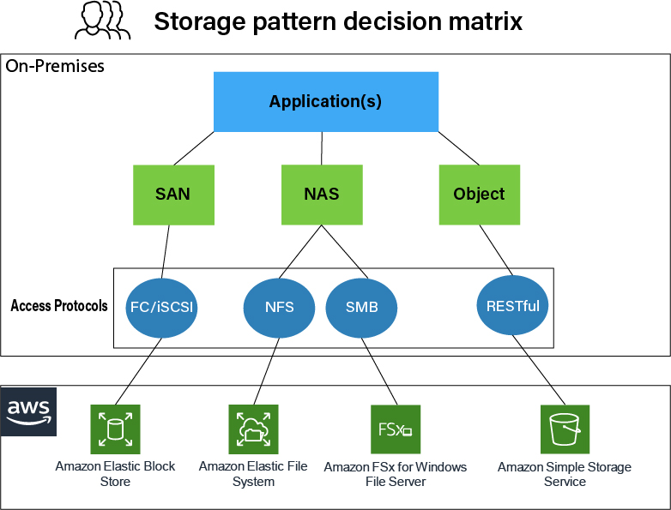

Figure 1 AWS Storage pattern decision matrix (AWS Blogs).

In this section, we will examine the storage patterns offered by AWS and analyze which use cases benefit from each storage solution. The objective is to ensure readers can make informed decisions when architecting their data management strategy in the AWS cloud.

SAN (Storage Area Network)

* **What it is**: SAN is a high-speed network that provides block-level storage to applications. The storage is accessed over dedicated high-performance networks, ensuring low latency and high throughput.
* **Best suited for**: Applications requiring high-performance storage, such as databases or transactional systems, which need low-latency, high-throughput access to storage.
* **AWS Services**:
  + **Amazon Elastic Block Store (EBS)** provides block storage that can be attached to EC2 instances and used similarly to SAN storage in traditional on-premises setups.
* **Real-world application**: In financial institutions or e-commerce platforms, transactional databases require SAN-like performance to manage millions of requests per second. For example, **Amazon EBS** volumes are ideal for databases like MySQL, PostgreSQL, and MongoDB that require fast, reliable storage for intensive workloads.

NAS (Network Attached Storage)

* **What it is**: NAS offers file-level access, enabling applications to share a centralized storage system. It is typically used for applications that require file sharing across different systems.
* **Best suited for**: Applications where multiple servers or users need access to shared files, such as content management systems, home directories, or web servers.
* **AWS Services**:
  + **Amazon Elastic File System (EFS)** provides scalable file storage that can be accessed by multiple EC2 instances simultaneously. It offers high availability and durability, making it a preferred choice for enterprise applications.
  + **Amazon FSx** supports Windows-based and Lustre file systems, ideal for users who need compatibility with existing NAS systems.
* **Real-world application**: Enterprises that run shared web servers, media workflows, or big data processing workloads benefit from **EFS** and **FSx**. For example, **Amazon EFS** is widely used when applications need to access shared file systems from multiple availability zones.

Object Storage

* **What it is**: Object storage manages unstructured data like media files, backups, or archives. Instead of using traditional file hierarchies, object storage uses metadata and unique identifiers, making it scalable and efficient for vast amounts of data.
* **Best suited for**: Applications where vast amounts of unstructured data, such as images, videos, logs, or backups, must be stored and retrieved with scalability and durability.
* **AWS Services**:
  + **Amazon S3 (Simple Storage Service)** is the foundational object storage service that provides unlimited scalability and 99.999999999% durability. It is ideal for storing backups, data archives, and substantial amounts of unstructured data.
  + **Amazon S3 Glacier** offers low-cost archival storage for long-term data retention and retrieval at varying speeds.
* **Real-world application**: Media streaming services, where videos are stored in S3 for global distribution, benefit from object storage. Additionally, organizations that need to store backup and archival data long-term leverage **Amazon S3 Glacier** for low-cost storage solutions.

Decision-Making Criteria

Each of these AWS storage solutions plays a distinct role, and the decision to use SAN, NAS, or object storage should consider the following key criteria:

1. **Performance Requirements**:
   * High-performance applications like databases or virtual desktops benefit from **Amazon EBS**, which provides fast, low-latency access to block storage (SAN-like performance).
   * Applications needing frequent access to shared files across distributed instances perform best with **Amazon EFS** or **Amazon FSx** (NAS-like services).
   * Workloads requiring high durability and scalability but less frequent access to data, such as backups or media content delivery, are ideal candidates for **Amazon S3** or **S3 Glacier**.
2. **Access Protocols**:
   * Applications using block storage protocols like iSCSI or Fibre Channel work well with **EBS**, as it supports these lower-level block interactions.
   * Amazon EFS or FSx best serves file-based protocols such as NFS or SMB. For example, **FSx for Windows File Server** is ideal for enterprise applications needing Windows-compatible systems.
   * HTTP or REST APIs interact with **Amazon S3** object storage, ideal for web-based applications, mobile apps, and data lakes.
3. **Scalability and Durability**:
   * **Amazon S3** provides unlimited scalability and unmatched durability, making it the go-to choice for long-term storage of large datasets.
   * File systems like **EFS** offer automatic scaling as workloads increase or decrease, while **EBS** scales by manually attaching additional volumes to EC2 instances.
4. **Cost Considerations**:
   * **Amazon S3** is one of the most cost-effective solutions for storing massive amounts of unstructured data, while **S3 Glacier** further reduces costs for long-term archival.
   * For active workloads requiring constant data interaction, **EFS** and **FSx** offer cost-effective options compared to setting up custom file-sharing systems.

Wrap up

In conclusion, selecting the correct AWS storage solution is contingent upon understanding the application’s requirements in terms of performance, scalability, and supported access protocols. The **Storage Pattern Decision Matrix** serves as a guide to identify which AWS service best aligns with specific needs, whether block storage through **Amazon EBS**, file storage with **EFS/FSx**, or object storage via **Amazon S3**. Organizations can optimize performance, control costs, and scale effectively within the AWS environment by choosing the right storage type.

Amazon Elastic Block Store

In cloud computing, storage forms the bedrock of modern applications, and Amazon Elastic Block Store (EBS) stands tall as a cornerstone within AWS's expansive array of storage solutions. Cloud storage is pivotal for businesses, providing scalability, flexibility, and reliability to support evolving application needs. Amazon EBS plays a critical role in this landscape by offering durable, high-performance block storage that underpins various workloads. Its key features include the ability to flawlessly create and attach block storage volumes to EC2 instances, support for different volume types tailored to specific performance characteristics, and robust data protection mechanisms such as automated snapshots and multi-availability zone replication.

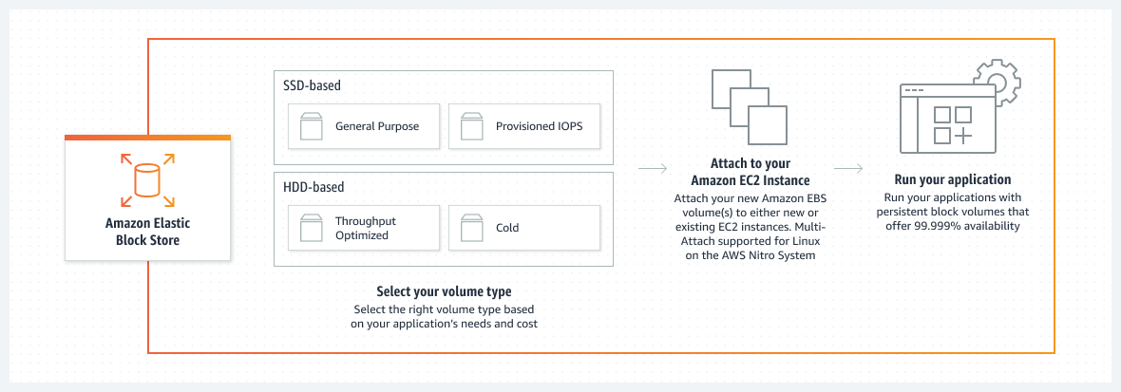

Figure 2 Amazon Elastic Block Store (Amazon EBS)

Amazon EBS provides businesses with scalability and flexibility, allowing them to resize volumes and attach them to different EC2 instances as their storage requirements evolve. Its uniform integration with other AWS services, including Amazon EC2, AWS Backup, and AWS CloudWatch, further enhances its utility as part of a comprehensive storage solution. Organizations across various industries have effectively embraced Amazon EBS to address their storage needs. For instance, companies hosting databases like MySQL, PostgreSQL, and Oracle rely on Amazon EBS for high-speed storage with demanding I/O requirements. Additionally, Amazon EBS serves as boot volumes for EC2 instances, providing consistent and predictable performance to meet stringent application requirements.

Customer success stories underscore Amazon EBS's practical benefits, highlighting its role in optimizing data storage and application performance in real-world scenarios. These examples also highlight Amazon EBS's adaptability and reliability, making it an indispensable component of cloud infrastructure for businesses seeking scalable and reliable storage solutions in the AWS cloud.

A Closer Look at Amazon Elastic Block Store (EBS)

Amazon EBS is a fully managed block storage service offered by Amazon Web Services (AWS), designed to provide organizations with scalable and reliable storage solutions for their cloud-based applications. With Amazon EBS, organizations can effortlessly create and attach block storage volumes to Amazon EC2 instances. These volumes offer persistent, low-latency storage, making them ideal for various use cases across different industries, with features like automated snapshots and multi-availability zone replication to protect data. EBS volumes can be easily resized and attached to different EC2 instances, offering flexibility as workloads evolve [2].

**Persistent, Low-latency Storage**: One of Amazon EBS's key features is its ability to provide persistent storage with low latency. This makes it suitable for critical workloads such as database storage, boot volumes, and application data requiring consistent and responsive access.

**Different Volume Types**: Amazon EBS offers different volume types optimized for various performance characteristics, allowing organizations to choose the right type based on their specific requirements. These volume types include:

* **SSD-backed General Purpose (gp2)**: This is ideal for many workloads, including boot volumes and small—to medium-sized databases.
* **Provisioned IOPS (io1)**: Designed for I/O-intensive workloads that require predictable and consistent performance, such as large database workloads and mission-critical applications.
* **HDD-backed Throughput Optimized (st1)**: Suited for frequently accessed, throughput-intensive workloads such as log processing and data warehouses.
* **Cold HDD (sc1)**: This type of storage is intended for infrequently accessed workloads where the lowest storage cost is paramount, such as file servers and data archives.

**High Availability and Durability**: Amazon EBS volumes are designed for availability and durability. There is replication within an Availability Zone to ensure redundancy and protect against hardware failures. Features like automated snapshots and multi-availability Zone replication further enhance data protection and durability.

**Flexibility and Scalability**: Amazon EBS volumes can be easily resized and attached to different EC2 instances, offering flexibility as workloads evolve. Organizations can adjust storage capacity and performance characteristics dynamically to meet changing requirements without impacting the availability of their applications.

In summary, Amazon EBS provides organizations with a versatile and reliable block storage solution that can adapt to various workloads and use cases. Its combination of low-latency storage, different volume types, high availability, durability, and scalability makes it an essential component of cloud infrastructure for businesses of all sizes.

Use cases and efficiency

Research articles consistently underscore the pivotal role of block storage in cloud computing, emphasizing the critical importance of selecting the appropriate storage type for specific workloads. Studies frequently highlight the crucial role of block storage in optimizing database performance, where low-latency and high IOPS (Input/Output Operations Per Second) storage are crucial [3]. AWS's documentation on EBS highlights its applicability in different scenarios, including hosting databases like MySQL, PostgreSQL, and Oracle, providing high-speed storage for applications with demanding I/O requirements, and serving as boot volumes for EC2 instances. EBS is known for its ability to deliver consistent and predictable performance, ensuring that applications can meet stringent requirements while enjoying the scalability and durability of the AWS cloud [4].

Amazon EBS, as a fully managed block storage service, caters to many use cases across various industries. Its versatility and reliability make it indispensable for organizations seeking efficient storage solutions in the cloud. Here are prominent use cases where Amazon EBS shines:

1. **Database Hosting**: Amazon EBS hosts MySQL, PostgreSQL, and Oracle databases. Its ability to provide high-speed storage with consistent performance ensures that database-intensive applications run smoothly, even under heavy workloads.
2. **Application Storage**: These applications have demanding I/O requirements, necessitating high-performance storage solutions. Amazon EBS is an ideal storage option for such applications, offering reliable and scalable storage volumes that can efficiently handle diverse workloads.
3. **Boot Volumes for EC2 Instances**: Amazon EBS volumes are used as boot volumes for Amazon EC2 instances. These volumes provide persistent storage for the operating system and application files, enabling smooth booting and quick access to critical resources.

Amazon EBS is renowned for its ability to deliver consistent and predictable performance, which is crucial for meeting the stringent requirements of modern applications. Whether ensuring low-latency access to data or managing high I/O workloads, Amazon EBS offers the scalability and durability required to support diverse use cases in the AWS cloud environment.

As we delve deeper into this chapter, we will explore Amazon EBS in greater detail, uncovering advanced configurations, best practices, and real-world case studies. By examining these examples, organizations can gain valuable insights into optimizing their data storage and application performance using this fundamental AWS storage service.

Amazon Elastic File System

**Amazon Elastic File System (EFS)** is a highly scalable, fully managed file storage service designed to facilitate the needs of applications requiring shared file systems. In contrast to block storage, which is tied to a single instance, **EFS** provides a multi-tenant, distributed file system, allowing multiple EC2 instances to access the same file system concurrently, regardless of their location within the same region. This capability proves invaluable for applications where **data sharing and collaboration** are critical, such as development environments, content management systems, or data analytics platforms.

The illustration below represents Amazon Elastic File System (EFS), according to Amazon’s documentation:

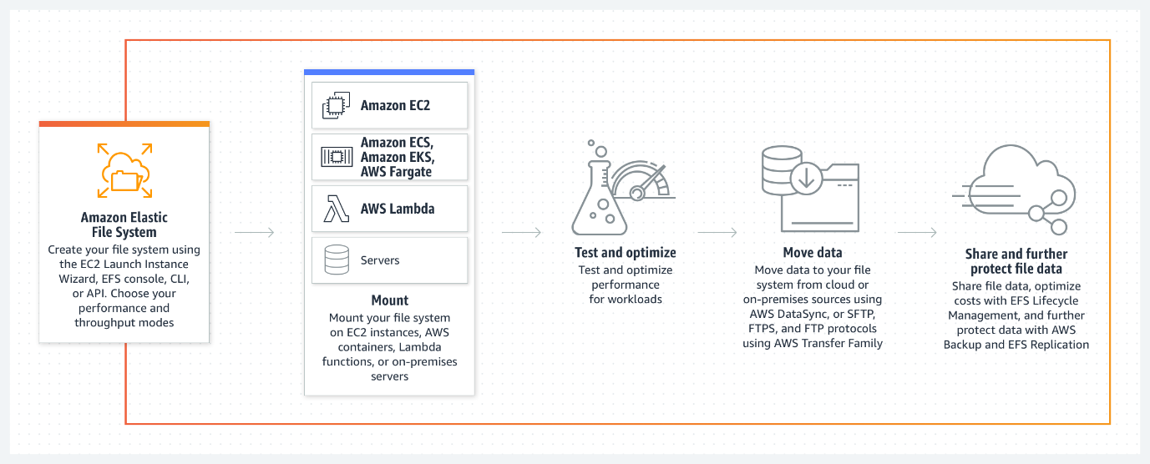

Figure 3 Amazon Elastic File System (EFS) (AWS EFS Documentation).

EFS Architecture and Elasticity

The architectural foundation of **EFS** is based on **NFS (Network File System)**, a well-established protocol that supports access from various EC2 instances. Unlike traditional on-premises storage, EFS is designed to **scale automatically** as your storage needs fluctuate, without requiring manual intervention. This feature ensures that your file system can dynamically grow or shrink, accommodating both **bursty workloads** and steady-state operations [5].

One of EFS's defining aspects is its **distributed file system architecture**, which allows data partitioning across multiple Availability Zones (AZs). This ensures that data is durable, resilient against potential failures, and universally available. Moreover, EFS boasts built-in **redundancy** across AZs, mitigating risks of data loss due to hardware failure or other infrastructure-level disruptions.

Performance Capabilities

EFS offers **multiple performance modes**, each designed to optimize workloads based on specific needs:

1. **General Purpose Mode**: Suitable for latency-sensitive applications, like web serving or content management systems, where consistent low-latency access to data is required.
2. **Max I/O Mode**: Optimized for applications that demand high throughput, such as big data analytics, media processing, or large-scale content delivery.

EFS also offers **storage classes** tailored to varying cost and performance needs:

* **Standard Storage Class**: Designed for frequently accessed data, this class provides high throughput and low latency.
* **Infrequent Access (IA)**: Optimized for data accessed less frequently but still requires rapid retrieval, this storage class offers cost savings for less critical data sets.

By allowing organizations to combine storage classes within the same file system, EFS optimizes costs while maintaining high-performance access for critical workloads.

Use Cases and Real-World Applications

EFS's versatility extends across various industries:

* **Media Processing and Collaboration**: In media production workflows, such as video editing or rendering, multiple instances require access to the same large files [6]. EFS simplifies **data sharing**, ensuring each instance can collaborate on shared assets without manual synchronization. For example, post-production teams working on high-resolution video can access a central repository of files in real-time, accelerating the entire workflow [7].
* **Web Hosting and Content Delivery**: EFS provides a scalable storage layer for **web hosting**, supporting dynamic content generation and distribution. When combined with services like **Amazon CloudFront**, web applications can offer users **low-latency content delivery** while benefiting from EFS's scalability and reliability.
* **Data Analytics**: Data scientists often need access to large datasets across multiple compute instances. EFS supports real-time collaboration, ensuring that all data points are readily accessible, enabling faster data processing and analysis. EFS’s elastic scalability ensures that no resources are wasted and that storage grows in coordination with increasing data needs.

Best Practices for Optimizing EFS Usage

To fully leverage **Amazon EFS**, adhering to the following best practices can enhance its performance and cost-efficiency:

1. **Select the Appropriate Performance Mode**: Choose between General Purpose and Max I/O modes to optimize cost and performance depending on the workload type.
2. **Leverage Lifecycle Policies**: Use **lifecycle management** to automatically move files not recently accessed into **Infrequent Access (IA)** storage. This reduces storage costs without compromising accessibility.
3. **Secure Your Data**: Implement **AWS Identity and Access Management (IAM)** to control access to EFS file systems. Then, leverage **encryption at rest** using AWS Key Management Service (KMS) to secure sensitive data.
4. **Monitor Usage and Performance**: Regularly monitor your file systems using **Amazon CloudWatch** metrics. This allows you to track I/O throughput, latency, and request counts, providing insights into optimizing performance based on real-time usage data.

Wrap up

**Amazon EFS** is a flexible and highly scalable file storage solution within the AWS ecosystem. Whether you are hosting websites, processing large media files, or supporting data-driven analytics, EFS offers a robust solution for shared, scalable file storage [4]. By employing best practices in performance tuning, cost optimization, and data protection, organizations can fully exploit the potential of **Amazon EFS** to drive innovation, enhance collaboration, and manage their cloud storage needs efficiently.

This in-depth look into **Amazon EFS** provides organizations with insights and tools to implement effective file storage solutions, ensuring their applications operate with agility and scalability in the cloud. As the demand for collaborative, distributed environments grows, **Amazon EFS** becomes an indispensable tool in the modern cloud landscape.

Amazon FSx

Amazon FSx emerges as a pivotal component within the AWS storage portfolio, addressing the escalating demand for managed file storage solutions tailored to specific workloads and use cases. As organizations increasingly transition to cloud-native architectures, the need for efficient, scalable, and available file storage becomes paramount. Amazon FSx addresses this need by offering fully managed file storage services optimized for Windows and Lustre workloads, empowering organizations to streamline data management and access within the AWS cloud environment.

At its core, Amazon FSx provides a comprehensive suite of features to enhance performance, reliability, and ease of use. With Windows and Lustre file systems support, Amazon FSx caters to various applications and industries, from traditional enterprise workloads to high-performance computing (HPC) environments.

For Windows workloads, Amazon FSx for Windows File Server delivers fully managed file storage with native Server Message Block (SMB) protocol support. This enables perfect integration with existing Windows environments, allowing users to access and share files using familiar interfaces and tools. Amazon FSx for Windows File Server provides features such as Active Directory integration, user quotas, and data deduplication, enhancing data management and security within Windows-based applications.

On the other hand, Amazon optimizes FSx for Lustre for HPC and data-intensive workloads, offering high-performance, scalable file storage for compute-intensive applications. Leveraging the Lustre parallel file system, Amazon FSx for Lustre delivers low-latency access to massive datasets, enabling organizations to accelerate data processing and analysis tasks. With support for high throughput and low latency, Amazon FSx for Lustre is well-suited for applications such as genomic sequencing, financial modeling, and scientific simulations.

In practical terms, Amazon FSx addresses many use cases across industries and domains. Amazon FSx provides a smooth migration path to the cloud for enterprises seeking to modernize their infrastructure, enabling organizations to transition legacy file storage systems to a fully managed, scalable environment. Amazon FSx for Lustre facilitates the analysis of large datasets and complex simulations in research and academic settings, empowering researchers to unlock new insights and discoveries.

Furthermore, Amazon FSx enhances operational efficiency and agility by automating routine tasks such as backup, maintenance, and patch management. By offloading these responsibilities to AWS, organizations can focus on innovation and value creation, leveraging the scalability and reliability of Amazon FSx to drive business outcomes.

In conclusion, Amazon FSx redefines the landscape of managed file storage, offering a robust and scalable solution for organizations seeking to modernize their data infrastructure in the cloud. With support for both Windows and Lustre file systems, Amazon FSx provides a versatile platform for a wide range of workloads and use cases, enabling organizations to optimize performance, streamline operations, and unlock new possibilities in the era of cloud computing.

Amazon FSx: A closer look

Amazon FSx is a managed file storage service that provides fully compatible file systems for Windows and Lustre workloads. FSx for Windows File Server offers a Windows-native file system flawlessly integrated with Active Directory, enabling organizations to run Windows-based applications requiring shared file storage. FSx for Lustre, on the other hand, delivers a high-performance, parallel file system designed for compute-intensive workloads such as **high-performance computing** (**HPC**) and machine learning. Both FSx offerings are fully managed, eliminating the operational overhead of file system provisioning, maintenance, and backup. With features like automated backups, data deduplication, and data synchronization, FSx simplifies file storage management in the AWS cloud [8].

Amazon FSx offers different file systems tailored to meet specific workload requirements and use cases. Each file system provides unique features and capabilities to optimize performance, reliability, and compatibility with different applications.

1. **Amazon FSx for NetApp ONTAP:** Amazon FSx for NetApp ONTAP delivers fully managed NetApp ONTAP file storage, offering industry-leading performance, scalability, and data management capabilities. This file system is ideal for enterprise workloads, including business applications, databases, and virtual desktop infrastructure (VDI). With features such as high availability, data deduplication, and SnapMirror data replication, Amazon FSx for NetApp ONTAP ensures robust data protection and perfect integration with existing NetApp environments.

Figure 4 Amazon FSx for NetApp ONTAP (AWS FSx documentation).

1. **Amazon FSx for OpenZFS:** Amazon FSx for OpenZFS provides scalable, high-performance file storage based on the open-source ZFS file system. Designed for compute-intensive workloads, machine learning, and data analytics, this file system offers advanced features such as copy-on-write snapshots, data compression, and native encryption. Amazon FSx for OpenZFS enables users to achieve low-latency access to large datasets while ensuring data integrity and security.

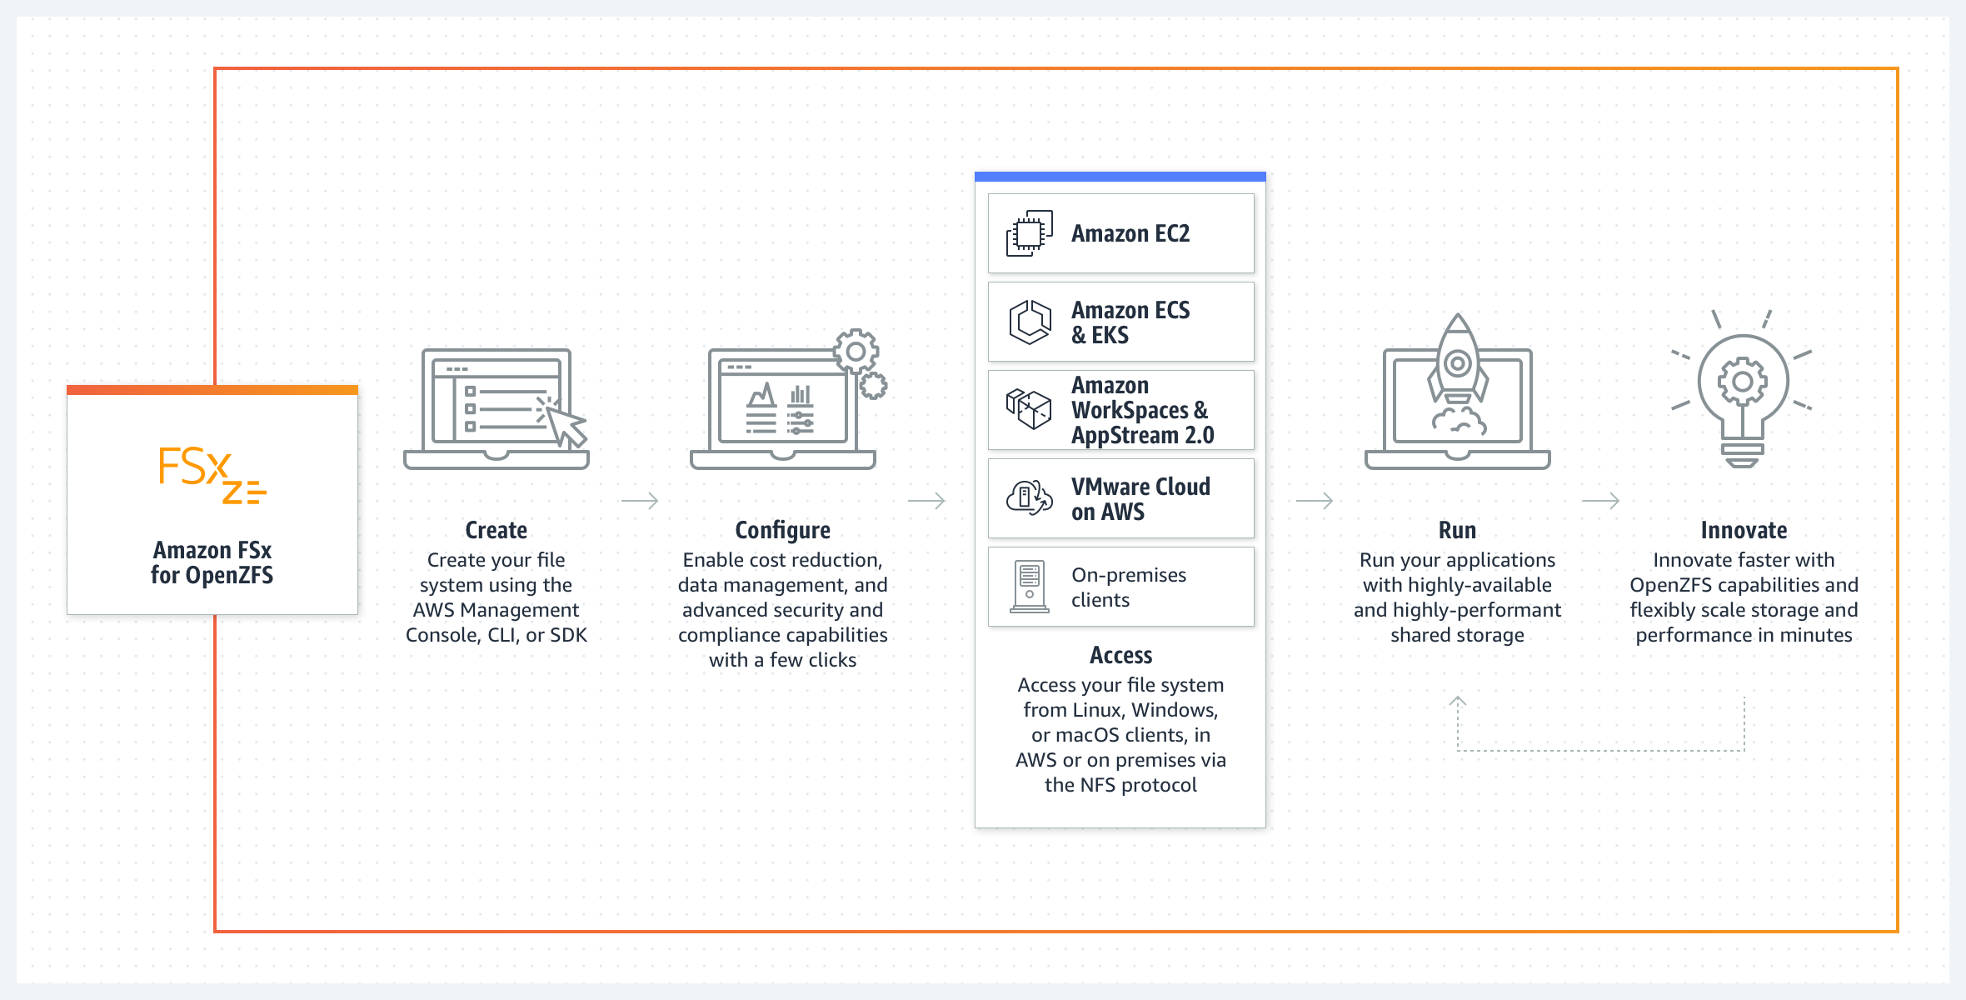

Figure 5 Amazon FSx for OpenZFS (AWS FSx documentation).

1. **Amazon FSx for Windows File Server:** Amazon FSx for Windows File Server delivers fully managed Windows file storage compatible with Microsoft Active Directory (AD) environments. It perfectly integrates Windows-based applications, user authentication, and access controls, enabling organizations to migrate and modernize their Windows workloads in the cloud. With support for NTFS permissions, Distributed File System (DFS), and multi-AZ deployments, Amazon FSx for Windows File Server offers enterprise-grade reliability and performance.

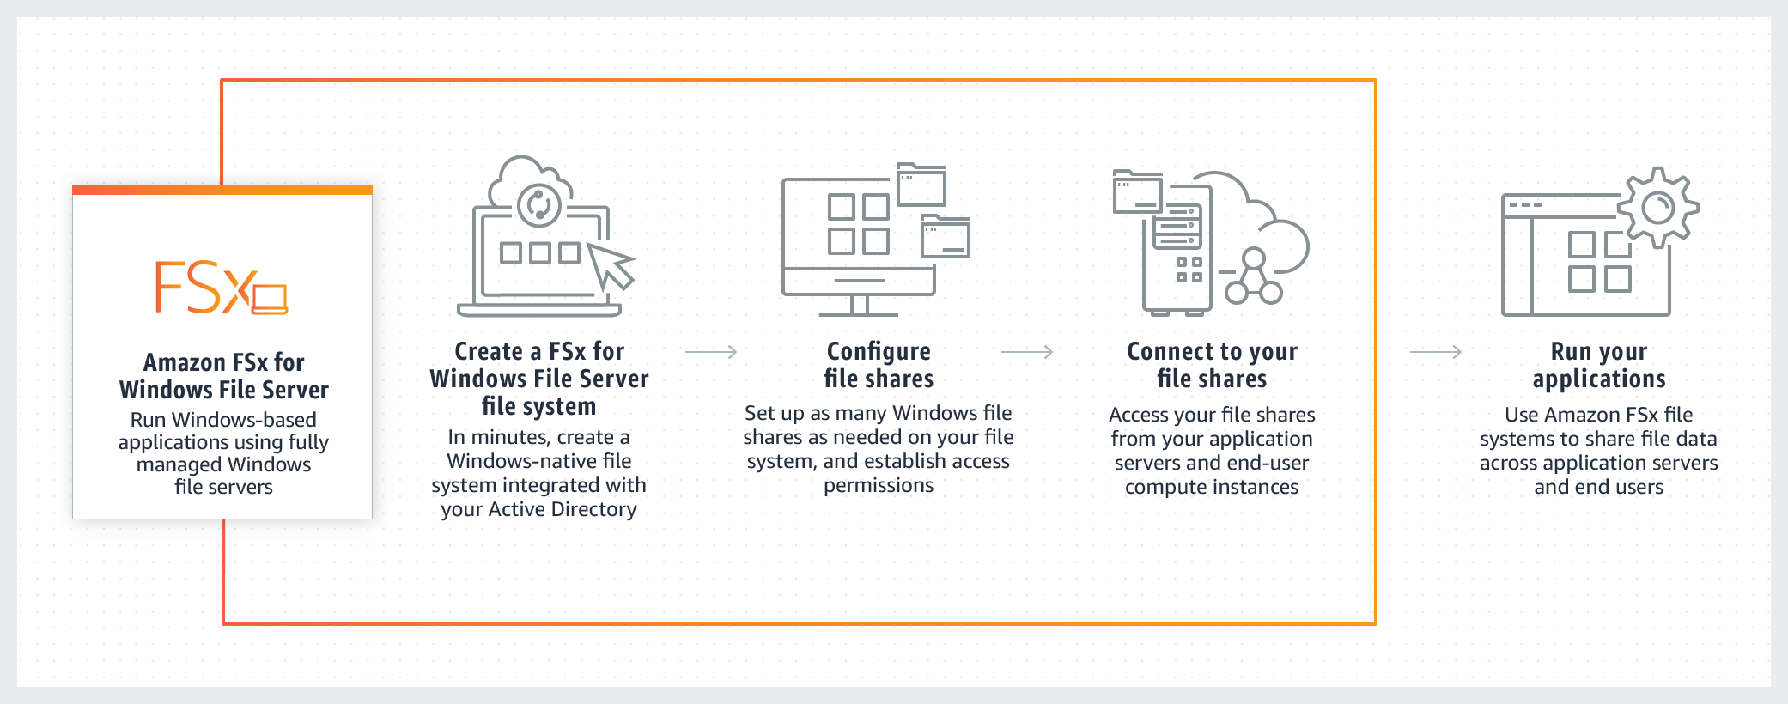

Figure 6 Amazon FSx for Windows File Server (AWS FSx documentation).

1. **Amazon FSx for Lustre:** Amazon FSx for Lustre offers high-performance, scalable file storage optimized for compute-intensive, high-throughput workloads such as simulation, rendering, and data analytics. Leveraging the Lustre parallel file system, this file system delivers sub-millisecond latencies and petabyte-scale storage capacity for processing large datasets. With features such as automatic data tiering, SSD caching, and integration with AWS compute services, Amazon FSx for Lustre accelerates cloud data processing and analysis workflows.

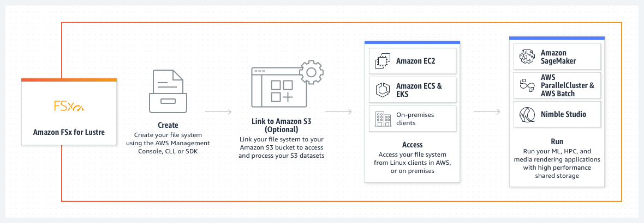

Figure 7 Amazon FSx for Lustre (AWS FSx documentation).

AWS designed each Amazon FSx file system to address specific workload requirements and use cases, providing organizations with flexible and reliable storage solutions tailored to their application needs.

Use cases and efficiency.

Existing studies highlight the significance of optimized file storage for specific workloads and the efficiency gains achieved through managed file systems. Research frequently underscores the role of file storage in Windows-centric environments and data-intensive applications, where performance and compatibility are paramount [9]. Amazon FSx emerges as a pivotal component within the AWS storage ecosystem, offering fully managed file storage services optimized for specific workloads and use cases. As organizations strive to maximize their data management strategies, the demand for efficient, scalable, and available file storage solutions continues to grow. Amazon FSx addresses this demand by providing managed file systems tailored to Windows-centric environments and data-intensive applications, delivering consistent performance and compatibility within the AWS cloud environment. AWS's documentation on FSx highlights its applicability in various scenarios, including Windows-based applications, analytics, media processing, and HPC. FSx is known for its ability to provide consistent and low-latency file storage, ensuring that applications meet their performance requirements while enjoying the benefits of AWS-managed services [10].

At its core, Amazon FSx offers a comprehensive suite of features to enhance performance, reliability, and ease of use. With Windows and Lustre file systems support, Amazon FSx caters to various applications and industries, from traditional enterprise workloads to high-performance computing (HPC) environments.

Amazon FSx for Windows File Server delivers fully managed file storage for Windows-centric environments with native Server Message Block (SMB) protocol support. This enables perfect integration with existing Windows environments, allowing users to access and share files using familiar interfaces and tools. Amazon FSx for Windows File Server provides features such as Active Directory integration, user quotas, and data deduplication, enhancing data management and security within Windows-based applications.

On the other hand, Amazon FSx for Lustre is optimized for data-intensive workloads and HPC environments, offering high-performance, scalable file storage for compute-intensive applications. Leveraging the Lustre parallel file system, Amazon FSx for Lustre delivers low-latency access to massive datasets, enabling organizations to accelerate data processing and analysis tasks. With support for high throughput and low latency, Amazon FSx for Lustre is well-suited for applications such as genomic sequencing, financial modeling, and scientific simulations.

In practical terms, Amazon FSx addresses many use cases across industries and domains. Amazon FSx provides a smooth migration path to the cloud for enterprises seeking to modernize their infrastructure, enabling organizations to transition legacy file storage systems to a fully managed, scalable environment. Amazon FSx for Lustre facilitates the analysis of large datasets and complex simulations in research and academic settings, empowering researchers to unlock new insights and discoveries.

Furthermore, Amazon FSx enhances operational efficiency and agility by automating routine tasks such as backup, maintenance, and patch management. By offloading these responsibilities to AWS, organizations can focus on innovation and value creation, leveraging the scalability and reliability of Amazon FSx to drive business outcomes.

In conclusion, Amazon FSx redefines the landscape of managed file storage, offering a robust and scalable solution for organizations seeking to modernize their data infrastructure in the cloud. With support for both Windows and Lustre file systems, Amazon FSx provides a versatile platform for a wide range of workloads and use cases, enabling organizations to optimize performance, streamline operations, and unlock new possibilities in the era of cloud computing. Through advanced configurations, best practices, and real-world case studies, organizations can harness the full potential of Amazon FSx to optimize their workloads and drive innovation in the AWS cloud environment.

As we continue this chapter, we will explore Amazon FSx in greater depth, unraveling advanced configurations, best practices, and real-world case studies that illustrate how organizations can leverage this managed file storage service to optimize their workloads in the AWS cloud.

Amazon S3 Glacier

In cloud storage, efficient and secure data archives are critical for organizations. Amazon S3 Glacier offers a solution by providing cost-effective archival storage that focuses on data durability and compliance. This section will explore the Amazon S3 Glacier in depth, uncovering its key features, benefits, use cases, and real-world applications supported by studies, successful deployments, and AWS sources.

The Amazon S3 Glacier is a foundation of cloud storage, offering organizations a cost-effective solution for efficient and secure data archiving. As data volumes grow, the need for reliable archival storage becomes increasingly pronounced, driving organizations to seek scalable and compliant solutions. Amazon S3 Glacier addresses this need by providing a robust platform optimized for long-term data retention, durability, and regulatory compliance.

At its core, Amazon S3 Glacier leverages a tiered storage model to accommodate varying data access frequencies and retrieval times. The service offers multiple storage classes, including Standard, Expedited, and Bulk retrievals, allowing users to tailor their storage strategy to meet specific requirements. With support for industry-standard encryption and compliance certifications, Amazon S3 Glacier ensures data security and integrity, making it a preferred choice for organizations operating in regulated industries.

One of Amazon S3 Glacier's key features is its uniform integration with other AWS services, enabling organizations to leverage the full capabilities of the AWS ecosystem. Whether backing up critical data, archiving log files, or storing regulatory documents, Amazon S3 Glacier provides a scalable and reliable platform for long-term data retention.

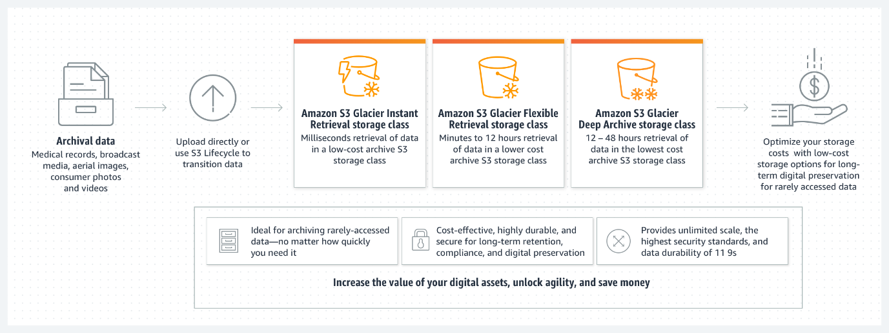

Figure 8 AmazonS3 Glacier storage classes (AWS S3 documentation).

Use cases for Amazon S3 Glacier span various industries and scenarios. For enterprises with regulatory compliance requirements, such as healthcare, finance, and government, Amazon S3 Glacier offers a secure and compliant solution for data archiving and retention. It is also a cost-effective storage option for long-term archival of video content, audio files, and multimedia assets in the media and entertainment industries.

Moreover, the Amazon S3 Glacier caters to data-intensive applications such as scientific research, genomics, and digital forensics, where large volumes of data must be retained for extended periods. By leveraging Amazon S3 Glacier's durable and scalable infrastructure, organizations can efficiently manage their data lifecycle, from creation to archival, while maintaining data accessibility and integrity.

As organizations navigate the complexities of data management and compliance, Amazon S3 Glacier emerges as a dependable partner, offering a comprehensive solution for long-term data archival and retention. With its robust feature set, scalable architecture, and uniform integration with the AWS ecosystem, Amazon S3 Glacier empowers organizations to unlock new possibilities in data storage and management, driving innovation and value creation in the cloud.

The upcoming chapter will dive into Amazon S3 Glacier and its advanced configurations, best practices, and real-world case studies. These examples demonstrate how organizations can use this archival storage service to improve their data management strategies in the AWS cloud.

Amazon S3 Glacier: A closer look

Amazon S3 Glacier stands as an essential component in the AWS storage ecosystem. It is an archival storage service designed for infrequently accessed data. Amazon S3 Glacier provides a scalable and durable platform for retaining data over extended periods, with data automatically distributed across multiple facilities and devices. S3 Glacier provides different retrieval options, including expedited, standard, and bulk retrievals, allowing organizations to balance cost and retrieval speed based on their needs. With features like data lifecycle policies, audit logging, and vault access policies, S3 Glacier ensures that archived data remains secure and compliant with industry regulations [11].

Amazon S3 Glacier employs a tiered storage model, allowing organizations to optimize storage costs based on data access frequency and retrieval speed. The service automatically distributes data across multiple facilities and devices, ensuring durability and availability even in the face of hardware failures or data center outages.

One of Amazon S3 Glacier's distinguishing features is its flexible retrieval options, which cater to various use cases and access patterns. Organizations can choose from expedited, standard, and bulk retrieval options, depending on their specific requirements for data access speed and cost considerations. This flexibility enables organizations to balance cost efficiency and retrieval speed, ensuring that archived data remains accessible when needed.

Amazon S3 Glacier offers comprehensive features to help organizations manage their archived data effectively. Data lifecycle policies allow organizations to define rules for automatically transitioning data to Glacier storage based on predefined criteria, such as age or access frequency. Audit logging capabilities provide visibility into data access and retrieval activities, enabling organizations to track and monitor data usage for compliance and auditing purposes.

Furthermore, Amazon S3 Glacier implements robust access controls through vault access policies, allowing organizations to restrict access to archived data based on user permissions and security policies. This ensures that archived data remains secure and protected against unauthorized access, maintaining compliance with industry regulations and data protection standards.

Use cases for Amazon S3 Glacier encompass various scenarios across various industries and business domains. Organizations can leverage S3 Glacier for archiving historical data, regulatory compliance, legal discovery, and long-term data retention. Industries such as healthcare, finance, and government, which have stringent compliance requirements, can benefit from the secure and scalable archival storage offered by Amazon S3 Glacier.

Moreover, organizations with data-intensive workloads, such as scientific research, genomics, and digital media, can leverage Amazon S3 Glacier to store and retain large volumes of data cost-effectively. By offloading infrequently accessed data to S3 Glacier, organizations can free up primary storage resources and reduce operational costs while ensuring data durability and availability.

In summary, Amazon S3 Glacier emerges as a reliable solution for organizations seeking cost-effective and secure archival storage for their data. With its scalable architecture, flexible retrieval options, and comprehensive feature set, the S3 Glacier enables organizations to manage their data lifecycle effectively, meet compliance requirements, and drive operational efficiency in the cloud.

Use cases and efficiency.

Amazon S3 Glacier is a pivotal solution for organizations grappling with long-term data retention, compliance, and cost management challenges in the cloud storage landscape. Learning from success cases, studies frequently underscore the role of archival storage in reducing costs associated with long-term data retention and compliance with data retention policies [12]. AWS's documentation on S3 Glacier highlights its applicability in various scenarios, including compliance archiving, digital preservation, and backup and restore operations. S3 Glacier's cost-effectiveness and durability make it an ideal choice for organizations seeking to meet regulatory requirements while optimizing storage costs [13].   
Tailored specifically for archival storage requirements, Amazon S3 Glacier offers a robust platform characterized by cost-effectiveness, durability, and scalability.

At its core, Amazon S3 Glacier provides organizations with a secure and reliable repository that must retain stored data accessed infrequently for compliance, regulatory, or business purposes. The service leverages a tiered storage model, allowing organizations to optimize costs by aligning storage tiers with data access patterns and retrieval requirements.

One of Amazon S3 Glacier's key features is its flexible retrieval options, which cater to a spectrum of use cases and access scenarios. Organizations can choose from expedited, standard, and bulk retrieval options, offering different trade-offs between retrieval speed and cost. This flexibility empowers organizations to tailor their data retrieval strategies based on specific business requirements and operational priorities.

Amazon S3 Glacier offers comprehensive data management capabilities, including data lifecycle policies, audit logging, and access controls. Data lifecycle policies enable organizations to automate data transition to Glacier storage based on predefined criteria, such as data age or access frequency. This helps streamline data management workflows and ensures data is stored cost-effectively without manual intervention.

Moreover, audit logging features give organizations visibility into data access and retrieval activities, facilitating compliance with regulatory requirements and internal governance policies. Access controls, implemented through vault access policies, enable organizations to enforce granular permissions and security policies, safeguarding archived data against unauthorized access and ensuring data integrity.

The use cases for Amazon S3 Glacier span a diverse range of industries and scenarios, reflecting its versatility and applicability across various domains. Organizations can leverage S3 Glacier for compliance archiving, regulatory retention, digital preservation, backup and restore operations, and disaster recovery preparedness. Industries such as healthcare, finance, legal, and government, subject to stringent regulatory requirements, can benefit significantly from the secure and cost-effective archival storage offered by Amazon S3 Glacier.

In addition, organizations with data-intensive workloads and large volumes of historical data can utilize S3 Glacier to optimize storage costs while maintaining data durability and accessibility. By offloading infrequently accessed data to Glacier storage, organizations can free up primary storage resources, reduce operational overhead, and ensure compliance with data retention policies and legal mandates.

In conclusion, Amazon S3 Glacier emerges as a strategic component in the AWS storage ecosystem, offering organizations a scalable, secure, and cost-effective solution for long-term data retention and archival storage. With its comprehensive feature set, flexible retrieval options, and robust data management capabilities, S3 Glacier empowers organizations to enhance their data management strategies, meet compliance requirements, and drive operational efficiency in the AWS cloud landscape.


                Relationship between JavaScript environments, the SDK, and S3 Glacier
            

Figure 9 JavaScript API for Amazon S3 Glacier (AWS SDK documentation).

As we continue this chapter, we will delve deeper into Amazon S3, unraveling advanced configurations, best practices, and real-world case studies that illustrate how organizations can leverage this versatile AWS storage service to optimize their data storage, distribution, and analysis in the AWS cloud.

Amazon Simple Storage Service

**Amazon Simple Storage Service (S3)** is one of AWS's most versatile and scalable storage solutions. As organizations increasingly move their workloads to the cloud, **Amazon S3** offers object storage designed to store and retrieve data from anywhere on the web, with unmatched flexibility and durability. The core advantage of **S3** is its **unlimited scalability**, allowing businesses to store data as needed without worrying about capacity limitations.

Architecture and Core Features

Amazon S3 organizes data into **buckets**, which store objects that consist of data, metadata, and a unique identifier. Each object can range from megabytes to terabytes, making S3 suitable for diverse workloads, such as small-scale backups and large-scale data lakes. The platform supports a wide range of **storage classes** tailored to different data access patterns and cost requirements:

* **S3 Standard**: Designed for frequently accessed data, providing high throughput and low latency.
* **S3 Intelligent-Tiering**: Automatically moves objects between two access tiers (frequent and infrequent) based on changing access patterns, optimizing cost.
* **S3 Glacier** and **Glacier Deep Archive**: Cost-effective solutions for long-term archival storage.

One of the cornerstones of S3 is its **global infrastructure**, which ensures durability by replicating data across multiple availability zones (AZs) in a region. This replication makes **S3 resilient to hardware failures**, safeguarding data against loss or corruption. **Versioning** is another crucial feature, allowing users to keep multiple versions of the same object. This feature is particularly valuable for protecting against accidental deletions or overwrites, providing businesses with more data integrity.

Security and Data Management

Amazon S3’s security architecture includes comprehensive mechanisms for access control and encryption. **Access control lists (ACLs)** and **bucket policies** provide fine-grained permission settings, allowing administrators to control who can access or modify objects in a bucket. These controls are crucial for maintaining **data confidentiality** and adhering to compliance requirements, especially in highly regulated industries like healthcare or finance. Furthermore, **server-side encryption (SSE)** and **client-side encryption** ensure that data remains protected in transit and at rest.

In addition to security, **Amazon S3 Lifecycle Policies** allow businesses to manage data efficiently by automatically transitioning objects between storage classes or expiring objects that are no longer needed. This automation helps optimize costs, ensuring that organizations pay only for the storage they require at any given time.

Real-World Use Cases and Applications

**Amazon S3** powers various applications across industries because it stores, protects, and retrieves massive amounts of data. Prominent use cases include:

1. **Data Lakes and Big Data Analytics**: S3 is the foundation for building **data lakes**, enabling businesses to store structured and unstructured data at any scale. It integrates effortlessly with analytics services like **Amazon Redshift**, **Amazon Athena**, and **Amazon EMR**, providing the infrastructure to derive insights from vast datasets [14]. For example, **e-commerce companies** store transaction logs and customer interaction data in S3, using analytics tools to optimize marketing strategies and improve user experiences.
2. **Archiving and Long-Term Data Retention**: Some organizations must retain large volumes of data for regulatory compliance, legal requirements, or historical analysis. With storage classes like **S3 Glacier** and **Glacier Deep Archive**, businesses can store infrequently accessed data cost-effectively. For instance, **financial institutions** rely on S3 to store transaction records and securely preserve critical financial data for extended periods.
3. **Content Delivery and Media Streaming**: Companies involved in **media and entertainment** leverage S3 to host and deliver multimedia content globally. Coupled with **Amazon CloudFront**, AWS’s content delivery network (CDN), S3 provides high-speed access to content by caching files at edge locations. This setup minimizes latency and optimizes the user experience for media streaming services or websites with heavy traffic.
4. **Mobile and Gaming Applications**: For mobile and gaming platforms [15], **Amazon S3** supports storing and delivering vast amounts of **user-generated content, media files, and in-game assets**. With **RESTful APIs** and SDKs, developers can integrate **S3** perfectly, enabling fast data access and ensuring that mobile apps and games provide users with real-time, responsive experiences.

In the next illustration, we share another use case: Mainframe data backup and archival augmentation, demonstrating the wide range of applications for Amazon S3

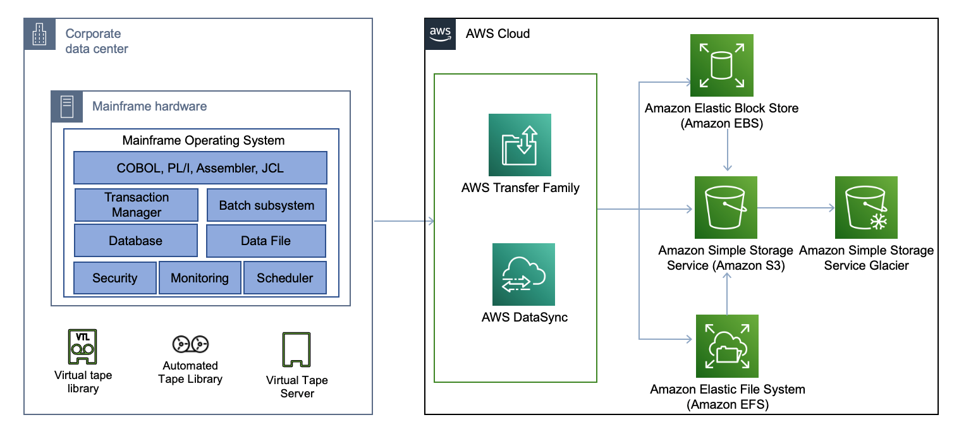Figure 10 Use case example: Mainframe data backup and archival augmentation (by Lewis Tang, AWS Architecture Blog).

Best Practices for Maximizing S3 Efficiency

To get the most out of **Amazon S3**, organizations should follow these best practices:

* **Optimize Data Access and Storage Classes**: To reduce storage costs, use S3 Intelligent-Tiering for data with unpredictable access patterns and S3 Glacier for long-term archival.
* **Enable Versioning and MFA Delete**: For added security, protect critical data from accidental deletions by enabling versioning and implementing Multi-Factor Authentication (MFA) Delete.
* **Use Encryption**: Ensure data is encrypted in transit and at rest using **S3’s built-in encryption** mechanisms, especially when managing sensitive or regulated data.
* **Leverage Event Notifications**: Automate workflows by enabling **S3 event notifications** to trigger actions like **AWS Lambda** functions for real-time processing or analysis of new data uploads.

Wrap up

In conclusion, **Amazon S3** continues to be a cornerstone of **AWS storage services**, empowering organizations across industries to store, manage, and retrieve data efficiently. Its scalability, cost optimization, and integration with other AWS services make it a versatile tool for diverse workloads. Whether it is powering **big data analytics**, managing **long-term archives**, or enhancing **content delivery** [16], S3 provides the flexibility and security required to succeed in the cloud era.

AWS Backup: A Comprehensive Overview

In the evolving landscape of cloud computing, **data protection** remains a critical priority for organizations striving to safeguard their assets and ensure **business continuity**. **AWS Backup** is a cornerstone solution, offering a **fully managed service** streamlining backup workflows for a wide range of AWS resources. This section delves into the **core functionalities, technical features, and practical applications** of AWS Backup, supported by real-world use cases and insights from authoritative AWS sources.

At its heart, **AWS Backup** provides a **centralized platform** for managing backup and recovery across AWS services, including **Amazon EBS volumes**, **Amazon RDS databases**, **Amazon DynamoDB tables**, and **Amazon EFS file systems**. This unified solution eliminates the need for multiple tools and custom scripts, significantly simplifying the backup process while improving operational efficiency. By automating backup scheduling and retention policies, **AWS Backup** allows organizations to define precise rules for **backup frequency**, **retention periods**, and **lifecycle management**, ensuring compliance with regulatory requirements and maintaining data consistency.

In the next illustration, we share a high-level architecture of AWS Backup, according to Amazon Web Services:

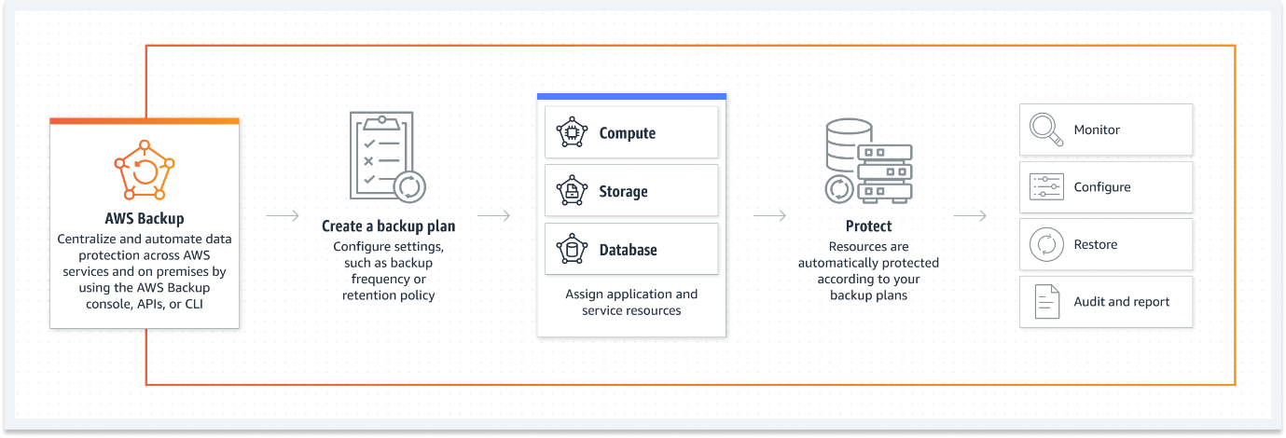

Figure 11 AWS Backup (AWS Backup documentation).

Core Features and Integration

AWS Backup is a fully managed service that automates data backup across AWS services, helping organizations ensure data resiliency and compliance with minimal effort. AWS Backup is a pivotal solution in cloud data protection, offering organizations a fully managed service that automates backup processes across a diverse array of AWS services. AWS Backup supports backup and restore for various AWS resources, including Amazon EBS volumes, Amazon RDS databases, Amazon DynamoDB tables, Amazon EFS file systems, and more. With a centralized and unified backup management interface, AWS Backup simplifies setting up and managing backups for a wide range of AWS services. By smoothly integrating with various AWS resources, AWS Backup empowers organizations to fortify their data resiliency strategies and achieve regulatory compliance with minimal operational overhead. It offers features such as backup policies, lifecycle management, cross-region and cross-account backups, and integration with AWS **Identity and Access Management** (**IAM**) for secure access control [17]. This section will delve deeper into the efficiency-enhancing features of AWS Backup and elucidate its versatile applications through real-world scenarios and industry best practices.

One of the standout features of **AWS Backup** is its **automated backup scheduling**. Users can set up policies that dictate how often backups are taken and how long they are retained. This capability significantly reduces the manual overhead typically associated with traditional backup systems. Additionally, **AWS Backup** integrates natively with AWS service APIs, facilitating uniform workflows without needing third-party tools or additional infrastructure. This native integration ensures data consistency and makes the backup and recovery process much more efficient across diverse AWS environments.

Another critical feature is the **cross-region and cross-account replication**, which enables organizations to replicate backups to different AWS regions or accounts, adding an extra layer of protection in case of regional outages or disasters. This replication capability is crucial for disaster recovery scenarios, where organizations must ensure their data is **always available and resilient** across different geographical locations.

**IAM integration** further enhances **AWS Backup's** security. Allowing organizations to define granular access controls and permissions ensures that only authorized personnel can perform backup and recovery operations. This capability helps to mitigate the risk of unauthorized access and provides an audit trail for compliance.

Use cases and efficiency.

We learn the importance of robust data protection and backup strategies in cloud environments from success cases. Use case studies emphasize the pivotal role of automated backup services in mitigating the risk of data loss and facilitating disaster recovery planning [18]. AWS's own documentation on AWS Backup highlights its applicability in various scenarios, including backup and recovery for critical databases, compliance archiving, and ensuring data durability for long-term retention. AWS Backup's flexibility and support for a wide array of AWS resources make it a valuable tool for organizations looking to safeguard their data assets in the cloud [19].

With its comprehensive features and managed service approach, AWS Backup exemplifies efficiency and reliability in data protection within AWS cloud environments.

1. **Backup and Recovery for Critical Databases**: Organizations rely on AWS Backup to safeguard critical databases, such as Amazon RDS and Amazon DynamoDB, against data corruption, accidental deletions, or system failures. By automating backup processes and enabling point-in-time recovery, AWS Backup ensures data integrity and availability, allowing organizations to maintain business continuity and minimize downtime during data loss incidents.
2. **Disaster Recovery Preparedness**: AWS Backup’s automation capabilities make it ideal for creating scheduled backups that ensure data availability in case of unexpected failures. Businesses can guarantee rapid recovery with minimal downtime by automating point-in-time recovery and utilizing cross-region replication.
3. **Regulatory Compliance**: Different industries, such as finance and healthcare, have strict data retention policies for regulatory compliance. AWS Backup enables organizations to implement data retention policies that comply with these regulations while maintaining secure access controls, audit trails, and encryption.
4. **Data Archiving and Long-Term Retention**: AWS Backup integrates with **Amazon S3 Glacier** and **S3 Glacier Deep Archive**, making it a cost-efficient solution for long-term data storage. Organizations can manage historical data archiving with lifecycle management features to optimize costs and retain data according to compliance mandates.
5. **Compliance Archiving**: Regulatory compliance mandates often require organizations to maintain archival copies of sensitive data for extended periods. AWS Backup facilitates compliance archiving by providing automated backup capabilities for various AWS resources, including Amazon EBS volumes, Amazon EFS file systems, and Amazon RDS databases. With AWS Backup, organizations can easily enforce data retention policies, implement audit trails, and demonstrate adherence to regulatory requirements.
6. **Ensuring Data Durability for Long-Term Retention**: Long-term data retention is crucial for organizations across various industries, including healthcare, finance, and government, where historical data analysis and regulatory compliance are paramount. AWS Backup offers a scalable and durable solution for long-term data retention, leveraging cross-region replication, encryption, and lifecycle management to ensure data durability and integrity over extended periods. By archiving data securely in Amazon S3 Glacier or Amazon S3 Glacier Deep Archive, organizations can optimize storage costs while maintaining data accessibility and compliance with regulatory mandates.

AWS Backup's flexibility and support for a wide array of AWS resources make it a valuable tool for organizations seeking to safeguard their data assets in the cloud. Whether protecting critical databases, ensuring compliance with regulatory requirements, or implementing long-term data retention strategies, AWS Backup empowers organizations to mitigate risks, streamline backup operations, and uphold data integrity in today's dynamic and data-driven landscape.

The flexibility of **AWS Backup** makes it applicable to a wide range of scenarios, including:

Cross-Region and Cross-Account Backup

**AWS Backup** excels in offering **cross-region and cross-account backups**, a crucial feature for organizations seeking to enhance their disaster recovery strategy. By replicating regional backups, organizations can safeguard their data against regional disasters or outages. This capability ensures **data redundancy** across geographically dispersed locations, ensuring high **data availability**. Additionally, cross-account backups provide a robust security mechanism by allowing businesses to store backups in separate AWS accounts, reducing the risk of data loss due to malicious activity or accidental deletion in the primary account.

In practical scenarios, AWS Backup's cross-region replication has proven invaluable for organizations that operate in **compliance-driven industries**. For instance, **financial services companies** must ensure their backup data is replicated and retained securely across multiple locations, adhering to international data protection regulations. AWS Backup provides a perfect solution by allowing data to be backed up across regions and accounts, with built-in encryption and compliance auditing.

Wrap up

In conclusion, **AWS Backup** is a comprehensive and pivotal tool in AWS's portfolio of data protection services. Its **automated backup scheduling**, **cross-region replication**, and **IAM-integrated security controls** give organizations flexibility and efficiency to safeguard their data assets. Whether disaster recovery, compliance archiving, or long-term retention, **AWS Backup** ensures businesses can protect their data and maintain continuity in an ever-changing digital landscape.

By leveraging AWS Backup's robust feature set and uniform integrations, organizations can simplify their **backup and recovery processes**, ensuring that critical data is protected and available whenever needed. As organizations migrate to cloud-native architectures, AWS Backup will remain essential for building resilient, scalable, and secure data protection strategies.

AWS Snow Family

The AWS Snow Family represents a critical component in addressing the challenge of transferring large datasets between on-premises and cloud environments. As organizations deal with ever-expanding volumes of data, the need for secure, efficient, and scalable data transfer solutions becomes paramount. The AWS Snow Family offers a range of physical devices tailored to diverse use cases, providing uniform integration between on-premises infrastructure and AWS cloud services.

At the core of the AWS Snow Family is the AWS Snowcone, AWS Snowball, and AWS Snowmobile, each designed to meet specific data transfer requirements and operational scenarios. The AWS Snowcone, a small, ruggedized device, is ideal for collecting, processing, and transferring data in remote or harsh environments with limited connectivity. With its compact form factor and built-in security features, the Snowcone enables organizations to efficiently perform edge computing tasks and data collection activities.

On the other hand, the AWS Snowball and AWS Snowball Edge devices cater to medium to large-scale data transfer needs. These rugged, tamper-resistant appliances facilitate the offline transfer of petabytes of data securely. Equipped with high-speed data transfer interfaces and encryption capabilities, Snowball devices streamline importing and exporting data to and from AWS cloud storage services, such as Amazon S3 and Amazon Glacier.

The AWS Snowmobile offers an unparalleled solution for organizations with massive data volumes exceeding petabytes. Housed in a secure, ruggedized shipping container, the Snowmobile is a high-capacity data transfer device capable of transporting exabytes of data to AWS data centers. With its massive storage capacity and high-speed connectivity, the Snowmobile accelerates data migration projects, enabling organizations to transition vast datasets to the cloud efficiently.

The AWS Snow Family finds extensive application across various industries and use cases. For example, organizations in the media and entertainment sector leverage Snowball devices to transfer large video files, production datasets, and media archives to the cloud for post-production, content distribution, and archival purposes. In the healthcare industry, healthcare providers use Snowball devices to securely transfer and store sensitive patient data, medical records, and imaging files in compliance with regulatory requirements.

Furthermore, scholarly articles and AWS documentation underscore the significance of the AWS Snow Family in facilitating data migration, disaster recovery, and hybrid cloud deployments. Research highlights its role in expediting data transfer processes, reducing network bandwidth constraints, and minimizing the time-to-value for cloud adoption initiatives.

In summary, the AWS Snow Family offers a comprehensive suite of data transfer solutions designed to address the complexities of modern data management and migration challenges. By providing secure, scalable, and efficient offline data transfer capabilities, the AWS Snow Family empowers organizations to transition to the cloud while maintaining control, compliance, and security over their data assets.

AWS Snow Family: A closer look

The AWS Snow Family encompasses a suite of purpose-built devices meticulously crafted to streamline the process of data migration to and from AWS, particularly for organizations dealing with large-scale datasets. Among these devices are the AWS Snowcone, AWS Snowball, and AWS Snowmobile, each engineered to cater to specific data transfer requirements and operational contexts. These devices include security features like encryption and tamper-evident seals, ensuring the confidentiality and integrity of the data during transit. AWS Snow Family also offers integration with AWS services and APIs to simplify the data import/export [20].

AWS Snowcone is a compact, rugged, and portable device ideally suited for edge and remote locations where network connectivity may be limited or unreliable. Snowcone packs robust data transfer capabilities, enabling organizations to collect, process, and transfer data efficiently in challenging environments despite its small form factor.

In contrast, AWS Snowball emerges as a larger, ruggedized data transfer device capable of easily handling petabytes of data. Designed for medium—to large-scale data migration tasks, Snowball simplifies securely transferring vast datasets to and from AWS cloud storage services. Its durable construction, high-speed data transfer interfaces, and built-in encryption features make it an indispensable tool for organizations seeking to accelerate their data migration initiatives.

AWS Snowmobile offers an unmatched solution for organizations grappling with exabyte-scale data migration challenges. Housed within a 45-foot-long shipping container, Snowmobile redefines the data transfer paradigm by enabling the uniform transportation of massive volumes of data to AWS data centers. With its colossal storage capacity and high-speed connectivity, Snowmobile empowers organizations to execute unprecedented-scale and complex data migration projects confidently and efficiently.

One of the AWS Snow Family's hallmark features is its robust security architecture, which includes encryption mechanisms and tamper-evident seals to safeguard data integrity and confidentiality throughout the transfer process. These security measures ensure that sensitive data remains protected against unauthorized access or tampering during transit, providing organizations with peace of mind and compliance assurance.

Moreover, the AWS Snow Family offers uniform integration with AWS services and APIs, enabling organizations to leverage the full capabilities of the AWS ecosystem for data import, export, and processing tasks. Whether integrating with Amazon S3 for scalable object storage or interfacing with AWS Lambda for serverless data processing, the AWS Snow Family empowers organizations to harness the power of AWS cloud services to address diverse data management and migration challenges effectively.

In summary, the AWS Snow Family represents a comprehensive suite of data transfer solutions designed to address the complexities of modern data migration requirements. By offering a diverse range of devices tailored to different use cases and scalability needs, robust security features, and uniform AWS integration, the AWS Snow Family enables organizations to execute data migration initiatives confidently, efficiently, and with scalability, accelerating their journey to the cloud.Top of Form

The illustration below shows an example architecture of how the AWS Snow Family and regional AWS services can facilitate data migration and analysis of autonomous vehicle fleets.

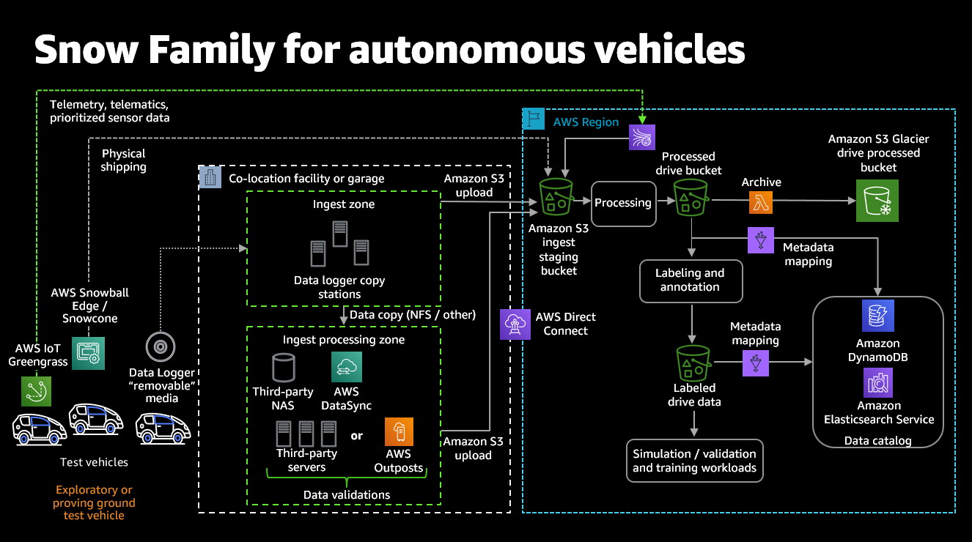Figure 12 This is an example architecture illustrating how the AWS Snow Family, combined with regional AWS services, can facilitate data migration and analysis of autonomous vehicle fleets (AWS Blogs).

Use cases and efficiency.

Existing studies, such as those cited as references for this book, often emphasize the challenges associated with large-scale data transfer to and from the cloud and the need for efficient data migration solutions. These references (and others) frequently underscore the role of physical devices in overcoming bandwidth limitations and reducing the time and cost of data transfer [21]. AWS's documentation on the AWS Snow Family highlights its applicability in various scenarios, including data center migrations, disaster recovery, and content distribution. AWS Snow Family's versatility and secure data transfer capabilities make it a valuable tool for organizations looking to bridge the gap between on-premises and cloud storage [22].

In academic discourse, the challenges inherent in large-scale data transfer to and from the cloud highlight the imperative for efficient data migration solutions. Bandwidth limitations and the associated time and cost of data transfer represent significant hurdles organizations must overcome in their cloud migration endeavors. The AWS Snow Family addresses these challenges head-on, offering a suite of physical devices purpose-built to streamline data migration operations.

One prominent use case for the AWS Snow Family is data center migrations. In scenarios where organizations need to transition large volumes of data from on-premises data centers to the cloud, the AWS Snow Family provides a robust solution. By leveraging the high-capacity storage and efficient data transfer capabilities of devices like AWS Snowball and AWS Snowmobile, organizations can expedite the migration process and minimize downtime, thereby accelerating their transition to cloud-based infrastructure.

Disaster recovery represents another critical use case for the AWS Snow Family. In the event of a data center outage or infrastructure failure, organizations must swiftly recover and restore their data to ensure business continuity. The AWS Snow Family offers a resilient and reliable solution for disaster recovery scenarios, enabling organizations to replicate and transfer mission-critical data to AWS cloud storage with minimal disruption. With features like encryption and tamper-evident seals, the AWS Snow Family ensures the security and integrity of data during transit, providing organizations with confidence in their disaster recovery capabilities.

The AWS Snow Family is also an invaluable tool for content distribution initiatives. In industries such as media and entertainment, where files and high-resolution content are distributed to a global audience, the AWS Snow Family offers a scalable and efficient solution for content delivery. Organizations can distribute content rapidly and securely by leveraging devices like AWS Snowball Edge and AWS Snowmobile, ensuring optimal performance and user experience for consumers worldwide.

The AWS Snow Family represents a versatile and efficient solution for diverse data migration and transfer scenarios. From data center migrations to disaster recovery and content distribution, the AWS Snow Family empowers organizations to overcome the challenges of large-scale data transfer, enabling them to leverage the scalability, flexibility, and reliability of AWS cloud storage with confidence and efficiency.

As we continue this chapter, we will delve deeper into AWS Storage Gateway, unraveling advanced configurations, best practices, and real-world case studies that illustrate how organizations can leverage this hybrid cloud storage service to enhance their data integration and management strategies within the AWS cloud.

AWS Storage Gateway

In today’s hybrid cloud environments, organizations often seek a bridge between their on-premises infrastructure and the vast capabilities of the cloud. **AWS Storage Gateway** serves as this critical bridge, enabling organizations to extend their local storage to the AWS cloud smoothly, thus unlocking the benefits of cloud scalability, elasticity, and cost-efficiency. This section will explore **AWS Storage Gateway** in detail, including its features, use cases, and technical capabilities. At its core, AWS Storage Gateway acts as a hybrid cloud storage service, enabling organizations to extend their on-premises storage environments into the cloud uniformly [23].

AWS Storage Gateway offers a range of storage protocols, including NFS, SMB, iSCSI, and Tape Gateway, catering to diverse use cases and application requirements. This versatility allows organizations to integrate AWS cloud storage flawlessly into their existing workflows and applications without requiring extensive reconfiguration or redevelopment.

Next illustration shows a high-level architecture of the AWS Storage Gateway options:

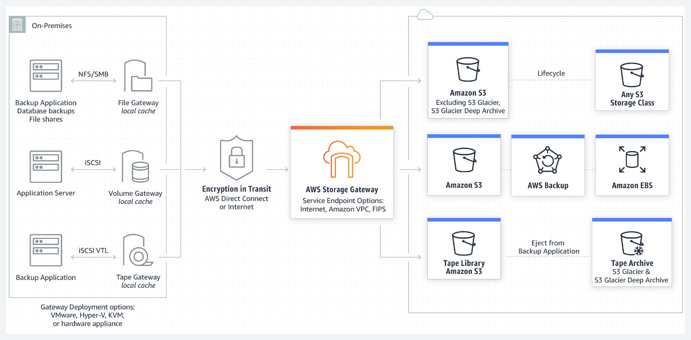

Figure 13 AWS Storage Gateway options – File, Volume, and Tape Gateways (AWS Blogs).

Key Features and Functionality

One of the key features of AWS Storage Gateway is its support for data tiering and caching mechanisms, which optimize storage utilization and access performance based on access patterns and data lifecycle policies. AWS Storage Gateway enables organizations to balance cost-efficiency and performance optimization by intelligently tiering data between on-premises and cloud storage tiers.

Use cases for AWS Storage Gateway abound across various industries and scenarios. For instance, organizations can utilize AWS Storage Gateway for data backup and disaster recovery, leveraging its uniform integration with AWS cloud storage to ensure data resiliency and business continuity. Similarly, an example of deployment of AWS Storage Gateway is for archival and long-term data retention, offering a cost-effective solution for storing historical data and regulatory compliance.

Furthermore, AWS Storage Gateway facilitates hybrid cloud storage architectures, allowing organizations to extend their on-premises storage environments flawlessly into the cloud. This enables businesses to leverage the scalability and elasticity of AWS cloud storage while retaining the familiarity and control of their on-premises infrastructure.

**AWS Storage Gateway** provides three distinct gateway types—**File Gateway**, **Volume Gateway**, and **Tape Gateway**—each catering to specific use cases:

1. **File Gateway** enables on-premises applications to access Amazon S3 as a scalable file storage solution via **NFS** or **SMB** protocols. This option is especially useful for storing unstructured data such as multimedia assets or application files. Data written to the File Gateway is stored in S3 as objects, allowing organizations to use S3’s cost-effective storage tiers, including **S3 Glacier** and **S3 Intelligent-Tiering**, for infrequently accessed data.
2. **Volume Gateway** presents a block storage interface and supports two modes: **cached volumes** and **stored volumes**. Cached volumes provide low-latency access to frequently used data while storing the bulk of the data in Amazon S3. In contrast, stored volumes keep the entire dataset on-premises while replicating it to AWS. This makes Volume Gateway ideal for databases and enterprise applications requiring consistent, low-latency access to data.
3. **Tape Gateway** enables organizations to transition from traditional tape backups to the cloud by emulating a **virtual tape library (VTL)**. This allows data to be archived in **Amazon S3 Glacier** for long-term storage, replacing physical tape infrastructures with a fully scalable and durable cloud solution.

In summary, AWS Storage Gateway represents a pivotal solution for organizations navigating the complexities of hybrid cloud storage environments. With its versatile features, uniform integration capabilities, and diverse use cases, it empowers organizations to unlock the full potential of cloud storage while smoothly bridging the gap between on-premises and cloud-based storage solutions.

In addition to its gateway types, AWS Storage Gateway offers distinctive features to optimize data transfer, enhance data security, and streamline storage management. These features include:

* **Data Transfer Optimization:** AWS Storage Gateway optimizes data transfer between on-premises environments and AWS cloud storage, ensuring efficient utilization of network bandwidth and reducing latency.
* **Caching:** The gateway caches frequently accessed data locally to minimize access latency and improve application performance.
* **Snapshot Backups:** Storage Gateway supports snapshot backups of volumes and file shares, enabling organizations to create point-in-time data protection and disaster recovery backups.
* **Data Encryption:** Storage Gateway encrypts data in transit and at rest, ensuring the confidentiality and integrity of data stored in AWS cloud storage.

Enhanced Data Tiering and Caching

A critical advantage of **AWS Storage Gateway** is its **data tiering** and **caching** mechanisms. By intelligently caching frequently accessed data locally, Storage Gateway minimizes latency and improves access times for on-premises applications. Data tiering between on-premises environments and AWS cloud storage also ensures that organizations can balance **performance and cost-efficiency** by moving less frequently accessed data to lower-cost storage classes in S3 or Glacier. This feature reduces storage costs without compromising access to mission-critical data.

Security and Compliance Features

**AWS Storage Gateway** includes robust security features, such as **end-to-end encryption** for data in transit and at rest. This ensures data integrity and confidentiality, particularly for sensitive healthcare, finance, and government workloads. Additionally, **IAM integration** allows organizations to enforce access controls for backup and restore operations, ensuring only authorized users can access critical data.

Use cases and efficiency.

Use cases and efficiency articles often emphasize the challenges associated with hybrid cloud storage and the need for efficient data integration between on-premises and cloud environments. Research frequently underscores the role of hybrid storage gateways in simplifying data management and facilitating cloud adoption while preserving existing on-premises investments [24]. AWS's documentation on AWS Storage Gateway highlights its applicability in various scenarios, including data backup and archive, disaster recovery, and content distribution. AWS Storage Gateway's flexibility and ease of integration make it a valuable tool for organizations looking to smoothly extend their on-premises storage to the AWS cloud [25].

As we continue this chapter, we will explore AWS Elastic Disaster Recovery (DRS) further, unraveling advanced configurations, best practices, and real-world case studies that illustrate how organizations can leverage this disaster recovery framework to enhance their business continuity strategies within the AWS cloud.

Extending On-Premises Storage into the Cloud

Organizations across various industries leverage AWS Storage Gateway to address a multitude of use cases and enhance operational efficiency:

1. **Backup and Archive**: One of the most common use cases for AWS Storage Gateway is as a **backup and archival solution**. By integrating on-premises backup workflows with Amazon S3 and Glacier, organizations can offload backups to the cloud, reducing their reliance on costly, limited-capacity on-premises storage. For example, a healthcare provider could use **Tape Gateway** to back up patient records to S3 Glacier, ensuring compliance with data retention regulations while eliminating the need for physical tapes. AWS Storage Gateway offers a uniform solution for backing up and archiving critical data to the cloud. By leveraging Storage Gateway's integration with Amazon S3 and Glacier, organizations can offload backups from on-premises infrastructure to scalable and durable cloud storage. This use case is particularly beneficial for organizations seeking to improve data resiliency, reduce storage costs, and simplify backup and recovery processes. For example, a financial institution can use Storage Gateway to securely archive transaction records and financial data for long-term retention and compliance, ensuring data integrity and regulatory compliance.
2. **Disaster Recovery (DR)**: **Volume Gateway** plays a vital role in **disaster recovery** strategies, enabling organizations to replicate on-premises data to the AWS cloud. This provides a reliable and scalable DR solution that reduces downtime during failure. An enterprise, for instance, could replicate its database volumes via **stored volumes**, ensuring mission-critical data is always available, even in the face of hardware failure. Disaster recovery planning is paramount for organizations to mitigate the impact of unexpected disruptions and ensure business continuity. AWS Storage Gateway enables organizations to implement robust disaster recovery strategies by replicating on-premises data to AWS cloud storage. In the event of a disaster or data loss incident, organizations can quickly restore critical data and applications from cloud backups, minimizing downtime and maintaining operational continuity. For instance, a healthcare provider can use Storage Gateway to replicate patient records and medical imaging data to the cloud, ensuring timely access to critical healthcare information during emergency situations and natural disasters.
3. **Content Distribution and Collaboration**: **File Gateway** can store and distribute files like video content, software updates, and digital assets. This case is particularly relevant for media companies and software vendors delivering content to users globally. By leveraging **Amazon CloudFront** for **content delivery**, businesses can serve files from S3 with minimal latency, enhancing the user experience. AWS Storage Gateway facilitates efficient content distribution by enabling organizations to distribute media files, software updates, and digital assets from on-premises storage to global audiences. By leveraging Storage Gateway's integration with Amazon CloudFront, organizations can deliver content with low latency and high transfer speeds to end-users worldwide. This case is particularly relevant for media and entertainment companies, software vendors, and e-commerce businesses looking to deliver rich media content and software applications to customers and users across diverse locations. For example, a media streaming platform can use Storage Gateway to catch popular video content locally and distribute it to users worldwide via CloudFront, ensuring uniform streaming experiences and reducing end-user latency.

In summary, AWS Storage Gateway's flexibility and ease of integration make it a valuable tool for organizations looking to extend their on-premises storage to the AWS cloud. By addressing diverse use cases, including data backup and archive, disaster recovery, and content distribution, Storage Gateway empowers organizations to optimize their storage infrastructure, enhance data management capabilities, and accelerate cloud adoption initiatives.

Integration with AWS Ecosystem

The true power of **AWS Storage Gateway** lies in its uniform integration with other AWS services, making it an integral part of an organization's **hybrid cloud strategy**. It works well with:

* **Amazon S3** for scalable object storage and archival.
* **Amazon CloudFront** for content delivery.
* **Amazon S3 Glacier** for cost-efficient long-term data retention.
* **Amazon EC2** and **Amazon RDS** are used to replicate workloads and ensure business continuity.

Wrap up: Bridging On-Premises and Cloud Storage

In conclusion, **AWS Storage Gateway** provides organizations a versatile and scalable solution for integrating on-premises applications with AWS cloud storage. Whether it is file storage, backup, disaster recovery, or content distribution, AWS Storage Gateway offers the tools to optimize storage infrastructure and enhance data management. By addressing diverse use cases, including **data backup and archiving**, **disaster recovery**, and **content distribution**, Storage Gateway empowers businesses to extend their storage footprint into the cloud faultlessly, driving innovation and efficiency in their operations.

As we progress, we will explore AWS Elastic Disaster Recovery (DRS), which will further strengthen an organization's ability to recover swiftly from disasters and ensure uninterrupted service delivery.

AWS Elastic Disaster Recovery (DRS)

AWS Elastic Disaster Recovery (DRS) plays a crucial role in ensuring business continuity by offering organizations a resilient framework for recovering critical workloads and data in the event of unexpected disruptions. As companies increasingly rely on cloud-based digital infrastructure, AWS DRS provides a sophisticated, scalable, and automated approach to disaster recovery (DR) within the AWS cloud, ensuring operational resilience across various scenarios.

The illustration below shows the AWS Elastic Disaster Recovery (AWS DRS) high-level architecture:

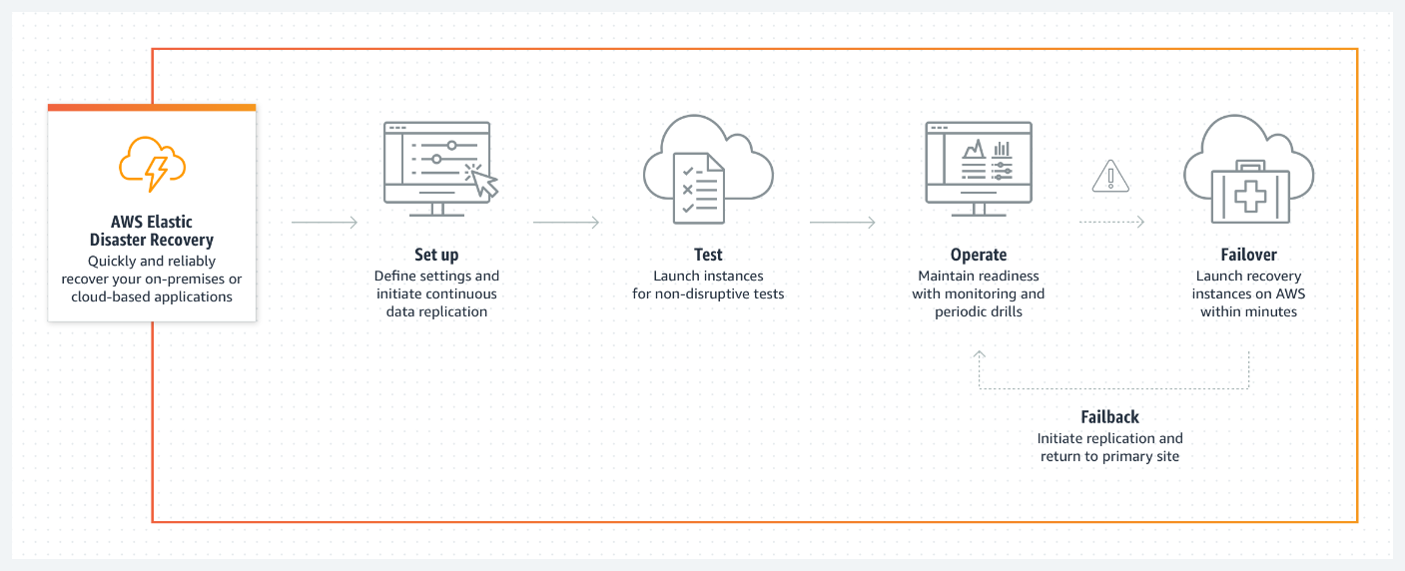

Figure 14 AWS Elastic Disaster Recovery (AWS DRS) (AWS Disaster Recovery documentation).

At its core, AWS Elastic DRS leverages the elasticity and scalability of the AWS cloud to orchestrate uniform failover and failback processes. This enables organizations to replicate their workloads and data across multiple AWS regions for enhanced resilience. By leveraging AWS's global infrastructure, Elastic DRS ensures high availability and durability, mitigating the risk of downtime and data loss associated with traditional disaster recovery approaches.

One of the key features of AWS Elastic DRS is its automation capabilities, which streamline the configuration, testing, and execution of disaster recovery plans. Organizations can define recovery point objectives (RPOs) and recovery time objectives (RTOs) tailored to their specific business requirements, allowing for granular control over recovery processes. Additionally, AWS Elastic DRS offers continuous monitoring and logging functionalities, enabling organizations to track the health and performance of their disaster recovery environments in real time.

The benefits of AWS Elastic DRS extend beyond mere disaster recovery, encompassing a wide range of use cases and scenarios. For example, organizations can leverage Elastic DRS to achieve regulatory compliance by implementing geographically dispersed disaster recovery sites that adhere to industry-specific mandates and standards. Furthermore, Elastic DRS facilitates uniform migration and workload mobility, allowing organizations to move their workloads between regions for optimization and resource allocation.

Real-world applications of AWS Elastic DRS abound across various industries and sectors. From financial institutions ensuring continuous access to banking services to healthcare providers safeguarding patient records and critical healthcare systems, Elastic DRS is a linchpin in preserving operational continuity and data integrity. Moreover, organizations in highly regulated sectors, such as government agencies and educational institutions, rely on Elastic DRS to uphold stringent compliance requirements and data protection standards.

In summary, AWS Elastic Disaster Recovery represents a change in thinking in disaster recovery management, offering organizations unparalleled flexibility, scalability, and resilience in mitigating the impact of disruptions. By embracing Elastic DRS, organizations can fortify their infrastructure, uphold operational excellence, and navigate the evolving landscape of digital resilience with confidence and resilience.

Key Features of AWS Elastic Disaster Recovery

At its core, AWS Elastic DRS leverages AWS’s cloud infrastructure to offer uniform failover and failback processes, ensuring data and workloads are replicated across AWS regions. This robust architecture protects organizations against regional outages, hardware failures, and potential risks.

Key features include:

1. **Automated Backup and Replication**: AWS Elastic DRS automates the continuous replication of workloads and data across AWS regions, ensuring data availability in case of failure. This minimizes the risk of data loss and ensures uniform recovery.
2. **Cross-Region Failover**: Elastic DRS replicates workloads to multiple AWS regions, providing redundancy and geographical resilience. In regional outages, organizations can automatically fail to another region without significant downtime.
3. **Runbook Automation**: Elastic DRS offers automated runbooks, which streamline disaster recovery procedures. By automating failover and recovery processes, DRS reduces the need for manual intervention and accelerates recovery times, minimizing downtime.

AWS Elastic Disaster Recovery (DRS) is a sophisticated solution crafted by AWS to empower organizations with robust disaster recovery capabilities within the AWS cloud environment. We find in reports about existing deployments an emphasis on the importance of robust disaster recovery solutions in minimizing business disruption and data loss during unexpected events. On those deployments. the role of cloud-based disaster recovery solutions is considered fundamental in providing scalability, reliability, and cost-efficiency [26]. AWS's documentation on AWS Elastic DRS highlights its applicability in various scenarios, including business continuity planning, disaster recovery testing, and regulatory compliance. AWS Elastic DRS's automation and integration with other AWS services make it a valuable tool for organizations looking to ensure business continuity in the cloud [27].

Let us delve deeper into the components, features, and scenarios where AWS Elastic DRS shines:

Components of AWS Elastic Disaster Recovery:

1. **Automated Backup and Replication**: AWS Elastic DRS automates the backup and replication of critical workloads, ensuring data integrity and availability during a disaster. Organizations can define backup policies and replication schedules to meet their recovery objectives.
2. **Cross-Region Failover**: Elastic DRS enables organizations to replicate their workloads across multiple AWS regions, facilitating uniform failover in case of regional outages or disruptions. This cross-region redundancy enhances resilience and minimizes downtime.
3. **Runbook Automation**: With built-in runbook automation, AWS Elastic DRS streamlines the execution of disaster recovery procedures. Organizations can define pre-configured runbooks to automate failover and failback processes, reducing manual intervention and accelerating recovery times.

When to Use AWS Elastic Disaster Recovery:

1. **Mission-Critical Workloads**: Organizations hosting mission-critical applications and services on AWS can benefit from AWS Elastic DRS to ensure continuous availability and data protection.
2. **Regulatory Compliance**: AWS Elastic DRS helps organizations meet regulatory compliance requirements by establishing resilient disaster recovery environments that adhere to industry-specific mandates.
3. **Geographically Distributed Applications**: Applications requiring geographically distributed deployments can leverage AWS Elastic DRS to replicate data and workloads across multiple AWS regions, ensuring high availability and fault tolerance.
4. **Disaster Recovery Testing**: Elastic DRS facilitates disaster recovery testing by providing sandbox environments for organizations to simulate failover scenarios and validate recovery procedures without impacting production systems.

Scenarios Resolved by AWS Elastic Disaster Recovery:

1. **Regional Outages**: AWS Elastic DRS mitigates the impact of regional outages by enabling organizations to fail over to secondary AWS regions.
2. **Data Loss Prevention**: Elastic DRS automates backup and replication processes to help organizations prevent data loss and maintain data integrity during disaster recovery events.
3. **Downtime Reduction**: Elastic DRS's automated failover capabilities minimize downtime and ensure business continuity, enabling organizations to resume operations swiftly following a disaster.
4. **Compliance Challenges**: Elastic DRS addresses compliance challenges by providing secure, auditable disaster recovery solutions that meet regulatory requirements and industry standards.

Use Cases and Benefits

AWS Elastic Disaster Recovery can be used in a variety of critical scenarios:

1. **Mission-Critical Workloads**: Organizations can use Elastic DRS to safeguard their most critical applications and services, ensuring continuous availability and data protection during disruptions.
2. **Compliance and Regulatory Requirements**: Elastic DRS helps meet stringent regulatory requirements by establishing resilient disaster recovery environments that comply with industry-specific standards, making it particularly useful in sectors like finance, healthcare, and government.
3. **Disaster Recovery Testing**: The service allows DR testing in isolated sandbox environments, enabling organizations to simulate failover and validate recovery procedures without impacting live operations.
4. **Geographically Distributed Deployments**: By leveraging Elastic DRS, companies running geographically distributed applications can replicate data across AWS regions, ensuring high availability and fault tolerance.

Real-World Applications

AWS Elastic DRS is widely adopted across various industries, where uninterrupted operations are crucial. Financial institutions, for instance, use Elastic DRS to ensure continuous access to banking services, even in the event of data center failures. Similarly, healthcare providers rely on the service to safeguard critical medical systems and patient records, ensuring these resources remain available even during disasters.

In regulated industries such as government and education, AWS Elastic DRS is essential for meeting compliance mandates by maintaining audit trails and ensuring data protection across dispersed environments.

Disaster Recovery and Operational Resilience

AWS Elastic DRS redefines how organizations approach disaster recovery, offering more than just a backup solution. Its scalability, automation, and integration with other AWS services make it a cornerstone for modern business continuity planning. Organizations can confidently maintain operations in the cloud while minimizing downtime and data loss in the face of minor disruptions and full-scale disasters.

AWS Elastic Disaster Recovery provides organizations with a powerful, automated, scalable disaster recovery framework for maintaining business continuity. By leveraging features like automated failover, cross-region replication, and runbook automation, AWS Elastic DRS enables organizations to minimize downtime, maintain compliance, and enhance their resilience in the cloud-driven digital age.

Conclusion

In this chapter, we have navigated the extensive landscape of AWS storage solutions, uncovering various services designed to address specific business needs and diverse use cases. AWS offers a robust suite of storage services, each pivotal in helping organizations store, manage, protect, and recover their data efficiently and securely.

Our journey began with **Amazon EBS**, a high-performance block storage service tailored for low-latency and high-throughput workloads on EC2 instances. We then explored **Amazon EFS**, which provides scalable, file-level storage for various applications, and **Amazon FSx**, a managed file storage service optimized for Windows and Lustre workloads. **Amazon S3** stands out as the cornerstone of scalable object storage, while **Amazon S3 Glacier** delivers cost-effective, long-term archival storage for infrequently accessed data.

As we progressed, we examined the importance of **AWS Backup**, which simplifies backup and recovery across AWS resources. We also discussed the **AWS Snow Family**, highlighting its role in bridging on-premises and cloud environments for efficient data transfer. **AWS Storage Gateway** further facilitates hybrid storage solutions by integrating on-premises data centers with the cloud. Finally, **AWS Elastic DRS** emerged as a vital disaster recovery tool, ensuring business continuity through the rapid recovery of critical systems.

Throughout this chapter, we have not only delved into the technical intricacies of these services but also examined real-world use cases and industry research emphasizing the critical role of cloud-based storage solutions. Whether ensuring data security, improving scalability, or optimizing performance, AWS storage services empower businesses to meet their evolving storage requirements flexibly and cost-effectively.

The illustration below reinforces the importance of knowing your data to pick the right store.

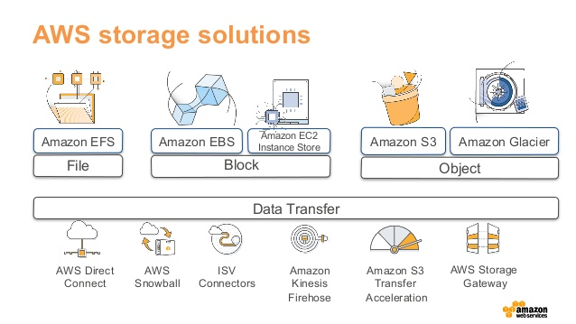

Figure 15 Picking the Right Data Store for Your Workload (AWS Blogs).

As we conclude, AWS’s comprehensive storage offerings are indispensable for organizations across industries. They deliver the necessary tools to adapt to data management, protection, and recovery demands.