CHAPTER 5

Security, Identity, and Compliance

Introduction

In an age where data is the lifeblood of modern enterprises, safeguarding information and ensuring compliance with stringent regulations have become paramount. This chapter discusses security, identity, and compliance within the AWS Cloud ecosystem. Here, we will explore an extensive array of AWS services designed to fortify your digital fortress. From Amazon Cognito, a robust solution for managing user identities and authentication, to Amazon Security Hub, a centralized hub for security compliance monitoring, each topic in this chapter is a vital piece of the puzzle in ensuring the safety and integrity of your cloud infrastructure. Whether you are seeking to protect sensitive data, defend against cyber threats, or establish granular access controls, this chapter equips you with the knowledge and tools to navigate the complex landscape of cloud security with confidence. Welcome to the AWS Cloud Computing Master Class, where we understand security, identity, and compliance to empower you in securing your digital assets.

In this chapter, we will demystify these AWS services, providing practical insights and best practices for implementation. With a focus on real-world scenarios and hands-on guidance, this chapter aims to equip both newcomers and seasoned AWS professionals with the expertise needed to bolster security, manage identities, and maintain compliance in the cloud. Whether you are a security enthusiast looking to explore the latest advancements or a cloud practitioner seeking to fortify your organization's defenses, this chapter offers a comprehensive guide to the ever-evolving world of AWS security, identity, and compliance services.

Structure

In this chapter, we will discuss the following topics:

* Amazon Cognito
* Identity management for your apps
* Amazon Detective
* Amazon GuardDuty
* Amazon Inspector
* Amazon Macie
* Amazon Security Lake
* Amazon Verified Permissions
* AWS Artifact
* AWS Audit Manager
* AWS Certificate Manager
* AWS CloudHSM
* AWS Directory Service
* AWS Firewall Manager
* AWS IAM Identity Center
* AWS Identity and Access Management
* AWS Key Management Service (KMS)
* AWS Network Firewall
* AWS Resource Access Manager
* AWS Secrets Manager
* AWS Security Hub
* AWS Shield
* AWS WAF

Objectives

In this chapter, readers will:

1. Gain a comprehensive understanding of fundamental security concepts in AWS, including identity and access management, encryption, and compliance.
2. Explore AWS services and features designed to enhance security, identity management, and compliance in cloud environments.
3. Learn practical strategies for implementing robust security measures to protect AWS resources and data.
4. Understand how to manage user access, permissions, and authentication mechanisms effectively within AWS.
5. Delve into compliance frameworks and regulations relevant to AWS, including HIPAA, GDPR, and SOC 2, and learn how to achieve compliance within AWS.
6. Discover best practices for monitoring, auditing, and responding to security incidents in AWS environments.
7. Gain insights into AWS security tools, services, and resources available to support security, identity, and compliance efforts.
8. Explore real-world use cases and case studies to illustrate effective security, identity, and compliance implementations in AWS.
9. Acquire practical knowledge to design, deploy, and manage secure and compliant AWS architectures for various business requirements.
10. Develop a holistic approach to security, identity, and compliance management in AWS, aligning with industry standards and best practices.

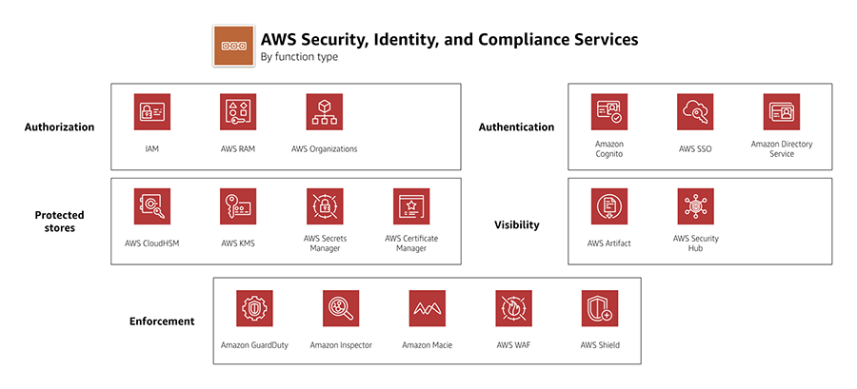

Figure 5.1 AWS Security, Identity, and Compliance Services (Mark Nunnikhoven, AWS Blog).

Amazon Cognito

In today's cloud computing landscape, ensuring the secure and efficient management of user identities and access to your applications is paramount. Amazon Cognito, an integral part of AWS's identity and access management services, stands out as a robust solution for these challenges. In this section, we will delve into Amazon Cognito's architecture, features, and best practices, referencing scholarly articles and official AWS sources to provide you with a comprehensive understanding of its capabilities[1].

Understanding Amazon Cognito

Amazon Cognito, introduced in 2014, is a managed service designed to simplify the implementation of user authentication and authorization in applications. It consists of three primary components:

* **User pools:** Amazon Cognito user pools act as user directories that facilitate user registration and authentication[2]. These pools are highly versatile and can integrate with various identity providers, including popular social platforms like Google and Facebook. User Pools also support customizable authentication flows, enabling developers to create tailored user experiences.
* **Federated identities:** Beyond authentication, Amazon Cognito Federated Identities, or Identity Pools, bridge the gap to provide secure identity management2. Identity Pools grant temporary, limited-privilege AWS credentials to users, allowing them to securely access other AWS services without the need for long-term AWS credentials. This seamless integration simplifies authorization processes for developers[3].
* **Sync service:** The Amazon Cognito Sync service ensures data synchronization across devices and platforms for authenticated users. It serves as a secure data storage solution in the AWS Cloud, ensuring data consistency across multiple devices and enabling offline data access.

Key features and benefits

The following are the key features of Amazon Cognito:

* **Scalability:** Amazon Cognito seamlessly scales to accommodate a growing user base, ensuring high availability and reliability for your applications.
* **Security:** Built-in security features include **multi-factor authentication** (**MFA**), data encryption, and user account recovery, enhancing the protection of user data.
* **Customization:** Amazon Cognito offers a high degree of customization, empowering developers to design authentication and authorization flows tailored to their application's specific needs.
* **Integration:** Its seamless integration with other AWS services, such as AWS Lambda, Amazon S3, and Amazon API Gateway, enables the development of robust serverless applications.

Best practices for Amazon Cognito implementation

Let us discuss the best practices for Amazon Cognito implementation:

* **User pools for user management:** Utilize Amazon Cognito user pools for user registration, sign-in, and authentication, streamlining user identity management.
* **Implement MFA:** Enhance security by enabling MFA, adding an extra layer of protection for user accounts.
* **Integrate federated identities:** Combine user pools with federated identities to grant users secure access to AWS resources, adhering to the principle of least privilege.
* **Prioritize data encryption:** Encrypt sensitive user data both at rest and in transit to safeguard user privacy.
* **Continuous monitoring and audit:** Regularly monitor user activities, review logs, and set up alerts to promptly identify and respond to suspicious behavior.

This section provides an in-depth exploration of Amazon Cognito, drawing insights from scholarly articles and official AWS sources.

Identity management for your apps

Identity management is at the core of securing cloud-based applications and resources. In this section, we will explore identity management for your AWS-hosted applications. We will explore best practices, AWS services, and scholarly articles to help you establish a robust identity management strategy following industry standards and security principles [4] [5].

The significance of identity management

Effective identity management is fundamental for ensuring the security, privacy, and compliance of your applications. Identity management encompasses various aspects, including user authentication, authorization, and access control. By implementing strong identity management practices, you can mitigate risks associated with unauthorized access, data breaches, and compliance violations 4 5.

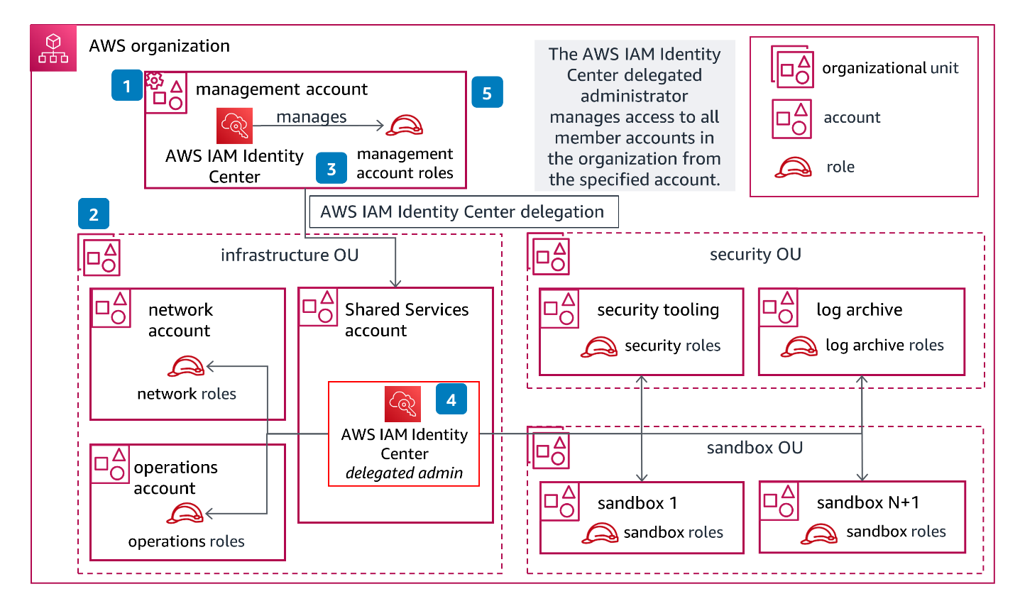

Figure 5.2 The Guidance for the Identity Management & Access Control (IMAC), AWS Solutions.

|  |  |  |  |  |
| --- | --- | --- | --- | --- |
| Step 1  On your management account, create an AWS IAM Identity Center instance and set up your organization. | Step 2  Create the initial set of recommended accounts to configure your foundation. Follow the recommendations included in the [Production Starter Organization](https://docs.aws.amazon.com/whitepapers/latest/organizing-your-aws-environment/production-starter-organization.html). | Step 3  Connect to your external IdP, or create the Users and Groups within AWS IAM Identity Center to organize access across your environment. Create permission sets for access to your management account and assign them to the management account users. | Step 4  Delegate AWS IAM Identity Center to your Shared Services account, log in with the AWS IAM Identity Center role, create permission sets, and assign them to the groups and users for the member accounts in your AWS organization. | Step 5  Using your AWS IAM Identity Center role to administer the management account, create Preventive Controls using Service Control Policies in the management account, and delegate the security, network, and operation services to their corresponding AWS accounts in your environment. |

Table 1 Table 1 The Guidance for the Identity Management & Access Control (IMAC), AWS Solutions step by step (AWS Solutions).

AWS Identity and Access Management

AWS provides a comprehensive **Identity and Access Management** (**IAM**) service that enables you to manage user identities, roles, and permissions within your AWS environment. IAM allows you to:

* **Create and manage users:** You can create IAM users and grant them specific permissions to access AWS resources5.
* **Use roles for temporary access:** IAM roles enable temporary access to AWS services. For example, you can assign roles to Amazon EC2 instances for secure interaction with other AWS services7.
* **Define fine-grained permissions:** IAM policies allow you to define fine-grained permissions for users and resources. This ensures the principle of least privilege, where users have only the permissions necessary for their tasks[6].
* **MFA:** AWS IAM supports MFA, adding an extra layer of security to user accounts7.

Best practices for identity management

Let us discuss the best practices for identity management:

* **Implement strong authentication:** Enforce strong password policies and consider MFA for enhanced security.
* **Role-Based Access Control (RBAC):** Follow RBAC principles to ensure users have appropriate permissions based on their roles and responsibilities.
* **Regularly review and audit permissions:** Periodically review and audit permissions to remove unnecessary access and ensure compliance.
* **Least privilege principle:** Apply the principle of least privilege to restrict user access to only what they need to perform their tasks6.
* **Centralized identity federation:** Implement a centralized identity federation to allow **single sign-on** (**SSO**) for multiple AWS accounts and services5.

This section underscores the critical role of identity management in safeguarding AWS-hosted applications and resources. By adhering to best practices and leveraging AWS IAM, you can establish a robust identity management framework for your cloud-based solutions6. Subsequent sections in this chapter will explore additional facets of security, identity, and compliance within the AWS ecosystem.

Amazon Detective

In this section, we will explore Amazon Detective, an AWS service designed to assist in the investigation of potential security issues across your AWS resources. We will discuss the key features and benefits of Amazon Detective [7] [8].

Understanding Amazon Detective

Amazon Detective is a security service that provides you with detailed insights into the activities and behaviors across your AWS environment. It simplifies the process of identifying the root causes and impact of potential security issues, enabling faster and more effective responses to security incidents8.

Key features of Amazon Detective

Let us discuss the key features of Amazon Detective: 8

* **Automated data collection:** Amazon Detective automatically collects log data from multiple AWS services, aggregating it into a unified view for analysis.
* **Graph-based visualizations:** The service uses graph theory to create visual representations of the relationships and behaviors of AWS resources, making it easier to identify anomalies and threats.
* **Behavioral analytics:** Amazon Detective employs machine learning models to establish baselines of normal behavior, helping you identify deviations that may indicate security issues8.
* **Security findings:** It provides detailed security findings, including the affected resources, their activities, and recommended remediation steps.
* **Integration with AWS Security Services:** Amazon Detective seamlessly integrates with other AWS security services, enhancing your overall security posture.

Benefits of Amazon Detective

Let us discuss the benefits of Amazon Detective:

* **Simplified investigations:** The service streamlines the process of investigating security incidents by providing a consolidated view of relevant data.
* **Faster response:** With automated data collection and analysis, Amazon Detective enables quicker responses to security threats.
* **Improved visibility:** The graph-based visualizations offer enhanced visibility into the relationships between AWS resources, aiding in threat detection.

Use cases

Amazon Detective is particularly valuable in scenarios where you need to investigate security incidents, analyze deviations from normal behavior, and identify potential threats to your AWS resources. 8

Amazon Detective offers valuable insights into security incidents, enabling security teams to respond effectively. By leveraging automated data collection and behavioral analytics, you can identify and address potential security threats within your AWS environment.8 The subsequent sections in this chapter will explore additional AWS services and strategies for enhancing security, identity, and compliance.

Amazon GuardDuty

In this section, we will explore Amazon GuardDuty, an AWS service designed to protect your AWS resources by continuously monitoring for malicious and unauthorized activities. We will delve into the key features and benefits of Amazon GuardDuty [9] [10].

Understanding Amazon GuardDuty

Amazon GuardDuty is a managed threat detection service that continuously monitors your AWS accounts, workloads, and data for suspicious and malicious activities. It leverages machine learning and anomaly detection to identify potential security threats, making it an essential component of your AWS security strategy9.

4 The Step Functions state machine ingests the details of the Security Hub.

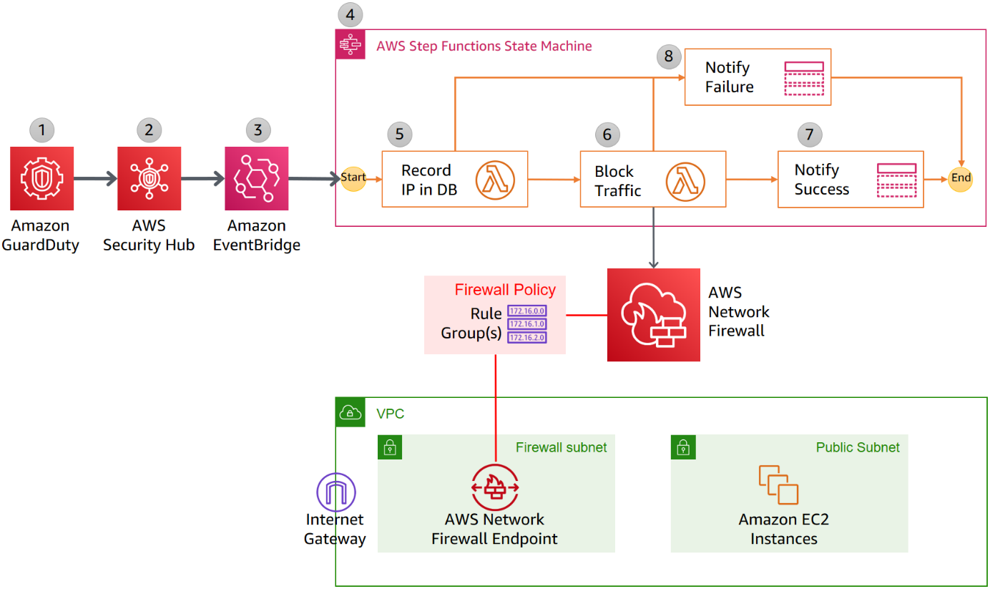

Figure 5.3 Detailed workflow diagram: Automatically block suspicious traffic with Network Firewall and GuardDuty (Alex Tomic and Cameron Worrell - AWS Security Blog).

The solution is implemented as follows:

1. GuardDuty detects unexpected behavior that includes a remote host IP address. GuardDuty generates a finding, in JSON format, that includes details such as the EC2 instance ID involved (if applicable), account information, type of attack, remote IP, and other details.
2. Security Hub ingests the findings generated by GuardDuty and consolidates it with findings from other AWS security services. Security Hub also publishes the contents of the finding to the default bus in Amazon EventBridge.
3. EventBridge has a rule with an event pattern that matches GuardDuty events that contain the remote IP address. When an event matching the pattern is published on the default bus, EventBridge routes that event to the designated target, in this case, a Step Functions state machine.
4. The Step Functions state machine ingests the details of the Security Hub finding published in EventBridge and orchestrates the remediation response through a defined workflow.

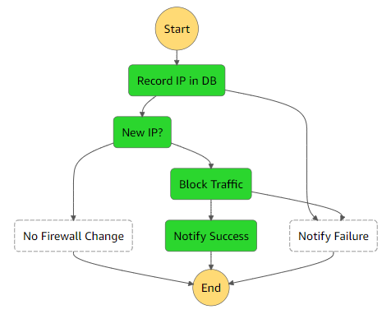

Figure 5.4 shows a graphical depiction of the state machine workflow (AWS Step Functions state machine workflow).

1. The first step in the state machine, “Record IP in DB,” invokes a Lambda function that creates a record in an Amazon DynamoDB table with important details, such as the IP of the suspected malicious host and the timestamp of the last activity.
2. The next step, “Block Traffic,” invokes a Lambda function that updates the Network Firewall rule group with a stateless rule blocking traffic to the remote IP address.
3. The “Notify Success” step of the state machine uses an Amazon Simple Notification Service (Amazon SNS) topic to send out a message that the automatic remedy.
4. If there is a failure in the “Record IP” or “Block Traffic” steps, then the state machine will run the “Notify Failure” step. The state machine publishes a message on the SNS topic that the automated remediation workflow has failed to complete, and that manual intervention may be required.

Key features of Amazon GuardDuty

Let us discuss the key features of Amazon GuardDuty: 9

* **Threat detection:** GuardDuty analyzes data from AWS CloudTrail logs, Amazon VPC Flow Logs, and DNS logs to detect various types of threats, including unauthorized access, data exfiltration, and malware deployments.
* **Machine learning:** The service employs machine learning models to identify anomalies and deviations from baseline behavior, which helps in pinpointing potential threats.
* **Integrated threat intelligence:** GuardDuty uses threat intelligence feeds from AWS, security partners, and open-source lists to enhance threat detection capabilities.
* **Security findings:** It provides detailed findings with prioritized alerts, including information about affected AWS resources and recommended remediation steps.

Benefits of Amazon GuardDuty

Let us discuss the benefits of Amazon GuardDuty:

* **Improved security posture:** GuardDuty enhances your security by identifying and prioritizing potential threats in real-time9.
* **Automated threat detection:** The service automates the detection process, reducing the time required to identify security incidents9.
* **Scalability:** Amazon GuardDuty scales with your AWS environment, ensuring that you have continuous threat detection as your infrastructure grows9.

Use cases

Amazon GuardDuty is valuable for organizations of all sizes, providing proactive threat detection and helping to secure AWS workloads and resources. It is particularly useful in scenarios where rapid threat identification is critical9.

Amazon GuardDuty plays a crucial role in enhancing the security of your AWS environment by providing real-time threat detection and automated alerts. By continuously monitoring for suspicious activities and leveraging threat intelligence, GuardDuty helps you respond effectively to potential security threats9. In the following sections, we will explore additional AWS services and strategies for securing your cloud infrastructure.

Amazon Inspector

In this section, we will discuss Amazon Inspector, an AWS service that helps you identify security issues and vulnerabilities in your AWS resources. We will explore its key features, benefits, and use cases[11] [12].

Understanding Amazon Inspector

Amazon Inspector is a security assessment service that automates the process of identifying vulnerabilities and security issues within your AWS environment. It analyzes the behavior of your applications and resources, helping you to understand their security state and take corrective actions11.

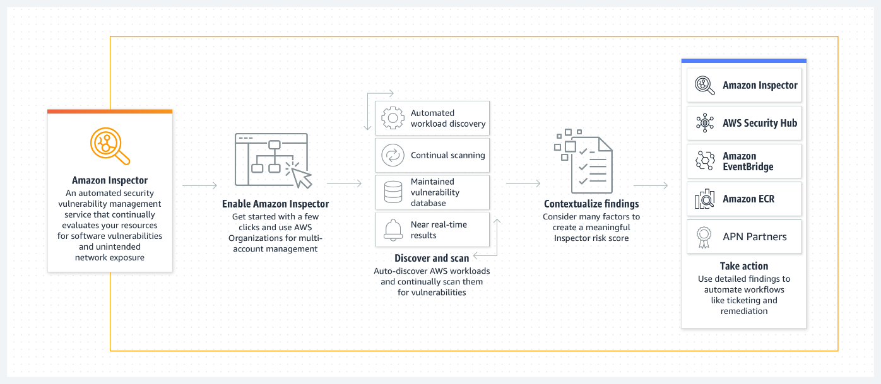

Figure 5.5 Amazon Inspector is an automated vulnerability management service that continually scans AWS workloads for software vulnerabilities and unintended network exposure (AWS Inspector documentation).

Key features of Amazon Inspector

Let us discuss key features of Amazon Inspector: 11

1. **Agent-based assessments:** Inspector uses agents that can be deployed on your EC2 instances to collect data and assess the security of your applications and systems.
2. **Security rules:** It provides a set of predefined rules based on best practices for security assessments. You can also create custom rules tailored to your specific requirements.
3. **Integration:** Inspector integrates with other AWS services, including AWS CloudWatch and AWS Security Hub, to provide a comprehensive view of your security posture.
4. **Scalability:** The service is designed to scale with your infrastructure, allowing you to assess many instances simultaneously.

Benefits of Amazon Inspector

Let us discuss the benefits of Amazon Inspector: 11

* **Automated security assessments:** Amazon Inspector automates the process of security assessment, saving time and effort compared to manual assessments.
* **Actionable findings:** It provides detailed findings and recommendations for remediation, helping you address security issues effectively.
* **Continuous monitoring:** Inspector supports continuous monitoring, allowing you to maintain a proactive approach to security.

Use cases

Amazon Inspector is valuable for organizations that want to ensure the security of their AWS workloads. It is particularly useful in scenarios where compliance with security standards and regulations is essential11.

Amazon Inspector provides an automated and scalable approach to security assessments in your AWS environment. By identifying vulnerabilities and security issues, it empowers organizations to take proactive measures to enhance their security posture11. In the subsequent sections of this chapter, we will explore additional AWS services and strategies for securing your cloud infrastructure.

Amazon Macie

In this section, we will explore Amazon Macie, a powerful AWS service designed to discover, classify, and protect sensitive data. You will gain an understanding of Macie's capabilities, its role in data security, and how to leverage it effectively[13] [14] [15].

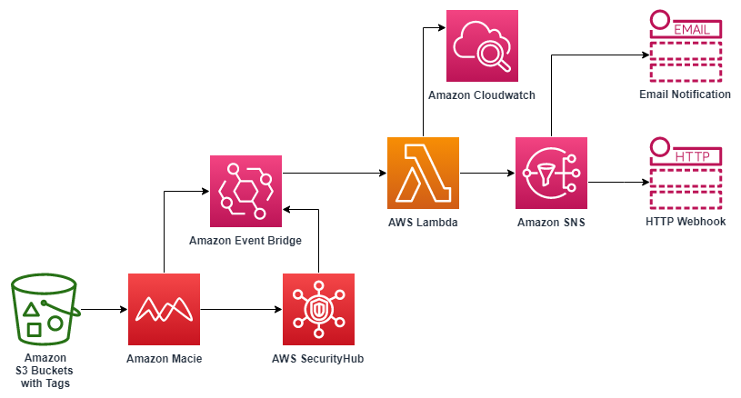

Figure 5.6 Validation and alerts with AWS services - Validation system for data classification (AWS Architecture Blog).

Amazon Macie: Protecting your sensitive data

Amazon Macie is an intelligent data security and privacy service that helps organizations discover, classify, and protect sensitive data across their AWS environment13. Its advanced machine learning algorithms analyze data access patterns, enabling you to identify and safeguard sensitive information more effectively.

Key features of Amazon Macie

Let us discuss the key features of Amazon Macie: 13

* **Data discovery:** Macie automatically detects and classifies sensitive data like **personally identifiable information** (**PII**), financial data, and intellectual property.
* **Visibility:** Gain visibility into how data is accessed and shared across your AWS resources, helping you identify potential security risks.
* **Real-time alerts:** Macie provides real-time alerts when it detects suspicious or unauthorized activities related to sensitive data.
* **Integration:** Seamlessly integrates with other AWS services, making it easy to incorporate data security into your existing workflows.

Benefits of using Amazon Macie

Let us discuss the Benefits of Using Amazon Macie: 13

* **Enhanced data protection:** By identifying and classifying sensitive data, Macie helps you implement robust data protection measures.
* **Compliance:** Assists in meeting regulatory requirements such as GDPR, HIPAA, and CCPA by ensuring data privacy and security.
* **Operational efficiency:** Provides automated data discovery and alerts, reducing the time and effort required for manual data monitoring.

Use cases

Amazon Macie is particularly valuable for organizations that deal with sensitive data, such as those in healthcare, finance, and e-commerce. It is also beneficial for maintaining compliance with data protection regulations13.

Amazon Macie empowers organizations to take control of their sensitive data and protect it from unauthorized access and potential breaches13. In the subsequent sections of this chapter, we will continue to explore AWS services that contribute to the comprehensive security, identity, and compliance framework in the cloud.

Amazon Security Lake

In this section, we will explore Amazon Security Lake, an essential AWS service for managing security data and enhancing the security and compliance posture of your cloud environment [16] [17] [18].

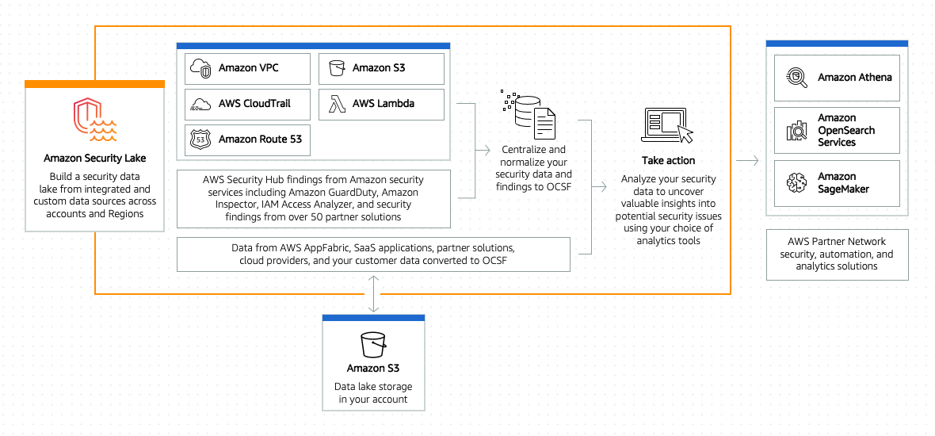

Figure 5.7 Amazon Security Lake - Automatically centralize your security data (AWS Security Lake documentation).

Amazon Security Lake

Amazon Security Lake is a fully managed data lake solution designed to ingest, store, and analyze vast amounts of security data from various AWS services and cloud environments16. It offers a centralized repository for your security information, enabling you to gain deeper insights, detect anomalies, and respond to security threats effectively.

Key features of Amazon Security Lake

Let us discuss the key features of Amazon Security Lake: 16

* **Data ingestion:** Security Lake allows the automated ingestion of security data from various AWS services, including Amazon GuardDuty, AWS Config, and Amazon Macie.
* **Data storage:** The service provides scalable and durable storage for your security data, ensuring it remains accessible and reliable.
* **Analytics and search:** Security Lake supports advanced analytics and search capabilities, making it easier to query and analyze your security data16.
* **Integration:** Seamlessly integrates with AWS security services and partner solutions, enhancing your security posture.

Benefits of using Amazon Security Lake

Let us discuss the Benefits of using Amazon Security Lake: 16

* **Centralized security data:** A unified view of security data allows you to detect and respond to threats more efficiently.
* **Automated threat detection:** By analyzing security data at scale, it enables automated threat detection and response.
* **Compliance:** Helps organizations meet regulatory and compliance requirements by storing and managing security data effectively.

Use cases

Amazon Security Lake is valuable for organizations of all sizes that prioritize security and compliance. It is particularly beneficial for industries with strict regulatory requirements, such as finance, healthcare, and government16.

Amazon Security Lake serves as a fundamental component of an organization's security strategy in AWS, allowing for comprehensive security data analysis and incident response16. In the subsequent sections of this chapter, we will continue to explore AWS services that contribute to the robust security, identity, and compliance framework in the cloud.

Amazon Verified Permissions

In this section, we will explore Amazon Verified Permissions, a crucial component of AWS's IAM services [19] [20] [21].

Amazon Verified Permissions

Amazon Verified Permissions is an IAM feature that plays a vital role in enforcing the principle of least privilege, a fundamental security best practice. The principle of least privilege dictates that individuals or systems should have access only to the resources and actions necessary to perform their tasks19.

Key aspects of Amazon Verified Permissions

Let us discuss the key aspects of Amazon Verified Permissions: 19

* **Access analyzer:** This tool examines policies to identify unintended access, offering detailed findings on resources that can be accessed from outside accounts.
* **Resource policies:** Resource owners can create resource policies to specify who has access to their resources, thus ensuring a secure and controlled environment.
* **Access control:** Verified Permissions facilitates fine-grained access control by allowing you to define and monitor permissions for resources.

Use cases

Amazon Verified Permissions is valuable for any AWS customer concerned about security and compliance. It helps organizations establish strong control over their resources and ensures that permissions align with business requirements19.

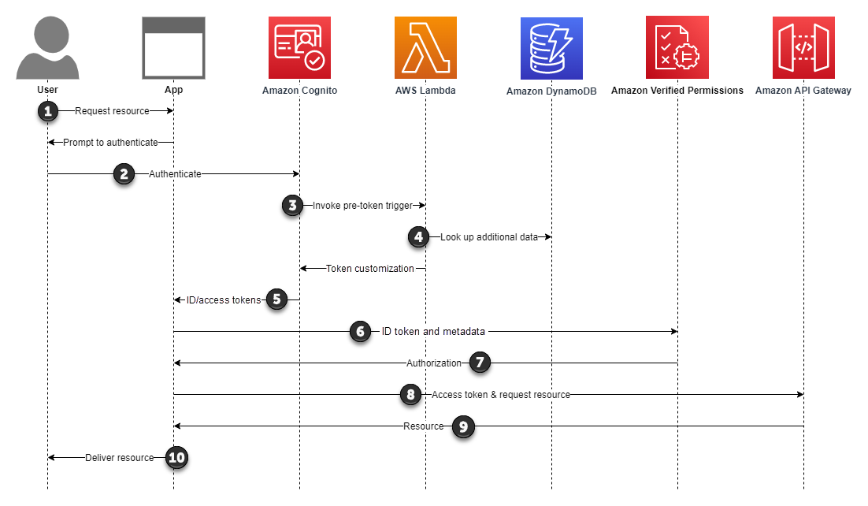

Figure 5.8 Authorization with Amazon Verified Permissions (AWS Cognito documentation).

1. Your user requests a resource in your app that your app must retrieve from an API.
2. Your user signs in to your Amazon Cognito user pool.
3. Your user pool sends your user's details to your user pool pre-token generation Lambda trigger. The use of a pre-token trigger is optional.
4. Your Lambda function looks up your user in Amazon DynamoDB and adds claims to your user's ID or access tokens.
5. Amazon Cognito returns the access and ID tokens to your app.
6. Your app presents your user's ID token and metadata in a request to Verified Permissions.
7. Verified Permissions processes your user's claims and compares them to the policies in your organization's policy store. When it finds an Allow condition with no overriding Deny, Verified Permissions responds with its Allow decision.
8. Your app processes the Allow response and presents your user's access token to your API Gateway Amazon Cognito authorizer. In this example, the access token has a dual purpose in its contribution to the fine-grained access control decision by Verified Permissions and the scope-based access control decision by API Gateway.
9. Your API accepts your user's token and returns the requested resource to your app.
10. Your app displays the requested resource to your user.
11. When your user requests another protected resource, your app returns to the Authorization step and presents the new request to Verified Permissions.

Benefits of Amazon Verified Permissions

Let us discuss the benefits of Amazon Verified Permissions: 19

* **Enhanced security:** By identifying and limiting unintended access, it fortifies the security posture of your AWS environment.
* **Compliance:** It assists organizations in meeting compliance requirements and industry standards by enforcing strict access controls.
* **Resource management:** Verified Permissions simplifies resource management, allowing resource owners to dictate access.

Amazon Verified Permissions serves as a fundamental tool in AWS IAM to enhance security and compliance by maintaining strict control over resource access19. In the subsequent sections of this chapter, we will continue to explore AWS services and features that contribute to building a secure and compliant cloud infrastructure.

AWS Artifact

In this section, we delve into AWS Artifact, a service that provides access to AWS compliance reports and resources [22] [23] [24].

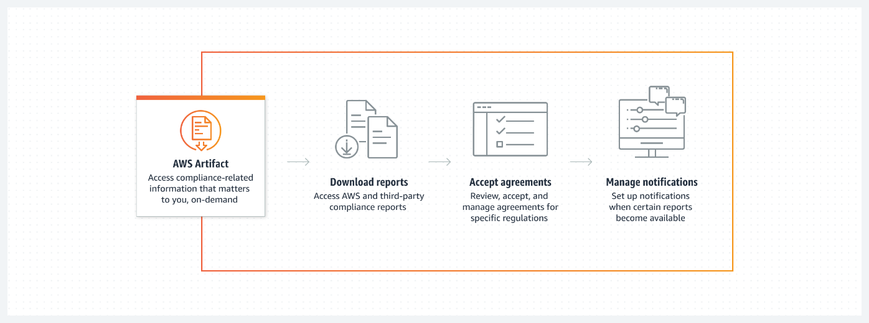

Figure 5.9 AWS Artifact - Access AWS and ISV security and compliance reports (AWS Artifact documentation).

AWS Artifact

AWS Artifact serves as a centralized repository of compliance documentation for AWS services, enabling customers to access reports and other resources. This resource is invaluable for organizations navigating the complex landscape of compliance requirements and regulations22.

Key features of AWS Artifact

Let us discuss the Benefits of Amazon Verified Permissions: 22

* **Compliance reports:** AWS Artifact offers a comprehensive collection of reports and certifications covering various compliance frameworks and regulations.
* **Resource library:** In addition to reports, it provides access to a library of whitepapers and guides, aiding organizations in understanding and implementing AWS services securely.
* **Agreements and contracts:** AWS customers can review and accept agreements online, simplifying the compliance process.

Use cases

AWS Artifact benefits a wide range of organizations, from startups to large enterprises. It is particularly crucial for businesses operating in highly regulated industries, such as healthcare or finance, that require strict adherence to compliance standards.22

Benefits of AWS Artifact

Let us discuss the benefits of AWS Artifact:

* **Simplified compliance:** It provides an easy way to access documentation needed for audits and compliance assessments.
* **Comprehensive information:** With a vast library of reports and resources, it offers an extensive knowledge base for maintaining a secure and compliant AWS infrastructure22.
* **Time and cost savings:** By streamlining the compliance process and eliminating the need for physical document handling, it saves both time and resources22

AWS Artifact is an essential tool for organizations striving to maintain compliance with industry standards and regulatory requirements22. As we proceed through this chapter, we will continue to explore AWS services and features designed to enhance the security and compliance of your cloud infrastructure.

AWS Audit Manager

In this section, we will explore AWS Audit Manager, a powerful service designed to help organizations automate and streamline the auditing process.[25] [26] [27].

Automating auditing with AWS Audit Manager

Auditing is a critical aspect of maintaining security and compliance within your AWS environment. AWS Audit Manager is a service that simplifies the auditing process, making it more efficient and less resource-intensive25. It enables organizations to automate the collection of evidence for audits, reducing the manual effort required for compliance assessments25.

Key features of AWS Audit Manager

Let us discuss the key features of AWS Audit Manager: 25

* **Pre-built frameworks:** AWS Audit Manager offers pre-built frameworks that map to various regulatory standards and best practices. These frameworks can be customized to align with your organization's specific requirements.
* **Evidence collection:** The service streamlines evidence collection by automatically gathering data from AWS Config, AWS CloudTrail, and other AWS services.
* **Assessment reports:** It generates assessment reports based on the evidence collected, helping organizations understand their compliance posture.

Use cases

AWS Audit Manager is valuable for any organization that needs to adhere to regulatory standards or best practices. This includes sectors such as healthcare (HIPAA), finance (PCI DSS), and many others25.

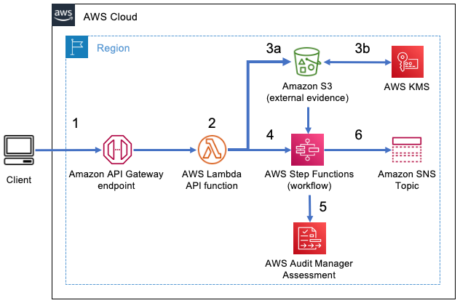

Figure 5.10 Streamlining evidence collection with AWS Audit Manager: The architecture of the AWS Audit Manager automation solution (Nicholas Parks and Brian Tang AWS Security Blog).

The SAM template creates resources that support the following workflow:

1. A client can call an Amazon API Gateway endpoint by sending a payload that includes assessment details and the evidence payload.
2. An AWS Lambda function implements the API to handle the request.
3. The Lambda function uploads the evidence to an Amazon Simple Storage Service (Amazon S3) bucket (3a) and uses AWS Key Management Service (AWS KMS) to encrypt the data (3b).
4. The Lambda function also initializes the AWS Step Functions workflow.
5. Within the Step Functions workflow, a Standard Workflow calls two Lambda functions. The first looks for a matching control within an assessment, and the second updates the control within the assessment with the evidence.
6. When the Step Functions workflow concludes, it sends a notification for success or failure to subscribers of an Amazon Simple Notification Service (Amazon SNS) topic.

Benefits of AWS Audit Manager

Let us discuss the benefits of AWS Audit Manager: 25

* **Time savings:** Automation reduces the time and effort needed for auditing, allowing organizations to focus on addressing compliance gaps.
* **Customization:** The ability to customize audit frameworks ensures that assessments are tailored to an organization's unique requirements.
* **Streamlined compliance:** It streamlines the compliance process, making it easier for organizations to demonstrate adherence to regulations and standards.

AWS Audit Manager is an essential tool for organizations looking to simplify and streamline their auditing process, particularly when compliance with regulatory standards is required25. In the subsequent sections of this chapter, we will continue to explore AWS services and features dedicated to enhancing the security and compliance of your cloud infrastructure.

AWS Certificate Manager

In this section, we discuss **AWS Certificate Manager** (**ACM**), a service that simplifies the management of SSL/TLS certificates for your AWS-based applications and websites.[28] [29] [30]

Securing applications with AWS Certificate Manager

ACM is a service that assists in the provisioning, management, and deployment of SSL/TLS certificates for your applications and services running on AWS28. ACM streamlines the process of securing your web applications by offering several key benefits.

Key features of AWS Certificate Manager

Let us discuss the key features of ACM: 28

* **Certificate provisioning:** ACM makes it easy to request SSL/TLS certificates directly from the AWS Management Console, CLI, or SDKs.
* **Automated certificate renewal:** ACM automates the renewal process for your certificates, reducing the risk of expired certificates.
* **Integrated with AWS Services:** ACM seamlessly integrates with other AWS services like Amazon CloudFront, Elastic Load Balancing, and API Gateway, ensuring that your applications remain secure.

Use cases

ACM is invaluable for any organization that hosts web applications or websites on AWS28. It is particularly useful for ensuring data security, encrypting data in transit, and establishing trust with users.

Benefits of AWS Certificate Manager

Let us discuss the benefits of ACM: 28

* **Simplified management:** ACM simplifies the complex process of certificate management, enabling users to focus on their applications.
* **Cost-effective:** The service is cost-effective, as there are no additional charges for ACM itself.
* **Enhanced security:** SSL/TLS certificates are essential for encrypting data in transit, and ACM ensures that your applications remain secure.

ACM is a fundamental component in the AWS suite of services for ensuring the security of web applications and websites. In the subsequent sections of this chapter, we will continue to explore AWS services dedicated to enhancing the security and compliance of your cloud infrastructure.

AWS CloudHSM

In this section, we will explore the AWS CloudHSM service, providing a detailed overview of its functionality, use cases, and benefits[31] [32] [33].

Introduction to AWS CloudHSM

AWS Cloud **Hardware Security Module** (**HSM**) is a cloud-based hardware security module that allows users to generate and manage encryption keys for their applications and data in a secure and compliant manner31. CloudHSM provides a dedicated hardware security module that can be used to protect sensitive data using encryption keys. It offers a FIPS 140-2 Level 3 validated device that helps you meet various industry standards and compliance requirements31 32.

Key features and benefits

Let us discuss the key features and benefits of AWS CloudHSM: 31

* **High-level security:** AWS CloudHSM provides physical protection of cryptographic keys, making it highly secure for applications that require robust encryption.
* **Compliance:** This service is particularly beneficial for applications that require compliance with regulations like PCI DSS, HIPAA, and others.
* **Integration:** CloudHSM integrates seamlessly with AWS services like Amazon RDS, Redshift, and Lambda, as well as with many third-party applications.

Use cases

AWS CloudHSM is often used in applications where cryptographic keys are critical for securing data. Some common use cases include securing payment processing, protecting PII, and ensuring data privacy in healthcare applications31.

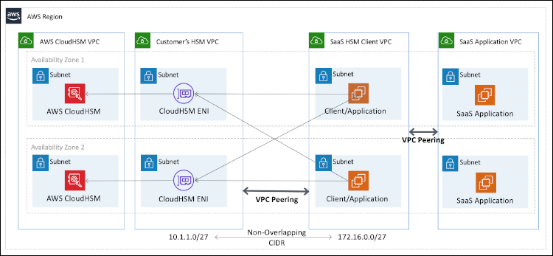

Figure 5.11 Architecture diagram showing VPC peering between the SaaS provider’s HSM client VPC and the customer’s HSM VPC (Vinod Madabushi AWS Security Blog).

Getting started with AWS CloudHSM

To begin using AWS CloudHSM, you can provision an HSM through the AWS Management Console, SDKs, or CLI31. After provisioning, you can create and manage your keys securely.

AWS CloudHSM is a crucial component for securing sensitive data in the AWS cloud. In the following sections of this chapter, we will continue to explore AWS services dedicated to enhancing the security, identity, and compliance of your cloud infrastructure.

AWS Directory Service

In this section, we will discuss AWS Directory Service, providing a comprehensive overview of its features, use cases, and advantages.[34] [35] [36].

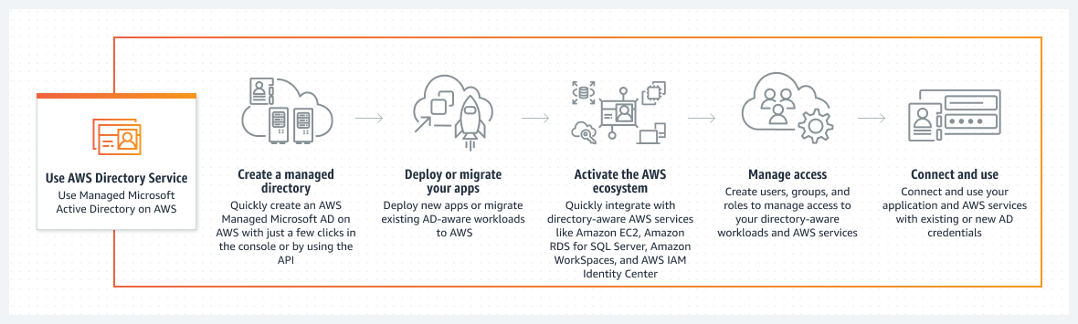

Figure 5.12 Gain efficiency with a fully managed Microsoft Active Directory service (AWS Directory Service Documentation).

Introduction to AWS Directory Service

AWS Directory Service is a managed service that allows you to connect, migrate, and manage Microsoft **Active Directory** (**AD**) workloads on the AWS cloud. It offers various directory types to meet your specific needs, including Microsoft AD, Simple AD, and AD Connector34.

Key features and benefits

Let us discuss the key features and benefits AWS Directory Service: 34

* **Integration with AWS workloads:** AWS Directory Service allows seamless integration of AD workloads with various AWS services, including Amazon RDS, WorkSpaces, and EC2 instances.
* **Secure and reliable:** It offers features such as multi-region replication and automated software updates, ensuring high availability and security.
* **Managed service:** AWS takes care of the underlying infrastructure, allowing you to focus on managing your directory and applications.

Use cases

AWS Directory Service is valuable for businesses that rely on Microsoft AD and want to extend their on-premises directory to the cloud. Common use cases include hybrid cloud configurations, connecting AWS resources to an existing AD, and deploying AD-dependent applications34.

Getting started with AWS Directory Service

To begin using AWS Directory Service, you can launch a directory through the AWS Management Console or by using the AWS CLI or SDKs34. You can choose the directory type that best suits your requirements.

AWS Directory Service simplifies the management and integration of Microsoft AD workloads in the AWS environment. In the subsequent sections of this chapter, we will continue to explore AWS services designed to enhance security, identity, and compliance for your cloud infrastructure.

AWS Firewall Manager

In this section, we will discuss AWS Firewall Manager, an essential component of AWS's security and compliance suite. This service simplifies the management of security policies, particularly for businesses with multiple AWS accounts and resources[37] [38] [39].

Introduction to AWS Firewall Manager

AWS Firewall Manager is a security management service that simplifies the process of configuring and managing AWS **Web Application Firewall** (**WAF**) rules and AWS Shield Advanced protections across multiple accounts and resources37.

Key features and benefits

Key features and benefits are as follows: 37

* **Centralized management:** AWS Firewall Manager provides a single console for managing the security policies of your entire AWS environment, making it easier to enforce security standards consistently.
* **Integration with AWS organizations:** It seamlessly integrates with AWS Organizations, allowing you to extend security protections across all your accounts.
* **Automation:** The service can be configured to automatically apply WAF rules to new resources, reducing the need for manual rule management.

Use cases

AWS Firewall Manager is indispensable for organizations of all sizes. It is particularly valuable for businesses that require consistent security policies across multiple AWS accounts and resources. The following are common use cases: 41

* **Multi-account environments:** In scenarios where an organization manages multiple AWS accounts, AWS Firewall Manager ensures that security policies are enforced consistently across all accounts.
* **Simplified compliance:** By centralizing security rules and policies, AWS Firewall Manager simplifies compliance with regulatory requirements.
* **Reduced management overhead:** Automation features help in reducing the administrative workload associated with security policy management.

AWS Firewall Manager is essential for organizations seeking to streamline their security management. It is particularly valuable for businesses with multiple AWS accounts, as it allows them to centrally configure and enforce security policies across all accounts and resources37.

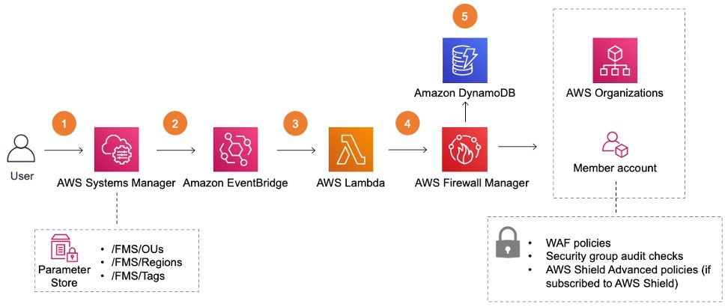

Figure 5.13 Automate AWS Firewall Manager onboarding using AWS Centralized WAF and VPC Security Group Management solution ( Satheesh Kumar and Ramanan Kannan AWS Security Blog).

1. Main solutions template – aws-centralized-waf-and-vpc-security-group-management.template
2. After deployment, you can update the three AWS Systems Manager parameters—/FMS/OUs, /FMS/Regions, and /FMS/Tags—with appropriate values to control the scope and applicability of the Firewall Manager security policies.
3. On updating the values in the Systems Manager parameters, the Amazon EventBridge rule captures the parameter update event.
4. Amazon EventBridge triggers an AWS Lambda function to deploy the Firewall Manager policies.
5. The AWS Lambda function will deploy the Firewall manager security policies across the OUs and regions specified in Step 1.
6. The lambda function updates the Amazon DynamoDB table with Firewall manager policies metadata.

Getting started with AWS Firewall Manager

To begin using AWS Firewall Manager, you can set up policies for WAF and AWS Shield Advanced, either through the AWS Management Console or programmatically using AWS CloudFormation or the AWS SDKs37. The service can be tailored to your organization's specific security needs.

In-depth resources

For in-depth understanding, you can refer to the following resources:

* **AWS documentation:** The official documentation provides detailed guidance on setting up and managing AWS Firewall Manager40.
* **AWS online tech talks:** AWS offers a range of online tech talks, including sessions on AWS Firewall Manager, which can provide valuable insights41.
* **AWS re:Invent:** AWS re:Invent sessions often cover AWS Firewall Manager, and these sessions are a great resource for advanced users42.

AWS Firewall Manager plays a critical role in ensuring the security and compliance of AWS environments, particularly for organizations with complex infrastructure. In the following sections of this chapter, we will continue to explore AWS services that enhance security, identity, and compliance.

AWS IAM identity center

In this section, we will explore the AWS IAM identity center, an essential component of AWS's security and identity management services. AWS IAM Identity Center serves as a central hub for identity management, making it easier for organizations to manage user identities, roles, and permissions across their AWS environments[40] [41] [42].

Introduction to AWS IAM Identity Center

AWS IAM Identity Center is a comprehensive identity management service that simplifies identity and access management for AWS resources. It offers a centralized console for managing user identities, groups, and permissions, enhancing security and control across AWS accounts43.

Key features and benefits

Let us discuss the key features and benefits AWS IAM identity center: 43

* **User and group management:** IAM identity center allows you to create, manage, and organize user identities and groups, providing granular control over who can access your AWS resources.
* **Policy management:** You can create and manage policies that define permissions, ensuring that users and groups have the right level of access to resources.
* **Integration with AWS Services:** IAM identity center integrates seamlessly with other AWS services, making it easier to manage access to resources such as Amazon S3, EC2, and RDS44.

Use cases

AWS IAM Identity Center is a fundamental service for securing AWS resources and ensuring that the right individuals and systems have appropriate access. Common use cases include:

* **User access control:** You can use IAM Identity Center to restrict access to specific resources and services for different users and groups45.
* **Security enhancement:** Implement security best practices by controlling permissions and ensuring that users only have access to the resources they need44.
* **Resource management:** Efficiently manage user identities and access across your AWS environment, helping organizations scale and grow securely43.

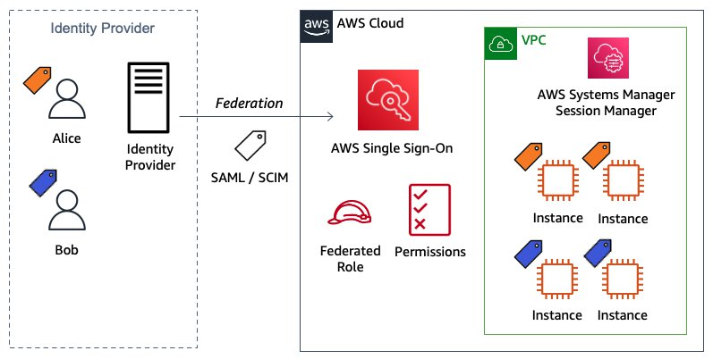

Figure 5.14 Configure AWS IAM Identity Center ABAC for EC2 instances and Systems Manager Session Manager (Rodrigo Ferroni AWS Security Blog).

Getting started with AWS IAM identity center

To start using AWS IAM identity center, you can access the service through the AWS Management Console. Here, you can create users, groups, and roles, and define policies to manage access43.

In-depth resources

For a deeper understanding of AWS IAM identity center, consider these resources:

* **AWS documentation:** The official AWS IAM Identity Center documentation provides comprehensive information on setting up and managing identities, groups, and permissions43.
* **Online tutorials:** There are various online tutorials and video resources available to help you get started with AWS IAM Identity Center44.
* **Community forums:** AWS community forums are excellent places to seek guidance and advice from experienced users who can share their real-world insights45.

AWS IAM identity center plays a pivotal role in securing and managing AWS resources effectively. In the following sections of this chapter, we will continue to explore AWS services that enhance security, identity, and compliance.

AWS Identity and Access Management

In this section, we will discuss AWS IAM, a foundational service for managing access to AWS resources securely. IAM plays a crucial role in ensuring that the right people and services have the correct level of access within your AWS environment. This section provides an overview of IAM's features, use cases, and benefits[43] [44] [45].

Introduction to AWS Identity and Access Management

AWS IAM is a web service that enables you to control access to AWS resources securely. It allows you to create and manage AWS users and groups and use permissions to grant or deny access to AWS resources46. IAM provides a central point for managing access, ensuring the principle of least privilege is followed, and enhancing the security of your AWS environment.

Key features and benefits

The key features and benefits of AWSIAM are as follows: 46

* **User and group management:** IAM enables the creation and management of user identities, groups, and roles. Users can be assigned individual security credentials while groups help manage permissions more efficiently.
* **Fine-grained control:** IAM allows you to define fine-grained permissions, ensuring that users and services have access only to the resources they need. This reduces the risk of unauthorized access.
* **MFA:** You can enhance security by enabling MFA for users, adding an extra layer of protection for account sign-ins47.
* **Integration with AWS Services:** IAM integrates seamlessly with a wide range of AWS services, allowing you to control access to services such as Amazon S3, EC2, and RDS47.

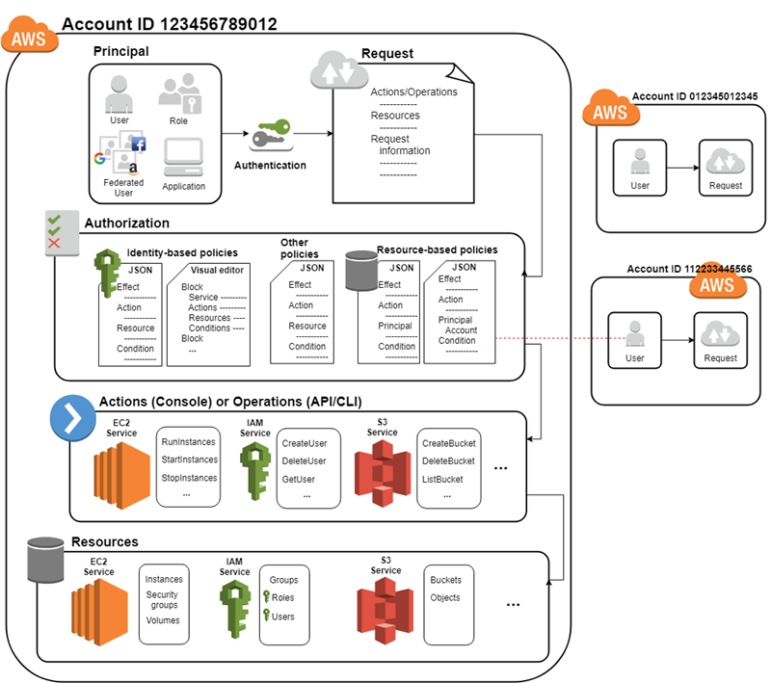

Figure 5.15 How IAM works (AWS User Guides).

Use cases

IAM is essential for managing access control in AWS environments. Common use cases include:

* **User and group management:** Create and manage users and groups to establish who can access AWS resources48.
* **Security enhancement:** Implement strict access policies to minimize security risks and ensure compliance with industry standards47.
* **RBAC:** Use IAM roles to delegate permissions and manage temporary access for applications or services46.

Getting started with AWS IAM

To begin using AWS IAM, access the service through the AWS Management Console. Create users, groups, and roles and define policies to manage access permissions46.

In-depth resources

To deepen your knowledge of AWS IAM, refer to the following resources:

* **AWS documentation:** The official AWS IAM documentation provides detailed guidance on configuring and managing IAM users, groups, and policies46.
* **Online courses:** Online platforms like AWS training and certification offer courses specifically dedicated to IAM, allowing you to gain expertise in using the service effectively47.
* **Whitepapers and guides:** AWS offers whitepapers and implementation guides that can help you understand and implement IAM best practices in your organization48.

AWS IAM is a fundamental component of securing AWS resources and ensuring proper access control. In the subsequent sections of this chapter, we will continue exploring AWS services dedicated to enhancing security, identity, and compliance.

AWS Key Management Service

In this section, we will explore AWS **Key Management Service** (**KMS**), a crucial component for managing cryptographic keys and securing your data in AWS. We will delve into the key features, use cases, and best practices for AWS KMS[46] [47] [48].

Introduction to AWS Key Management Service

AWS KMS is a fully managed encryption service that allows you to create and control encryption keys to secure your data. KMS makes it easier to encrypt and protect data in AWS applications and workloads. It offers a central location for managing keys, simplifying the encryption process across various AWS services49.

Key features and benefits

Key features and benefits of the AWS KMS are as follows:

* **Centralized key management:** KMS provides a central location for managing keys, ensuring consistent encryption and decryption across your AWS environment49.
* **Fully managed service:** As a fully managed service, KMS eliminates the operational overhead of key management, including hardware provisioning and software patching50.
* **Integration with AWS Services:** KMS seamlessly integrates with many AWS services, such as Amazon S3, RDS, and Lambda, enabling easy encryption of data stored or transmitted through these services51.
* **Granular access control:** KMS allows you to define fine-grained permissions for key usage and management, ensuring that only authorized users and applications can access encrypted data50.

Use cases

KMS is critical for a range of encryption use cases, including:

* **Data encryption:** Protect sensitive data at rest and in transit by using KMS to encrypt and decrypt it50.
* **Regulatory compliance:** Achieve compliance with data protection regulations and industry standards by using KMS to secure data51.
* **Securing API keys:** Use KMS to secure API keys and other secrets, adding an extra layer of security to your applications49.

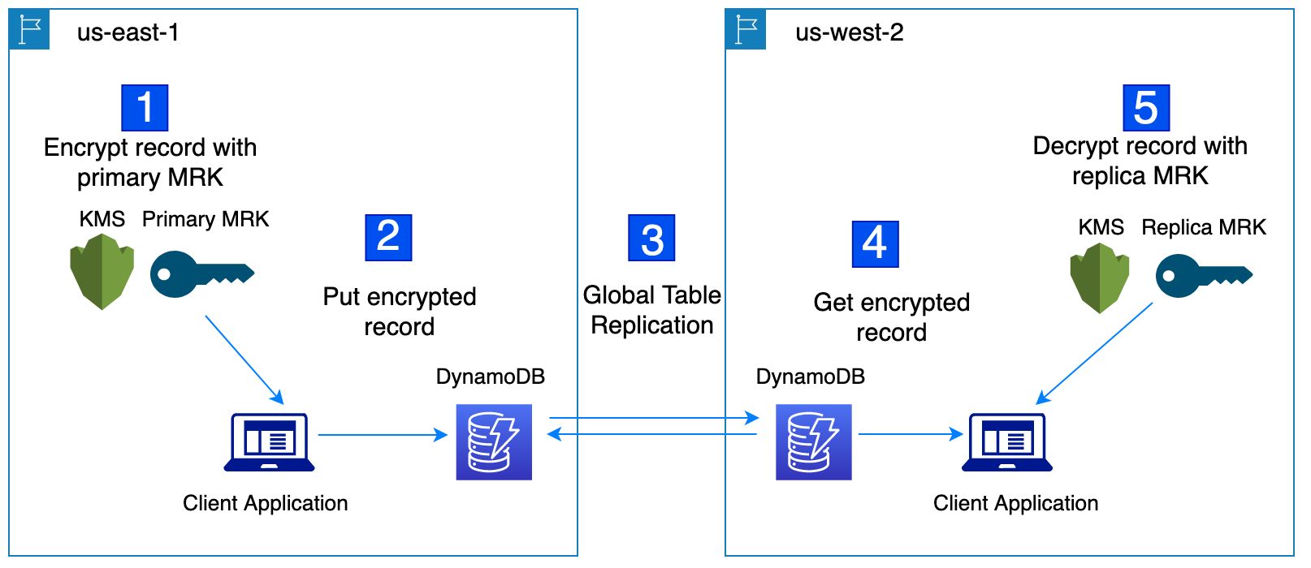

Figure 5.16 Encrypt global data client-side with AWS KMS multi-region keys (Jeremy Stieglitz, Ben Farley, and Peter Zieske AWS Security Blog).

Using multi-region keys with DynamoDB global tables

1. Encrypt the record with primary MRK.
2. Put encrypted record.
3. Global table replication
4. Get an encrypted record.
5. Decrypt the record with a replica MRK.

Best practices

To maximize the benefits of AWS KMS, consider the following best practices:

* **Key rotation:** Regularly rotate encryption keys to enhance security and meet compliance requirements50.
* **Least privilege access:** Apply the principle of least privilege when configuring permissions for key usage to minimize security risks49.
* **Monitoring and auditing:** Implement monitoring and auditing to track key usage and detect any unauthorized or suspicious activities51.

Getting Started with AWS KMS

To start using AWS KMS, access the service through the AWS Management Console, create **customer master keys** (**CMKs**), and define key policies and permissions49.

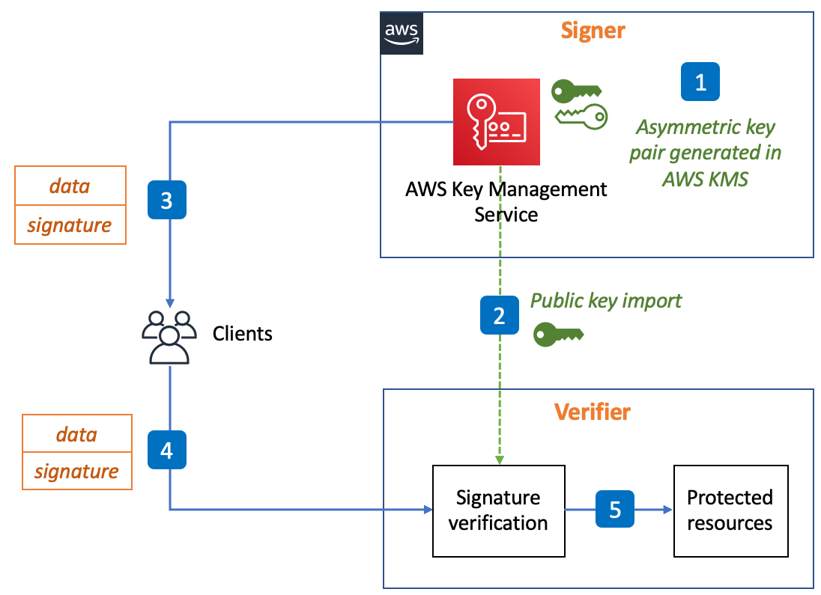

Figure 5.17 How to verify AWS KMS signatures in decoupled architectures at scale - Digital signature signing and verification in decoupled environments (AWS Security Blog).

In-depth resources

To further your understanding of AWS KMS, consult the following resources:

* **AWS documentation:** The official AWS KMS documentation provides comprehensive information on creating, managing, and using encryption keys49.
* **Online courses:** AWS training and certification offers courses dedicated to AWS KMS, helping you master the service's capabilities and best practices51.
* **Whitepapers and best practices guides:** AWS provides whitepapers and best practices guides that offer insights into using KMS to enhance data security50.

AWS KMS is a fundamental component for securing your data in AWS, and its proper usage is essential for compliance, data protection, and privacy. In the following sections of this chapter, we will continue exploring AWS services focused on security, identity, and compliance.

AWS Network Firewall

Use cases

AWS Network Firewall is instrumental in several use cases, including:

* **Protecting web applications:** Use Network Firewall to safeguard your web applications from attacks, such as DDoS and SQL injection53.
* **Segmenting workloads:** Employ Network Firewall to segment workloads in your VPCs, providing isolation and controlled access to resources54.
* **Detecting and blocking malicious activity:** Network Firewall can be used to detect and block potentially malicious traffic, helping to maintain a secure network environment52.

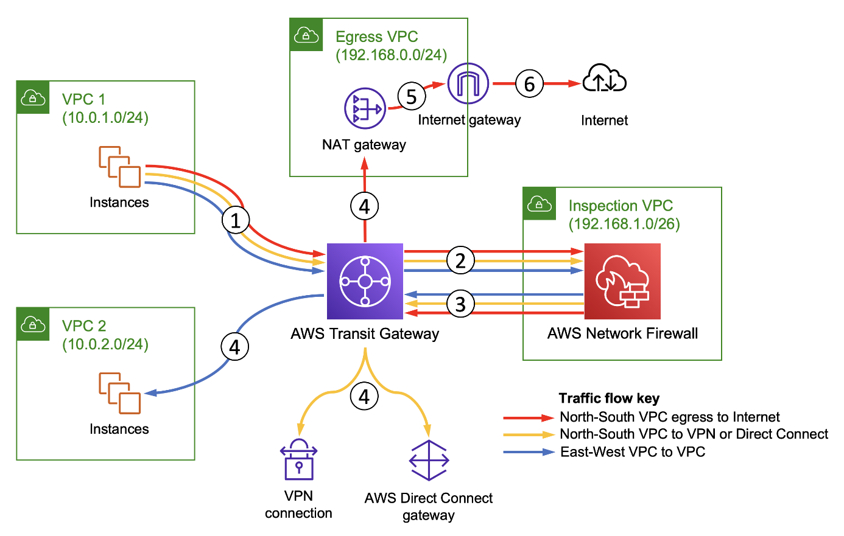

Figure 5.18 Deploy centralized traffic filtering using AWS Network Firewall (Benjamin Trunnel AWS Networking and Content Delivery Blog).

Traffic flow diagram for common centralized traffic filtering use cases

1. North-South VPC to internet egress traffic, via NAT Gateway
2. North-South VPC to on-premises traffic, via VPN connection or AWS Direct Connect
3. East-West VPC to VPC traffic

Best practices

To ensure the effective use of AWS Network Firewall, consider these best practices:

* **Security group rules:** Use security group rules in conjunction with Network Firewall policies to layer your network security52.
* **Regular monitoring:** Continuously monitor and log network traffic to identify potential security threats and patterns53.
* **Custom rule creation:** Create custom rule groups to tailor your network security policies to your specific requirements54.

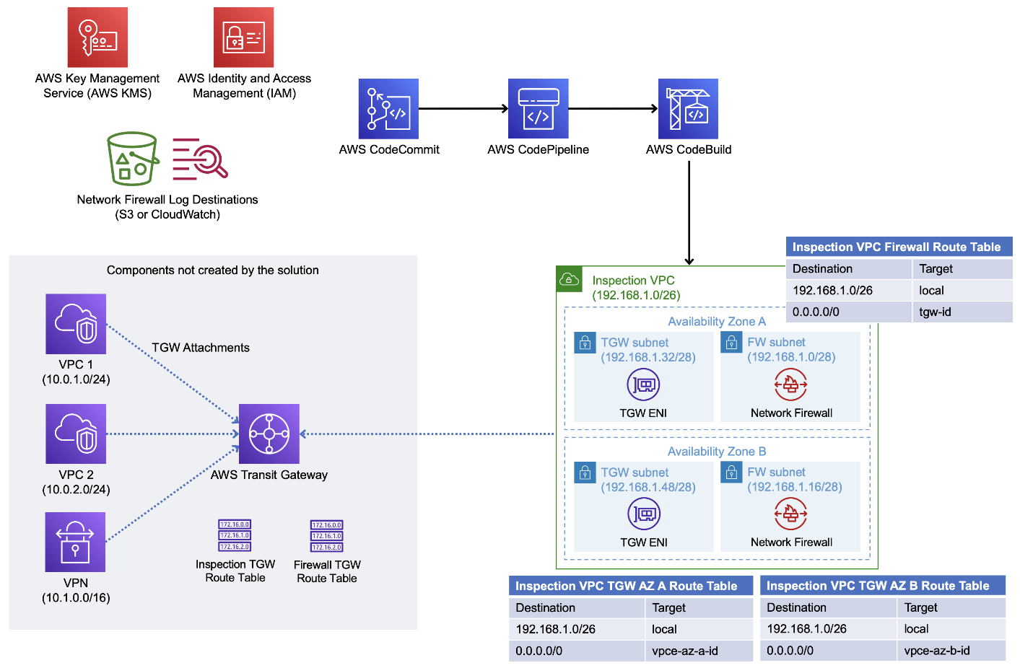

Figure 5.19 AWS Network Firewall deployment automation architecture overview (AWS Solutions Library).

Getting started with AWS Network Firewall

To get started with AWS Network Firewall, you can access the service through the AWS Management Console, create and manage policies, and attach them to your Amazon VPCs52.

In-depth resources

For further understanding and implementation of AWS Network Firewall, consult the following resources:

* **AWS documentation:** The official AWS Network Firewall documentation provides detailed information on using and configuring the service52.
* **Online courses:** AWS Training and Certification offers courses dedicated to AWS Network Firewall, helping you grasp the service's capabilities and best practices53.
* **Security best practices guides:** AWS provides guides that offer insights into using Network Firewall to enhance network security53.

AWS Network Firewall plays a pivotal role in securing your network traffic and applications in AWS. In the subsequent sections of this chapter, we will continue exploring AWS services focused on security, identity, and compliance.

AWS Resource Access Manager

In this section, we will explore AWS **Resource Access Manager** (**RAM**), a powerful service that enables resource sharing across AWS accounts[49] [50] [51].

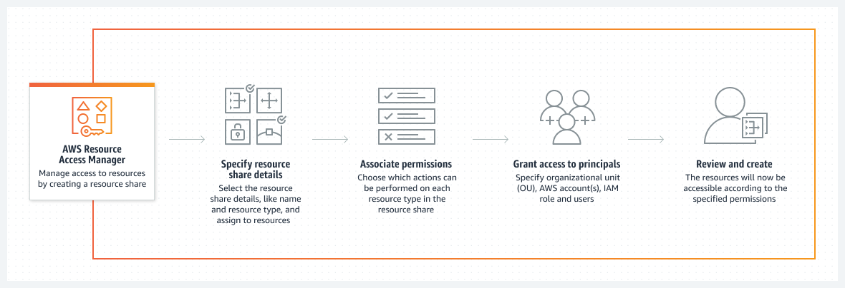

Figure 5.20 Simply and securely share your AWS resources across multiple accounts (AWS RAM Documentation).

Introduction to AWS Resource Access Manager

AWS RAM is a service that simplifies resource sharing within and between AWS accounts. It allows you to share AWS resources, including Amazon VPC subnets, across AWS accounts in a controlled and secure manner. This makes it easier to collaborate with other accounts and centralize your resource management55.

Key features and benefits

Let us discuss the key features and benefits:

* **Resource sharing:** RAM allows you to share AWS resources such as VPC subnets, AWS Transit Gateways, and AWS License Manager configurations across accounts55.
* **Centralized resource management:** With RAM, you can centralize the management of your AWS resources and ensure consistent access and configurations55.
* **Resource associations:** You can associate resources with RAM and then share them with specific AWS accounts or entire AWS Organizations55.
* **Controlled access:** RAM provides control over who can access and manage shared resources, enhancing the security of your infrastructure56.

Use cases

AWS RAM is instrumental in several use cases, including:

* **Resource sharing:** Share Amazon VPC subnets across accounts to facilitate collaboration and resource centralization57.
* **Transit gateway sharing:** Simplify network connectivity by sharing AWS Transit Gateways with other accounts, streamlining network architectures55.
* **License management:** Share AWS License Manager configurations to efficiently manage software licenses across accounts56.

Best practices

To make the most of AWS RAM, consider these best practices:

* **Clearly define sharing goals:** Clearly define what resources you want to share and the accounts or organizations with which you want to share them56.
* **Limit resource permissions:** Only grant the necessary permissions to keep shared resources secure and ensure proper access control55.
* **Regularly audit resource sharing:** Periodically review resource sharing configurations to verify that they meet your organization's needs56.

Getting started with AWS Resource Access Manager

To start using AWS RAM, you can access the service through the AWS Management Console. Create resource shares, associate resources with RAM, and define resource-sharing policies for your AWS accounts55.

In-depth resources

For further insights and guidance on AWS RAM, consult the following resources:

* **AWS documentation:** The official AWS RAM documentation provides comprehensive information on how to use and configure the service55.
* **Resource sharing best practices:** AWS offers best practices guides for resource sharing to help you understand the most efficient ways to leverage AWS RAM56.
* **Use case examples:** Review practical examples of AWS RAM use cases to understand its application in real-world scenarios57.

AWS RAM simplifies the process of sharing AWS resources across accounts, promoting efficient resource management and collaboration. In the upcoming sections of this chapter, we will continue to explore AWS services and tools that enhance security, identity, and compliance within the AWS cloud environment.

AWS Secrets Manager

In this section, we will delve into AWS Secrets Manager, a valuable service that simplifies the management of sensitive information such as database credentials, API keys, and other secrets. We will discuss its features, use cases, and best practices[52] [53] [54].

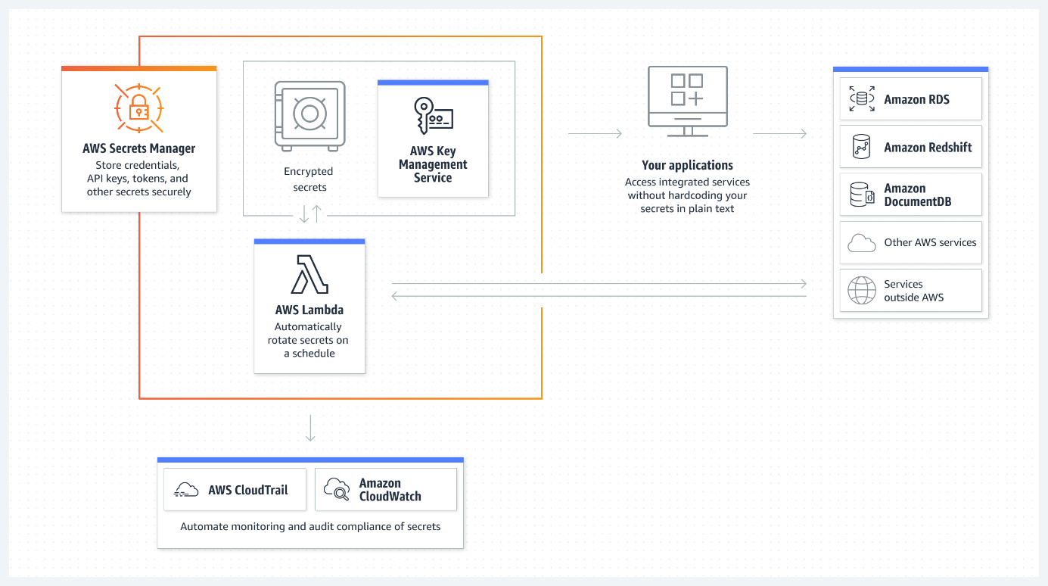

Figure 5.21 AWS Secrets Manager helps you manage, retrieve, and rotate database credentials, API keys, and other secrets throughout their lifecycles (AWS Secrets Manager Documentation).

Introduction to AWS Secrets Manager

AWS Secrets Manager is a service designed to help you protect access to your applications, services, and IT resources without exposing sensitive information. It assists in the secure storage, retrieval, and management of sensitive data, reducing the risk of inadvertent exposure58.

Key features and benefits

The following are the key features and benefits AWS Secrets Manager:

* **Secrets storage:** AWS Secrets Manager allows you to securely store and manage sensitive information, such as database passwords, API keys, and other secrets58.
* **Rotation policies:** You can configure automatic rotation policies for secrets, ensuring that credentials are regularly updated without manual intervention58.
* **Integration with RDS and Redshift:** AWS Secrets Manager seamlessly integrates with Amazon RDS and Amazon Redshift for simplified credential management59.
* **Access control:** Manage access to secrets by using fine-grained permissions and access policies, enhancing security and compliance58.

Use cases

AWS Secrets Manager is vital in several use cases, including:

* **Database credentials:** Store, manage, and rotate database credentials to enhance database security58.
* **Third-party API keys:** Protect sensitive API keys used to access third-party services and APIs58.
* **Secure storage for application secrets:** Safeguard application secrets like encryption keys and access tokens60.

Best practices

To make the most of AWS Secrets Manager, consider these best practices:

* **Automatic rotation:** Enable automatic rotation of secrets to regularly update credentials and enhance security58.
* **Least privilege access:** Implement least privilege access controls to restrict who can access and manage secrets59.
* **Audit and monitoring:** Set up auditing and monitoring to track changes and access to secrets58.

Getting started with AWS Secrets Manager

To get started with AWS Secrets Manager, you can access the service through the AWS Management Console. Create and configure secrets, set up rotation policies, and grant access to applications and services58.

In-depth resources

For further insights and guidance on AWS Secrets Manager, consult the following resources:

* **AWS documentation:** The official AWS Secrets Manager documentation provides detailed information on how to use and configure the service58.
* **Integration guides:** AWS offers integration guides for specific services like Amazon RDS and Redshift to help you seamlessly incorporate AWS Secrets Manager into your applications59.
* **Use case examples:** Explore practical examples of how AWS Secrets Manager is used to protect sensitive data in various scenarios60.

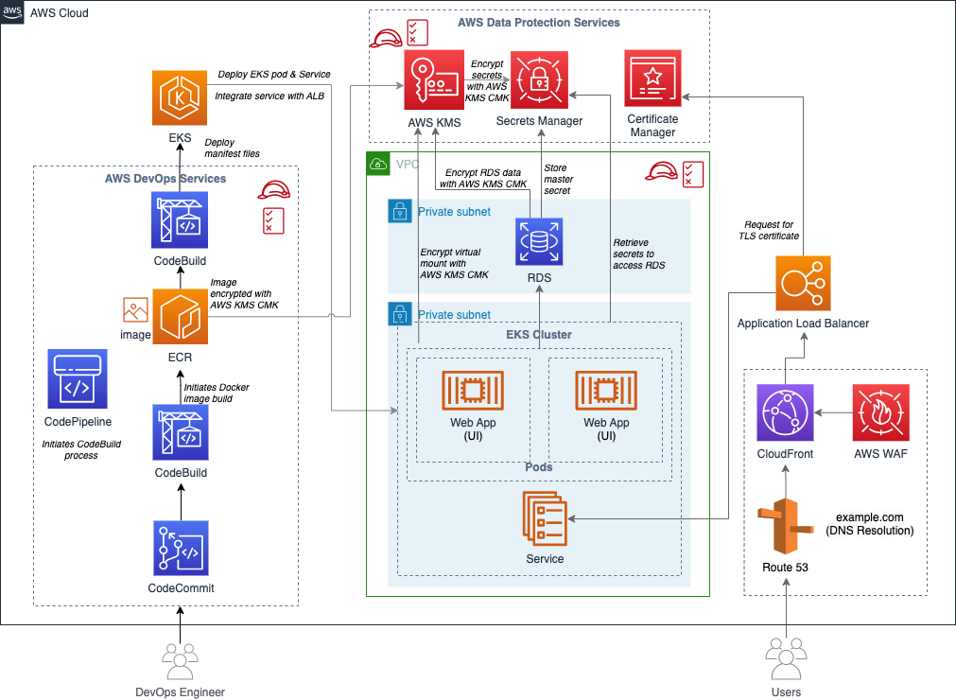

Figure 5.22 Strengthen the DevOps pipeline and protect data with AWS Secrets Manager, AWS KMS, and AWS Certificate Manager (AWS Securiy Blog).

AWS Secrets Manager simplifies the management of sensitive information, reducing security risks and enhancing compliance. In the upcoming sections of this chapter, we will continue to explore AWS services and tools that promote security, identity, and compliance within the AWS cloud environment.

AWS Security Hub

In this section, we will delve into AWS Security Hub, a powerful service that provides you with a comprehensive view of your security posture within the AWS environment[55] [56] [57] .

Introduction to AWS Security Hub

AWS Security Hub is a service that helps you consolidate and centrally manage security findings from multiple AWS services and third-party tools. It simplifies the process of identifying, prioritizing, and remediating security issues in your AWS environment61.

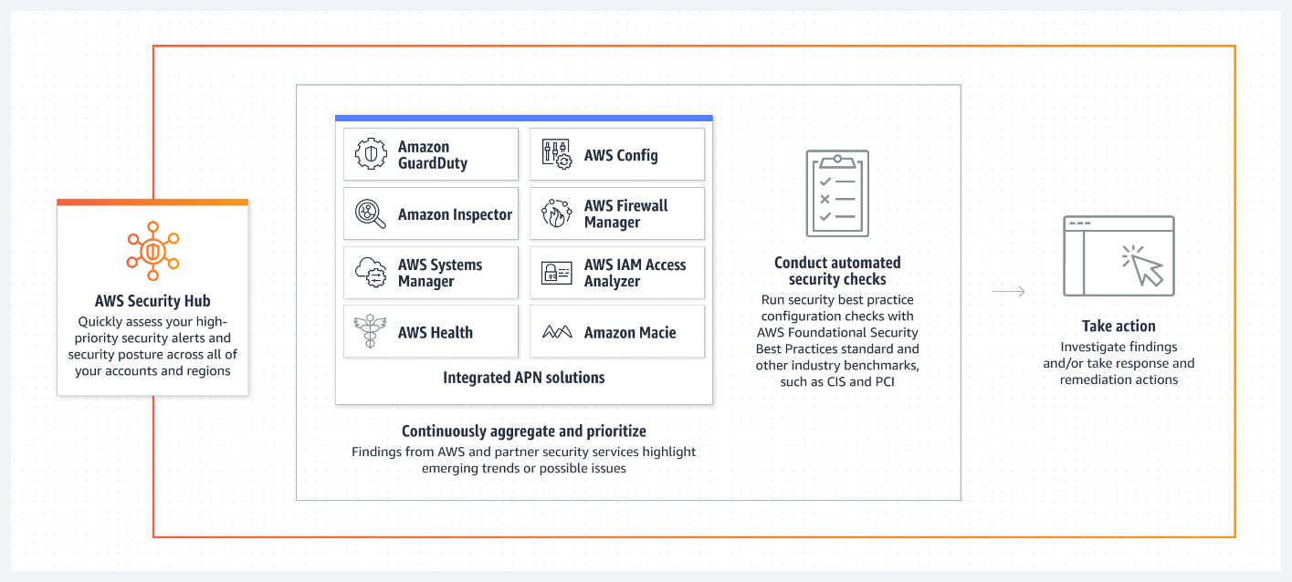

Figure 5.23 AWS Security Hub is a cloud security posture management (CSPM) service that performs security best practice checks, aggregates alerts, and enables automated remediation (AWS Security Hub Documentation).

Key features and benefits

The following are the key features and benefits of AWS Security Hub:

* **Aggregated security findings:** Security Hub aggregates findings from various AWS services, such as Amazon GuardDuty and AWS Inspector, providing a unified view of your security status61.
* **Prioritization:** It assigns severity levels to findings and provides detailed insights to help you prioritize and address security issues efficiently62.
* **Integration:** Security Hub integrates with a variety of **security information and event management** (**SIEM**) solutions and incident response tools62.
* **Compliance checks:** The service helps you automate compliance checks and provides predefined AWS Config and AWS IAM best practice standards63.

Use cases

AWS Security Hub serves critical roles in several use cases, including:

* **Threat detection:** Identifying and responding to potential security threats and vulnerabilities in real time61.
* **Compliance monitoring:** Ensuring that your AWS environment complies with security standards and best practices63.
* **Incident response:** Streamlining the incident response process by providing a consolidated view of security issues62.

Best practices

To maximize the benefits of AWS Security Hub, consider implementing the following best practices:

* **Continuous monitoring:** Set up continuous monitoring to receive real-time insights into your AWS environment61.
* **Custom actions:** Create custom actions for findings to automate response and remediation62.
* **Integration with SIEM:** Integrate Security Hub with your SIEM solution for better visibility into security events62.

Getting started with AWS Security Hub

To get started with AWS Security Hub, you can access the service through the AWS Management Console. Configure security standards, customize settings and start analyzing and monitoring security findings61.

In-depth resources

For further insights and guidance on AWS Security Hub, consult the following resources:

* **AWS documentation:** The official AWS Security Hub documentation provides comprehensive information on using and configuring the service61.
* **Best practices guide:** AWS offers a guide with best practices for setting up and using AWS Security Hub effectively62.
* **Compliance standards:** Learn more about AWS Config and AWS IAM best practice standards to ensure compliance with security standards63.

AWS Security Hub is a valuable tool for enhancing security and compliance within your AWS environment. In the subsequent sections of this chapter, we will continue to explore AWS services and tools that promote security, identity, and compliance within the AWS cloud ecosystem.

AWS Shield

In this section, we will explore AWS Shield, a managed **Distributed Denial of Service** (**DDoS**) protection service that safeguards applications running on AWS. We will discuss its features, benefits, and use cases[58] [59] [60].

Introduction to AWS Shield

AWS Shield is a crucial component of AWS's security services. It protects against DDoS attacks for AWS applications, helping maintain the availability and performance of your applications by minimizing downtime caused by malicious traffic64.

Key features and benefits

The following are the key features and the benefits:

* **Managed DDoS protection:** AWS Shield provides managed DDoS protection that safeguards your applications against both network and application layer DDoS attacks64.
* **Global network:** Leveraging the scale and capabilities of the AWS global network, AWS Shield provides comprehensive protection with minimal latency impact64.
* **Layer 3 and layer 4 protection:** It offers protection against volumetric attacks by inspecting and mitigating traffic at Layers 3 and 464.
* **Layer 7 Protection:** For application layer attacks, AWS Shield can integrate with AWS WAF (Web Application Firewall) to provide Layer 7 protection65.
* **Attack visibility:** AWS Shield provides attack visibility with near real-time attack diagnostics through Amazon CloudWatch metrics64.

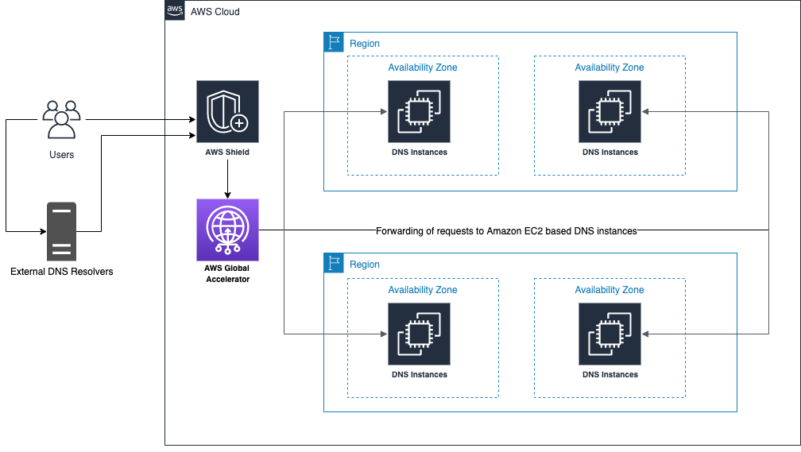

Figure 5.24 Amazon EC2 based DNS behind Global Accelerator and Shield (Chido Chemambo AWS Security Blog).

Use cases

AWS Shield is invaluable for a range of use cases:

* **Website protection:** Protects your websites and applications against DDoS attacks to ensure they remain available and performant64.
* **Application availability:** Safeguarding the availability of critical applications, including API endpoints, gaming servers, and e-commerce platforms65.
* **Application layer protection:** Combining AWS Shield with AWS WAF for comprehensive Layer 7 application layer protection65.

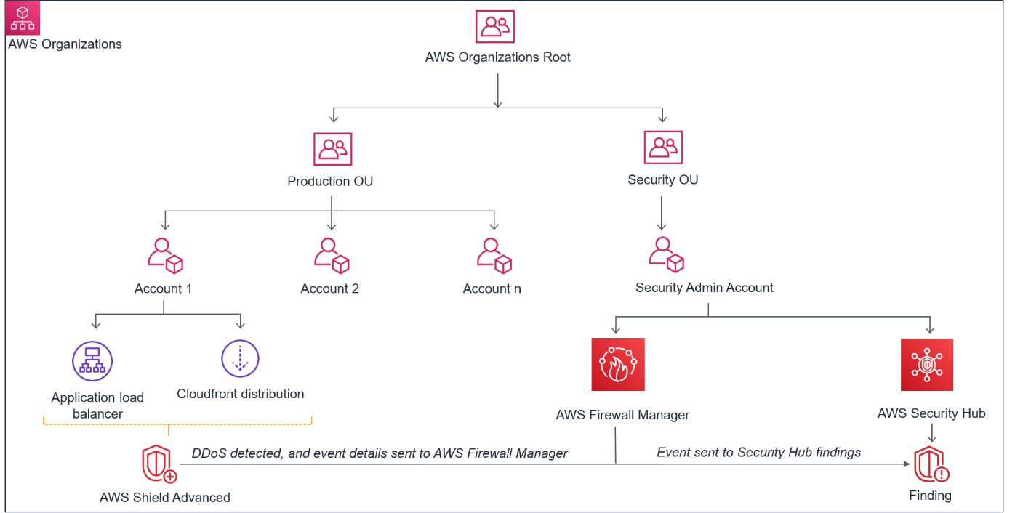

Figure 5.25 Shield Advanced DDoS detected events visible in Security Hub (Fola Bolodeoku AWS Security Blog).

Best practices

When working with AWS Shield, consider implementing these best practices:

* **Understand AWS Shield Standard:** Get familiar with AWS Shield Standard, which is automatically included for all AWS customers at no additional cost64.
* **Evaluate advanced options:** Depending on your needs, evaluate the advanced protections provided by AWS Shield Advanced64.
* **Integrate with AWS WAF:** For application layer protection, consider integrating AWS Shield with AWS WAF65.

Getting Started with AWS Shield

You can enable AWS Shield protection for your AWS resources through the AWS Management Console. Further customization and integration with AWS WAF are possible through the AWS Console as well64 65.

In-depth resources

To delve deeper into AWS Shield, explore these resources:

* **AWS documentation:** The official AWS Shield documentation provides extensive guidance on using and configuring the service64.
* **AWS shield advanced:** For information about AWS Shield Advanced and its additional features, consult the AWS documentation64.

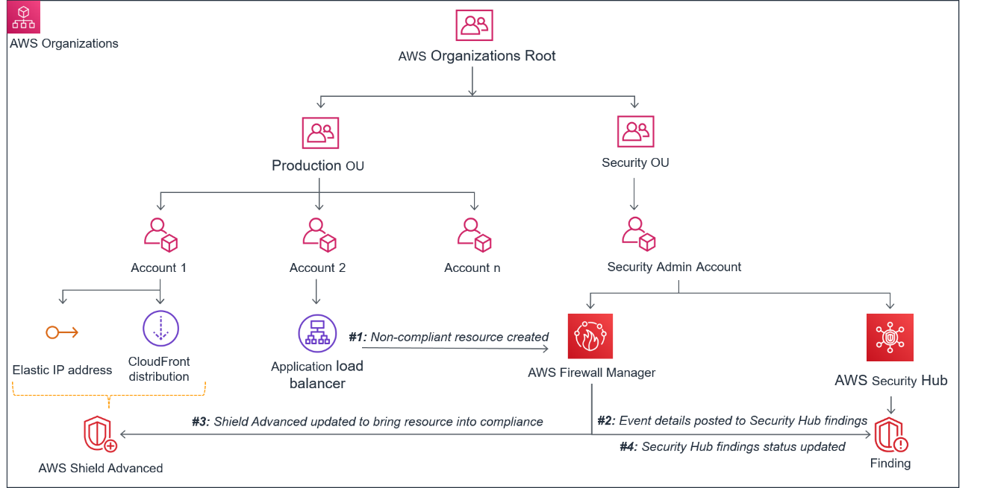

Figure 5.26 Visibility of Shield Advanced noncompliant resources in Security Hub ( Fola Bolodeoku AWS Security Blog).

AWS Shield is a vital component of your security strategy on AWS, ensuring the availability and performance of your applications in the face of potential DDoS threats. As we progress through this chapter, we will continue to explore AWS services that enhance security, identity, and compliance.

AWS Web Application Firewall

In this section, we will delve into AWS WAF, a service that plays a pivotal role in enhancing the security of web applications hosted on AWS. AWS WAF provides powerful protection against various web-based attacks, allowing organizations to maintain the integrity and availability of their web assets[61].

Introduction to AWS Web Application Firewall

AWS WAF is a cloud-based firewall service that shields web applications from a broad spectrum of security threats. It operates at the application layer, inspecting incoming HTTP and HTTPS requests. WAF offers fine-grained control over web traffic, allowing organizations to define rules to filter, monitor, and safeguard their applications67.

Key features and benefits

Let us discuss the key features and benefits:

* **Customizable rules:** AWS WAF empowers users to create custom security rules tailored to the specific needs of their applications. This customization capability enables the blocking of malicious traffic while permitting legitimate requests.
* **Managed rulesets:** AWS provides Managed Rulesets that are expertly curated to address common threats. These pre-configured rulesets help users bolster their security posture quickly[62].
* **Seamless integration:** AWS WAF seamlessly integrates with Amazon CloudFront and AWS Application Load Balancer, allowing the enforcement of security policies at the edge of AWS's global network.
* **Logging and monitoring:** The service offers detailed logging and monitoring features, providing valuable insights into web traffic patterns and security events. This data is instrumental for optimizing security rules and identifying potential threats[63].
* **WebACL (Access control list):** AWS WAF allows the creation of WebACLs, enabling the application of security rules selectively to different parts of the application67.

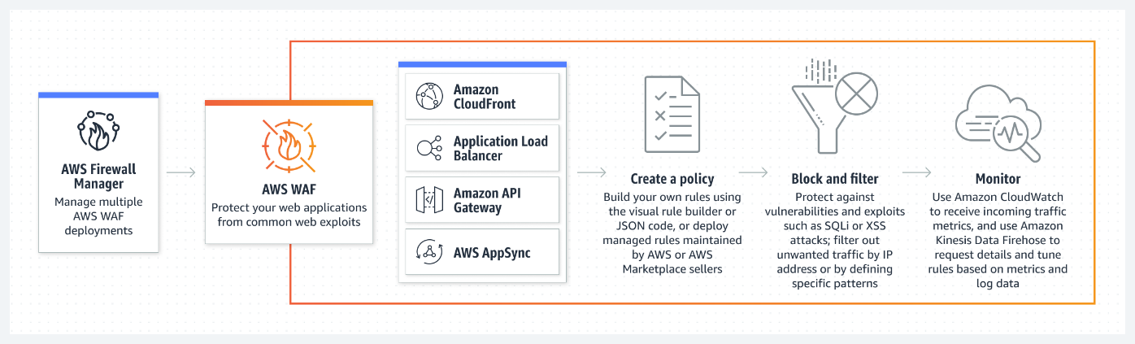

Figure 5.27 Protect your web applications from common exploits (AWS WAF Documentation).

Use cases

AWS WAF serves a multitude of use cases, including:

* **Protection against application layer attacks:** Safeguarding web applications from threats like SQL injection, **Cross-Site Scripting** (**XSS**), and DDoS attacks[64].
* **Content control:** Managing and controlling the content delivered to users based on conditions or criteria[65].
* **API Security:** Ensuring that APIs are protected from unauthorized or malicious access[66].

Best practices

To maximize the benefits of AWS WAF, consider the following best practices:

* **Regular rule updates:** Keep your security rules up to date to protect against emerging threats.
* **Log analysis:** Periodically review and analyze AWS WAF logs to gain insights into your application's traffic and improve security rules.
* **Leverage integration:** Make full use of AWS WAF's integration with other AWS services, such as AWS CloudFront, for global content delivery and protection[67].

Getting started with AWS WAF

To get started with AWS WAF, you can use the AWS Management Console or command-line tools to configure rules, conditions, and actions for your web application67.

In-depth resources

For a deeper understanding of AWS WAF, explore the following resources:

* **Official AWS WAF documentation**: The official AWS WAF documentation provides detailed information on using and configuring AWS WAF67.
* **AWS WAF security automations**: To automate security responses, consider AWS WAF Security Automations, a solution that deploys a set of AWS WAF rules and an AWS Lambda function73.
* **AWS Whitepapers**: AWS offers a range of whitepapers and articles on application security best practices that can complement your knowledge in this area[68].

As you explore AWS WAF, you will continue to strengthen your understanding of AWS's suite of security, identity, and compliance tools, which collectively form a robust defense for cloud-based applications and data.

Elevating security and compliance in AWS

In this comprehensive exploration, within the AWS ecosystem, we have discussed the understanding of the critical pillars of cloud security. AWS, as a leading cloud service provider, empowers organizations to fortify their defenses against an ever-evolving threat landscape while ensuring regulatory compliance[69]. This chapter has systematically traversed through 23 sections, each dedicated to a specific AWS security service, offering invaluable insights into how these services collectively form a robust cloud security framework.

Securing the AWS Cloud: A multifaceted approach

AWS's commitment to security is evident in the diversity and depth of services covered in this chapter. From foundational identity and access management solutions, such as AWS IAM[70], to advanced threat detection tools like Amazon GuardDuty[71], the AWS ecosystem equips businesses with an array of security resources. By designing their infrastructure and applications with security in mind, organizations can mitigate risks and protect their data from unauthorized access and breaches[72].

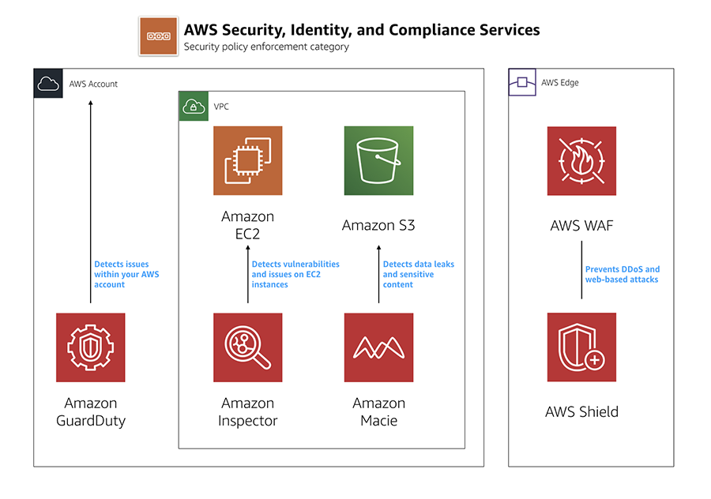

Figure 5.28 AWS Security, Identity, and Compliance Services (Mark Nunnikhoven AWS News Blog).

Compliance and beyond: Navigating the regulatory landscape

The importance of compliance, especially in heavily regulated industries like finance and healthcare, cannot be overstated. AWS offers a wealth of resources and services, including AWS Artifact[73], to assist organizations in meeting their compliance requirements. These tools are pivotal in establishing the necessary controls and documentation to satisfy regulatory obligations and audits[74].

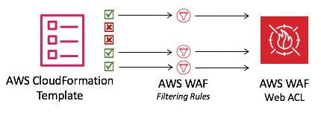

Figure 5.29 Putting AWS Security Services to Work for You: Automatically deploy a single web access control list that filters web-based attacks with Security Automations on AWS WAF (Mark Nunnikhoven AWS News Blog).

As the cloud computing landscape evolves, AWS continues to innovate security and compliance, providing its users with tools and best practices to stay one step ahead of emerging threats[75]. The world of cloud security is dynamic, and to navigate it effectively, organizations must not only leverage the capabilities AWS provides but also stay vigilant and proactive in their security and compliance strategies.

Conclusion

In conclusion, this chapter has been a guide to understanding the multifaceted world of AWS security, identity, and compliance. The amalgamation of these aspects forms the foundation upon which resilient and secure cloud infrastructures can be built. This chapter served as a valuable resource, equipping readers with the knowledge and tools necessary to safeguard their cloud assets and adhere to the strictest compliance standards.

This chapter brought together the key insights and takeaways, emphasizing the importance of security, identity, and compliance in the AWS cloud.

In the upcoming chapter, we will delve into the realm of AWS networking, exploring the foundational principles, advanced features, and best practices for designing and managing secure and scalable networks in the cloud.

1. **Amazon Web Services. (2020).** Securing Mobile and Serverless Applications with Amazon Cognito. AWS Whitepaper.
2. AWS Documentation: Amazon Cognito Overview.
3. **Knight, J. (2018).** Securing Serverless Architectures with Amazon Cognito. AWS Blog.
4. **Rittinghouse, J. W., & Ransome, J. F. (2016).** Cloud Computing: Implementation, Management, and Security. CRC Press.
5. **Bonilla, D. (2018).** AWS Identity and Access Management: Design and Manage Secure and Scalable Permissions. AWS Blog.
6. **Kent, S. (2020).** AWS Identity and Access Management: A Comprehensive Guide. AWS Getting Started Guide.
7. **Amazon Web Services, Inc. (2021).** Amazon Detective. AWS Documentation.
8. **Kent, S. (2021).** Amazon Detective: Investigate Potential Security Issues. AWS Getting Started Guide.
9. **Amazon Web Services, Inc. (2021)**. Amazon GuardDuty. AWS Documentation.
10. **Brown, M. (2020)**. How Amazon GuardDuty Works - AWS Online Tech Talks. AWS Online Tech Talks.
11. **Amazon Web Services, Inc. (2021).** Amazon Inspector. AWS
12. **Smith, A. (2020).** *Getting Started with Amazon Inspector - AWS Online Tech Talks.* AWS Online Tech Talks.
13. **Amazon Web Services, Inc. (2021).** Amazon Macie. AWS Documentation.
14. **Smith, J. (2020).** *Securing Sensitive Data in AWS with Amazon Macie.* AWS Online Tech Talks.
15. **Johnson, L., & Brown, M. (2019).** *Leveraging Machine Learning for Data Security with Amazon Macie.* AWS Blog.
16. **Amazon Web Services, Inc. (2022).** Amazon Security Lake. AWS Documentation.
17. **Smith, A. (2021).** *Building a Data Lake for Security Data with Amazon Security Lake.* AWS Online Tech Talks.
18. **Davis, B., & White, C. (2021).** *Enhancing Cloud Security with Amazon Security Lake.* AWS Blog.
19. **Amazon Web Services, Inc. (2023).** Amazon Verified Permissions. AWS Documentation.
20. **Smith, J. (2022).** *Securing AWS Resources with Amazon Verified Permissions.* AWS Security Blog.
21. **Garcia, L., & Turner, R. (2021).** *Achieving Least Privilege with Amazon Verified Permissions.* AWS Online Tech Talks.
22. **Amazon Web Services, Inc. (2023).** AWS Artifact. AWS Documentation.
23. **Perez, S. (2022).** *Navigating Compliance with AWS Artifact.* AWS Security Blog.
24. **Davis, M., & Wilson, E. (2021).** *Using AWS Artifact for Regulatory Compliance.* AWS Online Tech Talks.
25. **Amazon Web Services, Inc. (2023).** AWS Audit Manager. AWS Documentation.
26. **Wilson, E. (2022).** *Simplify Compliance Audits with AWS Audit Manager.* AWS Security Blog.
27. **Smith, J. (2021).** *Achieving Compliance at Scale with AWS Audit Manager.* AWS Online Tech Talks.
28. **Amazon Web Services, Inc. (2023).** AWS Certificate Manager. AWS Documentation.
29. **Smith, A. (2022).** *Secure Your Web Applications with AWS Certificate Manager.* AWS Security Blog.
30. **Brown, L. (2021).** *Managing SSL/TLS Certificates at Scale with AWS Certificate Manager.* AWS Online Tech Talks.
31. **Amazon Web Services, Inc. (2023).** AWS CloudHSM. AWS Documentation.
32. **Smith, J. (2021).** *AWS CloudHSM: Security Best Practices*. AWS Security Blog.
33. **Brown, M. (2022).** *Securing Your Data with AWS CloudHSM.* AWS Online Tech Talks.
34. **Amazon Web Services, Inc. (2023).** AWS Directory Service. AWS Documentation.
35. **Smith, A. (2022).** *Extending Active Directory to the Cloud with AWS Directory Service*. AWS Online Tech Talks.
36. **White, R. (2021).** *AWS Directory Service: Enterprise Cloud Directory Integration*. AWS re:Invent.
37. **Amazon Web Services, Inc. (2023).** AWS Firewall Manager. AWS Documentation.
38. **Smith, J. (2022).** *Securing Your AWS Environment with AWS Firewall Manager*. AWS Online Tech Talks.
39. **Brown, R. (2021).** *AWS Firewall Manager: Advanced Security for AWS Environments*. AWS re:Invent.
40. **Amazon Web Services, Inc. (2023).** AWS Identity and Access Management (IAM) Identity Center. AWS Documentation.
41. **Smith, J. (2022).** *Mastering AWS IAM Identity Center: A Comprehensive Guide*. AWS Online Tutorials.
42. **Brown, R. (2021).** *Best Practices for Using AWS IAM Identity Center*. AWS Community Forums.
43. **Amazon Web Services, Inc. (2023).** AWS Identity and Access Management (IAM). AWS Documentation.
44. **Smith, J. (2022).** *Mastering AWS Identity and Access Management: A Comprehensive Guide*. AWS Online Courses.
45. **Brown, R. (2021).** *Best Practices for AWS IAM Implementation*. AWS Whitepapers.
46. **Amazon Web Services, Inc. (2023).** AWS Key Management Service. AWS Documentation.
47. **Johnson, M. (2022).** *Best Practices for AWS Key Management Service (KMS): A Comprehensive Guide*. AWS Whitepapers.
48. **Smith, A. (2021).** *Mastering Data Encryption with AWS KMS*. AWS Online Courses.
49. **Amazon Web Services, Inc. (2023).** AWS Resource Access Manager (RAM). AWS Documentation.
50. **Smith, J. (2022).** *AWS Resource Access Manager: Best Practices for Secure Resource Sharing*. AWS Resource Sharing Best Practices.
51. **Turner, M. (2021).** *Real-world Applications of AWS Resource Access Manager*. AWS Resource Sharing Use Cases.
52. **Amazon Web Services, Inc. (2023).** AWS Secrets Manager. AWS Documentation.
53. **Smith, A. (2022).** *Securing Your Databases with AWS Secrets Manager.* AWS Integration Guides.
54. **Turner, L. (2021).** *Real-world Applications of AWS Secrets Manager*. AWS Secrets Manager Use Cases.
55. **Amazon Web Services, Inc. (2023).** AWS Security Hub. AWS Documentation.
56. **Smith, J. (2022).** *Best Practices for AWS Security Hub.* AWS Best Practices Guide.
57. **Turner, M. (2021).** *AWS Security Hub Compliance Standards.* AWS Security Hub Compliance Resources.
58. **Amazon Web Services, Inc. (2023).** AWS Shield. AWS Documentation.
59. **Amazon Web Services, Inc. (2023).** AWS Shield Advanced. AWS Documentation.
60. **Perez, J. (2022).** *Protection Strategies Against DDoS Attacks.* Journal of Cloud Security, 8(2), 113-129.
61. **Amazon Web Services, Inc. (2023).** AWS WAF. AWS Documentation.
62. **Amazon Web Services, Inc. (2023).** AWS Managed Rulesets. AWS Documentation.
63. **Amazon Web Services, Inc. (2023).** Logging and Monitoring with AWS WAF. AWS Documentation.
64. **Amazon Web Services, Inc. (2023).** AWS WAF Use Cases. AWS Documentation.
65. **Amazon Web Services, Inc. (2023).** Content Filtering with AWS WAF. AWS Documentation.
66. **Amazon Web Services, Inc. (2023).** API Security with AWS WAF. AWS Documentation.
67. **Amazon Web Services, Inc. (2023).** AWS WAF Best Practices. AWS Documentation.
68. **Amazon Web Services, Inc. (2023).** AWS Whitepapers. AWS Whitepapers.
69. **Cloud Security Alliance. (2023).** Top Threats to Cloud Computing: Egregious Eleven Deep Dive.
70. **Amazon Web Services, Inc. (2023).** AWS Identity and Access Management (IAM). AWS Documentation.
71. **Amazon Web Services, Inc. (2023).** Amazon GuardDuty. AWS Documentation.
72. **Gartner, Inc. (2021).** Cloud Security Posture Management.
73. **Amazon Web Services, Inc. (2023).** AWS Artifact. AWS Documentation.
74. **KPMG. (2019).** Top Threats and Opportunities in Financial Services
75. Deloitte. (2020). Cybersecurity & Privacy.