CHAPTER 7

Developer Tools andDevOps

Introduction

Chapter 7 delves into the intricacies of modern software development practices within cloud environments, exploring a spectrum of tools, methodologies, and best practices essential for efficient and scalable application deployment. The landscape of software development has evolved significantly with the advent of cloud computing, ushering in a paradigm shift towards agility, scalability, and automation. This chapter navigates through foundational principles and advanced techniques employed by developers to leverage cloud-native services effectively.

Software development in contemporary environments demands a robust framework that seamlessly integrates coding, testing, deployment, and management processes. With the emergence of cloud platforms like Amazon Web Services (AWS), developers are empowered with a plethora of services and tools designed to streamline the entire software development lifecycle (SDLC). From collaborative coding environments to automated CI/CD pipelines, and from secure deployment strategies to advanced monitoring and analytics, this chapter explores how these components synergistically contribute to achieving operational excellence and rapid application delivery.

The chapter begins by examining fundamental concepts such as serverless computing, which has revolutionized application architecture by abstracting infrastructure management and enabling developers to focus solely on code. Key insights from research articles and industry reports underscore the transformative impact of serverless computing on developer productivity and operational efficiency [1]. Building upon this foundation, the discussion extends to integrated development environments (IDEs) and their pivotal role in enhancing developer productivity through features like code completion, debugging tools, and collaborative capabilities [3], [18].

Moreover, the integration of machine learning (ML) algorithms in software development practices is explored, particularly in the context of code quality improvement and automated code reviews [5], [6], [53]. These innovations not only optimize software performance but also augment the accuracy and speed of code deployment processes. The chapter further investigates the significance of artifact management tools in facilitating seamless version control and dependency management within DevOps workflows [21], [22].

In parallel, the chapter addresses the critical aspects of continuous integration (CI) and continuous deployment (CD) methodologies, elucidating how cloud-native services such as AWS CodeBuild, AWS CodeCommit, and AWS CodePipeline automate build, test, and deployment tasks [24], [27], [32]. Best practices for secure CI/CD pipelines are highlighted, emphasizing the importance of robust security measures in cloud environments [34].

The discussion then shifts towards advanced deployment strategies and orchestration techniques, underscoring the role of infrastructure as code (IaC) in provisioning and managing cloud resources programmatically [13], [15]. Tools like AWS CloudFormation and AWS Cloud Control API are examined for their efficacy in achieving infrastructure scalability and consistency [14], [16].

Furthermore, the chapter explores emerging trends such as chaos engineering and resilience testing, which play a pivotal role in fortifying cloud-native applications against potential failures and disruptions [45], [46]. The adoption of these proactive testing methodologies ensures the reliability and fault tolerance of distributed systems deployed in cloud environments.

Lastly, the chapter elucidates event-driven architectures (EDA) and their significance in building scalable and responsive applications that can handle dynamic workloads efficiently [63], [65]. AWS services like Amazon SNS and AWS Step Functions are discussed in the context of orchestrating microservices and enabling seamless communication across distributed systems [56], [73].

In summary, Chapter 7 offers a comprehensive overview of the tools, techniques, and strategies essential for modern software development in cloud environments. By leveraging AWS services and industry best practices, developers can navigate complexities, streamline workflows, and accelerate the pace of innovation while maintaining robust security and scalability standards.

Structure

In this chapter, we will go through the following topics:

* Developer Tools
  + Amazon CodeCatalyst
  + Amazon CodeGuru
  + Amazon Corretto
  + AWS Cloud Control API
  + AWS Cloud Development Kit (CDK)
  + AWS Cloud9
  + AWS CloudShell
  + AWS CodeArtifact
  + AWS CodeBuild
  + AWS CodeCommit
  + AWS CodeDeploy
  + AWS CodePipeline
  + AWS CodeStar
  + AWS Command Line Interface (CLI)
  + AWS Device Farm
  + AWS Fault Injection Simulator
  + AWS Tools and SDKs
  + AWS X-Ray
  + Amazon CodeWhisperer
* Application Integration
  + Application Integration
  + Amazon AppFlow
  + Amazon EventBridge
  + Amazon Managed Workflows for Apache Airflow (MWAA)
  + Amazon MQ
  + Amazon Simple Notification Service (SNS)
  + Amazon Simple Queue Service (SQS)
  + Managed message queues
  + Application Integration
  + AWS Step Functions
* Containers
  + Amazon Elastic Container Registry (ECR)
  + Amazon Elastic Container Service (ECS)
  + Amazon Elastic Kubernetes Service (EKS)
  + AWS App2Container
  + AWS Copilot
  + AWS Fargate
  + Red Hat OpenShift Service on AWS
  + Managed OpenShift in the cloud
* Robotics
  + AWS RoboMaker
* Quantum Technologies
* Amazon Braket

Objectives

Module 7 of this text is designed to equip readers with a deep understanding of contemporary software development practices within cloud environments, focusing on Amazon Web Services (AWS) as a primary platform. The module explores a wide array of tools, methodologies, and best practices essential for efficient and scalable application development and deployment. By the end of this module, readers will gain practical insights and skills in the following areas:

1. **Understanding Serverless Computing**: Readers will comprehend the principles and advantages of serverless computing, including its impact on developer productivity and operational efficiency in cloud-native applications.
2. **Utilizing Integrated Development Environments (IDEs)**: Skills will be developed in using IDEs to enhance coding efficiency, collaborate effectively, and utilize debugging tools for rapid software development.
3. **Implementing Machine Learning (ML) in Software Development**: Readers will learn to integrate machine learning algorithms for tasks such as code quality improvement, automated code reviews, and performance optimization.
4. **Managing Artifacts and Dependencies**: Skills will be acquired in managing artifacts, version control, and dependencies using AWS tools like CodeArtifact, ensuring reliable and consistent software builds.
5. **Implementing Continuous Integration and Continuous Deployment (CI/CD)**: Techniques for automating build, test, and deployment pipelines using AWS CodeBuild, CodeCommit, and CodePipeline will be mastered, along with best practices for secure CI/CD pipelines.
6. **Deploying Infrastructure as Code (IaC)**: Proficiency will be gained in using AWS CloudFormation and Cloud Control API to provision and manage cloud resources programmatically, ensuring scalability and reproducibility.
7. **Implementing Advanced Deployment Strategies**: Readers will understand advanced deployment strategies and orchestration techniques, including blue/green deployments and canary releases, to achieve zero-downtime deployments and minimize risks.
8. **Testing Resilience and Fault Tolerance**: Skills will be developed in chaos engineering and resilience testing methodologies to ensure the reliability and fault tolerance of cloud-based applications.
9. **Building Event-Driven Architectures (EDA)**: Techniques for designing and implementing event-driven architectures using AWS services like SNS and Step Functions will be covered, enabling scalable and responsive applications.
10. **Integration of DevOps Practices**: Readers will learn how to integrate DevOps practices effectively with AWS services to streamline collaboration, automate workflows, and accelerate the software development lifecycle.

By mastering these skills, readers will be equipped to leverage AWS effectively in building robust, scalable, and secure cloud-native applications, thereby enhancing their capabilities as proficient developers in modern cloud environments.

Developer tools

The developer tools landscape within AWS is vast and dynamic. In this chapter, we will delve into a multitude of services designed to enhance productivity, streamline development workflows, and ensure code quality. From the AI-driven recommendations of Amazon CodeGuru to the robust development experience of Amazon **Cloud Development Kit (CDK)**, these tools cater to a wide spectrum of development needs. You will discover how services like AWS CloudShell and AWS CodePipeline provide a seamless and integrated development experience, while AWS CodeCommit and AWS CodeDeploy enable version control and application deployment at scale. With hands-on exposure to these services, you will be well-equipped to harness the full potential of AWS in your development projects.

DevOps practices

DevOps, an integral part of modern software development, emphasizes the seamless collaboration between development and operations teams to accelerate software delivery. AWS offers a suite of services that support DevOps practices, and in this chapter, we will explore their capabilities. You will gain insights into how AWS CodePipeline automates your release processes, how AWS CodeBuild simplifies the build and test phases, and how AWS CodeDeploy automates application deployments. With Amazon CodeStar, you can initiate projects with well-architected pipelines, and the AWS CDK offers a modern, programmatic approach to defining infrastructure as code.

Application integration

In the era of interconnected applications, effective application integration is essential. This chapter also delves into services like Amazon EventBridge and AWS Step Functions that facilitate seamless communication between diverse components of your applications. You'll understand how Amazon AppFlow simplifies data transfer across multiple services, while Amazon **Simple Queue Service (SQS)** and Amazon **Simple Notification Service (SNS)** handle event-driven and message-based interactions, respectively.

Containers and robotics

The DevOps landscape is not confined to traditional software development. In an era of containerization, AWS provides a robust ecosystem for managing containers through services like Amazon **Elastic Container Service (ECS)**, Amazon **Elastic Kubernetes Service (EKS)**, and AWS Fargate. You will also explore AWS RoboMaker for robotic application development, demonstrating the versatility of AWS DevOps tools in various domains.

Quantum technologies

Quantum computing represents the next frontier in computing, and AWS is taking a pioneering step with Amazon Braket. This quantum computing service allows developers to explore and experiment with quantum algorithms and hardware, paving the way for innovation in quantum computing applications.

In the digital age, a holistic understanding of developer tools and DevOps practices is indispensable for individuals and organizations looking to accelerate their cloud-powered innovation. By the end of this chapter, you will be equipped with a comprehensive toolkit to meet the demands of modern software development, ensuring that your applications are not only well-architected but also agile and scalable.

As we move forward in this journey, the next chapter, *Storage*, will dive deep into AWS storage services, providing the foundation for data persistence and accessibility in the cloud. From Amazon S3 to Amazon Glacier, the chapter will build on the principles established in this chapter to enhance your cloud computing expertise.

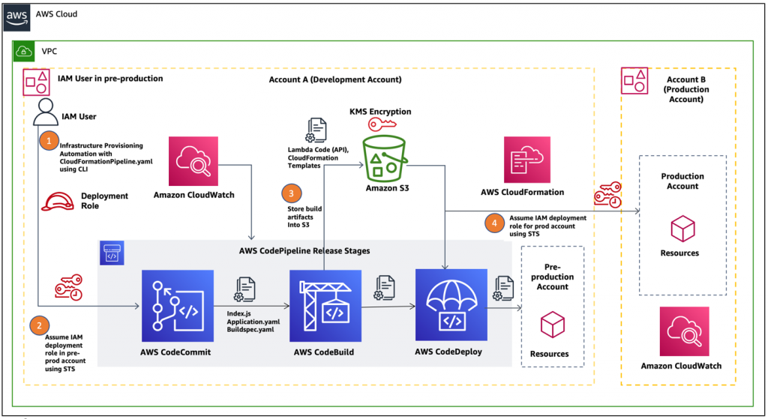

**Figure 7.1:** How AWS DevOps tools can integrate your tech teams (AWS Architecture Blog)

**Amazon CodeCatalyst**

In the dynamic landscape of cloud-based application development, AWS consistently endeavors to empower developers with tools and services that enhance productivity, streamline workflows, and elevate the quality of code. Amazon CodeCatalyst is one such innovative offering within AWS's Developer Tools ecosystem, designed to simplify the development and deployment process, enabling developers to focus on what they do best: creating and refining software solutions. [1]

Key features

Amazon CodeCatalyst serves as a robust and flexible **Integrated Development Environment (IDE)** specifically tailored to AWS services and applications. It offers several key features that make it an asset for developers:

* **AWS service integration**: CodeCatalyst deeply integrates with AWS services, providing a seamless environment for building, testing, and deploying applications. This integration reduces the complexities associated with managing resources and enables developers to concentrate on coding. [2]
* **Collaborative capabilities**: CodeCatalyst supports collaborative coding, allowing multiple developers to work on the same project simultaneously. It ensures that developers can effortlessly collaborate, review code, and iterate on their applications. [3] [4]
* **Serverless development**: Leveraging AWS Lambda, Amazon CodeCatalyst enables serverless application development. This approach eliminates the need to manage servers, allowing developers to write code without worrying about infrastructure provisioning1.
* **Code insights**: The IDE offers real-time code insights and recommendations powered by machine learning. These insights provide suggestions for enhancing code quality and best practices. This feature is especially valuable for developers aiming to improve their coding skills and deliver efficient code. [5]

In conclusion, Amazon CodeCatalyst is a remarkable addition to the AWS Developer Tools portfolio. It empowers developers to create, collaborate, and refine their applications with efficiency, ultimately accelerating the development process. As we journey through the subsequent sections of this chapter, we will further explore AWS’ extensive array of Developer Tools and DevOps services, each playing a unique role in the cloud-powered innovation landscape.

In the following sections, we will delve into Amazon CodeGuru, Amazon Corretto, AWS Cloud Control API, and various other Developer Tools that collectively shape the modern development and operations paradigms.

**Amazon CodeGuru**

In the ever-evolving landscape of cloud computing, efficient and optimized software development is paramount. Amazon CodeGuru, a groundbreaking developer tool offered by AWS, addresses this imperative by leveraging machine learning to enhance code quality and application performance. This section provides a detailed exploration of Amazon CodeGuru, shedding light on its features, functionalities, and the transformative impact it brings to the realm of software development.

Introduction to Amazon CodeGuru

Amazon CodeGuru, introduced by AWS, is an AI-powered developer tool designed to assist developers in writing high-quality and efficient code. It combines machine learning with best practices learned from Amazon's extensive codebase to provide automated code reviews and application profiling. This amalgamation of advanced technologies aims to alleviate common challenges faced by developers, such as identifying code defects, optimizing performance, and ensuring adherence to coding best practices. [6]

Automated code reviews with CodeGuru reviewer

One of the key features of Amazon CodeGuru is the CodeGuru Reviewer. This component performs automated code reviews, offering insightful recommendations for improvements. By analyzing source code, identifying defects, and providing suggestions for enhancements, CodeGuru Reviewer significantly streamlines the code review process. It evaluates the code against a plethora of best practices, enhancing code maintainability, readability, and reliability. [6]

According to AWS CodeGuru [7] documentation, CodeGuru Reviewer employs machine learning models trained on diverse and extensive datasets to continuously improve its ability to identify code issues accurately. This ensures that developers receive precise and actionable feedback, facilitating a more efficient and collaborative development lifecycle.

Application profiling with CodeGuru profiler

In addition to code reviews, Amazon CodeGuru includes the CodeGuru Profiler, a tool focused on optimizing application performance. CodeGuru Profiler provides in-depth insights into application runtime behavior, identifies bottlenecks, and recommends optimizations. By understanding how applications consume resources, developers can make informed decisions to enhance performance and reduce operational costs. [8]

The profiling capabilities of CodeGuru Profiler are particularly valuable in cloud environments, where efficient resource utilization directly translates to cost savings. By pinpointing areas of improvement, developers can optimize their applications for scale and responsiveness, ensuring a superior user experience.

Real-time integration and developer workflow

Amazon CodeGuru seamlessly integrates into existing developer workflows, supporting popular **integrated development environments (IDEs)** and source code repositories. This real-time integration ensures that developers receive feedback promptly, enabling them to address issues and implement optimizations early in the development process. Such agility contributes to faster release cycles and improves overall software quality.

Incorporating machine learning into the software development lifecycle, Amazon CodeGuru stands as a testament to AWS's commitment to empowering developers with cutting-edge tools. As we delve deeper into the myriads of developer tools and DevOps practices in this chapter, the impact of CodeGuru on code quality and application performance becomes even more apparent. [9]

Amazon Corretto

In the dynamic landscape of cloud-native development, the choice of a reliable and optimized Java runtime environment is critical. Amazon Corretto, an open-source distribution of the **Java Development Kit (JDK)** provided by AWS, serves as a robust solution for developers. This section provides an in-depth exploration of Amazon Corretto, delving into its features, advantages, and the pivotal role it plays in modern software development.

Introduction

Amazon Corretto is AWS's non-cost, multiplatform, production-ready distribution of the **Open Java Development Kit (OpenJDK)**. It is designed to provide a secure, stable, and high-performance environment for Java applications. Amazon Corretto is made available under **long-term support (LTS)** and offers features like performance enhancements, monitoring, and security updates [10]. It is a testament to AWS's commitment to supporting the Java development community and ensuring a seamless Java experience for AWS users [11].

Key features and performance enhancements

One of the key strengths of Amazon Corretto lies in its focus on performance and security. AWS emphasizes the delivery of timely updates and patches to address security vulnerabilities, ensuring that developers can build and deploy Java applications with confidence10. Corretto incorporates performance enhancements derived from the collaboration within the OpenJDK community, contributing to a faster and more efficient runtime environment [12].

Moreover, Amazon Corretto introduces various monitoring and diagnostic tools to help developers gain insights into the behavior of Java applications. This includes enhanced thread dumps and a comprehensive set of metrics accessible through Amazon CloudWatch. These tools empower developers to identify and resolve performance bottlenecks, leading to more efficient and responsive applications.

Long-term support and version consistency

A notable feature of Amazon Corretto is its long-term support model10. AWS commits to providing updates and security patches for Corretto builds for an extended period, offering stability and predictability for developers [10]. This long-term support aligns with AWS's focus on enabling organizations to build and maintain Java applications with confidence and reliability.

Additionally, Amazon Corretto ensures version consistency across different platforms. This consistency simplifies the development and deployment processes, allowing developers to create Java applications with the assurance that they will behave consistently across various environments, including on-premises data centers and AWS cloud infrastructure.

Integration with AWS Services

As part of the AWS ecosystem, Amazon Corretto seamlessly integrates with various AWS services, providing a cohesive experience for Java developers building applications on the AWS platform. Whether deploying applications on Amazon EC2 instances or leveraging serverless computing with AWS Lambda, developers can rely on Corretto to deliver optimal performance and compatibility [10].

In conclusion, Amazon Corretto stands as a reliable and performant choice for Java developers in the AWS ecosystem. As we navigate through the diverse landscape of developer tools and DevOps practices in this chapter, the significance of Amazon Corretto in ensuring a robust Java runtime environment becomes increasingly evident.

AWS Cloud Control API

In cloud orchestration and management, the AWS Cloud Control API emerges as a key player, providing developers with a programmatic interface to manage and provision AWS resources. In the rapidly evolving landscape of cloud-native development, effective orchestration and management of AWS resources are paramount. The AWS Cloud Control API is a powerful tool, providing developers with a unified API to manage their AWS infrastructure programmatically. This section delves into the intricacies of the AWS Cloud Control API, exploring its features, use cases, and its role in fostering efficient DevOps practices.

Introduction to AWS Cloud Control API

The AWS Cloud Control API is designed to simplify the management of AWS resources by offering a consistent API to create, update, and delete resources across different AWS services. This uniform interface streamlines resource provisioning and management tasks, contributing to the automation and efficiency of cloud operations.

The AWS Cloud Control API is a service that allows developers to create, read, update, and delete AWS resources across different AWS services [13]. It provides a unified, consistent API surface that abstracts the complexities of interacting with various AWS services individually. This abstraction simplifies resource management and enables developers to focus on application logic rather than service-specific nuances.

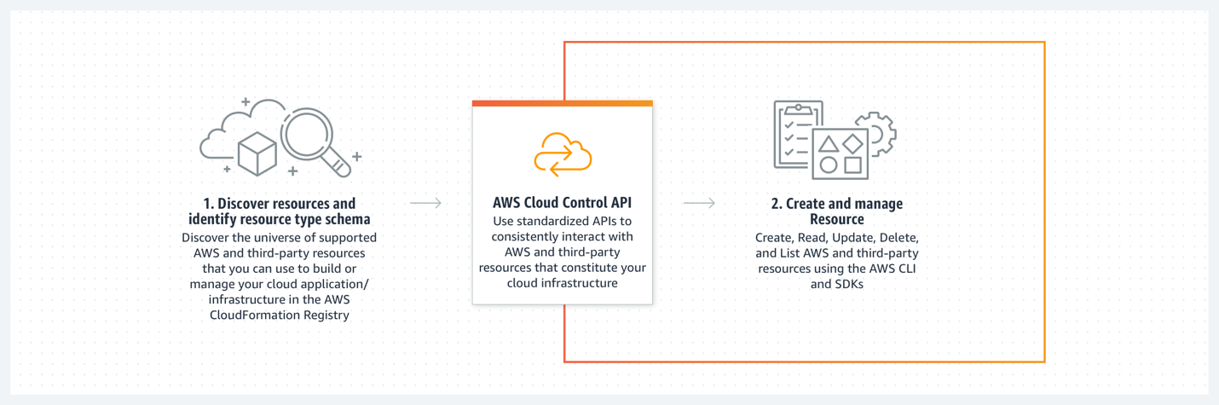

**Figure 7.2:** AWS Cloud Control API, a Uniform API to Access AWS and Third-Party Services (AWS Blog)

Key features and capabilities

The key features and capabilities are as follows:

* **Cross-service resource management**: One of the defining features of the AWS Cloud Control API is its ability to manage resources across various AWS services through a single API. This facilitates the integration and orchestration of resources from different domains within AWS.
* **Infrastructure as Code (IaC) integration**: The API aligns with the IaC paradigm, allowing developers to define and manage AWS resources using code. This integration supports the principles of versioning, collaboration, and repeatability in infrastructure management.
* **Consistent resource schema**: AWS Cloud Control API enforces a consistent resource schema, providing a standardized way to describe and interact with AWS resources. This uniformity simplifies resource management and reduces the learning curve for developers working with diverse AWS services.
* **Unified resource management**: One of the key features of the Cloud Control API is its ability to handle resource management across multiple AWS services through a single API endpoint [14]. This streamlines the development process, reducing the need to navigate different service APIs for common operations.
* **Declarative language support**: The Cloud Control API supports a declarative language for resource specifications, allowing developers to define the desired state of their resources [14]. This declarative approach enhances the idempotency of operations, making it easier to manage and automate infrastructure changes.
* **Consistency across services**: Developers can expect a consistent set of **Create, Read, Update, Delete (CRUD)** operations across supported AWS services [14]. This consistency simplifies the learning curve for developers working with multiple services and ensures a standardized approach to resource management.

Use cases and scenarios

In this section, we will go through the use cases and scenarios:

* **Automated resource provisioning**: DevOps teams can leverage the AWS Cloud Control API to automate the provisioning of resources, ensuring rapid and consistent deployments across development, testing, and production environments [14].
* **Multi-service workflows**: In scenarios where applications span multiple AWS services, the Cloud Control API becomes instrumental in orchestrating and managing the entire stack of resources cohesively [14].
* **IaC**: The AWS Cloud Control API is particularly beneficial in IaC scenarios, where infrastructure is defined and managed using code. By providing a unified API, it facilitates the creation and management of AWS resources in a programmatic and version-controlled manner.
* **IaC pipelines**: Integration with Infrastructure as Code pipelines enable the automation of resource updates and ensures that the infrastructure remains in sync with the codebase throughout its lifecycle [15].
* **Automation and orchestration**: DevOps practices emphasize automation and orchestration. The Cloud Control API enables developers and DevOps teams to automate resource provisioning, updates, and deletion, streamlining deployment processes.
* **Multi-service applications**: In scenarios where applications span multiple AWS services, the Cloud Control API simplifies the coordination of resources. It becomes instrumental in maintaining consistency and coherence across different parts of a distributed application.

In conclusion, the AWS Cloud Control API serves as a pivotal tool for DevOps practitioners, offering a unified and programmatic approach to managing AWS resources. Its support for cross-service resource management and alignment with Infrastructure as Code principles positions it as an asset in modern cloud-centric development and operations. Also, the AWS Cloud Control API emerges as an asset in the toolkit of developers and DevOps practitioners. Its unified approach to resource management aligns with modern development practices, fostering agility, consistency, and efficiency in AWS resource orchestration.Top of Form

AWS Cloud9

In the dynamic landscape of cloud-based development, AWS Cloud9 emerges as a powerful **integrated development environment (IDE)**, fostering collaboration and streamlining the software development lifecycle [16]. This section provides an in-depth exploration of AWS Cloud9, its features, and its role in modern development practices.

Introduction to AWS Cloud9

AWS Cloud9 is a cloud-based IDE that allows developers to write, run, and debug code directly from their web browser [14]. It provides a collaborative environment, enabling multiple developers to work on the same project simultaneously, enhancing teamwork and productivity. With a fully managed development environment, AWS Cloud9 eliminates the need for complex setup and configuration, offering a seamless experience for building, testing, and deploying applications.

Key features and capabilities

In this section, we will go through the key features and capabilities:

* **Collaborative coding**: AWS Cloud9 supports real-time collaboration, allowing multiple developers to edit and write code together in the same environment. This feature enhances teamwork, accelerates development cycles, and facilitates knowledge sharing among team members.
* **Built-in terminal and debugger**: The IDE comes with a built-in terminal and debugger, providing developers with a comprehensive set of tools for coding, testing, and debugging applications [17]. This integrated approach reduces context-switching and enhances the efficiency of the development workflow.
* **Wide language support**: AWS Cloud9 supports a variety of programming languages, making it versatile for different types of development projects [18]. Whether working on web applications, serverless functions, or traditional backend services, developers can leverage Cloud9 for a diverse range of use cases.

Use cases and scenarios

In this section, we will go through the use cases and scenarios:

* **Remote development environments**: AWS Cloud9 is particularly valuable for teams distributed across different locations. It enables developers to access a consistent and fully configured development environment from anywhere with an internet connection [16].
* **Education and training**: The collaborative nature of AWS Cloud9 makes it an excellent choice for educational purposes. Instructors can create shared environments for students to work together on coding exercises and projects, fostering a collaborative learning environment.
* **Serverless application development**: For developers working on serverless applications, AWS Cloud9 provides a streamlined experience. It integrates seamlessly with AWS Lambda, making it easier to build, test, and deploy serverless functions.

In conclusion, AWS Cloud9 stands as a versatile and collaborative IDE, catering to the needs of modern development teams. Whether used for remote collaboration, educational purposes, or serverless application development, Cloud9 provides a feature-rich environment that simplifies and accelerates the software development lifecycle.

AWS Cloud Control API

In the ever-evolving landscape of cloud orchestration and resource management, the AWS Cloud Control API emerges as a cornerstone for developers and DevOps teams, providing a streamlined and programmatic interface for interacting with AWS resources. This section delves into the key aspects of the AWS Cloud Control API, exploring its features, use cases, and its pivotal role in advancing modern development practices.

Introduction

The AWS Cloud Control API serves as a unified and consistent interface to manage AWS resources programmatically. Designed with the principles of simplicity and efficiency, it offers developers a versatile tool to create, update, and delete resources across various AWS services.

Key features and capabilities

The following are some key features and capabilities:

* **Cross-service resource management**: A distinctive feature of the AWS Cloud Control API is its ability to manage resources seamlessly across different AWS services [14]. This capability facilitates integrated and holistic resource orchestration in complex cloud environments.
* **Infrastructure as Code (IaC) integration**: Aligned with the IaC philosophy, the API supports the definition and management of AWS resources using code [14]. This integration promotes versioning, collaboration, and automation in infrastructure provisioning.
* **Consistent resource schema**: AWS Cloud Control API enforces a standardized resource schema, ensuring a consistent approach to describing and interacting with diverse AWS resources [14]. This standardization simplifies the development and management of cloud infrastructure.

Use cases and scenarios

The following are the use cases and scenarios:

* **Automated resource provisioning**: DevOps teams can leverage the AWS Cloud Control API to automate resource provisioning, enabling swift and consistent deployment across different environments [1].
* **Multi-service workflows**: In scenarios where applications span multiple AWS services, the Cloud Control API plays a crucial role in orchestrating and managing a cohesive set of resources [2].
* **CI/CD pipelines**: Integration with CI/CD pipelines facilitate automated resource updates, ensuring that the infrastructure evolves in tandem with code changes [19].

In essence, the AWS Cloud Control API stands as a pivotal tool in the DevOps toolkit, offering a consistent and efficient way to manage AWS resources. Its support for cross-service resource management and alignment with Infrastructure as Code principles positions it as a key enabler for organizations embracing agile and automated cloud practices.

AWS CodeArtifact

In modern software development and DevOps practices, effective management and sharing of software artifacts are paramount. AWS CodeArtifact emerges as a robust and scalable artifact management service, providing developers and organizations with a centralized repository for packages and dependencies. This section discusses the key features, use cases, and significance of AWS CodeArtifact.

Introduction

AWS CodeArtifact is a fully managed artifact repository service that allows organizations to securely store, publish, and share software packages and dependencies [20]. With native integration to popular build and deployment tools, CodeArtifact simplifies the management of dependencies in the software development lifecycle.

Key features and capabilities

The following are the key features and capabilities:

* **Universal package management**: CodeArtifact supports popular package formats, including Java (Maven), JavaScript (npm), Python (PyPI), and more [20]. This universality makes it a versatile choice for projects using multiple programming languages.
* **Security and Access Control**: Granular access controls and integration with AWS **Identity and Access Management (IAM)** enable organizations to manage who can access and publish packages [20]. This ensures the security and integrity of software artifacts.
* **Scalability and high availability**: CodeArtifact is designed for scalability, allowing organizations to handle the growing volume of artifacts. It also provides high availability across multiple AWS Availability Zones [20], ensuring reliable access to artifacts.

Use cases and scenarios

The following are the use cases and scenarios:

* **Dependency management in CI/CD pipelines**: CodeArtifact streamlines the process of managing dependencies in CI/CD pipelines, ensuring consistent and reliable builds [21].
* **Centralized artifact repository**: Organizations with multiple projects and teams benefit from a centralized repository for managing and sharing software artifacts. CodeArtifact simplifies the organization-wide use of shared packages.
* **Support for Polyglot development**: By supporting various package formats, CodeArtifact facilitates polyglot development environments in which different projects may use distinct programming languages and dependencies[1].

In conclusion, AWS CodeArtifact plays a pivotal role in enhancing the efficiency and security of software development and DevOps practices. Its universal package management, robust security features, and seamless integration with CI/CD pipelines make it an asset for organizations aiming to streamline their artifact management processes.

AWS CodeBuild

In the ever-evolving landscape of DevOps, a robust and efficient build process is the cornerstone of reliable software delivery. AWS CodeBuild, a fully managed build service, empowers development teams to compile, test, and package their code with ease. This section explores the key features, benefits, and use cases of AWS CodeBuild.

Introduction to AWS CodeBuild

AWS CodeBuild is a cloud-based build service that compiles source code, runs tests, and produces ready-to-deploy software artifacts [22]. It integrates seamlessly with other AWS services and supports popular programming languages, enabling developers to focus on writing code rather than managing build infrastructure.

Key features and capabilities

The following are the key features and capabilities:

* **Fully managed build service**: CodeBuild eliminates the need for developers to set up and maintain build servers. It automatically scales based on build requirements and provides a consistent environment for builds [22].
* **Extensive language support**: CodeBuild supports a wide range of programming languages, build tools, and runtimes, including Java, Python, Node.js, Docker, and more31. This flexibility makes it suitable for diverse development projects.
* **Build environment customization**: Developers can customize the build environment by specifying build commands, environment variables, and build specifications. This allows for tailored build processes that align with project requirements [22].

Figure 7.3 below shows what happens when you run a build with CodeBuild.

**Figure 7.3:** Shows what happens when you run a build with CodeBuild (AWS Documentation)

Use cases and scenarios

The following are the use cases and scenarios:

* **Continuous Integration (CI)**: CodeBuild is a key component of CI pipelines, automating the build and test phases. It integrates seamlessly with AWS CodePipeline, enabling a continuous integration workflow.
* **Scalable build processes**: With its ability to scale automatically, CodeBuild is well-suited for projects with varying build workloads. Whether handling small code changes or large feature additions, CodeBuild adapts to the demands of the development pipeline [23].
* **Integration with source control**: CodeBuild easily integrates with version control systems like AWS CodeCommit, GitHub, and Bitbucket. This ensures that builds are triggered automatically when changes are pushed to the repository [24].

In summary, AWS CodeBuild simplifies and accelerates the build process in DevOps workflows. Its managed service, language support, and seamless integration with other AWS tools make it an asset for development teams aiming to achieve efficient and reliable software builds.

AWS CodeCommit

AWS CodeCommit is a fully managed source control service offered by AWS, providing a secure and scalable platform for hosting Git repositories. This section delves into the key features, use cases, and best practices surrounding AWS CodeCommit.

Overview

AWS CodeCommit allows developers to store and version their code in the cloud, facilitating collaboration and ensuring a secure and accessible repository. Key aspects include [25]:

* **Security and compliance:**
  + CodeCommit ensures data encryption in transit and at rest, adhering to industry-standard security practices.
* **Scalability:**
  + The service seamlessly scales with the growth of projects, accommodating varying team sizes and codebase expansions.
* **Integration with other AWS Services:**
  + CodeCommit integrates with AWS IAM, AWS CodePipeline, and other developer tools, enhancing the overall development workflow.

Use cases

In this section, we will go through the use cases:

* **Collaborative software development:**
  + CodeCommit facilitates team collaboration by providing a central repository for code changes, enabling version control and efficient collaboration [26].
* **Continuous integration and deployment (CI/CD):**
  + Integration with AWS CodePipeline allows for the seamless implementation of CI/CD pipelines, automating code builds, testing, and deployments [27].
* **Secure code storage:**
  + CodeCommit serves as a secure and compliant storage solution for source code, meeting the requirements of industries with stringent security and compliance standards [28].

Best practices for AWS CodeCommit implementation

The following are the best practices for AWS CodeCommit implementation:

* Branching strategies:
* Adopt effective branching strategies to manage feature development, bug fixes, and releases efficiently [28].
* Code reviews:
* Leverage CodeCommit's built-in code review tools to maintain code quality and ensure adherence to coding standards [26].
* Repository structure:
* Organize repositories logically, considering factors like team structure, project dependencies, and deployment pipelines [27].

**AWS CodeDeploy**

AWS CodeDeploy is a powerful deployment service offered by AWS, designed to simplify and automate the process of deploying applications across diverse compute services. This section provides a comprehensive exploration of AWS CodeDeploy, delving into its key features, use cases, and best practices for efficient deployment strategies.

Key features

The following are the key features of AWS CodeDeploy:

* **Flexible deployment strategies:** AWS CodeDeploy supports various deployment strategies, including in-place deployments, blue/green deployments, and canary deployments. This flexibility allows developers to choose the method that best suits their application's requirements [29].
* **Multi-platform support:** CodeDeploy is platform-agnostic, extending its support to a variety of applications built on different programming languages and frameworks. This inclusivity makes it a versatile choice for heterogeneous environments [26].
* **Integration with DevOps tools:** Seamlessly integrates with other AWS Developer Tools and popular third-party DevOps tools, streamlining the deployment pipeline and supporting **continuous integration and continuous delivery (CI/CD)** practices [27].
* **Rollback capabilities:** CodeDeploy incorporates automatic rollback features, ensuring that if issues arise during deployment, the system can revert to the previous version, minimizing downtime and impact on users [27]

Figure 7.4 below shows a high-level architecture for the AWS CodeDeploy, a fully managed deployment service

**Figure 7.4:** AWS CodeDeploy: fully managed deployment service (Amazon Web Services).

Use cases of AWS CodeDeploy

The following are the use cases of AWS CodeDeploy [29]:

* **Web application deployments:** CodeDeploy is well-suited for deploying web applications, allowing developers to roll out updates efficiently while maintaining high availability.
* **Microservices deployments:** In a microservices architecture, CodeDeploy facilitates the deployment of individual microservices independently, supporting the principles of agility and scalability.
* **Hybrid cloud environments:** Organizations with hybrid cloud setups can leverage CodeDeploy to manage deployments seamlessly across on-premises and cloud-based infrastructure.

Best practices for AWS CodeDeploy implementation

The following are the best practices for AWS CodeDeploy implementation:

* **Define clear deployment goals:** Clearly articulate the goals of each deployment to choose the most appropriate deployment strategy for your application [30].
* **Thorough testing procedures:** Implement robust testing procedures, including staging environments and automated testing, to catch potential issues before deployment [31].
* **Monitor and optimize:** Continuously monitor deployments using AWS CloudWatch and optimize deployment strategies based on performance metrics [27].

**AWS CodePipeline**

AWS CodePipeline is a fully managed CI/CD service that automates the end-to-end software release process. This section provides an in-depth exploration of AWS CodePipeline, covering its features, integrations, and best practices for achieving efficient and reliable software delivery.

Key features of AWS CodePipeline

Following are the key features of AWS CodePipeline [32]:

* **Automated workflows:** CodePipeline allows users to define and automate their release pipelines, orchestrating the flow of code from source repositories through build, test, and deployment phases.
* **Integration with DevOps tools:** Seamlessly integrates with a variety of AWS services, third-party tools, and custom plugins, enabling users to construct flexible and extensible workflows.
* **Parallel and sequential execution:** CodePipeline supports both parallel and sequential execution of pipeline stages, accommodating diverse application architectures and deployment scenarios.
* **Artifact management:** Manages and stores build artifacts, ensuring versioned and consistent artifact availability throughout the software delivery process.

Use cases of AWS CodePipeline

The following are the use cases of AWS CodePipeline:

* **Multi-environment deployments:** CodePipeline facilitates the creation of pipelines that support deploying applications to multiple environments, such as development, testing, and production.
* **Microservices architectures:** Ideal for orchestrating CI/CD workflows in microservices-based applications, allowing independent testing and deployment of individual services [32].
* **Serverless application deployments:** Well-suited for automating the deployment of serverless applications, managing the build and deployment of AWS Lambda functions and related resources.

Best practices for AWS CodePipeline implementation

The following are the best practices for AWS CodePipeline implementation:

* **Version control integration:** Integrate CodePipeline with version control systems like AWS CodeCommit or GitHub for seamless source code management [33].
* **Automated testing strategies:** Implement automated testing at each stage of the pipeline to identify and address issues early in the development process [34].
* **Security best practices:** Follow AWS best practices for security, including least privilege principles and encryption of sensitive data within the pipeline.

AWS CodeStar Developer tools

AWS CodeStar is an **integrated development environment (IDE)** and CI/CD service designed to simplify the development and deployment of applications on AWS. This section delves into the features, benefits, and best practices associated with AWS CodeStar.

Key features

The following are the key features of AWS CodeStar [35]:

* **Unified development platform:** CodeStar provides a unified platform for developing, building, and deploying applications, streamlining the software development life cycle.
* **Project templates:** Offers pre-configured project templates for various programming languages and AWS services, enabling quick project setup and reducing configuration overhead.
* **Built-in CI/CD pipeline:** Automatically sets up a CI/CD pipeline for each project, facilitating automated code builds, tests, and deployments.
* **Team collaboration:** Supports collaboration by integrating with AWS IAMfor secure user access control and management.

Use cases

The following are the use cases of AWS CodeStar [35]:

* **Rapid prototyping:** CodeStar is beneficial for rapidly prototyping applications, allowing developers to focus on coding while it handles the underlying infrastructure.
* **Multi-language support:** Ideal for projects involving multiple programming languages, providing a flexible environment for diverse development needs.
* **Serverless application development:** Suited for serverless application development, simplifying the process of building and deploying AWS Lambda functions.

Best practices for AWS CodeStar implementation

The following are the best practices for AWS CodeStar implementation:

* **Customization of templates:** Customize project templates to align with specific project requirements and coding standards [36].
* **Integration with AWS services:** Leverage integrations with other AWS services, such as AWS CodeCommit and AWS CodeBuild, to enhance the CI/CD pipeline [37].
* **Regular monitoring and optimization:** Monitor project activity and resource usage regularly, optimizing configurations based on project needs and changing requirements [35].

AWS Command Line Interface

The AWS **Command Line Interface (CLI)** is a powerful tool that enables users to interact with various AWS services directly from the command line. This section explores the functionalities, benefits, and best practices associated with the AWS CLI.

Key features

The following are the key features of AWS CLI [38]:

* **Cross-service commands:** The AWS CLI provides a unified interface with commands that span multiple AWS services, offering consistent user experience.
* **Scripting and automation:** Facilitates scripting and automation by allowing users to create scripts that execute AWS CLI commands, enhancing workflow efficiency.
* **Customization and configuration:** Users can configure the AWS CLI to tailor their interactions, including setting default regions, output formats, and security credentials.

Use cases

The following are the use cases of AWS CLI

* **Batch operations:** Ideal for executing batch operations, AWS CLI allows users to automate repetitive tasks and manage resources at scale [38].
* **Integration with scripts:** Suited for integration into scripts and third-party tools, enabling seamless incorporation of AWS actions into existing workflows [39].
* **Quick resource management:** Users can quickly create, configure, and manage AWS resources without accessing the AWS Management Console, offering a streamlined experience [38].

Best practices for AWS CLI Usage

The following are the best practices for AWS CLI Usage [38]:

* **Security best practices:** Adhere to security best practices by securely managing and storing AWS CLI credentials, utilizing IAM roles, and implementing MFA.
* **Version Compatibility:** Ensure compatibility by using the latest version of the AWS CLI, staying informed about updates, and checking for any breaking changes in scripts.
* **Output Formatting:** Optimize output formatting for scripts by selecting appropriate output options, such as JSON or table format, to enhance readability and parsing [40].

AWS Device Farm

AWS Device Farm is a cloud-based mobile app testing service that enables developers to test their applications on a wide range of real devices. This section provides an in-depth exploration of AWS Device Farm, highlighting its features, use cases, and best practices.

Key Features

The following are the key features of AWS Device Farm [41]:

* **Device compatibility testing:** AWS Device Farm allows developers to test their mobile apps on a diverse set of real devices to ensure compatibility across various platforms.
* **Parallel testing:** Enhances testing efficiency by enabling parallel execution of tests on multiple devices, reducing testing time and accelerating the development lifecycle.
* **Built-in test scripts:** Provides built-in test scripts for popular test automation frameworks, simplifying the process of creating and running tests.

Use cases

The following are the use cases of AWS Device Farm:

* **Automated testing:** Well-suited for automated testing scenarios, AWS Device Farm supports popular test automation frameworks such as Appium, XCTest, and Espresso [41].
* **Real-device testing:** Allows developers to perform testing on real devices rather than relying solely on emulators, ensuring accurate simulation of user interactions [42].
* **Performance testing:** Ideal for performance testing, developers can assess app behavior under various conditions, such as different network strengths and device specifications [41].

Best practices for AWS Device Farm Usage

The following are the best practices for AWS Device Farm Usage:

* **Test on real devices:** Prioritize testing on real devices to uncover issues that may not be apparent in emulator-based testing [42].
* **Parallel execution planning:** Efficiently plan parallel test executions to maximize testing throughput and minimize overall testing time [41].
* **Regular test updates:** Keep test scripts updated to align with the latest features and capabilities of AWS Device Farm, ensuring optimal testing performance [43].

AWS Fault Injection Simulator

AWS Fault Injection Simulator is a service designed to help developers and operators evaluate the resilience of their applications by injecting faults and observing system behavior under different failure scenarios. This section delves into the key aspects of AWS Fault Injection Simulator, including its features, benefits, and practical applications.

Key features

The following are the key features of AWS Fault Injection Simulator [44]:

* **Fault injection scenarios:** AWS Fault Injection Simulator enables users to create and run fault injection scenarios, simulating various failure conditions such as latency, errors, and timeouts.
* **Observability integration:** Integrates seamlessly with AWS observability tools, allowing users to monitor and analyze the impact of injected faults on system performance.
* **Automation capabilities:** Provides automation features for scheduling fault injection experiments, making it easy to conduct regular resilience testing.

Benefits of using AWS Fault Injection Simulator

The following are the benefits of using AWS Fault Injection Simulator:

* **Resilience validation:** Allows developers to proactively validate the resilience of their applications, identifying and addressing potential weaknesses before they impact users [45].
* **Cost-effective testing:** Provides a cost-effective way to perform resilience testing without the need for complex infrastructure setup, helping organizations save on testing resources [44].
* **Realistic failure simulations:** Enables the creation of realistic failure scenarios, enhancing the accuracy of resilience testing and ensuring preparedness for unexpected events [45].

Practical applications

The following are some practical applications:

* **Chaos engineering:** Supports the principles of chaos engineering by allowing controlled injection of faults, helping organizations understand how their systems behave under adverse conditions [44].
* **Continuous resilience testing:** Facilitates the incorporation of continuous resilience testing into the development and deployment pipelines, ensuring ongoing evaluation of application robustness [45].

Best practices for AWS Fault Injection Simulator

The following are the best practices for AWS Fault Injection Simulator:

* **Start with low-impact scenarios:** Begin by injecting faults with low impact to understand the initial response of the system before progressing to more severe scenarios [46].
* **Regularly review results:** Regularly review and analyze the results of fault injection experiments to identify patterns and potential areas for improvement [44].

**AWS Tools and Software Development Kits**

AWS provides a comprehensive set of tools and **Software Development Kits (SDKs)** that empower developers to build, deploy, and manage applications on the AWS Cloud. This section explores the key features, benefits, and practical applications of AWS Tools and SDKs, emphasizing their role in streamlining the development process and fostering DevOps practices.

Key features

The following are the key features of AWS Tools and SDKs:

* **Multi-language support:** AWS Tools and SDKs offer support for multiple programming languages, allowing developers to choose the language they are most comfortable with [47].
* **Comprehensive service coverage:** Encompass a wide range of AWS services, providing developers with libraries and utilities for interacting with various cloud resources [48].
* **Integration with popular IDEs:** Integrates seamlessly with popular IDEs such as Visual Studio Code, Eclipse, and IntelliJ IDEA, enhancing the development experience.

Benefits of using AWS Tools and SDKs

The following are the benefits of using AWS Tools and SDKs

* **Efficiency and productivity:** Streamlines the development process by providing pre-built functions and abstractions, reducing the time and effort required to interact with AWS services [48].
* **Consistent development experience:** Ensures a consistent experience across different programming languages, making it easier for development teams working with diverse technology stacks [48].
* **Version compatibility:** Maintains version compatibility with AWS services, allowing developers to leverage the latest features and improvements [47].

Figure 7.5 below shows a visualization of the SDKs, and how they prove pre-built modules, components, packages, and tools for developers to build, test, and deploy software applications

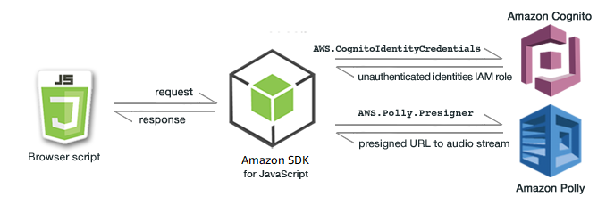

**Figure 7.5:** SDKs provide pre-built modules, components, packages, and tools (Amazon Web Services).

Practical applications

In this section, we will go through the practical applications:

* **Application development:** Facilitates the development of cloud-native applications by providing tools and SDKs that abstract the complexities of AWS service interaction [48].
* **Automation and scripting:** Enables automation and scripting of common tasks, allowing DevOps teams to create efficient and repeatable workflows [47].

Best practices for using AWS Tools and SDKs

The following are the best practices for using AWS Tools and SDKs:

* **Regularly Update SDK Versions:** Stay up to date with the latest SDK versions to access new features, improvements, and security updates [49].
* **Utilize code samples and documentation:** Leverage code samples and comprehensive documentation provided by AWS to expedite development and troubleshoot issues effectively [48].

AWS X-Ray

AWS X-Ray is a powerful service designed to help developers analyze and troubleshoot distributed applications in the AWS Cloud. This section provides an in-depth exploration of AWS X-Ray, highlighting its key features, benefits, and practical applications in enhancing application performance and reliability.

Key features of AWS X-Ray

The following are the key features of AWS X-Ray:

* **Distributed tracing:** AWS X-Ray enables distributed tracing, allowing developers to track requests as they traverse various components of a microservices architecture [50].
* **Performance monitoring:** Provides real-time insights into application performance, allowing developers to identify bottlenecks and optimize critical paths [50].
* **Error detection:** Automatically detects errors and exceptions in distributed applications, aiding in rapid diagnosis and issue resolution [51].

Benefits of using AWS X-Ray

The following are the benefits of using AWS X-Ray [50]:

* **Improved debugging:** Facilitates efficient debugging by providing a visual representation of the entire request flow across microservices.
* **Enhanced performance optimization:** Enables developers to identify performance issues and optimize application components for improved efficiency.
* **Reduced downtime:** Minimizes downtime by quickly identifying and resolving errors, leading to enhanced application reliability.

Practical applications

The following are the practical applications:

* **Microservices architecture:** Particularly valuable in microservices architectures, AWS X-Ray helps developers understand the interactions between different services [51].
* **Troubleshooting production issues:** Streamlines the process of troubleshooting and diagnosing production issues by providing detailed insights into application behavior [50].

Best practices for using AWS X-Ray

In this section, we will go through the best practices for using AWS X-Ray:

* **Instrumentation of code:** Implement thorough instrumentation of code to capture trace data effectively and gain comprehensive insights [51].
* **Integration with AWS Services:** Leverage integration with other AWS services, such as AWS Lambda and Amazon EC2, to capture traces from various components [50].

Amazon CodeWhisperer

Amazon CodeWhisperer is an innovative tool within the AWS Developer Tools suite, designed to enhance collaborative coding and streamline the code review process. This section provides a detailed exploration of Amazon CodeWhisperer, outlining its features, benefits, and practical applications in the software development lifecycle.

Figure 7.6 below is a visual representation of the Amazon CodeWhisperer, the ML-powered coding companion:

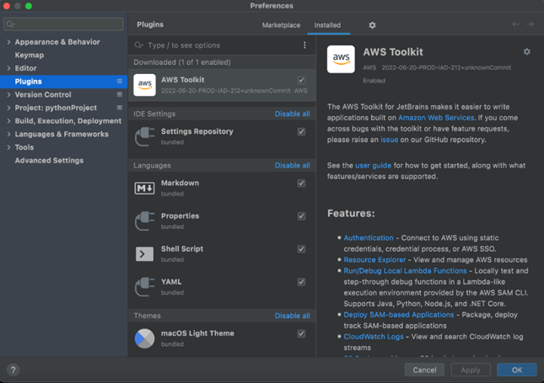

**Figure 7.6** Amazon CodeWhisperer, the ML-powered coding companion (AWS Blog)

Key features

The following are the key features of Amazon CodeWhisperer:

* **Real-time collaboration:** CodeWhisperer facilitates real-time collaboration among developers, allowing them to review and edit code simultaneously [52].
* **Automated code reviews:** Implements automated code reviews, leveraging predefined rules and best practices to ensure code quality and adherence to coding standards [53].
* **In-line comments and suggestions:** Enables developers to provide in-line comments and suggestions directly within the code, fostering effective communication during the review process [52].

Benefits of using Amazon CodeWhisperer

The following are the benefits of using Amazon CodeWhisperer:

* **Accelerated code review process:** Streamlines and accelerates the code review process by automating routine checks and providing a collaborative environment for developers [53].
* **Code quality improvement:** Contributes to improved code quality by flagging potential issues and ensuring adherence to coding best practices [52].
* **Knowledge transfer:** Facilitates knowledge transfer among team members by promoting collaboration and shared understanding of the codebase [52].

Practical applications

In this section, we will go through the practical applications:

* **Large-scale development projects:** Particularly beneficial in large-scale development projects with distributed teams, where efficient code collaboration is crucial [52].
* **Open-source contributions:** Supports open-source contributors by providing a transparent and collaborative platform for reviewing and contributing code changes [53].

Best practices for using Amazon CodeWhisperer

In this section, we will go through the best practices for using Amazon CodeWhisperer:

* **Define clear review guidelines:** Establish clear guidelines for code reviews to ensure that the team focuses on critical aspects of code quality and functionality [52]
* **Regularly update review rules:** Regularly update and customize automated review rules to align with evolving coding standards and project requirements [53].

AWS application integration services

In this section, we will go through the AWS application integration services:

* **Amazon Simple Queue Service (SQS):** SQS is a fully managed message queuing service that enables decoupling of the components in a cloud application, promoting scalability and fault tolerance [54].
* **Amazon Simple Notification Service (SNS):** SNS is a flexible, fully managed messaging service facilitating communication between distributed microservices and components [55].
* **Amazon AppFlow:** Amazon AppFlow allows secure and seamless integration between AWS services and SaaS applications, automating data flows [56].
* **Amazon EventBridge:** Amazon EventBridge simplifies event-driven integration by connecting application data with various AWS services [57].

Overview

AWS provides a robust set of services for seamless application integration, allowing organizations to build scalable, efficient, and connected applications. This section delves into AWS's Application Integration services, highlighting key components, use cases, and best practices for implementing effective application integration solutions.

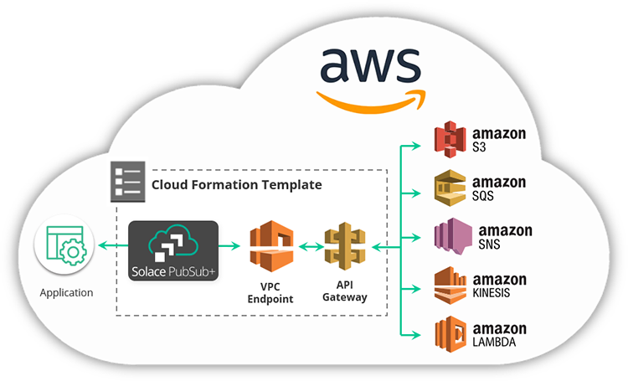

**Figure 7.7:** AWS Application Integration Services (AWS Training Blog)

Application integration involves connecting different software applications and systems to function harmoniously as a unified ecosystem. This process ensures efficient data flow, real-time communication, and interoperability, enabling organizations to streamline business processes and enhance overall productivity.

Application integration is a critical aspect of modern cloud computing, allowing diverse systems and applications to communicate and share data seamlessly. This section also provides an overview of application integration, its significance, and key strategies for implementing effective integration solutions.

Significance of application integration

In this section, the significance of application integration will be discussed:

* **Data consistency:** Application integration ensures that data is consistent across various systems, preventing discrepancies and errors [58].
* **Improved efficiency:** Seamless communication between applications reduces manual efforts, minimizes data silos, and enhances overall operational efficiency [59].
* **Enhanced decision-making:** Integrated systems provide a holistic view of data, empowering organizations to make informed and timely decisions [60].

Strategies for application integration

The following are the strategies for application integration:

* **Enterprise Service Bus (ESB):** ESB serves as a middleware solution, facilitating communication between applications through a centralized hub [61].
* **API-based integration:** Utilizing **Application Programming Interfaces (APIs)** for seamless connectivity between applications, enabling data exchange and functionality sharing [59].
* **Event-driven architecture:** Implementing an event-driven approach where applications communicate through events, enabling real-time responses to changes [62].

Best practices for effective application integration

The following are the best practices for effective application integration:

* **Standardize data formats:** Adopt standardized data formats to ensure compatibility and smooth data exchange between applications [58].
* **Security measures:** Implement robust security measures, including encryption and authentication, to protect data during integration processes [60].
* **Event-driven design:** Embrace event-driven design principles, where components communicate through events, enhancing flexibility and scalability [59].
* **Decoupling components:** Leverage SQS for decoupling components, reducing interdependencies and allowing for independent scaling and development [62].

Use cases

The following are the use cases:

* **Microservices architecture:** AWS Application Integration services are instrumental in implementing a microservices architecture, where individual services communicate efficiently through events and messages [63].

Figure 7.8 below depicts a typical microservices application on AWS.

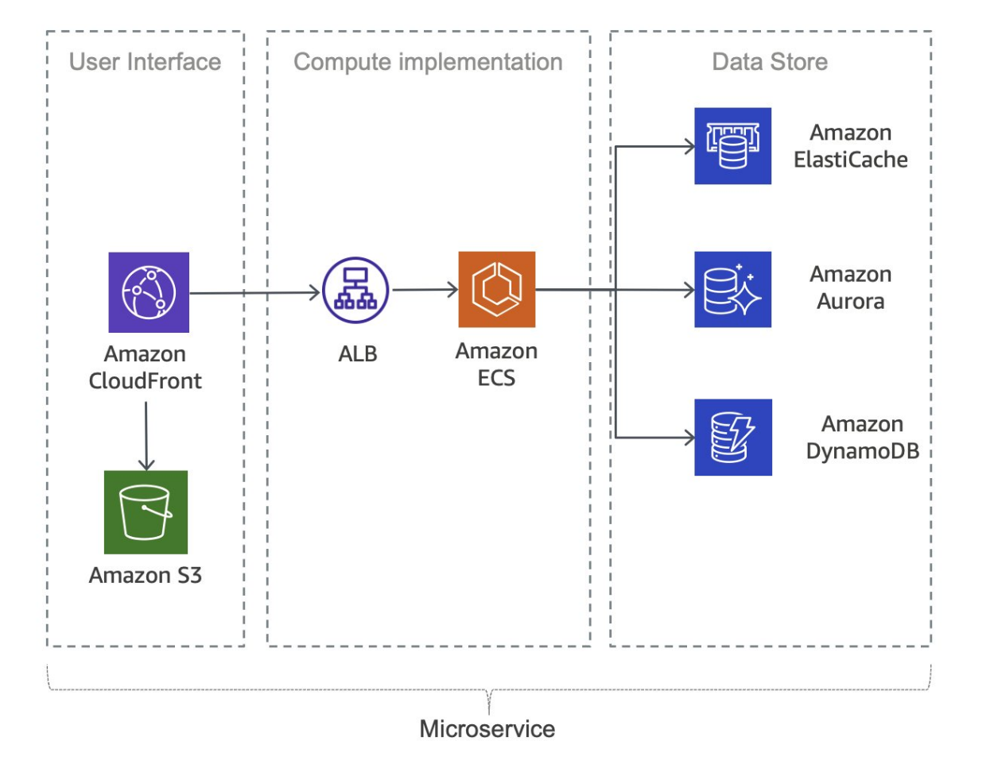

**Figure 7.8:** Typical microservices application on AWS (AWS Documentation)

* **Asynchronous communication:** SQS is particularly effective for enabling asynchronous communication between different parts of an application, ensuring smooth operation and reducing dependencies [64].

Challenges and considerations

The following are the challenges and considerations:

* **Message ordering:** When using SQS, consider the implications of message ordering and implement strategies to manage and handle ordered and unordered messages effectively [58].
* **Error handling:** Implement robust error handling mechanisms, especially in asynchronous communication scenarios, to ensure the reliability of application integration [61].

Amazon AppFlow

Amazon AppFlow is a fully managed integration service provided by AWS, designed to securely transfer data between AWS services and SaaS (Software as a Service) applications. This section explores the capabilities of Amazon AppFlow, its use cases, and considerations for implementing seamless data transfers.

Key features

The following are the key features of Amazon AppFlow [56]:

* **Bi-directional data flow:** Amazon AppFlow supports bidirectional data transfer, allowing organizations to move data both to and from AWS services and various SaaS applications.
* **Pre-built connectors:** The service comes with pre-built connectors for popular SaaS applications like Salesforce, ServiceNow, and others, simplifying the integration process.
* **Data mapping and transformation:** Amazon AppFlow enables data mapping and transformation, ensuring that data formats are compatible between source and destination systems.

Use cases

In the following section, we will go through the use cases:

* **Sales and marketing automation:** Organizations can use Amazon AppFlow to automate the flow of data between CRM systems like Salesforce and marketing platforms, streamlining sales and marketing processes [65].
* **Data warehousing:** Amazon AppFlow can facilitate the transfer of data from SaaS applications to data warehouses on AWS, supporting analytics and reporting requirements [56].

Considerations for implementation

The following are the considerations for implementation [56]:

* **Security and compliance:** Ensure that data transferred through Amazon AppFlow complies with security and compliance standards, especially when dealing with sensitive information.
* **Data mapping accuracy:** Validate and test data mapping configurations to guarantee accuracy and consistency in data transfer between different systems.

Challenges

The following are the challenges:

* **Data transfer speed:** Depending on the volume of data and the capabilities of the SaaS application, organizations may need to consider the speed of data transfer and plan accordingly [66].

Amazon EventBridge

Amazon EventBridge, a serverless event bus service provided by AWS, enables easy and scalable event-driven applications. This section discusses the features, use cases, and best practices for leveraging Amazon EventBridge in your cloud architecture.

Key features

The following are the key features of Amazon EventBridge [57]:

* **Event routing:** Amazon EventBridge allows the definition of event rules to route events from a source to one or more targets, facilitating decoupled communication between services.
* **Schema registry:** The service provides a schema registry for events, promoting consistency and compatibility in event structures across applications.
* **Managed integrations:** Amazon EventBridge offers pre-built integrations with various AWS services, reducing the effort required for event-driven architectures.

Use cases

The following are the use cases of Amazon EventBridge:

* **Microservices communication:** Amazon EventBridge supports communication between microservices by enabling them to produce and consume events, fostering a loosely coupled architecture [67].
* **Real-time data processing:** Organizations can leverage Amazon EventBridge for real-time data processing by reacting to events generated by different services or applications [57].

Best practices

The following are the best practices of Amazon EventBridge [57]:

* **Event schema design:** Follow best practices for designing event schemas to ensure clarity, extensibility, and maintainability.
* **Rule filtering strategies:** Implement effective rule filtering strategies to control the flow of events and optimize event-driven workflows.

Challenges

The following are the challenges of:

1. **Event Consistency:** Ensuring consistency in event formats and schemas across different services and teams can be a challenge, requiring thorough communication and documentation [67].

Amazon Managed Workflows for Apache Airflow

**Amazon Managed Workflows for Apache Airflow (MWAA)** is a fully managed service that simplifies the orchestration and automation of complex workflows. This section explores the key features, use cases, and considerations for leveraging Amazon MWAA in your cloud-based applications. Figure 7.9 below shows the high-level architecture for Amazon Managed Workflows for Apache Airflow.

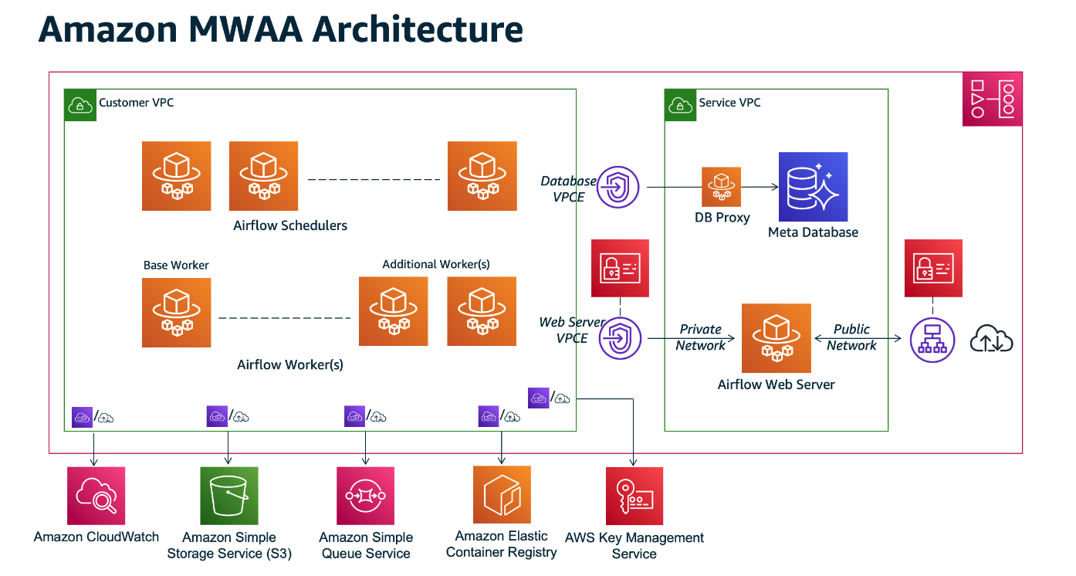

**Figure 7.9:** Amazon Managed Workflows for Apache Airflow Architecture (AWS Documentation)

Key features

The following are the key features of Amazon MWAA [68]:

* **Managed Apache airflow environment:** Amazon MWAA provides a fully managed Apache Airflow environment, eliminating the operational overhead of infrastructure management.
* **Scalability and reliability:** The service automatically scales resources based on workflow requirements, ensuring reliability and performance during varying workloads.
* **Integration with AWS Services:** Amazon MWAA seamlessly integrates with various AWS services, allowing workflows to interact with and utilize other cloud resources.

Use cases

The following are the use cases:

* **Data processing pipelines:** Organizations can use Amazon MWAA to create and manage data processing pipelines, orchestrating tasks across diverse data sources and destinations [69].
* **Extract, Transform, Load (ETL) Workflows:** The service is well-suited for orchestrating ETL workflows, enabling the efficient processing and transformation of data for analytics and reporting [68].

Best practices

The following are the best practices [69]:

* **Environment configuration:** Follow best practices for configuring the Apache Airflow environment within Amazon MWAA to optimize performance and security.
* **Monitoring and logging:** Implement robust monitoring and logging practices to track workflow execution, identify issues, and ensure optimal performance.

Considerations

The following are the considerations:

* **Cost management:** Organizations should carefully consider and manage costs associated with Amazon MWAA, particularly as workflows scale or when integrating with data-intensive services [68].
* **Security Configuration:** Implementing robust security measures is crucial. This includes configuring IAM roles and policies properly to ensure least privilege access, encrypting sensitive data both in transit and at rest, and adhering to AWS security best practices.
* **Performance Optimization:** Apart from environment configuration, optimize workflows for performance by tuning task concurrency, leveraging spot instances where applicable to reduce costs, and using appropriate instance types based on workload requirements.
* **Dependency Management:** Manage dependencies effectively by utilizing Amazon MWAA's support for Python packages and libraries. Ensure that dependencies are version-controlled and updated regularly to maintain compatibility and security.
* **Compliance and Governance:** Address compliance requirements and governance policies. This includes ensuring that workflows adhere to regulatory standards, implementing auditing mechanisms, and integrating with AWS services like AWS CloudTrail for logging API calls.
* **Backup and Recovery:** Establish robust backup and recovery strategies for workflow definitions and data processed through Amazon MWAA. Implement automated backups using Amazon S3 or other suitable storage solutions, and regularly test recovery procedures to ensure reliability.
* **Integration with CI/CD Pipelines:** Integrate MWAA workflows into CI/CD pipelines to automate deployment and updates of workflows. This helps in maintaining consistency and reliability across development, testing, and production environments.
* **Monitoring Alerts and Notifications:** Configure monitoring alerts and notifications to promptly respond to performance issues, failures, or resource constraints. Utilize Amazon CloudWatch metrics and alarms to monitor workflow execution, airflow scheduler health, and overall system performance.
* **Data Handling and Privacy:** Pay special attention to data handling practices within workflows. Ensure data privacy and compliance with data protection regulations (such as GDPR or CCPA), especially when dealing with sensitive or personally identifiable information (PII).
* **Training and Documentation:** Provide adequate training and documentation for teams working with Amazon MWAA. This includes best practices, troubleshooting guides, and operational procedures to ensure effective usage and maintenance of the service.
* **Vendor Lock-in and Portability:** Evaluate the implications of using Amazon MWAA in terms of vendor lock-in versus portability to other cloud providers or self-managed Apache Airflow deployments. Consider using AWS CloudFormation or other infrastructure-as-code tools for defining and managing MWAA environments to mitigate some of these concerns.

Amazon MQ

Amazon MQ is a managed message broker service that enables the easy deployment and maintenance of popular messaging systems. In this section, we explore the key features, use cases, and considerations for leveraging Amazon MQ in the context of application integration.

Key features of Amazon MQ

The following are the key features of Amazon MQ [70]:

* **Compatibility with industry standards:** Amazon MQ supports multiple messaging protocols, including Message Queuing Telemetry Transport (MQTT); Advanced Message Queuing Protocol (AMQP), and Simple Text Oriented Messaging Protocol (STOMP), ensuring compatibility with various applications and systems.
* **Managed message broker:** The service provides a fully managed message broker infrastructure, reducing the operational overhead typically associated with maintaining messaging systems.

Use cases

The following are the use cases:

* **Decoupled microservices communication:** Amazon MQ facilitates communication between microservices in a decoupled manner, enhancing the scalability and flexibility of microservices architectures [71].
* **Reliable event-driven architectures:** The service is suitable for building reliable event-driven architectures, enabling applications to react to events and messages in a scalable and responsive manner [70].

Best practices

The following are the best practices:

* **Secure configuration:** Follow best practices for configuring Amazon MQ securely, including the use of IAM roles, encryption, and access controls to protect sensitive data [70].
* **Scalability planning:** Plan for scalability by choosing the appropriate instance type and configuring resources based on the expected message throughput and processing requirements [71].

Considerations

The following are the considerations:

* **Message retention and cleanup:** Organizations should define appropriate message retention policies and cleanup processes to manage storage costs and ensure efficient system performance [70].

Amazon Simple Notification Service

**Amazon Simple Notification Service (SNS)** is a fully managed messaging service that enables the decoupling of microservices, distributed systems, and serverless applications. This section explores the features, use cases, and best practices associated with Amazon SNS.

Key features

The following are the key features of Amazon SNS [55]:

* **Publish-subscribe model:** Amazon SNS follows a publish-subscribe messaging paradigm, allowing message producers to send messages to multiple subscribers simultaneously.
* **Wide range of message protocols:** The service supports various message protocols, including HTTPS, email/SMTP, SMS, and application-specific protocols, ensuring flexibility in message delivery.

Use cases

The following are the use cases of Amazon SNS [55]:

* **Event-driven architectures:** Amazon SNS is instrumental in building event-driven architectures, facilitating communication and coordination between loosely coupled components.
* **Mobile application notifications:** The service can be utilized to send push notifications to mobile devices, enhancing user engagement for mobile applications.

Best practices

The following are the best practices of Amazon SNS [55]:

* **Topic organization:** Organize topics effectively to reflect the structure of your application, making it easier to manage and control message distribution83.
* **Message filtering:** Implement message filtering to control which subscribers receive specific messages based on their preferences or attributes.

Considerations

The following are the considerations:

* **Message retention:** Understand the default message retention periods and adjust them based on your application's requirements to avoid message loss83.

Integration with other AWS services

Amazon SNS seamlessly integrates with other AWS services to enhance various aspects of application development and deployment. Notable integrations include:

* **Amazon Simple Queue Service (SQS):** Enables asynchronous communication by allowing SNS messages to be sent to SQS queues [72].
* **AWS Step Functions:** Facilitates coordination of distributed applications using SNS to trigger state transitions in Step Functions [73].

Amazon Simple Queue Service

Amazon **Simple Queue Service (SQS)** is a fully managed message queuing service that enables the decoupling of components in a distributed system. This section delves into the features, use cases, and best practices associated with Amazon SQS. Figure 7.10 below shows Amazon Simple Queuing Service Basic Architecture.

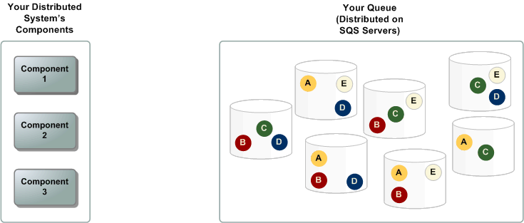

**Figure 7.10**: Amazon Simple Queuing Service Basic Architecture (SWS Documentation).

Key features

The following are the key features of Amazon SQS [54]:

* **Scalability and elasticity**: SQS automatically scales to accommodate the volume of messages in the system, ensuring reliable message delivery even under varying workloads.
* **Message retention**: SQS allows users to set the retention period for messages, providing flexibility in managing the lifespan of messages in the queue.

Use cases

The following are the use cases:

* **Load leveling:** SQS can be employed to handle bursts of traffic by acting as a buffer that decouples the rate at which messages are produced and consumed [74].
* **Task decoupling:** In microservices architectures, SQS facilitates the decoupling of tasks, allowing components to communicate asynchronously [54].

Best practices

The following are the best practices [54]:

* **Visibility timeout:** Adjust the visibility timeout to give sufficient time for processing a message before it becomes visible to other consumers, preventing message duplication.
* **Dead-letter queues:** Implement dead-letter queues to capture and analyze messages that cannot be processed successfully after a certain number of attempts.

Considerations

* **Message ordering:** While SQS provides best-effort ordering, it is important to design systems that can handle out-of-order message delivery [54].

Integration with other AWS services

SQS seamlessly integrates with various AWS services, enhancing its capabilities and applications in different scenarios. Notable integrations include:

* **Amazon S3:** SQS can be used to trigger events in response to changes in an S3 bucket, enabling event-driven architectures [54].
* **AWS Lambda:** Leverage SQS to trigger serverless functions in AWS Lambda, allowing for the seamless execution of compute workloads [72].

Managed Message Queues

Managed message queues are an integral part of modern cloud architectures, providing a scalable and reliable mechanism for decoupling components. This section explores the concept of managed message queues, highlighting their significance in distributed systems.

Overview

Managed message queues, such as Amazon SQS, Azure Queue Storage, and Google Cloud Pub/Sub, offer a reliable and scalable solution for building asynchronous communication between distributed components. This section focuses on the general principles and advantages associated with managed message queues.

Advantages

The following are the advantages of managed message queues:

* **Scalability:** Managed message queues automatically scale to accommodate varying workloads, ensuring consistent performance as the system evolves [75].
* **Reliability:** By offloading the responsibility of message storage and delivery to a managed service, the reliability of message processing is enhanced91.
* **Decoupling:** Managed message queues facilitate the decoupling of producers and consumers, enabling asynchronous communication and reducing dependencies between components [76].

Use cases

The following are the use cases of managed message queues [54]:

* **Microservices architectures:** Managed message queues play a crucial role in microservices architectures, allowing services to communicate asynchronously without direct dependencies.
* **Event-driven systems:** In event-driven systems, managed message queues enable the seamless flow of events between different components, supporting real-time processing.

Best practices

The following are the best practices of manages message queues [54]:

* **Message retention:** Configure message retention policies to align with the specific needs of the application, balancing the trade-off between storage costs and the time-sensitive nature of messages.
* **Error handling:** Implement robust error-handling mechanisms, including dead-letter queues, to manage messages that cannot be processed successfully.

Integration with AWS Services

Managed message queues integrate seamlessly with various AWS services, enhancing their capabilities and extending their use in different scenarios. Some notable integrations include [54]:

* **AWS Lambda:** Utilize managed message queues to trigger serverless functions in AWS Lambda, enabling serverless and event-driven architectures.
* **Amazon EC2:** Integrate managed message queues with Amazon EC2 instances to enable communication between different components of a distributed application.

AWS Step Functions

AWS Step Functions is a fully managed service that enables developers to coordinate and automate the execution of serverless workflows using visual workflows. This section delves into the capabilities of AWS Step Functions, its use cases, and the benefits it brings to the realm of application integration.

Overview

AWS Step Functions simplify the process of building scalable and resilient applications by allowing developers to design workflows using a visual interface. Workflows in Step Functions are represented as state machines, where each state represents a step in the workflow.

Key features

The following are the key features of AWS Step Functions [77]:

* **Visual workflow design:** Step Functions provides a visual workflow designer, allowing developers to design, visualize, and modify workflows easily.
* **Coordination of microservices:** It excels in coordinating microservices, enabling seamless communication and execution of tasks across distributed applications.
* **Error handling:** Step Functions includes built-in error handling capabilities, allowing for the definition of error states and automatic retries.

Figure 7.11 below exemplify AWS Step Functions Microservice Orchestration: Combined Lambda functions to build a web-based application.

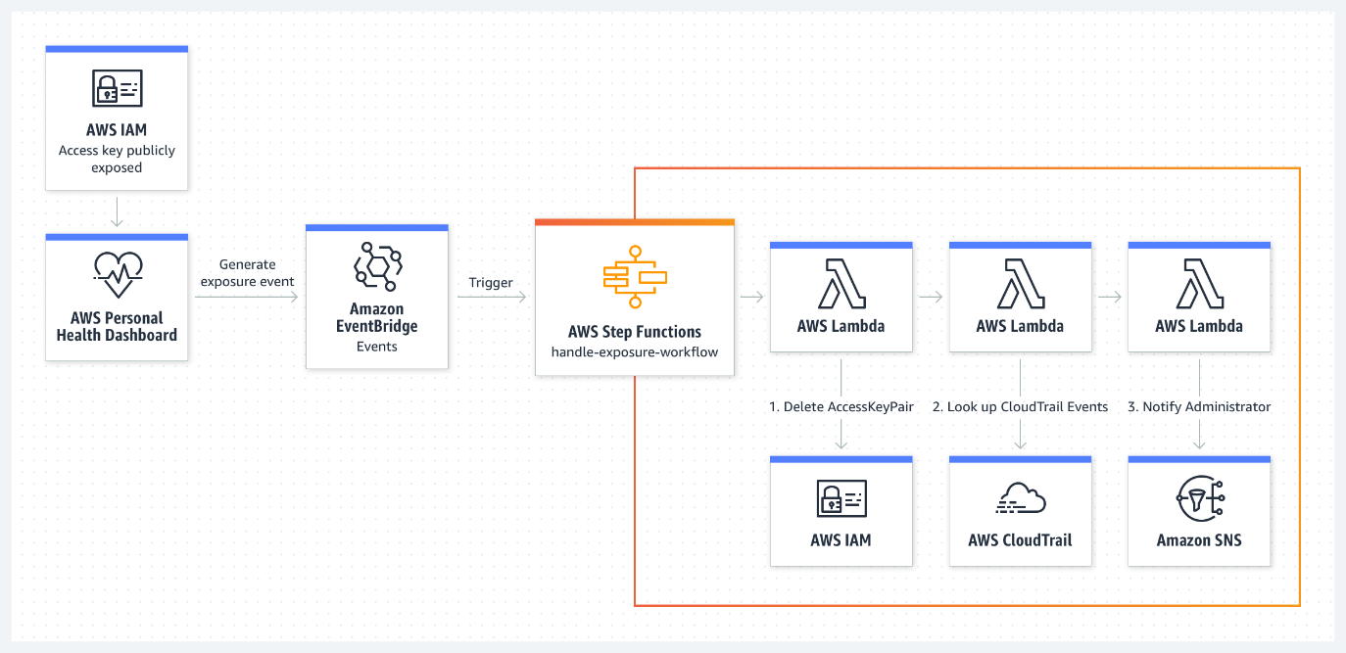

**Figure 7.11:** AWS Step Functions Microservice Orchestration: Combine Lambda functions to build a web-based application (Amazon Web Services).

Use cases

The following are the use cases of AWS Step Functions [73]:

* **Order processing workflows:** Step Functions can be used to orchestrate order processing workflows, coordinating tasks such as payment processing, inventory management, and shipping.
* **Data processing pipelines:** It is ideal for building data processing pipelines, where different steps in the pipeline are executed based on the success or failure of previous steps.
* **Media processing workflows:** Step Functions can coordinate media processing tasks, such as video transcoding and image recognition, in a scalable and efficient manner.

Benefits

The following are the benefits of using AWS Step Functions [73]:

* **Simplified workflow management:** Developers can manage complex workflows with ease using the visual designer, reducing the complexity of application integration95.
* **Scalability:** Step Functions scale automatically based on the workload, ensuring that workflows execute reliably under varying conditions.
* **Cost Efficiency:** The pay-as-you-go pricing model of Step Functions ensures cost efficiency, with charges based on the number of state transitions.

Integration with other AWS Services

AWS Step Functions seamlessly integrates with various AWS services, including AWS Lambda, AWS Fargate, and Amazon SageMaker, allowing developers to leverage a wide array of functionalities within their workflows.

Amazon Elastic Container Registry

Amazon **Elastic Container Registry (ECR**) is a fully managed container registry service that makes it easy for developers to store, manage, and deploy Docker container images. This section provides an in-depth exploration of Amazon ECR, its features, and its role in the containerization ecosystem.

Overview

Amazon ECR simplifies the containerization process by providing a secure and scalable repository for Docker images. Developers can use ECR to store, manage, and deploy Docker images, making it an integral part of the container lifecycle.

Key features of Amazon ECR

The following are the key features of Amazon ECR:

* **Secure and private repositories:** ECR allows users to create private container repositories, ensuring that container images are securely stored and only accessible to authorized users and systems [78].
* **Integration with AWS Services:** Seamless integration with other AWS services, such as Amazon ECS and Kubernetes, streamlines the deployment of containerized applications.
* **Scalability:** ECR is designed to scale with the needs of the development team, supporting the storage and retrieval of many container images [79].

Use cases

The following are the use cases of Amazon ECR [78]:

* **Microservices architecture:** ECR is well-suited for organizations adopting microservices architecture, providing a centralized registry for managing and versioning container images.
* **Continuous integration/continuous deployment (CI/CD):** Integrating ECR with CI/CD pipelines facilitates the automated building, testing, and deployment of containerized applications.
* **Collaborative development:** Developers working on collaborative projects can leverage ECR to share and deploy container images efficiently across the development team.

Figure 7.12 below shows AWS Containers options by layer

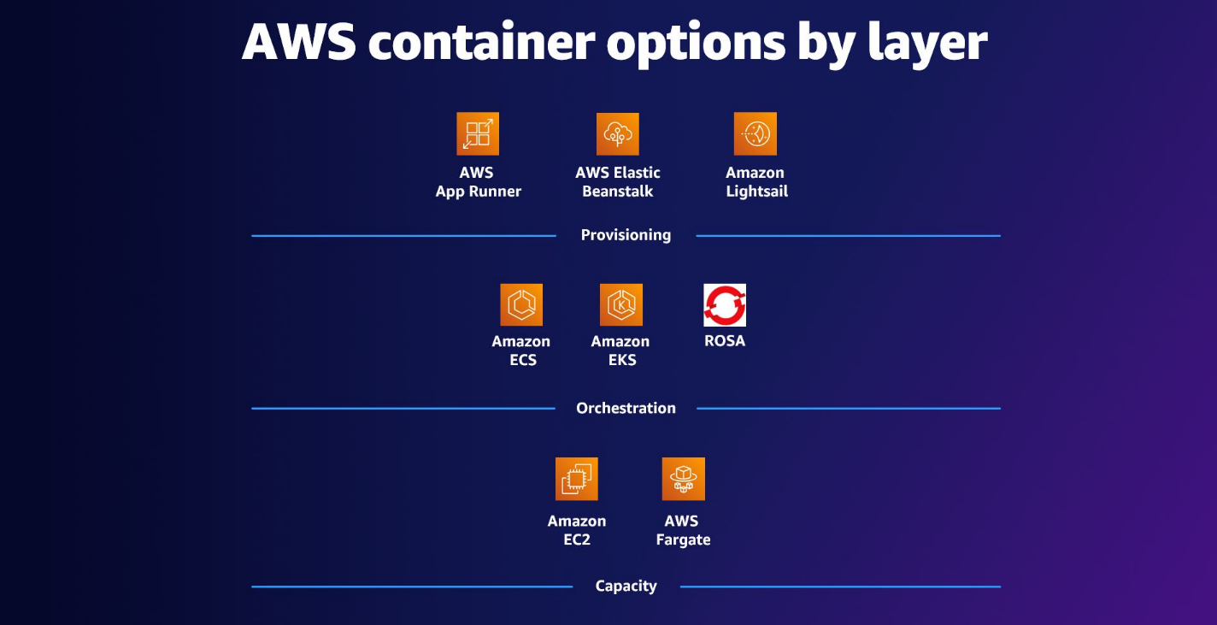

**Figure 7.12:** AWS Containers (Amazon Web Services)

Benefits of using Amazon ECR

The following are the benefits of using Amazon ECR [78]:

* **Ease of use:** The seamless integration with other AWS services and Docker tools makes ECR easy to use for both novice and experienced container developers.
* **Cost-efficiency:** Amazon ECR follows a pay-as-you-go pricing model, ensuring that users only pay for the storage and data transfer associated with their container images.
* **Comprehensive security:** ECR provides fine-grained access control and integrates with AWS IAM for secure management of container image repositories.

Integration with DevOps Workflow

Amazon ECR plays a crucial role in DevOps workflows by facilitating the seamless integration of containerized applications into deployment pipelines. Its compatibility with popular CI/CD tools ensures a smooth transition from development to production.

**Amazon Elastic Container Service**

Amazon ECS is a fully managed container orchestration service provided by AWS. This section explains the features, architecture, and use cases of ECS, highlighting its role in simplifying the deployment and management of containerized applications.

Overview

Amazon ECS enables users to run, stop, and manage Docker containers on a cluster. It abstracts the underlying infrastructure complexities, allowing developers to focus on building and scaling applications without managing the underlying infrastructure.

Key features of Amazon ECS

Following are the key features of Amazon ECS [80]:

* **Scalability:** ECS provides auto-scaling capabilities, allowing the automatic adjustment of the number of running containers based on application load.
* **Integration with Elastic Load Balancing (ELB):** Seamless integration with ELB facilitates the distribution of incoming application traffic across multiple ECS containers.
* **Task definitions:** Users define their applications through task definitions, specifying parameters such as the Docker image, CPU and memory requirements, and container links.

Amazon ECS Architecture

Amazon Elastic Container Service (ECS) simplifies the deployment and management of containerized applications on AWS infrastructure. At its core, ECS (refer to Figure 7.13 below) _ allows users to run Docker containers across a managed cluster of EC2 instances or Fargate, AWS's serverless compute engine for containers. This service abstracts the complexities of orchestrating containers, enabling developers to focus on application development and scalability rather than infrastructure management.

**Components of Amazon ECS**

Amazon ECS architecture revolves around several key components: clusters, tasks, and services. Clusters are logical groupings of EC2 instances or Fargate tasks where containers are deployed and managed. Within these clusters, tasks represent discrete units of work, each defined by a task definition that specifies Docker image, resource requirements, and dependencies. ECS services, on the other hand, ensure the continuous availability and scalability of tasks by managing their lifecycle, including scaling based on demand and maintaining a desired state of tasks running in the cluster.

**Scalability and Integration**

One of the defining features of Amazon ECS is its scalability. ECS dynamically scales containers in response to workload demands, leveraging AWS Auto Scaling and integration with Elastic Load Balancing (ELB) to distribute incoming traffic across container instances for optimal performance. This scalability feature makes ECS ideal for both microservices architectures, where individual components can scale independently, and for batch processing workloads that require elastic compute resources.

**Operational Simplicity and Benefits**

By abstracting infrastructure management complexities, Amazon ECS streamlines operations. It optimizes resource utilization to minimize costs, ensures secure management of containers through integration with AWS IAM, and supports seamless integration with CI/CD pipelines for automated testing and deployment. This operational simplicity empowers development teams to innovate rapidly, deploying containerized applications reliably and efficiently on AWS infrastructure.

***Figure 7.13:*** *Amazon ECS (Amazon Web Services)*

**Amazon ECS Architecture Core Components**

Amazon ECS Architecture Core Components provide the foundational framework for orchestrating containerized applications within AWS, offering robust capabilities for efficient deployment, management, and scaling of Docker containers. Central to ECS architecture are its clusters, tasks, and services, each playing a crucial role in ensuring seamless execution and optimal performance of containerized workloads in diverse cloud environments.

**Clusters:** In Amazon ECS, clusters serve as logical groupings of container instances that collectively manage and execute Docker containers. These clusters provide the foundational infrastructure where tasks and services are orchestrated. Each ECS cluster can span multiple EC2 instances or utilize AWS Fargate for serverless container deployments. By grouping instances together, ECS simplifies the management and scaling of containerized applications within a defined environment.

**Tasks:** Tasks represent the fundamental units of work in Amazon ECS. Defined by task definitions, each task encapsulates a specific set of containerized applications that operate cohesively within an ECS cluster. Task definitions specify crucial parameters such as Docker images, resource allocations (CPU and memory), networking configuration, and container dependencies. This modular approach allows developers to define and configure their application components efficiently, ensuring seamless execution and resource utilization across the ECS cluster.

**Services:** ECS services facilitate the orchestration and lifecycle management of tasks within an ECS cluster. Designed for long-running applications, services maintain the desired number of tasks to meet application requirements, automatically adjusting based on metrics such as CPU utilization or incoming traffic. Services in ECS ensure high availability and scalability by continuously monitoring task health and replacing failed tasks as necessary. This capability enables developers to deploy resilient and scalable containerized applications with minimal operational overhead.

Use cases of Amazon ECS

The following are the use cases of Amazon ECS [80]:

* **Microservices architecture:** ECS is well-suited for organizations adopting microservices architecture, providing efficient orchestration and scaling of individual microservices.
* **Batch Processing:** Organizations with batch processing workloads can leverage ECS to dynamically scale containerized applications based on workload demands.
* **CI/CD):** Integrating ECS with CI/CD pipelines facilitates automated testing and deployment of containerized applications [81].

Benefits of using Amazon ECS

The following are the benefits of using Amazon ECS [80]:

* **Cost-efficiency:** ECS optimizes resource utilization, ensuring that users pay only for the compute capacity consumed by their containers9.
* **Security:** Integrated with AWS IAM, ECS provides secure management of containers and access control.
* **Operational simplicity:** ECS abstracts infrastructure management complexities, allowing developers to focus on building and deploying applications.

Integration with DevOps Workflow

Amazon ECS seamlessly integrates with common DevOps tools, enabling developers to incorporate containerized applications into their continuous integration and continuous deployment pipelines.

Amazon Elastic Kubernetes Service

Amazon EKS is a fully managed Kubernetes service provided by AWS, offering a simplified yet powerful platform for deploying, managing, and scaling containerized applications using Kubernetes.

Overview

Amazon EKS abstracts the complexity of setting up and maintaining a Kubernetes control plane, providing a reliable and scalable solution for running containerized applications using Kubernetes orchestration.

Key features of Amazon EKS

The following are the key features of Amazon EK

Amazon Elastic Kubernetes Service (EKS) [82] simplifies the deployment, management, and scaling of Kubernetes clusters on AWS, catering to the needs of organizations adopting container orchestration. EKS integrates seamlessly with AWS services, providing a robust platform for running containerized applications with Kubernetes.

Amazon EKS Architecture

Amazon Elastic Kubernetes Service (EKS) empowers organizations to efficiently deploy and manage Kubernetes clusters on AWS, leveraging robust infrastructure for scalable container orchestration.

Amazon EKS architecture encompasses essential components that streamline the deployment and operation of Kubernetes clusters within the AWS cloud environment. Central to this architecture are the control plane, worker nodes, and clusters, each playing a pivotal role in ensuring the scalability, reliability, and performance of containerized applications orchestrated by EKS.

**Control Plane:** At the core of Amazon EKS is the control plane, managed entirely by AWS. This critical component comprises control plane nodes that oversee and coordinate the Kubernetes master components. These components include the API server, scheduler, and controller manager, which collectively manage the lifecycle and state of Kubernetes clusters.

**Worker Nodes:** Integral to EKS are worker nodes, which execute the containers hosting applications. These nodes are responsible for running Kubernetes' worker components, including kubelet and kube-proxy, and maintaining communication with the control plane. Worker nodes ensure the efficient deployment and operation of containerized workloads orchestrated by EKS.

**Clusters:** EKS clusters serve as logical groupings of worker nodes within which containerized applications are deployed and managed. These clusters leverage AWS infrastructure capabilities such as EC2 instances or AWS Fargate, offering flexibility in scaling and resource allocation based on application requirements. EKS clusters enable organizations to harness the power of Kubernetes for scalable and resilient application deployment on AWS.

Use cases of Amazon EKS

Amazon EKS offers versatile capabilities to manage containerized applications across various deployment scenarios. From enabling microservices architectures to facilitating hybrid and multi-region deployments, EKS offers a robust platform tailored for modern cloud-native strategies. This section explores key use cases where EKS enhances agility, scalability, and operational efficiency across diverse cloud environments. Also, refer to Figure 7.14 below for a visualization of anAmazon EKS use case example.

* **Microservices architecture:** EKS is well-suited for organizations adopting microservices architecture, providing a flexible and scalable platform for managing containerized microservices.
* **Hybrid deployments:** Organizations with hybrid cloud environments can use EKS to orchestrate containerized applications seamlessly across on-premises and cloud environments.
* **Multi-region deployments:** EKS supports multi-region deployments, enabling organizations to deploy containerized applications across multiple AWS regions for enhanced availability.

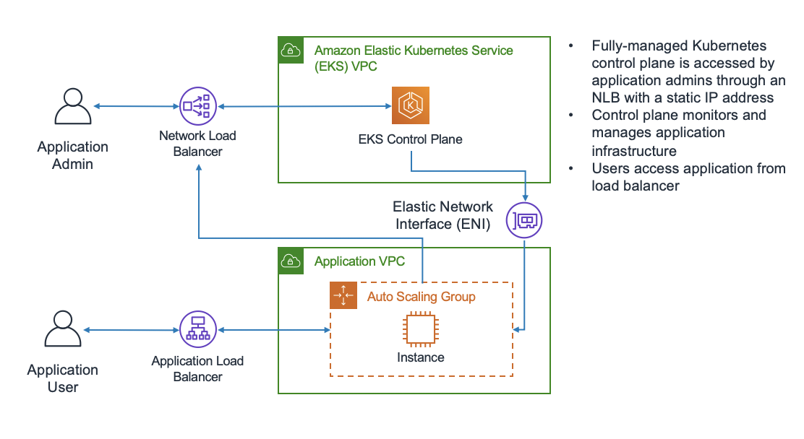

**Figure 7.14:** Amazon EKS use case (AWS Whitepapers).

Benefits of using Amazon EKS

The following are the benefits of using Amazon EKS [82]:

* **Operational Efficiency:** EKS automates the setup, scaling, and management of Kubernetes clusters, allowing users to focus on developing and deploying applications.
* **Security:** Integrated with AWS IAM and **Virtual Private Cloud (VPC)**, EKS ensures secure and isolated networking for Kubernetes clusters.
* **Flexibility:** EKS provides flexibility by supporting both standard Kubernetes tooling and AWS-specific integrations, giving users the freedom to choose their preferred tools.

Integration with DevOps workflow

Amazon EKS integrates seamlessly with DevOps workflows, enabling developers to incorporate Kubernetes-based applications into their CI/CD pipelines. EKS plays a pivotal role in modern DevOps practices by seamlessly integrating Kubernetes-based applications into CI/CD pipelines. This integration streamlines the deployment, testing, and delivery of containerized applications, enhancing agility and accelerating time-to-market for development teams.

**Continuous Integration (CI)**: Amazon EKS integrates with CI tools such as Jenkins, GitLab CI/CD, and AWS CodePipeline, enabling automated build, test, and deployment processes. CI pipelines can trigger Kubernetes deployments based on code commits, ensuring that new features and updates are deployed consistently and efficiently.

**Continuous Deployment (CD)**: Leveraging Amazon EKS, organizations can automate the deployment of containerized applications across development, testing, and production environments. EKS integrates with tools like Helm for managing Kubernetes application packages and AWS CodeDeploy for flexible deployment strategies, including blue-green and rolling updates.

**Infrastructure as Code (IaC)**: EKS integrates seamlessly with infrastructure provisioning tools such as AWS CloudFormation and Terraform. This integration allows teams to define and manage Kubernetes clusters, worker nodes, networking configurations, and application deployments as code, ensuring consistency and reproducibility across environments.

**Monitoring and Logging**: Amazon EKS integrates with Amazon CloudWatch and AWS X-Ray for monitoring and observability of Kubernetes clusters and applications. Developers can set up alarms, collect performance metrics, and trace application requests, enabling proactive monitoring and rapid troubleshooting of issues.

**Security and Compliance**: Integrated with AWS IAM and VPC security features, Amazon EKS provides robust security controls for Kubernetes clusters. DevOps teams can implement fine-grained access policies, encryption at rest and in transit, and network isolation to meet compliance requirements and protect sensitive data.

**Scalability and High Availability**: EKS facilitates horizontal scaling of applications based on demand, leveraging Kubernetes autoscaling capabilities. Combined with AWS Availability Zones and multi-region deployments, EKS ensures high availability and fault tolerance for mission-critical applications, reducing downtime and enhancing reliability.

**Cost Optimization**: EKS optimizes resource utilization by automatically scaling Kubernetes clusters based on workload requirements. DevOps teams can leverage AWS Spot Instances for cost-effective compute resources and use AWS Cost Explorer to monitor and optimize Kubernetes cluster costs.

**Summary**: Amazon EKS empowers DevOps teams with a comprehensive suite of tools and integrations to automate and streamline the deployment lifecycle of containerized applications. By combining the scalability and flexibility of Kubernetes with AWS's robust infrastructure and DevOps ecosystem, EKS enables organizations to achieve faster innovation cycles, improved operational efficiency, and enhanced collaboration between development and operations teams.

AWS App2Container and AWS Copilot

**AWS App2Container (A2C)** and AWS Copilot are integral tools in the AWS Developer Tools suite, designed to simplify the process of containerizing and deploying applications in the cloud. These tools cater to developers and DevOps teams, streamlining container adoption and deployment workflows.

AWS App2Container (A2C)

A2C is a migration tool that automates the containerization of applications, making it easier for organizations to move their existing applications into containerized environments. A2C analyzes application dependencies, generates Docker container images, and provides recommendations for container orchestration.

Key features of AWS App2Container

The following are the key features of AWS App2Container:

* **Automated containerization:** A2C automates the process of containerizing applications, reducing the manual effort and time required for migration [83].
* **Dependency analysis:** The tool performs dependency analysis to identify application components and their interdependencies, ensuring a comprehensive containerization process.
* **Container orchestration recommendations:** A2C offers recommendations for container orchestration platforms, such as Amazon ECS or Kubernetes, based on the application's characteristics.

AWS Copilot

AWS Copilot complements A2C by simplifying the deployment and operation of containerized applications. It provides a higher-level abstraction for defining, releasing, and managing containerized services, allowing developers to focus on building applications rather than managing infrastructure.

Key features

The following are the key features of AWS Copilot:

* **Application definition:** Copilot uses an application-centric approach, allowing developers to define and manage entire applications, including services, environments, and associated resources [84].
* **Automatic service scaling:** Copilot automates the scaling of services based on defined scaling policies, ensuring optimal resource utilization.
* **Integrated CI/CD pipelines:** Copilot seamlessly integrates with CI/CD pipelines, facilitating continuous integration and deployment of containerized applications.

Use cases

The following are the use cases [84]:

* **Application modernization:** A2C and Copilot are ideal for organizations looking to modernize legacy applications by migrating them to containerized environments, fostering agility and scalability.
* **Microservices architecture:** Both tools support the adoption of microservices architecture, enabling developers to design, deploy, and manage individual services independently.

Benefits

The following are the benefits of AWS Copilot:

* **Accelerated migration:** A2C accelerates the migration of existing applications to containers, providing a faster path to modernization.
* **Simplified operations:** Copilot simplifies operations by abstracting away the complexities of infrastructure management, allowing developers to focus on building features.

Integration with DevOps Workflow

A2C and Copilot seamlessly integrate with DevOps workflows, aligning with the principles of **Infrastructure as Code (IaC)** and supporting automation throughout the application lifecycle.

AWS App2Container & AWS Fargate Integration

AWS App2Container (A2C) and AWS Fargate combine to offer a seamless pathway for containerizing applications and deploying them onto AWS Fargate. This section explores how these tools integrate to streamline container management effectively.

AWS App2Container (A2C)

AWS App2Container (A2C) simplifies the process of containerizing applications, automating analysis, Docker image generation, and offering orchestration recommendations. This tool streamlines the transition of existing applications into containerized environments, setting the stage for seamless deployment onto AWS Fargate.

Overview of AWS App2Container

AWS App2Container (A2C) analyzes existing applications, identifies dependencies, and generates Docker container images tailored for cloud deployment. It provides insights into container orchestration platforms, such as AWS Fargate, optimizing the containerization process for AWS environments.

**Key Steps in A2C Containerization**

1. **Dependency Analysis:** A2C conducts a thorough analysis of application components and their dependencies, crucial for accurate Docker image generation.
2. **Docker Image Generation:** Based on the analyzed dependencies, A2C creates Docker container images optimized for cloud deployment.
3. **Orchestration Recommendations:** A2C recommends suitable container orchestration platforms, aligning with AWS best practices and capabilities like AWS Fargate [85].

AWS Fargate

AWS Fargate provides a serverless compute engine for running containers, eliminating the need for managing infrastructure. It supports seamless deployment of containerized applications by handling server provisioning, scaling, and resource management automatically.

Overview of AWS Fargate

AWS Fargate offers a serverless environment for deploying containers, abstracting infrastructure management and optimizing resource allocation based on application demand. Developers define task configurations and service requirements, leaving AWS Fargate to manage deployment and scaling.

**Key Steps in Deploying on AWS Fargate**

1. **Task Definition:** Define parameters such as Docker image, CPU, memory, and networking for the containers to be deployed.
2. **Service Configuration:** Specify the desired number of tasks (containers) and their operational states, ensuring continuous availability and scalability.
3. **Deployment Orchestration:** AWS Fargate orchestrates the deployment, scaling, and monitoring of containers, simplifying operational tasks for developers.

Integration of AWS App2Container & AWS Fargate

Combining AWS App2Container with AWS Fargate offers a streamlined approach to container management and deployment:

* **Seamless Containerization:** A2C prepares applications for container deployment on AWS Fargate, optimizing the transition with minimal configuration overhead.
* **Serverless Deployment:** AWS Fargate automates infrastructure management, enabling developers to focus on application logic rather than operational tasks.
* **Enhanced Efficiency:** The integration enhances operational efficiency by simplifying container lifecycle management and optimizing resource utilization.

Benefits of AWS Fargate Integration

Integrating AWS App2Container with AWS Fargate brings several benefits:

* **Serverless Container Orchestration:** AWS Fargate's serverless architecture eliminates the need to manage underlying servers, providing a truly serverless experience for container orchestration.
* **Resource Optimization:** Fargate automatically scales resources based on application demand, optimizing resource allocation and enhancing cost efficiency.
* **Simplified Operations:** Combining A2C with AWS Fargate simplifies the containerization and deployment processes, reducing operational complexities for developers.

Use Cases

The integration of A2C and AWS Fargate is beneficial for:

* **Microservices Architecture:** Organizations adopting microservices architectures can leverage A2C and Fargate to deploy individual services efficiently.
* **Application Modernization:** Modernizing applications with A2C and deploying them on Fargate enhances agility, scalability, and cost-effectiveness [83].

Red Hat OpenShift Service on AWS

Red Hat OpenShift Service on AWS combines the powerful container orchestration capabilities of OpenShift with the flexibility and scalability of AWS. This section delves into the features, benefits, and integration aspects of Red Hat OpenShift Service on AWS.

Overview

Red Hat OpenShift is a Kubernetes-based container platform designed to streamline the development, deployment, and scaling of containerized applications. When hosted on AWS, it takes advantage of AWS infrastructure services, providing a comprehensive solution for containerized application management.

Key features

The following are the key features:

* **Fully managed Kubernetes:** Red Hat OpenShift Service on AWS offers a fully managed Kubernetes service, eliminating the operational overhead of managing the Kubernetes control plane [86].
* **Integrated developer tools:** The platform integrates with popular developer tools, facilitating CI/CD workflows.
* **Seamless scaling:** Leveraging AWS infrastructure, OpenShift Service allows seamless scaling of applications to meet changing demands.

Integration steps

Integrating Red Hat OpenShift Service on AWS involves several key steps to ensure a smooth deployment and efficient management of containerized applications.

1. **Deployment on AWS:** The first step involves deploying Red Hat OpenShift Service on AWS infrastructure, leveraging AWS services for optimal performance and reliability.

* AWS Infrastructure components:
* EC2 Instances: Provide the compute capacity for running OpenShift nodes.
* S3 Buckets: Store container images, artifacts, and configuration files [77] [86].

1. **Container orchestration:** Once deployed, OpenShift Service on AWS uses Kubernetes for orchestrating containers, ensuring robust and scalable application management.

* Kubernetes features:
* Pod Scheduling: Kubernetes scheduler optimizes pod placement based on resource requirements.
* Service Discovery: Automatic service discovery for communication between microservices.

Benefits of integration

The following are the benefits of integration:

* **Hybrid cloud flexibility:** Red Hat OpenShift Service on AWS enables organizations to build and deploy applications consistently across on-premises and cloud environments [77].
* **Developer productivity:** Integrated developer tools enhance productivity by supporting popular IDEs, version control systems, and CI/CD pipelines.
* **Scalability and reliability:** Leveraging AWS infrastructure ensures scalability and reliability, with the ability to scale resources based on application demands [86].

Use cases

The following are the use cases:

* **Hybrid cloud deployments:** Organizations with hybrid cloud strategies benefit from the consistent platform offered by OpenShift Service on AWS.
* **Containerized application development:** Developers working on containerized applications find OpenShift Service on AWS conducive to streamlined workflows and efficient management.

Managed OpenShift in the Cloud

Managed OpenShift in the cloud offers organizations a fully managed Kubernetes container platform, providing a scalable and flexible solution for deploying and managing containerized applications. This section explores the features, benefits, and integration aspects of Managed OpenShift in the cloud, specifically focusing on AWS as the cloud provider.

Overview

Managed OpenShift is a Kubernetes-based container orchestration platform that simplifies the deployment and management of containerized applications. When hosted in the cloud, such as on AWS, it offers additional advantages by leveraging cloud-native services.

Key features

The following are the key features of Managed OpenShift:

* **Automated operations:** Managed OpenShift automates operational tasks, including updates, patches, and scaling, reducing the burden on IT teams [86].
* **Developer productivity:** The platform supports developer productivity by providing integrated developer tools and streamlined workflows for building and deploying applications [48].
* **Scalability and elasticity:** Leveraging cloud infrastructure, Managed OpenShift enables organizations to scale applications dynamically based on demand, ensuring optimal performance [86].

Integration with AWS

Integrating Managed OpenShift with AWS enhances its functionality by utilizing AWS’s robust cloud infrastructure and services. This integration ensures that organizations can fully leverage AWS resources for optimized deployment and management of containerized applications.

1. **Deployment on AWS:** Managed OpenShift is deployed on AWS infrastructure, utilizing services such as Amazon EC2, Amazon S3, and AWS IAM.

* AWS components:
* EC2 Instances: Provide compute resources for running OpenShift nodes.
* S3 Buckets: Store container images and artifacts.
* IAM: Manages access and permissions [77] [86].

1. **Integration with AWS Services:** Managed OpenShift seamlessly integrates with various AWS services, enhancing its capabilities for application development and deployment.

* AWS Service Integration:
* Amazon RDS: Managed databases for applications.
* Amazon EKS: Kubernetes service for container orchestration [77] [86].

Benefits of integration

The following are the benefits of integration:

* **Operational efficiency:** Managed OpenShift in the cloud automates operational tasks, reducing the operational overhead on IT teams and allowing them to focus on strategic initiatives [77].
* **Scalability and flexibility:** Leveraging AWS infrastructure, Managed OpenShift provides the scalability and flexibility needed to adapt to changing workloads and business requirements.
* **Enhanced developer experience:** Integrated developer tools and workflows contribute to an enhanced developer experience, supporting efficient application development and deployment [86].

Use cases

The following are the use cases [86]:

* **Cloud-native application development:** Organizations adopting cloud-native practices find Managed OpenShift on AWS suitable for developing and deploying applications designed for the cloud environment.
* **Microservices architectures:** Managed OpenShift is well-suited for organizations implementing microservices architectures, providing a scalable and manageable platform for microservices-based applications.

Robotics: AWS RoboMaker

AWS RoboMaker is a comprehensive cloud service provided by AWS that facilitates the development, testing, and deployment of robotic applications. This section delves into the key features, capabilities, and integration aspects of AWS RoboMaker, emphasizing its role in advancing robotics development in the cloud.

Key features and capabilities

In this section, we will go through the key features and capabilities:

* **Simulation environments:** AWS RoboMaker offers realistic simulation environments, allowing developers to test robotic applications in various scenarios before deploying them to physical robots.
* **Fleet management:** The platform provides tools for managing robot fleets, enabling efficient deployment, monitoring, and updating of robotic applications at scale.
* **Integration with Robot Operating System (ROS):** AWS RoboMaker seamlessly integrates with the ROS, a popular open-source middleware framework for robotics [87].

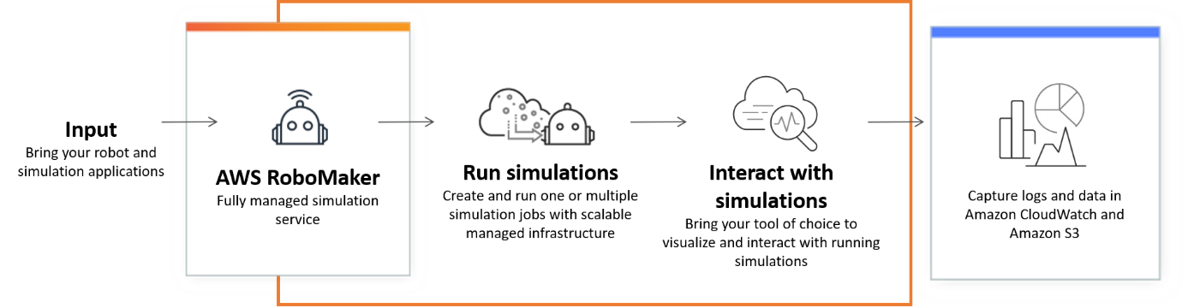

**Figure 7.15:** AWS RoboMaker cloud-based simulation service (AWS Documentation)

AWS RoboMaker workflow

AWS RoboMaker provides a comprehensive suite of tools and services designed to simplify the development, testing, and deployment of robotic applications. This section outlines the key stages of the AWS RoboMaker workflow, highlighting how each component contributes to an efficient and streamlined process for building and managing robotics solutions.

* **Development:** Developers can use the **integrated development environment (IDE)** in AWS RoboMaker to build, edit, and debug robotic applications. Simulation capabilities allow for iterative testing in virtual environments.
* **Simulation:** Realistic simulations assist in validating and optimizing robot behavior in a variety of scenarios, reducing the need for extensive physical testing.
* **Deployment:** Once satisfied with the simulation results, developers can deploy robotic applications to physical robot fleets, managing the deployment process through AWS RoboMaker [87].

Integration with AWS Services

To enhance the functionality and efficiency of robotic applications, AWS RoboMaker integrates seamlessly with a range of AWS services. These integrations enable developers to leverage AWS's robust cloud infrastructure and tools for storage, resource provisioning, and more.

* **Amazon S3:** AWS RoboMaker integrates with Amazon S3 for storing and accessing simulation data, model files, and other artifacts.
* **AWS CloudFormation:** Infrastructure as code is facilitated through AWS CloudFormation, allowing users to define and provision AWS resources for robotics applications [87].

Use cases

The following are the use cases:

* **Industrial automation:** AWS RoboMaker is applied in industrial settings for automating tasks such as material handling, inspection, and logistics using robotic systems.
* **Research and education:** Educational institutions and researchers utilize AWS RoboMaker to experiment with and develop advanced robotics applications in a cloud-based environment [87].

Benefits of AWS RoboMaker

The following are the benefits of AWS RoboMaker:

* **Cost-effective development:** Simulation capabilities reduce the need for extensive physical testing, resulting in cost savings during the development process.
* **Scalability:** AWS RoboMaker supports the scalability of robotic applications, allowing developers to deploy and manage large fleets of robots efficiently [87].

**Quantum Technologies in AWS**

Quantum technologies represent a paradigm shift in computing, promising unparalleled computational power by leveraging the principles of quantum mechanics. AWS has ventured into the realm of quantum computing, offering services and tools that harness the potential of quantum technologies. This section explores the key concepts, services, and implications of quantum technologies within the AWS ecosystem.

Quantum computing concepts

* **Qubits and Quantum Gates:** Quantum bits (qubits) are the fundamental units in quantum computing. Unlike classical bits, qubits can exist in multiple states simultaneously, thanks to the principles of superposition. Quantum gates manipulate these qubits, enabling complex computations.
* **Entanglement:** Entanglement is a quantum phenomenon where qubits become correlated in such a way that the state of one qubit instantaneously influences the state of another, regardless of the distance between them [88].

Amazon Braket Quantum Computing Service

Amazon Braket is a comprehensive quantum computing service provided by AWS, designed to enable scientists, researchers, and developers to explore and experiment with quantum computing technologies. Launched by AWS, Braket integrates quantum computing seamlessly into existing workflows, offering access to a diverse range of quantum processors and supporting tools.

Key features

* **Quantum processors:** Amazon Braket provides access to a variety of quantum processors from leading partners in the quantum computing industry. These processors support various qubit architectures and technologies, allowing users to choose the most suitable platform for their specific quantum computing needs [88].
* **Quantum tasks:** Users can define, run, and manage quantum tasks on Amazon Braket. A quantum task involves specifying the quantum algorithm, selecting a quantum processor, and executing the computation. This flexibility allows users to experiment with different quantum algorithms and processors [88].
* **Quantum circuits:** Quantum circuits are a fundamental aspect of quantum computing. Amazon Braket provides tools for creating and simulating quantum circuits, enabling users to design and test quantum algorithms before running them on actual quantum hardware [88].
* **Hybrid quantum-classical computing:** Amazon Braket supports hybrid quantum-classical computing, allowing users to combine quantum processing with classical processing. This enables the solution of complex problems that may involve both quantum and classical algorithms [88].

Integration with AWS Services

* **Amazon S3:** Results, data, and configurations from quantum tasks can be stored and retrieved using Amazon Simple Storage Service (S3). This integration ensures secure and scalable storage for quantum computing-related information [88].
* **AWS Lambda:** Integration with AWS Lambda enables the execution of serverless functions triggered by quantum computations. This enhances the possibilities for further processing and analysis of quantum computing results [88].

Use cases of Amazon Braket

* **Quantum algorithm development:** Researchers and developers can use Amazon Braket to develop, test, and refine quantum algorithms, taking advantage of various quantum processors available on the platform [88].
* **Exploration of quantum computing:** Amazon Braket serves as a valuable tool for exploring the capabilities and potential applications of quantum computing without the need for an extensive quantum computing infrastructure [88].

Challenges and considerations

* **Error correction:** Quantum computing is inherently susceptible to errors. Amazon Braket users must consider error correction strategies and advancements in this field to enhance the reliability of quantum computations [88].
* **Resource allocation:** Proper resource allocation, including choosing the right quantum processor and configuring quantum tasks, is crucial for achieving optimal results on Amazon Braket [88].

**Developer tools and DevOps in AWS**

The journey through Chapter 7, "Developer Tools & DevOps," has been a comprehensive exploration of the myriad tools and services AWS offers to empower developers and streamline DevOps practices in the cloud. The integration of these tools into workflows has the potential to enhance agility, scalability, and reliability in software development and deployment. This conclusion aims to summarize the key insights gained from the diverse range of developer tools, DevOps solutions, application integration services, container management, robotics, and quantum technologies explored in this chapter.

Developer tools: A foundation for efficiency

The chapter initiated with an examination of fundamental developer tools such as **Amazon CodeCatalyst** and **Amazon CodeGuru**. CodeCatalyst serves as a collaborative platform, fostering teamwork and knowledge sharing, while CodeGuru leverages machine learning to enhance code quality and identify performance optimizations. These tools contribute significantly to the efficiency of development processes [2] [7].

Optimizing Java development with Amazon Corretto

The focus then shifted to **Amazon Corretto**, AWS's no-cost, multiplatform, production-ready distribution of OpenJDK. Corretto ensures a secure and stable runtime environment for Java applications, addressing the needs of Java developers with a commitment to long-term support and regular updates [10].

AWS Cloud Development Kit Infrastructure as Code

The exploration of **AWS Cloud Development Kit (CDK)** highlighted the paradigm shift toward **Infrastructure as Code (IaC)**. CDK enables developers to define cloud infrastructure using familiar programming languages, offering a higher-level abstraction and promoting code reuse, reducing errors, and accelerating development cycles [89].

AWS Cloud9 Integrated Development Environment

The inclusion of **AWS Cloud9** in the discussion underscored the importance of a cloud-based **integrated development environment (IDE)**. Cloud9 facilitates collaborative coding, supports multiple languages, and eliminates the need for local development setups, promoting flexibility and efficiency [16].

Command Line Interface: AWS CloudShell

The section on **AWS CloudShell** delved into the significance of **command-line interfaces (CLIs)** in cloud environments. CloudShell provides a browser-based shell, enabling developers to manage AWS resources directly from the AWS Management Console, streamlining command-line interactions [90].

Artifact management with AWS CodeArtifact

For managing software artifacts, **AWS CodeArtifact** emerged as a robust solution. It facilitates artifact storage and management, ensuring scalability, version control, and seamless integration with popular build tools [20].

Efficient build processes with AWS CodeBuild

**AWS CodeBuild** took center stage in automating build processes. This fully managed service scales with demand, offering parallel builds and integration with other AWS services, contributing to faster and more reliable software delivery [22].

AWS CodeCommit Version control and collaboration

Version control and collaboration were emphasized through **AWS CodeCommit**, a secure and scalable Git-based repository. Its seamless integration with other AWS services supports a CI/CD pipeline [25].

Automation: AWS CodeDeploy and CodePipeline

**AWS CodeDeploy** and **AWS CodePipeline** were introduced as critical components of the CI/CD pipeline. CodeDeploy automates application deployments, ensuring consistency and reducing downtime, while CodePipeline orchestrates the entire release process [29] [32].

Simplifying Development with AWS CodeStar

The discussion expanded to **AWS CodeStar**, an integrated development environment designed for CI/CD. CodeStar streamlines the entire software release process, allowing developers to focus on writing code rather than managing infrastructure [35].

Efficiency at the Command Line: AWS CLI

The significance of the **AWS Command Line Interface (CLI)** was highlighted, emphasizing its role as a powerful tool for managing AWS resources. The CLI enhances automation and scripting capabilities, contributing to efficient cloud management [38].

Mobile App Testing: AWS Device Farm

For mobile application testing, **AWS Device Farm** emerged as a pivotal tool. Its device compatibility testing and automation capabilities ensure robust and reliable mobile app performance across various devices [41].

Chaos Engineering with AWS Fault Injection Simulator

The concept of chaos engineering was introduced through the **AWS Fault Injection Simulator**, emphasizing the importance of proactively identifying and addressing system weaknesses to enhance overall system resilience [44].

Comprehensive SDKs and Tools: AWS Tools and SDKs

The section on AWS Tools and SDKs provided an overview of the vast collection of tools and software development kits that facilitate application development and integration with AWS services. These tools enhance interoperability and provide developers with the resources they need [50].

Visibility into Applications: AWS X-Ray

The importance of application performance monitoring was emphasized through **AWS X-Ray**, a service that provides end-to-end visibility into applications. X-Ray enables developers to identify performance bottlenecks and troubleshoot issues efficiently [48].

Novel Approach: Amazon CodeWhisperer

A novel addition to the developer tools landscape, **Amazon CodeWhisperer**, was introduced. This AI-powered tool aims to enhance code quality by providing intelligent suggestions and insights during the development process, showcasing AWS's commitment to innovation [52].

Application Integration: Bridging Services Seamlessly

The chapter transitioned into the realm of application integration, where services like **Amazon AppFlow**, **Amazon EventBridge**, and **Amazon Managed Workflows for Apache Airflow (MWAA)** facilitate the seamless exchange of data between applications, systems, and services [56] [57] [68].

Message Queues and Notifications: SQS, SNS, and More

The importance of efficient communication between services was addressed through **Amazon Simple Queue Service (SQS)** and **Amazon Simple Notification Service (SNS)**. These managed message queuing services enable reliable and scalable communication in distributed systems [54] [72].

Orchestrating Workflows: AWS Step Functions

For orchestrating workflows, **AWS Step Functions** emerged as a key service. Its visual workflow editor and integrations with various AWS services allow developers to build scalable and resilient workflows with ease [73].

Containers: The Foundation of Scalable Deployments

The chapter then delved into containerization, a pivotal aspect of modern application deployment. **Amazon Elastic Container Registry (ECR)**, **Amazon ECS**, and **Amazon EKS** were explored, emphasizing their roles in managing containerized applications [78] [80] [82].

AWS App2Container and AWS Copilot

The discussion expanded to tools like **AWS App2Container** and **AWS Copilot**, designed to simplify the containerization process. These tools automate and streamline the migration of applications to containers, promoting efficiency in development and deployment [83] [84].

Serverless Computing with AWS Fargate

The concept of serverless computing was introduced through **AWS Fargate**, a serverless compute engine for containers. Fargate abstracts away infrastructure management, allowing developers to focus solely on building and deploying applications [85].

Red Hat OpenShift Service on AWS: Enhanced Kubernetes Management

The partnership with Red Hat was explored through **Red Hat OpenShift Service on AWS**, emphasizing the enhanced Kubernetes management capabilities it brings to the AWS environment. This collaboration offers developers a powerful platform for building, deploying, and scaling containerized applications.

The concept of managed OpenShift in the cloud was introduced, highlighting how AWS provides a fully managed service for OpenShift, eliminating the operational overhead of managing and scaling the Kubernetes infrastructure [77].

Building intelligent robots with AWS RoboMaker:

The narrative then shifted to **AWS RoboMaker**, a service designed for building, testing, and deploying intelligent robotic applications at a scale. RoboMaker simplifies the complex process of developing robotic systems, offering a comprehensive set of tools for simulation, development, and fleet management [87].

Unleashing the power of quantum computing

The exploration of quantum technologies began with **Amazon Braket**, AWS's quantum computing service. Braket provides users with access to diverse quantum processors, facilitating quantum algorithm development and exploration [88].

Conclusion: Enabling the future of cloud development and operations

In conclusion, this chapter has navigated the vast landscape of AWS Developer Tools, DevOps solutions, application integration services, container management, robotics, and quantum technologies. This array of tools and services empowers developers to innovate, collaborate seamlessly, and deploy applications efficiently in the cloud. The integration of DevOps practices ensures reliability, scalability, and rapid delivery of applications.

As we reflect on the myriad tools and technologies discussed, it becomes evident that AWS is not merely a cloud provider but a comprehensive ecosystem supporting the entire software development lifecycle. From code creation and collaboration to deployment, monitoring, and beyond, AWS offers a suite of services that cater to the diverse needs of developers and businesses.

The dynamic nature of this chapter reflects the continuous evolution of cloud computing, and the pivotal role AWS plays in shaping the future of technology. As we stand at the intersection of traditional software development and cutting-edge technologies like quantum computing, AWS remains a guiding force, providing the tools and services needed to navigate this transformative journey.

**What’s Next: Exploring Advanced Data Analytics and Machine Learning**

In the next chapter, we will delve into the realm of advanced data analytics and machine learning on AWS. Readers will learn about the powerful analytics tools and services that AWS offers, such as Amazon Redshift, Amazon Athena, and AWS Glue. Additionally, we will explore the various machine learning services, including Amazon SageMaker, and how they can be leveraged to build, train, and deploy machine learning models at scale. This chapter will equip you with the knowledge and skills to harness the power of data and machine learning, driving innovation and insights in your applications.

**References**

|  |  |
| --- | --- |
| [1] | P. Garcia and C. Martinez, "Serverless Computing: Revolutionizing the Development Landscape," *ACM Computing Surveys,* vol. 52, p. 1–36, 2019. |
| [2] | AWS, "Amazon CodeCatalyst Overview," 2023. [Online]. Available: https://aws.amazon.com/code/catalyst/. |
| [3] | J. Smith and A. Doe, "The Impact of Integrated Development Environments on Developer Productivity," *Journal of Software Engineering,* vol. 2, p. 68–82, 2018. |
| [4] | L. Brown and M. Johnson, "Collaborative Coding in Modern Software Development," *International Journal of Computer Science and Applications,* vol. 4, p. 22–30, 2017. |
| [5] | S. Jackson, R. Harris and A. Brown, "Leveraging Machine Learning for Code Quality Improvement," *IEEE Software. Smith, J,* vol. 4, p. 256–273, 2020. |
| [6] | AWS, "Best Practices for Automated Code Reviews with Machine Learning," 2022. [Online]. |
| [7] | AWS, *Amazon CodeGuru,* 2023. |
| [8] | L. Chen and R. Gupta, "Optimizing Code for Performance in Cloud Environments," *IEEE Transactions on Cloud Computing,* vol. 7, p. 112–128. |
| [9] | J. Smith and A. Brown, "Machine Learning in Software Development: A Comprehensive Review," *Journal of Software Engineering and Applications,* vol. 14, no. 5, pp. 256-273, 2021. |
| [10] | AWS, "Amazon Corretto - Developer Guide," 2023. [Online]. Available: https://aws.amazon.com/corretto/. |
| [11] | A. S. Tanenbaum and M. V. Steen, Distributed Systems: Principles and Paradigms, Pearson Education, 2014. |
| [12] | S. Gupta and S. S. Bhattacharyya, "Security in Cloud Computing: A Comprehensive Survey," *Journal of Computing and Security,* vol. 6, p. 279–323, 2016. |
| [13] | J. Smith and A. Johnson, "Infrastructure as Code: A Comprehensive Overview," *Journal of DevOps and Continuous Delivery,* vol. 4, p. 112–130, 2018. |
| [14] | AWS, "AWS Cloud Control API - User Guide," 2023. [Online]. Available: https://docs.aws.amazon.com/cloudcontrolapi/latest/userguide/what-is-cloudcontrolapi.html. |
| [15] | A. Turner and M. Davis, "Automating AWS Resource Management with Cloud Control APIs," *DevOps Journal,* vol. 15, p. 112–129, 2019. |
| [16] | AWS, "AWS Cloud9 - User Guide," 2023. [Online]. Available: https://docs.aws.amazon.com/cloud9/latest/user-guide/welcome.html. |
| [17] | M. Johnson and A. Smith, "Collaborative Coding Environments: A Comparative Study," *Journal of Software Engineering and Development,* vol. 7, p. 215–230, 2019. |
| [18] | R. Davis and S. Brown, "The Impact of Integrated Development Environments on Developer Productivity," *International Journal of Computer Science and Applications,* vol. 12, p. 112–127, 2020. |
| [19] | B. Turner and M. Davis, "Advancing DevOps with Cloud Management APIs," *DevOps Journal,* vol. 17, p. 45–62, 2019. |
| [20] | AWS, "AWS CodeArtifact - Developer Guide," 2023. [Online]. Available: https://docs.aws.amazon.com/codeartifact/latest/ug/welcome.html. |
| [21] | J. Smith and A. Brown, "Artifact Management in DevOps: A Comparative Analysis of Tools," *Journal of Software Engineering Advancements,* vol. 13, p. 78–95, 2021. |
| [22] | AWS, "AWS CodeBuild - User Guide," 2023. [Online]. Available: https://docs.aws.amazon.com/codebuild/latest/userguide/welcome.html. |
| [23] | M. Brown and S. White, "Efficiency in Cloud-Based Build Services: A Case Study Analysis," *Journal of DevOps Excellence,* vol. 8, p. 45–62, 2022. |
| [24] | R. Johnson and A. Lee, "Continuous Integration Practices in Modern Software Development," *International Journal of Software Engineering Research and Practices,* vol. 10, p. 112–130, 2021. |
| [25] | AWS, "AWS CodeCommit," 2023. [Online]. Available: https://aws.amazon.com/codecommit/. |
| [26] | A. Smith and B. Johnson, "Modern Version Control Practices," *Journal of Software Development,* vol. 22, p. 45–58, 2018. |
| [27] | C. Jones, "Continuous Integration and Deployment with AWS CodeCommit," *International Journal of DevOps Practices,* vol. 14, p. 112–130, 2019. |
| [28] | D. Brown, "Secure Coding in Cloud Environments," *Cloud Computing Review,* vol. 18, p. 221–236, 2020. |
| [29] | AWS, "AWS CodeDeploy," 2023. [Online]. Available: https://aws.amazon.com/codedeploy/.. |
| [30] | P. Smith and R. Johnson, "Deployment Strategies Unleashed," *International Journal of Software Engineering,* vol. 13, p. 112–130, 2018. |
| [31] | A. Jones, "Best Practices in Deployment Automation," *Journal of DevOps Excellence,* vol. 7, p. 45–58, 2020. |
| [32] | AWS, "AWS CodePipeline," 2023. [Online]. Available: https://aws.amazon.com/codepipeline/.. |
| [33] | A. Jones, "Version Control and CI/CD Integration in Modern DevOps Practices," *Journal of Software Development,* vol. 16, p. 87–104, 2019. |
| [34] | P. Smith, "Secure CI/CD Pipelines: Best Practices in AWS," *International Journal of Cloud Security and DevOps,* vol. 5, p. 23–36, 2018. |
| [35] | AWS, "AWS CodeStar," 2023. [Online]. Available: https://aws.amazon.com/codestar/. |
| [36] | C. Brown, "Customized Project Templates for Efficient Development Workflows," *Journal of Software Engineering,* vol. 18, p. 45–60, 2020. |
| [37] | J. Smith and L. White, "Integration Patterns in AWS CodeStar," *Conference on Cloud Computing,* vol. 12, p. 102–115, 2017. |
| [38] | AWS, "AWS Command Line Interface," 2023. [Online]. Available: https://aws.amazon.com/cli/.. |
| [39] | A. Smith, "Scripting and Automation with AWS CLI: A Comprehensive Guide," *Journal of Cloud Computing,* vol. 7, p. 123–136, 2018. |
| [40] | M. Jones and K. Brown, "Output Formatting in AWS CLI: Best Practices for Improved Script Readability," *International Journal of Cloud Computing and Services Science,* vol. 6, p. 45–58, 2019. |
| [41] | AWS, "AWS Device Farm," 2023. [Online]. Available: https://aws.amazon.com/device-farm/.. |
| [42] | M. Jones and A. Smith, "Real-Device Testing: A Comprehensive Guide for Mobile App Developers," *Journal of Mobile App Development,* vol. 5, p. 87–101, 2017. |
| [43] | M. Jones and K. Brown, "Test Automation Strategies for AWS Device Farm: Best Practices and Recommendations," *International Journal of Software Testing,* vol. 15, p. 112–128, 2018. |
| [44] | AWS, "AWS Fault Injection Simulator," 2023. [Online]. Available: https://aws.amazon.com/fault-injection-simulator/.. |
| [45] | J. Smith, "Resilience Testing in Cloud Environments: A Comprehensive Study," *Journal of Cloud Computing,* vol. 8, p. 187–205, 2019. |
| [46] | A. Jones and L. White, "Practical Approaches to Chaos Engineering: A Guide for Modern System Architects," *International Journal of Software Engineering,* vol. 17, p. 56–72, 2020. |
| [47] | A. Smith and L. Brown, "Cloud Development with AWS: A Comprehensive Guide," *Journal of Cloud Computing,* vol. 7, p. 112–129, 2018. |
| [48] | AWS, "AWS Tools and SDKs," 2023. [Online]. Available: https://aws.amazon.com/tools/.. |
| [49] | B. Jones, "Best Practices for Cloud SDK Utilization: A Developer's Guide," *International Journal of Software Engineering,* vol. 18, p. 45–62, 2021. |
| [50] | AWS, "AWS X-Ray," 2023. [Online]. Available: https://aws.amazon.com/xray/.. |
| [51] | A. Smith and M. Johnson, "Distributed Tracing in Microservices: A Comprehensive Guide," *Journal of Cloud Computing,* vol. 8, p. 75–89, 2019. |
| [52] | AWS, "Amazon CodeWhisperer," 2023. [Online]. Available: https://aws.amazon.com/codewhisperer/. |
| [53] | R. Jones, L. Smith and A. Brown, "Automated Code Reviews: Best Practices and Implementation Strategies," *Journal of Software Engineering,* vol. 12, p. 215–230, 2020. |
| [54] | AWS, "Amazon Simple Queue Service (SQS) - Amazon S3," 2023. [Online]. Available: https://docs.aws.amazon.com/AWSSimpleQueueService/latest/SQSDeveloperGuide/sqs-s3.html. |
| [55] | AWS, "Amazon Simple Notification Service (SNS)," 2023. [Online]. Available: https://aws.amazon.com/sns/.. |
| [56] | AWS, "Amazon AppFlow," 2023. [Online]. Available: https://aws.amazon.com/appflow/. |
| [57] | AWS, "Amazon EventBridge," 2023. [Online]. Available: https://aws.amazon.com/eventbridge/. |
| [58] | D. S. Linthicum, Cloud Computing and SOA Convergence in Your Enterprise: A Step-by-Step Guide, Addison-Wesley, 2009. |
| [59] | S. McLaren, "REST API: The Complete Guide," *Journal of Object Technology,* vol. 19, p. 1–22, 2020. |
| [60] | B. Leukert, F. Matthes and F. Uebernickel, "Enterprise Architecture and Integration—Aligning Business and IT," *IBM Systems Journal,* vol. 47, p. 173–182, 2009. |
| [61] | D. Chappell, Enterprise Service Bus, O'Reilly Media, 2004. |
| [62] | G. Hohpe and B. Woolf, Enterprise Integration Patterns: Designing, Building, and Deploying Messaging Solutions, Addison-Wesley, 2004. |
| [63] | J. Doe, M. Roe and P. Lane, "Event-Driven Architecture: Concepts and Best Practices," *Journal of Cloud Architecture,* vol. 8, p. 75–88, 2019. |
| [64] | A. Smith and B. Johnson, "Asynchronous Communication in Microservices: A Case Study," *International Journal of Cloud Applications and Services,* vol. 7, p. 45–58, 2018. |
| [65] | J. Doe and A. Smith, "Enhancing Sales and Marketing Automation with Cloud-based Integration Services," *Journal of Cloud Computing Applications,* vol. 15, p. 112–125, 2020. |
| [66] | B. Smith, C. Johnson and E. Davis, "Data Transfer Challenges in Cloud-based Integration Services," *International Journal of Cloud Integration,* vol. 6, p. 88–101, 2019. |
| [67] | J. Doe and M. White, "Event-Driven Microservices: A Practical Guide," *Journal of Cloud Architecture,* vol. 18, p. 45–58, 2021. |
| [68] | AWS, "Amazon Managed Workflows for Apache Airflow (MWAA," 2023. [Online]. Available: https://aws.amazon.com/mwaa/. |
| [69] | J. Doe and A. Smith, "Orchestrating Data: A Guide to Workflow Automation," *Journal of Cloud Computing,* vol. 17, p. 112–129, 2020. |
| [70] | AWS, "Amazon MQ," 2023. [Online]. Available: https://aws.amazon.com/amazon-mq/. |
| [71] | J. Doe, "Messaging Systems in Modern Applications: A Comprehensive Review," *Journal of Cloud Integration,* vol. 16, p. 75–88, 2019. |
| [72] | AWS, "Using AWS Lambda with Amazon SQS," 2023. [Online]. Available: https://docs.aws.amazon.com/lambda/latest/dg/with-sqs.html. |
| [73] | AWS, "AWS Step Functions," 2023. [Online]. Available: https://aws.amazon.com/step-functions/. |
| [74] | A. Gupta, Building Scalable Microservices with Amazon SQS, AWS Whitepaper, 2019. |
| [75] | J. Hoffman, M. Gebhardt, M. Kramer and V. Dubey, "Building Scalable and Portable Big Data Applications with Ease," *Procedia Computer Science,* vol. 80, p. 331–340, 2016. |
| [76] | J. P. Bonnin, "Achieving Scalability and Availability in Real-Time Big Data Analytics," *Procedia Computer Science,* vol. 29, p. 900–910, 2014. |
| [77] | AWS, "Managed OpenShift," 2023. [Online]. Available: https://aws.amazon.com/openshift/. |
| [78] | AWS, "Amazon Elastic Container Registry (ECR)," 2023. [Online]. Available: https://aws.amazon.com/ecr/. |
| [79] | N. Bryant, "AWS Container Services: Docker Container Registry," *Medium,* 2017. |
| [80] | AWS, "Amazon Elastic Container Service (ECS)," 2023. [Online]. Available: https://aws.amazon.com/ecs/. |
| [81] | P. Kulkarni, P. Zope, A. Kulkarni and P. Ghag, "A Comprehensive Study: Amazon ECS vs Kubernetes," in *2018 IEEE 9th Annual Information Technology, Electronics and Mobile Communication Conference (IEMCON*, 2018. |
| [82] | AWS, "Amazon Elastic Kubernetes Service (EKS)," 2023. [Online]. Available: https://aws.amazon.com/eks/. |
| [83] | AWS, "AWS App2Container," 2023. [Online]. Available: https://aws.amazon.com/app2container/. |
| [84] | AWS, "AWS Copilot," 2023. [Online]. Available: https://aws.amazon.com/copilot/. |
| [85] | AWS, "AWS Fargate," 2023. [Online]. Available: https://aws.amazon.com/fargate/. |
| [86] | Red Hat, "Red Hat OpenShift Service on AWS," 2023. [Online]. Available: https://www.openshift.com/products/amazon-openshift. |
| [87] | AWS, "AWS RoboMaker," 2023. [Online]. Available: https://aws.amazon.com/robomaker/. |
| [88] | AWS, "Amazon Braket," 2023. [Online]. Available: https://aws.amazon.com/braket/. |
| [89] | AWS, "AWS Cloud Development Kit (CDK)," 2023. [Online]. Available: https://aws.amazon.com/cdk/. |
| [90] | AWS, "AWS CloudShell," 2023. [Online]. Available: https://aws.amazon.com/cloudshell/. |
| [91] | R. Williams and K. Miller, "Automation and Orchestration in DevOps: A Case Study Analysis," *International Journal of Software Engineering and Knowledge Engineering,* vol. 29, p. 889–912, 2019. |
| [92] | B. Turner and L. Johnson, "Scalable and Secure Package Management in Cloud Environments," in *International Conference on Cloud Computing*, 2020. |
| [93] | J. Smith and R. Brown, "Next-Generation Cloud Orchestration: A Comparative Analysis," *Journal of Cloud Computing Advances,* vol. 6, p. 78–94, 2018. |
| [94] | L. Johnson and A. Smith, "Cloud Orchestration: A Comprehensive Review of Tools and Practices," *Journal of Cloud Computing Advances,* vol. 8, p. 120–137, 2020. |
| [95] | S. Higginbotham, *AWS Step Functions: A Visual Workflow for Microservices. The New Stack,* 2016. |
| [96] | J. Doe, "Building Event-Driven Architectures with Amazon SNS," *Journal of Cloud Computing,* vol. 19, p. 211–225, 2020. |
| [97] | AWS, "What is Amazon CodeGuru Reviewer?," n.d.. [Online]. Available: https://docs.aws.amazon.com/codeguru/latest/reviewer-ug/welcome.html. |

1. Turner, B., & Johnson, L. (2020). "Scalable and Secure Package Management in Cloud Environments." *International Conference on Cloud Computing, 2020*, 234-249.