CHAPTER 8

Developer Tools and DevOps : Part 2

Introduction

As modern cloud applications grow increasingly complex, seamless integration, automation, and scalability are critical for efficiency and reliability. AWS offers a comprehensive suite of developer tools and DevOps services, enabling organizations to build, manage, and deploy cloud-native applications at scale. This chapter explores advanced AWS services for application integration, container orchestration, robotics, and quantum computing, enabling optimized workflows and innovation-driven development.

Objectives

By the end of this chapter, you will be able to:

* Understand **AWS application integration services** and their role in modern cloud architecture.
* Explore AWS **container management solutions**, including Amazon EKS and AWS App2Container.
* Analyze how AWS supports **robotics development** through AWS RoboMaker.
* Examine **quantum technologies in AWS**, with a focus on Amazon Braket for experimentation with quantum algorithms.
* Identify best practices for leveraging AWS DevOps tools to **automate, optimize, and scale cloud applications**.

Structure

This chapter brings us to the second and final part of Developer Tools, diving deeper into AWS services for application integration, container management, robotics, and quantum technologies. We will cover the following topics:

* Application integration
* Containers
* Robotics
* Quantum technologies
* Amazon Braket

AWS application integration services

AWS offers a comprehensive suite of services for seamless application integration, enabling organizations to build scalable, efficient, and connected applications. The integration of different software applications and systems ensures efficient data flow, real-time communication, and interoperability, which streamlines business processes and enhances overall productivity [1]. Key services include:

* **Amazon Simple Queue Service**: **Simple Queue Service** (**SQS**) is a fully managed message queuing service that helps decouple application components, promoting scalability and fault tolerance by ensuring reliable message delivery.
* **Amazon Simple Notification Service:** Simple Notification Service (SNS) is a flexible messaging service that facilitates communication between distributed components, enabling **seamless** message delivery across microservices.
* **Amazon AppFlow**: This service enables secure integration between AWS services and SaaS applications, allowing for automated data flows to and from various platforms.
* **Amazon EventBridge**: EventBridge simplifies event-driven integration by connecting application data with various AWS services and enabling real-time event processing.

These services provide a robust infrastructure to connect diverse applications, systems, and data sources, promoting business agility, enhanced decision-making, and overall system reliability.

To better illustrate how these services integrate applications and data sources seamlessly, **Figure 8.1** below highlights AWS Application Integration services and their key functionalities:

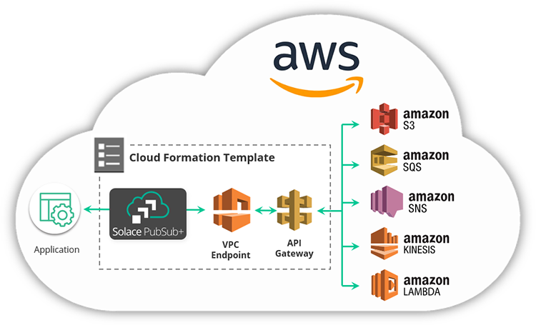

**Figure 8.1:** AWS Application Integration Services (AWS Training Blog)

Application integration allows different systems and software to work together by ensuring efficient data flow and real-time communication. This process ensures smooth data exchange and real-time communication, enabling organizations to create more agile and responsive business operations [2]. In modern cloud computing, it ensures that systems communicate and share data effectively. Key integration strategies include the use of **an Enterprise Service Bus (ESB), which serves as middleware to connect applications, API-based integration for seamless data exchange, and an event-driven architecture** to manage real-time data responses. The significance of application integration lies in its ability to synchronize data across various systems, minimize errors, and reduce manual processes [3]. Furthermore, it improves decision-making by offering a holistic view of data, empowering organizations to act on the most relevant insights quickly [4].

Asynchronous communication via SQS is crucial in environments such as **microservices architectures**, where services interact through events and messages. The following figure illustrates a typical microservices application on AWS, highlighting the role of integration services in supporting these architectures.

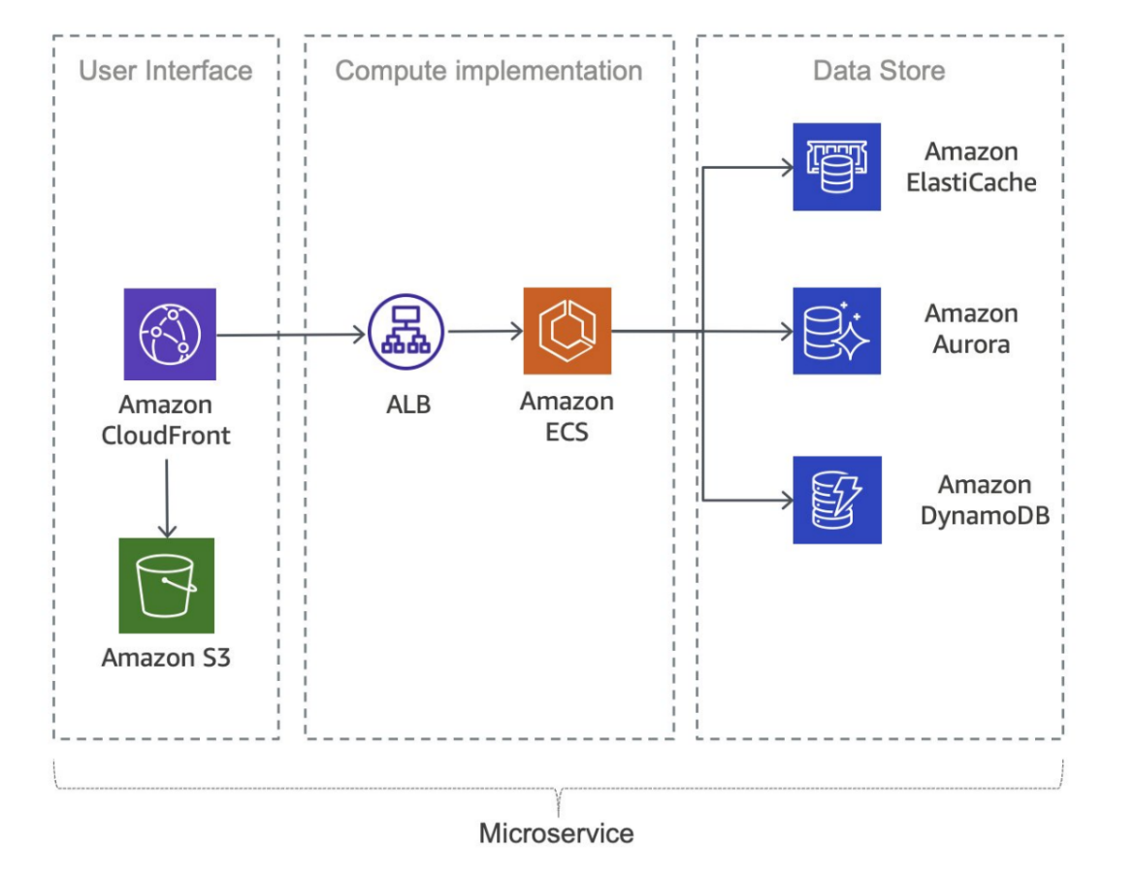

**Figure 8.2:** Typical microservices application on AWS (AWS Documentation)

Significance of application integration

Application integration plays a crucial role in modern software ecosystems by ensuring data consistency across various platforms, enhancing efficiency, and facilitating better decision-making. Through seamless communication between applications, integration cuts data silos and minimizes manual tasks, ultimately driving operational efficiency [3]. Moreover, when systems work together cohesively, businesses can make informed, data-driven decisions that promote agility and innovation [4].

With the growing need for dynamic, real-time capabilities, integrating applications ensures that organizations can react promptly to changes, whether it’s scaling operations, responding to market shifts, or addressing customer demands. Through integrated systems, organizations can achieve a unified view of their processes, ensuring they stay competitive in fast-moving industries [1].

Strategies for application integration

Different strategies are essential for implementing effective application integration in cloud-native environments. A common approach is the use of an **Enterprise Service Bus (ESB)**, which acts as a middleware, enabling communication between disparate systems and services through a central hub [5]. This approach simplifies the management of communications between applications, ensuring that they interact in a standardized manner.

Another strategy involves **API-based integration**, where applications communicate with each other via APIs. This approach offers flexibility, scalability, and easy data exchange across services, allowing applications to work independently while sharing necessary functionality [1]. The third strategy is adopting **event-driven architectures**, where systems communicate by triggering events based on specific actions or changes in the environment, thus enabling real-time responses [6].

Best practices for effective application integration

To ensure smooth and efficient integration, best practices should be followed. Standardizing data formats is efficient for compatibility between applications and guarantees the smooth flow of information [3]. Robust **security measures**, including encryption and authentication, are essential for safeguarding sensitive data during integration processes [4]. Additionally, adopting **event-driven design principles** enhances flexibility and scalability by allowing applications to interact through events rather than direct calls, which decouples components and simplifies system architecture [1].

Another best practice is **decoupling components**, where systems like **Amazon SQS** (Simple Queue Service) are used to manage asynchronous communication between applications. This decoupling allows services to scale independently and promotes system reliability, making applications more adaptable to changes and failures [6].

Amazon AppFlow

Amazon AppFlow is a fully managed integration service provided by AWS, enabling secure and efficient data transfer between AWS services and various SaaS (Software as a Service) applications. As businesses increasingly rely on cloud-based applications, Amazon AppFlow helps seamless data flows, supporting operational efficiency and enhancing decision-making capabilities across platforms.

Key features

Amazon AppFlow offers critical features that enhance its utility for organizations seeking to improve their data integration strategies [7]. These include:

* **Bi-directional data flow**: AppFlow supports bidirectional data transfer, enabling seamless movement of data in both directions between AWS services and external SaaS applications. This flexibility allows organizations to integrate various systems efficiently while keeping consistent data flows.
* **Pre-built connectors**: The service offers pre-built connectors for popular SaaS applications, including Salesforce, ServiceNow, and others, streamlining the integration process. These connectors simplify the connection between AWS and SaaS platforms, reducing the need for manual configurations.
* **Data mapping and transformation**: AppFlow enables automatic data mapping and transformation, ensuring compatibility between different data formats across source and destination systems. This functionality ensures that data can be transferred and processed seamlessly without format mismatches.

**Use cases**

Everyday use cases highlight the practical benefits of Amazon AppFlow:

* **Sales and marketing automation**: Businesses can automate the data flow between Customer Relationship Management (CRM) systems, such as Salesforce, and marketing platforms. This automation streamlines sales and marketing processes, helping organizations to keep up-to-date customer data and improve marketing campaign effectiveness [8].
* **Data warehousing**: AppFlow facilitates the transfer of data from SaaS applications into AWS-based data warehouses, enabling powerful analytics and reporting capabilities. By moving data to centralized storage solutions, organizations can leverage AWS’s analytical services to gain insights and make data-driven decisions [7].

Considerations for implementation

When implementing Amazon AppFlow, organizations must consider several key factors to ensure seamless data transfers and integration. These considerations include:

* **Security and compliance**: Ensuring the security and compliance of data transferred through Amazon AppFlow is paramount. Organizations should show proper security protocols and ensure that data transfers meet regulatory requirements, especially when dealing with sensitive or personal data [7].
* **Data mapping accuracy**: To ensure the integrity of data flows, organizations must verify and assess their data mapping configurations. Any inaccuracies in mapping could lead to inconsistencies or errors in the transferred data, thereby compromising the effectiveness of the integration.

Challenges

While Amazon AppFlow offers robust integration capabilities, specific challenges may arise during implementation:

* **Data transfer speed**: The speed at which data can be transferred between SaaS applications and AWS services depends on the volume of data and the capabilities of the SaaS application in use. Organizations need to account for potential bottlenecks and consider transfer speed when designing data integration processes [9]. Planning for these challenges will ensure that integration continues smoothly and that data flows as efficiently as possible.

Amazon EventBridge

Amazon EventBridge is a serverless event bus service provided by AWS that simplifies the development of event-driven applications. This service enhances the scalability and flexibility of cloud architectures by enabling seamless communication between different services through events.

Key features

Amazon EventBridge provides features [10]:

* **Event routing**: The service allows the creation of event rules that route events from sources to one or more targets, promoting decoupled service communication.
* **Schema registry**: EventBridge includes a schema registry, ensuring consistency and compatibility in event formats across applications.
* **Managed integrations**: The service event-driven architecture.

**Use cases**

Amazon EventBridge serves various use cases:

* **Microservices communication**: EventBridge facilitates communication between microservices by enabling them to publish and subscribe to events, which encourages a loosely coupled architecture [11].
* **Real-time data processing**: Organizations can use EventBridge for real-time data processing, responding to events generated by different services or applications [10].

Best practices

To maximize the effectiveness of EventBridge, follow these best practices [10]:

* **Event schema design**: Ensure event schemas are designed for clarity, extensibility, and long-term maintainability.
* **Rule filtering strategies**: Develop efficient rule filtering strategies to manage event flow and enhance event-driven workflows.

Challenges

While EventBridge offers a robust framework for event-driven applications, there are challenges:

* **Event consistency**: Ensuring consistency in event formats and schemas across diverse services and teams requires comprehensive communication and documentation [11].

Amazon managed workflows for Apache Airflow

Amazon **Managed Workflows for Apache Airflow** (**MWAA**) is a fully managed service that simplifies the orchestration of complex workflows, cutting the operational overhead of managing Apache Airflow environments. This service enhances the scalability and reliability of workflows, making it ideal for orchestrating data-intensive tasks across various cloud resources. Figure 8.3 below provides an overview of Amazon MWAA's architecture.

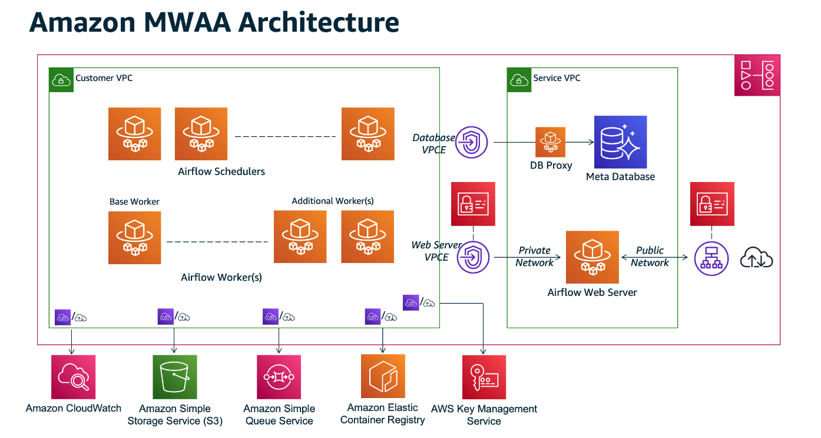

**Figure 8.3:** Amazon Managed Workflows for Apache Airflow Architecture (AWS Documentation)

Key features

Amazon MWAA offers different key features that make it a powerful tool for workflow automation [12]:

* **Managed Apache Airflow environment**: The service provides a fully managed environment, reducing the burden of infrastructure management.
* **Scalability and reliability**: MWAA automatically scales resources based on workload requirements, ensuring high performance and reliability.
* **Integration with AWS services**: Seamless integration with various AWS services allows workflows to interact with cloud resources effectively.

**Use cases**

MWAA is particularly useful for the following use cases:

* **Data processing pipelines**: They help automate data workflows across diverse data sources and destinations [13].
* **ETL workflows**: MWAA efficiently orchestrates ETL tasks, streamlining data processing for analytics and reporting [12].

Best practices

To maximize the benefits of Amazon MWAA, follow these best practices [13]:

* **Environment configuration**: Properly configure the Airflow environment to improve performance and security.
* **Monitoring and logging**: Implement robust monitoring and logging systems to track workflow performance and promptly identify issues.

Considerations

While MWAA offers powerful capabilities, distinct factors should be considered for successful implementation:

* **Cost management**: As workflows scale, watch and manage associated costs, particularly when integrating data-intensive services [12].
* **Security configuration**: Ensure robust security practices, including proper IAM roles, data encryption, and AWS security best practices.
* **Performance optimization**: Tune task concurrency, use spot instances, and select the correct instance types to enhance performance and reduce costs.
* **Dependency management**: Manage dependencies effectively by utilizing MWAA’s support for Python packages, ensuring they are up-to-date and compatible.
* **Compliance and governance**: Ensure the utilization of tools like AWS CloudTrail for , auditing, and logging and verify that workflows adhere to relevant standards.
* **Backup and recovery**: Implement reliable backup strategies, using services like Amazon S3 for workflow definitions and regularly evaluate recovery procedures.
* **CI/CD integration**: Incorporate MWAA workflows into CI/CD pipelines to ensure consistency and reliability across environments.
* **Monitoring, alerts, and notifications**: Set up CloudWatch metrics, alarms, and notifications to watch workflow execution and system performance.
* **Data Privacy:** Ensure data handling practices comply with privacy regulations, such as **GDPR** and **CCPA,** particularly when handling sensitive data.
* **Training and documentation**: Provide comprehensive training and operational documentation to ensure the effective use and maintenance of MWAA.
* **Vendor lock-in and portability**: Consider the implications of vendor lock-in and utilize infrastructure-as-code tools, such as AWS CloudFormation, to mitigate portability concerns.

Amazon MQ

Amazon MQ is a fully managed message broker service that simplifies the deployment and maintenance of popular messaging systems. This service supports multiple messaging protocols, including MQTT, AMQP, and STOMP, ensuring high compatibility with a wide range of applications and systems. By offering a managed infrastructure, Amazon MQ reduces the operational complexity typically associated with running messaging systems, allowing developers to focus on application logic.

Key features

The key features of Amazon MQ include [14]:

* **Industry-standard compatibility: Amazon MQ supports various messaging protocols, including** MQTT, AMQP, and STOMP, ensuring seamless integration with different systems and applications.
* **Managed broker**: It provides a fully managed message broker, minimizing the operational overhead of keeping the infrastructure and scaling the messaging system.

**Use cases**

Amazon MQ excels in the following use cases:

* **Decoupled microservices communication**: It helps communication between microservices in a decoupled manner, enhancing scalability and flexibility in microservices architectures [15].
* **Event-driven architecture**: Amazon MQ supports building reliable event-driven architectures by enabling applications to respond to events and messages in a scalable, efficient way [14].

Best practices

To improve the use of Amazon MQ, the following best practices should be implemented:

* **Secure configuration**: Secure the service by using IAM roles, encryption, and access control mechanisms to protect sensitive data [14].
* **Scalability planning**: Choose the correct instance types and configure resources based on expected message throughput and processing needs to ensure the best performance [15].

Considerations

When implementing Amazon MQ, the following factors should be considered:

* **Message retention and cleanup**: Set the right retention policies and cleanup processes to manage storage costs and keep system efficiency [14].

Amazon's simple notification service

SNSis a fully managed messaging service that enables the decoupling of microservices, distributed systems, and serverless applications. This section examines the features, use cases, and best practices related to Amazon SNS.

Key features

The following are the key features of Amazon SNS. [16]:

* **Publish-subscribe model:** Amazon SNS adheres to a publish-subscribe messaging paradigm, enabling message producers to send messages to multiple subscribers simultaneously.
* **Wide range of message protocols:** The service supports various message protocols, including HTTPS, email/SMTP, SMS, and application-specific protocols, ensuring flexibility in message delivery.

**Use cases**

The following are the use cases of Amazon SNS. [16]:

* **Event-driven architecture:** Amazon SNS plays a crucial role in building event-driven architecture, facilitating communication and coordination between loosely coupled components.
* **Mobile application notifications:** The service enables the sending of push notifications to mobile devices, thereby enhancing user engagement for mobile applications.

Best practices

The following are the best practices of Amazon SNS. [16]:

* **Topic organization:** Organize topics effectively to reflect the structure of your application, making it easier to manage and control message distribution [17].
* **Message filtering:** Implement message filtering to control which subscribers receive specific messages based on their preferences or attributes.

Considerations

One efficiency consideration is message retention. Details of which are as follows:

* **Message retention:** Understand the default message retention periods and adjust them based on your application's requirements to avoid message loss [17].

Integration with other AWS services

Amazon SNS seamlessly integrates with other AWS services to enhance various aspects of application development and deployment. Notable integrations include:

* **Amazon Simple Queue Service (SQS):** Enables asynchronous communication by allowing SNS messages to be sent to SQS queues [18].
* **AWS Step Functions:** Helps coordination of distributed applications using SNS to trigger state transitions in Step Functions [19].

Amazon's simple queue service

SQS is a fully managed message queuing service that helps with decoupled components in a distributed system. This section examines features, use cases, and best practices related to Amazon SQS**. Figure 8.4** illustrates the basic architecture of Amazon Simple Queue Service:

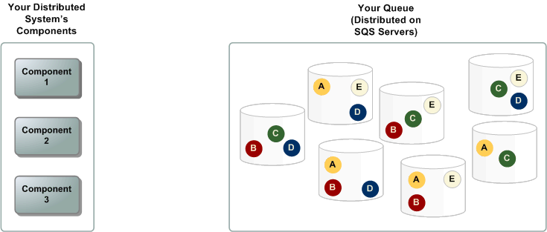

**Figure 8.4:** Amazon Simple Queuing Service Basic Architecture (SWS Documentation)

Key features

Amazon SQS provides different key features that enhance its utility in distributed systems. [20]:

* **Scalability and elasticity**: The service automatically scales to manage variable message volumes, ensuring reliable message delivery even during fluctuations in workload.

**Message retention**: SQS enables users to define the retention period for messages, offering flexibility in managing how long messages remain in the queue.

**Use cases**

Amazon SQS is beneficial in various scenarios, including:

* **Load leveling**: SQS helps smooth out traffic spikes by acting as a buffer, decoupling the rate at which messages are produced and consumed [21].
* **Task decoupling**: In microservices architectures, SQS facilitates task decoupling, enabling components to communicate asynchronously.

Best practices

To improve the use of Amazon SQS, follow these best practices:

* **Visibility timeout**: Adjust the visibility timeout to ensure a message is still hidden from other consumers while being processed, preventing duplication.
* **Dead-letter queues**: Implement dead-letter queues to capture undeliverable messages after a predefined number of attempts and analyze their failure [20].

Considerations

While Amazon SQS offers best-effort ordering, it is efficient to design systems that can manage potential out-of-order message delivery. [20].

Integration with other AWS services

SQS seamlessly integrates with various AWS services, enhancing its capabilities and applications in different scenarios. Notable integrations include:

* **Amazon S3:** SQS can be used to trigger events in response to changes in an S3 bucket, enabling event-driven architectures [20].
* **AWS Lambda:** Leverage SQS to trigger serverless functions in AWS Lambda, allowing for the seamless execution of compute workloads [18].

Managed message queues

Managed message queues are essential components of modern cloud architecture, offering a scalable and reliable way to decouple system components. This section discusses the role of managed message queues and their importance in distributed systems.

Overview

Managed message queues, such as Amazon SQS, Azure Queue Storage, and Google Cloud Pub/Sub, provide a robust solution for enabling asynchronous communication in distributed systems. These queues help streamline message handling by ensuring scalability, reliability, and efficient decoupling between system components.

Advantages

Managed message queues offer advantages that enhance the performance and reliability of distributed systems:

* **Scalability**: These queues scale automatically to manage changing workloads, ensuring consistent performance as demand fluctuates [22].
* **Reliability**: By offloading the tasks of message storage and delivery to managed services, the reliability of message processing is greatly improved.
* **Decoupling**: Managed message queues help the decoupling of producers and consumers, supporting asynchronous communication and reducing the interdependencies between components [23].

**Use cases**

Managed message queues are pivotal in different use cases:

* **Microservices architectures**: These queues enable microservices to communicate asynchronously, avoiding direct dependencies between services.
* **Event-driven systems**: In these systems, managed message queues facilitate the smooth transfer of events across components, enabling real-time processing.

Best practices

To maximize the efficiency of managed message queues, adhere to the following best practices:

* **Message retention**: Configure retention policies based on application needs, striking a balance between storage costs and the time-sensitive nature of messages.
* **Error handling**: Implement robust error-managing mechanisms, including the use of dead-letter queues, to manage messages that do not process [20].

Integration with AWS services

Managed message queues integrate seamlessly with different AWS services, enhancing their capabilities in various scenarios. Key integrations include:

* **AWS Lambda**: Use managed message queues to trigger AWS Lambda functions, enabling serverless, event-driven architectures.
* **Amazon EC2**: Integrate with EC2 instances to allow communication between different components of a distributed application [20].

AWS **step functions**

AWS Step Functions is a fully managed service that enables developers to coordinate and automate the execution of serverless workflows using visual workflows. This section explores the capabilities of AWS Step Functions, its use cases, and the benefits it offers in the realm of application integration.

Overview

AWS Step Functions simplify the process of building scalable and resilient applications by allowing developers to design workflows using a visual interface. Workflows in Step Functions are represented as state machines, where each state is a step in the workflow.

Key features

The following are the key features of AWS Step Functions. [19]; [24]

* **Visual workflow design**: Step Functions provides a visual workflow designer, allowing developers to design, visualize, and change workflows easily.
* **Coordination of microservices**: It excels in coordinating microservices, enabling seamless communication and task execution across distributed applications.
* **Error handling**: Step Functions include built-in error management capabilities, allowing for the definition of error states and automatic retribution.

**Figure 8.5** illustrates AWS Step Functions Microservice Orchestration, combining Lambda functions to build a web-based application.

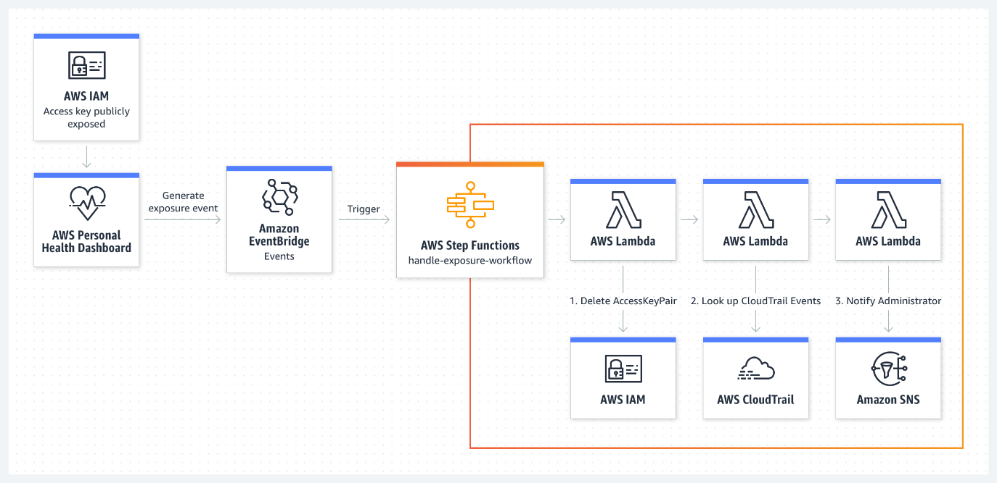

**Figure 8.5:** AWS Step Functions Microservice Orchestration: (Amazon Web Services)

**Use cases**

Thefollowing are the use cases of AWS Step Functions [19]:

* **Order processing workflows**: Step Functions can be used to orchestrate order processing workflows, coordinating tasks such as payment processing, inventory management, and shipping.
* **Data processing pipelines**: It is ideal for building data processing pipelines, where different steps in the pipeline are executed based on the success or failure of earlier steps.
* **Media processing workflows**: Step Functions can coordinate media processing tasks, such as video transcoding and image recognition, in a scalable and efficient manner.

Benefits

The following are the benefits of using AWS Step Functions. [19]:

* **Simplified workflow management**: Developers can easily manage complex workflows using the visual designer, thereby reducing the complexity of application integration.
* **Scalability**: Step Functions scale automatically based on the workload, ensuring that workflows execute reliably under varying conditions.
* **Cost Efficiency**: The pay-as-you-go pricing model of Step Functions ensures cost efficiency, with charges based on the number of state transitions that occur.

The benefits of using AWS Step Functions are as follows. [19]:

* **Simplified workflow management:** Developers can manage complex workflows with ease using the visual designer, reducing the complexity of application integration95.
* **Scalability:** Step Functions scale automatically based on the workload, ensuring that workflows execute reliably under varying conditions.
* **Cost Efficiency:** The pay-as-you-go pricing model of Step Functions ensures cost efficiency, with charges based on the number of state transitions that occur.

Integration with other AWS services

AWS Step Functions seamlessly integrates with various AWS services, including AWS Lambda, AWS Fargate, and Amazon SageMaker, enabling developers to utilize a wide range of functionalities within their workflows.

Amazon elastic container registry

Amazon **Elastic Container Registry (ECR**) is a fully managed container registry service that enables developers to store, manage, and deploy Docker container images efficiently. This section explores Amazon ECR's features and its role in the containerization ecosystem.

Amazon ECR simplifies containerization by offering a secure and scalable repository for Docker images, supporting the entire lifecycle of containerized applications.

Key features of Amazon ECR

The following are the key features of Amazon ECR. [25]; [26]:

* **Secure and private repositories**: ECR provides private repositories where container images are securely stored and accessed only by authorized users and systems.
* **Integration with AWS Services**: It integrates seamlessly with AWS services, such as Amazon ECS and Kubernetes, facilitating the deployment of containerized applications.
* **Scalability**: ECR scales with the development team's needs, efficiently managing the storage and retrieval of large numbers of container images.

**Use cases**

The following are the key features of Amazon ECR. [25]; [26]:

* **Secure and private repositories**: ECR provides private repositories where container images are securely stored and accessed only by authorized users and systems.
* **Integration with AWS Services**: It integrates seamlessly with AWS services, such as Amazon ECS and Kubernetes, facilitating the deployment of containerized applications.
* **Scalability**: ECR scales with the development team's needs, efficiently managing storage and retrieval of large numbers of container images

**Figure 8.6** shows AWS Containers options by layer:

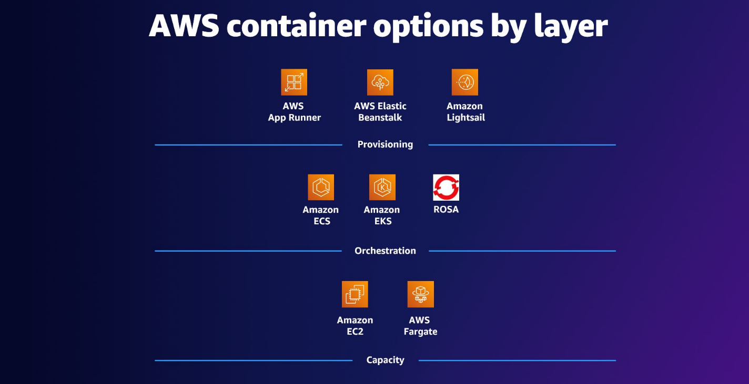

**Figure 8.6:** AWS Containers (Amazon Web Services)

Benefits of using Amazon ECR

The benefits of using Amazon ECR are as follows: [25]:

* **Ease of use**: The integration with AWS services and Docker tools simplifies usage for both novice and experienced container developers.
* **Cost efficiency: ECR follows a pay-as-you-go pricing model, charging users** based on storage and data transfer for container images.
* **Comprehensive security**: ECR provides fine-grained access control, integrating with AWS IAM to securely manage container image repositories.

Integration with DevOps workflow

Amazon ECR plays a pivotal role in DevOps workflows by integrating containerized applications into deployment pipelines. Its compatibility with CI/CD tools ensures a smooth transition from development to production.

**Amazon elastic container service**

Amazon **Elastic Container Service** (**ECS**) is a fully managed service for container orchestration, simplifying the deployment and management of containerized applications. This section highlights ECS's features, architecture, and use cases, emphasizing its role in scaling containerized applications.

Amazon ECS enables users to run, stop, and manage Docker containers across clusters, abstracting infrastructure complexities to let developers focus on scaling applications without managing the underlying resources.

Key features of Amazon ECS

The key features of Amazon ECS include [27]:

* **Scalability**: ECS automatically scales containers based on application load, ensuring efficient resource utilization.
* **Integration, thereby** improving load balancing.
* **Task definitions**: Developers define applications through task definitions, specifying Docker images, CPU, memory, and container links.

Amazon ECS architecture

Amazon ECS orchestrates Docker containers on EC2 instances or AWS Fargate, AWS's serverless compute engine for containers. The architecture revolves around clusters, tasks, and services. Clusters group EC2 instances or Fargate tasks, while tasks are discrete units of work defined by task definitions. ECS services manage tasks’ lifecycle, ensuring high availability and scalability [27].

Components of Amazon ECS

Amazon ECS architecture includes:

* **Clusters**: Logical groups of EC2 instances or Fargate tasks where containers are deployed.
* **Tasks**: Units of work defined by task definitions that specify Docker images, resource allocations, and dependencies.
* **Services**: Ensure high availability and scalability by managing task lifecycles and adjusting based on demand [27].

Scalability and integration

ECS scales containers dynamically in response to workload demands. Integrated with AWS Auto Scaling and ELB, ECS distributes traffic across containers, improving performance in microservices and batch-processing environments. [28].

Operational simplicity and benefits  
ECS abstract infrastructure complexities, streamlining operations. It improves resource use, integrates with AWS IAM for secure container management, and supports CI/CD pipelines for automated testing and deployment, enabling rapid innovation. [27].

To better understand the architecture and key components of Amazon ECS, **Figure 8.7** below illustrates how the service orchestrates containerized applications across managed clusters, leveraging EC2 instances or AWS Fargate for scalable deployment.

**Figure 8.7:** Amazon ECS (Amazon Web Services)

Amazon ECS architecture core components  
ECS architecture includes:

* **Clusters**: Logical groupings of container instances or Fargate tasks.
* **Tasks**: Units of work based on task definitions, ensuring seamless execution across ECS clusters.
* **Services**: Manage the lifecycle and scaling of tasks to keep availability [27].

**Use cases of Amazon ECS.**  
ECS is ideal for:

* **Microservices architecture**: Efficient orchestration and scaling of microservices.
* **Batch Processing**: Scaling containerized applications dynamically in response to workload demands.
* **CI/CD**: ECS integrates with CI/CD pipelines for automated testing and deployment [28].

Benefits of using Amazon ECS  
Key benefits of ECS include [27]:

* **Cost efficiency: ECS improves resource utilization, charging users only for the compute resources they consume**.
* **Security**: Integrated with AWS IAM for secure container management and access control.
* **Operational simplicity**: ECS abstracts infrastructure management, enabling developers to focus on building applications.

Integration with DevOps workflow  
Amazon ECS integrates seamlessly with DevOps tools, enhancing the deployment and management of containerized applications in continuous integration and continuous deployment (CI/CD) pipelines.

Amazon elastic Kubernetes service

Amazon EKS is a fully managed Kubernetes service provided by AWS, offering a simplified yet powerful platform for deploying, managing, and scaling containerized applications using Kubernetes.

Overview

Amazon **Elastic Kubernetes** **Service** (**EKS**) is a fully managed Kubernetes service by AWS, simplifying container orchestration and scaling for Kubernetes-based applications. This section discusses the features, architecture, and use cases of EKS, and its role in modern containerized applications.

Amazon EKS abstracts the complexity of Kubernetes control plane management, providing a scalable solution for running containerized applications with Kubernetes orchestration.

Key features of Amazon EKS  
Amazon EKS delivers a fully managed Kubernetes environment, simplifying container orchestration while ensuring scalability, security, and deep integration with AWS services. Designed for organizations leveraging Kubernetes, EKS automates infrastructure management, optimizes performance, and enhances reliability, enabling seamless deployment of containerized applications across hybrid and multi-cloud environments.

Key features include [29]:

* **Scalability**: Automatically adjusts to workload demands, ensuring efficient use of resources.
* **Seamless AWS integration**: EKS integrates with other AWS services, such as IAM and VPC, for enhanced security and networking.
* **Flexibility**: Supports Kubernetes tooling and AWS-specific integrations, providing operational flexibility.

Amazon EKS architecture  
EKS architecture is built on essential components:

* **Control plane**: Managed by AWS, the control plane includes components such as the API server, scheduler, and controller manager.
* **Worker nodes**: These nodes execute containerized applications and communicate with the control plane.
* **Clusters**: EKS clusters group worker nodes utilizing AWS infrastructure, such as EC2 instances or AWS Fargate, for scalable deployments.
* **Use cases of Amazon EKS:** EKS supports various deployment strategies [29].
* **Microservices architecture**: Scalable orchestration for managing containerized microservices.
* **Hybrid deployments**: Orchestrates applications across on-premises and cloud environments.
* **Multi-region deployments**: Supports multi-region setups for enhanced availability.

Refer to **Figure 8.8** for a visualization of an Amazon EKS use case example:

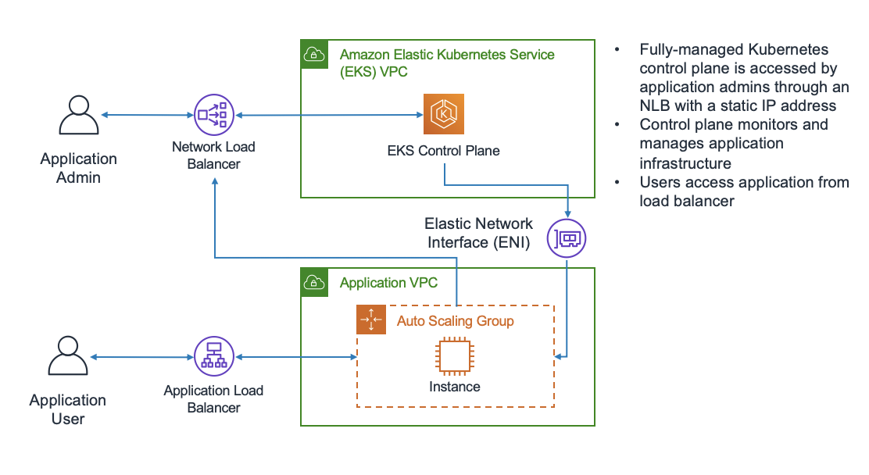

**Figure 8.8:** Amazon EKS use case (AWS Whitepapers)

Benefits of using Amazon EKS  
Key benefits include [29]:

* **Operational efficiency**: Automates setup, scaling, and management of Kubernetes clusters.
* **Security**: Integrated with AWS IAM and VPC for secure, isolated networking.
* **Flexibility**: Supports both standard Kubernetes tools and AWS integrations, choices providing users with a broad range of options.

Integration with DevOps workflow  
EKS integrates seamlessly with DevOps pipelines, enhancing CI/CD practices and accelerating the deployment of containerized applications.

Modern DevOps workflows rely on automation, scalability, and seamless orchestration to accelerate software delivery. Amazon EKS enhances DevOps practices by integrating with popular CI/CD tools, infrastructure-as-code frameworks, and monitoring solutions, enabling the efficient, scalable, and cost-effective deployment of containerized applications.

* **Continuous integration**: Works with Jenkins, GitLab CI/CD, and AWS CodePipeline to automate builds and deployments.
* **Continuous deployment**: EKS automates deployments using Helm and AWS CodeDeploy, ensuring consistent updates.
* **Infrastructure as code**: Integrates with AWS CloudFormation and Terraform, ensuring consistent environments.
* **Monitoring and logging**: Works with Amazon z and AWS X-Ray to provide visibility and initiative-taking troubleshooting.
* **Scalability and high availability**: Supports auto-scaling and multi-region deployments, ensuring fault tolerance and reduced downtime.
* **Cost Optimization**: EKS reduces costs with dynamic scaling, AWS Spot Instances, and tools like AWS Cost Explorer for cost management.

Summary  
Amazon EKS streamlines the management of Kubernetes clusters by automating key tasks, improving operational efficiency, and integrating seamlessly with the AWS ecosystem. This service accelerates the deployment lifecycle for containerized applications, helping high availability, scalability, and security [29].

AWS App2Container

AWS App2Container is a service that simplifies the process of containerizing legacy applications, enabling organizations to modernize and migrate their applications to cloud-native architectures. This section examines the capabilities of AWS App2Container, its use cases, and the benefits it provides for modern application development.

AWS App2Container is designed to convert existing applications into containerized environments without requiring significant code changes. It works by packaging an application and its dependencies into containers, allowing users to deploy them in container orchestration environments such as Amazon ECS or Amazon EKS.

Key features of AWS App2Container

The following are the key features of AWS App2Container (AWS, AWS App2Container, 2023):

* **Automated containerization**: App2Container automatically scans applications and packages them into Docker containers, making the process more efficient and less error prone.
* **Support for Java and .NET**: The service supports both Java and .NET applications, enabling organizations with legacy systems to migrate to the cloud.
* **Integration with AWS services**: Once the application is containerized, users can integrate it seamlessly with Amazon ECS, EKS, or AWS Fargate for orchestration.

**Use cases**

The following are common use cases for AWS App2Container:

* **Legacy application modernization**: Organizations can use App2Container to modernize legacy applications, enabling them to move from monolithic architectures to containerized solutions.
* **Cloud migration**: App2Container accelerates the process of migrating applications to the cloud, particularly for organizations moving from on-premises data centers to AWS.
* **Microservices conversion**: For organizations transitioning to a microservices architecture, App2Container helps break down legacy monolithic applications into manageable, containerized services.

Benefits of AWS App2Container

The benefits of using AWS App2Container [17] are as follows:

* **Simplified containerization**: By automating the containerization process, App2Container reduces the complexity of manually configuring and packaging legacy applications.
* **Accelerated cloud migration**: App2Container helps expedite cloud migration by providing a streamlined approach to containerization, making it easier to migrate workloads to AWS.
* **Scalability**: Once containerized, applications can be easily scaled using AWS container services, ensuring that they perform reliably under varying workloads.

Integration with DevOps workflows

AWS App2Container integrates seamlessly into DevOps workflows, allowing developers to incorporate containerization into their continuous integration and deployment (CI/CD) pipelines. This integration streamlines the development-to-production cycle, improving the efficiency of application deployment.

**AWS Fargate**  
AWS Fargate is a serverless compute engine for containers that cuts the need for managing servers. This section discusses how Fargate simplifies container management and provides a scalable solution for running containers in a serverless environment.

Overview  
Fargate allows developers to run containers without worrying about the underlying infrastructure, as it automatically manages provisioning, scaling, and managing the compute resources needed to run containers. This enables teams to focus on application logic rather than infrastructure management.

Key features of AWS Fargate  
The key features of AWS Fargate include [30]:

* **Serverless architecture**: Fargate abstracts infrastructure management, enabling developers to focus on writing code rather than managing servers.
* **Automatic scaling**: Fargate automatically scales the number of containers based on demand, ensuring optimal resource utilization.
* **Integration with AWS services**: Seamless integration with Amazon ECS, Amazon EKS, and AWS Lambda enables users to run containers in various configurations, enhancing workflows.

**Use cases of AWS Fargate**  
The main use cases are as follows [30]:

* **Microservices architecture**: Fargate simplifies the management of microservices by allowing independent scaling of individual services.
* **Batch processing**: Fargate can be used to run containerized batch jobs that scale automatically based on workload.
* **CI/CD pipelines**: Integrating Fargate with CI/CD pipelines enables the automation of testing, building, and deployment processes.

Benefits of using AWS Fargate  
The benefits of AWS Fargate include:

* **Operational simplicity**: With no need to manage infrastructure, Fargate reduces the operational complexity associated with running containers.
* **Cost efficiency**: Fargate offers a pay-per-use pricing model, where users only pay for the compute resources their containers use.
* **Scalability and flexibility**: Fargate scales containers based on demand, ensuring that applications can manage traffic spikes and fluctuating workloads.

Integration with DevOps workflow  
AWS Fargate seamlessly integrates into DevOps workflows, enabling the management and scaling of containerized applications without manual intervention. It works with services like AWS CodePipeline and ECS, helping teams automate their development, testing, and deployment processes [30].

AWS App2Container and AWS Fargate integration

When combined, AWS App2Container and AWS Fargate offer a comprehensive solution for containerizing and deploying applications:

* **Seamless containerization**: A2C prepares applications for deployment on Fargate with minimal configuration.
* **Serverless deployment**: Fargate manages all infrastructure management, providing a fully serverless deployment experience.
* **Enhanced efficiency**: This integration streamlines container lifecycle management, optimizing resource utilization and minimizing operational overhead.

Benefits of AWS Fargate integration

Integrating AWS App2Container with AWS Fargate delivers multiple advantages:

* **Serverless container orchestration**: Fargate automates the entire container orchestration process, freeing developers from managing infrastructure.
* **Resource optimization**: Fargate scales resources automatically based on application demand, enhancing performance and cost efficiency.
* **Simplified operations**: The combination of A2C and Fargate simplifies the containerization and deployment process, making operations more efficient.

**Use cases**

The A2C and Fargate integration is ideal for:

* **Microservices architecture**: Perfect for deploying individual services independently and efficiently.
* **Application modernization**: Helps the migration of legacy applications to cloud-native environments, enhancing scalability and cost-effectiveness.

AWS Copilot

AWS Copilot is a powerful **command-line interface** (**CLI**) that streamlines the deployment, management, and execution of containerized applications on Amazon ECS and AWS Fargate. This section discusses the capabilities, key features, and benefits of using AWS Copilot to streamline the development and deployment of containerized applications.

Overview

AWS Copilot provides a streamlined, opinionated approach to deploying containerized applications. It allows developers to quickly create production-ready environments for their applications without requiring deep knowledge of AWS services. Copilot automates the setup of the necessary AWS infrastructure, enabling developers to focus on writing code and building features.

Key features of AWS Copilot

The following are the key features of AWS Copilot [31]:

* **Application scaffolding**: Copilot automatically generates the necessary AWS infrastructure components for deploying containerized applications, such as load balancers, security groups, and auto-scaling settings.
* **Multi-environment support**: AWS Copilot enables the creation and management of applications across multiple environments, including development, staging, and production, ensuring a seamless deployment process for each stage of development.
* **Integrated CI/CD**: Copilot offers built-in integration with Amazon CodePipeline and GitHub Actions, simplifying automated build and deployment workflows.
* **Environment configuration**: Copilot enables users to define environment-specific settings for their containerized applications, including resource allocation and environment variables.

**Use cases of AWS Copilot**

Everyday use cases for AWS Copilot are as follows:

* **Microservices deployment**: Copilot is well-suited for deploying microservices applications, where different services can be deployed and scaled independently across multiple environments.
* **Rapid development and deployment**: For teams seeking to develop and deploy containerized applications rapidly, Copilot streamlines the entire process, enabling developers to push code to production without manual configuration quickly.
* **Cloud-native migration**: Organizations seeking to migrate their containerized applications from on-premises or other cloud environments to AWS can utilize Copilot for a seamless transition.

Benefits of AWS Copilot

The benefits of using AWS Copilot are as follows [31]:

* **Simplified application deployment**: Copilot streamlines the deployment of containerized applications by automating much of the setup, making it easier for developers to deploy their applications quickly and reliably.
* **Best practice defaults**: The service implements AWS best practices for security, scalability, and cost efficiency, ensuring that applications are deployed securely and optimized for optimal performance.
* **Faster time to market**: With automated infrastructure setup and integration with CI/CD tools, Copilot accelerates the development cycle, enabling teams to release applications more quickly.

Integration with DevOps workflows

AWS Copilot integrates smoothly into DevOps workflows by providing a simplified yet powerful toolset for managing containerized applications in AWS. It enables automated deployment through continuous integration and delivery pipelines, making it an ideal choice for organizations looking to streamline their DevOps processes and keep a consistent, repeatable deployment flow.

AWS App2Container and AWS Copilot integration

Combining AWS App2Container with AWS Copilot delivers a robust solution for containerizing and deploying legacy applications into scalable, serverless environments.

As organizations modernize their legacy applications, they require efficient tools that automate containerization and deployment while minimizing **complexity.** The integration of **AWS App2Container and AWS Copilot** provides a **comprehensive solution** for transitioning traditional applications into **cloud-native, scalable environments** without disrupting existing workflows.

* **Seamless migration & deployment**: App2Container prepares legacy applications by generating Docker images, and AWS Copilot simplifies the deployment process, ensuring a streamlined CI/CD pipeline and environment setup.
* **Simplified container management**: App2Container automates containerization, and Copilot handles deployment and scaling with minimal configuration, enabling developers to focus on application logic.
* **End-to-end DevOps integration**: Integrates with AWS CodePipeline, enabling automated continuous integration and deployment and supporting agile DevOps workflows.

Benefits of AWS App2Container and Copilot integration

Organizations leveraging AWS App2Container and Copilot gain a streamlined approach to modernization**.** By automating **containerization, deployment, and scaling**, these tools **enhance operational efficiency and accelerate cloud adoption** while ensuring **cost optimization** through AWS’s flexible pricing model.

* **Accelerated modernization**: Quickly migrate legacy applications to containerized environments, reducing the manual work involved in modernizing legacy systems.
* **Operational efficiency**: Both App2Container and AWS Copilot simplify container management and deployment, reducing operational complexity.
* **Cost efficiency**: With AWS's pay-as-you-go pricing model, organizations pay only for the resources they use, improving cost management.

**Use cases**

AWS App2Container and Copilot cater to businesses aiming for a seamless transition to containerized environments. Whether **modernizing legacy applications** or **integrating with DevOps pipelines**, these tools simplify deployment, management, and scaling, making cloud adoption more accessible and efficient.

* **Legacy application modernization**: Easily containerize and migrate traditional applications to modern cloud-native architectures.
* **CI/CD integration**: Simplify the integration of containerized applications into continuous integration and delivery workflows, enhancing DevOps practices.

Red Hat OpenShift service on AWS

The **Red Hat OpenShift Service on AWS** (**ROSA**) is a fully managed Kubernetes service that combines the power of Red Hat OpenShift with the scalability of AWS infrastructure. This section delves into the capabilities, benefits, and use cases of ROSA for organizations seeking a streamlined, enterprise-grade platform for deploying and managing containerized applications on AWS [32].

Overview of Red Hat OpenShift service on AWS

ROSA is designed to offer a seamless integration of Red Hat OpenShift's container orchestration capabilities with AWS’s cloud infrastructure. By providing a fully managed Kubernetes environment, ROSA simplifies the deployment, scaling, and management of containerized applications while using the operational benefits of OpenShift’s enterprise features, such as integrated CI/CD pipelines and enhanced security [32].

Key features of Red Hat OpenShift service on AWS

As organizations embrace **containerized application development**, they require a **fully managed, enterprise-grade Kubernetes solution** that simplifies deployment and operations. ROSA (Red Hat OpenShift Service on AWS) bridges the gap between Kubernetes flexibility and enterprise-ready features, offering a seamless cloud-native experience [32].

* **Enterprise-grade Kubernetes**: ROSA combines the flexibility and power of Kubernetes with Red Hat OpenShift’s added capabilities, such as integrated logging, monitoring, and CI/CD tools.
* **Fully managed service**: ROSA manages the installation, configuration, and management of OpenShift clusters, allowing teams to focus on developing applications without worrying about the underlying infrastructure.
* **Seamless integration with AWS**: ROSA integrates with AWS services like Amazon RDS, Amazon S3, and AWS **Identity and Access Management** (**IAM**) to provide a robust platform for cloud-native application deployment.
* **Enhanced security and compliance**: Red Hat OpenShift’s security features, such as **role-based access control** (**RBAC**), automated patching, and security updates, are integrated into ROSA, ensuring that your applications follow enterprise security standards

Benefits of Red Hat OpenShift service on AWS

Businesses seeking faster deployment cycles and operational efficiency benefit from ROSA’s fully managed infrastructure. By combining **automated scaling, built-in security, and deep AWS integration**, ROSA enables teams to focus on building and deploying applications rather than managing clusters [32].

* **Faster time to market**: ROSA accelerates application development and deployment with integrated CI/CD workflows, automated scaling, and simplified management.
* **Operational efficiency**: By offloading the management of Kubernetes clusters and infrastructure to AWS, ROSA reduces the operational burden on DevOps teams, allowing them to focus on building and deploying applications.
* **Scalability and flexibility**: ROSA leverages AWS's elastic compute resources to scale containerized applications dynamically, ensuring high availability and best performance under varying workloads.
* **Security and compliance**: ROSA offers built-in enterprise security features, including network isolation, IAM integration, and automated updates, ensuring that applications meet stringent compliance and security requirements.

**Use cases for Red Hat OpenShift Service on AWS**

ROSA is designed for modern application development, supporting a diverse range of use cases, from microservices architecture to hybrid cloud strategies. With its **integrated CI/CD pipelines, scalability, and cross-cloud compatibility**, ROSA provides an optimized environment for enterprises to accelerate their digital transformation initiatives [32].

* **Microservices architecture**: ROSA supports the deployment and management of microservices, enabling teams to break down applications into more minor, independently deployable services.
* **Hybrid cloud deployments**: ROSA is ideal for hybrid cloud environments, allowing organizations to run containerized applications both on-premises and on AWS, seamlessly integrating with on-premises infrastructure
* **CI/CD pipelines**: With built-in CI/CD capabilities, ROSA enables automated testing, integration, and deployment of containerized applications in fast-moving environments.

Integration with AWS services

ROSA integrates tightly with various AWS services, enhancing the management and deployment of containerized applications [32]:

* **Amazon RDS and Amazon EFS**: ROSA can easily integrate with Amazon RDS for relational database services and Amazon EFS for scalable storage, making it suitable for applications with diverse data storage needs.
* **Amazon CloudWatch**: Integration with CloudWatch enables monitoring and logging of containerized applications, providing insights into performance, errors, and system health.
* **AWS IAM**: ROSA uses AWS IAM to manage access to resources, providing fine-grained control over who can access OpenShift resources within the AWS cloud environment.

Managed OpenShift in the Cloud

**Managed OpenShift in the Cloud** offers a fully managed Kubernetes platform designed to accelerate the development and deployment of containerized applications. This service combines the power of Red Hat OpenShift with the scalability of public cloud providers like AWS, allowing organizations to focus on application development while leaving the management of the underlying infrastructure to the provider [24].

Overview of managed OpenShift in the Cloud

Managed OpenShift in the cloud provides organizations with a streamlined approach to deploying, managing, and scaling containerized applications. With OpenShift's powerful Kubernetes orchestration and enterprise-grade features, teams can use an integrated platform that simplifies container management, scaling, and security. Whether it’s an on-demand service or a private cloud deployment, managed OpenShift offers a robust platform that integrates seamlessly with a wide range of cloud-native tools and services [24].

Key features of managed OpenShift in the Cloud

Organizations leveraging **Managed OpenShift** in the cloud gain access to a **fully integrated Kubernetes solution** designed for enterprise-scale application deployment. With enhanced security, automation, and cloud-native integrations, OpenShift simplifies the complexities of managing containerized workloads while ensuring flexibility and efficiency [24].

* **Enterprise-Grade Kubernetes**: Managed OpenShift brings Kubernetes orchestration with added security, scalability, and enterprise capabilities, making it ideal for organizations with complex application needs.
* **Simplified application deployment**: OpenShift's native tools for automated deployment, continuous integration/continuous delivery (CI/CD) pipelines, and monitoring streamline the process of getting applications up and running in the cloud.
* **Integrated security features**: The platform offers built-in security features, including **role-based access control** (**RBAC**), automated patching, and vulnerability scanning, to protect applications in production.
* **Cloud-native integrations**: Managed OpenShift integrates seamlessly with cloud services like storage, networking, and identity management tools, enabling flexible, cloud-native application architectures.

Benefits of managed OpenShift in the Cloud

By offloading infrastructure management, organizations can focus on innovation rather than operational challenges**.** Managed OpenShift delivers **scalability, security, and automation**, enabling businesses to streamline development workflows, maintain compliance, and optimize performance across dynamic cloud environments [24].

* **Reduced operational overhead**: By outsourcing the management of Kubernetes clusters and OpenShift components, development teams can focus on building applications rather than managing infrastructure.
* **Scalability and flexibility**: Managed OpenShift in the cloud dynamically scale resources based on application load, ensuring high availability and performance.
* **Simplified CI/CD**: With built-in CI/CD capabilities, OpenShift accelerates the development cycle, automating testing, integration, and deployment pipelines.
* **Enhanced security and compliance**: Managed OpenShift in the cloud integrates with IAM (Identity and Access Management) and provides comprehensive logging, monitoring, and auditing features that help meet stringent security and compliance requirements.

Use cases for Managed OpenShift in the Cloud

Businesses adopting modern cloud strategies require platforms that support scalable architecture, hybrid deployments, and DevOps automation. Managed OpenShift caters to diverse workloads, from microservices-driven applications to hybrid cloud integrations and fully automated CI/CD pipelines, making it a preferred solution for enterprises embracing cloud-native development [24].

* **Microservices deployment**: Managed OpenShift is ideal for organizations transitioning to a microservices architecture. It supports the deployment and management of microservices at scale.
* **Hybrid Cloud solutions**: By offering seamless integration with public and private cloud environments, Managed OpenShift enables hybrid cloud strategies, allowing organizations to run applications across diverse cloud platforms.
* **DevOps and CI/CD pipelines**: Managed OpenShift simplifies the adoption of DevOps practices by integrating CI/CD pipelines directly into the platform, ensuring smooth and consistent deployment processes.

Integration with AWS services

Managed OpenShift in the cloud integrates with various AWS services, enhancing its capabilities and extending its use for different application needs. They are as follows [24].

* **Amazon EC2 and Amazon S3**: These services are often integrated with Managed OpenShift for compute and storage solutions, ensuring that applications can scale dynamically while utilizing secure, reliable cloud storage.
* **AWS IAM**: Integrated with AWS IAM, Managed OpenShift ensures secure access control for cloud resources, providing robust identity and permissions management.
* **Amazon CloudWatch**: Managed OpenShift integrates with Amazon CloudWatch for monitoring, enabling organizations to track performance metrics, logs, and health status of applications in real time.

Robotics: AWS RoboMaker

**AWS RoboMaker** simplifies the development, testing, and deployment of robotics applications in the cloud. It provides comprehensive tools for building intelligent robots, including simulation environments, fleet management, and integration with the **Robot Operating System** (**ROS**). RoboMaker supports a streamlined workflow, from development and simulation to deployment [33].

Key features and capabilities

AWS RoboMaker equips developers with a **comprehensive suite of tools** for building, testing, and deploying robotics applications on a scale. By offering realistic simulation environments, fleet management solutions, and deep integration with ROS, RoboMaker accelerates the development lifecycle of intelligent robots.

* **Simulation environments**: AWS RoboMaker provides realistic testing scenarios before deploying applications to physical robots [33].
* **Fleet management**: It provides tools for efficiently managing and scaling robot fleets.
* **ROS integration**: Seamlessly integrates with ROS, allowing compatibility with widely used robotic frameworks [33].

To visualize how AWS RoboMaker helps cloud-based robotic development, **Figure 7.10** below illustrates its simulation service in action, highlighting how realistic simulations are used to refine and evaluate robotic applications before deploying them to physical robots.

***Figure 7.10:*** *AWS RoboMaker cloud-based simulation service (AWS Documentation)*

Workflow

RoboMaker's workflow covers:

* **Development**: Use the integrated IDE to build and debug applications.
* **Simulation**: Test applications in virtual environments to refine robot behavior.
* **Deployment**: Deploy tested applications to physical robots using RoboMaker [33].

Integration with AWS services

Seamless integration with AWS services enhances the **scalability, storage, and automation** of robotics applications. AWS RoboMaker leverages **cloud-native capabilities** to efficiently manage robotics infrastructure, ensuring secure data storage and scalable deployments [33].

* **Amazon S3**: Store simulation data and model files.
* **AWS CloudFormation**: Provision infrastructure for robotics applications.

**Use cases**

AWS RoboMaker is widely adopted across **industrial automation, research, and education**, providing a cloud-powered solution for robotics innovation. Organizations leverage RoboMaker to enhance operational efficiency, streamline development, and enable cutting-edge research in AI-driven robotics.

* **Industrial automation**: Automating tasks like material handling and inspection.
* **Research and education**: Supporting robotic research and educational purposes [33].

Quantum technologies in AWS

**Quantum technologies** represent a significant leap forward in computing, harnessing the principles of quantum mechanics to enable robust computation. AWS helps the adoption of quantum computing through services like **Amazon Braket**, providing access to diverse quantum processors and tools to experiment with quantum algorithms [34].

Key concepts

Understanding the fundamental principles of quantum computing is crucial for leveraging its computational advantages. AWS provides resources to explore key concepts in quantum mechanics, including qubits, quantum gates, and entanglement, which form the foundation of quantum algorithms and computation [34].

* **Qubits and Quantum Gates**: Qubits exist in multiple states simultaneously, enabling complex computations.
* **Entanglement**: Qubits influence each other across distances, a fundamental property of quantum systems.

Amazon Braket

Amazon Braket serves as AWS's gateway to quantum computing, offering a unified environment for designing, testing, and executing quantum algorithms. It provides researchers and developers with access to multiple quantum processors and hybrid computing resources, enabling real-world experimentation with quantum mechanics.

By bridging classical and quantum computing, Amazon Braket enables users to explore next-generation computational models and push the boundaries of problem-solving in fields such as optimization, cryptography, and materials science.

* **Quantum processors**: Access to multiple quantum processors for varied algorithm testing.
* **Quantum tasks**: Execute quantum tasks by selecting processors and algorithms v.
* **Hybrid quantum-classical computing**: Combines quantum and classical computing for complex problem-solving [34].

Integration with AWS services

AWS seamlessly integrates quantum computing with its existing cloud infrastructure, enabling businesses to store, process, and analyze data generated by quantum computing. By combining quantum resources with AWS services, organizations can enhance efficiency and extend the capabilities of quantum computing to broader applications [34].

* **Amazon S3**: Store quantum data and results.
* **AWS Lambda**: Execute serverless functions triggered by quantum tasks.

**Use cases**

Quantum computing has the potential to revolutionize industries by tackling problems beyond the reach of classical computing. AWS Braket enables researchers, scientists, and businesses to experiment with quantum algorithms, optimize computations, and explore novel applications in fields such as cryptography, materials science, and artificial intelligence [34].

* **Quantum algorithm development**: For refining and testing algorithms.
* **Exploring quantum capabilities**: Testing quantum computing applications without dedicated infrastructure.

Challenges

Despite its transformative potential, quantum computing faces several technical and practical challenges. Issues such as error rates, resource optimization, and quantum decoherence require ongoing advancements in hardware and algorithm development. AWS provides tools and research support to address these challenges, helping users maximize the benefits of quantum computing [34].

* **Error correction**: Quantum computing’s susceptibility to errors requires effective strategies.
* **Resource allocation**: Optimal quantum processor and task configuration are key to success.

Developer tools and DevOps in AWS

AWS **Developer Tools** and **DevOps** services empower development teams by automating software delivery, optimizing infrastructure management, and enhancing operational efficiency. These tools are designed to streamline **continuous integration and continuous delivery (CI/CD)**, infrastructure provisioning, and deployment automation, allowing developers to focus on innovation rather than manual configurations. [35] [36]. The following key areas highlight how AWS accelerates modern DevOps workflows:

* **CI/CD**: Integrating **AWS CodeCommit** and **AWS CodePipeline** streamlines code management and automation [37]; [38].
* **Cloud Development Kit**: **AWS CDK** promotes **Infrastructure as Code**, making it easier to define cloud infrastructure [39].
* **DevOps Automation**: Tools like **AWS CodeDeploy** and **AWS Fargate** simplify deployment and management [40]; [30].

The integration of AWS tools into DevOps and cloud development workflows boost efficiency, security, and scalability. These tools provide seamless solutions for application management, fostering rapid deployment and innovation.

Conclusion

This chapter revolved around AWS Developer Tools, DevOps solutions, application integration services, container management, robotics, and quantum technologies. These services empower developers to innovate, collaborate, and deploy applications with speed, scalability, and reliability. AWS supports the entire software development lifecycle, making it not just a cloud provider but a comprehensive ecosystem for code creation, collaboration, deployment, and monitoring.

The evolution of cloud computing, with AWS at the forefront, highlights its role in shaping the future of technology. From traditional development to quantum computing, AWS provides the tools necessary to navigate this transformative landscape.

Next, we will explore AWS's powerful analytics and machine learning tools, including Amazon Redshift, Athena, AWS Glue, and SageMaker. *Chapter 9*, “End-user, Front-User, and Mobile,” will equip you with the skills to harness data and machine learning, driving innovation and insights in your applications.

**References**

|  |  |
| --- | --- |
| [1] | S. McLaren, "REST API: The Complete Guide," *Journal of Object Technology,* vol. 19, p. 1–22, 2020. |
| [2] | J. Smith and A. Brown, "Machine Learning in Software Development: A Comprehensive Review," *Journal of Software Engineering and Applications,* vol. 14, no. 5, pp. 256-273, 2021. |
| [3] | D. S. Linthicum, Cloud Computing and SOA Convergence in Your Enterprise: A Step-by-Step Guide, Addison-Wesley, 2009. |
| [4] | B. Leukert, F. Matthes and F. Uebernickel, "Enterprise Architecture and Integration—Aligning Business and IT," *IBM Systems Journal,* vol. 47, p. 173–182, 2009. |
| [5] | D. Chappell, Enterprise Service Bus, O'Reilly Media, 2004. |
| [6] | G. Hohpe and B. Woolf, Enterprise Integration Patterns: Designing, Building, and Deploying Messaging Solutions, Addison-Wesley, 2004. |
| [7] | AWS, "Amazon AppFlow," 2023. [Online]. Available: https://aws.amazon.com/appflow/. |
| [8] | J. Doe and A. Smith, "Enhancing Sales and Marketing Automation with Cloud-based Integration Services," *Journal of Cloud Computing Applications,* vol. 15, p. 112–125, 2020. |
| [9] | B. Smith, C. Johnson and E. Davis, "Data Transfer Challenges in Cloud-based Integration Services," *International Journal of Cloud Integration,* vol. 6, p. 88–101, 2019. |
| [10] | AWS, "Amazon EventBridge," 2023. [Online]. Available: https://aws.amazon.com/eventbridge/. |
| [11] | J. Doe and M. White, "Event-Driven Microservices: A Practical Guide," *Journal of Cloud Architecture,* vol. 18, p. 45–58, 2021. |
| [12] | AWS, "Amazon Managed Workflows for Apache Airflow (MWAA," 2023. [Online]. Available: https://aws.amazon.com/mwaa/. |
| [13] | J. Doe and A. Smith, "Orchestrating Data: A Guide to Workflow Automation," *Journal of Cloud Computing,* vol. 17, p. 112–129, 2020. |
| [14] | AWS, "Amazon MQ," 2023. [Online]. Available: https://aws.amazon.com/amazon-mq/. |
| [15] | J. Doe, "Messaging Systems in Modern Applications: A Comprehensive Review," *Journal of Cloud Integration,* vol. 16, p. 75–88, 2019. |
| [16] | AWS, "Amazon Simple Notification Service (SNS)," 2023. [Online]. Available: https://aws.amazon.com/sns/.. |
| [17] | AWS, "AWS App2Container," 2023. [Online]. Available: https://aws.amazon.com/app2container/. |
| [18] | AWS, "Using AWS Lambda with Amazon SQS," 2023. [Online]. Available: https://docs.aws.amazon.com/lambda/latest/dg/with-sqs.html. |
| [19] | AWS, "AWS Step Functions," 2023. [Online]. Available: https://aws.amazon.com/step-functions/. |
| [20] | AWS, "Amazon Simple Queue Service (SQS) - Amazon S3," 2023. [Online]. Available: https://docs.aws.amazon.com/AWSSimpleQueueService/latest/SQSDeveloperGuide/sqs-s3.html. |
| [21] | A. Gupta, Building Scalable Microservices with Amazon SQS, AWS Whitepaper, 2019. |
| [22] | J. Hoffman, M. Gebhardt, M. Kramer and V. Dubey, "Building Scalable and Portable Big Data Applications with Ease," *Procedia Computer Science,* vol. 80, p. 331–340, 2016. |
| [23] | J. P. Bonnin, "Achieving Scalability and Availability in Real-Time Big Data Analytics," *Procedia Computer Science,* vol. 29, p. 900–910, 2014. |
| [24] | AWS, "Managed OpenShift," 2023. [Online]. Available: https://aws.amazon.com/openshift/. |
| [25] | AWS, "Amazon Elastic Container Registry (ECR)," 2023. [Online]. Available: https://aws.amazon.com/ecr/. |
| [26] | N. Bryant, "AWS Container Services: Docker Container Registry," *Medium,* 2017. |
| [27] | AWS, "Amazon Elastic Container Service (ECS)," 2023. [Online]. Available: https://aws.amazon.com/ecs/. |
| [28] | P. Kulkarni, P. Zope, A. Kulkarni and P. Ghag, "A Comprehensive Study: Amazon ECS vs Kubernetes," in *2018 IEEE 9th Annual Information Technology, Electronics and Mobile Communication Conference (IEMCON*, 2018. |
| [29] | AWS, "Amazon Elastic Kubernetes Service (EKS)," 2023. [Online]. Available: https://aws.amazon.com/eks/. |
| [30] | AWS, "AWS Fargate," 2023. [Online]. Available: https://aws.amazon.com/fargate/. |
| [31] | AWS, "AWS Copilot," 2023. [Online]. Available: https://aws.amazon.com/copilot/. |
| [32] | Red Hat, "Red Hat OpenShift Service on AWS," 2023. [Online]. Available: https://www.openshift.com/products/amazon-openshift. |
| [33] | AWS, "AWS RoboMaker," 2023. [Online]. Available: https://aws.amazon.com/robomaker/. |
| [34] | AWS, "Amazon Braket," 2023. [Online]. Available: https://aws.amazon.com/braket/. |
| [35] | AWS, "Amazon CodeCatalyst Overview," 2023. [Online]. Available: https://aws.amazon.com/code/catalyst/. |
| [36] | AWS, *Amazon CodeGuru,* 2023. |
| [37] | AWS, "AWS CodeCommit," 2023. [Online]. Available: https://aws.amazon.com/codecommit/. |
| [38] | AWS, "AWS CodePipeline," 2023. [Online]. Available: https://aws.amazon.com/codepipeline/.. |
| [39] | AWS, "AWS Cloud Development Kit (CDK)," 2023. [Online]. Available: https://aws.amazon.com/cdk/. |
| [40] | AWS, "AWS CodeDeploy," 2023. [Online]. Available: https://aws.amazon.com/codedeploy/.. |