CHAPTER 9

End User, Front End, and Mobile

Introduction

In the dynamic landscape of cloud computing, empowering end-users and enabling seamless front-end interactions is critical for modern applications, especially across web and mobile platforms. AWS offers a range of tools and services to help with this, enhancing user experience and development agility. This chapter navigates the essential AWS services, focusing on end-user computing, front-end web development, and mobile application integration. It also explores how they contribute to building robust, user-centric applications.

Structure

In this chapter, we will cover the following. The chapter has two main sections:

* End-user, front-end, and mobile
* End-user computing
* Front-end web and mobile

Objectives

In this chapter, readers will explore how AWS empowers End-User Computing through services such as Amazon AppStream 2.0 and Amazon WorkSpaces, which provide flexible and secure computing environments. Build responsive, scalable, and secure applications; this course will examine front-end web and mobile services using AWS tools, including API Gateway, Location Service, Pinpoint, and SES. The chapter will also cover AWS Amplify and AppSync, simplifying web and mobile development by providing real-time data synchronization and API management. Using AWS Device Farm, quality assurance best practices will ensure that applications perform optimally across a diverse range of devices and platforms.

This chapter will equip readers with the knowledge to empower end-users, build secure APIs, integrate location-based services, streamline mobile development, and ensure top-quality testing and performance for web and mobile applications.

End-user, front-end, and mobile

In the dynamic landscape of cloud computing, empowering end-users and helping seamless interaction with front-end applications, particularly in the web and mobile spaces, are key factors. This chapter examines the multifaceted aspects of End-User Computing and the intricacies of Front-end Web and mobile services provided by **Amazon Web Services** (**AWS**).

End-user computing

In today’s increasingly remote and digital-first world, the need for robust, flexible, and scalable end-user computing solutions has never been greater. AWS provides a comprehensive suite of services to meet organizational needs, helping secure and deliver high-performance access to applications and desktops regardless of user location. This section will explore key AWS offerings in end-user computing and examine how these solutions drive productivity, security, and efficiency.

Amazon AppStream 2.0

One of the key components explored in this chapter is Amazon AppStream 2.0, an innovative service that transforms end-user computing. It enables the secure streaming of desktop applications to various devices, ensuring a consistent and responsive user experience. As we navigate through the details of AppStream 2.0, we will uncover its applications across diverse use cases, from educational institutions to enterprise scenarios, highlighting its role in enhancing accessibility and flexibility for end-users.

Amazon WorkSpaces family

The exploration of End-User Computing is incomplete without a comprehensive look at the Amazon WorkSpaces Family. This suite of services offers cloud-based desktop solutions, allowing organizations to provide their users with a personalized, secure, and scalable desktop experience. We will dissect the features of various WorkSpaces options, shedding light on how they cater to different user requirements and scenarios.

In *Figure 9.1,* you will find a high-level architecture showingstandard EUC technologies such as **virtual desktop infrastructure** (**VDI**), **Desktop as a Service** (**DaaS**), **and application as a service:**

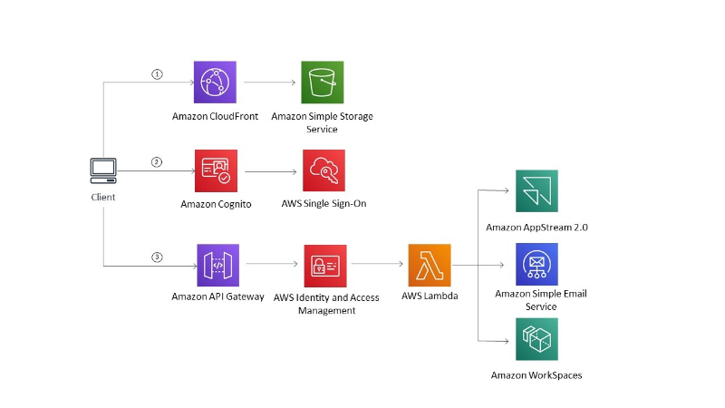

**Figure 9.1** AWS End User Computing services (AWS Documentation)

Front-end web and mobile

In an increasingly mobile and interconnected world, delivering high-quality, responsive, and engaging front-end web and mobile experiences is invaluable. AWS offers a rich portfolio of services that empower developers to build, manage, and scale applications easily. This section will explore key services that enable seamless integration, communication, and location-based functionality designed to improve front-end application development.

Amazon API gateway

Transitioning to Front-end Web and Mobile services, our journey begins with Amazon API Gateway. This service is a gateway for creating, publishing, and managing APIs, helping to integrate applications seamlessly. The chapter will navigate through the functionalities of API Gateway, emphasizing its role in building robust, scalable, and secure APIs that drive innovation in the front-end ecosystem.

Amazon location service

Geospatial applications are gaining prominence, and Amazon Location Service takes center stage in this section. We will explore how this service simplifies the integration of location-based features into applications, opening new possibilities for developers to create context-aware and location-aware user experiences.

Amazon pinpoint

Communication is essential for user engagement, and Amazon Pinpoint is a tool for improving customer interactions. Our exploration will uncover how Pinpoint enables personalized and targeted communication across multiple channels, including email, SMS, and mobile push notifications.

Amazon Simple Email Service

Email communication is still a cornerstone in the digital landscape. Amazon **Simple Email Service** (**SES**) takes center stage as we discuss its role in sending transactional and marketing emails on a large scale. We will unravel the features of SES that ensure deliverability, reliability, and compliance in email communication strategies.

AWS Amplify

AWS Amplify offers a comprehensive framework for developers building scalable and secure full-stack applications. We will enter the Amplify ecosystem, exploring how it simplifies the development process for web and mobile applications by providing a unified set of tools and services.

AWS AppSync

The chapter concludes its exploration of Front-end Web and mobile services with a detailed look at AWS AppSync. As a fully managed service, AppSync helps develop responsive and collaborative applications by enabling real-time data synchronization. We will examine its role in building GraphQL APIs and integrating with diverse data sources.

AWS Device Farm

Quality assurance is paramount in the world of mobile applications. AWS Device Farm is our destination in this chapter, providing a comprehensive testing environment for web and mobile applications. We will explore how Device Farm enhances the testing process, ensuring the reliability and functionality of applications across a myriad of devices.

This chapter provides a comprehensive examination of AWS's user-centric and front-end services. From empowering end-users with innovative computing solutions to providing developers with robust tools for crafting engaging front-end experiences, this chapter sets the stage for a comprehensive understanding of AWS services across the end-user, front-end, and mobile segments.

End-user computing

**End-user computing (EUC**) refers to the technologies, policies, and processes that enable users to securely access the applications, desktops, and data they need, often from remote locations and on various devices [1]. In modern IT environments, where remote and hybrid work is increasingly common, EUC is crucial for keeping productivity and business continuity. By allowing employees to work from anywhere using laptops, tablets, or phones, a well-designed EUC strategy ensures that staff have immediate access to the digital tools they need, without compromising security or compliance [1] [2]. In essence, EUC empowers organizations to support flexible work styles (e.g., work-from-home, bring-your-own-device) in a safe and scalable manner, making it a foundational part of cloud-era IT strategy.

AWS’s secure, scalable, and flexible EUC solutions

Cloud providers like AWS have adopted EUC by offering fully managed services that deliver desktops and applications securely and elastically from the cloud. AWS End User Computing services enable organizations to quickly provision virtual desktops and stream applications to users on demand, with AWS handling infrastructure management. These services are built with security in mind—data remains encrypted and centralized in AWS, rather than residing on user devices—and they can seamlessly scale from a few users to thousands as business needs evolve.​ [3]. Because AWS EUC solutions are device-agnostic and delivered over the Internet, employees can work from any supported device or location, enjoying the same access to tools and information for maximum flexibility.​ [3]. In short, AWS provides a robust platform to implement EUC, ensuring that end users receive a responsive, secure, and scalable experience. At the same time, IT keeps control and agility in managing those resources.

Key AWS EUC services

AWS offers different specialized services to meet EUC needs, each addressing distinct aspects of end-user computing**:**

* **Amazon WorkSpaces** – a fully managed **Desktop-as-a-Service (DaaS)** solution that delivers persistent cloud-hosted desktops to users. With Amazon WorkSpaces, organizations can provide Windows or Linux virtual desktops that employees access from anywhere on any supported device without needing to deploy or keep on-premises VDI infrastructure​ [4]. This service provides secure and reliable desktop experience over the cloud, ending the hassle of managing physical PCs for each user.
* **Amazon AppStream 2.0** – a fully managed **application streaming** service that enables users to run desktop applications directly in a web browser, cutting the need for local installations. Applications are hosted on AWS, and only the interactive streaming visuals are delivered to the user’s device. This allows organizations to manage complex centrally [3] or resource-intensive apps and securely stream them to any compatible device. Amazon AppStream 2.0 is ideal for delivering software to diverse user environments (for example, 3D design tools for Chromebooks or Macs) and converting traditional software into a Software-as-a-Service (SaaS) model without requiring rewriting.
* **AWS WorkLink** – a managed service for secure mobile access, providing one-click, **remote access to internal websites and web apps** from employees’ smartphones without a VPN. Amazon WorkLink renders internal web content in a secure container on AWS and streams it to the mobile device [5], ensuring that no sensitive corporate data is ever stored or cached on the phone's cloud. This provides field workers and remote staff with instant access to internal corporate portals or web-based tools, as if they were on the company network, while keeping strong security isolation.

**Common EUC use cases**: The flexibility and security of cloud-based EUC make it applicable to a variety of scenarios across industries:

* **Enterprise workforce**: Large companies use EUC services to support distributed teams and global offices. Instead of shipping laptops or keeping regional data centers, an enterprise can onboard new employees or contractors in minutes by provisioning cloud desktops (via WorkSpaces) pre-loaded with corporate applications. This ensures all users get a consistent, secure environment without the hassle of managing physical hardware​ [3]. EUC solutions also help when scaling up teams quickly or integrating acquisitions, as IT can deliver standardized work environments on demand.
* **Education**: Schools and universities leverage EUC to provide students and faculty access to specialized software and lab environments from anywhere. For example, Amazon AppStream 2.0 enables students to run high-performance applications (like engineering, graphic design, or STEM software) on low-cost devices through a browser, effectively turning any internet-connected computer into a powerful virtual lab​ [6]. This is invaluable for remote learning programs, computer labs, or Bring Your Device (BYOD) initiatives in education, as it ensures that every student can use required applications without needing expensive workstations.
* **Remote and hybrid workforce**: In today’s remote work era, EUC solutions enable employees to work from home or on the go while keeping access to internal systems secure. Organizations can rapidly set up virtual desktops for teleworkers and provide them with the same applications they would have in the office, all delivered through the cloud. AWS EUC services allow companies to **onboard remote workers** quickly and give them the tools and data access needed to do their jobs effectively, all while keeping sensitive data within the secure cloud environment​ [1] This capability proved critical for business continuity during events like the COVID-19 pandemic, when hundreds of millions suddenly had to work from personal devices and locations outside the office.​ [1]. A remote or hybrid work policy supported by EUC allows employees to be productive anywhere while maintaining organizational control over the work environment.

**Benefits of cloud-based EUC (security, accessibility, and management):** Adopting EUC in a cloud computing model yields different vital benefits for organizations and end users alike:

* **Security**: Cloud EUC significantly enhances data security by centralizing applications and information in the cloud rather than on endpoint devices. Only screen updates (in pixels) and user input travel between the cloud and the device, so no sensitive data is stored on laptops, tablets, or phones [1]. This reduces the risk of data loss or theft (for example, if a device is lost or stolen) and enables IT to enforce security policies in a single, centralized location, such as encryption, access control, and backups.
* **Accessibility**: EUC enhances accessibility by enabling authorized users to access their desktops or apps from anywhere and on almost any device. Whether an employee is on a home PC, a tablet while traveling, or a shared computer, they can log into their cloud-hosted workspace and find the same applications and data ready to use ​ [6]. This *work-from-anywhere* capability boosts user productivity and flexibility and ensures that work isn’t tied to a specific physical machine or office, making the organization more resilient and agile.
* **Simplified IT management**: From an IT perspective, cloud EUC streamlines the management of user computing environments. Instead of updating and troubleshooting hundreds of individual PCs, administrators can keep a golden image or a set of applications in the cloud and deploy updates centrally. AWS EUC services allow apps and desktops to be managed in one place, reducing the complexity of software distribution, patching, and hardware refresh cycles​ [1]. Scaling is simplified, with new users added instantly and resources adjusted or deactivated as needed, leading to better IT resource use and reduced costs.

In summary, end-user computing in the cloud is a notable change for organizations looking to provide secure, anywhere access to work resources. AWS’s suite of EUC services exemplifies how the cloud can deliver desktops and applications as an on-demand utility, with robust security, global accessibility, and simplified management, ultimately empowering end users and IT departments alike. Companies can enhance workforce agility and productivity by using AWS EUC solutions like WorkSpaces, AppStream 2.0, and WorkLink while strictly controlling data and compliance in a cloud-first environment. [3].​

Amazon AppStream 2.0

In the ever-evolving landscape of cloud computing, **end-user computing (EUC) is a critical area that focuses** on delivering a seamless and flexible computing experience to end-users. Amazon AppStream 2.0, a service offered by **Amazon Web Services** (**AWS**), takes center stage in this section. This service revolutionized application delivery, offering responsive and secure streaming across various devices. [7]

Amazon AppStream 2.0 is a fully managed application streaming service that enables users to securely stream desktop applications to their devices. It eliminates the need for users to install and run applications locally, providing a dynamic and scalable solution for enterprises and educational institutions. [7]

Key features and capabilities

Amazon AppStream 2.0 offers powerful features that enhance its functionality, making it a versatile choice for businesses and educational institutions. Below, we examine the key features that enable AppStream 2.0 to deliver a seamless, secure, and scalable application streaming experience across various platforms and devices.

To fully understand Amazon AppStream 2.0's impact, one must explore its features that make it a powerful cloud-based application streaming solution. By leveraging AWS’s scalable infrastructure, AppStream 2.0 delivers high-performance applications to users regardless of their device or location. The following key capabilities illustrate how AppStream 2.0 enhances accessibility, security, and performance for businesses, educational institutions, and other organizations that need flexible, on-demand application streaming.

The significance of AWS’s cloud capabilities extends beyond traditional business applications. As shown in *Figure 9.2*, AWS built a highly secure data lake and a global-scale analytics environment to help forecast the spread and risk of COVID-19. This exemplifies the scalability, resilience, and security of AWS services such as Amazon AppStream 2.0 in real-world crisis management.

***Figure 9.2:*** *Data lake solution for the COVID-19 risk study (AWS Blogs)*

Amazon AppStream 2.0 aims to solve the issues of providing desktop applications to various users on different devices. Its core features focus on improving accessibility, strengthening security, and ensuring scalable performance for various use cases. The following capabilities show how AppStream 2.0 enables organizations to provide reliable, high-performance application streaming in a secure, flexible cloud environment.

* **Application streaming:** AppStream 2.0 enables real-time application streaming, ensuring that users can access and use resource-intensive applications without requiring powerful local hardware.
* **Security and isolation:** The service prioritizes security by isolating each user session, ensuring data privacy, and preventing interactions between streaming sessions. This is important for keeping a secure computing environment.
* **Cross-platform compatibility:** AppStream 2.0 supports various devices, including Windows and Mac computers, Chromebooks, and multiple tablets. This cross-platform compatibility enhances its versatility and user accessibility.
* **Dynamic Scaling:** The service allows dynamic scaling based on the number of users, ensuring best performance during peak usage periods and cost efficiency during periods of lower demand.

Use cases

Diverse industries and segments adopted Amazon AppStream 2.0, providing tailored solutions catering to enterprise needs and educational institutions. The key use cases where AppStream 2.0's secure, scalable, and dynamic capabilities bring significant value to organizations are listed below:

* **Enterprise applications**: AppStream 2.0 enables enterprises to manage and stream resource-intensive applications to end-user devices centrally, thereby reducing the need for extensive local computing resources. [8]
* **Educational institutions**: The service helps deliver software applications to students without complex local installations, streamlining the learning process in educational settings. [9]. Amazon AppStream 2.0 presents a transformative solution in End-User Computing, offering a flexible, secure, and scalable approach to application delivery. As we explore its features, capabilities, and real-world applications, it becomes clear that AppStream 2.0 is not merely a technological advancement but a strategic tool for organizations aiming to enhance user experience and streamline application management in an increasingly digital world.

Amazon WorkSpaces

In the cloud-driven End-User Computing (EUC) landscape, the Amazon WorkSpaces Family is prominent, offering a comprehensive solution for virtualized desktops. This section explores Amazon WorkSpaces' intricacies, features, capabilities, and implications for providing end-users a flexible and secure computing environment.

Amazon WorkSpaces is a cloud-based service for provisioning and managing virtual desktops. It enables users to access their desktop environment from various devices, promoting flexibility and mobility in today's dynamic work environments. [10].

Key features and capabilities

To better understand Amazon WorkSpaces' transformative potential, let us examine its core features, which enhance usability, security, and performance for end-users. [10]:

* **Virtual desktop provisioning**: WorkSpaces simplifies creating and managing virtual desktops, allowing organizations to provision desktop environments for their users without complex on-premises infrastructure.
* **Customizable compute resources:** Users can customize the compute resources of their WorkSpaces, ensuring that each virtual desktop meets the individual user's performance requirements, from standard office applications to graphics-intensive tasks.
* **Security and compliance**: The service strongly emphasizes security, featuring encryption, multi-factor authentication, and integration with AWS Key Management Service (KMS). This ensures that sensitive data stays secure in transit and at rest.
* **Cross-device accessibility**: WorkSpaces supports access from various devices, including computers, tablets, and zero clients, providing users with a consistent desktop experience regardless of their device.

*Figure 9.3 below* highlights the architecture of Amazon WorkSpaces’ automation solution, which streamlines virtual desktop deployment and management:

***Figure 9.3****Amazon WorkSpaces automation solution architecture (AWS Blog).*

Use cases

Amazon WorkSpaces addresses various workplace scenarios. Below are key use cases where this service can significantly change the workplace.

* **Remote work environments**: WorkSpaces enables remote work by allowing users to access their desktops from any location, fostering collaboration and productivity outside the traditional office setting. [11].
* **Bring your device policies:** Organizations can implement **Bring Your Device** (**BYOD**) policies seamlessly, as WorkSpaces ensures a uniform and secure desktop experience regardless of the device used by the end-user [12].

Amazon WorkSpaces Family presents a transformative solution in End-User Computing, offering a flexible, customizable, and secure approach to virtual desktop provisioning. As organizations continue to adopt cloud technologies to enhance workforce mobility and productivity, WorkSpaces is a testament to cloud-based EUC solutions' distinct role in the modern workplace.

Front-end web and mobile

AWS provides robust services that empower developers to build, deploy, and manage front-end and mobile applications efficiently. The following figure illustrates how AWS Front-End services interact with the back end, highlighting the layered architecture that supports dynamic, user-centric applications.

**Amazon API Gateway**

In the dynamic landscape of web and mobile development, the efficient management and deployment of **Application Programming Interfaces** (**APIs**) play a fundamental role. Amazon API Gateway, a fully managed service, takes center stage in this context, providing developers with tools to create, publish, and secure APIs. This section examines the intricacies of Amazon API Gateway, its key features, and importance in modern application development.

Amazon API Gateway is a scalable and fully managed service that simplifies the creation, deployment, and management of APIs. It can be used for web, mobile, or backend services and allows seamless communication between diverse applications and services. [13].

**Key features and capabilities**

In the dynamic landscape of web and mobile development, the efficient management and deployment of **Application Programming Interfaces (APIs)** are crucial. Amazon API Gateway, a fully managed service, takes center stage in this context, providing developers with tools to create, publish, and secure APIs. This section examines the intricacies of Amazon API Gateway, its key features, and importance in modern application development. [13].

* **API creation and deployment**: API Gateway helps create RESTful APIs, WebSocket APIs, and others, providing a unified platform for developers to build and deploy their application interfaces.
* **Scalability**: The service scales automatically to manage different traffic levels, which is key for applications with fluctuating demand.
* **Security and access control**: API Gateway supports various authentication mechanisms, including AWS **Identity and Access Management** (**IAM**), OAuth, and custom authorizers. This ensures that APIs are secure and accessible only to authorized users.
* **Monitoring and analytics**: Integrated monitoring and analytics tools help developers gain insights into API usage, performance, and error rates, helping them find and address issues proactively.

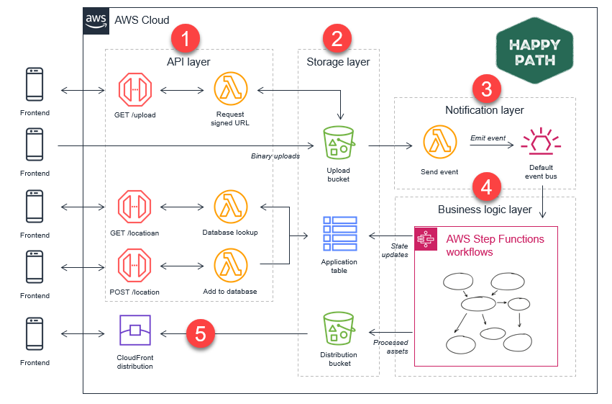

**Figure 9.4:** Front End and Back End application interactions (AWS Compare Documentation).

Use cases

The following scenarios highlight the versatility of Amazon API Gateway and its integral role in supporting modern application architecture:

* **Microservices architecture**: API Gateway is instrumental in implementing microservices architecture by acting as the entry point for various microservices, enabling efficient communication and orchestration [14].
* **Serverless architecture**: In serverless architecture, API Gateway seamlessly integrates with AWS Lambda, allowing developers to build serverless applications easily. [15].

Amazon API Gateway plays a key role in modern application development, providing a unified and scalable platform for creating, deploying, and managing APIs. As organizations strive for agility and flexibility in their application architectures, API Gateway is a testament to the innovative capabilities that cloud-based API management services bring to the forefront of web and mobile development.

The figure below describes the AWS Frontend Computing layers, presenting the architecture components that facilitate efficient and responsive user interactions (AWS Compare Documentation).

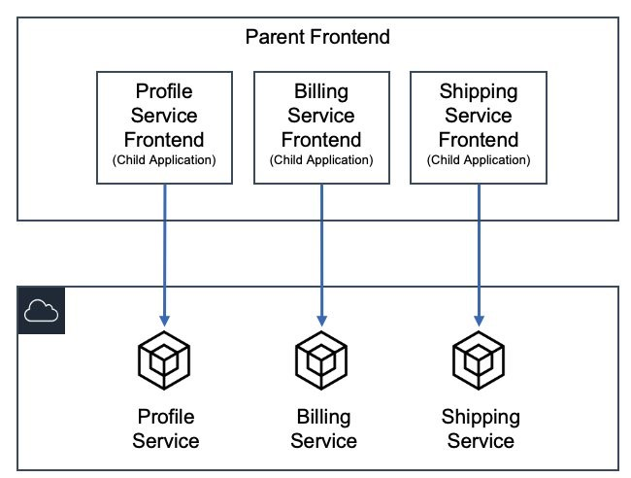

**Figure 9.5** AWS Frontend Computing layers (AWS Comprehend documentation)

Amazon location service

Geospatial data has become integral to modern applications, especially those in the realm of location-based services. Amazon Location Service is a fully managed service that enables developers to incorporate location-based features into their applications without the complexity of managing infrastructure. In this section, we detail Amazon Location Service's capabilities and applications.

Amazon Location Service enables developers to add location-based services such as maps, places, and geofencing to their applications. Leveraging data from top-tier providers, it offers a scalable and cost-effective solution for integrating location-based features into applications. [16].

Key features and capabilities

The following features of Amazon Location Service provide developers with powerful tools to build engaging and responsive applications. [16]:

* **Maps**: Amazon Location Service provides high-quality, customizable maps that developers can integrate into their applications. These maps include points of interest and terrain details.
* **Places**: Developers can incorporate location-based information into Places, making it easier for users to find and explore nearby points of interest. This feature enhances the user experience in travel, e-commerce, and social networking applications.
* **Geofencing**: Geofencing allows developers to create virtual boundaries around specific geographic areas. This feature enables applications to trigger events or notifications when users enter or exit a defined location, enhancing user experience personalization.

Integration with other AWS services

Amazon Location Service seamlessly integrates with other AWS services, fostering interoperability within the AWS ecosystem. Integration with AWS IAM ensures secure access control to location resources.

Use cases

The following examples illustrate how Amazon Location Service can improve operations and user interactions across different applications:

* **Asset tracking**: Amazon Location Service helps with real-time tracking of assets, which is valuable in scenarios such as planning and supply chain management [17].
* **Fleet management**: Applications related to fleet management can leverage geofencing capabilities to improve routes, watch vehicle locations, and enhance overall operational efficiency [18].

Amazon Location Service appears to be a transformative tool for developers looking to enhance their applications with location-based features. This service enables developers to create engaging and personalized experiences for end-users across diverse areas by providing access to high-quality maps, location data, and geofencing capabilities.

Amazon pinpoint

In the ever-evolving digital communication landscape, engaging users successfully is paramount for the success of applications. Amazon Pinpoint, a fully managed AWS service, plays a key role by enabling developers to understand, segment, and target their audience with personalized and prompt messages. In this section, we explore Amazon Pinpoint's features and functionalities.

Amazon Pinpoint is a versatile service designed to help developers communicate with end-users in targeted ways across various channels, including email, SMS, and mobile push notifications. It provides analytics and insights that empower developers to refine their communication strategies and enhance user engagement. [19].

Key features and capabilities

Below are the key features of Amazon Pinpoint that equip developers to build effective, multi-channel communication strategies: [19].

* **User engagement analysis**: Amazon Pinpoint provides detailed analytics on user engagement, offering developers insights into user behavior, preferences, and interactions with the application. This data-driven approach enables the optimization of communication strategies.
* **Multi-channel communication**: The service supports a range of communication channels, including email, SMS, and push notifications. This multi-channel capability enables developers to reach users through their preferred communication channels, thereby increasing the efficiency of their messages.
* **Personalization**: Amazon Pinpoint enables developers to create personalized messages based on user attributes and behavior. This personalization enhances user experience and fosters a connection with the application.
* **Journey orchestration**: Developers can design customer journeys by defining communication workflows based on user actions and interactions. This feature ensures that users receive relevant messages at distinct stages of their interaction with the application.

Integration with other AWS services

Amazon Pinpoint seamlessly integrates with other AWS services, enhancing its capabilities and extending its reach within the AWS ecosystem. Integration with Amazon **Simple Notification Service** (**SNS**) and AWS Identity and Access Management ensures secure and efficient communication.

Use cases

Here are practical ways organizations can use Amazon Pinpoint to drive user engagement:

* **Marketing campaigns**: Amazon Pinpoint is instrumental in orchestrating targeted marketing campaigns, delivering personalized promotions, and analyzing campaign performance [20].
* **User onboarding**: Developers can use the service to guide users through onboarding processes by sending prompts and relevant information, thereby enhancing the overall user experience [21].

Amazon Pinpoint is a valuable tool for developers looking to enhance user engagement through targeted and personalized communication. By offering a range of communication channels, robust analytics, and the ability to create personalized customer journeys, Amazon Pinpoint empowers developers to build applications that resonate with their audience, contributing to the success of their digital initiatives.

Amazon Simple Email Service (SES)

Email communication is still a cornerstone for engaging end-users, and Amazon SES is a cloud-based solution provided by AWS to help with scalable and cost-effective email sending. This section explores Amazon SES's features and functionalities, exploring its reliable and secure email communication capabilities.

Amazon SES streamlines the process of sending transactional and marketing emails. It provides a reliable infrastructure for email delivery that is scalable to meet the demands of businesses of all sizes. By leveraging AWS's cloud infrastructure, SES ensures high deliverability rates while offering flexibility and better cost. [22].

Key features and capabilities

The following key features make Amazon SES an efficient choice for handling email communication needs. [22]:

* **Email sending**: Amazon SES enables developers to send various email types, including transactional and marketing emails. Its robust infrastructure ensures reliable delivery and easy integration with applications and systems.
* **Deliverability**: With features like dedicated IP addresses, content filtering, and bounce and complaint tracking, Amazon SES prioritizes high deliverability rates. This is relevant for ensuring that emails reach the intended recipients' inboxes.
* **Content personalization:** Developers can personalize email content using dynamic variables, allowing for customizing messages based on user attributes or behaviors. This personalization enhances user engagement and the overall efficiency of email campaigns.
* **Integration with AWS ecosystem:** Amazon SES seamlessly integrates with other AWS services, such as AWS Lambda and Amazon S3. This integration enhances SES's capabilities, allowing developers to build comprehensive and automated email workflows.

Security and compliance

Amazon SES prioritizes security and compliance, implementing measures to protect against spam, phishing, and other email-related threats. Features like **DomainKeys Identified Mail** (**DKIM**) and **Sender Policy Framework** (**SPF**) authentication contribute to the security of email communications.

Use cases

Here are typical applications of Amazon SES that highlight its versatility:

* **Transactional emails**: Amazon SES is well-suited for sending transactional emails, such as order confirmations, password resets, and other personalized communications [23].
* **Marketing campaigns**: Developers can use Amazon SES for marketing campaigns, ensuring that promotional emails reach a broad audience reliably [24].

Amazon SES is a robust solution for businesses and developers looking to set up reliable and scalable email communication. Focusing on deliverability, security, and integration with the broader AWS ecosystem, SES offers a comprehensive platform for both transactional and marketing email needs. Its flexibility and cost savings make it a valuable tool for organizations looking to enhance their email communication strategies.

AWS amplify

AWS Amplify is a comprehensive set of tools and services designed to streamline building scalable and feature-rich front-end applications in the ever-evolving web and mobile application development landscape. This section explores the functionalities and benefits of AWS Amplify and its role in simplifying the development lifecycle.

AWS Amplify is a development platform for building and deploying full-stack web and mobile applications. Focusing on providing developers with seamless experience, Amplify integrates with popular frameworks and services, creating modern, serverless applications. [25].

Key features and capabilities

The following features make AWS Amplify an invaluable tool for developers to build efficient and scalable applications. [25]:

* **Front-end framework agnostic**: AWS Amplify supports React, Angular, and Vue.js front-end frameworks. This framework agnosticism enhances developer flexibility, allowing them to use the tools with which they are most comfortable.
* **Authentication and authorization**: Amplify simplifies user authentication and authorization processes, offering built-in authentication workflows and support for social identity providers. This streamlines the implementation of secure user access controls.
* **API management**: With Amplify, developers can easily manage REST and GraphQL APIs. The platform streamlines the creation and integration of APIs, enabling developers to connect their applications to various data sources efficiently.
* **CI/CD integration**: Continuous integration and deployment (CI/CD) are integral to modern application development. AWS Amplify integrates popular CI/CD tools, automating web and mobile application build, test, and deployment processes.

*Figure 9.6* illustrates the typical Amplify architecture within an AWS Region, highlighting its integration capabilities and streamlined structure for deploying robust applications across AWS:

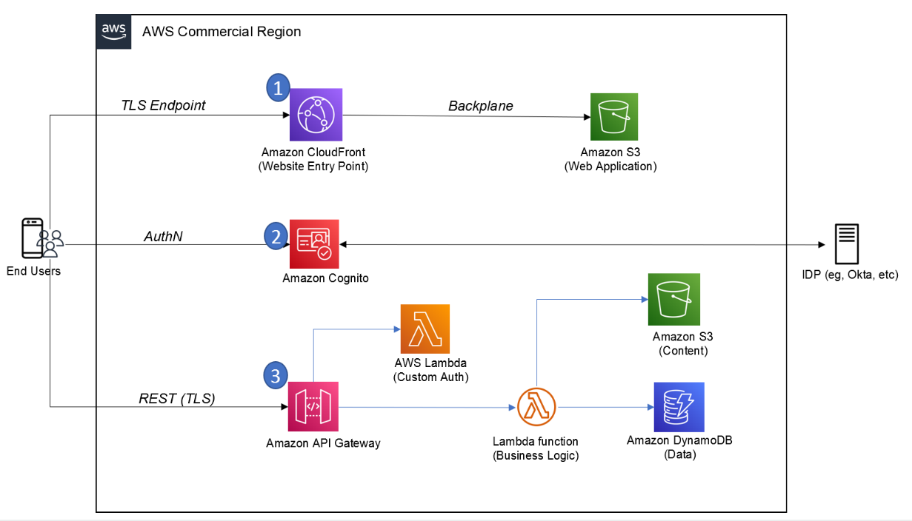

**Figure 9.6** Common Amplify Architecture in an AWS Region (AWS Blogs)

Serverless functionality

AWS Amplify promotes serverless architecture, allowing developers to focus on building features without managing the underlying infrastructure. Serverless functions enhance application functionality and scalability. [26].

Scalability and performance

Amplify applications use the scalability and performance features offered by AWS services. This ensures that applications can manage varying workloads and deliver a responsive user experience. [27].

AWS Amplify is a versatile and powerful toolset for developers venturing into front-end web and mobile application development. Amplify accelerates the development lifecycle with its flexibility, integration capabilities, and focus on simplifying complex tasks. Whether managing authentication, integrating APIs, or implementing serverless functions, Amplify provides a cohesive platform that aligns with the modern demands of building responsive and scalable applications.

AWS AppSync

AWS AppSync is a powerful service that simplifies building scalable and interactive applications in the dynamic realm of front-end web and mobile development. This section examines its functionalities and features, highlighting its role in efficiently synchronizing and communicating data between applications and backend services.

AWS AppSync is a managed service that enables developers to create flexible and scalable APIs for applications by controlling the heavy lifting of securely connecting to data sources such as AWS DynamoDB, Lambda, or HTTP data sources. It plays a relevant role in simplifying data fetching, updates, and real-time data synchronization across various platforms. [28].

Key features and capabilities

The following key features highlight AWS AppSync's extensive functionality for front-end application developers. [28]:

* **GraphQL as a service**: AWS AppSync utilizes GraphQL, a powerful query language for APIs, providing a flexible and efficient way to request and deliver data. This enables clients to order only the needed data, reducing over-fetching and improving performance.
* **Real-time data synchronization**: One of AppSync's standout features is its support for real-time data synchronization. This enables developers to build applications that receive real-time backend updates, enhancing the overall user experience.
* **Offline data access**: AppSync includes features for offline data access, allowing applications to be still functional even when there is no internet connection. This is particularly valuable for mobile applications that need to provide a seamless user experience in various network conditions.
* **Data source integration**: The service seamlessly integrates with various data sources, including AWS DynamoDB, AWS Lambda, and HTTP data sources. This flexibility allows developers to use different backend services based on their application requirements.

Serverless functionality

AWS AppSync's serverless architecture cuts the need for developers to manage servers. This serverless approach enables automatic scaling based on demand, ensuring the best performance under varying workloads. [29].

AWS AppSync appears as an asset for developers in the front-end web and mobile development space, offering a robust and scalable solution for building APIs [30]. Whether enabling real-time data synchronization, supporting offline access, or seamlessly integrating with various data sources, AppSync empowers developers to create responsive and feature-rich applications. Its adoption of GraphQL as a service further enhances its capabilities, providing a modern and efficient approach to data communication in the cloud.

AWS Device Farm

In the ever-evolving landscape of front-end web and mobile development, ensuring the seamless functionality of applications across various devices and platforms is paramount [31]. AWS Device Farm is a comprehensive testing service, allowing developers to enhance the quality and reliability of their applications by conducting tests on a diverse range of real devices. This section provides an in-depth exploration of AWS Device Farm, elucidating its features, advantages, and the significant role it plays in improving the end-user experience.

AWS Device Farm is a cloud-based mobile application testing service that enables developers to run tests on real devices, ensuring their applications perform optimally across different devices, screen sizes, and operating systems. This service supports Android and iOS platforms, offering a more efficient solution for testing applications on real devices in the AWS Cloud. [32].

Key features and capabilities

The following features underscore AWS Device Farm's extensive support for mobile application testing, highlighting how it improves testing accuracy and efficiency: [32]

* **Real device testing**: AWS Device Farm provides access to a vast collection of real devices, allowing developers to execute tests on actual hardware rather than relying solely on emulators. This ensures a more correct representation of the application's behavior in real-world scenarios.
* **Parallel testing**: The service supports parallel testing, enabling developers to execute tests concurrently on multiple devices. This accelerates the testing process, saving time and resources.
* **Appium and Selenium compatibility**: Device Farm is compatible with popular testing frameworks, including Appium and Selenium, providing flexibility for developers who prefer these frameworks for their testing processes.
* **Remote access**: During testing, developers can remotely access and interact with devices in real time. This feature is incomparable for diagnosing issues and gaining insights into the application's behavior on specific devices.
* **Built-in test reports**: Device Farm generates detailed test reports, including logs, screenshots, and videos of the test execution. This comprehensive feedback aids developers in finding and resolving issues efficiently.

AWS Device Farm is a valuable tool for front-end web and mobile development developers. It provides a robust testing environment on real devices. By offering a diverse array of devices, supporting parallel testing, and integrating seamlessly with popular testing frameworks, Device Farm empowers developers to identify and rectify issues early in the development lifecycle. [33]. The service's ability to generate comprehensive test reports further helps a streamlined testing process, contributing to delivering high-quality and reliable mobile applications to end-users.

*Figure 10.7* illustrates an example of web applications hosted in a private network using AWS Device Farm, highlighting the practical application of this testing environment within secure configurations:

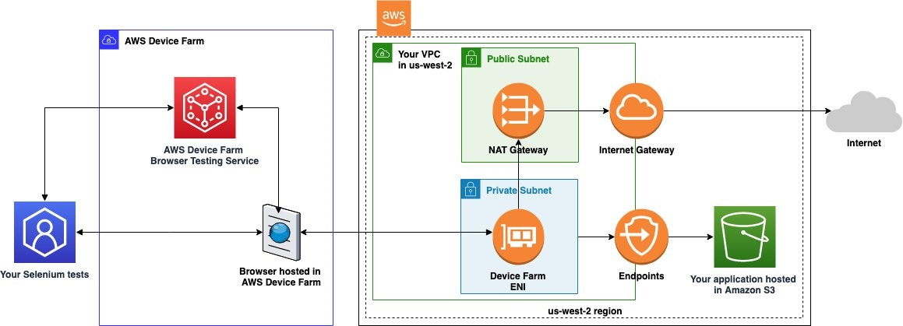

**Figure 10.7**Web applications using AWS Device Farm (AWS Blogs)

Reflecting further

*Chapter 10, End User, Front End, and Mobile*, provides a detailed exploration of AWS services essential for delivering seamless and innovative user experiences. These services are vital in transforming application development, deployment, and usage.

End user computing

Within the **Amazon AppStream 2.0 and Amazon WorkSpaces Family**, we explored the future of end-user computing. The ability to stream resource-intensive applications and provide virtual desktops on demand not only enhances user flexibility but also ensures data security and compliance. This becomes particularly important in the evolving remote work landscape, where organizations seek scalable solutions for delivering a consistent and secure computing experience to their workforce. [7] [10] [34]

Front-end web and mobile

The journey through **Amazon API Gateway** highlighted its defining role as a fully managed service for creating, publishing, and securing APIs at any scale. The service bridges back-end services and front-end applications, helping ensure seamless communication and integration. **Amazon Location Service** introduced a geospatial dimension, enabling developers to build location-aware applications. **Amazon Pinpoint** and **Amazon SES** underscore the significance of targeted communication, with Pinpoint providing personalized engagement across multiple channels and SES ensuring reliable and scalable email communication. [13] [16] [19] [22].

The trifecta of **AWS Amplify, AWS AppSync, and AWS Device Farm** showcases AWS's commitment to simplifying front-end development. **AWS Amplify** streamlines the development process, allowing developers to build scalable and secure cloud-powered web and mobile apps. **AWS AppSync** simplifies application development by enabling real-time data synchronization and offline data access, which is relevant for responsive and user-friendly applications. **AWS Device Farm** facilitates continuous testing, ensuring that applications function seamlessly across a myriad of devices, browsers, and operating systems [25] [28] [32] [36].

Conclusion

In conclusion, *Chapter 10, End User, Front End, and Mobile*, has unraveled the diverse sides of AWS services catering to end-user computing and front-end development. The flexibility, scalability, and user-centric design embedded in these services position AWS as a pioneer in the cloud computing landscape. In addition, these services are not merely tools but enablers of innovation, playing a significant role in shaping the future of user interactions, mobile experiences, and front-end development.

As technology advances, AWS stays at the forefront, continually refining and expanding its services to meet the evolving demands of the digital landscape. This chapter serves as a testament to the integral role AWS plays in empowering developers and organizations to create innovative applications that redefine the boundaries of user experiences.

The next chapter will examine DevOps and Infrastructure as Code (IaC), highlighting AWS tools and services that enhance automation, configuration management, and deployment workflows.