CHAPTER 9

**End User, Front End and Mobile**

# Introduction

In the dynamic landscape of cloud computing, empowering end-users and enabling seamless front-end interactions is critical for modern applications, especially across web and mobile platforms. AWS offers a range of tools and services to help this, enhancing both user experience and development agility. This chapter navigates through these essential AWS services, focusing on end-user computing, front-end web development, and mobile application integration, while exploring how they contribute to building powerful, user-centric applications.

## In this chapter, we will cover:

In this chapter, we will cover the following. The chapter has two main sections:

* End User Computing
  + Amazon AppStream 2.0
  + Amazon WorkSpaces Family
* Front-end Web & Mobile
* Amazon API Gateway
* Amazon Location Service
* Amazon Pinpoint
* Amazon Simple Email Service (SES)
* AWS Amplify
* AWS AppSync
* AWS Device Farm

## Objectives

In Chapter 9, readers will explore how AWS empowers End User Computing through services like Amazon AppStream 2.0 and Amazon WorkSpaces, providing flexible and secure computing environments. This will examine Front-end Web & Mobile services using AWS tools like API Gateway, Location Service, Pinpoint, and SES to build responsive, scalable, and secure apps. Additionally, the chapter will cover AWS Amplify and AppSync, simplifying web and mobile development with real-time data synchronization and API management. Quality assurance best practices using AWS Device Farm will ensure applications perform optimally across diverse devices.

This chapter will equip readers with the knowledge to empower end-users, build secure APIs, integrate location-based services, streamline mobile development, and ensure top-quality testing and performance for web and mobile applications.

End User Computing

In today’s increasingly remote and digital-first world, the need for robust, flexible, and scalable end-user computing solutions has never been greater. AWS provides a comprehensive suite of services designed to meet organizational needs, helping secure and high-performance access to applications and desktops regardless of user location. In this section, we will explore key AWS offerings in the realm of end-user computing and examine how these solutions drive productivity, security, and efficiency.

In the dynamic landscape of cloud computing, the empowerment of end-users and the seamless interaction with front-end applications, especially in web and mobile space, are key factors. This chapter explores the multifaceted aspects of End User Computing and the intricacies of Front-end Web and mobile services provided by **Amazon Web Services** (**AWS**).

In the *Figure 9.1,* below you will find a high-level architecture showingWe explain common EUC technologies such as **virtual desktop infrastructure** (**VDI**); **Desktop as a Service** (**DaaS**), **and application as a service:**

***Figure 9.1:*** *AWS End User Computing services (AWS Documentation)*

# Amazon AppStream 2.0

In the ever-evolving landscape of cloud computing, **End User Computing** (**EUC**) stands as a critical area, focusing on delivering a seamless and flexible computing experience to end-users. Amazon AppStream 2.0, a service offered by **Amazon Web Services** (**AWS**), takes center stage in this section. This service transformed application delivery, providing responsive and secure streaming for various devices.

Amazon AppStream 2.0 Overview

Amazon AppStream 2.0 is a fully managed application streaming service that allows users to stream desktop applications securely to their devices. It cuts the need for users to install and run applications locally, providing a dynamic and scalable solution for both enterprises and educational institutions (Amazon Web Services, 2003).

Key Features and Capabilities

Amazon AppStream 2.0 offers a wide array of powerful features that enhance its functionality and make it a versatile choice for businesses and educational institutions alike. Below, we explore key features that allow AppStream 2.0 to deliver a seamless, secure, and scalable application streaming experience across various platforms and devices.

* **Application Streaming:** AppStream 2.0 enables the streaming of applications in real-time, ensuring that users can access and use resource-intensive applications without the need for powerful local hardware.
* **Security and Isolation:** The service prioritizes security by isolating each user session, ensuring data privacy, and preventing interactions between streaming sessions. This is important for keeping a secure computing environment.
* **Cross-Platform Compatibility:** AppStream 2.0 supports a wide range of devices, including Windows and Mac computers, Chromebooks, and various tablets. This cross-platform compatibility enhances its versatility and user accessibility.
* **Dynamic Scaling:** The service allows for dynamic scaling based on the number of users, ensuring best performance during peak usage periods and cost efficiency during periods of lower demand.

The significance of AWS’s cloud capabilities extends beyond traditional business applications. As shown in *Figure 9.2*, AWS built a highly secure data lake and a global-scale analytics environment to help in forecasting the spread and risk of COVID-110, exemplifying the scalability, resilience, and security of AWS services such as Amazon AppStream 2.0 in real-world crisis management.

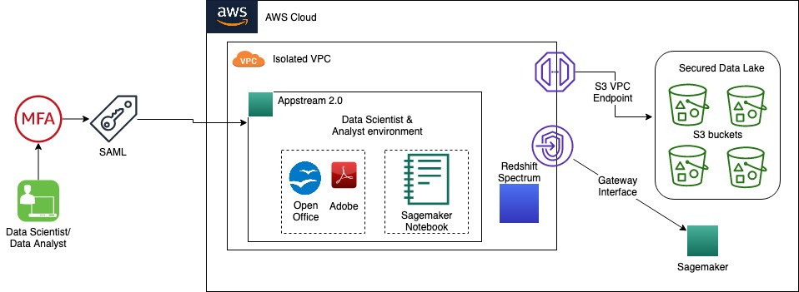

**Figure 9.2:** Amazon built secure data lake solution for the COVID-19spread risk study (AWS Blogs).

Use Cases

Diverse industries and segments adopted Amazon AppStream 2.0, providing tailored solutions that cater to both enterprise needs and educational institutions. Below are key use cases where AppStream 2.0's secure, scalable, and dynamic capabilities bring significant value to organizations.

* **Enterprise Applications**

AppStream 2.0 finds applications in enterprises where resource-intensive applications can be centrally managed and streamed to end-user devices, reducing the need for extensive local computing resources (Smith & Jones, Revolutionizing End User Computing: A Case Study of Amazon AppStream 2.0., 2019).

* **Educational Institutions**

In educational settings, the service helps the delivery of software applications to students without the need for complex local installations, streamlining the learning process (Brown M. e., 2020).

Amazon AppStream 2.0 appears as a transformative solution in the realm of End User Computing, offering a flexible, secure, and scalable approach to application delivery. As we explore its features, capabilities, and real-world applications, it becomes clear that AppStream 2.0 is not merely a technological advancement but a strategic tool for organizations aiming to enhance user experiences and streamline application management in an increasingly digital world.

Amazon WorkSpaces Family

In the landscape of cloud-driven **End User Computing** (**EUC**), the Amazon WorkSpaces Family takes a prominent position, offering a comprehensive solution for virtualized desktops. This section explores the intricacies of Amazon WorkSpaces, exploring its features, capabilities, and the broader implications it has for providing a flexible and secure computing environment to end-users.

Amazon WorkSpaces Overview

Amazon WorkSpaces is a cloud-based service that helps the provisioning and management of virtual desktops. It enables users to access their desktop environment from a variety of devices, fostering flexibility and mobility in today's dynamic work scenarios (Amazon Web Services, 2003).

Key Features and Capabilities

To better understand the transformative potential of Amazon WorkSpaces, let’s explore some of its core features that enhance usability, security, and performance for end users (Amazon Web Services, 2003):

* **Virtual Desktop Provisioning**

WorkSpaces simplifies the process of creating and managing virtual desktops, allowing organizations to provision desktop environments for their users without the need for complex on-premises infrastructure.

* **Customizable Compute Resources:**

Users can customize the compute resources of their WorkSpaces, ensuring that each virtual desktop meets the performance requirements of the individual user, from standard office applications to graphics-intensive tasks.

* **Security and Compliance**

The service places a strong emphasis on security, with features such as encryption, multi-factor authentication, and integration with AWS Key Management Service (KMS). This ensures that sensitive data stays secure in transit and at rest.

* **Cross-Device Accessibility**

WorkSpaces supports access from a variety of devices, including computers, tablets, and zero clients, providing users with a consistent desktop experience regardless of the device they use.

Use Cases

Amazon WorkSpaces addresses various workplace scenarios. Below are key use cases where this service can make a significant impact.

* **Remote Work Environments**

WorkSpaces is instrumental in enabling remote work by allowing users to access their desktops from any location, fostering collaboration and productivity outside the traditional office setting (Anderson, 2018).

* **BYOD (Bring Your Device) Policies**

Organizations can implement BYOD policies seamlessly, as WorkSpaces ensures a uniform and secure desktop experience regardless of the device used by the end-user (Garcia & Patel, 2021).

Amazon WorkSpaces Family appears as a transformative solution in the realm of End User Computing, offering a flexible, customizable, and secure approach to virtual desktop provisioning. As organizations continue to embrace cloud technologies for enhancing workforce mobility and productivity, WorkSpaces stands as a testament to the differential role that cloud-based EUC solutions play in the modern workplace.

The following illustration highlights the architecture of Amazon WorkSpaces’ automation solution, which streamlines virtual desktop deployment and management:

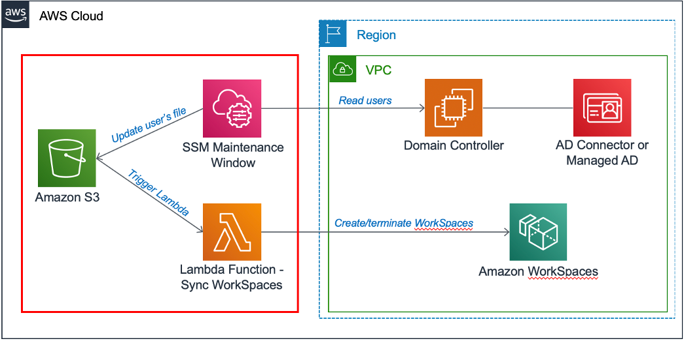

**Figure 9.3:** Amazon WorkSpaces automation solution architecture (AWS Blog).

Front-end Web and Mobile

AWS provides a suite of robust services that empower developers to build, deploy, and manage front-end and mobile applications with efficiency and scalability. The following figure illustrates how AWS Front-End services interact with the back end, highlighting the layered architecture that supports dynamic, user-centric applications.

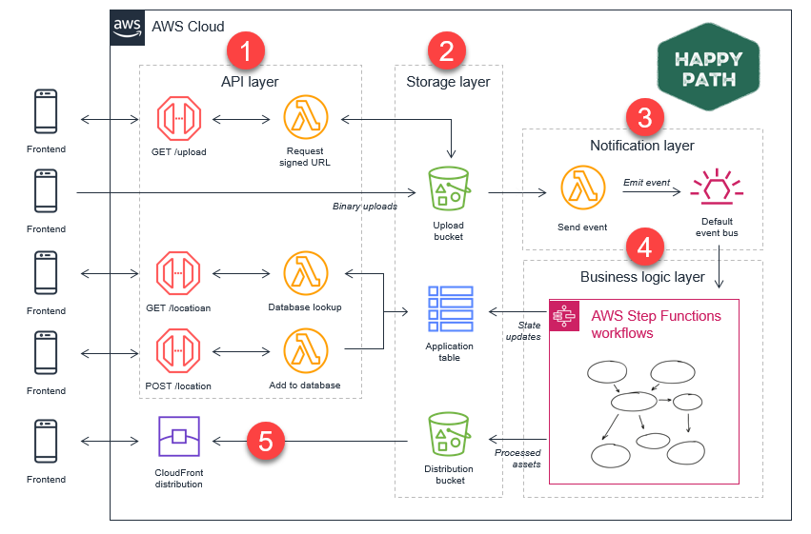

**Figure 9.4:** ASW Front End interactions with the Back End of an application (AWS Compare Documentation).

Amazon API Gateway

In the dynamic landscape of web and mobile development, efficient management, and deployment of **Application Programming Interfaces** (**APIs**) play a fundamental role. Amazon API Gateway, a fully managed service, takes center stage in this context, providing developers with tools to create, publish, and secure APIs. This section explores the intricacies of Amazon API Gateway, its features, and its significance in modern application development.

Amazon API Gateway Overview

Amazon API Gateway is a scalable and fully managed service that simplifies the creation, deployment, and management of APIs. Whether catering to web applications, mobile applications, or backend services, API Gateway acts as a gateway that allows seamless communication between diverse applications and services (Amazon Web Services, 2003).

Key Features and Capabilities

In the dynamic landscape of web and mobile development, efficient management, and deployment of Application Programming Interfaces (APIs) play a crucial role. Amazon API Gateway, a fully managed service, takes center stage in this context, providing developers with tools to create, publish, and secure APIs. This section explores the intricacies of Amazon API Gateway, its features, and its significance in modern application development (Amazon Web Services, 2003).

* **API Creation and Deployment**

API Gateway helps the creation of RESTful APIs, WebSocket APIs, and other types of APIs, providing a unified platform for developers to build and deploy their application interfaces.

* **Scalability**

The service scales automatically to manage different traffic levels. This scalability is key for applications with fluctuating demand.

* **Security and Access Control**

API Gateway supports various authentication mechanisms, including AWS Identity and Access Management (IAM), OAuth, and custom authorizers. This ensures that APIs are secure and accessible only to authorized users.

* **Monitoring and Analytics**

Developers can gain insights into API usage, performance, and error rates through integrated monitoring and analytics tools. This helps in finding and addressing issues proactively.

Use Cases

The following scenarios highlight the versatility of Amazon API Gateway and its integral role in supporting modern application architectures.

* **Microservices Architecture**

API Gateway is instrumental in implementing microservices architecture by acting as the entry point for various microservices, enabling efficient communication and orchestration (Fielding, 2000).

* **Serverless Architectures**

In serverless architectures, API Gateway seamlessly integrates with AWS Lambda, allowing developers to build serverless applications with ease (Richardson, Amundsen, & Ruby, 2013).

Amazon API Gateway appears as a key part in modern application development, providing a unified and scalable platform for creating, deploying, and managing APIs. As organizations strive for agility and flexibility in their application architectures, API Gateway stands as a testament to the innovative capabilities that cloud-based API management services bring to the forefront of web and mobile development.

The following figure illustrates AWS Frontend Computing layers, detailing the architecture components that power efficient, responsive user experiences (AWS Compare Documentation

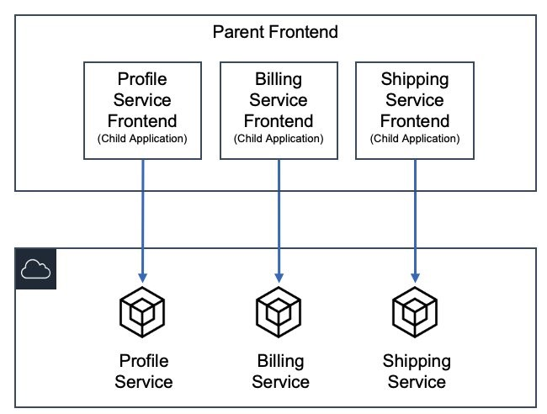

**Figure 9.5:** AWS Frontend Computing layers (AWS Compre documentation).

Amazon Location Service

Geospatial data has become integral to modern applications, especially those in the realm of location-based services. Amazon Location Service is a fully managed service by AWS that empowers developers to include location-based features in their applications without the complexity of managing infrastructure. In this section, we detail the capabilities and applications of Amazon Location Service.

Amazon Location Service Overview

Amazon Location Service enables developers to add location-based services such as maps, places, and geofencing to their applications. Leveraging data from top-tier providers, it offers a scalable and cost-effective solution for integrating location-based features into applications (Amazon Web Services, 2003).

Key Features and Capabilities

The following features of Amazon Location Service provide developers with powerful tools to build engaging and responsive applications (Amazon Web Services, 2003).

* **Maps**

Amazon Location Service provides high-quality, customizable maps that developers can integrate into their applications. These maps include points of interest and terrain details.

* **Places**

Developers can use Places to incorporate location-based information, making it easier for users to find and explore nearby points of interest. This feature enhances the user experience in applications such as travel, e-commerce, and social networking.

* **Geofencing**

Geofencing allows developers to create virtual boundaries around specific geographic areas. This feature enables applications to trigger events or notifications when a user enters or exits a defined location, enhancing the personalization of user experiences.

Integration with Other AWS Services

Amazon Location Service seamlessly integrates with other AWS services, fostering interoperability within the AWS ecosystem. For instance, integration with AWS **Identity and Access Management** (**IAM**) ensures secure access control to location resources.

Use Cases

The following examples illustrate how Amazon Location Service can improve operations and improve user interactions across different applications:

* **Asset Tracking**

Amazon Location Service helps real-time tracking of assets, which is valuable in scenarios such as planning and supply chain management (Longley, Goodchild, Maguire, & Rhind, 2015).

* **Fleet Management**

Applications related to fleet management can leverage geofencing capabilities to improve routes, watch vehicle locations, and enhance overall operational efficiency (Craglia, Bie, Jackson, Pesaresi, & Remetey-Fülöpp, 2012).

Amazon Location Service appears as a transformative tool for developers looking to enhance their applications with location-based features. By providing access to high-quality maps, location data, and geofencing capabilities, this service empowers developers to create compelling and personalized experiences for end-users in diverse areas.

Amazon Pinpoint

In the ever-evolving landscape of digital communication, engaging users successfully is paramount for the success of applications. Amazon Pinpoint, a fully managed AWS service, plays a key role in this area by enabling developers to understand, segment, and target their audience with personalized and prompt messages. In this section, we explore the features and functionalities of Amazon Pinpoint.

Amazon Pinpoint Overview

Amazon Pinpoint is a versatile service designed to help targeted communication with end-users across various channels, including email, SMS, and mobile push notifications. It provides analytics and insights that empower developers to refine their communication strategies and enhance user engagement (Amazon Web Services, 2023).

Key Features and Capabilities

Below are the key features of Amazon Pinpoint that equip developers to build effective, multi-channel communication strategies: (Amazon Web Services, 2023).

* **User Engagement Analysis**

Amazon Pinpoint offers detailed analytics on user engagement, providing developers with insights into user behavior, preferences, and interactions with the application. This data-driven approach enables the optimization of communication strategies.

* **Multi-Channel Communication**

The service supports a range of communication channels, including email, SMS, and push notifications. This multi-channel capability allows developers to reach users through their preferred communication channels, increasing the efficiency of messages.

* **Personalization**

Amazon Pinpoint enables developers to create personalized messages based on user attributes and behavior. This personalization enhances user experience and fosters a sense of connection with the application.

* **Journey Orchestration**

Developers can design customer journeys by defining communication workflows based on user actions. This feature ensures that users receive relevant messages at distinct stages of their interaction with the application.

Integration with Other AWS Services

Amazon Pinpoint seamlessly integrates with other AWS services, enhancing its capabilities and extending its reach within the AWS ecosystem. Integration with Amazon **Simple Notification Service** (**SNS**) and AWS Identity and Access Management ensures secure and efficient communication13.

Use Cases

Here are practical ways organizations can use Amazon Pinpoint to drive user engagement:

* **Marketing Campaigns**

Amazon Pinpoint is instrumental in orchestrating targeted marketing campaigns, delivering personalized promotions, and analyzing campaign performance (Smith & Johnson, 2018).

* **User Onboarding**

Developers can use the service to guide users through onboarding processes by sending prompt and relevant information, thereby enhancing the overall user experience (Gupta & Zeithaml, 2006).

Amazon Pinpoint appears as a valuable tool for developers looking to improve user engagement through targeted and personalized communication. By offering a range of communication channels, robust analytics, and the ability to create personalized customer journeys, Amazon Pinpoint empowers developers to build applications that resonate with their audience, contributing to the success of their digital initiatives.

Amazon Simple Email Service

Communication through email stays a cornerstone in engaging end-users, and Amazon **Simple Email Service** (**SES**) is a cloud-based solution provided by AWS to help scalable and cost-effective email sending. In this section, we explore the features and functionalities of Amazon SES, exploring its capabilities in delivering reliable and secure email communication.

Amazon SES Overview

Amazon SES streamlines the process of sending transactional and marketing emails. It provides a reliable infrastructure for email delivery, scalable to meet the demands of businesses of all sizes. By leveraging AWS's cloud infrastructure, SES ensures high deliverability rates while offering flexibility and better cost (Amazon Web Services, 2023).

Key Features and Capabilities

The following key features make Amazon SES an efficient choice for handling email communication needs (Amazon Web Services, 2023):

* **Email Sending**

Amazon SES enables developers to send a variety of email types, including transactional and marketing emails. Its robust infrastructure ensures reliable delivery while allowing for easy integration with applications and systems.

* **Deliverability**

With features like dedicated IP addresses, content filtering, and bounce and complaint tracking, Amazon SES prioritizes high deliverability rates. This is relevant for ensuring that emails reach the intended recipients' inboxes.

* **Content Personalization:**

Developers can personalize email content using dynamic variables, allowing for the customization of messages based on user attributes or behaviors. This personalization enhances user engagement and the overall efficiency of email campaigns.

* **Integration with AWS Ecosystem:**

Amazon SES seamlessly integrates with other AWS services, such as AWS Lambda and Amazon S3. This integration enhances SES's capabilities, allowing developers to build comprehensive and automated email workflows.

Security and Compliance

Amazon SES prioritizes security and compliance, implementing measures to protect against spam, phishing, and other email-related threats. Features like **DKIM** (**DomainKeys Identified Mail**) and **SPF** (**Sender Policy Framework**) authentication contribute to the security of email communications.

Use Cases

Here are common applications of Amazon SES that highlight its versatility:

* **Transactional Emails**

Amazon SES is well-suited for sending transactional emails, such as order confirmations, password resets, and other personalized communications (Brown J. , 2019).

* **Marketing Campaigns**

Developers can use Amazon SES for marketing campaigns, ensuring that promotional emails reach a wide audience reliably (Sharma, 2016).

Amazon SES appears as a robust solution for businesses and developers looking to set up reliable and scalable email communication. With a focus on deliverability, security, and integration with the broader AWS ecosystem, SES offers a comprehensive platform for both transactional and marketing email needs. Its flexibility and cost savings make it a valuable tool for organizations looking to enhance their email communication strategies.

AWS Amplify

In the ever-evolving landscape of web and mobile application development, AWS Amplify stands out as a comprehensive set of tools and services designed to streamline the process of building scalable and feature-rich front-end applications. This section explores the functionalities and benefits of AWS Amplify, exploring its role in simplifying the development lifecycle.

AWS Amplify Overview

AWS Amplify is a development platform that helps the building and deployment of full-stack web and mobile applications. With a focus on providing developers with a seamless experience, Amplify integrates with popular frameworks and services, enabling the creation of modern, serverless applications (Amazon Web Services, 2023).

Key Features and Capabilities

The following features make AWS Amplify an invaluable tool for developers focused on building efficient and scalable applications (Amazon Web Services, 2023):

* **Front-end Framework Agnostic**

AWS Amplify supports React, Angular, and Vue.js front-end frameworks. This framework agnosticism enhances developer flexibility, allowing them to use the tools with which they are most comfortable.

* **Authentication and Authorization**

Amplify simplifies user authentication and authorization processes, offering built-in authentication workflows and support for social identity providers. This streamlines the implementation of secure user access controls.

* **API Management**

With Amplify, developers can easily manage APIs, both REST and GraphQL. The platform simplifies the creation and integration of APIs, making it efficient for developers to connect their applications to various data sources.

* **CI/CD Integration**

Continuous integration and deployment (CI/CD) are integral to modern application development. AWS Amplify integrates with popular CI/CD tools, automating the build, test, and deployment processes for web and mobile applications.

Figure 9.6 illustrates the common Amplify architecture within an AWS Region, highlighting its integration capabilities and streamlined structure for deploying robust applications across AWS:

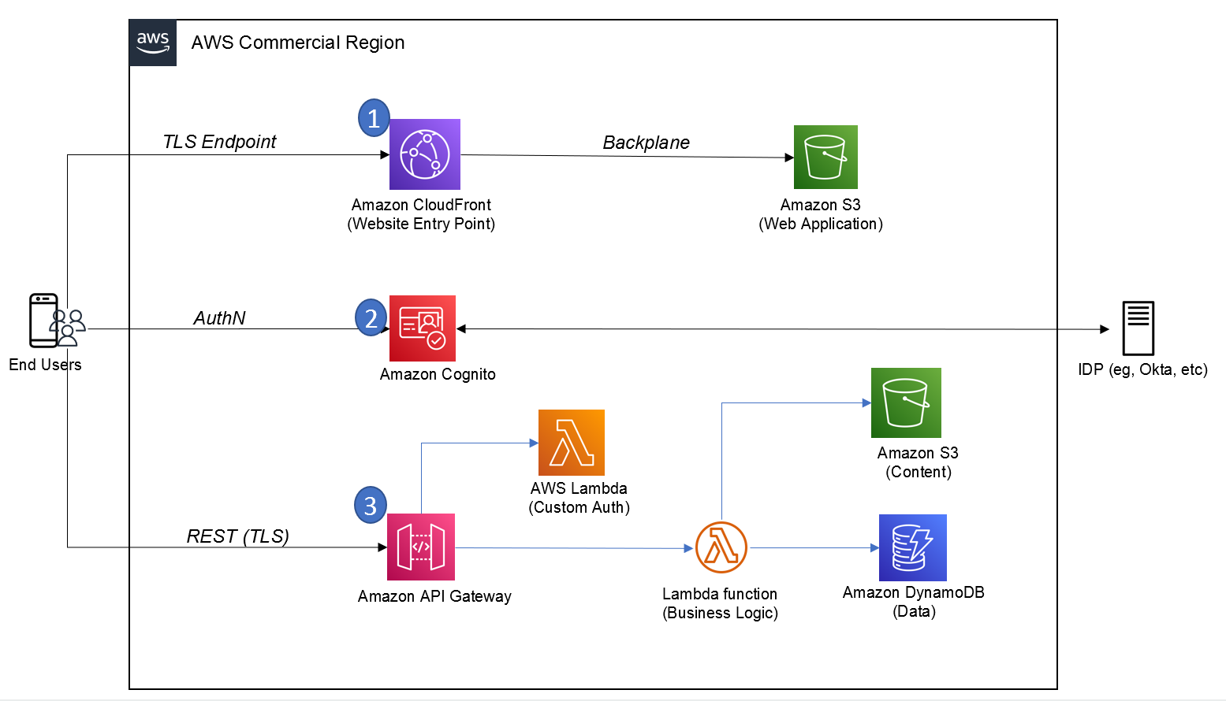

**Figure 9.6:** Common Amplify Architecture in an AWS Region (AWS Blogs).

Serverless Functionality

AWS Amplify promotes serverless architecture, allowing developers to focus on building features without managing the underlying infrastructure. Serverless functions enhance application functionality and scalability (Brennan, 2019).

Scalability and Performance

Amplify applications benefit from the scalability and performance optimizations provided by AWS services. This ensures that applications can manage varying workloads and deliver a responsive user experience (Chambers & Bacon, 2020).

AWS Amplify appears as a versatile and powerful toolset for developers venturing into front-end web and mobile application development. With its flexibility, integration capabilities, and focus on simplifying complex tasks, Amplify accelerates the development lifecycle. Whether managing authentication, integrating APIs, or implementing serverless functions, Amplify provides a cohesive platform that aligns with the modern demands of building responsive and scalable applications.

AWS AppSync

In the dynamic realm of front-end web and mobile development, AWS AppSync stands as a powerful service that simplifies the process of building scalable and interactive applications. This section explores the functionalities and features of AWS AppSync, exploring its role in helping efficient data synchronization and communication between applications and backend services.

AWS AppSync Overview

AWS AppSync is a managed service that enables developers to create flexible and scalable APIs for applications by managing the heavy lifting of securely connecting to data sources such as AWS DynamoDB, Lambda, or HTTP data sources. It plays a relevant role in simplifying data fetching, updates, and real-time data synchronization across various platforms (Amazon Web Services, 2023).

Key Features and Capabilities

The following key features highlight the extensive functionality AWS AppSync offers to developers building front-end applications (Amazon Web Services, 2023):

* **GraphQL as a Service**

AWS AppSync utilizes GraphQL, a powerful query language for APIs, providing a flexible and efficient way to request and deliver data. This enables clients to request only the data they need, reducing over-fetching and improving performance.

* **Real-time Data Synchronization**

One of the standout features of AppSync is its support for real-time data synchronization. It enables developers to build applications that can receive real-time updates from the backend, enhancing the overall user experience.

* **Offline Data Access**

AppSync includes features for offline data access, allowing applications to still be functional even when there is no internet connection. This is particularly valuable for mobile applications that need to provide a seamless user experience in various network conditions.

* **Data Source Integration**

The service seamlessly integrates with various data sources, including AWS DynamoDB, AWS Lambda, and HTTP data sources. This flexibility allows developers to use different backend services based on their application requirements.

Serverless Functionality

AWS AppSync's serverless architecture cuts the need for server management by developers. This serverless approach enables automatic scaling based on demand, ensuring best performance under varying workloads (Raj & Breskim, 2018).

AWS AppSync appears as an asset for developers in the front-end web and mobile development space, offering a powerful and scalable solution for building APIs (Johnson, 2019). Whether enabling real-time data synchronization, supporting offline access, or seamlessly integrating with various data sources, AppSync empowers developers to create responsive and feature-rich applications. Its adoption of GraphQL as a service further enhances its capabilities, providing a modern and efficient approach to data communication in the cloud.

AWS Device Farm

In the ever-evolving landscape of front-end web and mobile development, ensuring the seamless functionality of applications across various devices and platforms is paramount (Srinivasan, 2019). AWS Device Farm serves as a comprehensive testing service, allowing developers to enhance the quality and reliability of their applications by conducting tests on a diverse range of real devices. This section provides an in-depth exploration of AWS Device Farm, elucidating its features, advantages, and the significant role it plays in improving the end-user experience.

AWS Device Farm Overview

AWS Device Farm is a cloud-based mobile application testing service that enables developers to run tests on a multitude of real devices, ensuring their applications perform optimally across different devices, screen sizes, and operating systems. This service supports both Android and iOS platforms, offering a more efficient solution for testing applications on real devices in the AWS Cloud (Amazon Web Services, 2023).

Key Features and Capabilities

The following features underscore AWS Device Farm's extensive support for mobile application testing, highlighting how it improves testing accuracy and efficiency: (Amazon Web Services, 2023)

* **Real Device Testing**

AWS Device Farm provides access to a vast collection of real devices, allowing developers to execute tests on actual hardware rather than relying solely on emulators. This ensures a more correct representation of how the application will behave in real-world scenarios.

* **Parallel Testing**

The service supports parallel testing, enabling developers to execute tests concurrently on multiple devices. This accelerates the testing process, saving time and resources.

* **Appium and Selenium Compatibility**

Device Farm is compatible with popular testing frameworks like Appium and Selenium, offering flexibility for developers who prefer these frameworks for their testing processes.

* **Remote Access**

Developers can remotely access and interact with devices in real-time during testing. This feature is incomparable for diagnosing issues and gaining insights into the application's behavior on specific devices2.

* **Built-in Test Reports**

Device Farm generates detailed test reports, including logs, screenshots, and videos of the test execution. This comprehensive feedback aids developers in finding and resolving issues efficiently.

**Figure 10.7** illustrates an example of web applications hosted in a private network using AWS Device Farm, highlighting the practical application of this testing environment within secure configurations:

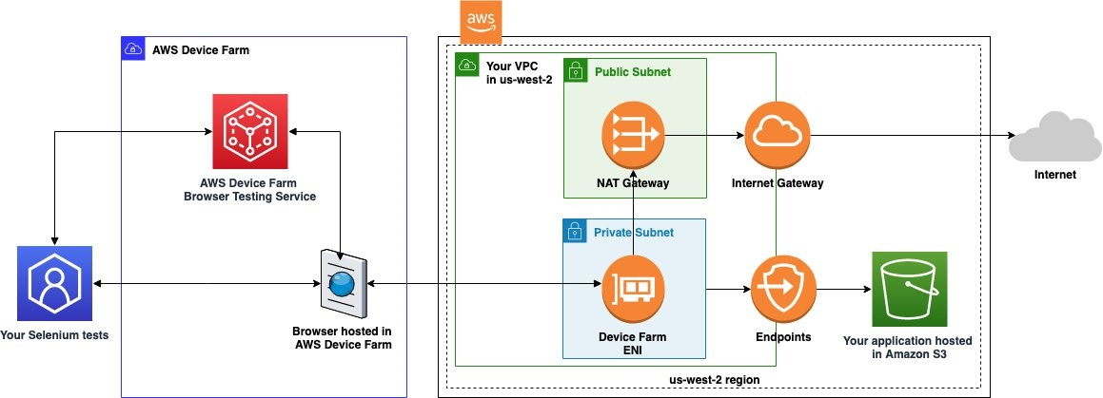

**Figure 10.7:** Web applications hosted in a private network using AWS Device Farm (AWS Blogs).

AWS Device Farm appears as a valuable tool for developers engaged in front-end web and mobile development, providing a robust testing environment on real devices. By offering a diverse array of devices, supporting parallel testing, and integrating seamlessly with popular testing frameworks, Device Farm empowers developers to identify and rectify issues early in the development lifecycle (Bender & Karnowski, 2018). The service's ability to generate comprehensive test reports further helps a streamlined testing process, contributing to the delivery of high-quality and reliable mobile applications to end-users.

Reflecting on AWS for End-User, Front-End, and Mobile Development

*Chapter 10, End User, Front End and Mobile*, has provided a detailed exploration of AWS services essential for delivering seamless and innovative user experiences. In summary, these services are vital in transforming application development, deployment, and usage.

.

End User Computing

Within the realm of **Amazon AppStream 2.0 and Amazon WorkSpaces Family**, we explored the future of end-user computing. The ability to stream resource-intensive applications and provide virtual desktops on-demand not only enhances user flexibility but also ensures data security and compliance. This becomes particularly important in the context of the evolving remote work landscape, where organizations seek scalable solutions for delivering a consistent and secure computing experience to their workforce (Amazon Web Services, 2003) (Amazon Web Services, 2003) (Smith & Jones, Cloud Computing Advances in Modern Business, 2018).

Front-end Web and Mobile

The journey through **Amazon API Gateway** highlighted its defining role as a fully managed service for creating, publishing, and securing APIs at any scale. The service acts as a bridge between back-end services and front-end applications, helping seamless communication and integration. **Amazon Location Service** introduced a geospatial dimension, enabling developers to build location-aware applications. **Amazon Pinpoint** and **Amazon SES** underscored the significance of targeted communication, with Pinpoint providing personalized engagement across multiple channels and SES ensuring reliable and scalable email communication (Amazon Web Services, 2003) (Amazon Web Services, 2003) (Amazon Web Services, 2023) (Amazon Web Services, 2023).

The trifecta of **AWS Amplify, AWS AppSync, and AWS Device Farm** showcases AWS's commitment to simplifying front-end development. **AWS Amplify** streamlines the development process, allowing developers to build scalable and secure cloud-powered web and mobile apps. **AWS AppSync** simplifies application development by enabling real-time data synchronization and offline data access, relevant for responsive and user-friendly applications. **AWS Device Farm** facilitates continuous testing, ensuring that applications function seamlessly across a myriad of devices, browsers, and operating systems (Amazon Web Services, 2023) (Amazon Web Services, 2023) (Amazon Web Services, 2023) (Chen & Wang, 2020).

Conclusion

In conclusion, *Chapter 10, End User, Front End and Mobile*, has unraveled the diverse sides of AWS services catering to end-user computing and front-end development. The flexibility, scalability, and user-centric design embedded in these services position AWS as a pioneer in the cloud computing landscape. In continuation, these services are not merely tools but enablers of innovation, playing a significant role in shaping the future of user interactions, mobile experiences, and front-end development.

As technology advances, AWS stays at the forefront, continually refining and expanding its services to meet the evolving demands of the digital landscape. This chapter serves as a testament to the integral role AWS plays in empowering developers and organizations to create innovative applications that redefine the boundaries of user experiences.

In the next chapter, we will examine DevOps and Infrastructure as Code (IaC), highlighting AWS tools and services that enhance automation, configuration management, and deployment workflows.

# References

Amazon Web Services. (2003). Amazon API Gateway Documentation. Retrieved from https://aws.amazon.com/api-gateway/

Amazon Web Services. (2003). Amazon AppStream 2.0 Documentation. Retrieved from AWS Documentation: https://aws.amazon.com/appstream2/

Amazon Web Services. (2003). Amazon Location Service Documentation. Retrieved from https://aws.amazon.com/pm/location/

Amazon Web Services. (2003). Amazon WorkSpaces Documentation. Retrieved from https://aws.amazon.com/pm/workspaces/

Amazon Web Services. (2023). Amazon Amplify Documentation. AWS Amplify. Retrieved from https://aws.amazon.com/amplify/

Amazon Web Services. (2023). Amazon Pinpoint Documentation. Retrieved from https://aws.amazon.com/pinpoint/

Amazon Web Services. (2023). Amazon Simple Email Service (SES) Documentation. Retrieved from https://aws.amazon.com/ses/

Amazon Web Services. (2023). AWS Amplify Documentation. Retrieved from https://aws.amazon.com/amplify/

Amazon Web Services. (2023). AWS AppSync Documentation. Retrieved from https://aws.amazon.com/pm/appsync/

Amazon Web Services. (2023). AWS Device Farm Documentation. Retrieved from https://aws.amazon.com/device-farm/

Anderson, R. e. (2018). Cloud-Based Virtual Desktops: A Comparative Analysis of WorkSpaces Solutions. *Journal of Cloud Computing Advances and Applications, 4*, 78–94.

Bender, M., & Karnowski, D. (2018). *Continuous Delivery for Mobile with fastlane: Automate your mobile development pipeline for faster, more reliable releases.* O'Reilly Media.

Brennan, R. (2019). *Full Stack Serverless: Modern Application Development with React, AWS, and GraphQL.* Apress.

Brown, J. (2019). *Email Marketing Rules: A Step-by-Step Guide to the Best Practices that Power Email Marketing Success.* Wiley.

Brown, M. e. (2020). Enhancing Security in Application Streaming Services: A Comparative Analysis. *International Conference on Cloud Security*, (pp. 45-52).

Chambers, D., & Bacon, J. (2020). *Building Scalable Apps with AWS Amplify: A Developer's Guide to Designing Cloud-Enabled Applications.* O'Reilly Media.

Chen, L., & Wang, Y. (2020). Mobile Application Development in the Cloud Era. *IEEE Transactions on Cloud Computing, 8*, 456–467.

Craglia, M., Bie, K., Jackson, D., Pesaresi, M., & Remetey-Fülöpp, G. (2012). *Digital Earth from Vision to Practice: Making Sense of Citizen Observatories.* Springer.

Fielding, R. T. (2000). Architectural Styles and the Design of Network-based Software Architectures. *Architectural Styles and the Design of Network-based Software Architectures*. Irvine.

Garcia, M., & Patel, S. (2021). Security Measures in Cloud-Based Virtual Desktop Environments., (pp. 211–225).

Gupta, S., & Zeithaml, V. (2006). Customer Metrics and Their Impact on Financial Performance. *Marketing Science, 25*, 718–739.

Johnson, E. (2019). *Mastering AWS AppSync: Build Scalable and High-Performing GraphQL APIs for Your Applications.* Packt Publishing.

Longley, P. A., Goodchild, M. F., Maguire, D. J., & Rhind, D. W. (2015). *Geographic Information Science and Systems.* John Wiley and Sons.

Raj, R., & Breskim, A. (2018). *Hands-On Full Stack Development with AWS AppSync and React.* Packt Publishing.

Richardson, L., Amundsen, M., & Ruby, S. (2013). RESTful Web APIs. *RESTful Web APIs*. O'Reilly Media.

Sharma, A. (2016). *Email Marketing: An Hour a Day.* John Wiley and Sons.

Smith, A., & Johnson, B. (2018). *Digital Marketing Strategies: An Integrated Approach to Online Marketing.* Routledge.

Smith, J., & Jones, A. (2018). *Cloud Computing Advances in Modern Business.* Academic Press.

Smith, J., & Jones, A. (2019). Revolutionizing End User Computing: A Case Study of Amazon AppStream 2.0. *Journal of Cloud Computing Advances and Applications, 5*(2), 112-129.

Srinivasan, V. (2019). *Mobile DevOps: Deliver Continuous Mobile Apps Faster and More Efficiently.* Apress.